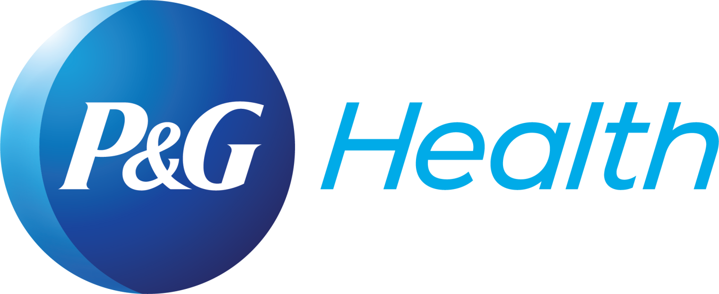

P&G Health unveils New Livogen Multivitamin Tonic
– a new age comprehensive multivitamin
Scientifically-proven, the product comes packed with goodness of nine essential nutrients

Lucknow, September 4, 2019: Procter & Gamble Health Limited (formerly known as Merck Limited) today announced the launch of its the New Livogen Multivitamin Tonic at Hotel Hyatt Regency, Lucknow.

Speaking at the launch event, Milind Thatte - Managing Director, Procter & Gamble Health Limited stated, “Meeting the wellness needs of consumers for over 50 years, Livogen is one of India’s leading Iron Supplements. We are delighted to introduce the New Livogen Multivitamin Tonic which is formulated to aid people combat fatigue, weakness while giving them the strength to be active & productive. With the New Livogen Multivitamin Tonic, we are very pleased to offer a comprehensive health syrup that will ensure patients and consumers are protected from the most common concerns that we face today. We will also be continuing our efforts to increase awareness on nutritional deficiencies with our Brand Ambassador Shubhangi Atre & our digital mascot Shuklaji”

Shuklaji – Livogen’s digital mascot - is an endearing elderly woman who shares her wisdom on correct diet and holistic living with families and will be joining Shubhangi – popularly known as Bhabhiji- in spreading awareness among consumers and patients.

According to noted city physician Dr. Dinesh Lalwani, “India is endemic for nutritional deficiencies, and has one of the highest rates of Iron deficiency and anemia cases. Fatigue, lethargy, weakness and diminished immunity are rising concerns across all ages. The lack of essential vitamins and other nutrients also contribute to loss of appetite, hair fall, skin pallor and lack of strength adding on to the daily stressors. There is an increasing need for a comprehensive composition that is trusted and can address common concerns with proven results. While there is no substitute for a healthy diet, a multivitamin tonic enriched with essential nutrients could be the answer to address this situation, besides educating the masses”

Formulated as a one stop care for the entire family, the New Livogen Multivitamin Tonic - available as an Adult tonic and Kid’s syrup - is enabled with nine essential nutrients viz. Iron, Vitamin B12, Vitamin B6, Vitamin B3, Vitamin B5, Folic acid, Protein hydrolysate, Zinc, and L-Lysine that play a pivotal role in nurturing the body. It is also available as Baby Drops which contains Iron and Folic Acid.

The New Livogen Multivitamin Tonic brand ambassador, Shubhangi Atre, “I am delighted to be the face of the New Livogen Multivitamin Tonic, and help spread the benefits of ‘Real Strength, Real Tonic’ among the people of India. Today, most of us are hustling and juggling between multiple responsibilities. We have to cope with stress, infections, and excessive fatigue daily. There is little or no time for self-care. This leads to us unknowingly compromising on our daily nutritional intake. This wholesome tonic from India’s leading Vitamins Company, Procter & Gamble Health Limited will help enable families to take a step towards healthier self and cope with the demands of our daily schedules.”

New Livogen Multivitamin Tonic (Adult tonic and Kid’s syrup) contains the following nine essential nutrients:  - Iron – improves strength and agility¹  - Vitamin B12 – fights fatigue and weakness²  - Vitamin B6 – helps in brain function²  - Vitamin B3 – helps in metabolism²  - Vitamin B5 – helps in energy production²  - Folic Acid – helps in new cell formation³  - Protein hydrolysate – enhances tissue repair⁴  - Zinc – supports healthy immunity⁵  - L-Lysine – stimulates appetite⁶. | New Livogen Multivitamin Tonic (Baby Drops) contains:  - Iron– improves strength and agility¹  - Folic Acid – helps in new cell formation²

About Procter & Gamble Health Limited:

Procter & Gamble Health Limited (formerly Merck Limited) is one of India’s largest VMS Companies manufacturing and marketing over-the-counter products, vitamins, minerals, and supplements products for a healthy lifestyle and improved quality of life. Please visit www.pghealthindia.com for the latest news and information about Procter & Gamble Health Limited and its brands.

About Procter & Gamble:
P&G serves consumers around the world with one of the strongest portfolios of trusted, quality, leadership brands, including Always®, Ambi Pur®, Ariel®, Bounty®, Charmin®, Crest®, Dawn®, Downy®, Fairy®, Febreze®, Gain®, Gillette®, Head & Shoulders®, Lenor®, Olay®, Oral-B®, Pampers®, Pantene®, SK-II®, Tide®, Vicks®, and Whisper®. The P&G community includes operations in approximately 70 countries worldwide.

MEDIA CONTACTS

AGENCY - Current Global:
- Sarah Rajan | srajan@currentglobal.com

Procter & Gamble Health Limited:
- Ruchita Mehra | mehra.r@pg.com
- Paromita Kundu| kundu.p.1@pg.com
References
- Panicker NK et al. Comparison of Efficacy and Safety Profile of Oral Iron Formulations in Patients with Iron Deficiency AnemiaInt. J. Pharm. Sci. Rev. ResOthers2016;
- Schellack G, et al. B-complex vitamin deficiency and supplementation S Afr Pharm JOthers2015; 4B-complex vitamin deficiency and supplementation
- Milman N, Intestinal absorption of folic acid - new physiologic & molecular aspects, Indian J Med Res. 2012 Nov; 136(5): 725–728
- Thomson RL, Buckley JD Protein hydrolysates and tissue repair Nutr Res Rev. 2011 Dec;24(2):191-7
- Prasad AS, Zinc in Human Health: Effect of Zinc on Immune Cells, Mol Med. 2008 May-Jun; 14(5-6): 353–357
- Krasniqi E et al. Approved health claims for amino acids in/as food supplements Maced. pharm. bull.,Others2016; 4Approved health claims for amino acids in/as food supplements

# # #

