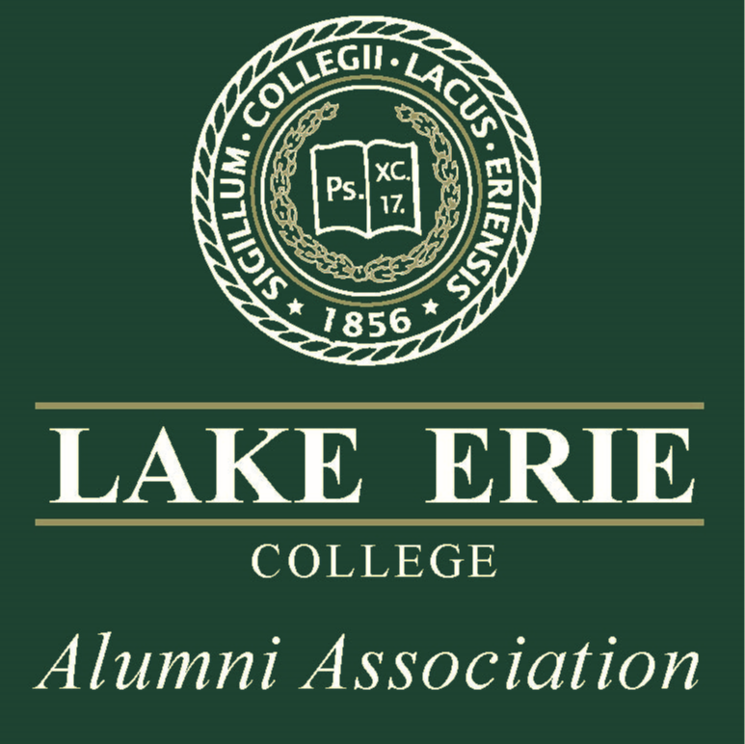

NATIONAL ALUMNI BOARD

OF LAKE ERIE COLLEGE
Thank you for your interest in serving on the National Alumni Board.
The National Alumni Board (NAB) is the governing body of the Alumni Association of Lake Erie College and is composed of elected officers, chairpersons of the Board's standing committees, and two representatives to the Lake Erie College Board of Trustees. The mission of the NAB is to reach, serve and engage all alumni and students and to provide the College with goodwill and charitable support.
Persons interested in the National Alumni Board membership are expected to:
- Attend regularly scheduled Board meetings
- Serve on a committee
- Participate in Alumni Weekend
- Serve as an active ambassador for the College
- Make a monetary donation of $1,000 **Talent, Time and Treasurer are considered; a $100 monetary donation is expected.
The NAB is currently comprised of 16 board members. Election of members usually takes place in the Fall around alumni weekend.
Trustee meetings are held quarterly, usually the third Saturday of the month, at 10:00 a.m. at various sites on the LEC campus.
If you would like to be considered as a member, please complete the attached application and return it to a member of the nominating committee:
Sharan McPadden, 2000 & 2003
s.mcpadden13@gmail.com

Denise Molesch, 1995
Denmol1@gmail.com

NATIONAL ALUMNI BOARD

OF LAKE ERIE COLLEGE TRUSTEE APPLICATION

NAME: _______________________________________________________________________________
ADDRESS: ____________________________________________________________________________
CITY: _________________________________ STATE: _________________ ZIP CODE: ______________
HOME PHONE: ( ) ________________________________ CELL PHONE: ( ) _________________
GRADUATION YEAR: ____________________ MAJOR: ________________________________________
EMPLOYER: ___________________________________________________________________________
TITLE: ________________________________________________________________________________

wHY ARE YOU INTERESTED IN SERVING ON THE NAB?
_____________________________________________________________________________________________________________________________________________________________________________________________________________________________________________________________________________________________________________________________________________________________________________________________________________________________________________________________________________________________________________________________________________________________________________________________________________________________________________________________________________________________________________________________________________________________________________________________

i WOULD BE INTERESTED IN SERVING ON THE FOLLOWING COMMITTEES:
Event Planning Nominating Committee Distinguish Alumni Award
Young Alumni Award Sunshine

