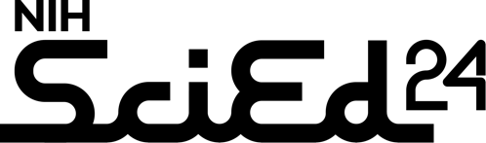

Project Name:
Authors, Affiliations, and Email Address of Primary Contact: |  |  | Funder:
Website: |  | If SEPA project, URL for project on https://nihsepa.org/
Brief Program Description (50 – 60 words)

Program and Participant Characteristics | Please use this space for any images  that best represent your project |  | Program Activities
Program type (Please check all that apply):  __ Curriculum. __ Out-of-school program  __ Exhibit __ Interactive multimedia  __ Teacher PD  __ Research experiences for students or teachers  __ Other (describe): |  |  | Please describe anything that you’ve done or created for your project so far. Add graphics if you’d like!
Setting(s): ___ Formal ___Informal
Types of participants
__ Students __ Teachers __ Scientists
__ Families __ Public
__ Other (describe):
Grade level(s) of participants
__ PreK __ Elementary (K-5) __ Middle (6-8)
__ High (9-12) __ Adult
Characteristics of the populations you serve relative to DEIA:

Evaluation | Key Accomplishments and/or Findings
Constructs measured
__ Content knowledge __ Skills
__ Nature of science __ Career awareness
__ Attitudes (e.g., interest, identity, belonging)
__ Quality or fidelity of implementation
__ Other (describe):

Methods
__ Tests/surveys __ Interviews/focus groups
__ Observations __ Artifacts (e.g., student work)
__ Other (describe):

Design characteristics
__ Comparison or control group
__ Pre/post surveys or assessments
__ Longitudinal tracking of participants
__ Other (describe):

Project Lessons Learned
Questions, Advice Wanted, or Topics of Discussion for the SciEd Community (optional)

