Guide to Suppliers
To register and start submitting cost estimates:

- This document is to introduce suppliers to use the new cost estimate tool (Lighthouse) to submit their estimates.

Please follow the below steps to submit a cost estimate for Elsevier titles.
- Suppliers will be receiving an email such as the below when a new title (New/re-print) is transmitted.

Dear Team
A new Print project is available to quote. Please use the link below and submit your quote within 2 working days.
https://seisint.quickbase.com/db/brj5ebqym?a=dr&r=ky
For any queries, write to Wade, Gregory (g.wade@elsevier.com)
Regards,
Elsevier Print Specialist team

- When suppliers click on the link in the email, it will ask them to sign in. Scroll down and use the Create a log-in button if you are using this tool for the first time.

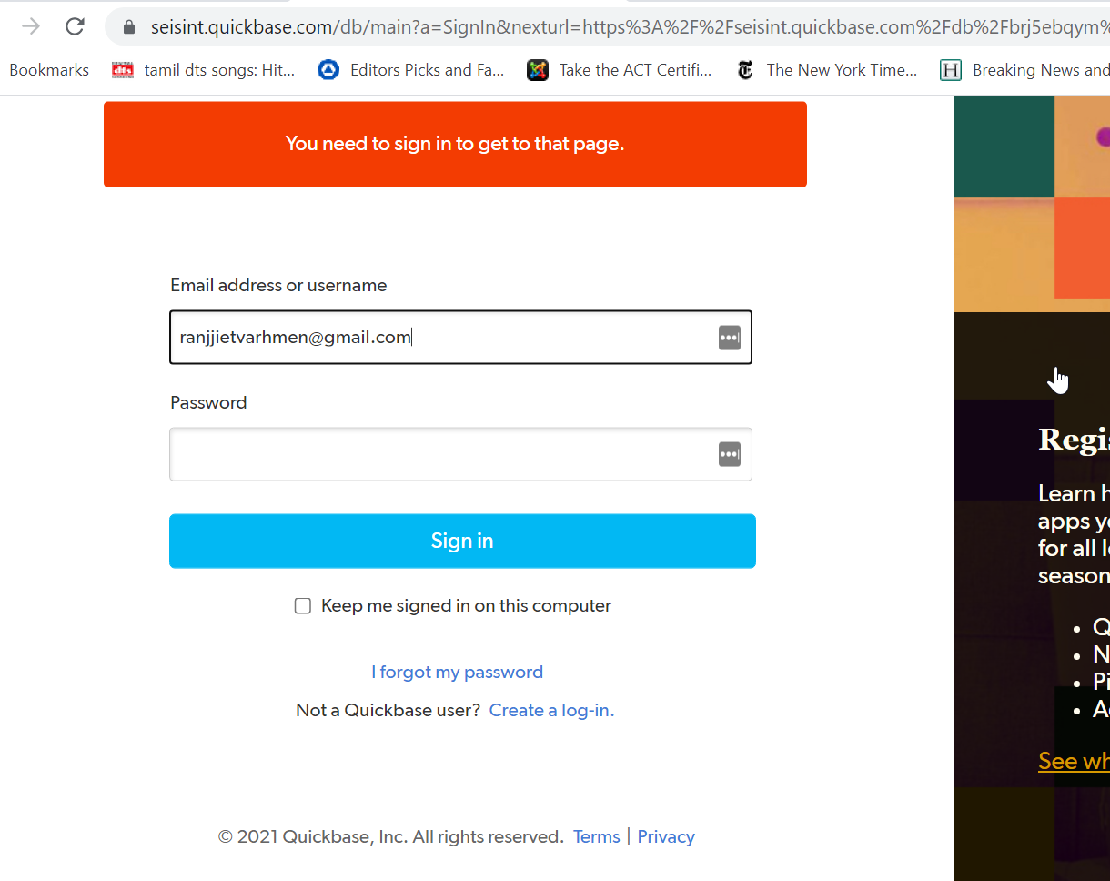
- Fill in your official email id.
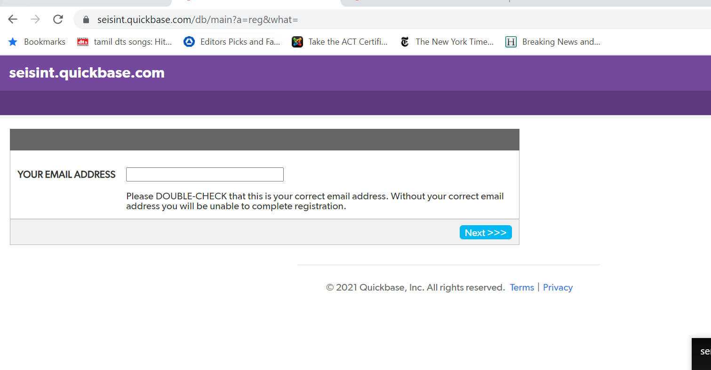
- Fill in other information. Please remember to create a password that can be shared with other estimators (If more than one people will be estimating in your organization).

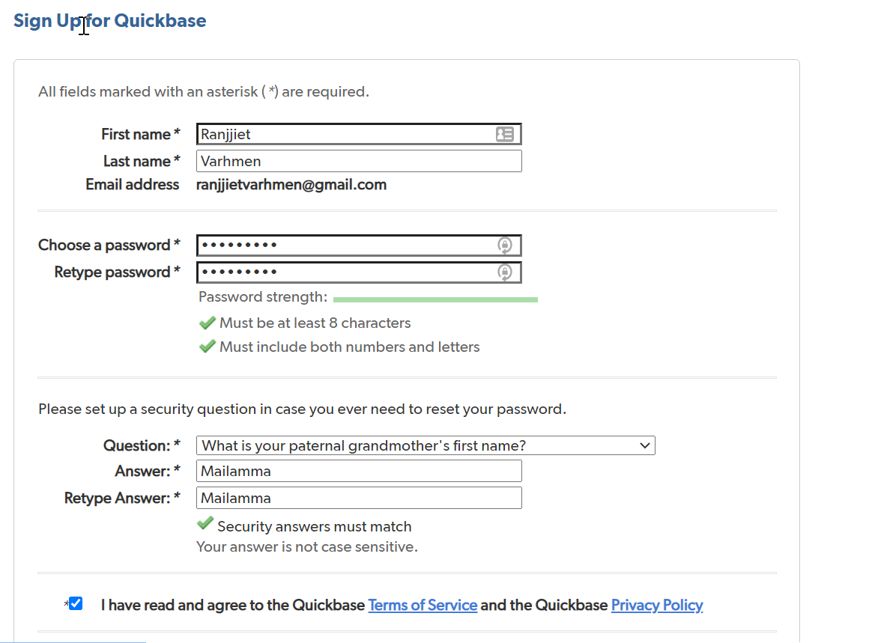

- You will be able to log-in using the new credentials that you have created.
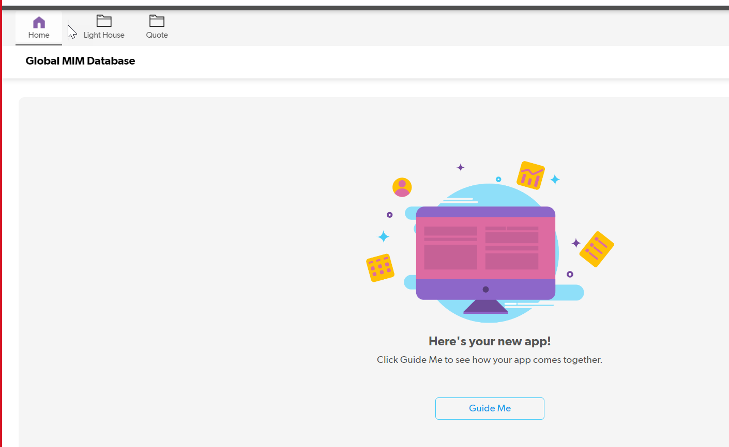
- Click on the lighthouse button at the top and you will be able to see all the titles that are available to estimate. Click on the eye or blue ISBN number.
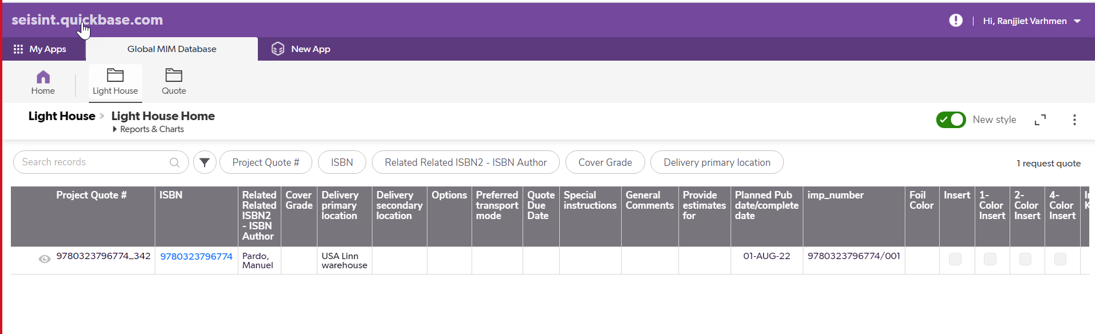
- Review the title specs and other information and click on ‘Add request quote’ button when are ready with the costs.
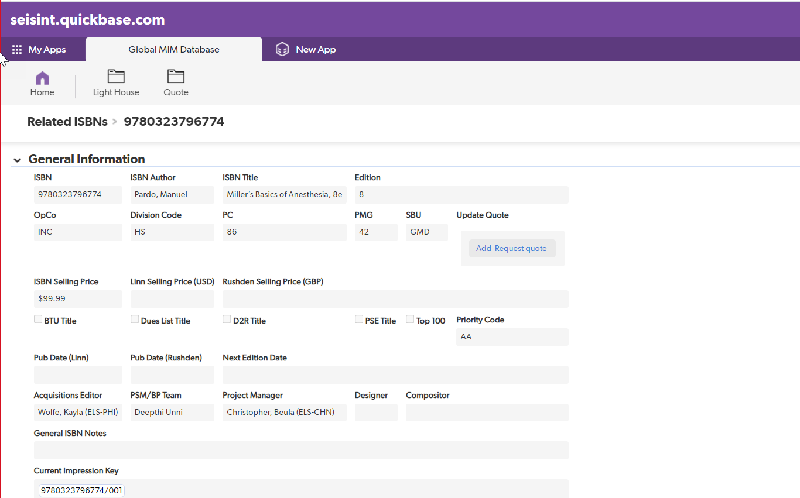
- Fill in the cost details and other fields.
  - Provide estimates
    - Please fill in the print method that you will be using.
    - You could choose to submit multiple estimates for the same title(Offset and Digital). For e.g. First fill this estimate for Offset and use the save & close to submit. Redo the entire process and fill the form again for Digital. This will help Elsevier choose the right estimate by comparing cost and timelines.
  - Print run is not editable, however, if you would like to offer better cost for higher print runs please mention the same in the comments sections.
  - Supplier FTP date: Please calculate backwards from the pub date. This is based on the time taken for the supplier from the files received date till the books reach the warehouse.
  - Currency
  - Username: Pick the correct email id. If you do not see your/your organisation mail id here. Please write to m.jeyakodi@elsevier.com
  - Paper cost
  - Print cost
  - Bind cost
  - Total additional cost
  - Total shipping cost (FOB/Frieght)
  - Preferred transport mode
  - Unit cost- Auto calculated
  - Total cost- Auto calculated
  - Run back cost per thousand copies
  - Run forward cost per thousand copies
  - Spine width
  - Unit weight
  - Total weight of the order
  - If Elsevier supplied Stock
    - Size of the paper
    - Total weight of paper
    - Size of paper 2
    - Total weight of paper 2
  - Comments: Kindly mentions any assumptions made estimating the cost. Also any general notes.
  - Attachment: Please attach the cost estimate in your organisation format for reference.

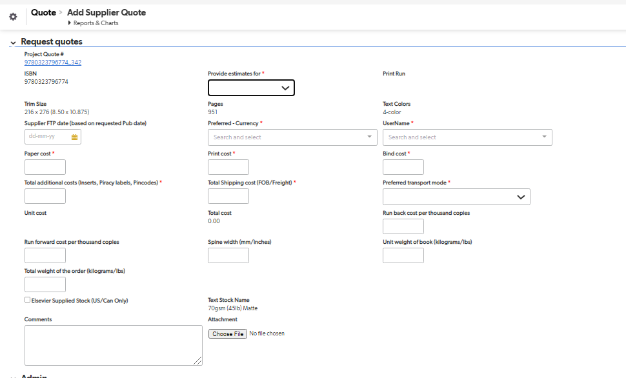

- Click Save and Close to submit the cost estimate.

If you have any issues with access, sign-in or submissions. Please contact m.jeyakodi@elsevier.com. We will respond in 2-3 working days.

