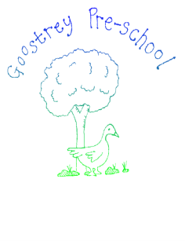**Babysitting Policy**

Goostrey Pre-School are happy for its staff to help parents/carers from time to time with babysitting in the evenings and weekends.

All staff who babysit for our families must declare they are doing so to their manager and complete the Conflict of Interest form. (See Conflict of Interest Policy)

This is to ensure the Pre-School is aware, and that any special considerations can be addressed and actioned.

However, we would like to make it clear that staff are bound by contract of the confidentiality policy and data protection act that they are unable to discuss any issues regarding Goostrey Pre-School, other staff members, parents or other children. Should it be found that any staff member has discussed anything relating to the matters above, this will result in gross misconduct and the staff member will be subject to investigation.

If a member of staff is employed to babysit for a family, they are completing that job role independently of Goostrey Pre-School, therefore they are not covered under any of our insurances.

|  |  |
| --- | --- |
| This policy was adopted by: Goostrey Pre-School | Date: April 2022 |
| To be reviewed: April 2023 | Approved by Anne-Louise Warren |