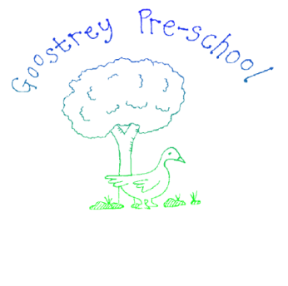

**Dummy Policy**

Policy statement

The Department for Children, Schools and Families have issued a document called, ‘Supporting children with speech, language and communication needs: Guidance for the Early Years Foundation Stage’, from which the following quotation can be found:

‘Dummies and bottles can contribute to delayed communication development’.

As babies and children get older they need to learn to move their mouths in different ways, to smile, to blow bubbles, to make sounds, to chew food and eventually to talk. As they move their mouths and experiment with babbling sounds they are learning to make the quick mouth movements needed for speech. The more practice they get the better their awareness of their mouths and the better their speech will be. The overuse of a dummy or bottle may restrict these movements from taking place and therefore affect a child’s language development.

Procedure

Goostrey Pre-School believe that a child who is still in need of a dummy, is not be ready for Pre-school and therefore we ask that you delay your child starting with us until a dummy is no longer required during the day.

|  |  |
| --- | --- |
| This policy was adopted by: Goostrey Pre-School | Date: April 2019 |
| To be reviewed: February 2025 | Signed: Nicola Ellershaw |