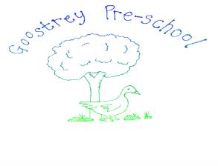**Social Media (Facebook) Policy**

Social media is a huge part of our lives. It provides a wonderful platform to communicate with friends, family and new people.

Goostrey Pre-School have ownership of 2 pages on Facebook.

The first is a page is Goostrey Pre-School. Here Staff, Parents and Committee members can share Pre-School experiences, about the day to day activities of the children in the setting and on Pre-School outings.

The following rules apply:

* The Pre-School Manager accepts/ declines friend requests to join the group.
* Photographs of children engaged in pre-school activities are only used with the specific written permission of their parent or legal guardian.
* Children’s faces may be obscured if a parent does not wish them to be readily identified.
* The page is not to be used as a way to communicating a child’s absence from Pre-School .
* Offensive language will not be tolerated.
* Private information, such as telephone numbers or addresses must not be shared.
* Negative comments about the Pre-School will be not be allowed. Please refer to our Complaints Policy if you have any issues .

The second page is Goostrey Pre-School Chit chat. This is managed by current parents.

* They accept/decline friend requests to join the group.
* Posts on this page are generally linked to fund raising and activities outside of the day to day running of the Pre-School.
* Again, this page is not a way of communicating a child’s absence from Pre-School.
* Offensive language will not be tolerated.
* Negative comments about the Pre-School will not be allowed. Please refer to our Complaints Policy if you have any issues.

Failure to comply with these rules will result in your permanent removal from these pages.

Both pages are reviewed annually to remove parents/carers that no longer have connections to the Pre-School.

Staff are to think carefully and discuss with the manager or chairperson about whether to become new friends via social media with current parents/carers.

|  |  |
| --- | --- |
| This policy was adopted by Goostrey Pre-School | Date 21st April 2019 Updated 28/02/2024 |
| To be reviewed February 2025 | Approved Jessica Moores |