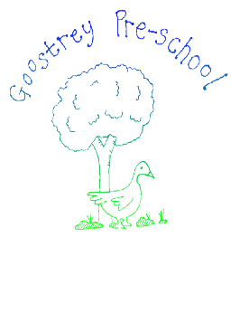Holiday Pay Policy

**Policy Statement**

Goostrey Pre-School employees are employed on fixed hour contracts for term time only. This policy details how holiday pay is calculated and how and when it is paid.

**Procedures**

Working term time only is defined as part year working. The holiday year runs from September 1st to August 31st.

By law, all employees are entitled to receive 5.6 weeks statutory holiday pay per year. Because staff are on fixed hour contracts then their holiday pay is at there usual pay rate.

Holiday pay is paid as follows:

1.6 weeks in Decembers pay (Christmas holidays)

1 week in Aprils pay (Easter holidays)

3 weeks in Augusts pay (Summer holidays)

If an employee increases their fixed hours during the academic year, their holiday pay will be based on their new weekly rate.

**Bank Holiday pay**

There are typically 8 Bank Holidays a year.

Pre-School is always closed for Christmas Day, Boxing Day, Spring (May) and Summer (August) Bank Holidays.

There is the possibility that New Years Day, Good Friday, Easter Monday and Early May Bank Holidays could fall when Pre-School is operational and we would close for that day.

To ensure fairness, all staff whether they are rostered to work that day or not will be paid their usual daily rate.

Additional Bank Holidays for a Jubilee, Monarch’s Funeral or Coronation when the Pre-School is closed will be treated as above and staff will be paid for the day at their usual daily rate.

**Taking time off in term time**

Staff are encouraged to plan their holidays when the Pre-School is closed for holidays. If this is not possible then staff must have leave authorised by the Manager and the trustees prior to booking it. This time off is classed as unpaid leave.

For further guidance on all matters relating to holiday pay, including your rights as an employee and the relative legislation please refer to guidance found at www.acas.org.uk and/or www.gov.uk. These sites were also used as a point of reference/guidance in the process of creating this document.

This policy is reviewed annually, or as deemed necessary.

Policy written by Nicola Ellershaw 04/10/2022