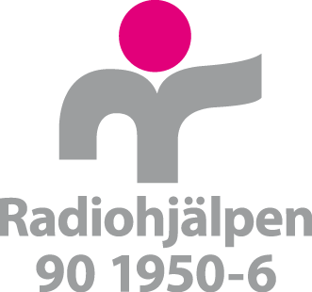

Framework organisations

Part 1 application for international projects

1. Information applying organisation
1.1 Name organisation | 1.2 Total amount applied from the fund/campaign
1.3 Organisational account for disbursements from Radiohjälpen (PG/BG/90-konto)

1.4 Amount of funding received previous budget year form institutional donors  SEK | 1.5 Organisational number
1.6 Project manager Sweden | 1.7 E-mail project manager Sweden
1.8 Address to organisations in Sweden | 1.9 Phone number to project manager Sweden
1.10 Direct costs for international projects previous year  SEK | 1.11 Amount of funding fundraised by the organisation previous year  SEK

2. Summary applying organisation
Here you, as an applying organisation, shall give a brief review of your work on several topics. This information is not project specific. In case of any project included in part two of the application to Radiohjälpen has involved deviations from the below information, this should be clearly stated and motivated below, under question 2.2. This could entail contexts where there is a need for ’remote partnership’ or ’remote monitoring’ for instance. The measures taken to uphold sound systems for internal management and control should be stated.

2.1 Radiohjälpen requires that the applying organisation has conducted a review of internal management and control, including anti-corruption, prior to project funding being approved.

The applying organisation has systems in place to conduct reviews of implementing organisations with regards to internal management and control and has conducted a review with sound results of the implementing organisations included in part 2 of the application

The applying organisation has ensured that the implementing organisation(s) included in part two of the application to Radiohjälpen has the capacity to implement the project as well as to prevent, detect and handle corruption

The applying organisation ensures that an agreement between the applying and implementing organisation(s) is signed priori to funds from Radiohjälpen is forwarded

Please describe, in short, how the applying organisation is working with internal management and control as well as anti-corruption. Also include a description on how the applying organisation works with reviews of implementing partners systems for internal management and control

2.2 Please specify if the any deviations have been made in the projects included in the application regarding the above information

2.3 Have you been involved in the campaign that you are applying from?
Yes
No

If yes, please describe how

Undertecknande
Jag intygar genom att kryssa i denna ruta samt genom min signatur att informationen angiven i ansökans samtliga delar (del ett och två) är korrekt samt att jag har fullmakt att översända ansökan i min organisations namn. Genom undertecknande av denna ansökan är sökande organisation införstådda med att viss information om våra representanter sparas för att möjliggöra uppföljning och dialog gällande den verksamhet som handläggs av Radiohjälpen.
Ort | Datum
Underskrift projektansvarig i Sverige | Titel
Namnförtydligande | Ifylld ansökan skickas per post till:  Radiohjälpen  105 10 Stockholm

