Siemens Techcellence Awards planning submissions planning information. This is not the official form – questions here are provided for nominee to plan/prepare responses prior to submitting. The official nomination must be completed online by March 31, 2026.

Nominee’s name:
Nominee’s email address:
Nominee’s company name:
Nominated by:
Key Stakeholders:

Category: Sustainability impact - Team award
The Sustainability impact award honors a Siemens customer organization demonstrating exceptional commitment to sustainability through the innovative use of Siemens technologies. This award recognizes leaders driving measurable progress in decarbonization, energy efficiency, resource management, and circularity—while also empowering communities and applying data-driven insights to achieve long-term environmental and social impact.
Eligibility: Open to any Siemens customer organization that has integrated sustainability into their operational strategy. Nominees must showcase initiatives completed between January 1, 2025, and December 31, 2025, and is registered for Realize LIVE Americas or Europe 2026.
The rubric can be found below:
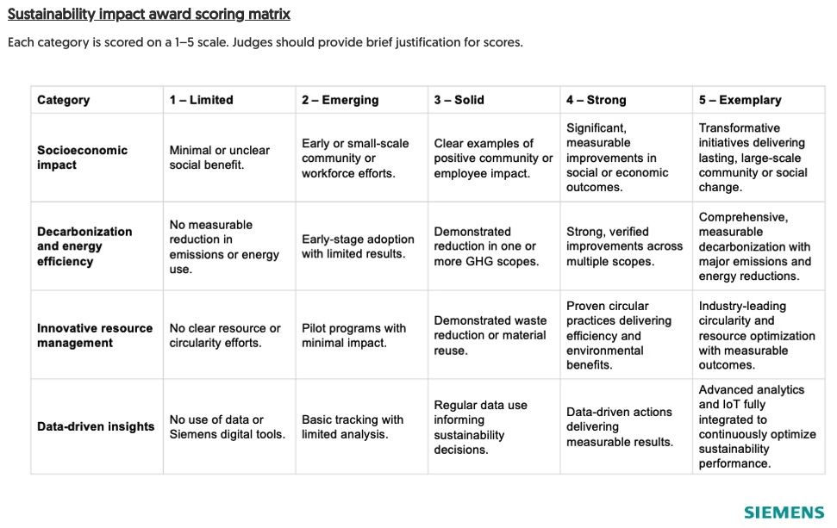
Q. Has the organization showcased the outlined initiatives between January 1, 2025, and December 31, 2025?

Q. Briefly describe your organization, including your mission, industry, and how sustainability aligns with your overall business strategy.

Q. How has your organization leveraged Siemens technologies to deliver social or economic value for employees, customers, or communities? Provide examples of programs or outcomes demonstrating social progress or community impact.

Q. How has your organization leveraged Siemens technologies to reduce emissions and improve energy efficiency across the Greenhouse Gas (GHG) Protocol Emissions Scopes 1, 2, and 3? Provide examples of tools, processes, or measurable outcomes.

- Scope 1: Direct emissions from owned or controlled sources.
- Scope 2: Indirect emissions from purchased electricity, heat, or steam.
- Scope 3: Other indirect emissions from activities not owned or controlled by the organization.

Q. How has your organization applied Siemens technologies to improve resource efficiency and circularity? Share examples of initiatives that reduced waste, extended product life, or optimized material use.

Q. How does your organization use Siemens technologies for sustainability measurement and decision-making? For example, how Siemens-powered data analytics, IoT sensors, and digital platforms have been used to monitor, report, and optimize sustainability performance.

Q. What is your organization’s long-term sustainability roadmap? How will Siemens technologies support in meeting those goals?

Optional: When submitting online, include upload of any supporting content (presentations, videos, metrics, testimonials, etc.) that strengthen this nomination.
The content notes won't be shared within the organization, and only the judges will have visibility into the content.

Personal Notes

