Siemens Techcellence Awards planning submissions planning information. This is not the official form – questions here are provided for nominee to plan/prepare responses prior to submitting. The official nomination must be completed online by March 31, 2026.

Nominee’s name:
Nominee’s email address:
Nominee’s company name:
Nominated by:
Siemens community username (if applicable):

Category: Innovation Leader - Individual award
The Innovation leader award recognizes Siemens customers who drive meaningful change through creativity and forward thinking. These innovators use Siemens technologies to develop new ideas, products, or processes that advance their organizations and push the boundaries of what’s possible.
Eligibility: Open to any Siemens customer who has implemented innovative solutions or practices between January 1, 2025, and December 31, 2025, and will attend Realize LIVE Americas or Europe 2026.
The rubric can be found below:
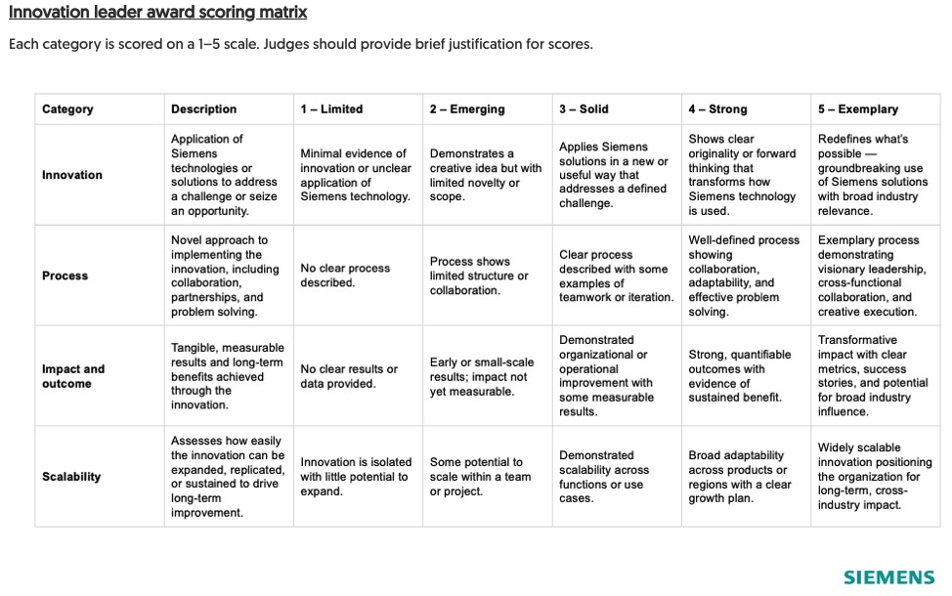
Q. Has the nominee showcased outlined initiatives between January 1, 2025, and December 31, 2025?
Q. What inspired you to nominate yourself or this individual for the Siemens Innovation leader award? (Briefly describe what makes this person’s contributions exceptional.)
Q. How has the nominee applied Siemens technologies or solutions to address a specific challenge or seize an opportunity within their organization?
Q. What makes their approach unique or novel?
Q. Describe the process behind this innovation. (Include details on collaboration, partnerships or challenges overcome during development.)
Q. How adaptable or scalable is this innovation across other teams, products, or industries?
Q. How has the nominee and their innovation created long-term, positive, and measurable impact within their organization or industry overall?
Q. What tangible results or outcomes have emerged from these efforts? (Provide relevant data, metrics, or success stories.)

Optional: When submitting online, include upload of any supporting content (presentations, videos, metrics, testimonials, etc.) that strengthen this nomination.
The content notes won't be shared within the organization, and only the judges will have visibility into the content.

Personal Notes

