Siemens Techcellence Awards planning submissions planning information. This is not the official form – questions here are provided for nominee to plan/prepare responses prior to submitting. The official nomination must be completed online by March 31, 2026.

Nominee’s name:
Nominee’s email address:
Nominee’s company name:
Nominated by:
Key Stakeholders:

Category: Responsible AI – Company Award
The Responsible AI category recognizes organizations that are designing, developing, and deploying AI technologies with integrity and purpose — balancing innovation with ethical responsibility. It honors teams that demonstrate how AI can empower people and businesses while maintaining transparency, fairness, and accountability in every stage of design, development or deployment.
Eligibility: Open to any Siemens customer organization that has demonstrated responsible use of AI. Nominees must showcase initiatives completed between January 1, 2025, and December 31, 2025, and will attend Realize LIVE Americas or Europe 2026.
The rubric can be found below:

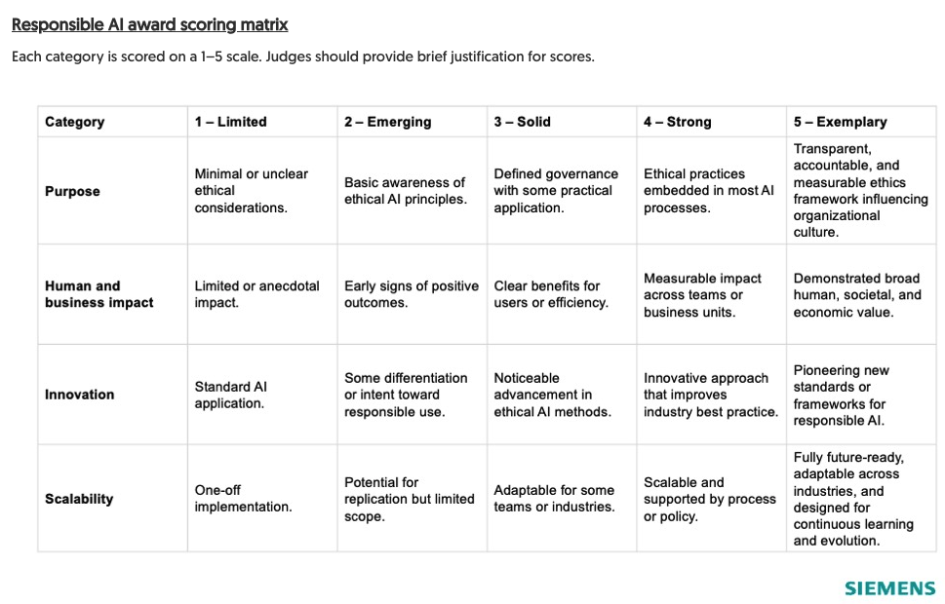

Q. Has the organization showcased the outlined initiatives between January 1, 2025, and December 31, 2025?

Q. Describe your organization’s use of Siemens AI technologies. How do you ensure transparency, fairness, and accountability?

Q. How does your AI initiative empower people, enhance decision-making, or improve business performance? Include measurable outcomes that demonstrate value to employees, customers, or society.

Q. Describe how your approach to Responsible AI advances the current state of the field. What differentiates your application or methodology, and how does it set a new benchmark for responsible innovation?

Q. Explain how your Responsible AI framework or solution can be adapted or scaled to other use cases, products, or industries. How are you ensuring it remains effective and relevant as technologies evolve?

Optional: When submitting online, include upload of any supporting content (presentations, videos, metrics, testimonials, etc.) that strengthen this nomination.
The content notes won't be shared within the organization, and only the judges will have visibility into the content.

Personal Notes

