Siemens Techcellence Awards planning submissions planning information. This is not the official form – questions here are provided for nominee to plan/prepare responses prior to submitting. The official nomination must be completed online by March 31, 2026.

Nominee’s name:
Nominee’s email address:
Nominee’s company name:
Nominated by:
Key Stakeholders:

Category: Digital transformation - Team award
The Digital transformation award recognizes Siemens customers who are leading their organizations toward a sustainable digital enterprise. These organizations combine strategic vision, measurable results, and collaboration to accelerate transformation using Siemens’ technologies.
Eligibility: Open to any Siemens customer organization that has demonstrated a commitment to digital transformation within their operations. Nominees must showcase initiatives completed between January 1, 2025, and December 31, 2025, and will attend Realize LIVE Americas or Europe 2026.
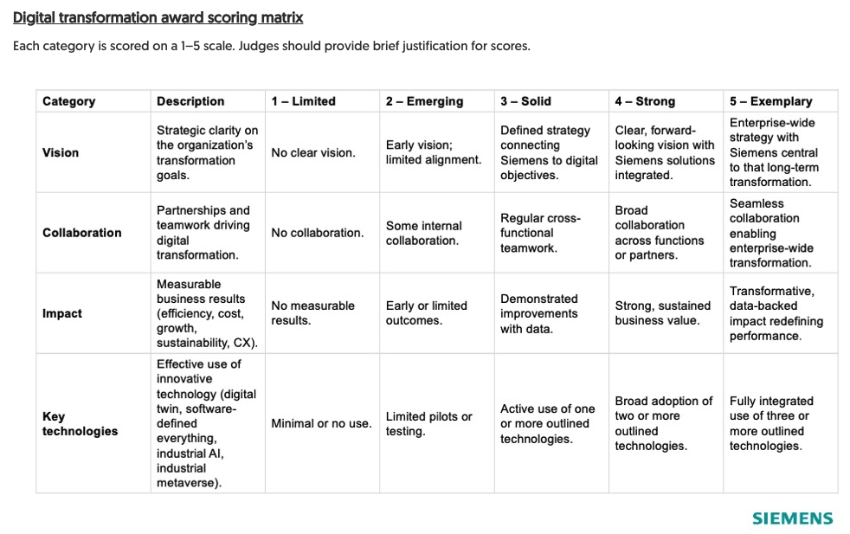
The rubric can be found below:

Q. Has the organization showcased the outlined initiatives between January 1, 2025, and December 31, 2025?
Q. How does the organization demonstrate a clear, strategic vision for digital transformation?
Q. How is Siemens technology embedded in that vision?
Q. How does the organization foster collaboration to accelerate digital transformation?
Q. Provide examples of cross-departmental, cross-business-unit, or external partnerships that have advanced key initiatives.
Q. How has the organization’s digital transformation vision driven measurable business outcomes?
Q. Have these efforts resulted in greater efficiency, cost savings, revenue growth, sustainability progress, or enhanced customer experiences?
Q. Which of the following Siemens technologies are used by the organization?
Comprehensive digital twin
Digital threads
Industrial AI
Industrial metaverse
Cloud technologies
Q. Describe how these technologies have enabled meaningful business outcomes.
Optional: When submitting online, include upload of any supporting content (presentations, videos, metrics, testimonials, etc.) that strengthen this nomination.
The content notes won't be shared within the organization, and only the judges will have visibility into the content.

Personal Notes

