Siemens Techcellence Awards planning submissions planning information. This is not the official form – questions here are provided for nominee to plan/prepare responses prior to submitting. The official nomination must be completed online by March 31, 2026.

Nominee’s name:
Nominee’s email address:
Nominee’s company name:
Nominated by:
Siemens community username (if applicable):

Category: Community Champion - Individual award
The Community champion award honors an individual who goes above and beyond to share their expertise with Siemens technology. This person actively supports peers by offering guidance, speaking at events, and creating educational content. They not only champion Siemens solutions but also provide valuable feedback and insights to help improve them. The Siemens Community champion exemplifies true leadership through their meaningful and sustained contributions to the broader community.
Eligibility: Open to any individual Siemens customer who has demonstrated active participation and commitment within community programs (i.e., Mendix Pioneers, Path Makers, Community Catalysts) and will attend Realize LIVE Americas or Europe 2026. Nominees must showcase expertise in Siemens technologies and products, and be able to demonstrate initiatives completed between January 1, 2025, and December 31, 2025.
The rubric can be found below:
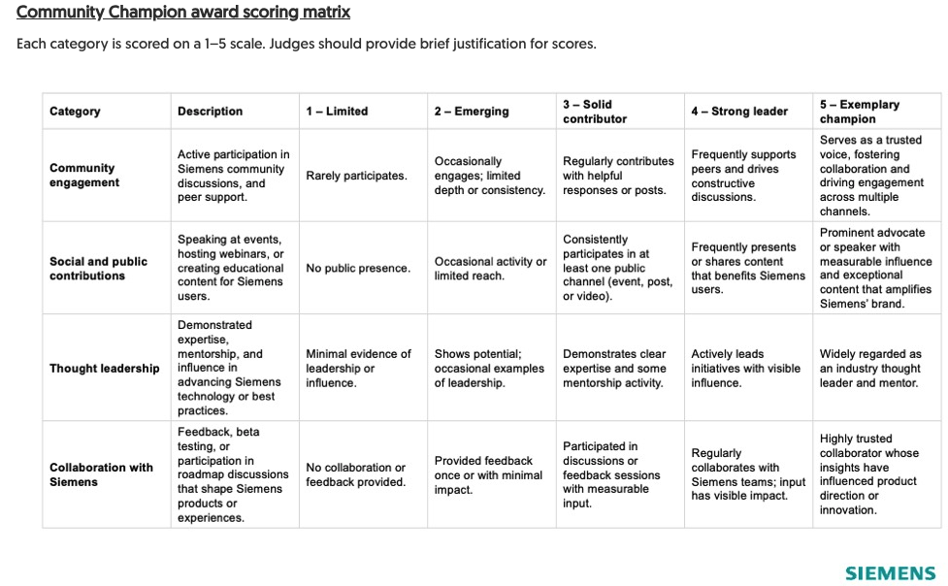
Q. Has the nominee showcased outlined initiatives between January 1, 2025, and December 31, 2025?
Q. Why are you submitting this nomination? What inspired you to nominate yourself or this individual for the Siemens Community champion award? (Briefly describe what makes this person’s contributions exceptional.)
Q. How does the nominee actively contribute within the Siemens community (forums, discussions, sharing insights, supporting peers)? Include relevant links or examples (e.g., community profile, discussions, or threads).

Q. How does the nominee share Siemens expertise and support others through public channels — such as speaking engagements, webinars, educational content, or social media? Provide details and any related links (e.g., event recordings, blogs, posts).

Q. In what ways has the nominee demonstrated leadership or expertise in their broader industry?

Q. Has the nominee provided valuable product feedback, participated in beta testing, or joined roadmap discussions? Describe how their input has influenced Siemens technologies or the user experience.

Optional: When submitting online, include upload of any supporting content (presentations, videos, metrics, testimonials, etc.) that strengthen this nomination.
The content notes won't be shared within the organization, and only the judges will have visibility into the content.

Personal Notes

