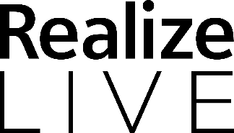

Click here to enter today’s date.

To: US Embassy
Re: Visa Application

On behalf of:
Click here to enter your Full Name.
Click here to enter your Company.
Click here to enter your address – line 1.
Click here to enter your address – line 2.
Click here to enter your address – line 3.
Click here to enter your phone number.
Click here to enter your business email address.

Dear Click here to enter your Full Name.,

This letter serves as an official invitation for you to attend Realize LIVE Americas 2024 which is taking place from May 13 - 16, 2024 at the Mandalay Bay Hotel in Las Vegas.

Realize LIVE unites the Siemens global user community to advance innovation, engineer the circular economy, and drive change that’s as sustainable as it is profitable. This event is the place to get better acquainted with the services and software you already have, and to catch a sneak peek at the innovations coming soon.

While in the United States, Click here to enter your Full Name. will be residing at the following hotel:

Name of hotel: Click here to enter name of hotel.
Dates of stay: Click here to enter a date. to Click here to enter a date.
Confirmation Number: Click here to enter hotel confirmation number.
Hotel Phone: Click here to enter hotel phone number.
Hotel Address: Click here to enter hotel address – line 1.
Click here to enter hotel address – line 2.
Click here to enter hotel address – line 3.

Passport Information

Click here to enter your Full Name.
Country of Issue: Click here to enter Country.
Passport No.: Click here to enter your passport number
Birthdate: Click here to enter a date.
Issue Date: Click here to enter a date.
Expiration Date: Click here to enter a date.

Sincerely,

Stacey Gromlich

Stacey Gromlich, Director of Audience Engagements and Global Events,
Siemens Digital Industries Software

