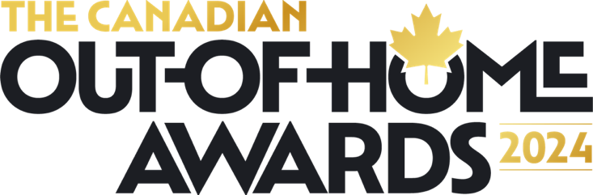

The Canadian Out-of-Home Awards 2024 winners and runners-up:

Best Creative Award
IKEA | Moving Day Stunt | Carat /  Quebecor Out-of-Home
Scene+ Rewards Program | Make it Rain Rewards | PHD /  Quebecor Out-of-Home
Best Multi-Media Award
Paw Patrol | Pups, Planes &  Pupmobiles | Paramount+ / Wavemaker / Kinetic / Travel Path Media/ Adapt
Nutella | Savour the  Beauty of Canada | Publicis Montreal, Vistar/  Astral/ Pattison/ OUTEdge/  Vendo/ Directwest
Best Classic Award
The Strong National Museum of Play | N/A | Partners and Napier /  Billups
Cheetos (PepsiCo Canada) | Sponsortips | Pattison Outdoor
Best Digital Award
Air Transat | Win Back Sunlight | Sid Lee / Pattison Outdoor
Pizza Pizza | Pizza Pizza  Stuffed Crust | Ad Track Media /  Media Experts
Best Client-Direct Award
Air Transat | Win Back Sunlight | Sid Lee / Pattison Outdoor
Sico Paint | The Colour  Swatches Mural | PHD Montreal /  Publicite Suavage
Best Global Award
Destination Toronto | You Gotta See  What We See | Wavemaker / Scarlett Street  / Bensimon Byrne /  TIktok Canada / DIVE
Maybelline New York | Extend Your Lash  Reality | Maybelline / DOOH.com
Best Data-Focused Award
Tim Hortons | Tim Hortons  CaffinAITed | Horizon/ Astral/Pattison
Uber Eats | Only On Uber Eats | Talon OOH
Best High-Impact Award
KFC | Fry Funeral | Wavemaker/Kinetic/Statements Media / Courage / Narrative
Pet Valu | Take Me Home Tonight | True Media
Best Community Involvement Award (Winning tie)
Silk | Bee Hotel | Wavemaker / CARL Social Club / MINT / Pattison Outdoor
Aura Freedom | End Femicide | UB Media
Swab the World | Swab the World - Patients | UB Media

