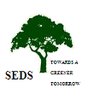
TOWARDS A GREENER TOMORROW
SEDS ANNUAL REPORT
APRIL 2018 - MARCH 2019

During this financial year the work at SEDS has carried on keeping in line with the mission and vision statement of the organisation.
The programs undertaken are:

- The monitoring and supervision and repairs of units that were constructed.
- Low carbon sustainable Agriculture program
- Child sponsorship
- Tank desilting program
- SEDS Ananda Vidyalayam school year.

Programs have been implemented as always with the involvement of the end user and their participation.

The sponsorship program supported by PIA had sponsor strength of 184 children supported under this program

The school gets support from IKIKI Japan for Yen 600000 every year and is able to keep the school costs funded. Although the strength is small our commitment to provide good all round education still holds. Proud to mention one of our students was selected for a state scholarship on AP Model school scheme. He completed his 5th class in SEDS and now will continue in the scheme where his parents do not have to pay fees. He will be provided with hostel accommodation and uniforms and books for free till the 10th grade.

PIA had started a crowd funding initiative in June of 2017 and has been able to raise an amount of Australian $ 9300. Their accounting year ends in June every year so we had together decided to wait till the end of June 2019 for the transfer of the monies.

Reflections………………

SEDS is walking into its 40th year of existence in 2020
Aims have always been water, food and basic needs. Improving the environment and focus on the poorest of the poor.

The bio gas has forced our hand to expand from 250 villages to 350 today and our start was 10!
A mission and vision realised with a lot of hard work and perseverance has accomplished this.

We are now in the stage of change and self sustainability and to achieve this stage development has to be looked at from a business angle. Most Organisations started with donor funding but today all NGOs are concentrating on sustainability of the organisation to continue the work.

SEDS can proudly reiterate that as an NGO from the 80s we have been trail blazers or firsts in many fields of development. We wanted change and today looking at the area a change can be seen very clearly with environment, health, children going to school and the community.

All work taken up in the last 39 years was the need of the hour. It involved charity approach/pragmatic approach/community taking responsibility of their lives/community being made aware of their lives along with their rights to be able to demand basic rights and legal rights from the government. Food and environment was a main focus. Hence all SEDS work aimed at a richer sustainable environment and agriculture.

From this developed tree nurseries, vegetable gardens, homestead plantations, bund plantations, reforestation, community woodlots, tank bed planting, avenue plantations, horticulture plots, and the program hectares of Hillocks being greened and Watershed management with Tank de-silting thus became the forte of SEDS. With tank de-silting fish farming became big income additionality for the communities

Since 2010 SEDS has been working on mitigating climate change through a Clean Development Mechanism approach.
We have completed a program for 5000 bio gas plants in 5 Mandals.

The problems faced in implementing such a program have been enormous but it was accomplished with the same doggedness that has been a very positive strength of SEDS and the people on the field.

The problems faced in implementing such a program have been enormous but it was accomplished with the same doggedness that has been a very positive strength of SEDS and the people on the field.
The agreement with the buyer remains the same that is to deliver 105716 CERs of which our delivery has been 62118 CERs. The next verification is from 0.11.18 to 31.12.19. The balance to be delivered is 43598 CERs which will take us past 2020 as we see it now. The rules have become more stringent and we will now have to also monitor fuel usage in the homes annually and according to this CERs will be deducted so the delivery is going to be harder now.
Our registration as the DOE has been completed.

The drought situation with NO WATER has made the task of keeping the units viable is becoming more and more difficult. People have no drinking water and it is difficult to mix dung with no water available. Our staff is on a high alert and are sometimes mixing the dung with the beneficiaries themselves.
The detailed report from the computer is added for more details as Annexure 1

The LCF team is now headed by Imran and with this new funding we are paying a stipend to selected lead farmers to monitor the program in the field. A detailed report is added from Imran and team as an annexure 2.
The new funding from PIA has made us only start intensely from July of 2018.till then we were keeping the program going at a minimum.

In this financial year we have completed de silting in 4 villages
Details with pictures are in annexure 3.

The Sponsorship covered 184 children this year. 22 students sat for their High school graduation which is the 10th Grade. 21 passed and can continue onto pre-university or Inter as it is called in Andhra Pradesh. One student completed his 11th Grade with a 78.3 %. The PIA Sponsorship report is attached as annexure 4.

SEDS School
This year the SEDS School has been run by Rashna Joshua and the Education Coordinator Rasool Khan and E. Balaji.
Teacher’s skill up gradation is an ongoing process and especially since we are linked with the government system since 2016. We have been registered online as being on the CCE (Continuous Comprehensive Evaluation) program of the government. Internal marks of 20 are a must especially for the 10th STD and all children are registered online with biometrics of each child.

All students leaving a school have to procure a TC or Record sheet from the previous school before joining another. Earlier students just left and joined up in other schools which resulted in most cases default in payment of fees. The school report is attached as annexure 5 prepared by Rasool Khan

Visitors and volunteers:
Lyn Pickering from PIA visited SEDS this year. Ronny Smet from Belgium visited twice in the last year.

We had two volunteers in October-November Kirra Pickering and husband Maurice Kleine from the Netherlands.

Interns from Queensland University – Debbie Scholes and Alex Mc Donald from Queensland University spent three months doing their internship.

The highlight at the end of March our CEO Manil Jayasena was invited to give three lectures in Antwerp Belgium on the work SEDS had done in 4 decades and to show a link between Psychology and Sociology in development. Two lectures were for students and 1 was the faculty of Thomas Moore University in Antwerp. It was well received and the response was very good. Attached is a synopsis of the lectures as Annexure 8
Finances: SEDS has received support from PIA Australia, Bread for the world/EED Germany, IKIKI Japan and several individual donors.

Income Foreign: Rs 54, 09,307

Income Indian: Rs. 5, 83,720

Annexure I - CDM April 2018-March 2019

Annexure II - Low Carbon Farming Report April 2018-March 2019

Annexure III – Tank Desilting Report April 2018-March 2019

Annexure IV – PIA Report April 2018-March 2019

Annexure V – SEDS School Report April 2018-March 2019

Annexure VI – Old People Programme Report April 2018-March 2019

Annexure VII - Exposure trip and its learning’s

Annexure VIII - Synopsis of the Belgium visit by our CEO

Annexure I - CDM Super Report April 2017-March 2018
Annexure I - CDM April 2018-March 2019

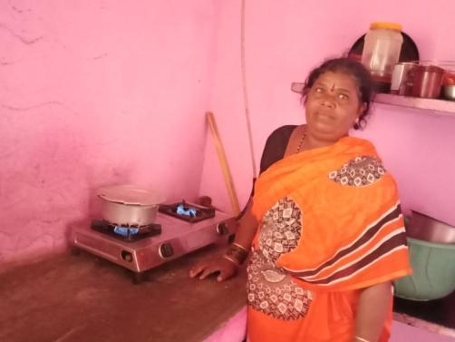
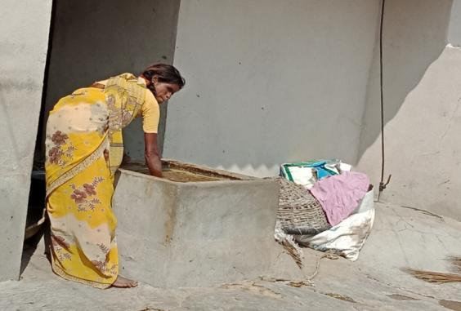
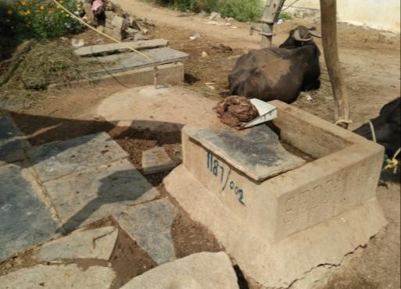
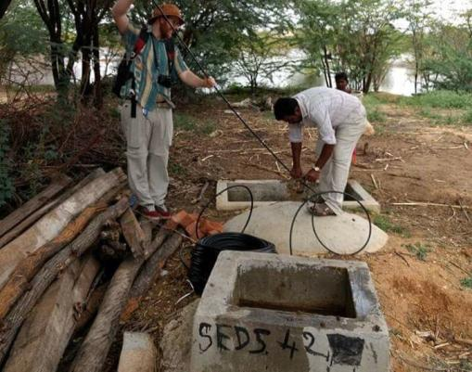

Cooking on the Bio Gas Stove
Mixing the Cow Dung for the Bio Gas Unit
Monitoring the Bio Gas Unit
Stove & Pipe Repairing to the Bio Gas
Repairing the Bio Gas Unit
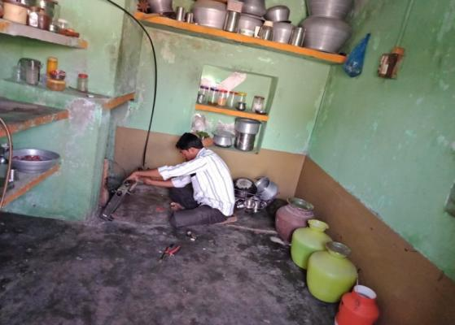
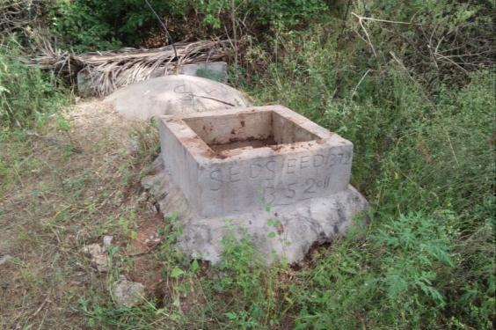
Annexure II - Low Carbon Farming Report April 2018-March 2019
Mixing the Cow Dung for the
CDM – BIO Gas UNIT
Mixing the Cow Dung for the
CDM – BIO Gas UNIT
SEDS PIA LCF Report – March 2018 to April 2019

March:-

- Conducted regular meetings in 25 villages and gave Sustainable Agriculture training,
- Gave Sustainable Agriculture training to staff for 2 days
- Bank accounts opened for farmer groups - 12 out of 25
April:-

- Conducted regular meetings in 19 villages and gave Sustainable Agriculture training
- Gave Sustainable Agriculture training to staff for 2 days
- LCF Readings done in Hussainpuram, 12 farmers, 12 plots

May:-

- Bank accounts opened for farmer groups - 16 out of 25
- Sustainable Agriculture training was conducted for staff for 2 days
- Conducted regular meetings in 18 villages and gave Sustainable Agriculture training

June:-

- Conducted regular meetings in 15 villages and gave Sustainable Agriculture training
- LCF Readings done in Kavetinagepalli, 20 farmers, 20 plots
- LCF Plots rechecked in Hussainpuram, 12 farmers, 12 plots

July:-

- LCF Readings done in Bramhanapalli, 14 farmers, 14 plots
- Conducted regular meetings in 17 villages and gave Sustainable Agriculture training
- LCF Plots rechecked in Kavetinagepalli, 20 farmers, 20 plots
- SEDS had two Interns from Australia Debbie and Alex and introduced them to SEDS work.

August:-

- Started new project “Sustainable Agriculture program” with the PIA
- Selected 25 farmers group for Sustainable agriculture program for PIA
- Bank accounts opened for farmer groups - 18 out of 25
- Brought support from NABARD 7,500/- for 5 groups
- Conducted regular meetings in 12 villages and gave Sustainable Agriculture training

September:-

- Selected Lead farmers in 25 groups
- Conducted regular monthly meetings in 15 farmer groups
- Opened 2 bank accounts for new farmer groups total completed 20 out of 25
.
October :-

- 10 staff members took driving lessons and got their licenses also
- Conducted regular monthly farmer groups meetings and the trainings in 18 farmer groups
- Bank Accounts opened to farmer groups in 5 villages, total completed in 25 farmer groups

November :-

- Selected 26 farmer groups by meetings
- Selected Lead farmers in 26 groups
- Selected 5 model villages in the 26 farmer group villages, and prepared horticulture trees list to distribute to the farmers, total 847 trees needed.
- Conducted regular monthly farmer groups meetings and the trainings in 18 farmer groups

December :-

- Collected new family data for 6 villages.
- Conducted Old peoples food and cloths distribution program in our SEDS main farm, we served to 25 men and 25 women.
- Updated all data and prepared to take GPS Readings of the farmers cultivating lands
- Tank Desilting program – we did in Chinnakodipalli village for 35 farmers, 1050 tractor loads.

January 2019:-

- Tank Desilting program – in Suddakuntapalli village, 28 farmers, 840 tractor loads
- Tank Desilting program – in Buchepalli village, 38 farmers, 913 tractor loads
- Conducted regular monthly farmer groups meetings and the trainings for 22 farmer groups
- GPS Readings – in 6 villages, 109 farmers, 109 plots
- Visited Atal incubation Center (AIC)in Anantapur, SK university to get help for farmer groups

February 2019 :-

- SEDS Staff Exposure – Prepared staff list and 15 members ready
- Plots Recheck – in 6 villages, 109 farmers, 109 plots
- Conducted regular monthly farmer groups meetings and trainings in 17 farmer groups
- Tank Desilting program – in Seshapuram village, 91 farmers, 1820 tractor loads which brings the total to 4 villages.
- Conducted Lead farmers training about Sustainable Agriculture, and prepared yearly plan.

March 2019:-

- SEDS Staff Exposure – 15 staff members went for an exposure for 4 days to Mysore, Ooty.
- Conducted regular monthly farmer groups meetings and the trainings in 21 farmer groups
- Millets Business – Collected farmers data to do millets business
          - Total villages – 13
          - Total farmers – 270
          - Total acres – 427 acres
- Conducted Lead farmers training about Sustainable Agriculture, and prepared yearly plan.

April 2019:-

- Conducted regular monthly farmer groups meetings and the trainings in 25 farmer groups
- Millets Business – Prepared business plan
Step – 1 - in Khareef season (June to Dec) we will undertake a pilot project with 25 Lead farmers in 45 acres, foxtail millet – 31.5 acres, Brown top millet – 11acres, Little millet – 2.5 acres
Step – 2 - in Rabi Season (Dec to May) we will work with all 25 farmers groups in 641 acres.
- GPS plots recheck – done in 4 villages, Guddumnagepalli, Suddakuntapalli, Marakuntapalli, and Kolimipalli.

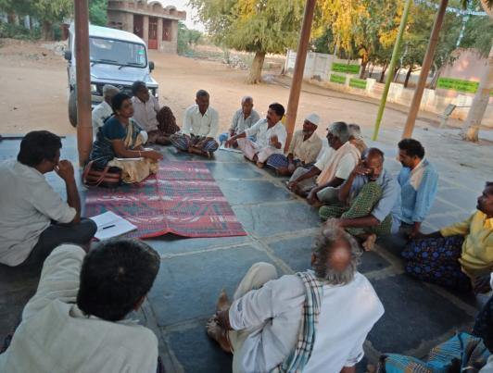
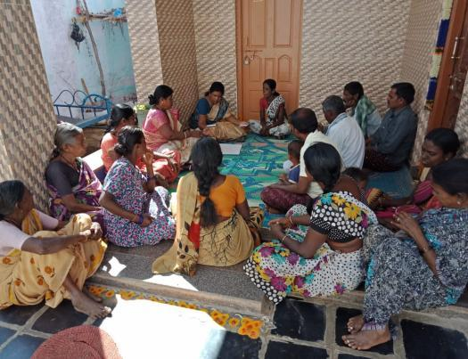
LCF Photos:
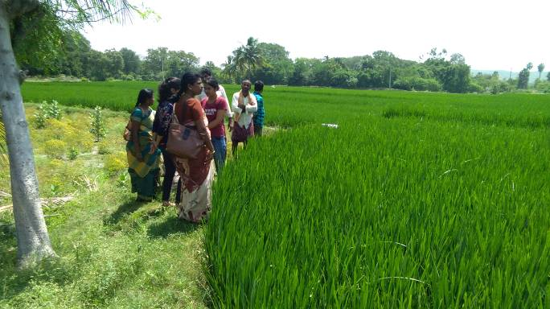

Annexure III - Tank Desilting Report April 2018-March 2019

Tank Desilting a Note for the reader

Tank Desilting is a program taken up for some of the following reasons:

- To enhance storage capacity in the existing tanks through more efficient catchment which, have been silted from runoff from the hills of soil due to de-forestation.

- To increase water resources through efficient micro catchments based on local knowledge and simple low cost structures.

- To return fertile soils to the farmer lands for higher yields in crops.

- Farmers are able to generate income in balance with their natural environment.

- To ensure that a natural resource is managed efficiently by the community.

- To promote livelihoods for women through kitchen gardens and homestead plantations.
- To promote farmer groups to take up sustainable agricultural practices leading to Low Carbon Farming (mixed cropping, farming with attention for food crops and input cost reduction)

- To promote an ownership of these catchments to the communities.
We try to reach as many farmers as the budget allows.

No of Farmers | No of Loads | Unit Cost | Payment | Pit size | No of Cubic meters
35 | 90 | 100 | 9000.00 | 40*42*2 | 3360
 | 30 | 130 | 3900.00
 | 240 | 150 | 36000.00
 | 30 | 160 | 4800.00
 | 570 | 180 | 102600.00
 | 90 | 200 | 18000.00
TOTAL | 1050 |  | 1,74,300.00
JCB Hours | 98.1 | 750 | 73,575.00
Grand Total |  |  | 2,47,875.00
1. Chinnakodipalli Tank Desilting Work Report

Water storage capacity brought to 887518 gallons.

Marking

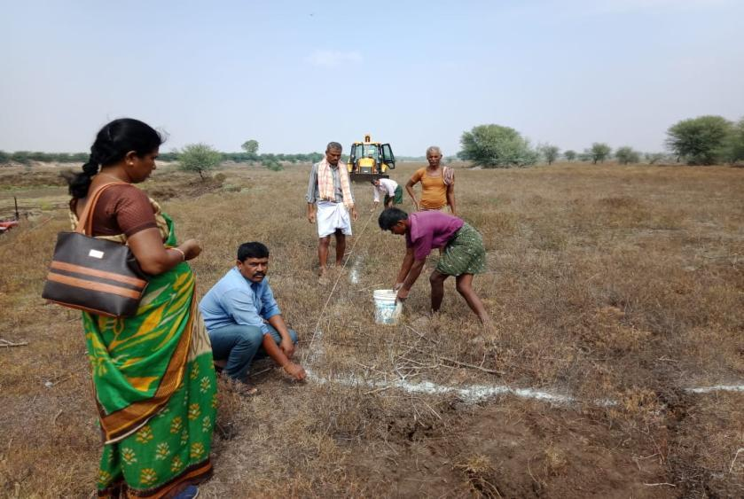

Ongoing Work

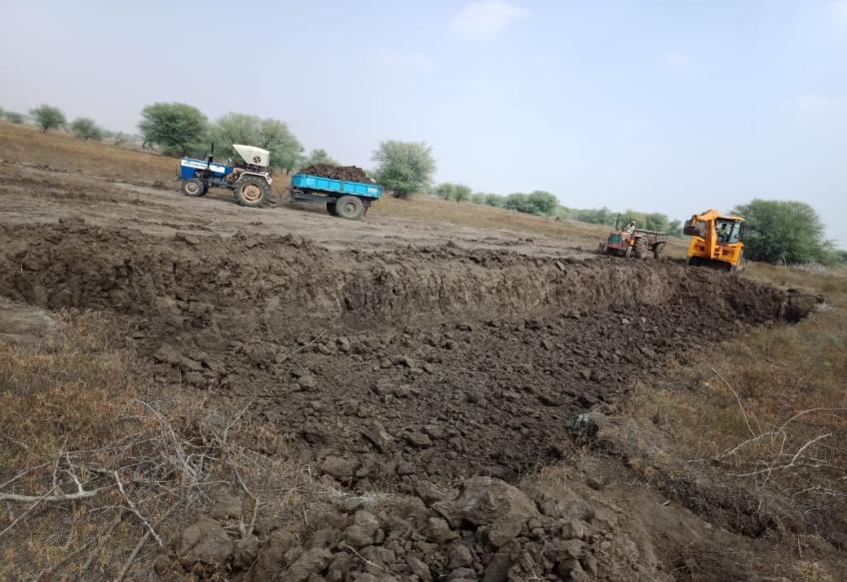

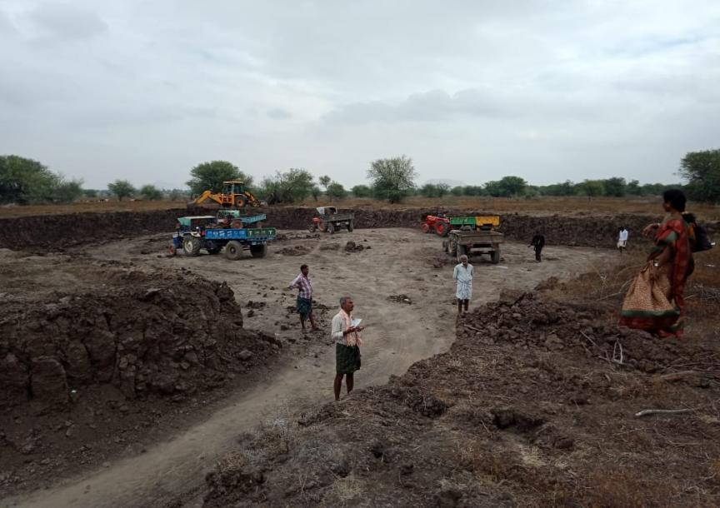
After Completed

No of Farmers | No of Loads | Unit Cost | Payment | Pit size | No of Cubic meters
28 | 360 | 110 | 39,600.00 | 35*40*1.5 | 2100
 | 480 | 130 | 62,400.00
TOTAL | 840 |  | 1,02,000.00
JCB Hours | 66.7 | 750 | 50,025.00
Grand Total |  |  | 1,52,025.00
2. Suddakuntapalli Tank Desilting Work Report

Water storage capacity brought to 554761 gallons.

Marking
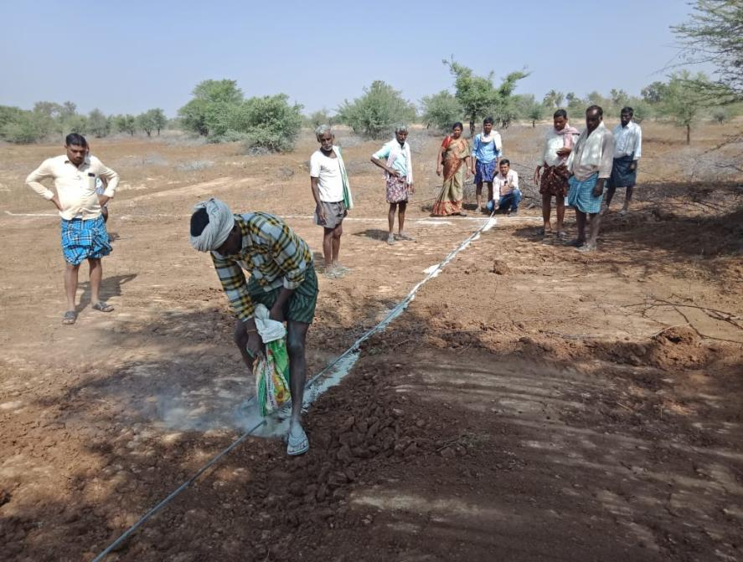

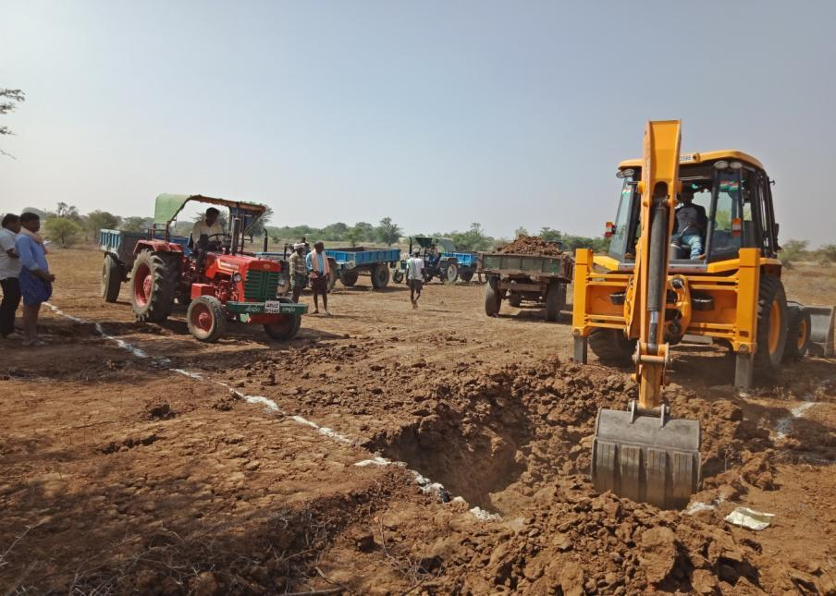
Ongoing Work

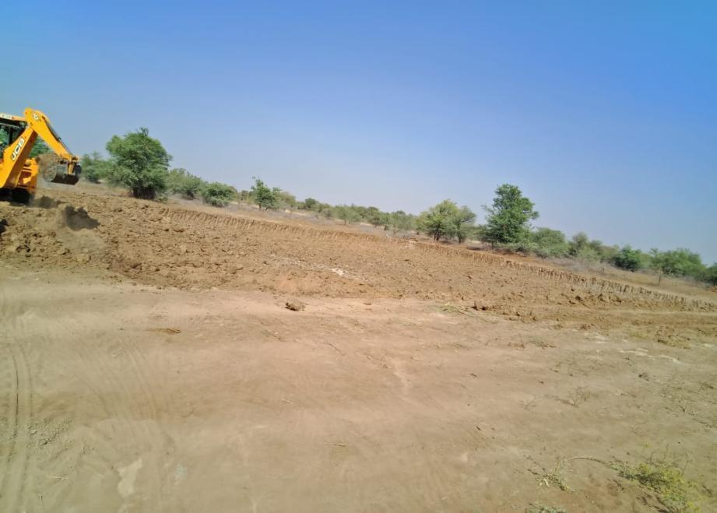
After Completed

No of Farmers | No of Loads | Unit Cost | Payment | Pit size | No of Cubic meters
38 | 913 | 150 | 1,36,950.00 | 35*35*2 | 2450
TOTAL | 913 | 150 | 1,36,950.00
JCB Hours | 71.9 | 750 | 53,925.00
Grand Total |  |  | 1,90,875.00
3. Buchepalli Tank Desilting Work Report

Water storage capacity brought to 647221 gallons

Marking
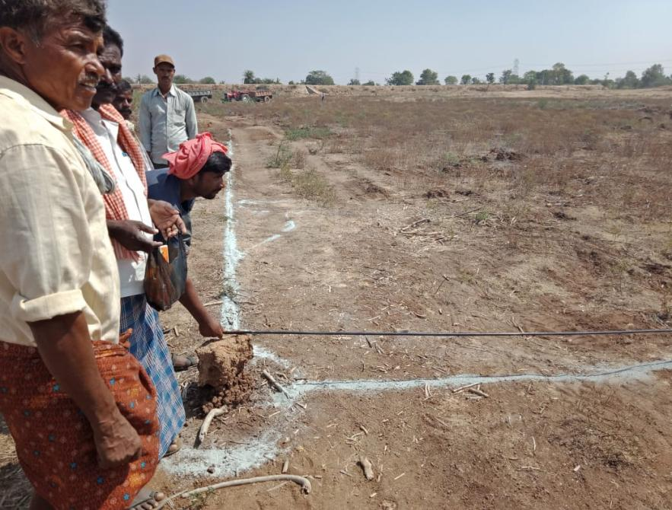

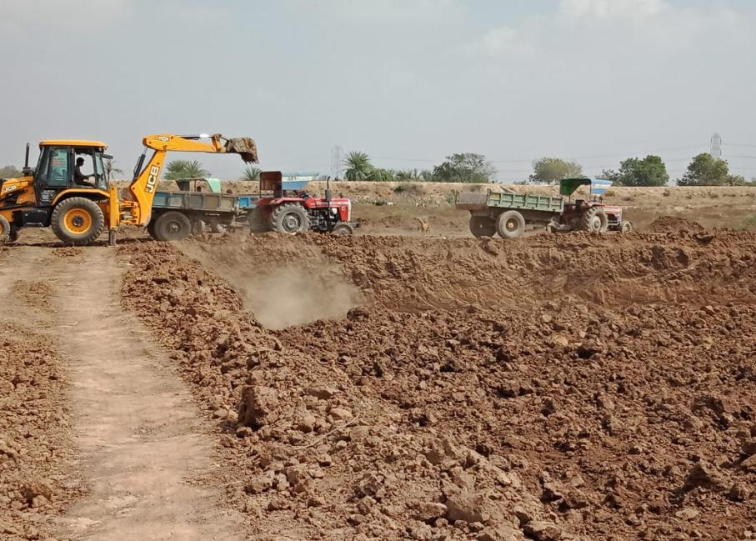
Ongoing Work

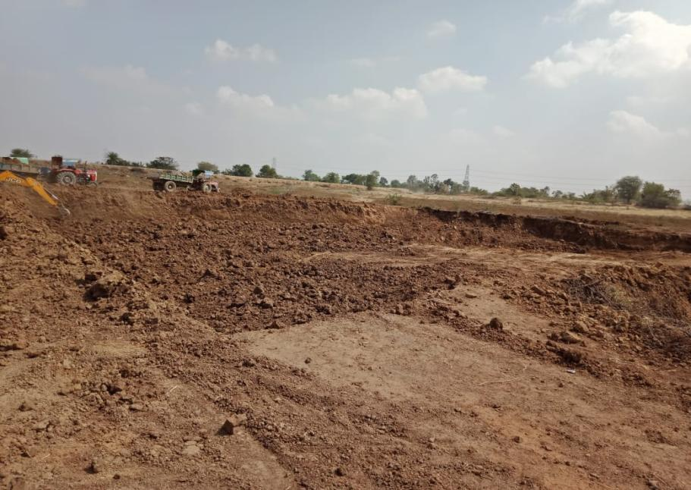
After Completed

No of Farmers | No of Loads | Unit Cost | Payment | Pit size | No of Cubic meters
91 | 200 | 80 | 16,000.00 | 55*45*2 | 4950
 | 740 | 100 | 74,000.00
 | 180 | 120 | 21,600.00
 | 280 | 130 | 36,400.00
 | 420 | 140 | 58,800.00
TOTAL | 1820 |  | 2,06,800.00
JCB Hours | 143.30 | 750 | 1,07,475.00
Grand Total |  |  | 3,14,275.00
4. SeshapuramTank Desilting Work Report

Water storage capacity brought to 1307651 gallons

Marking
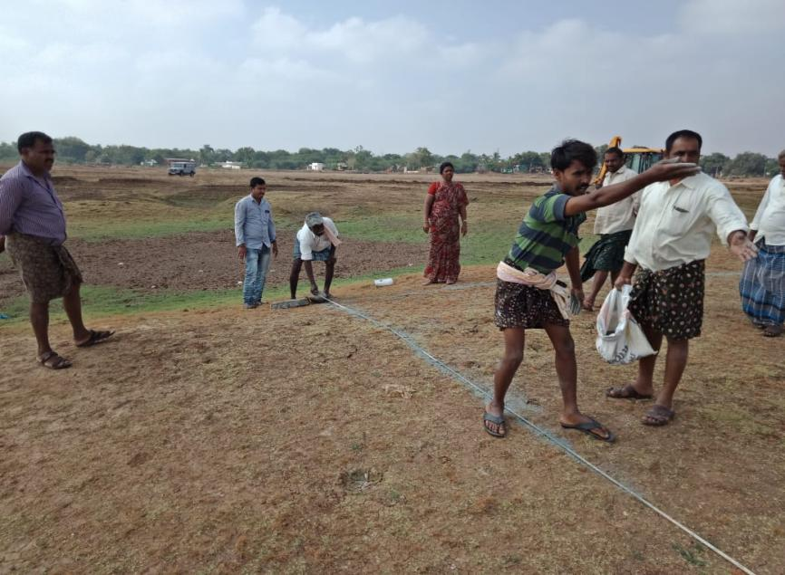

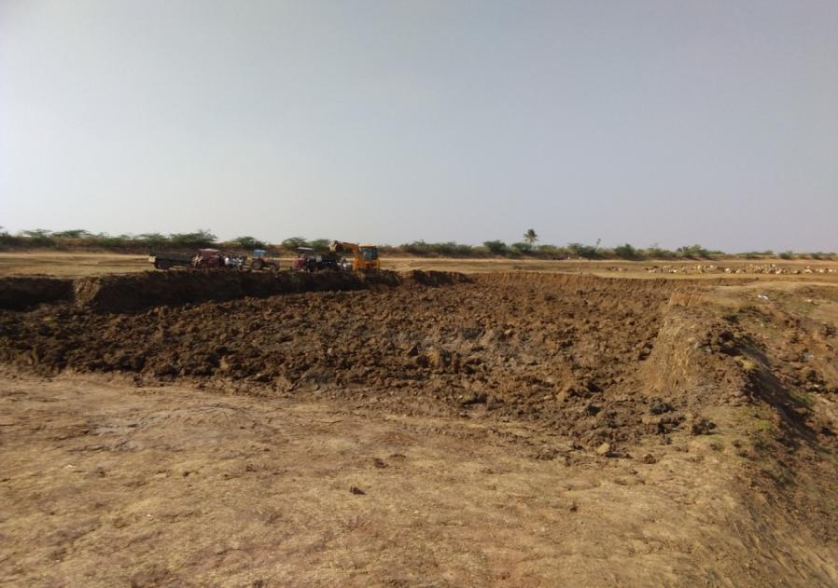
Ongoing Work

After completed
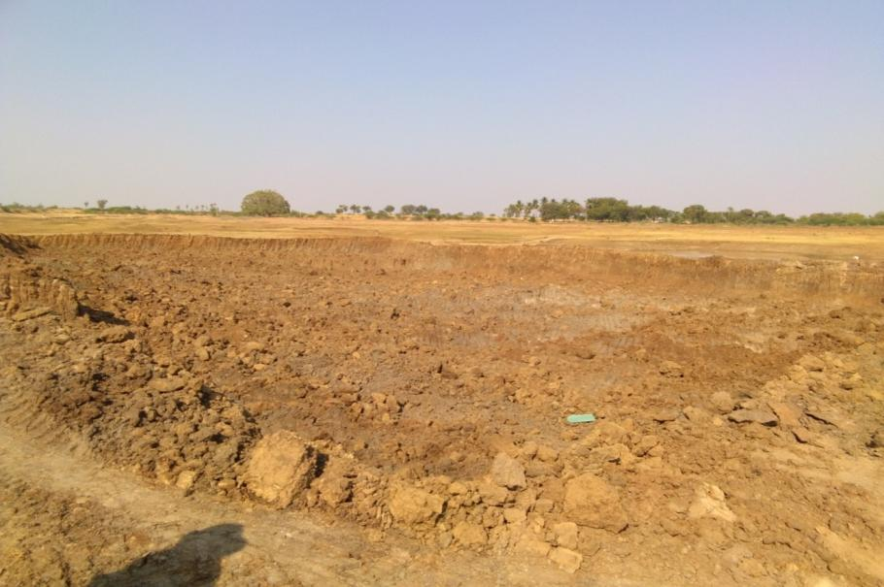

Annexure IV - PIA Report April 2018-March 2019

SEDS PIA

Sponsorship program report April to March 2018-19

April:
On April-14-2018 we conducted the PIA second Saturday program of the month; as the standard procedure weights, heights and attendance were registered. In the part of program we started the arts and crafts activities where we provided pencils, eraser, and sharpener & color sketch pens for all the children. In the first part of the activity the children did some sketch’s & color filling and then we collected thank you letters from the exit children. Later we had some music and dance. Children received their bus fare, had lunch and went to their home happily.

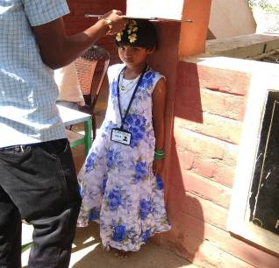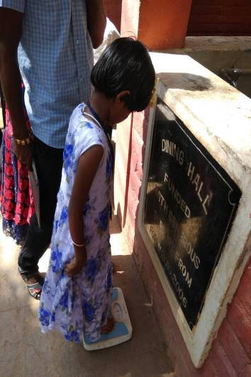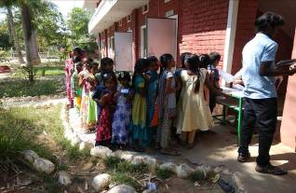

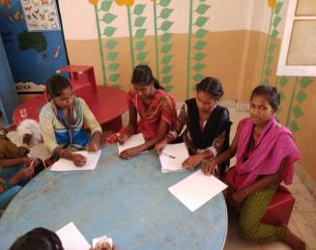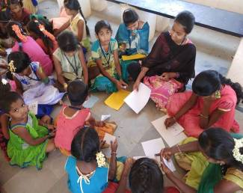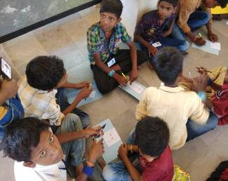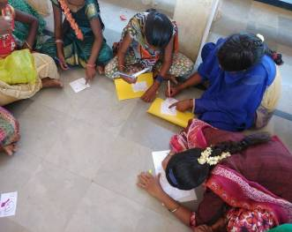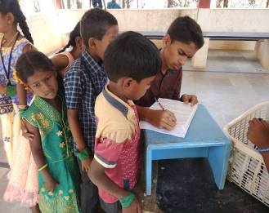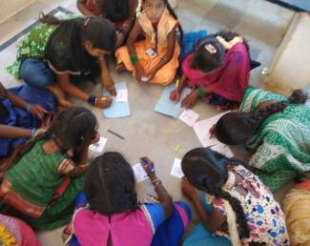

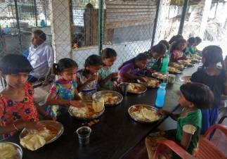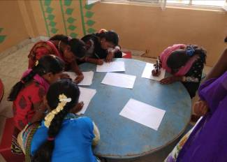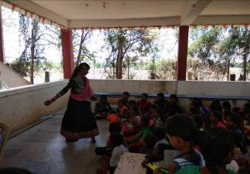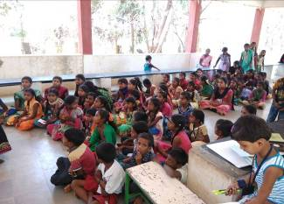

May:
On May 12- 2018 we conducted the PIA second Saturday program of the month; on this particular day measurements, heights & weight measurements are taken of sponsored children. We had a discussion about the 10th class students who got good marks and we congrats them. After that we had some story-telling and they played Indore and outdoor games. The children then collected their bus fare went to lunch and they return to their villages.

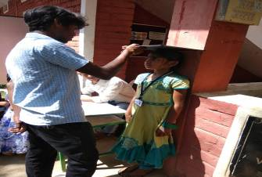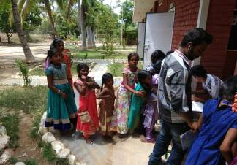

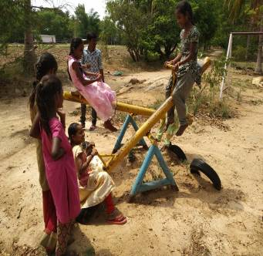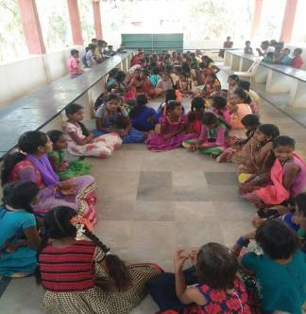

June:
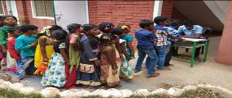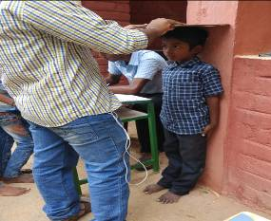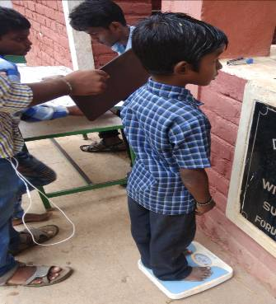On June-09-2018 we conducted the PIA second Saturday program of the month; as is standard procedure weights, heights and attendance were registered. we took foot-measurements for bags distribution in July. They played different types of games like cricket, Coco and tennis. After that they receive their bus fare, had lunch and went to their villages.

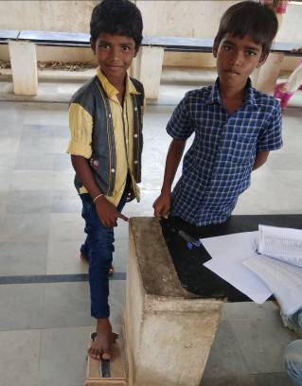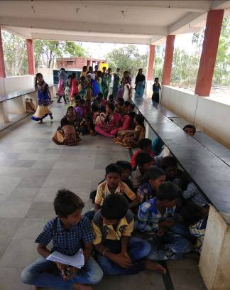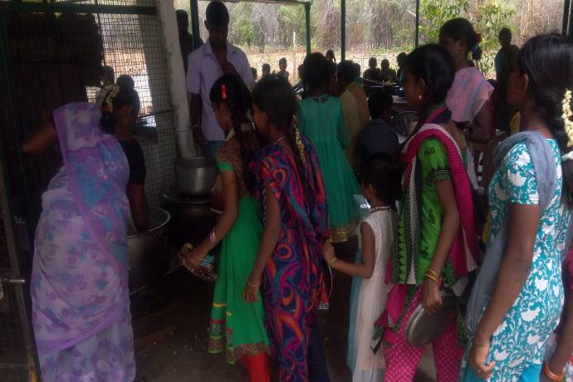

JULY:
On 14 of july PIA second Saturday programme was conducted. On that particular day Attendance, Heigh and weight measurements were taken. Distribution of Note books and uniform were highlight of the programme. Photos were captured for documentation. Children received their new set of books and uniform. At the end of the programme children had a healthy meal , received their bus fare and went to their home happily.
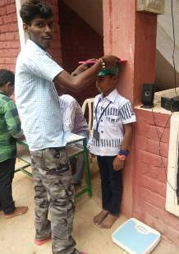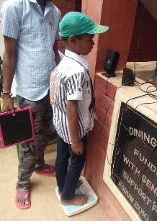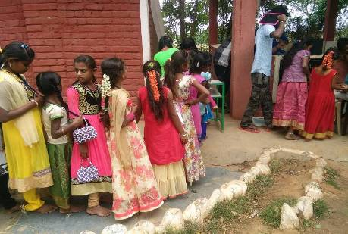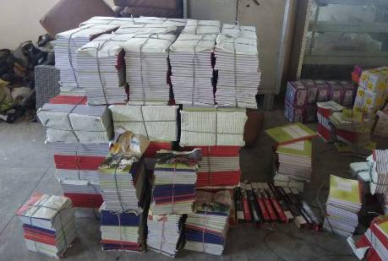
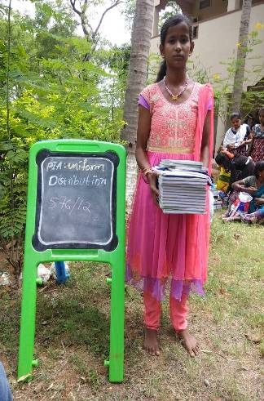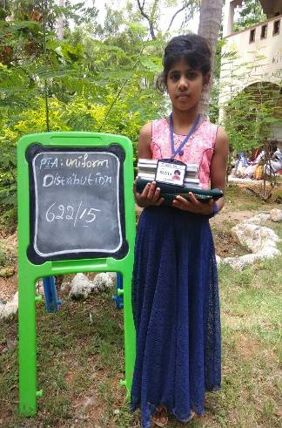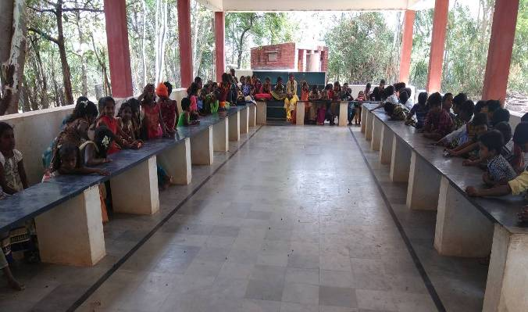

August:
On August 11 PIA Second Saturday program was carried on with two interns Alex and Debbie from Australia. On this particular day measurements, heights & weight measurements are taken of sponsored children. In July we distributed note books and uniforms, in august school bags were distributed. Photos were captured for documentation. Children received their bus fare, had a meal and went home with their new bags.

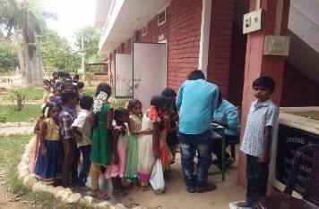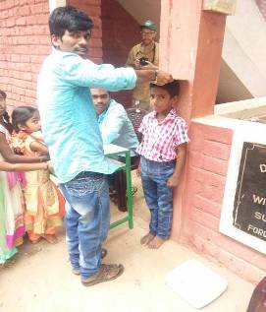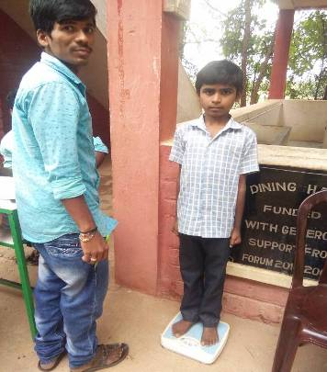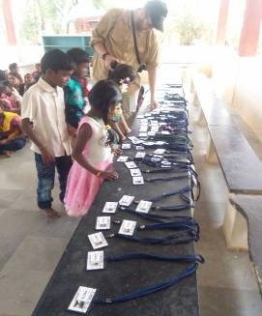

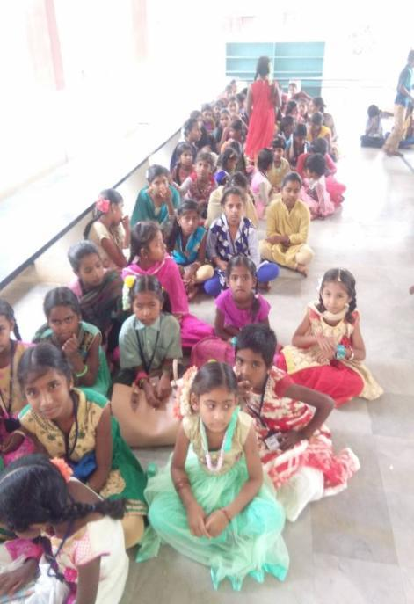
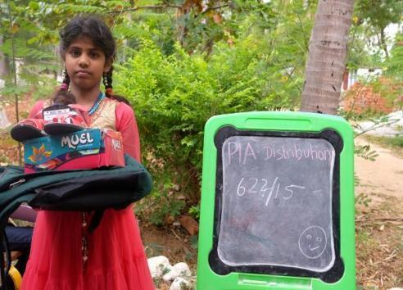

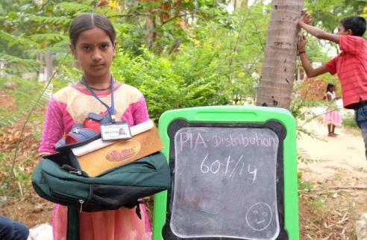

September:-
On 08 of september PIA second Saturday programme was conducted. On that particular day Attendance, Heigh and weight measurements were taken. On this particular day children prepare chirstmas cards for their donors. Photos were captured for documentation. At the end of the programme children had a healthy meal , received their bus fare and went to their home happily
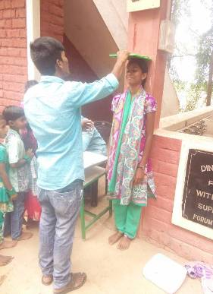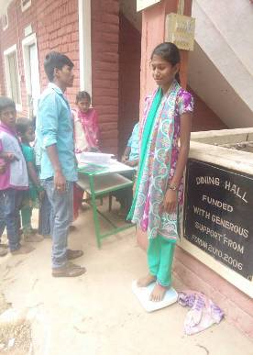

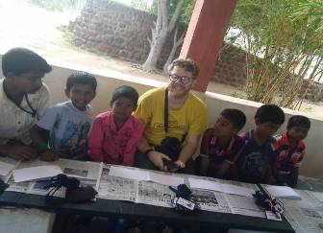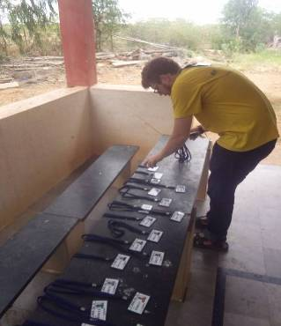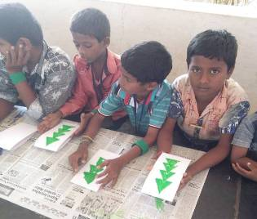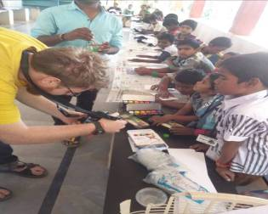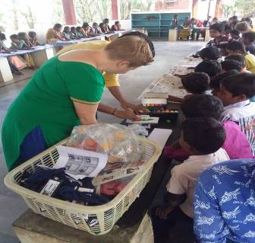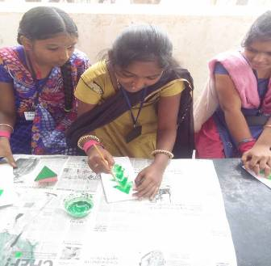
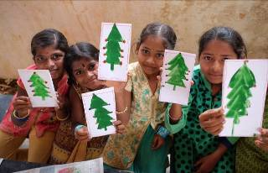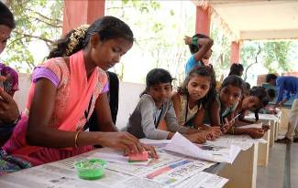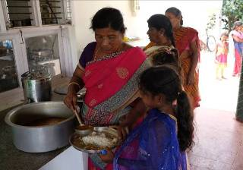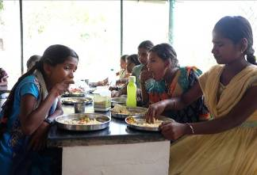

.

October:
On 13 of October PIA second Saturday programme was conducted. On that particular day Attendance, Heigh and weight measurements were taken. On this particular day children prepare playing to kabadi for their donors. Photos were captured for documentation. At the end of the programme children had a healthy meal , received their bus fare and went to their home happily.
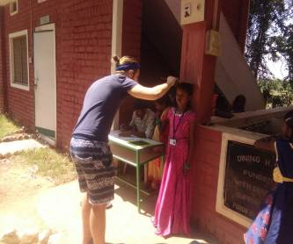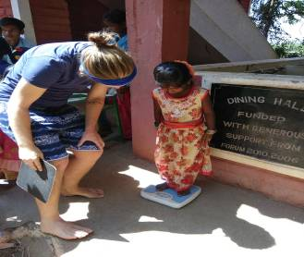
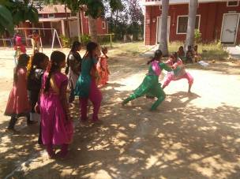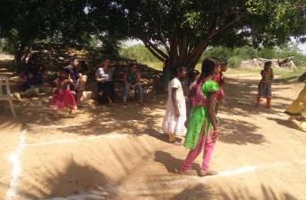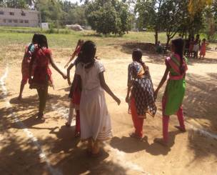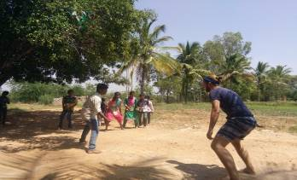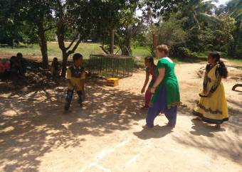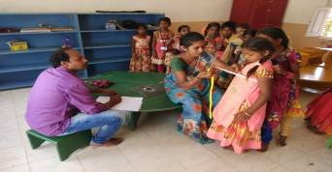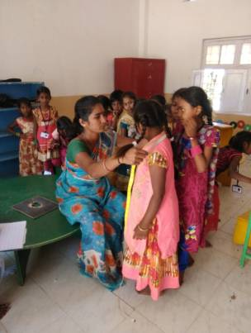

November:
On 10th november we conducted 2nd Saturday programme. On this day the regular height and weight measurements were taken and registration also done. This particular day we conduct culutural activitice to the childrens, chidren played kabbadi. Where we divided them into age in Group A and Group B, where the group B wins the game. Measurements for christmas were taken. At the end of the programme children received their bus fare, have lunch and went to their villages.

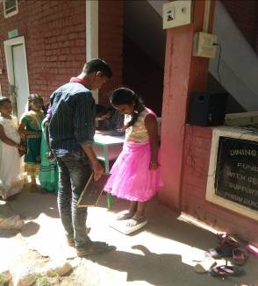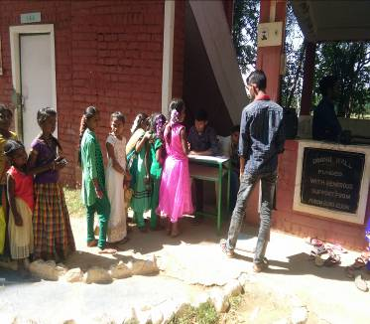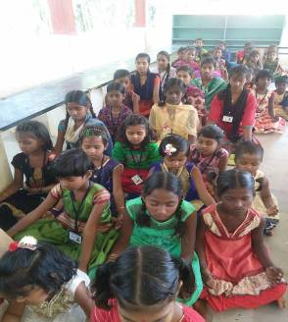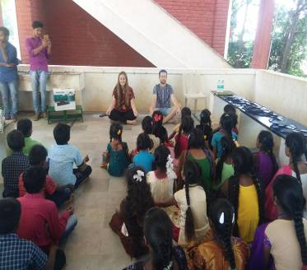

December :
On 8th December we conducted 2nd Saturday programme. On this day the regular height and weight measurements were taken and registration also done. This particular day we conduct culutural activitice to the childrens, chidren played kabbadi. Measurements for christmas were taken.Why do coming to the every second Saturday meaing telling now Basha sir in the programe. At the end of the programme children received their bus fare, have lunch and went to their villages.
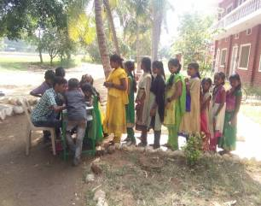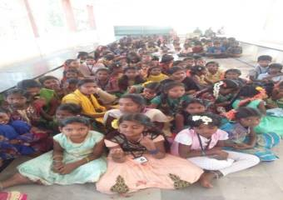

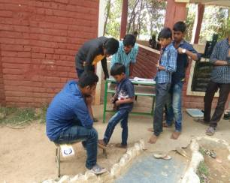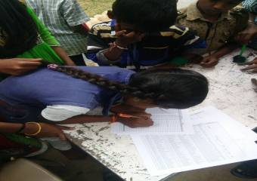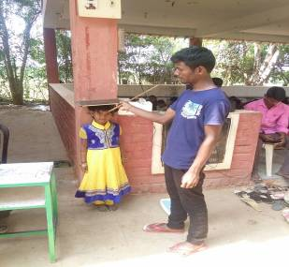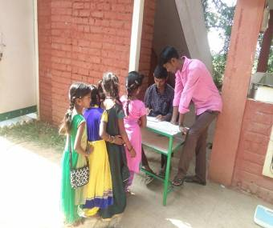
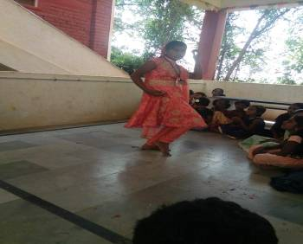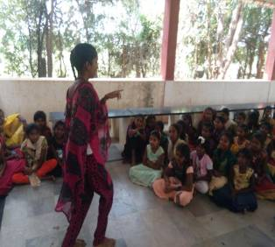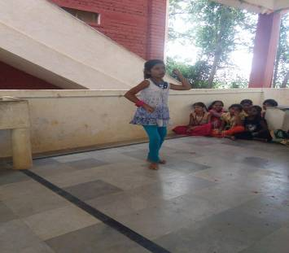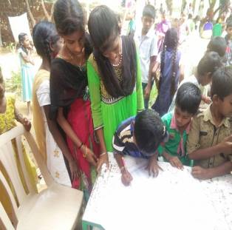

January:
January is very special to our children because of cloth distribution. Before starting the program we took height & weight measurements of children then we started the program. New Christmas clothes and footwear were distributed to the children. Before and after photographs were taken for the records. After that they played, had lunch of chicken, bananas and sweets. Thereafter they received their bus fare and went to home happily with new clothes and footwear.

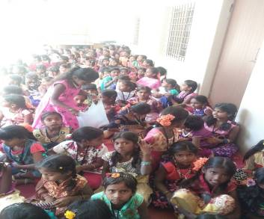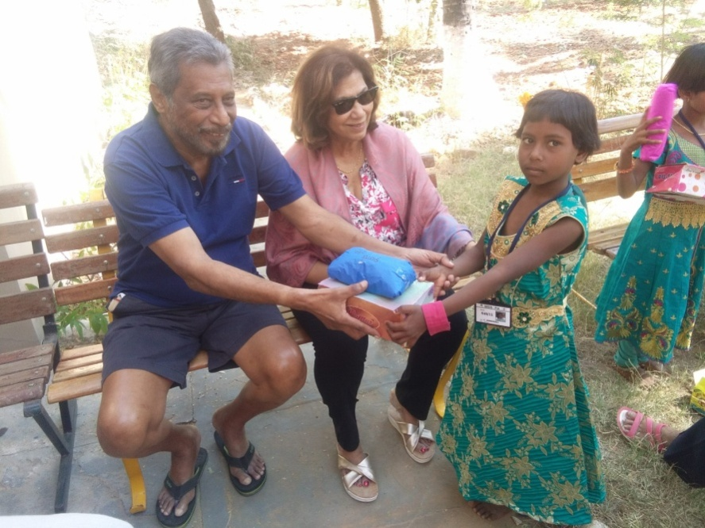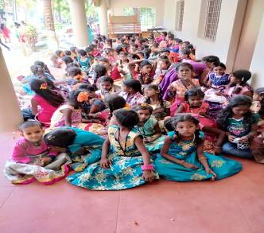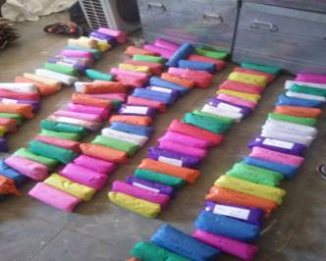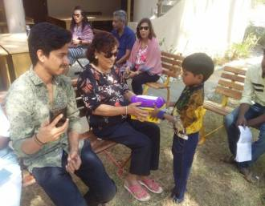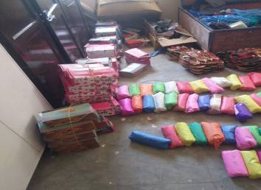

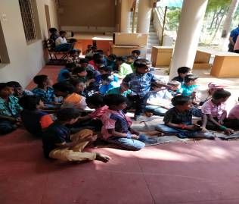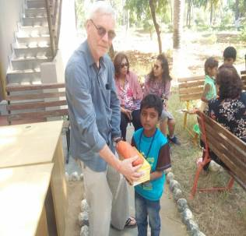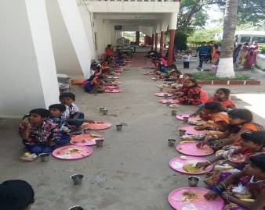

February:
In the month of February the PIA second Saturday program started with attendance where we took the height & weight measurements of all the children. We then started the Quiz [General Knowledge] program. Divided six groups asking for general questions. In the first part of the activity the lower kinder garden children did some drawings and upper kindergarten had a drawing competition in arts and crafts class. We had some story-telling and they played Kabaddi. The children then collected their bus fare went to lunch happily.

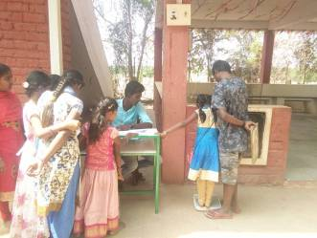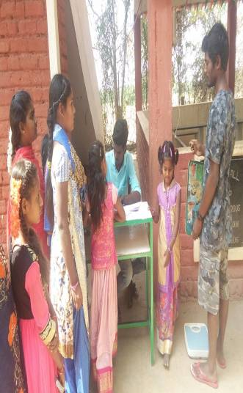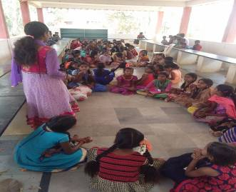

March:

On March-09-2019 we conducted the PIA second Saturday program of the month; as is standard procedure weights, heights and attendance were registered. In the part of program we started the arts and crafts activities where we provided pencils, eraser, and sharpener & color sketch pens for all the children. In the first part of the activity the children did some sketch’s & color filling and then we collected thank you letters from the exit children. Later we had some music and dance. Children received their bus fare, had lunch and went to their home happily.

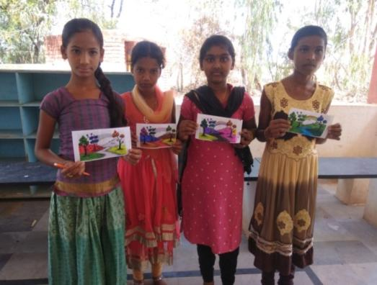
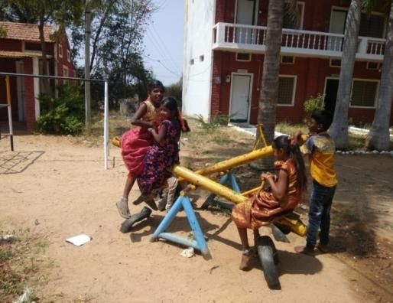
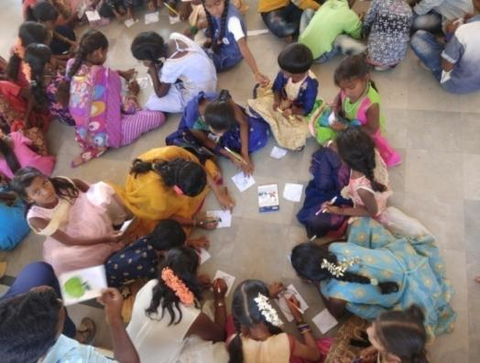
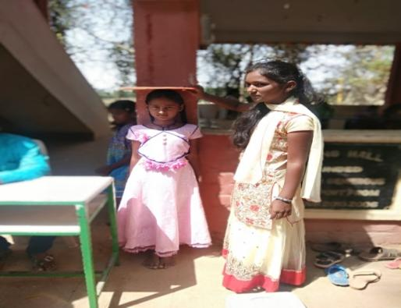
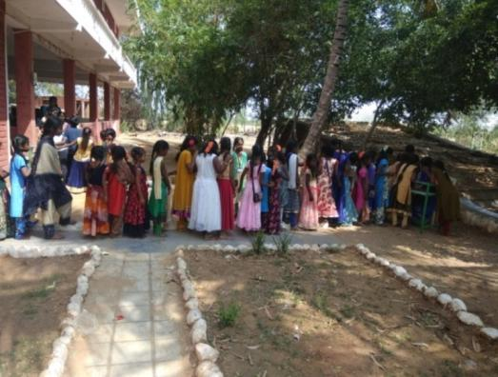
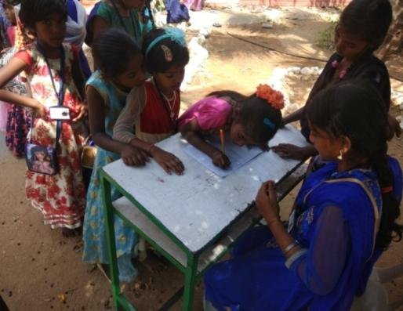
Annexure V - School Report April 2018-March 2019

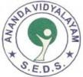
SEDS ANANDA VIDYALAYAM SCHOOL

April to March 2018-19 Report

April:

In this month students were busy with their final exams. Exams were started on 9th of April finished on 21st April. On 23rd of April a parent teacher meeting was conducted and student progress cards were issued to the parents. Summer holidays were announced from the date of 24th April to June 12th.

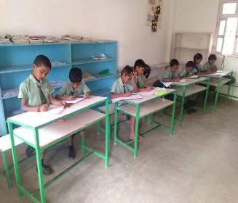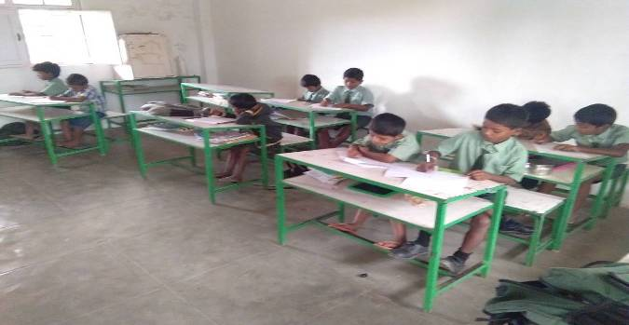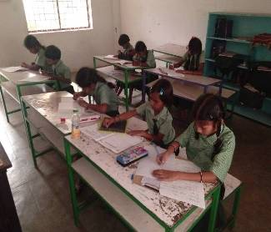

May:
During the 2nd week of May we prepared the required material for canvassing. We held 5 days of canvassing in nearby villages to the school. Pamphlets were distributed and posters were stuck on the walls. Required Academic books, stationery were order.

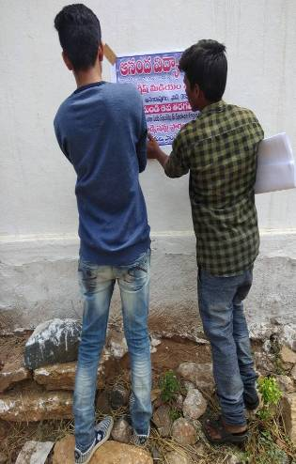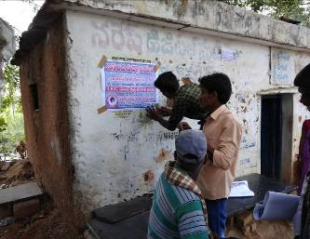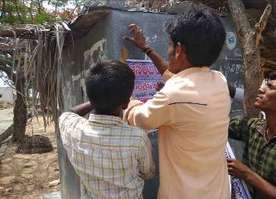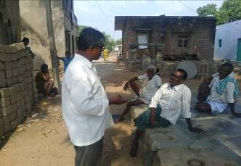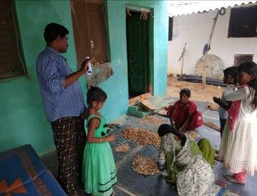

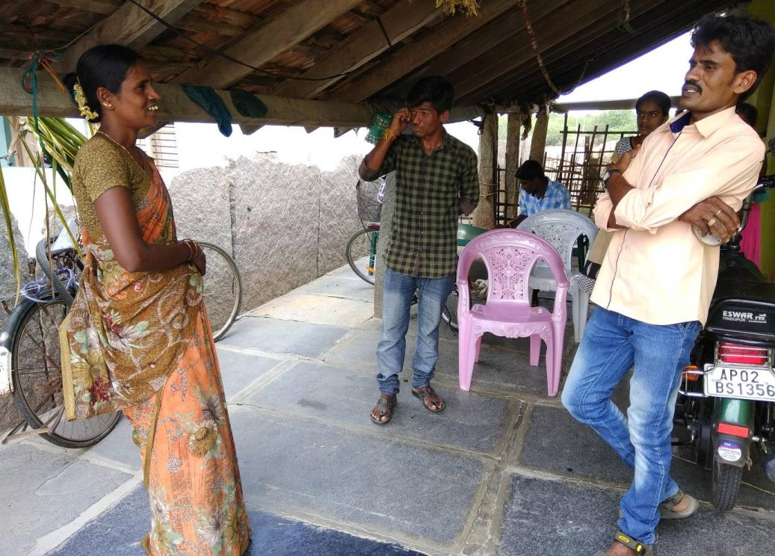

JUNE:

On 12th of June school we re-opened. New books and uniforms were distributed for the new academic year. In the end of the month sports drill was practiced by the students.

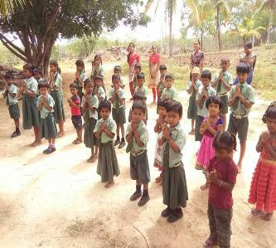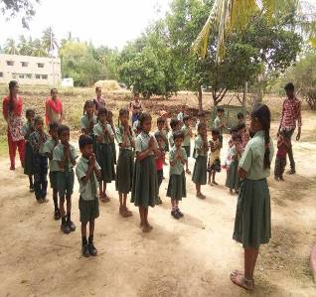

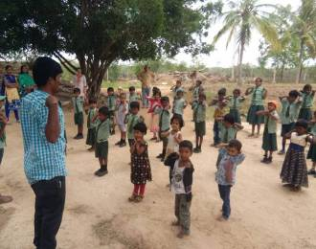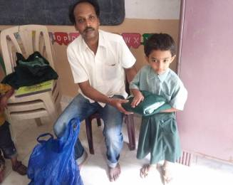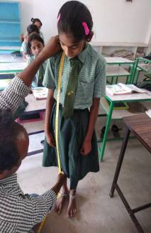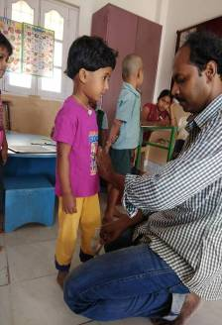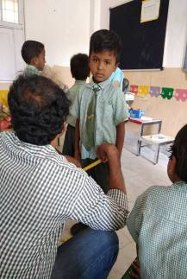

JULY:
In July we had intern students from Australia and they conducted English and arts crafts sessions with the students. During 3rd week of July students were given their 1st unit test exams. At the end of the month children were busy in practicing the cultural activities for the upcoming Independence Day program.
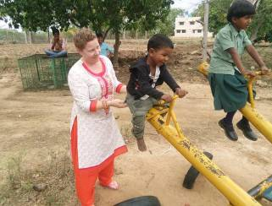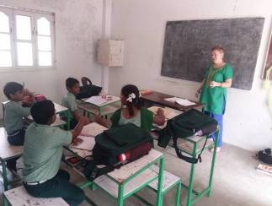

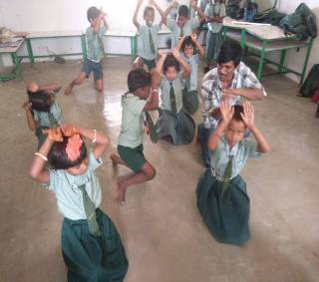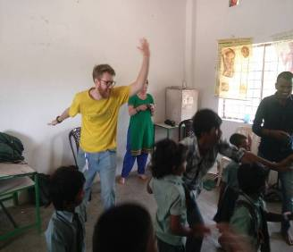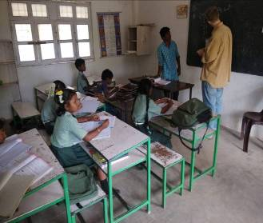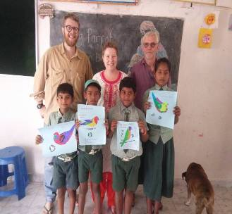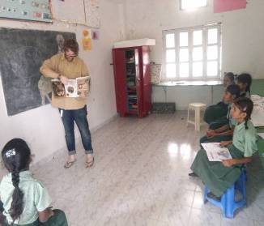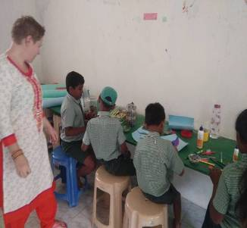

AUGUST:
August began with classes as usual and some preparations for Independence Day. The day began with prayers and flag hoisting and singing the national anthem. This was followed by cultural programs of drama and singing. Prizes were distributed.
Children collected sweets and biscuits and they went home. Classes commenced as normal the following week, the children got back to their studies of preparing for their 2nd Unit test.

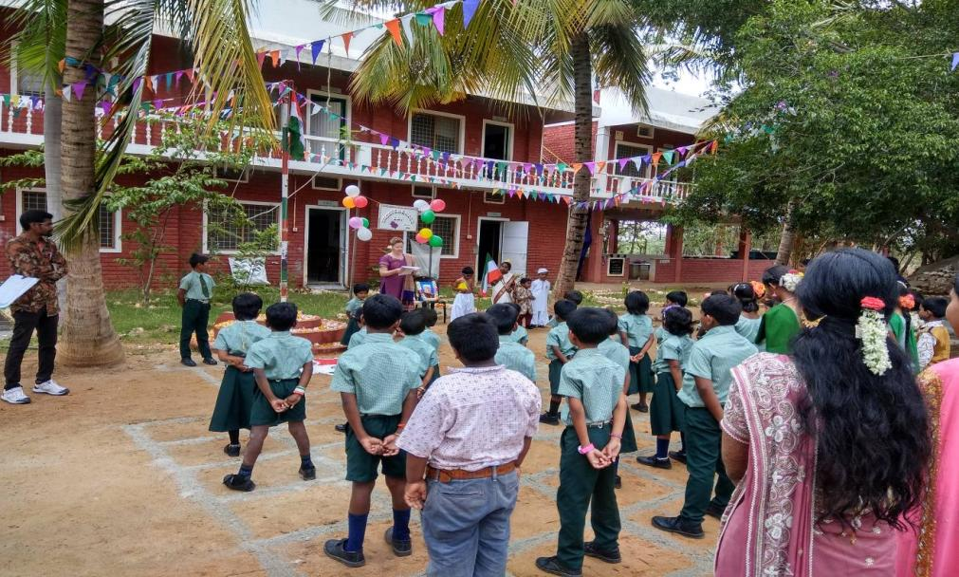

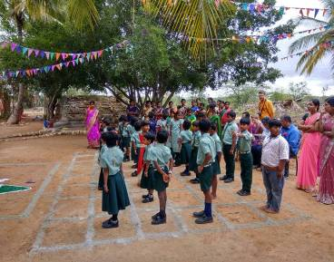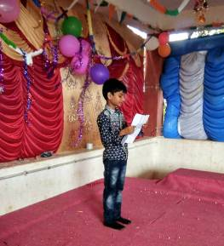
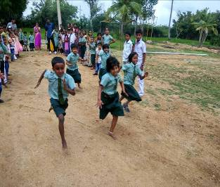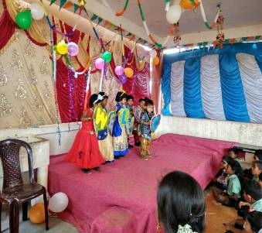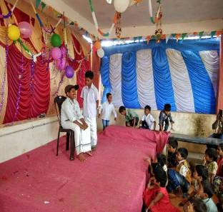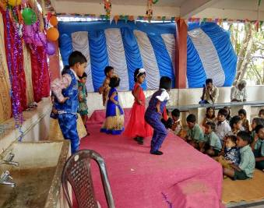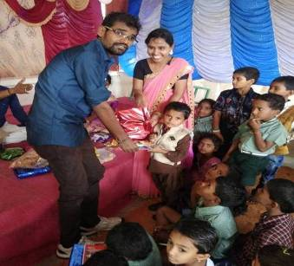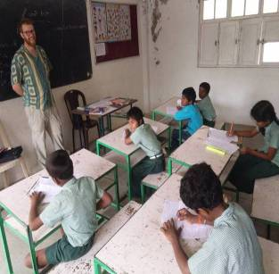

September:
Following the activities of August, month of September started as usual with children preparing for their exams which are conducted in October 2nd week. Apart from this children also participated in the Arts & crafts classes
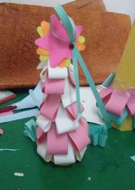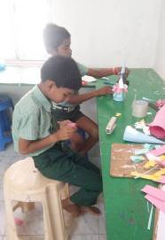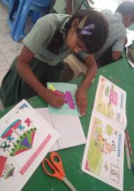

October:
In the month of October two volunteers Maurice Kleine from Netherland and Kirra Pickering from Australia participated in school activities, where they taught students arts crafts and English Classes. Quarterly exams were conducted during 2nd week of October. After that Dasara Festival holidays were announced. Maurice and Kirra also took special classes in English for the teachers.
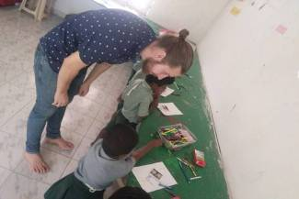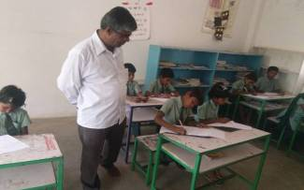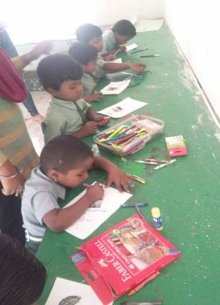

November:
In first week of November students were busy with their 3rd unit exams. After successful completion of exams we celebrated children’s day on 14th of November, where children’s dance performances were shown, later we distributed sweets to the children. Children prepared arts and crafts and participated in quiz program.
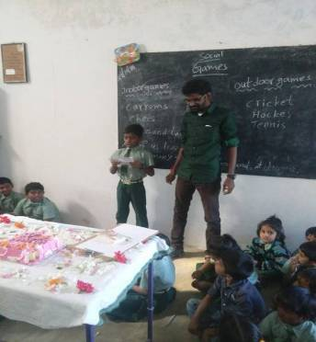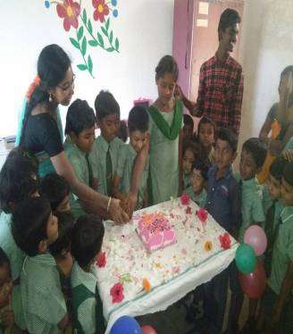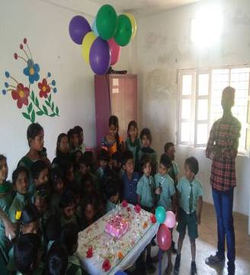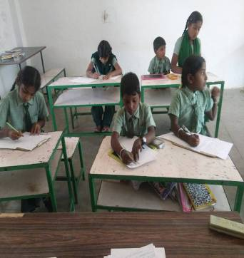

December:
December continued classes. School closed for Christmas holidays
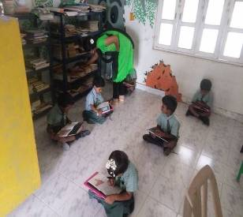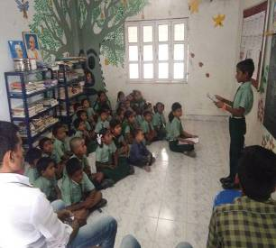

January:
School started on 2nd January after completion of Christmas holidays. Half-yearly exam was held on 4/01/2019 to 15/01/2019. After that was Republic day celebrations on the 26th of January. We started the program with flag hoisting, prayer, speeches by the students and chief guest and cultural & entertaining activities performed by the students. We also conducted games and distributed prizes for the winners
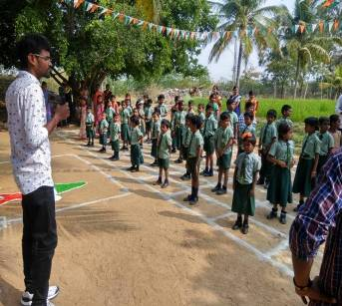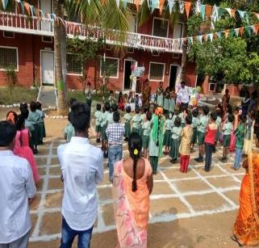
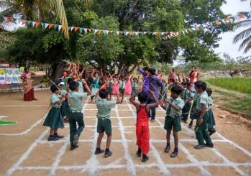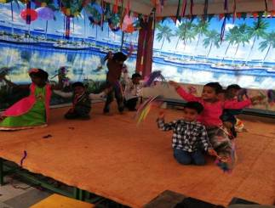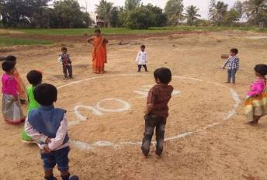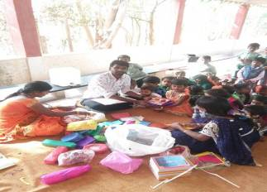

February:
In beginning of this month children had a lot of arts and crafts classes and they really enjoy these creativity days. 4th unit test was conducted from 13-02-17 to 18-02-17. Damaged and corroded water pipeline and taps were repaired.
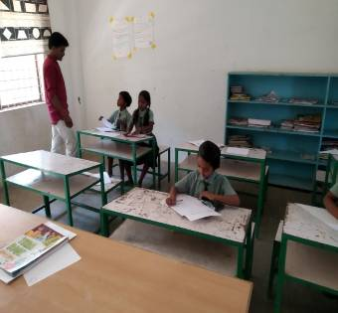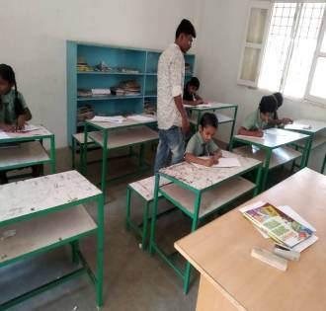
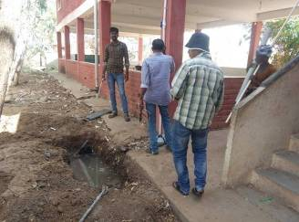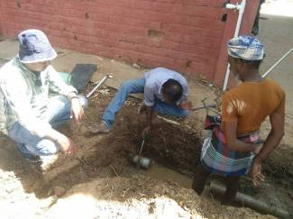

March:
Due to the summer and the heat school timings are from7.30 am till 12.20 pm. On 21st March children celebrated holi festival. Holi is the festival of colors in India. Holi is celebrated in the spring season because it is welcoming spring. Hindus believe that spring is full of colors so they throw colored water on each other. Holi is based on a legend about a King Hiranyakashyap who ordered his sister to sit on a burning fire along with Prahlada. Holi is celebrated as a festival of triumph of good over evil in the honor of Hindu god Vishnu and his follower Prahlada. Children throw colors and water on each other. Children had a lot of fun.
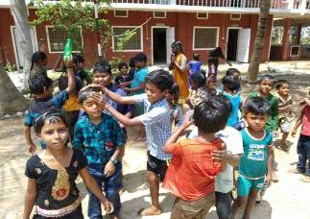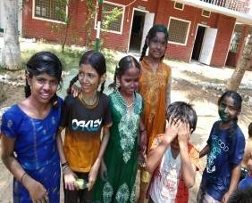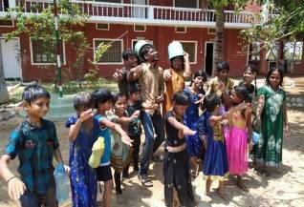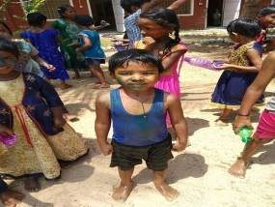

Annexure VI – Old People Program Report April 2018-March 2019

SEDS – Old People Program (April 2018 to March 2019)

Old people living on the streets are brought to the farm and bathed, hair cut and shaves for the men, their nails are cut and feet and hands cleaned. They are given new clothes bags pouches medicines and a good chicken meal and sent back. They refuse to stay when asked.
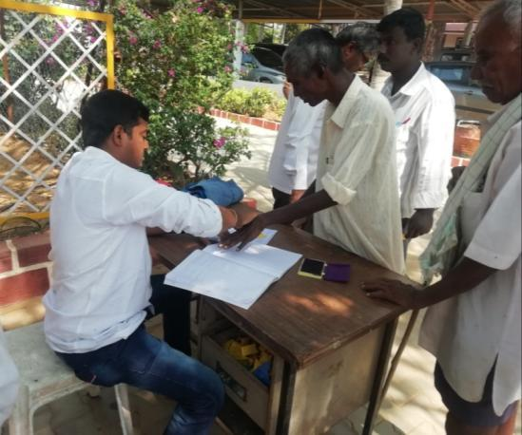
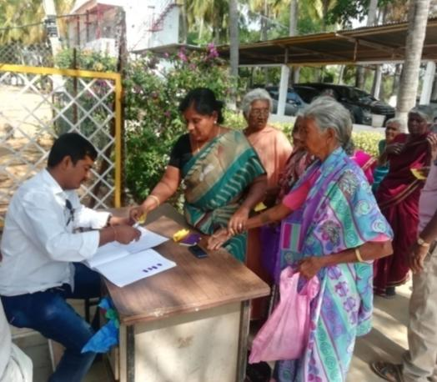
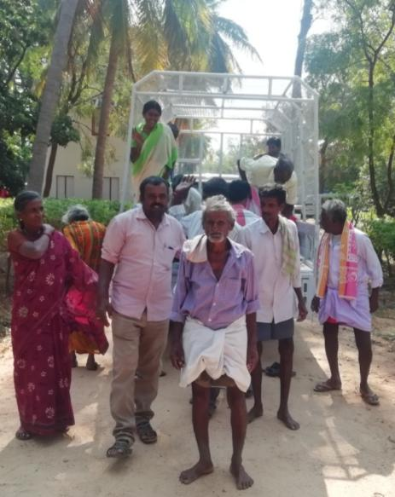
Participants Registration for the Program
Invited old people for the Program
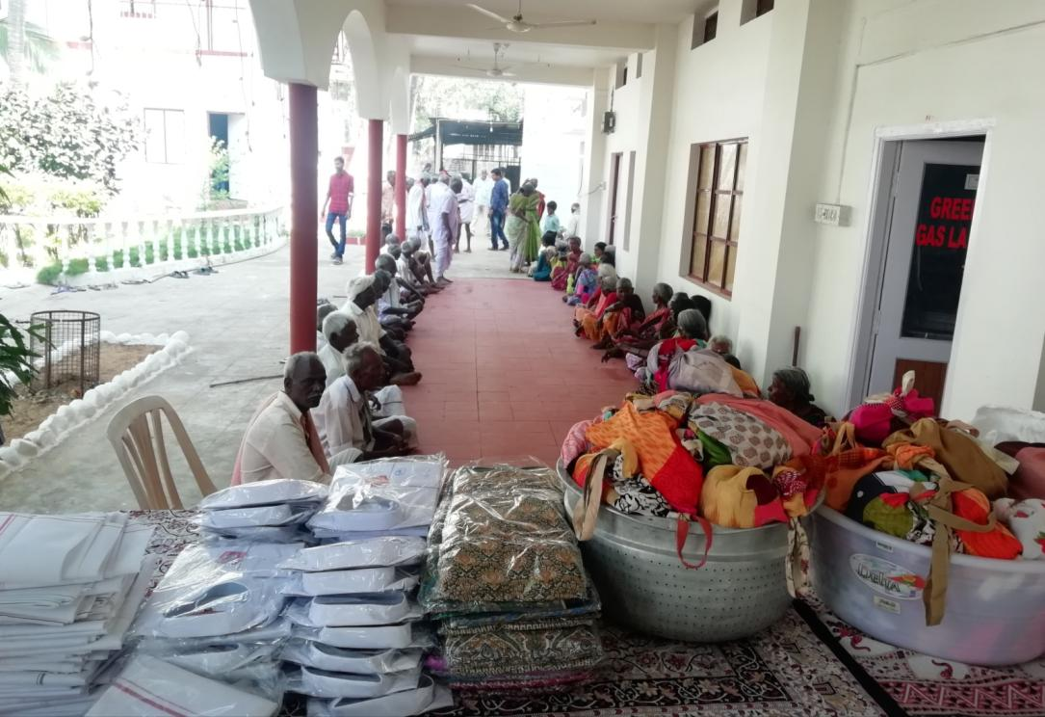

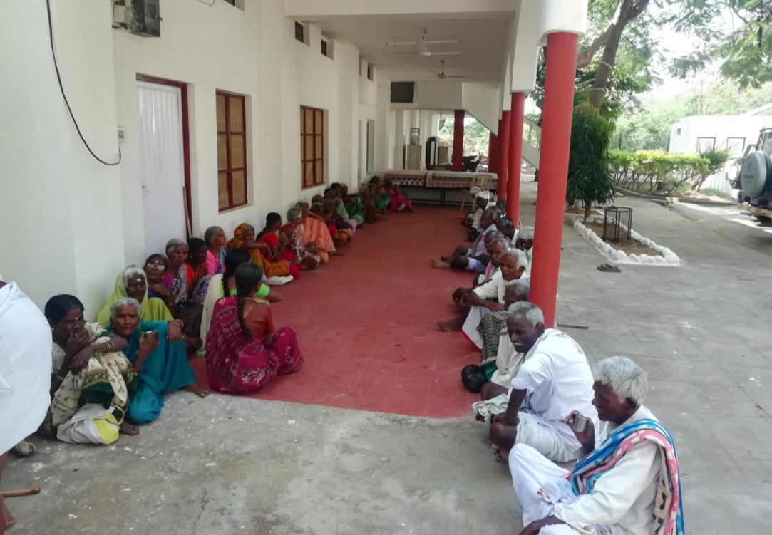
Hair Cutting and Shaving for the old people

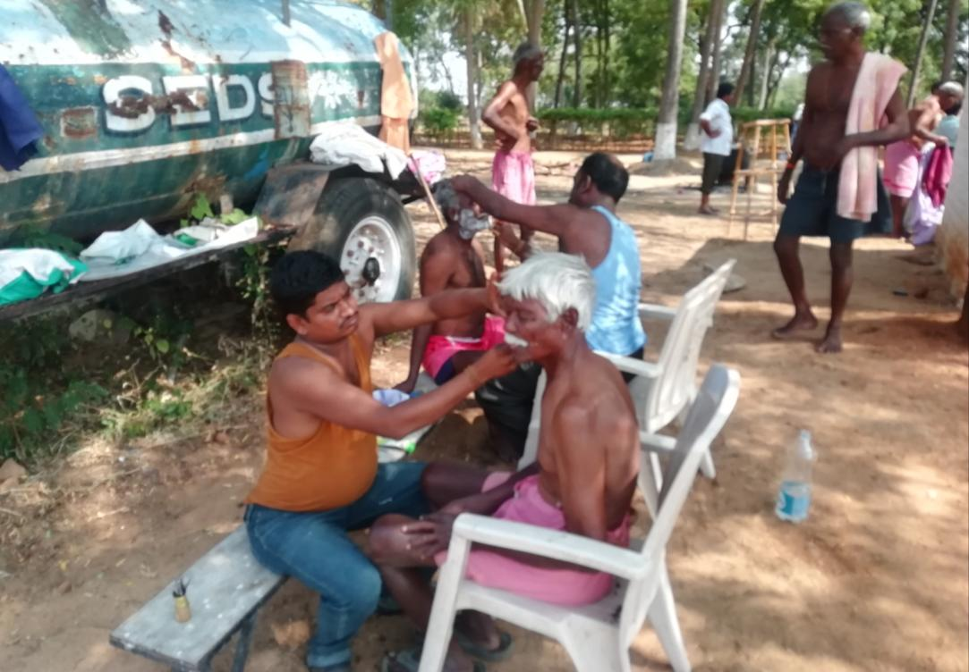
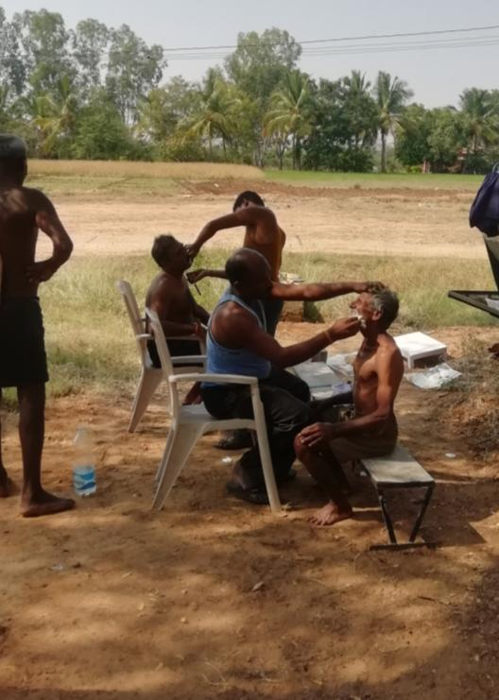
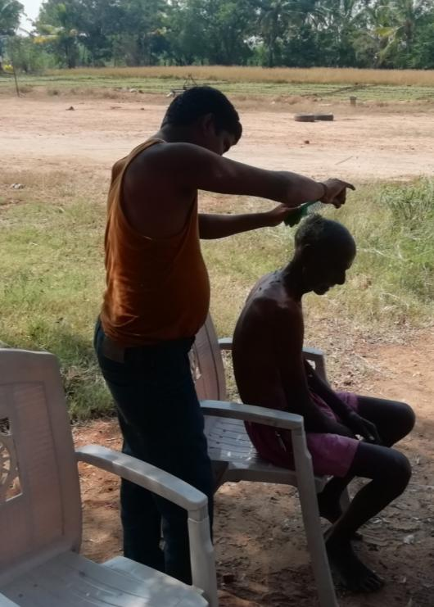

NailsCutting for the old people

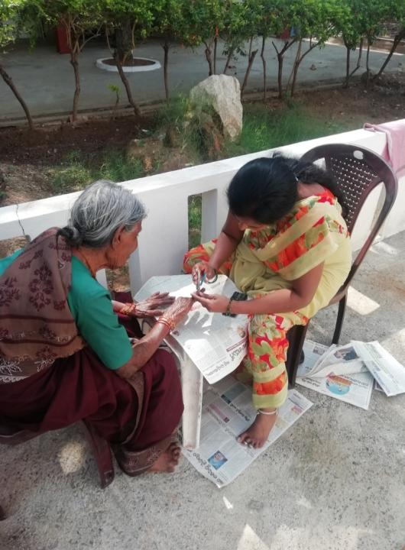
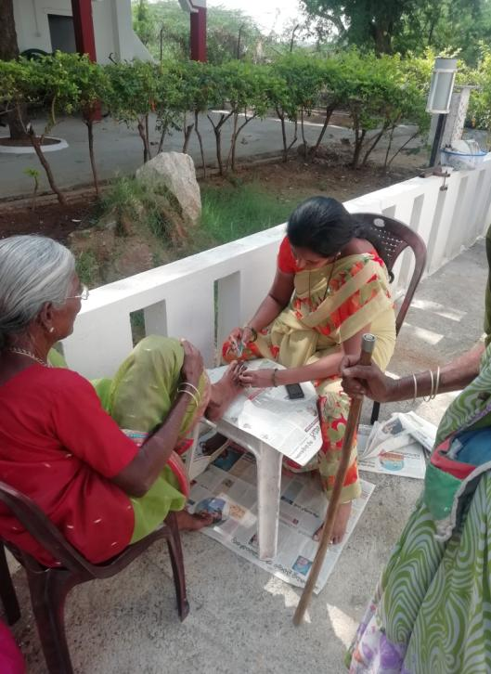
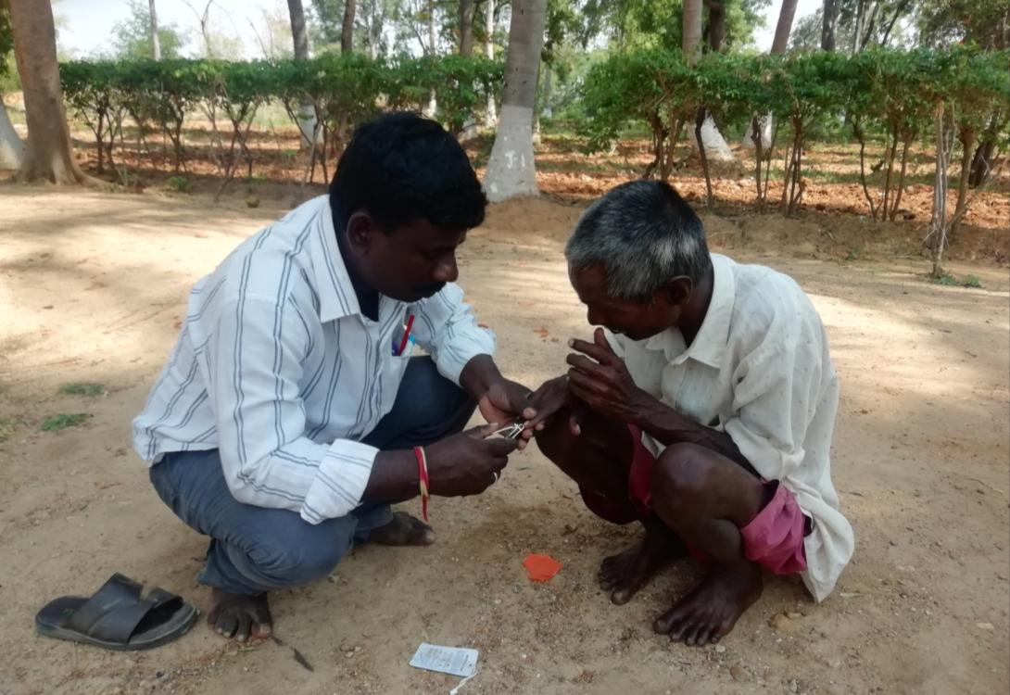
Hot Baths for the old people

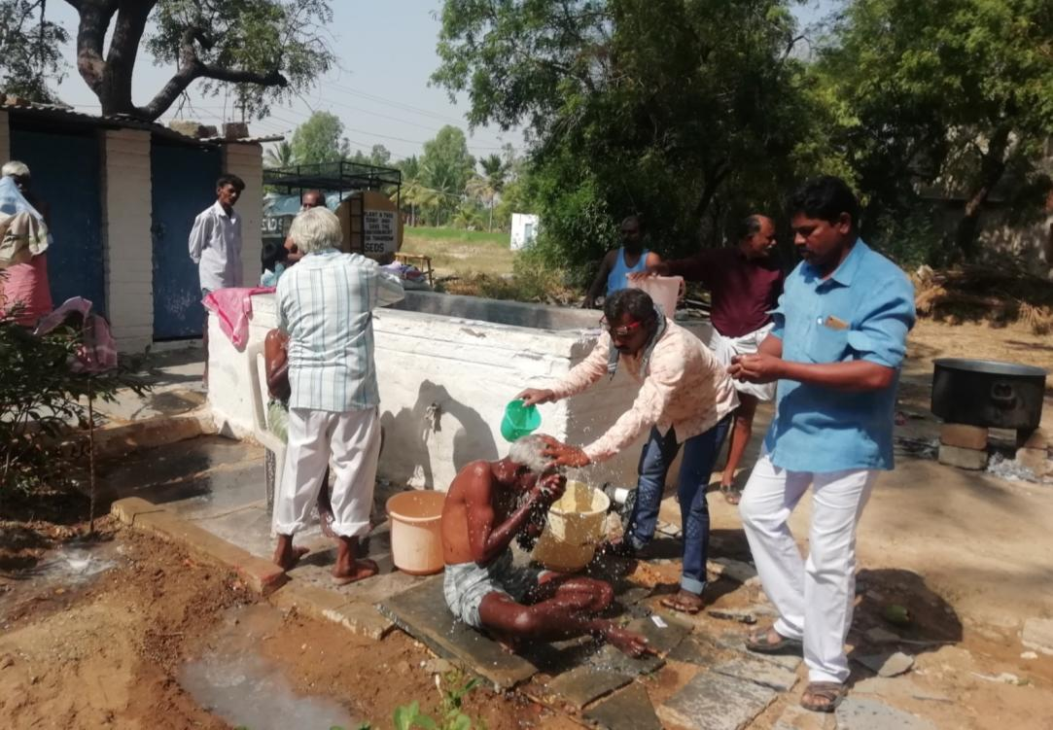
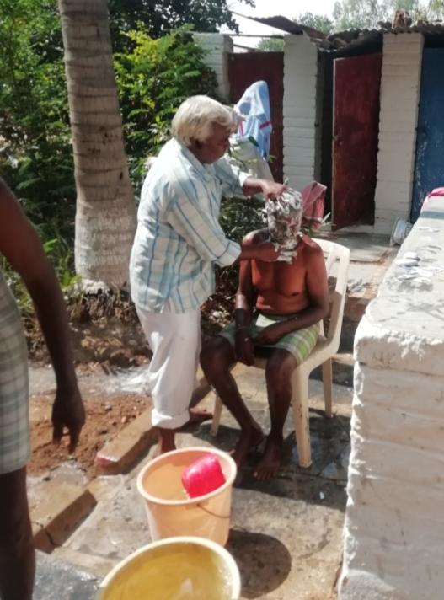
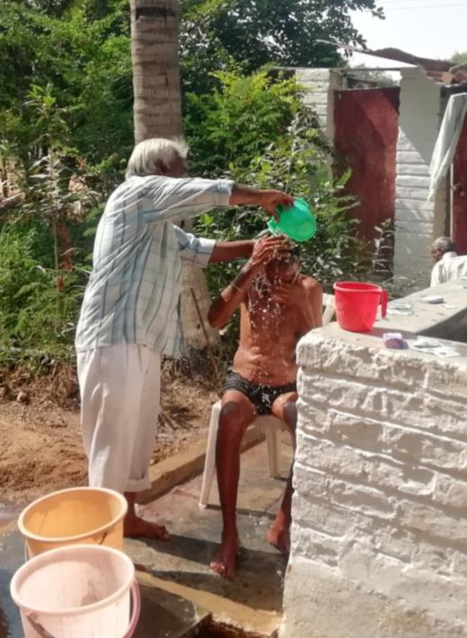

Distribution of Clothes for the old people

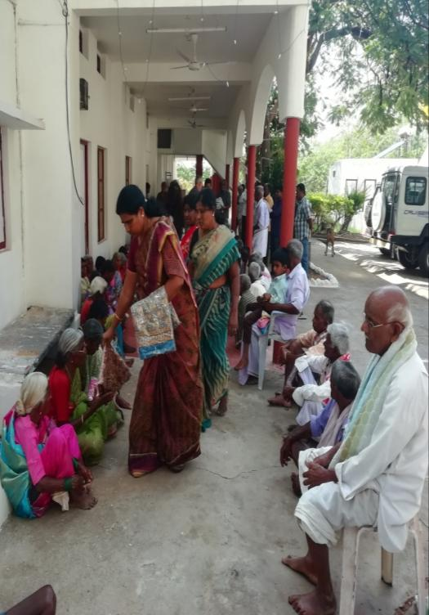
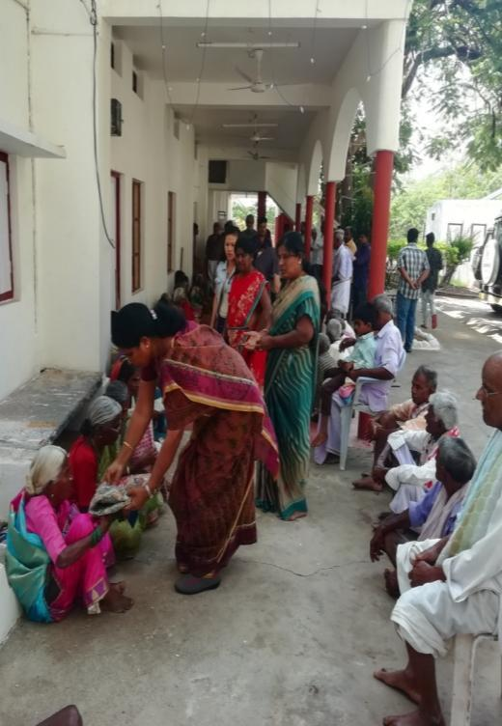
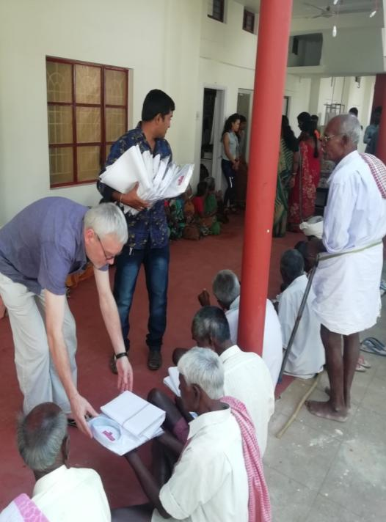
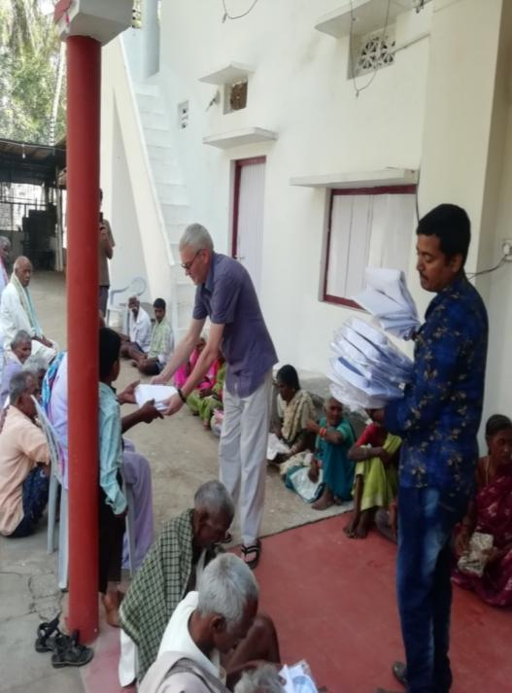

Distribution of Medicines for the old people
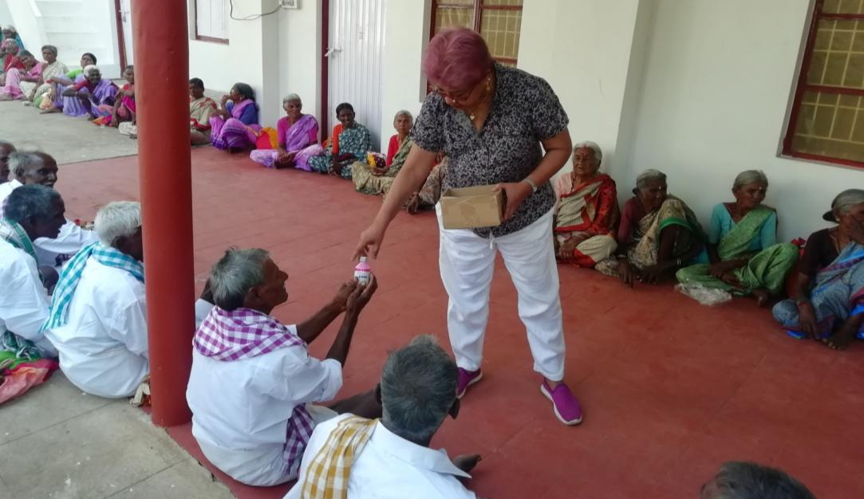
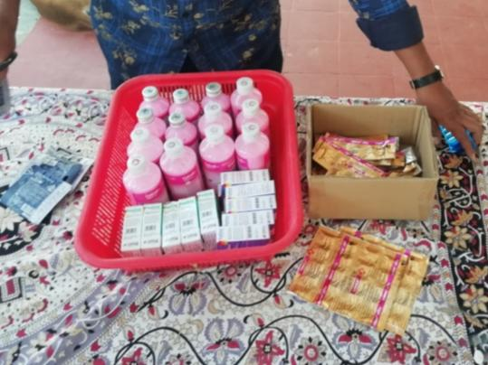
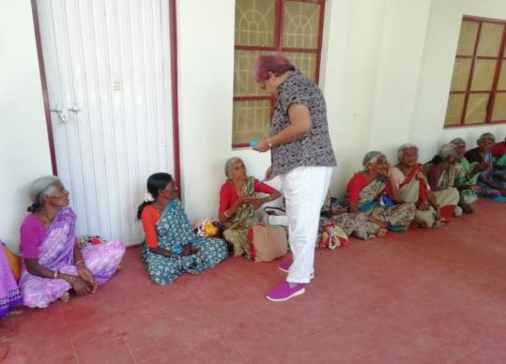
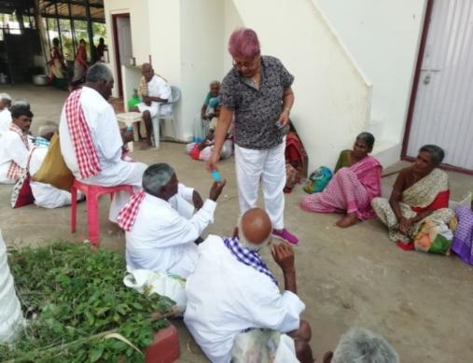
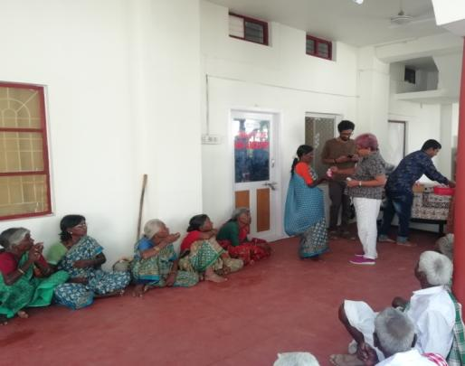
Distribution of other items (Tooth paste & Brush, Comb, Hair Oil, Vaseline, Nail cutters, Shampoo, Towels, Soaps etc,)
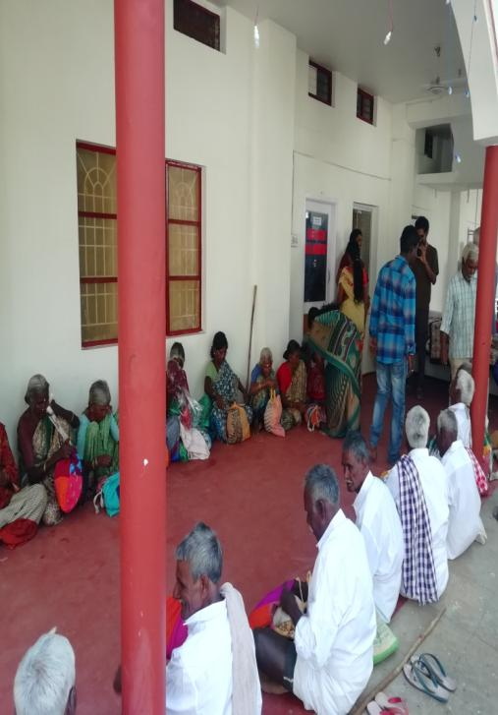
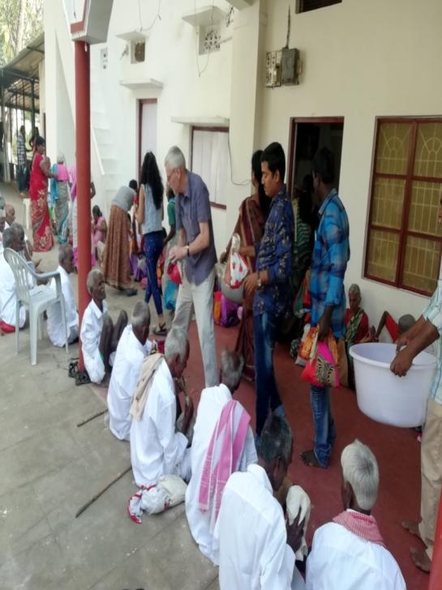
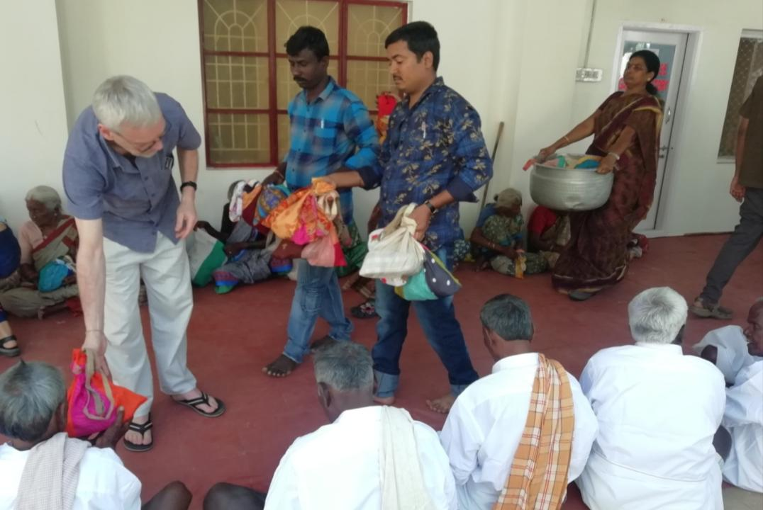

Distribution of Footwear for the old people

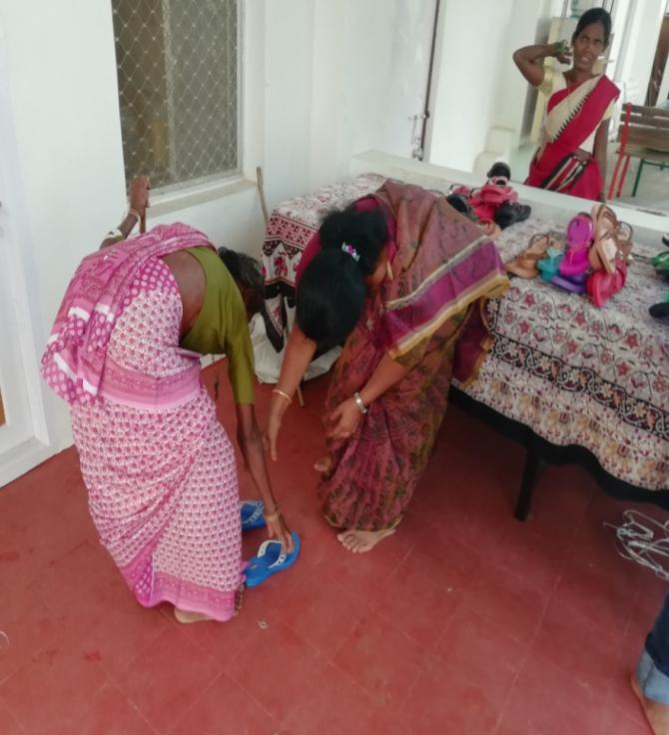
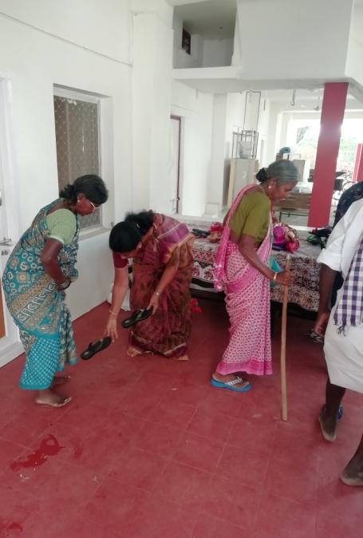
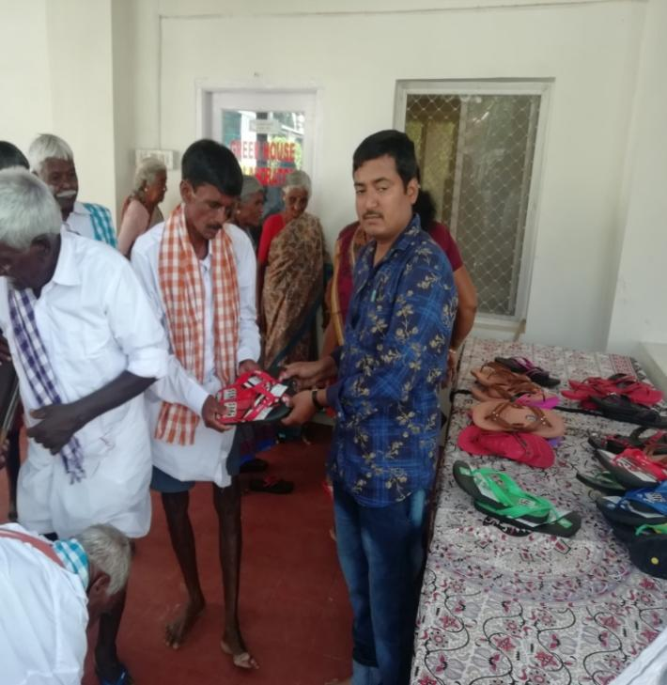
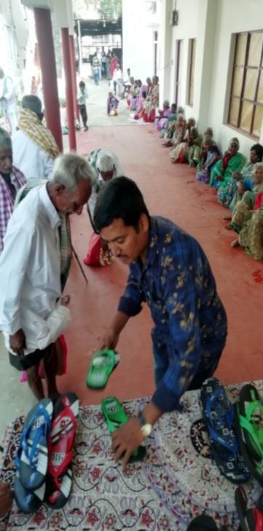

Preparing Food for the old people

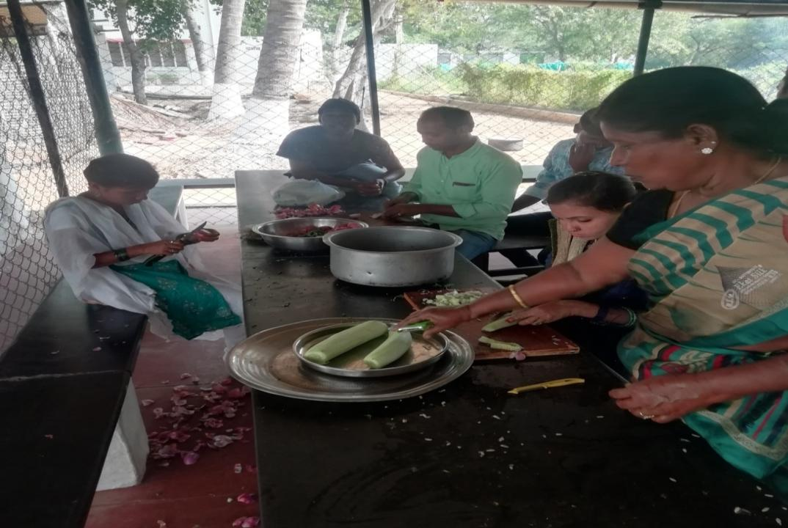
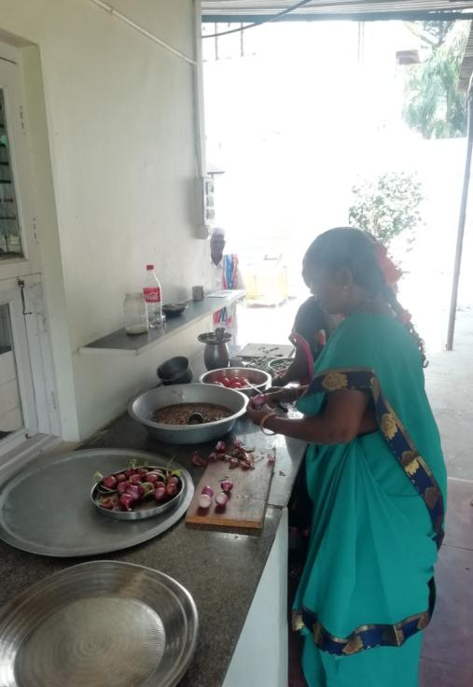
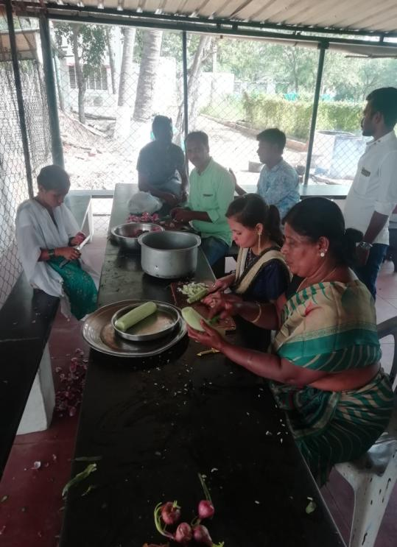

Supplying Food for the old people

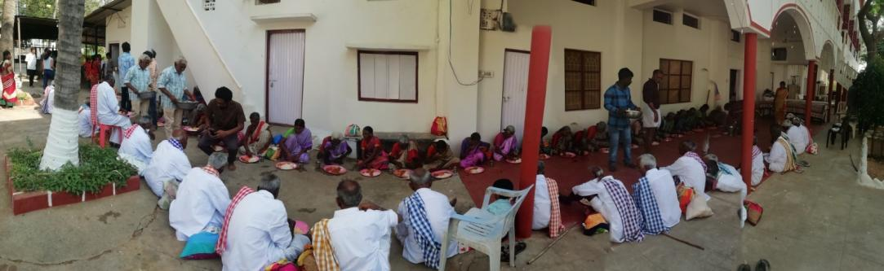
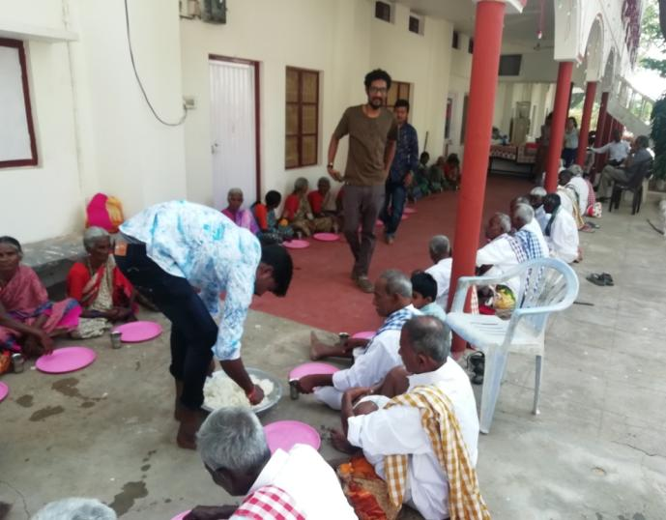
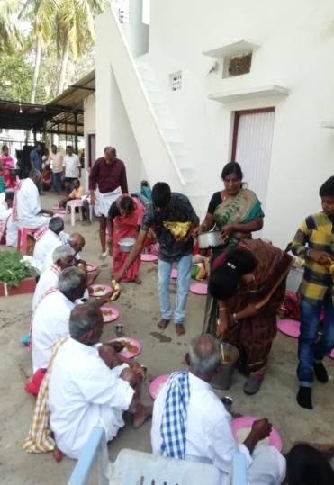
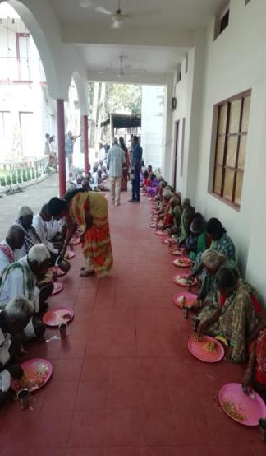
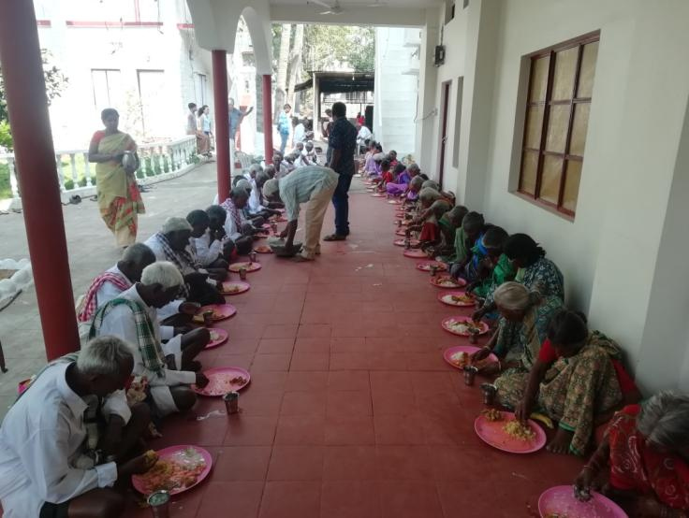

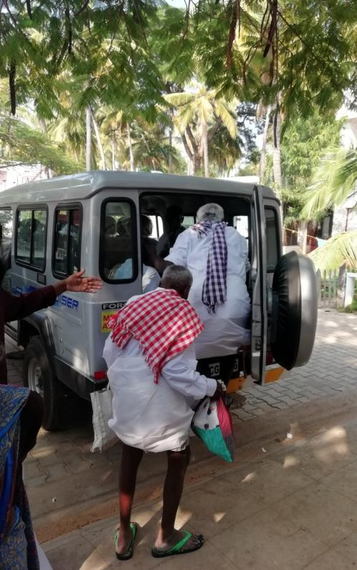
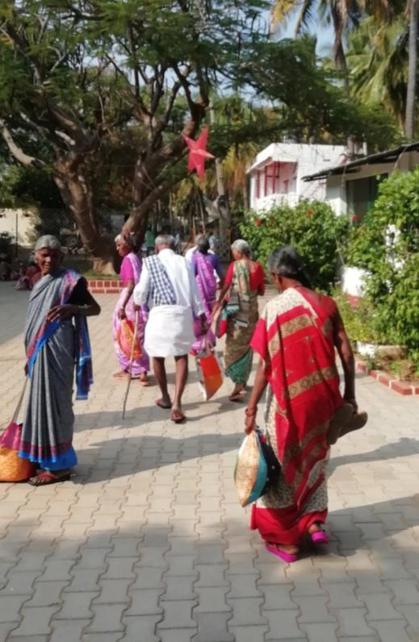

Going Home

Annexure VII – Exposure trip and its learning’s

SEDS STAFF Exposure Report 2019 March 07-03-19 to 10-03- 19
Participated Staff List
- Rohith,
- Nagamani,
- Shaik Basha,
- Imran,
- Tanveer,
- Venkataramudu,
- Anjinappa,
- Ramanjineyulu,
- Anil,
- Govindamma,
- Radha,
- Rathnamma,
- Anand,
- Hanumaiah,
- Ramanji (Driver),
- Venkatesh (Driver).

Visited Places
- Srirangapatnam,
- Brindavan Gardens,
- Mysore,
- Ooty ( 2 NGO’s – RDO & MPDA)

Day – 1 (07-03-19)

We visited Srirangapatnam and Mysore first day and seen 1. Kaveri Sangamam, 2. Tippu Sultan Museum, 3 .Brindavan Gardens. 4 Mysore Palace.

Day – 2 (08-03-19)

We went to Chamundi Hills in Mysore, then Pykara Waterfalls (Near Ooty).

Day – 3 (09-03-19)

Visited Rural Development Organization (RDO) in Ooty and had a meeting with the CEO and the Rajkumar. We saw their activities and the programs at field level like 1. Compost (Waste Management), 2. Grey water, 3. Carrot processing machine,
4. Medicinal Plants Development Area (MPDA).
- Compost (Waste Management) – The RDO and The government are working together in this program. Waste collection is the role of Gram Panchayat and 3 staff salary also being supported by the Gram Panchayat the Compost preparation part is being done by RDO. In the compost they are mixing toilet wastage also. 75% is Village waste and 25% is toilet wastage. Its good manure; and they are selling 1 kg for 5 rupees. All this is done by the Producer Company under the facilitation of RDO. The Gram Panchayat receives a payment of 2% of sales.

- Waste Water Management – The waste water of the bathrooms they are converting to agriculture water through tank filters, we saw the waste water from one hostel, filtered and cultivating carrots.

- Carrot processing machine – we saw a carrot processing machine, it is run by the producers company under RDO. They charge Rs. 40 for a 50 Kg bag for cleaning and grading..

- Medical Plants Development Area (MPDA) – it’s a club of producer companies under MPDA organization. They cultivate medical and herbal plants, Ex – rosemary… etc. Over the last seven years since 1995 the local community gradually built up the MPDA area including land development, establishment of medicinal plant nursery, plantations, harvest, and post harvest techniques, extraction of oil, its packaging and marketing. Besides providing the members with guaranteed employment, the Dodabetta MPDA is maintaining the revenue generation and profit thus indicating that the programme is moving towards sustainability.

Day – 4 (10-03-19)
On the last day of the exposure we went sightseeing in Ooty.
And we started our return journey in the evening.

We Learned
We learned so many new things in this exposure, in every moment of the trip and in every new place we visited we observed the practical things and how others are going forward with positive results towards sustainability. SEDS has been doing development which has been service oriented but today’s world is a business world towards a sustainable platform. In every sector like hotels, restaurants, and the tourist places they are not only doing business, they are ma king memorable moments for the people. They advertise and label their products to make it attractive for the buyer.
In waste management they are making money with waste, which is an amazing thing. And waste water management is really a simple answer to waste water with benefits.
This exposure is a learning opportunity for our staff. After we visited that area and absorbed the activities of that area and the people we learnt lot.
- To bring Sustainability to our staff with business activities
- The idea along with service motive to become a business model
- To do this we must first select the local resources in our area for a business
- Through these resources, select the needful activity
- At the same time study the market facilities
- The activity are to be taken forward collectively through the farmers company
- After all this observations the staff discussed and decided to start the “Millet” cultivation and business, and along with this Mushroom & Azolla cultivation also
- Also with this to do homestead plantation through a cooperative system

So in conclusion we understand the world is not what we thought that it was just service that we have to change from this service mode to a business mode for sustainability f the organization.

Photo Gallery

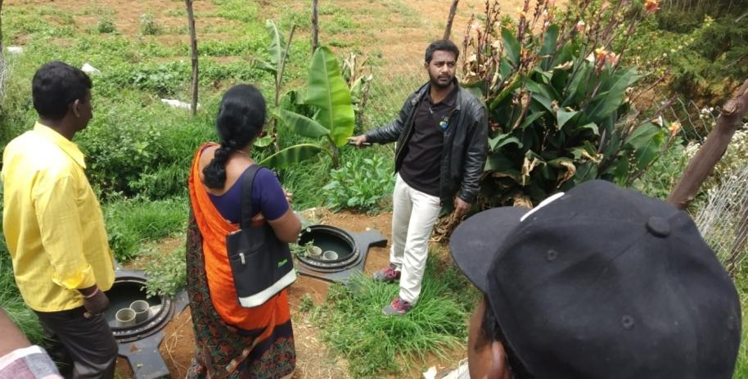
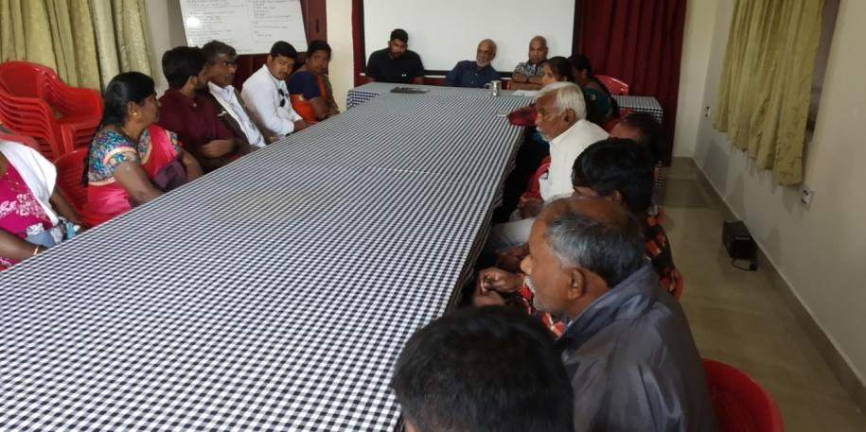
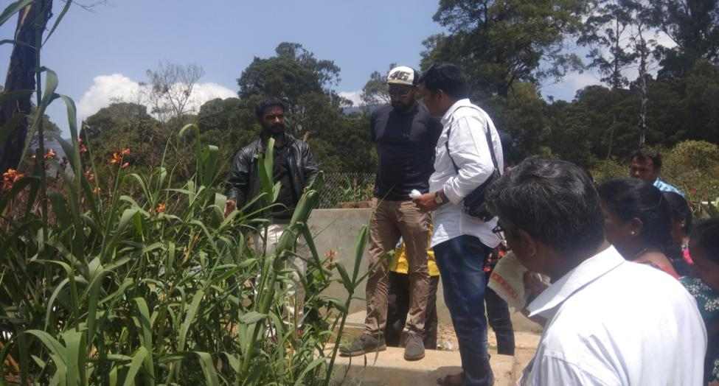
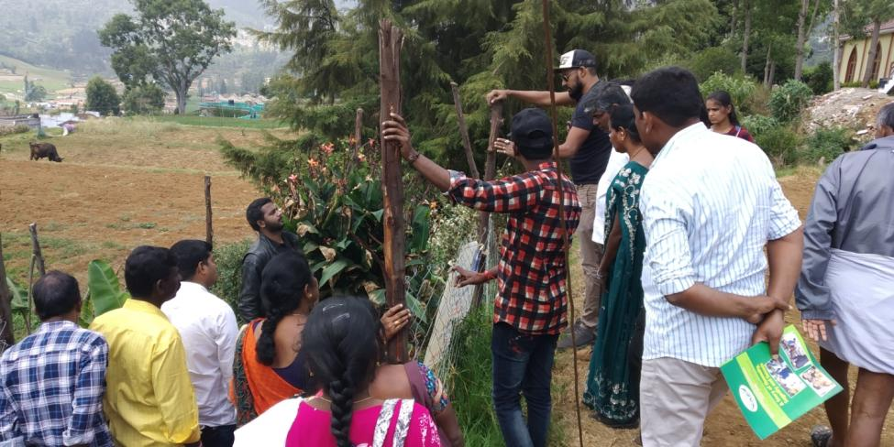
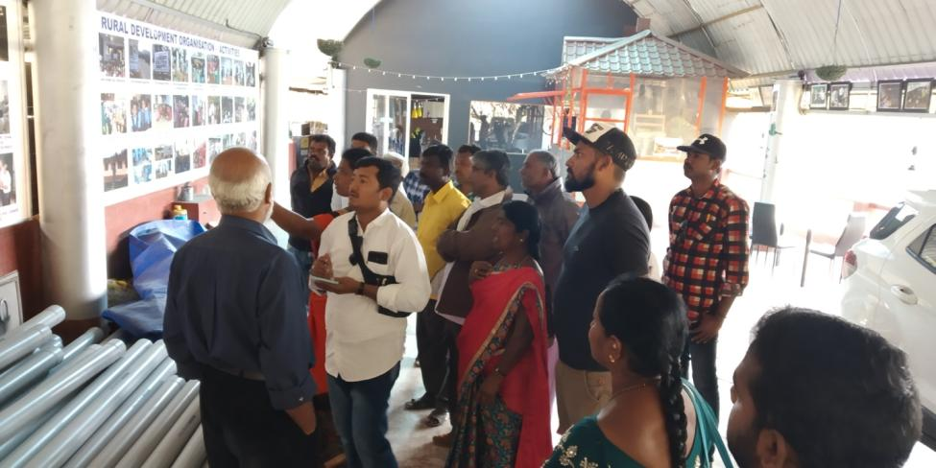

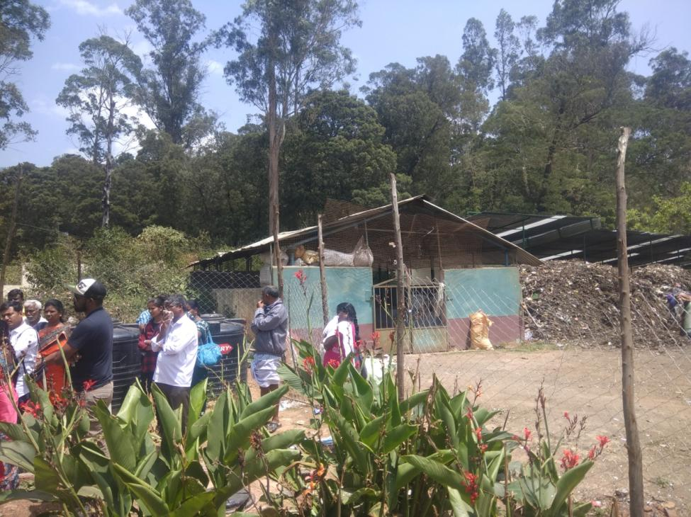
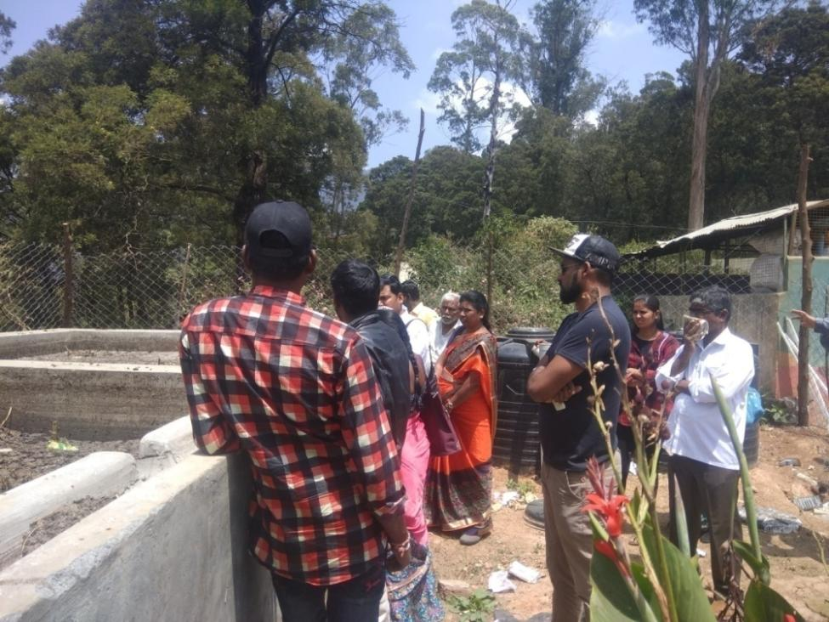
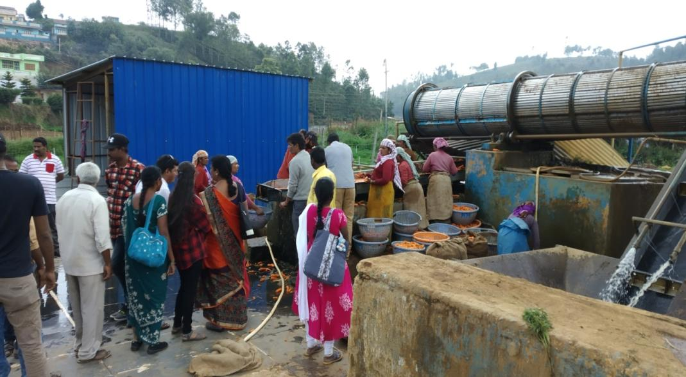
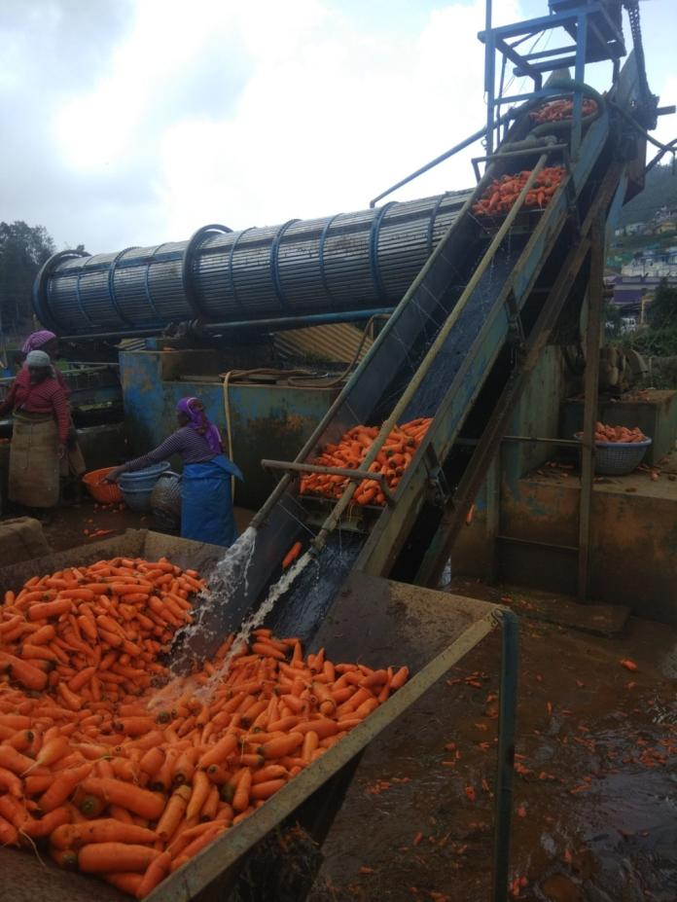
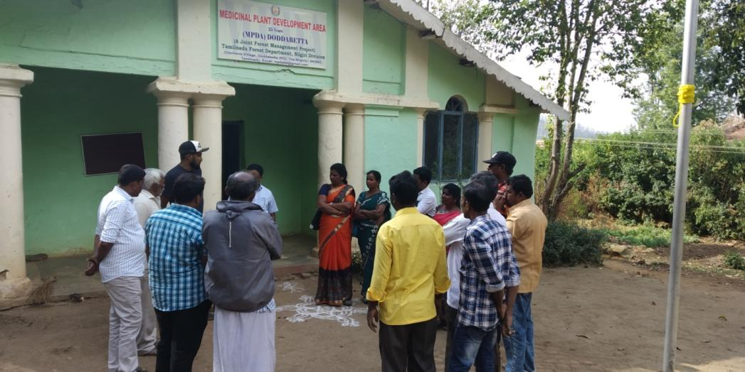
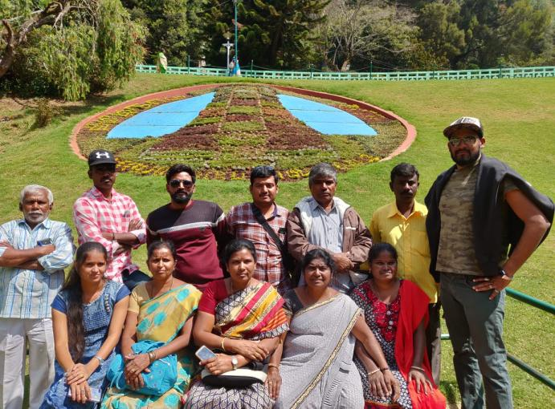
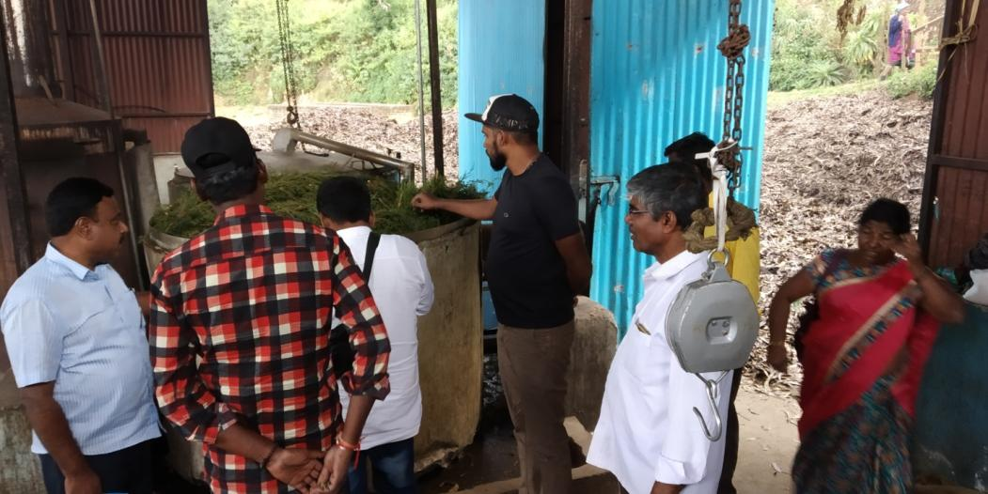
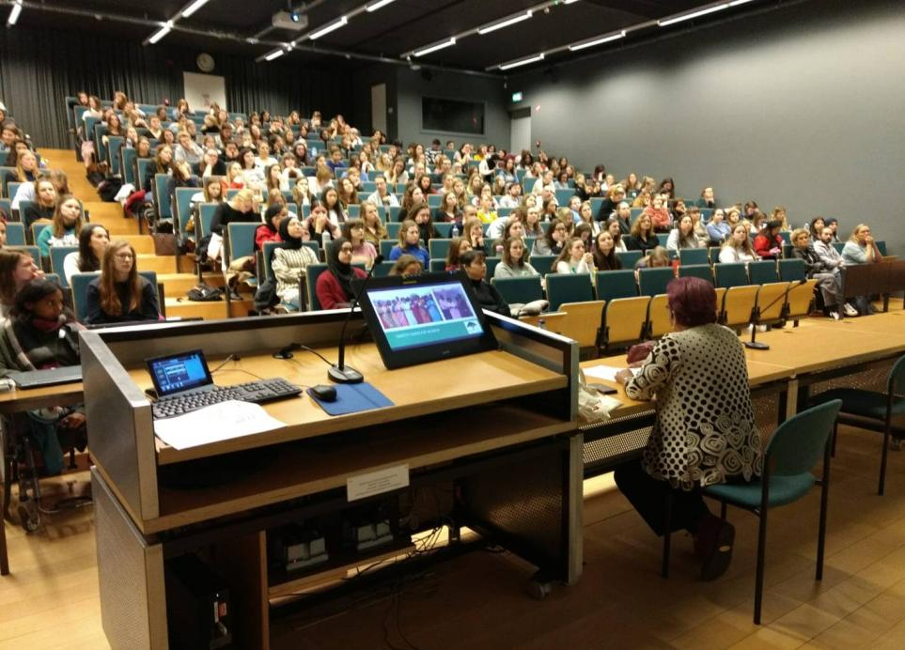
Annexure VIII – Synopsis of the Belgium visit by our CEO

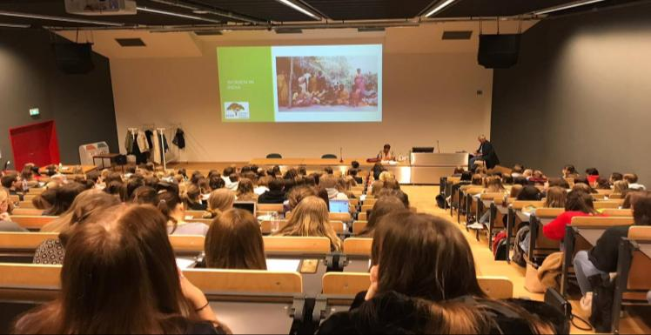

In early February I was invited by The Thomas More University in Antwerp Belgium to give three lectures of one hour each. Two lectures for first year Psychology students and one for the faculty.
The main focus on the lectures was to talk about the work SEDS has done n the past 4 decades and the link between of Sociology and Psychology.
In the lectures I gave I spoke about the diversity of India in regard to language, ethnic groups, cultures and religion and how in spite of this it was united in its diversity. It being the largest democracy on earth, it has a free press and independent judiciary system, and although the country is united, about how deep divisions persist still.

Synopsis of the lectures:

In all the work we did in the last 40 years we had to deal with people.

We had to deal with human behaviour, emotions and projections. In order to make a meaningful sustainable change we were confronted with changing the norms and culture of a society. We had to break the rigid patterns that kept people down and submissive. The knowledge of these socialisation processes depend upon psychology. In order to change the lives of people we also had to change their minds. So an understanding of human behaviour is essential for the profession of social work in order to deal with socio-economic or psychosomatic problems faced by people. We must understand behavioural patterns at individual, group or community level in order to help them.

We had to understand them.

We had to analyse or diagnose the situation which is an on-going process till today. We do this through cooperation, open dialogues and casual conversation, village meetings, participatory rural appraisal, assistance, coordination, but overall an interest and willingness to resolve their most pressing problems.

Social work and psychology are two different disciplines. They are not the same but similar. Both are a profession that aims to improve the lives of people. While psychology focuses more on human behaviour and examines how the human mind functions, social work tends to deal more with delivering social, mental and welfare services. The two disciplines deal with components of human personality, human nature and needs, human abilities, behaviour and problems. Both have their own ways of tackling human problems, whether in physical, mental or social way. It is extremely relevant to understand the interdisciplinary relationship of these two disciplines.

I then spoke briefly of how SEDS conducted its activities, how we operated within the communities and how all the activities were vital for changing behaviour and ultimately improving the livelihood conditions of the people. Development is surely a dynamic process and our interventions have been focusing on these issues for the past 4 decades. We are glad that our initiatives have been not only in addressing the immediate needs of the community but has also in building the capacities of the community so as to move towards becoming a more sustainable and self-reliant society.

At any given moment an individual is the product of countless interactions between his genetic endowment and physical and socio-cultural environment. Genetically we can’t change much but as social workers we can offer an alternative for the physical and socio-cultural environment.

Each of our programs from food for work programs, self-help groups, tuition classes, environment and now the biogas project fosters certain values, beliefs and approved behaviour patterns. This led people to question the status-quo and society in which they grew up. They saw and learned and it made them realise what could be done and aspire for other things.

Learning, in its various forms, especially conditioning, imitation and training, or learning under the guidance and direction of another, fostered new knowledge. This plays a prime role in the development of person’s personality.
This leads them to define new roles and status. The village health worker for example, has the privilege of practicing some simple medicine which holds her in high regard by other members of the community. Gradually, a new self-concept developed for the individual as well as a new identity for the community.

As a result I feel these changes have created mental confidence in the villages. In all honesty we never looked deep into this as we never had the means neither the know-how to research this properly and we had more important things to do than look at all the outcomes of our work.Surely new problems are there such as study pressure or looking for a stable income. But overall by eradicating the worst practices of an archaic society while at the same time create new roles and responsibilities for the most vulnerable members of the society I think we provided opportunities for prevention of depression and anxiety disorders.

In conclusion:

The response from the lectures was astounding halls were full, pin drop silence and the questions and applause after made me proud of the work SEDS had done.

The highlight to the trip was that I was able to meet about 30 of the Belgium volunteers who have come to SEDS to teach in the school and do other things over the last 25years.

