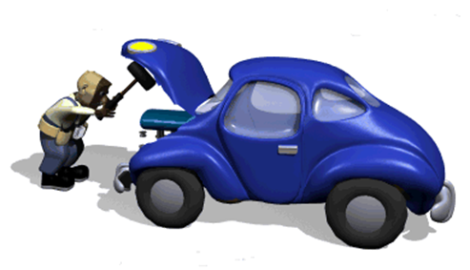
Are you having car problems and need your car to get to work?

HELP MAY BE AVAILABLE FOR YOU OR SOMEONE THAT YOU KNOW!!!
Requirements
- You live in Madison County
- Are employed or can prove upcoming employment
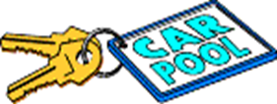
- Meet income guidelines (listed on reverse)
- Have dependent children (even if they do not live with you)

Assistance Available to qualified applicants
- Car repairs, insurance, and loan payment.
- Fees for NYS Driver’s license, current registration, and vehicle inspection
- Gas and Tires

For more information and assistance, please call and leave a message with your name and phone number stating that you are asking about help with your transportation issues.

Morrisville (315) 684-3144 or Canastota (315) 697-3588

All inquiries & information are confidential

Disclaimer: To be considered for the program, a phone intake session with a Supportive Services team member is required and documentation must be submitted. Limits and restrictions apply. In no event shall Community Action Partnership of Madison County be liable nor held responsible for committee selections.

See reverse for INCOME GUIDELINES

Income Guidelines
for
Madison County
Residents

Please note your income has to be less than the amount listed to be eligible for assistance

Family Size  (Family members per household) | Maximum Gross Annual Income  Before Tax
1  2  3  4  5  6  7  8 | $24,980  $33,820  $42,660  $51,500  $60,340,  $69,180  $78,020  $86,860

NV 2/25/2020

