****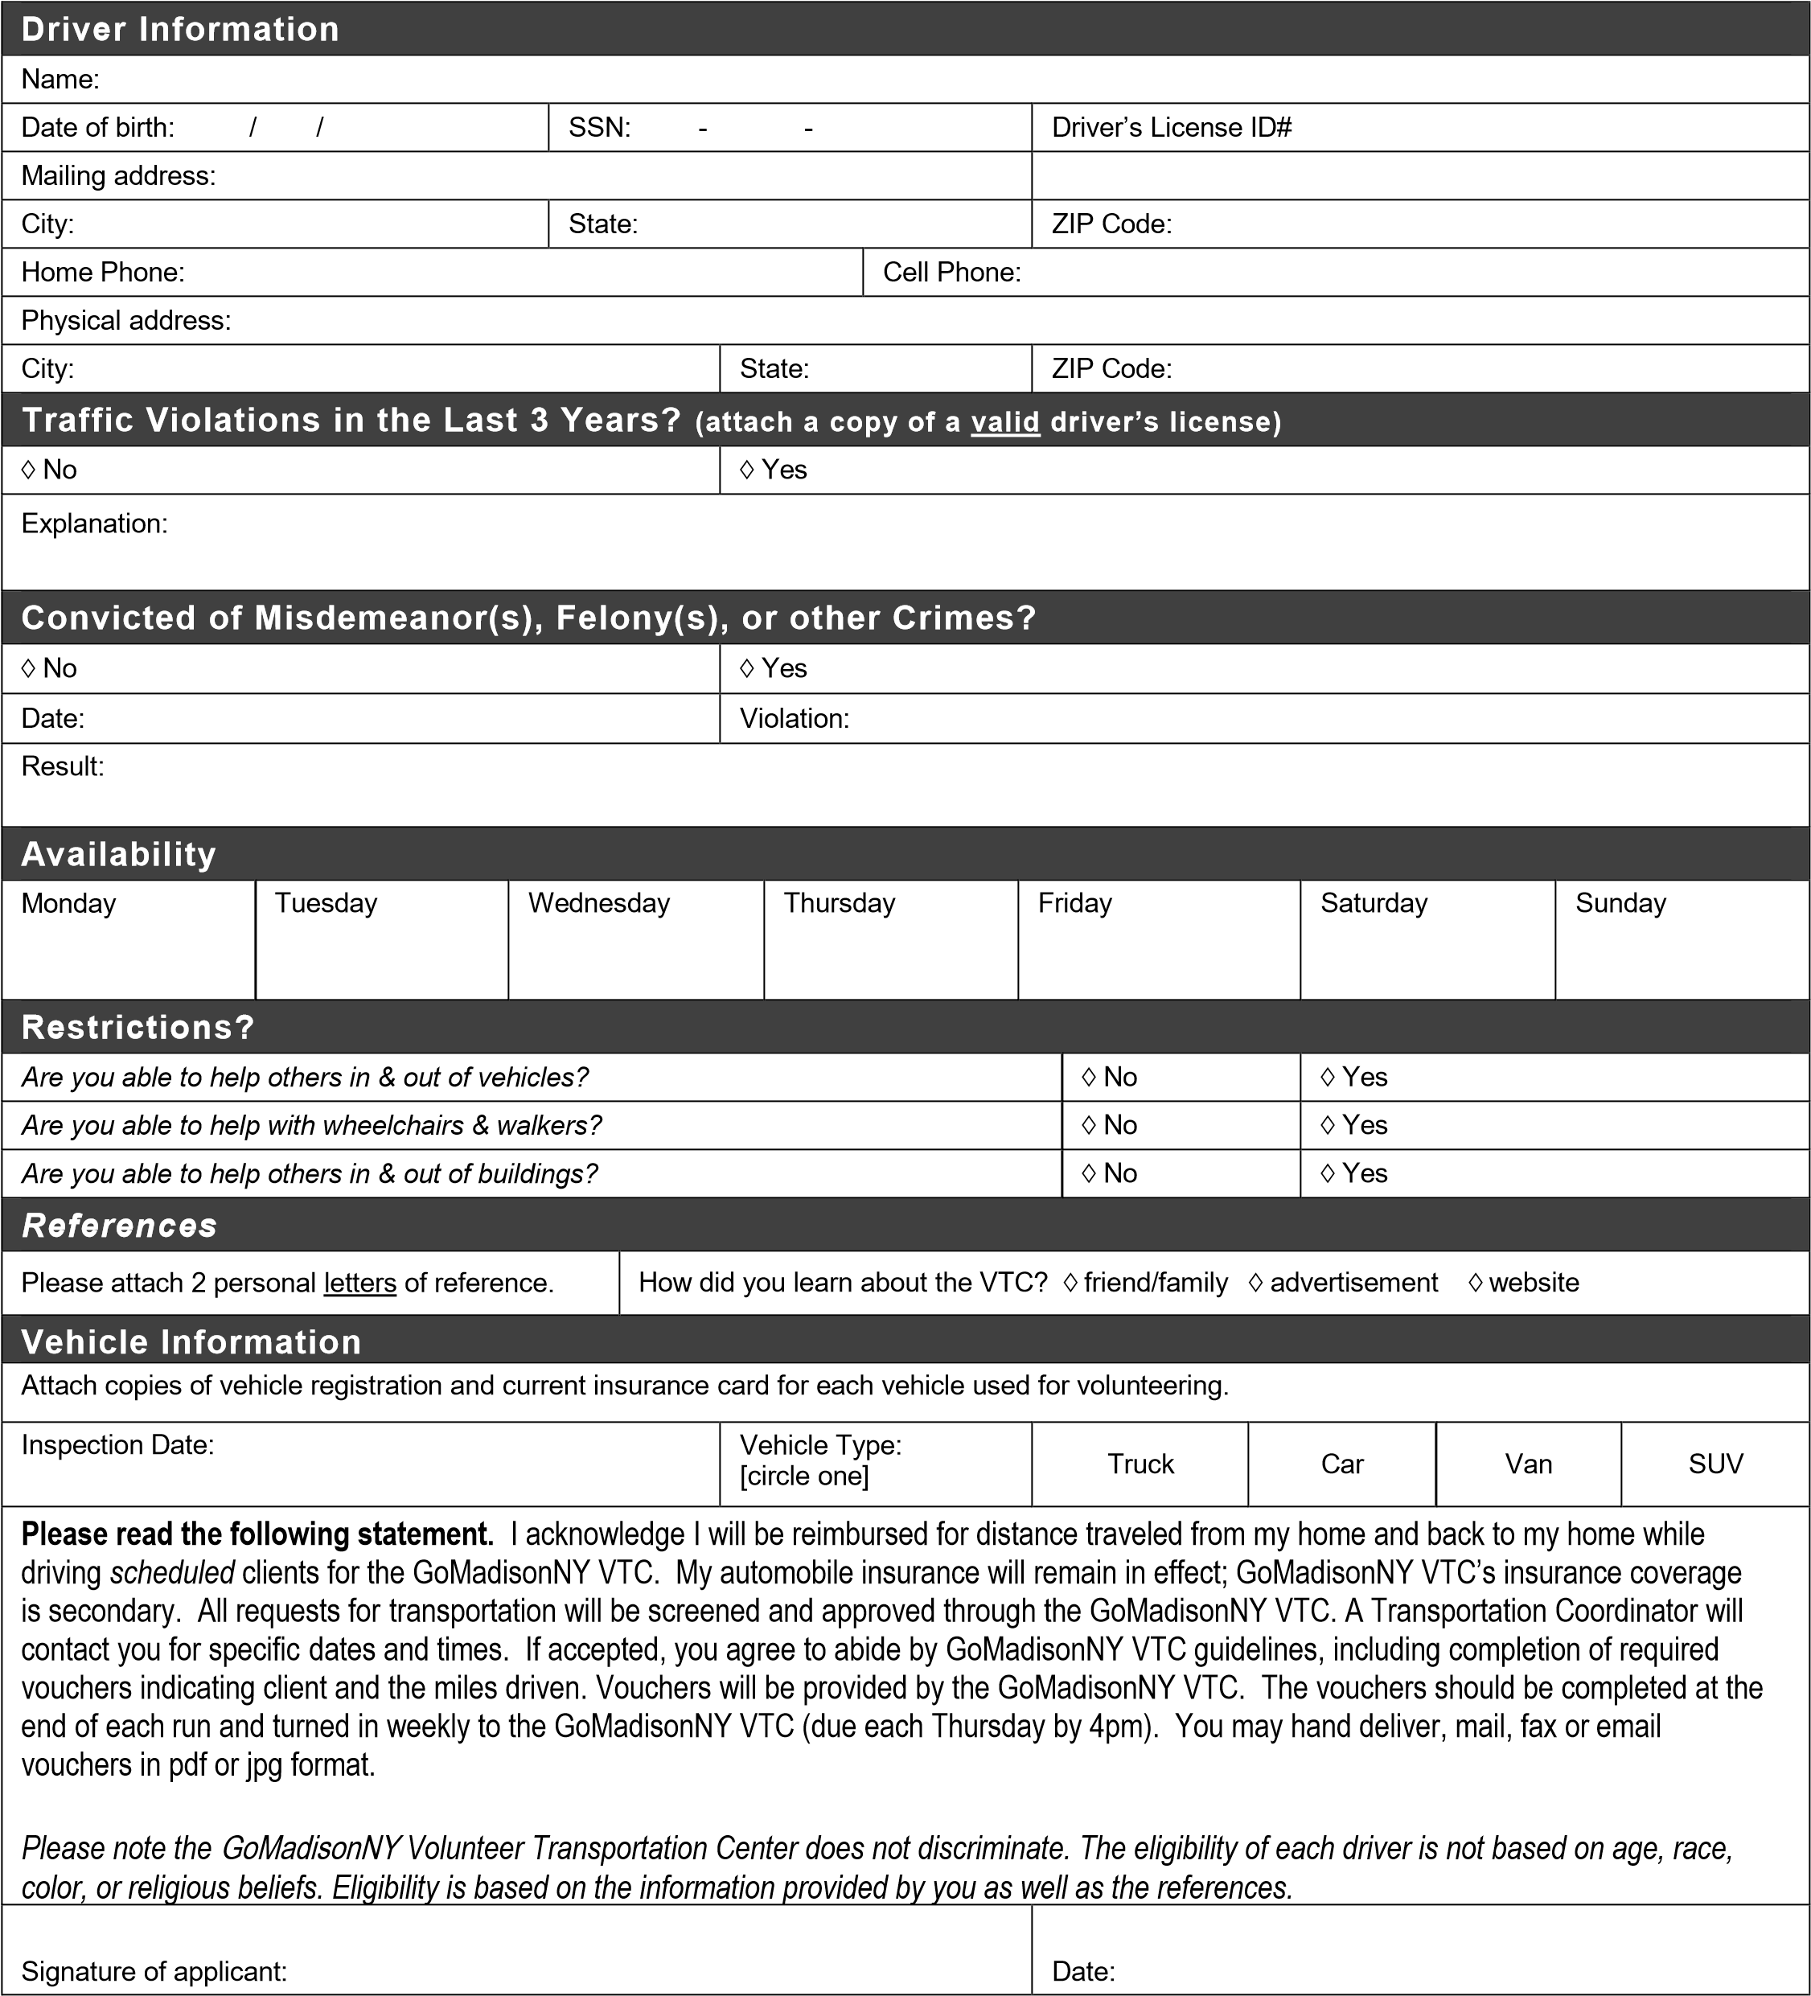**Volunteer Driver Application**

2662 Rt. 20 East (Unit 1)  
P.O. Box 430  
Cazenovia, NY 13035  
(315) 628-8372  
vtc@mcruralhealthcouncil.org