OLG Cinema Park at David Pecaut Square Visual Guide

Location
215 King Street West, Toronto, ON M5V 3G2
Closest Intersection
King St. W. & Simcoe St.
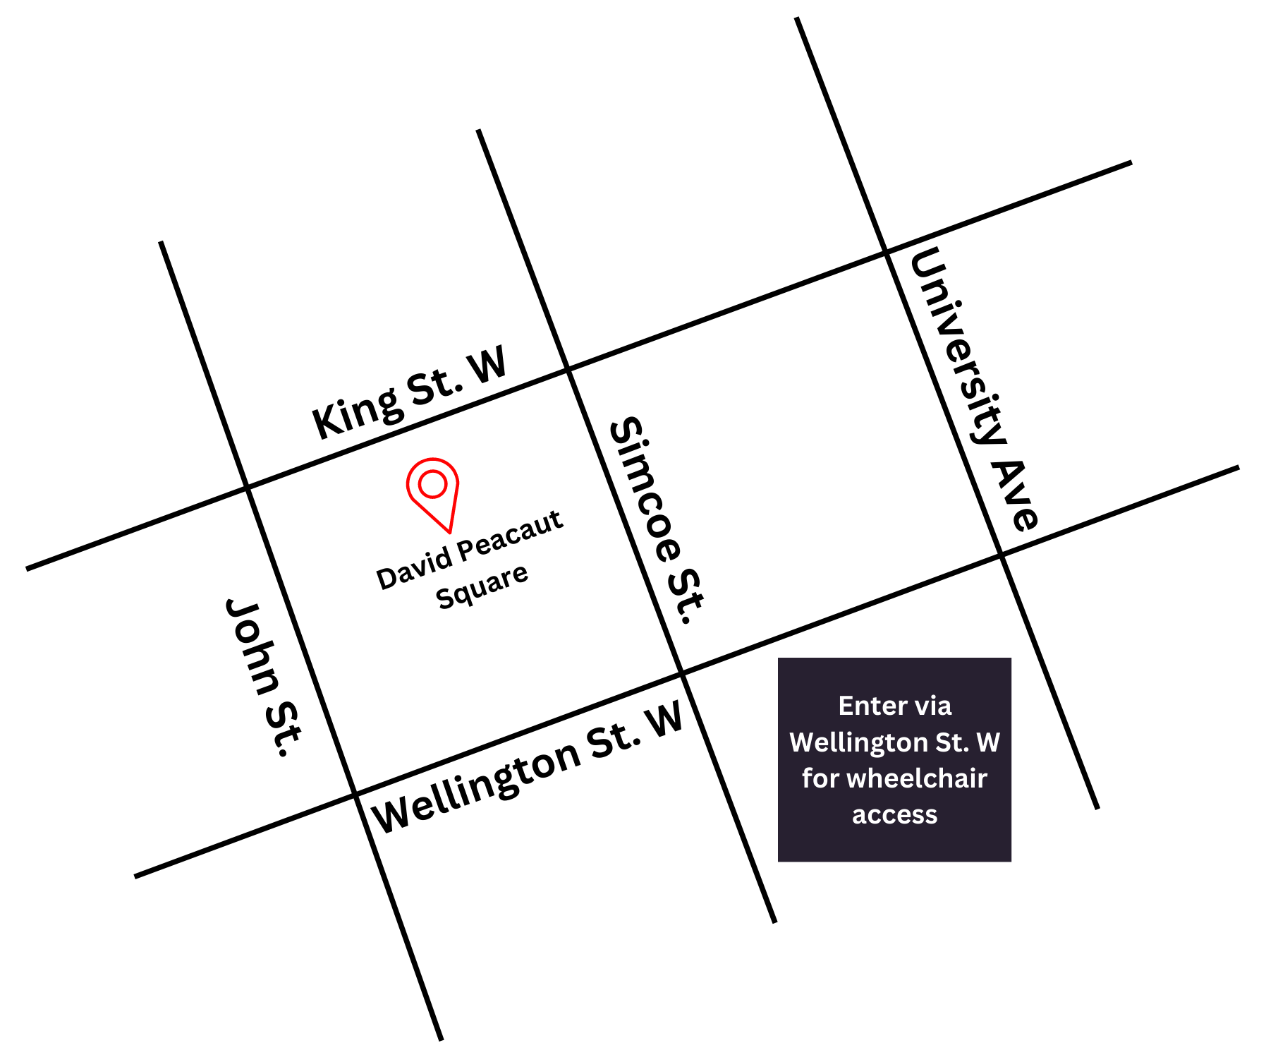
Figure 1: A Map of downtown Toronto with David Pecaut Square in between King St. W. and John St., and King St. W. and Simcoe St.

General information
- There is one open air cinema screen at this venue with a capacity of 250 general admission.
- All screenings are free.

Routes of arrival
Subway
David Pecaut Square is located next to St. Andrew subway station on Line 1. It is beside Roy Thomson Hall. It is a 210 m or 3-minute walk from the subway.
Streetcar or bus
The King streetcar (Route 504) stops at the corner of King Street & University Street. It is a 300 m or 4-minute walk from the streetcar.
GO Transit or Via Rail
David Peacaut Square is a 1.2 km or 15-minute walk from Union Station. It can also be reached by subway (one stop from Union Station to St. Andrew).
Driving
There is accessible parking available at the rear of Roy Thomson Hall via Wellington Street. There are 23 spots available in the surface parking lot, and 6 parking spots in the underground parking lot.

The entrance and seating

- This area is an outdoor venue; there is little to no protection from the elements.
- This area is on ground level with grass and can be best accessed from Wellington St. W. for those with a wheelchair or other mobility needs.
- Lawn-style chairs are available as seating.
Figure 2: Photograph of OLG Cinema Park.

Accessibility services

All films screened at the OLG Cinema Park open air cinema will include open captions onscreen.

Washrooms
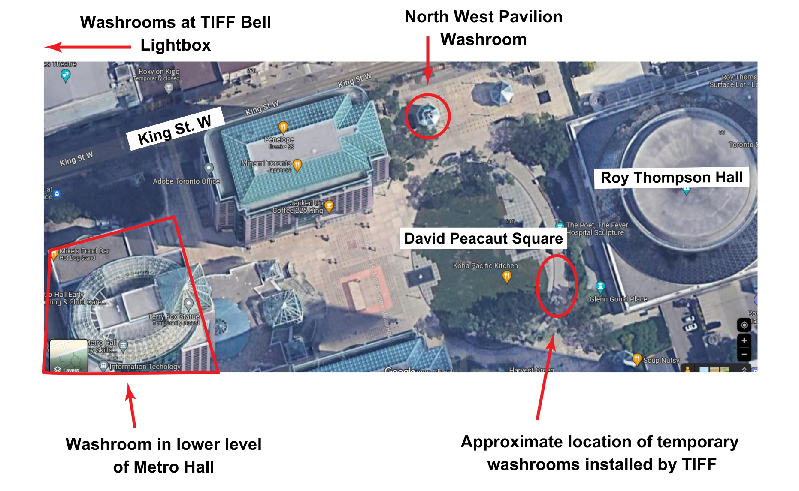
Figure 3: Aerial view of washrooms available near David Pecaut square. Arrows point to the Pavillion washroom near King St. W., and the temporary washrooms installed by TIFF in the square, Metro Hall, and TIFF Bell Lightbox

Washroom facilities are available at the following locations:

- Temporary mobile washroom on David Pecaut Square can be accessed by wheelchair or those with mobility considerations
- North West Pavilion
- Metro Hall (Lower Level) open daily between 7am–11pm (accessible stalls available)
- TIFF Bell Lightbox
- Please note if you exit any Fan Zones within the area, you may need to line back up to enter if capacity has been reached

