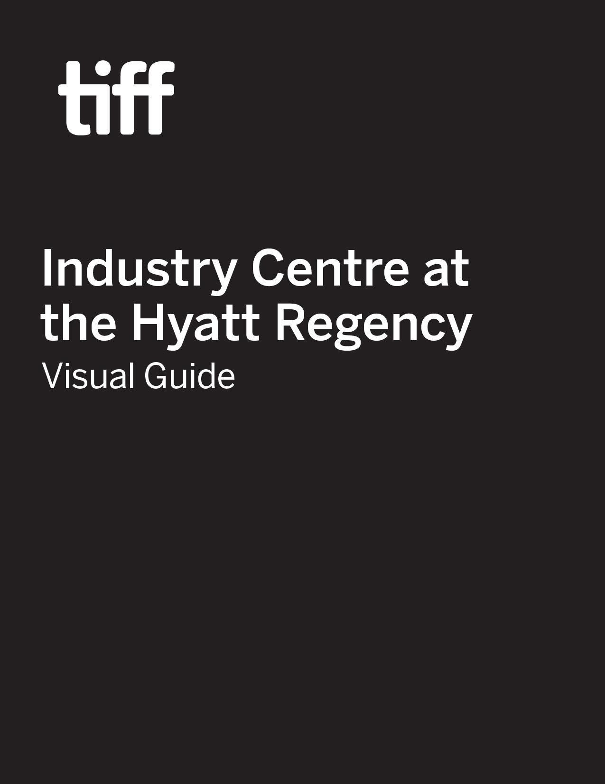

Industry Centre at the Hyatt Regency Visual Guide

Location
370 King Street West, Toronto, ON M5V 1J9
Closest intersection
King St. W. and Peter St. 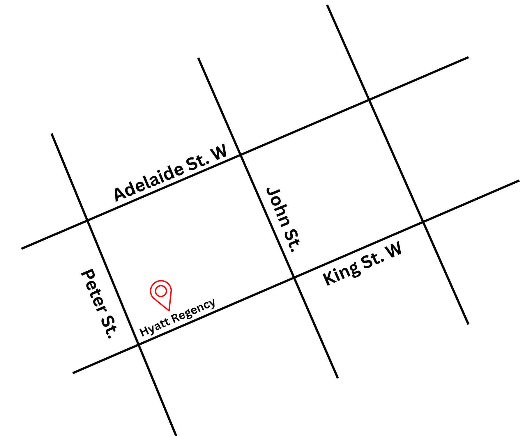
Figure 1: A map of downtown Toronto with the Hyatt Regency at King St. W. and Peter St., with Adelaide St. W. to
the north

General information
- Outside food and drink is permitted but discouraged
- Water stations located on Mezzanine level for attendees
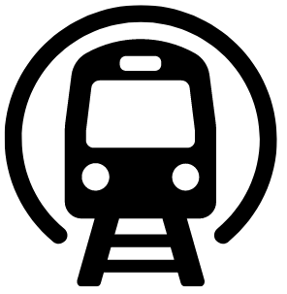
Routes of arrival
*Please see Festival Street closures
Subway
The Hyatt Regency is located nearest to St. Andrew subway station on Line 1. It is a 7-minute or 550 m walk from the subway.
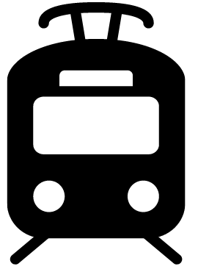
Streetcar or bus
From September 4th to September 7th, the King streetcar (Route 504) stops at the corner of King Street & University Ave., or the corner of King St. and Spadina Ave. It is diverted to Adelaide between these stops during those dates. From September 8th onwards, the King streetcar (Route 504) stops at the corner of King St. and John St., in front of TIFF Lightbox. It is a 2-minute walk from this stop.
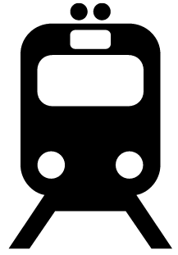
GO Transit or VIA Rail

It is a 19-minute or 1.4 km walk via the PATH from Union Station.
Driving
Underground paid parking available at GoPark, 5 Widmer St. There is an elevator in the parking garage to street level near King St. W. and John St.

The entrance and lobby
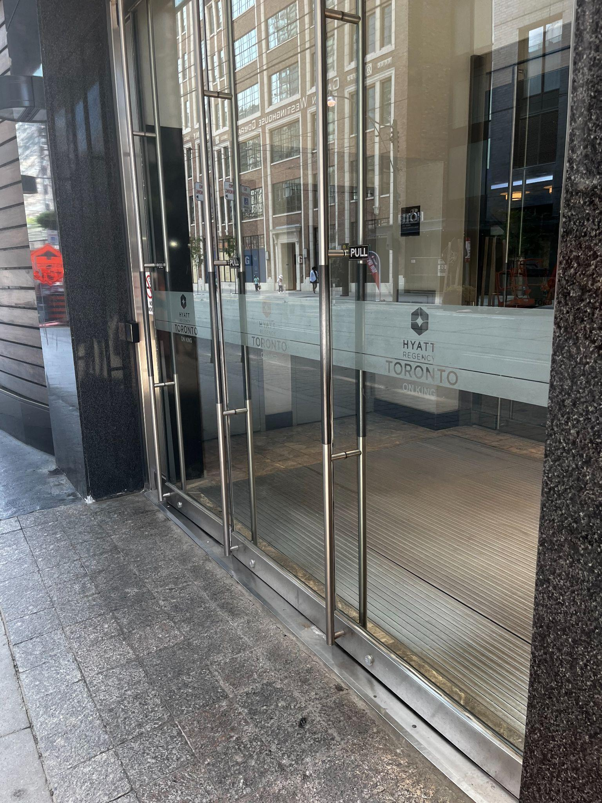
Figure 2: A photograph of the entrance along King St. W.
- To access the main hotel lobby there is a set of steps, but there is also an elevator to the left of the stairs for those with accessibility needs
  - The Hyatt recommends the roundabout entrance on Widmer St. for those with mobility devices or accessibility needs
  - Please note: vehicles frequent the Widmer St. entrance.
The ground surface is made up of uneven concrete tiling, and the incline to the entrance may be steep for those in a manual wheelchair
- There are currently no tactile colour-contrast cane detection tiles or truncated domes at the entrance or drop-off areas.

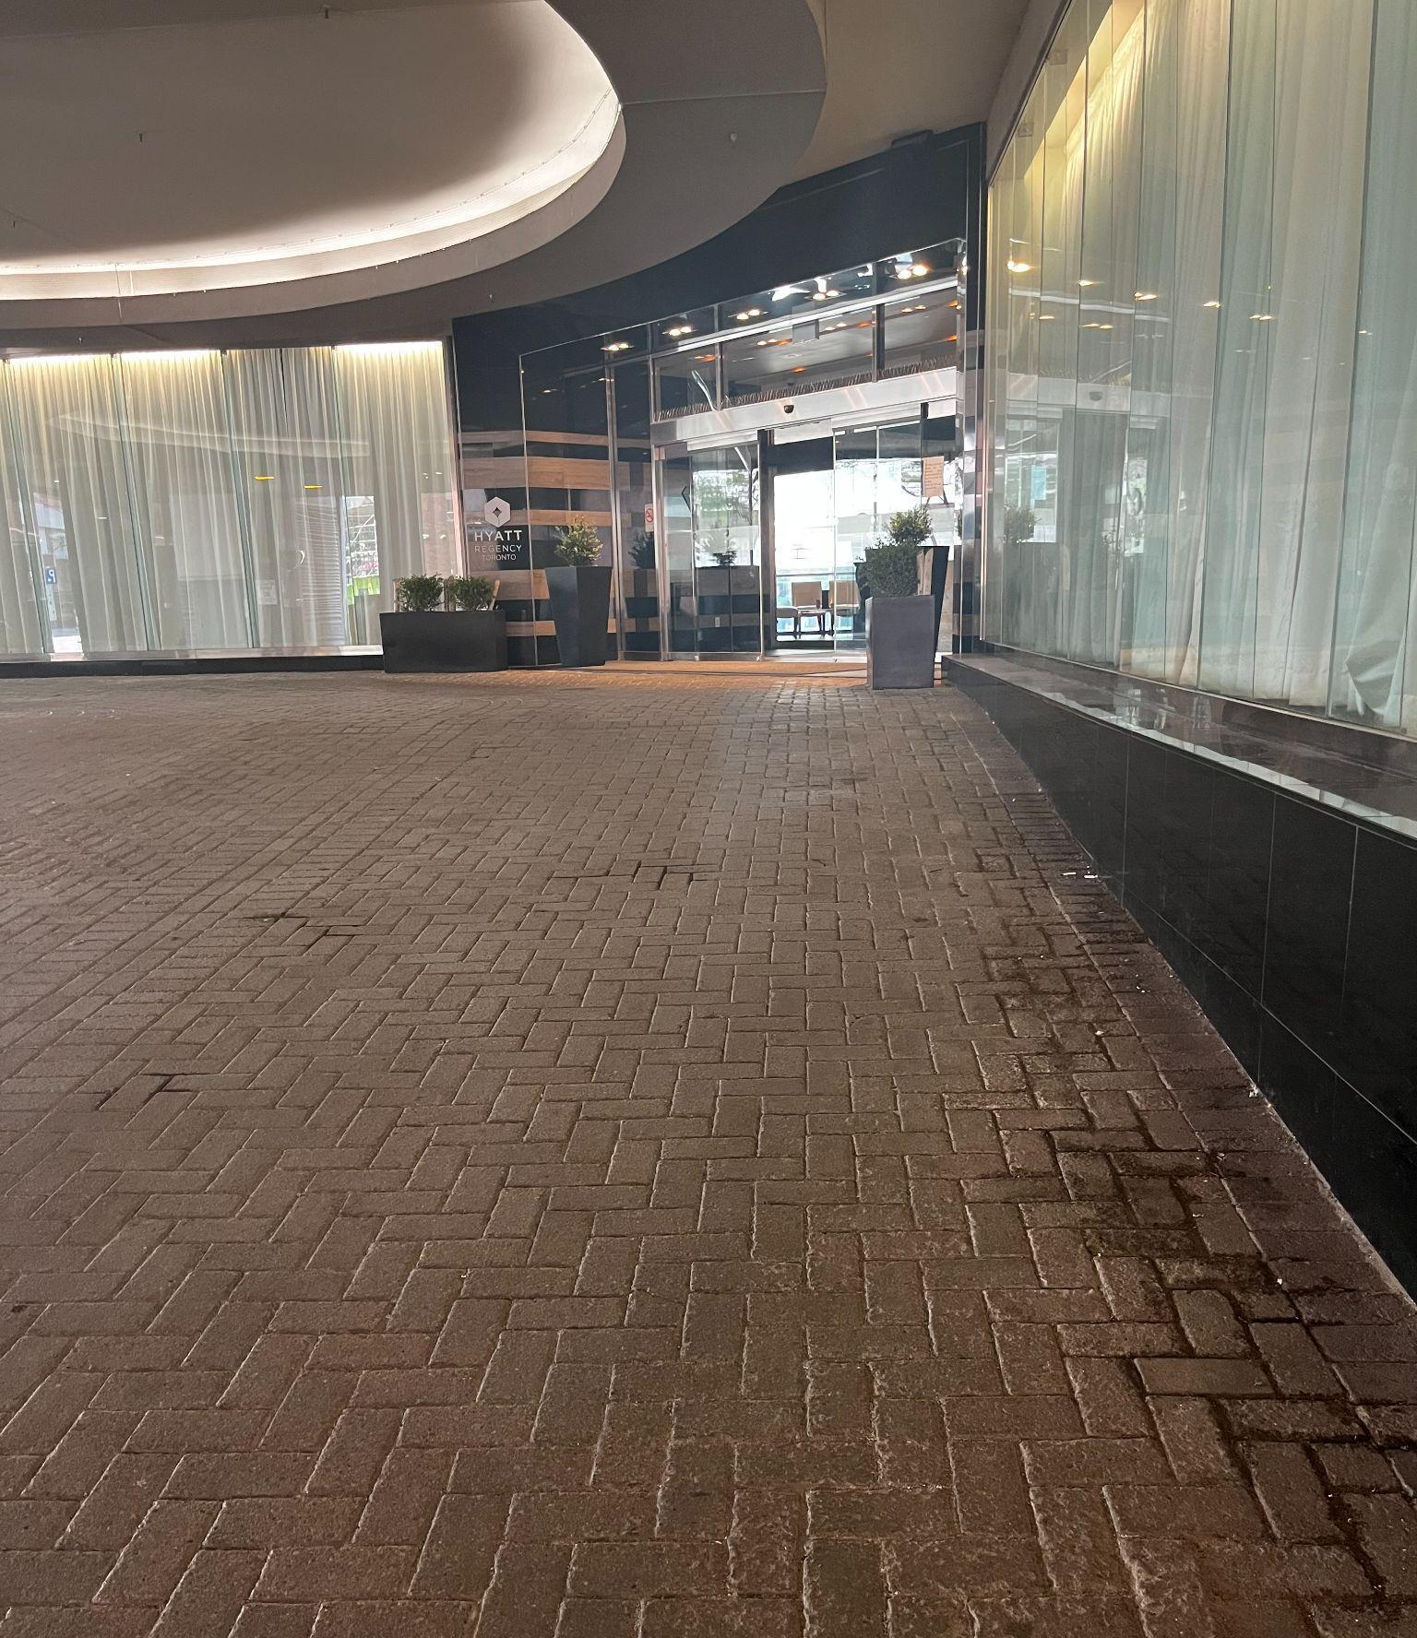
Figure 3: A photograph of the entrance ramp along Widmer St.
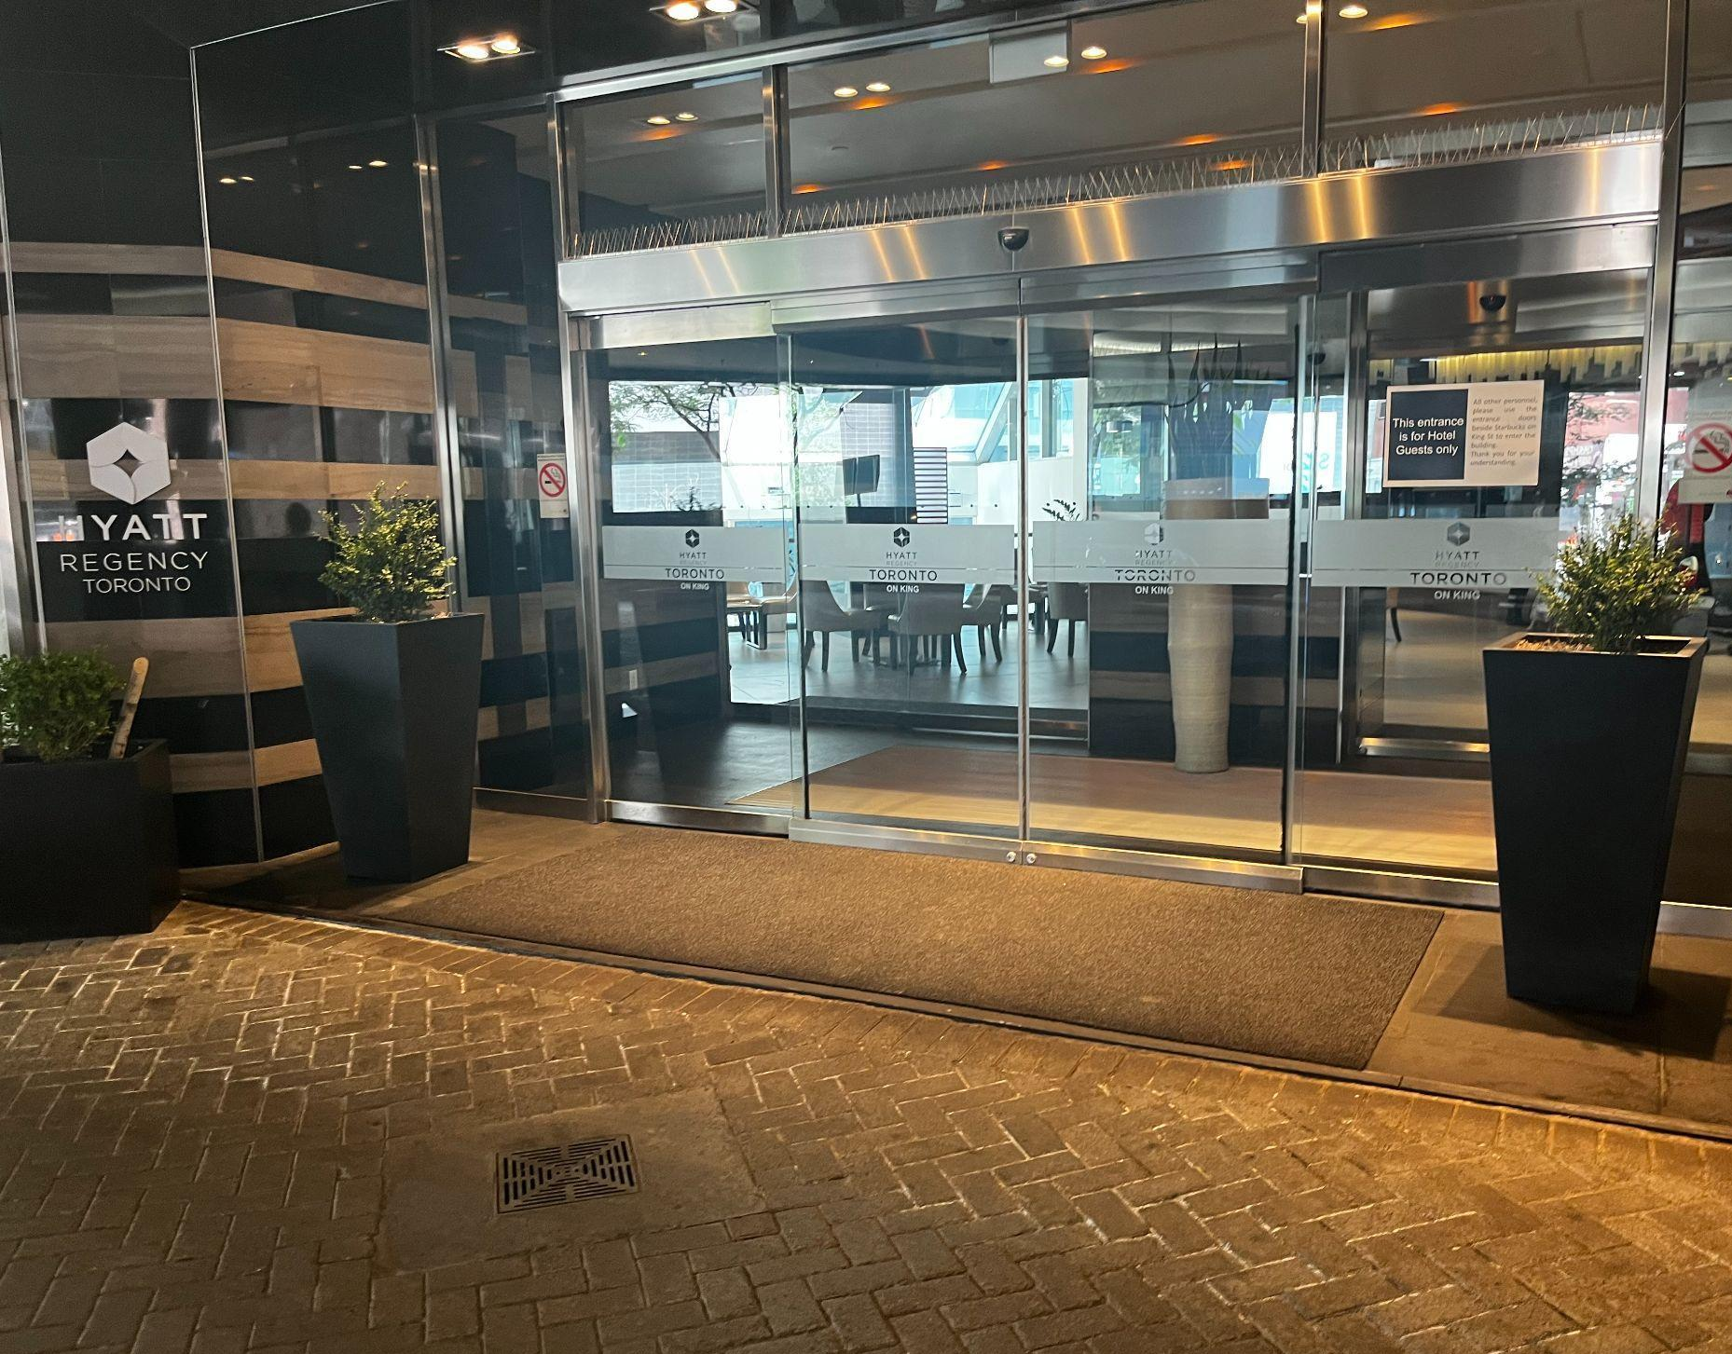
Figure 4: A photograph of the sliding door on Widmer St.

Access to ballrooms
- There are escalators up to Mezzanine Floor and Stairs to Lower Level
  - The stairs are in between the escalators, to the left when facing the entrance moves downward, and to the right when facing the entrance moves upward
  - There are elevators available to access both floors
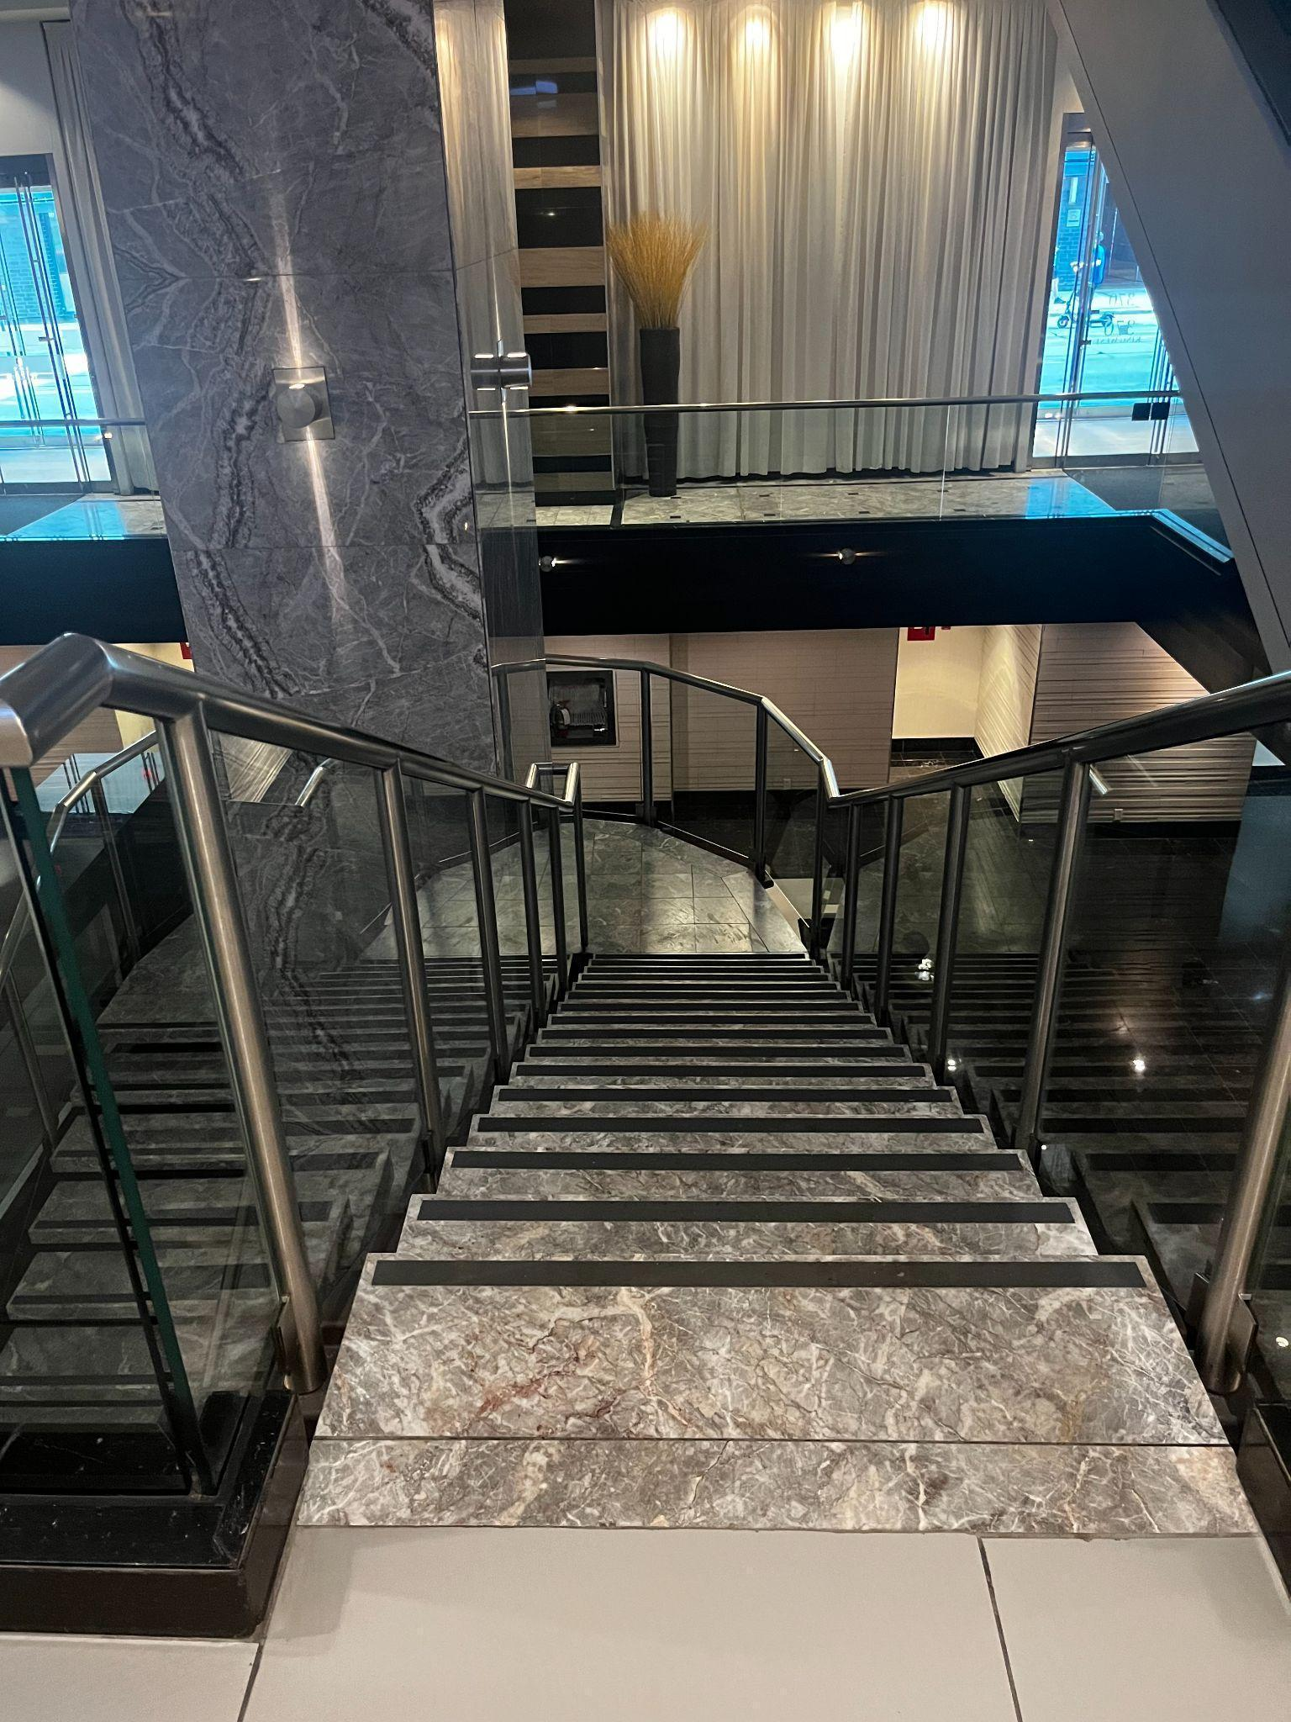
Figure 5: A photograph of stairs leading to the lower level.
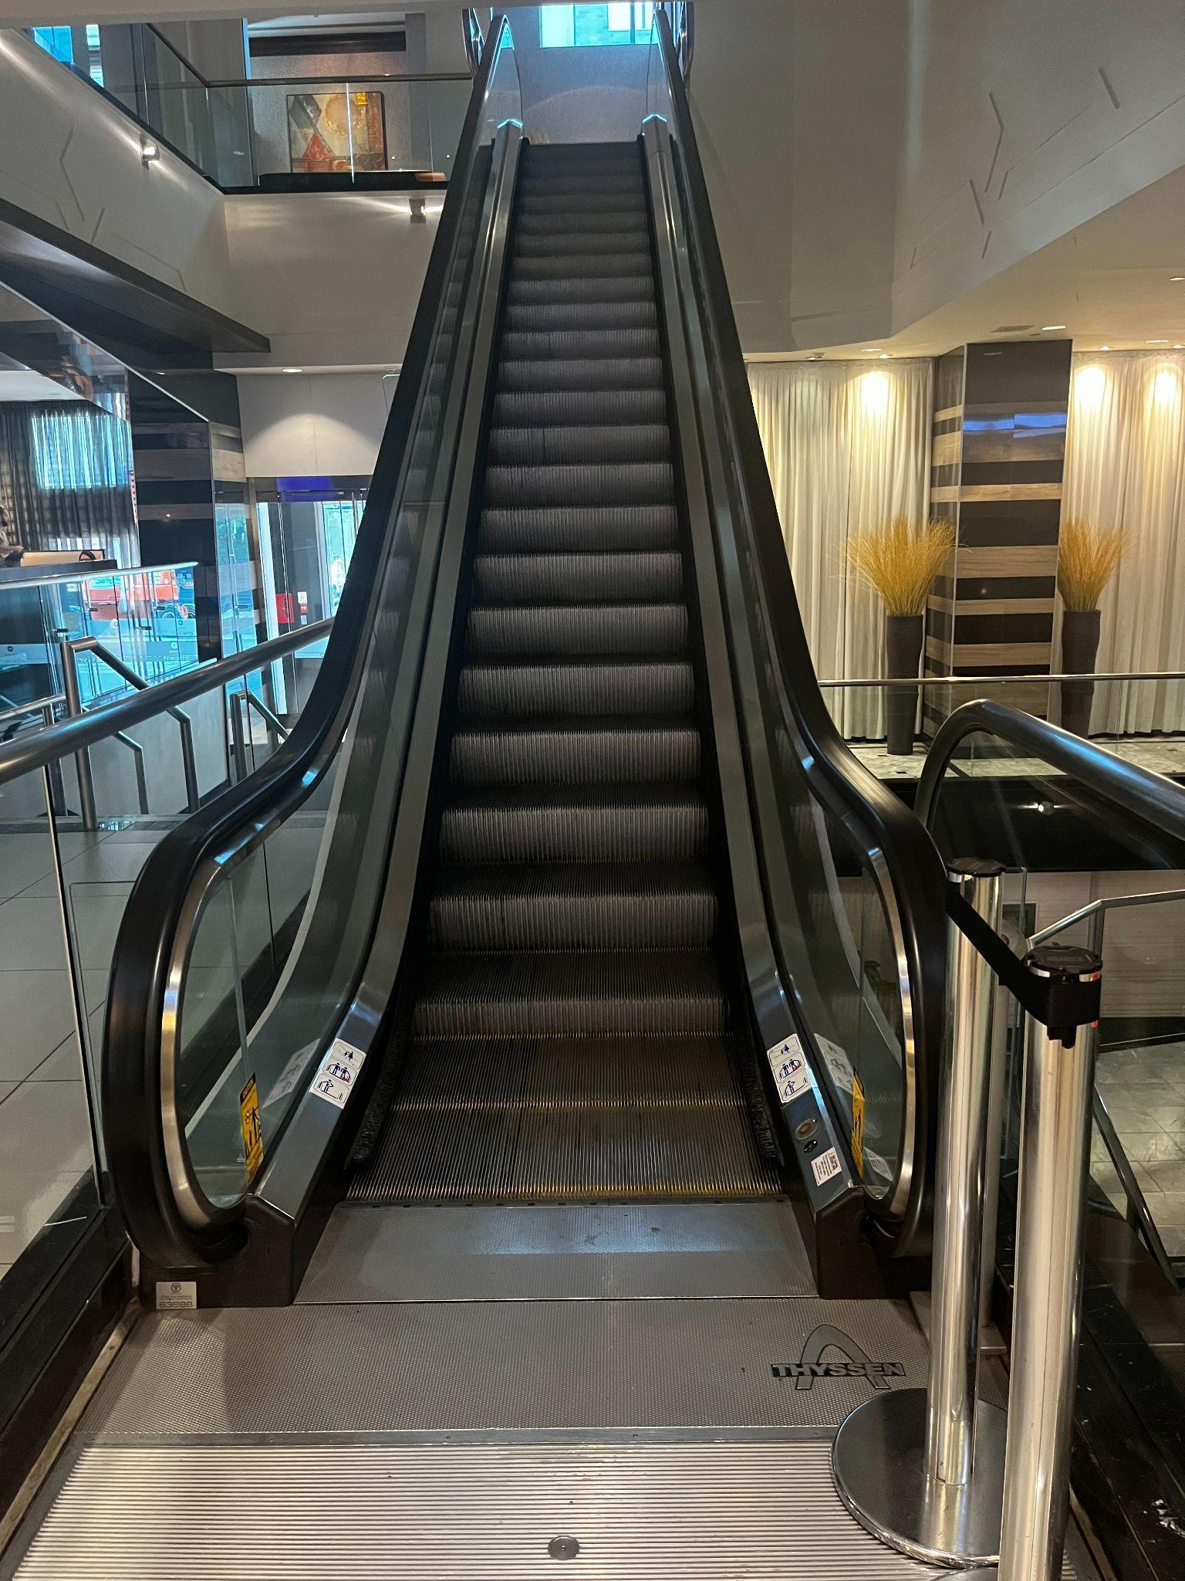
Figure 6: A photograph of escalators.
- Rooms used include Regency & King Ballrooms (Mezzanine Level) and Conference Centre rooms and Family Room (Lower Level)
  - Seating areas available in both ballrooms

Accessibility services and devices available
On a first come, first served basis and upon request:
- FM Systems
- Pocket Talkers (personal sound amplifier)
- Raised Seating Platforms
- Walkers
- Walking Canes
- Wheelchairs

Washrooms
- Accessible washrooms are located on Lower, Ground, and Mezzanine levels of the hotel

Mezzanine accessible washroom
Gender neutral | Yes | Single Washroom
Sensored flushing | No
Sensored faucets | No
Automatic soap dispensers | No
Sensored hand dryer or paper towel | Yes
Change tables | Yes
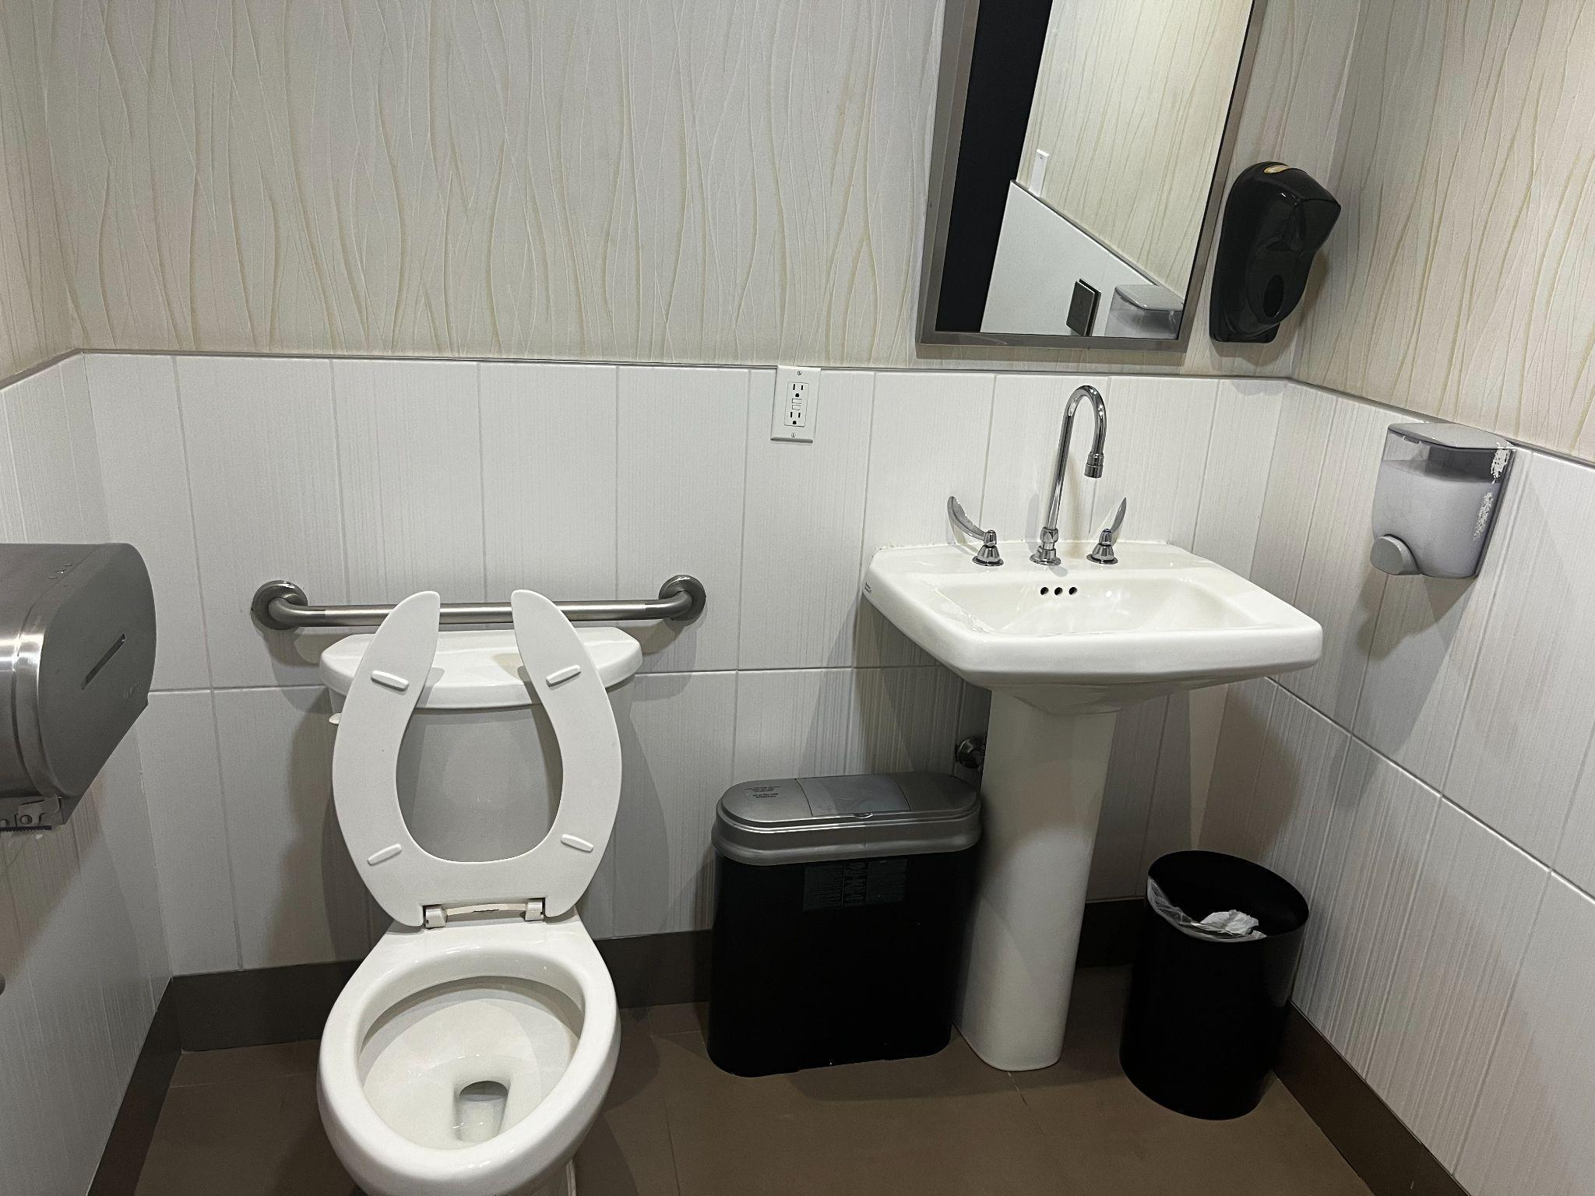
Figure 6: A photograph of the mezzanine accessible washroom at the Hyatt Regency.
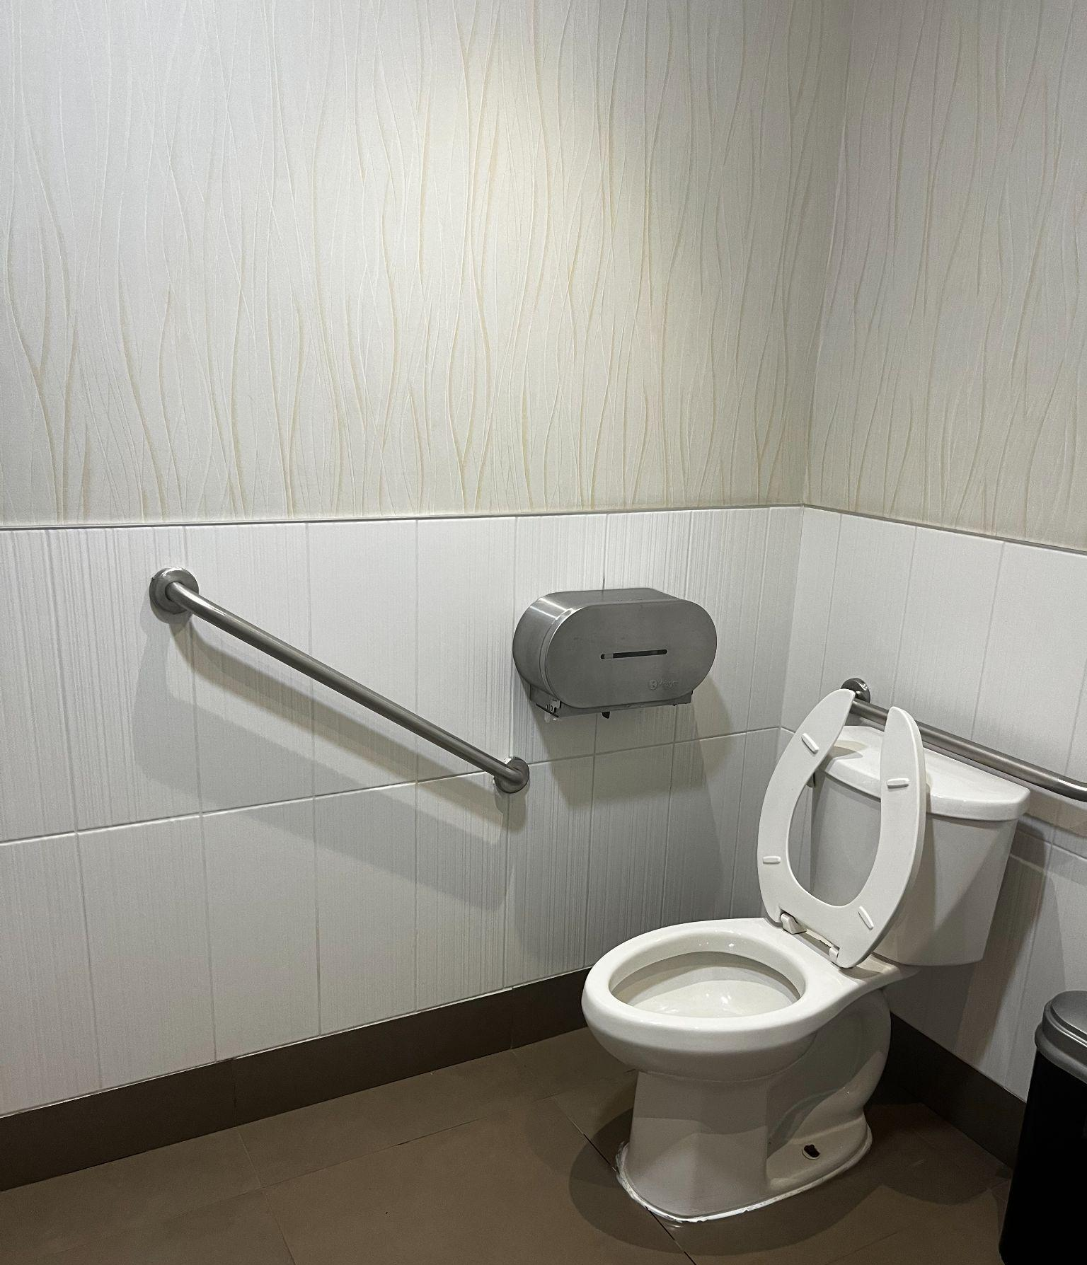
Figure 7: A photograph of the secondary angle of the mezzanine accessible washroom at the Hyatt. There is a toilet to the left and sink to the right

Mezzanine washrooms
Gender neutral | No
Sensored flushing | Yes
Sensored faucets | Yes
Automatic soap dispensers | Yes
Sensored hand dryer or paper towel | Yes
Change tables | Partial, see notes | Change table in accessible washroom and in Family Room on Lower Level

