TIFF Bell Lightbox Visual Guide

Location
350 King Street West, Toronto, ON M5V 3X5

Closest intersection
King St. and John St.
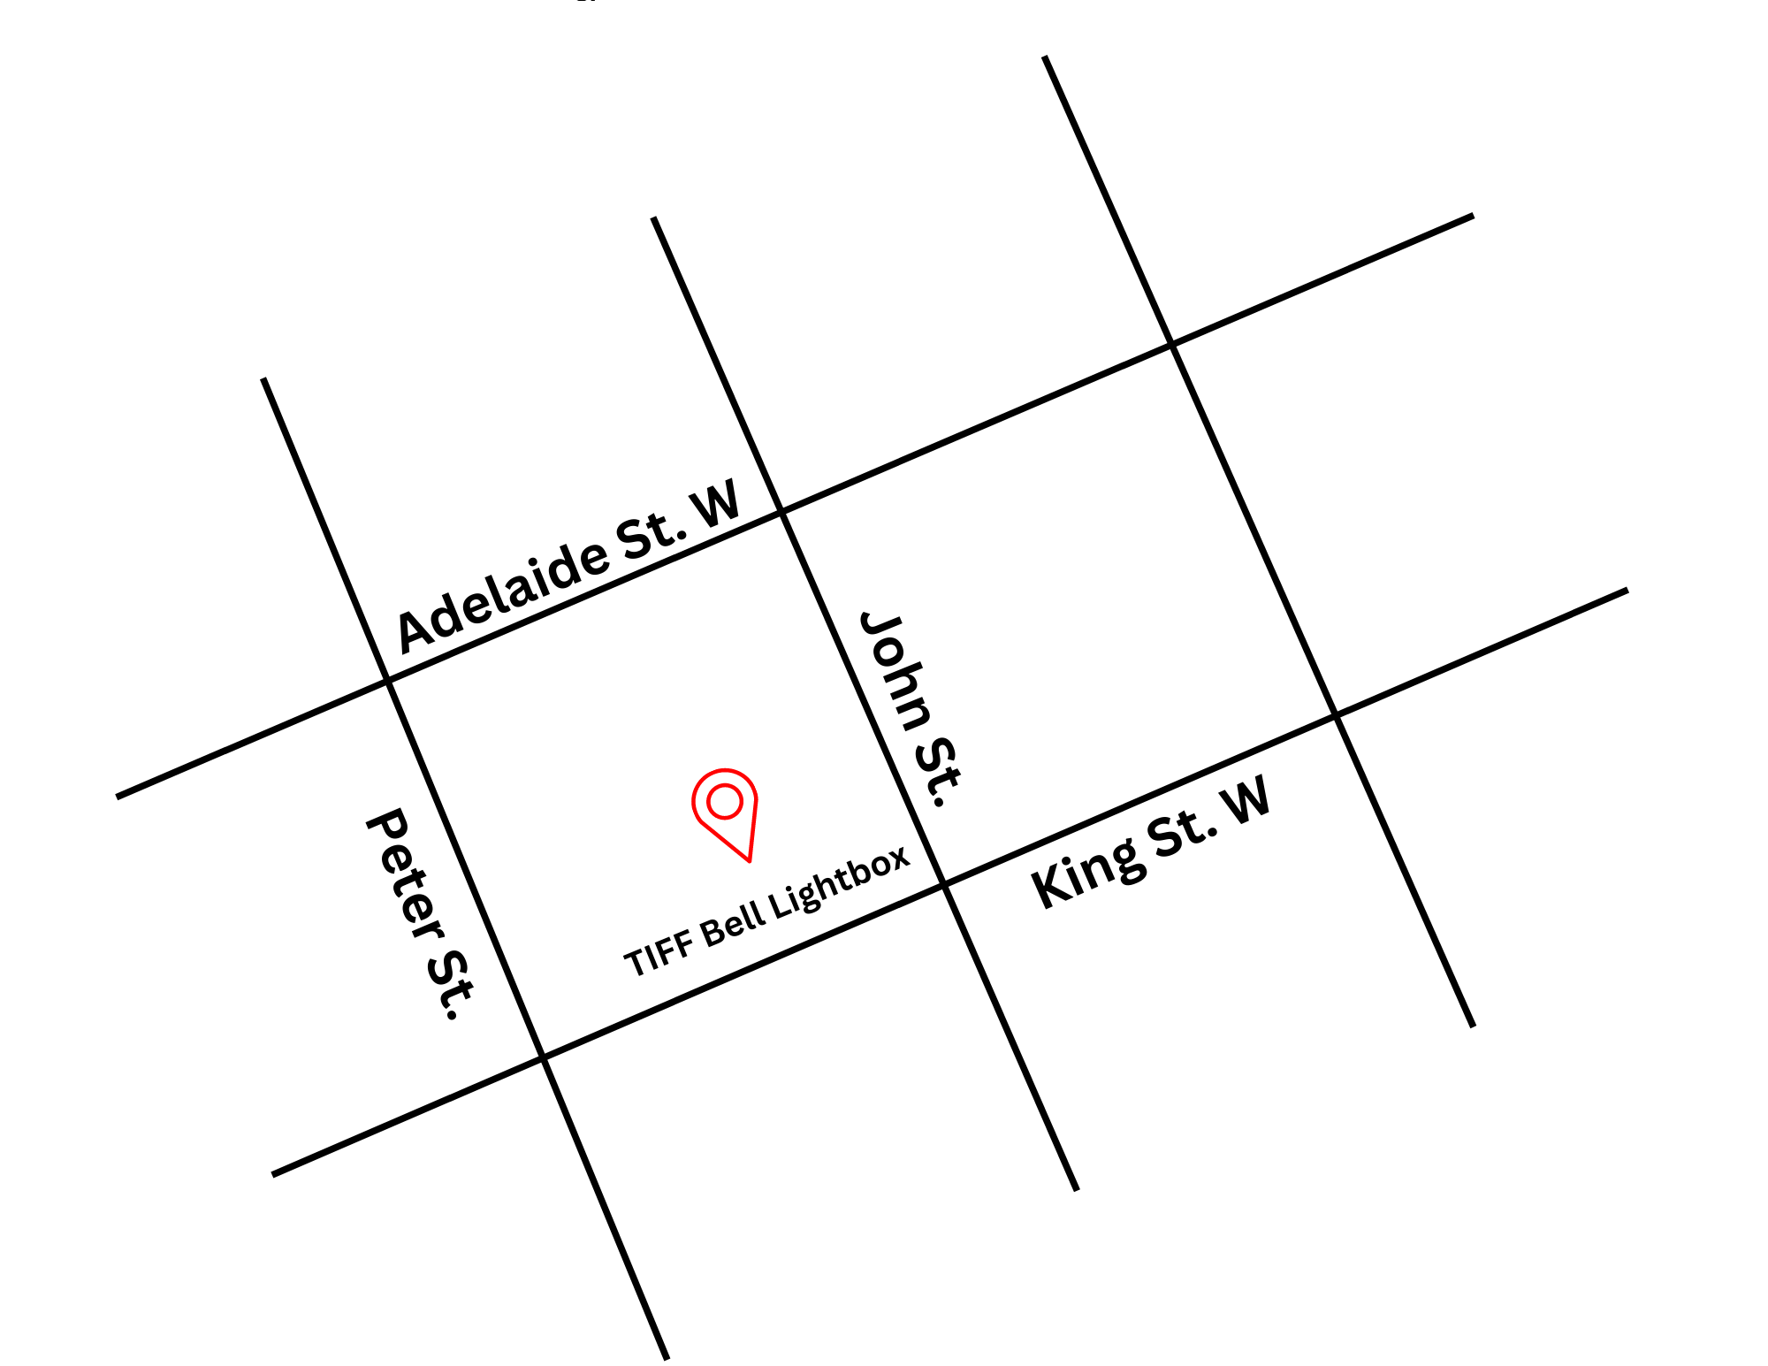
Figure 1: A Map of downtown Toronto with TIFF Bell Lightbox between John St. and Peter St. to the West and East and Adelaide St. W. and King St. W. to the North and South.

General information
- This venue is general admission

Routes of arrival
*Please see Festival Street closures
Subway
TIFF Bell Lightbox is closest to the St. Andrew subway station on Line 1. TIFF is a 450 m or 6-minute walk from the subway.
Streetcar or bus
Take the King streetcar (Route 504). The closest stop is John St. This will place you directly in front of TIFF Bell Lightbox.
GO Transit or Via Rail
TIFF Bell Lightbox is a 550 m or 15-minute walk from Union Station. It can also be reached by subway (one stop from Union Station to St. Andrew).
Driving
Paid underground parking is available at TBLB, but it is not operated by TIFF.

Reitman Square parking
- Precise ParkLink runs the underground parking at TBLB
    - Note: P2 is not available from the elevator. It must be accessed from P1 or P3, then by walking up/down the ramp
    - Parking App Code: #1176

The Entrance and Lobby
- The front entrance to the TBLB is step-free.
- There is an overhang for protection from wind and rain.
- There are currently no tactile colour-contrast cane detection tiles or truncated domes at the entrance or drop-off areas.
- There is a small road ramp directly in front of the building.
- The entrance utilizes double automatic sliding doors

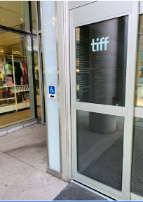
Figure 2: The door on the left side has a pressure sensitive plate for opening.

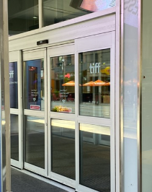
Figure 3: The larger doors on the right side have movement sensors which will automatically open for you.
Rush line
Located outside TIFF Bell Lightbox on the west side of the King Street entrance and extends towards Widmer Street.
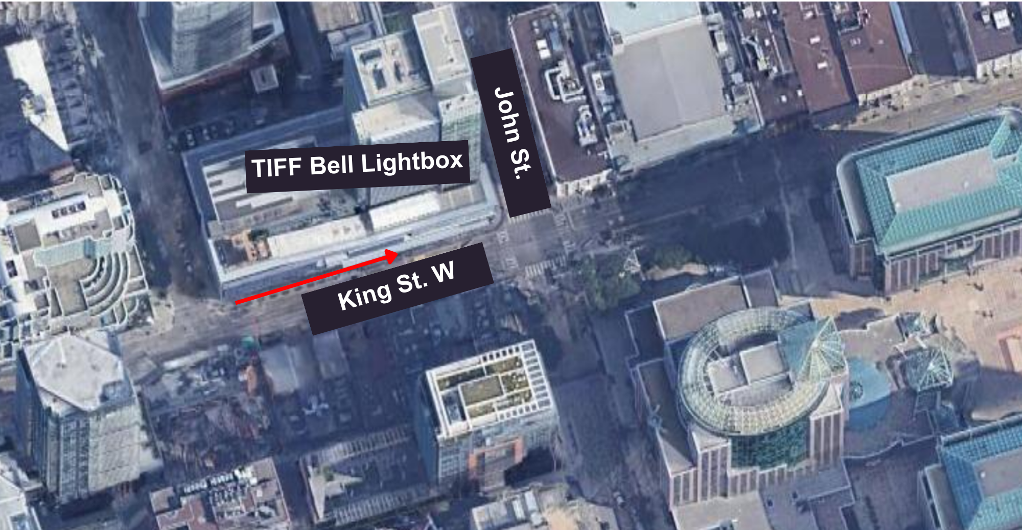
Figure 4: Map of TIFF Bell Lightbox rush line from an aerial view

Access to theatres and seating
- TIFF Bell Lightbox has two escalators leading up to and from the atrium lobby.
  - The escalator on the right side from the ground floor leads upwards to Cinemas 1–3.
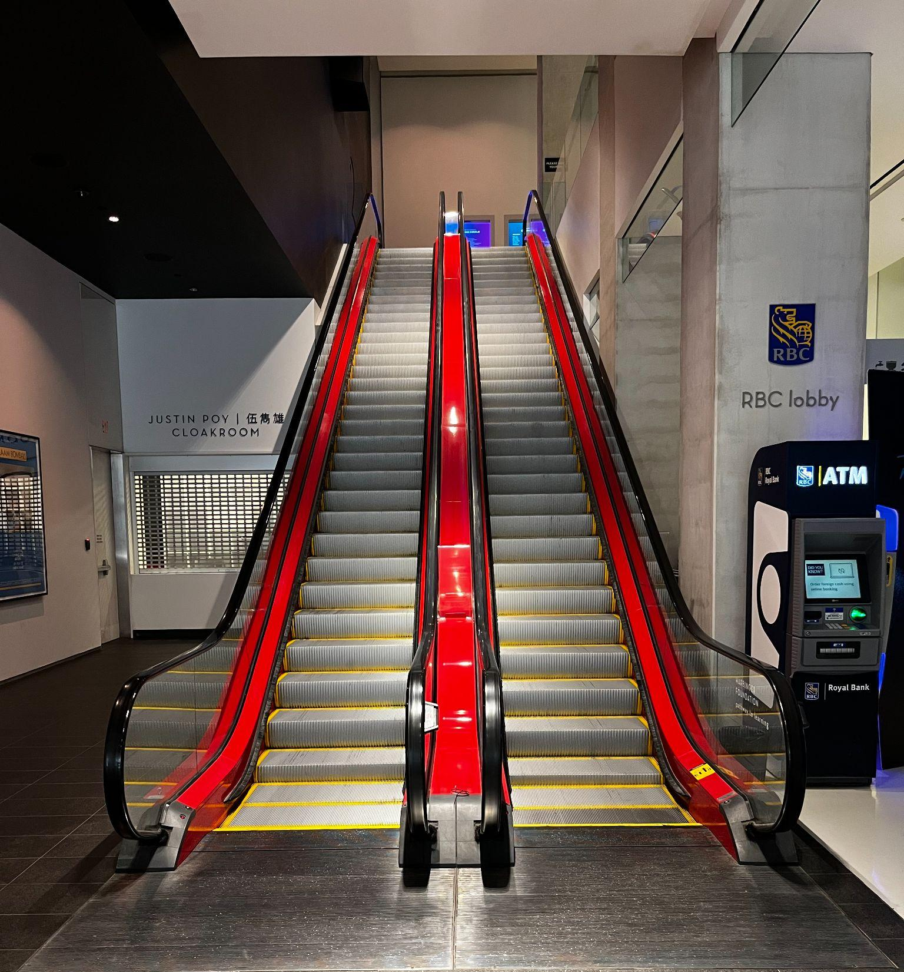
Figure 5: Photograph of the escalators in the front lobby of TIFF Bell Lightbox. The escalator to the right will allow you to move upwards to the second floor.

- There are 2 elevators located on the east side of the atrium beside the escalators. If you’re facing the escalators, it is a right turn to access the escalators.
  - Cinemas 4 and 5 on floor 3 can be accessed via elevator.
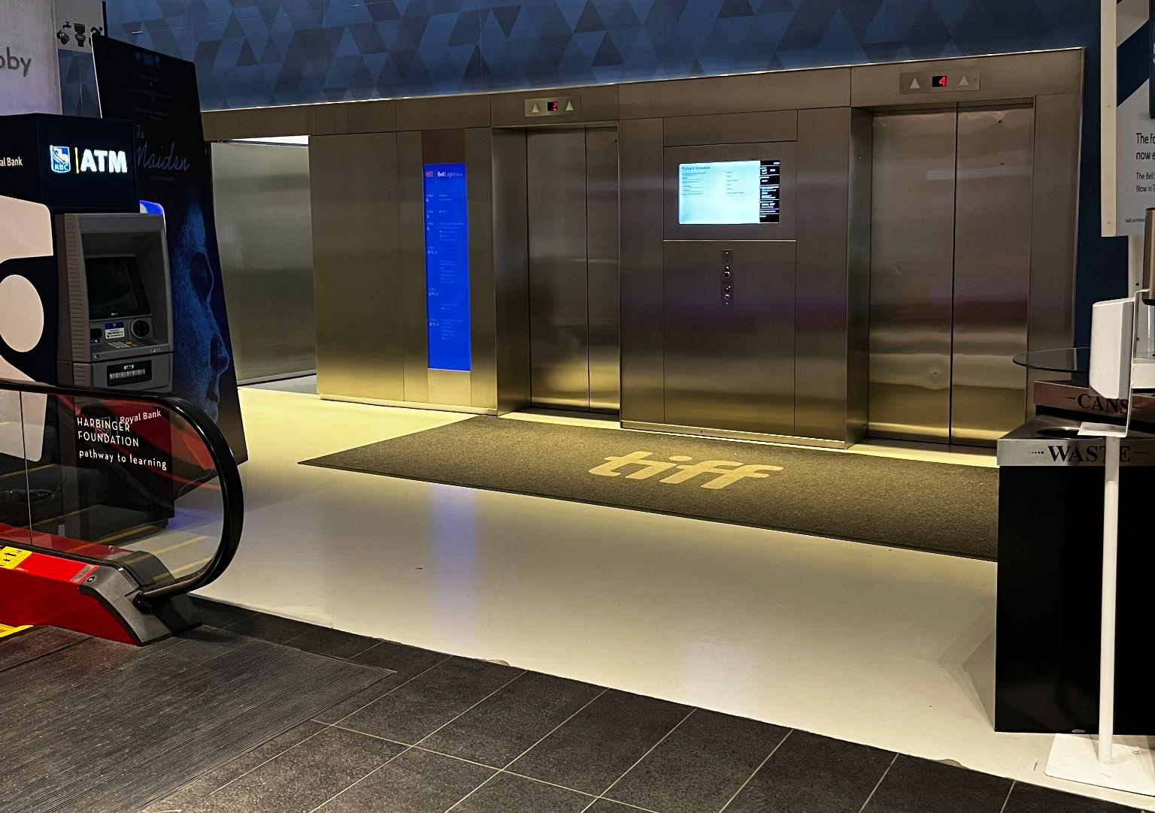
Figure 6: Photograph of the two metal elevators on the right side of the Atrium beside the escalators.
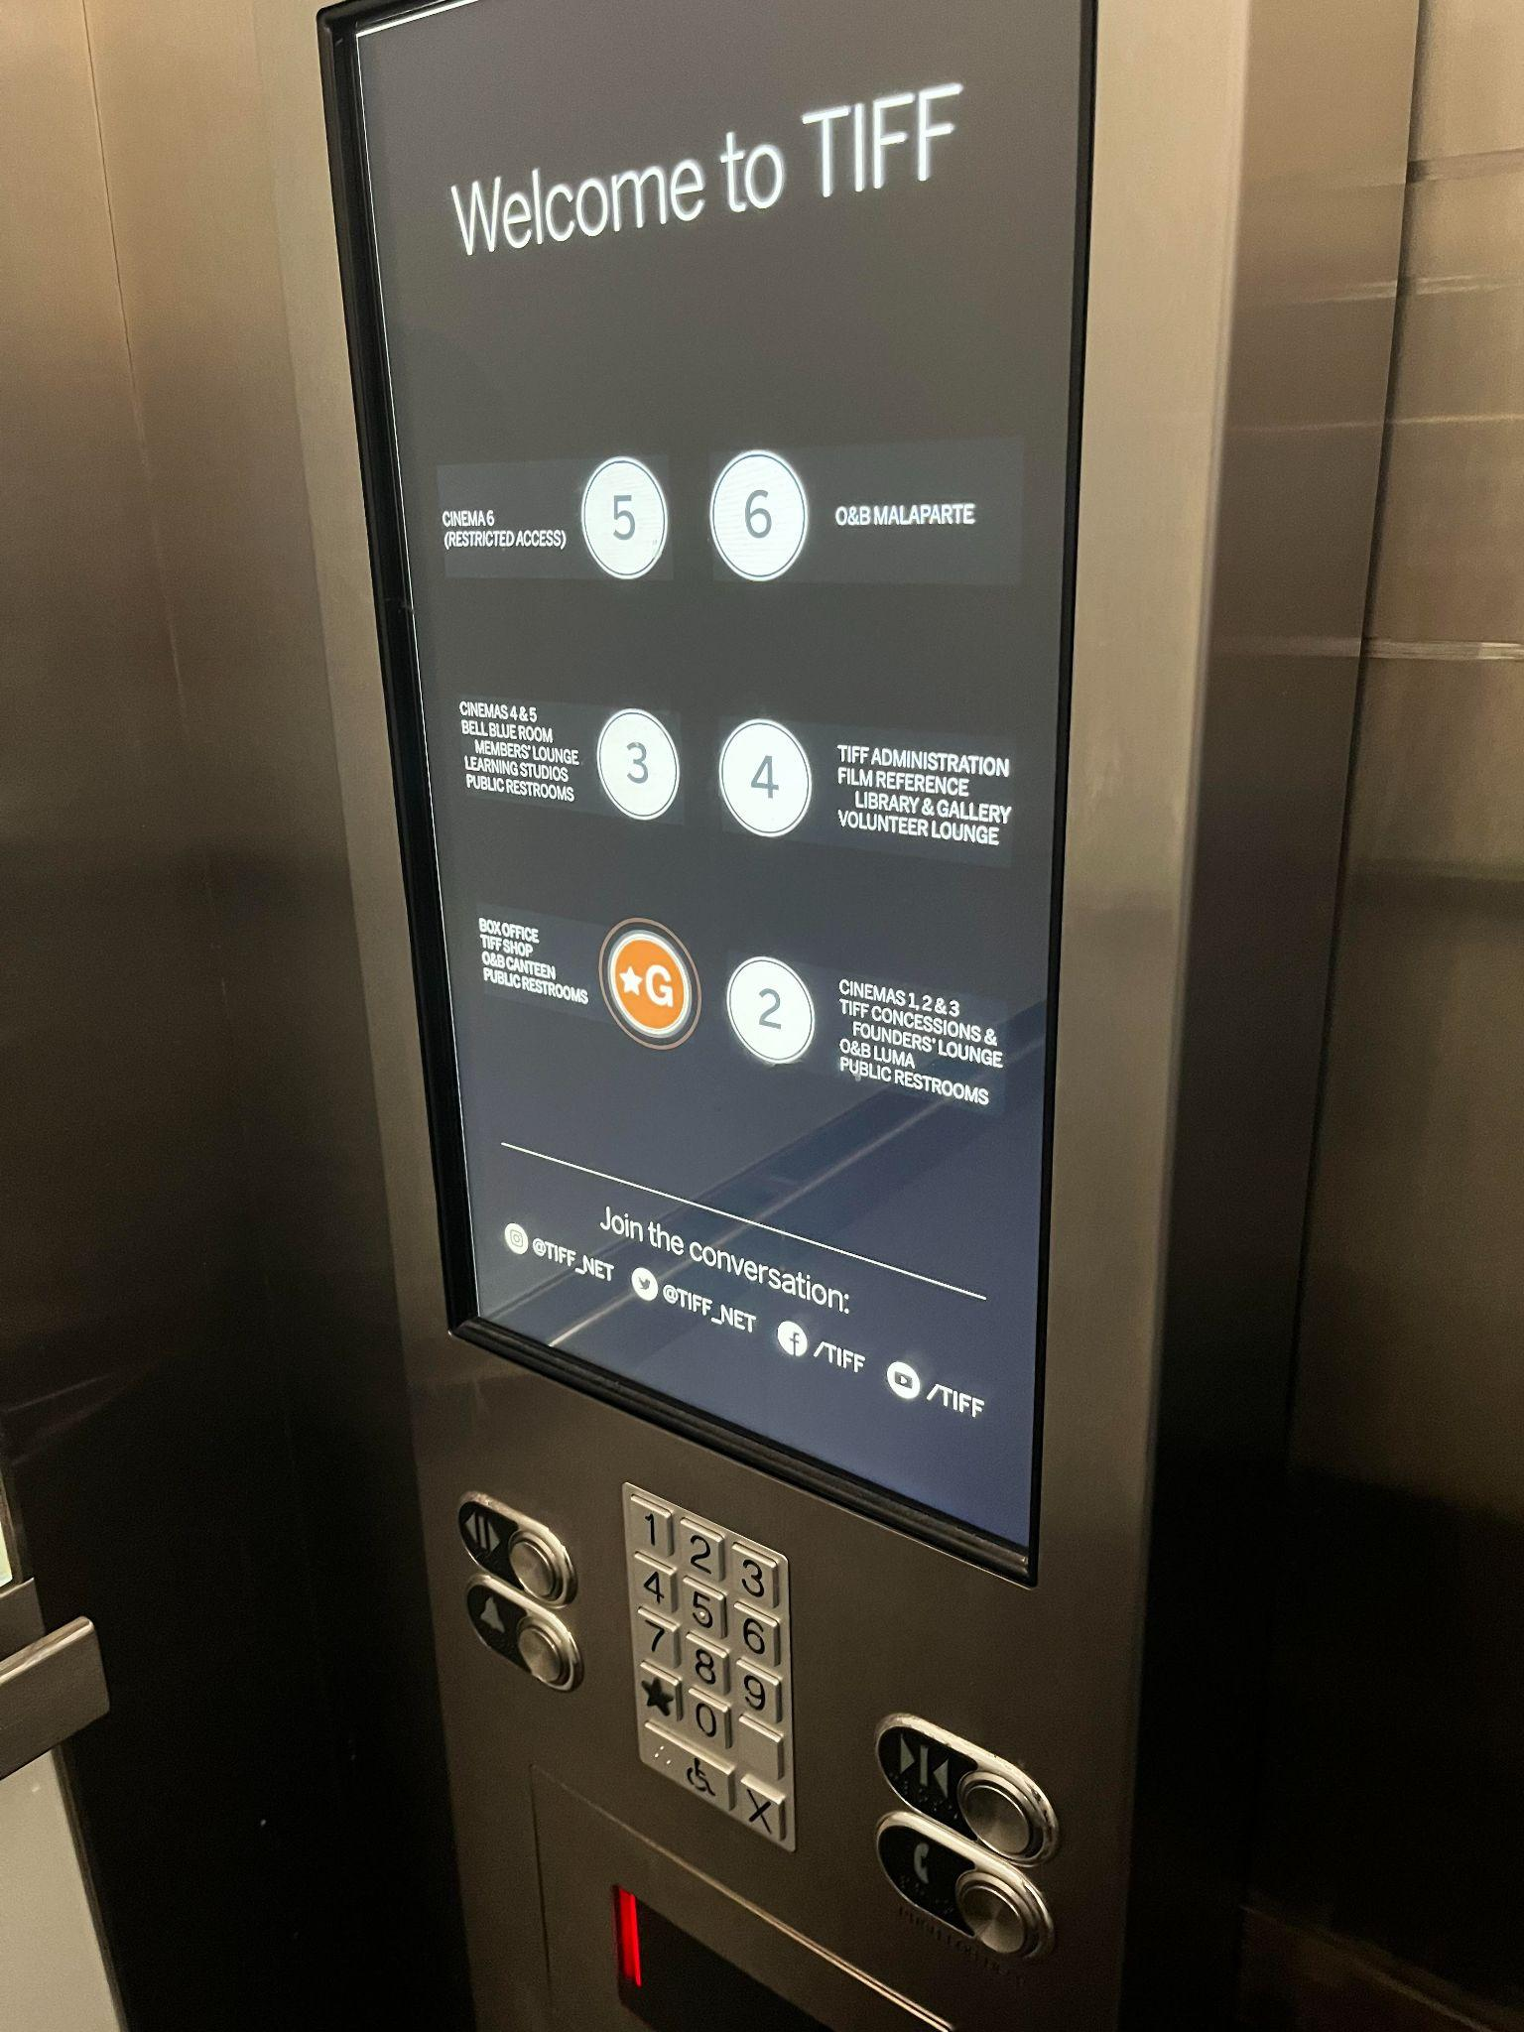
Figure 7: Photograph of elevator touchscreen and keypad underneath

- The elevator contains a touch screen to select a floor. The elevator will audibly announce once it has arrived at the floor selected.
  - There is a keypad underneath the touch screen that can also be used to select a floor.

- The 2nd floor utilizes both stairs and a ramp to access the concession stand and Cinemas 1–3.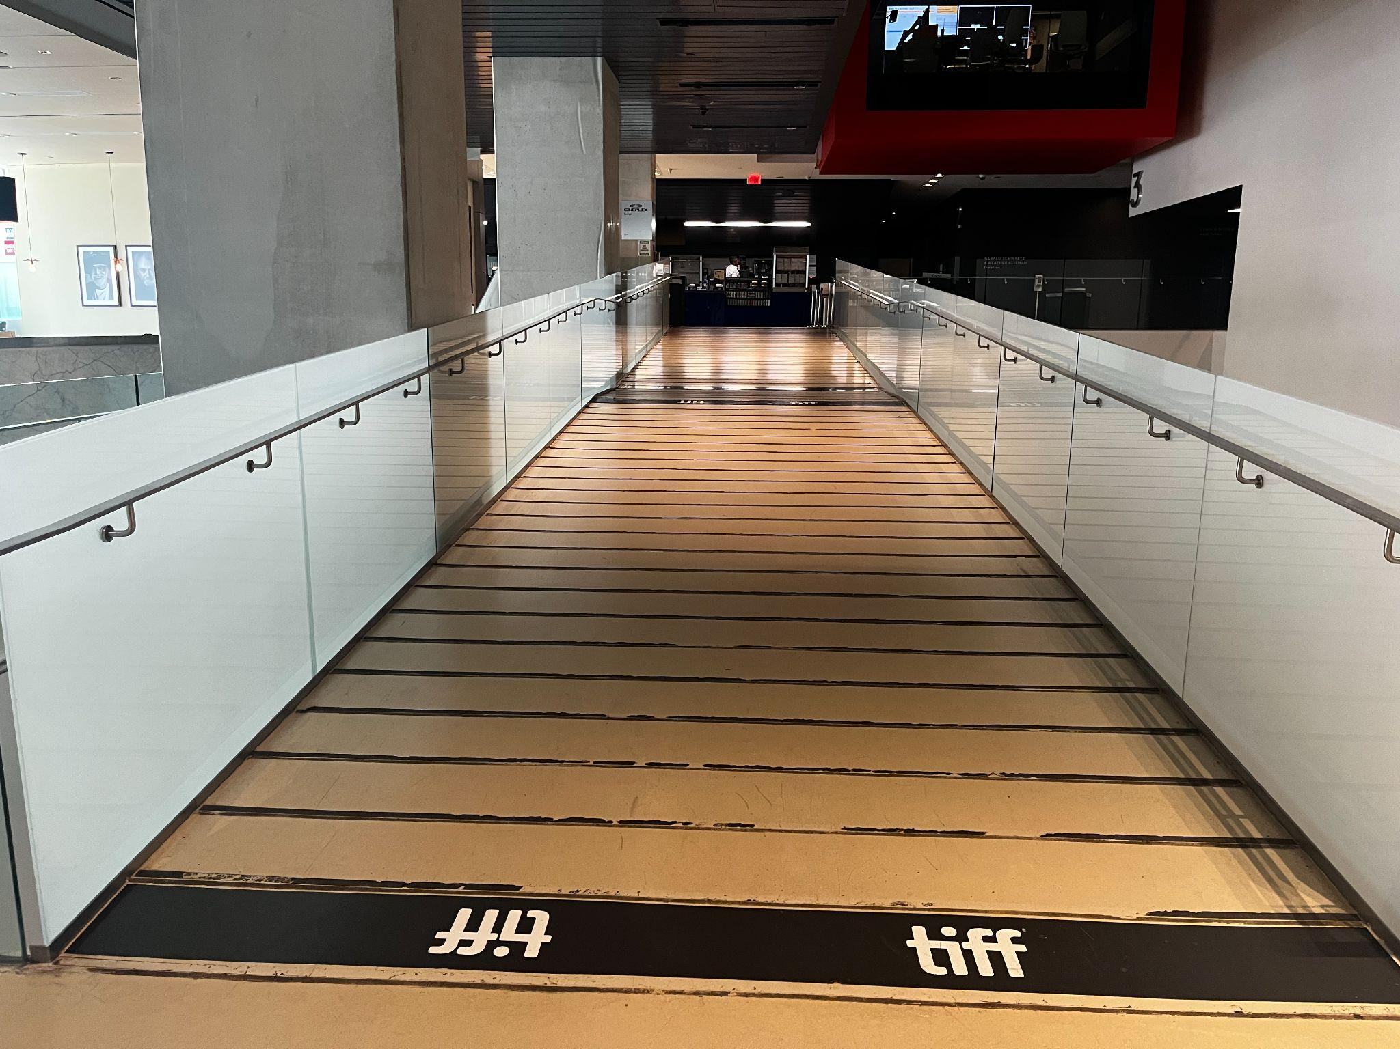
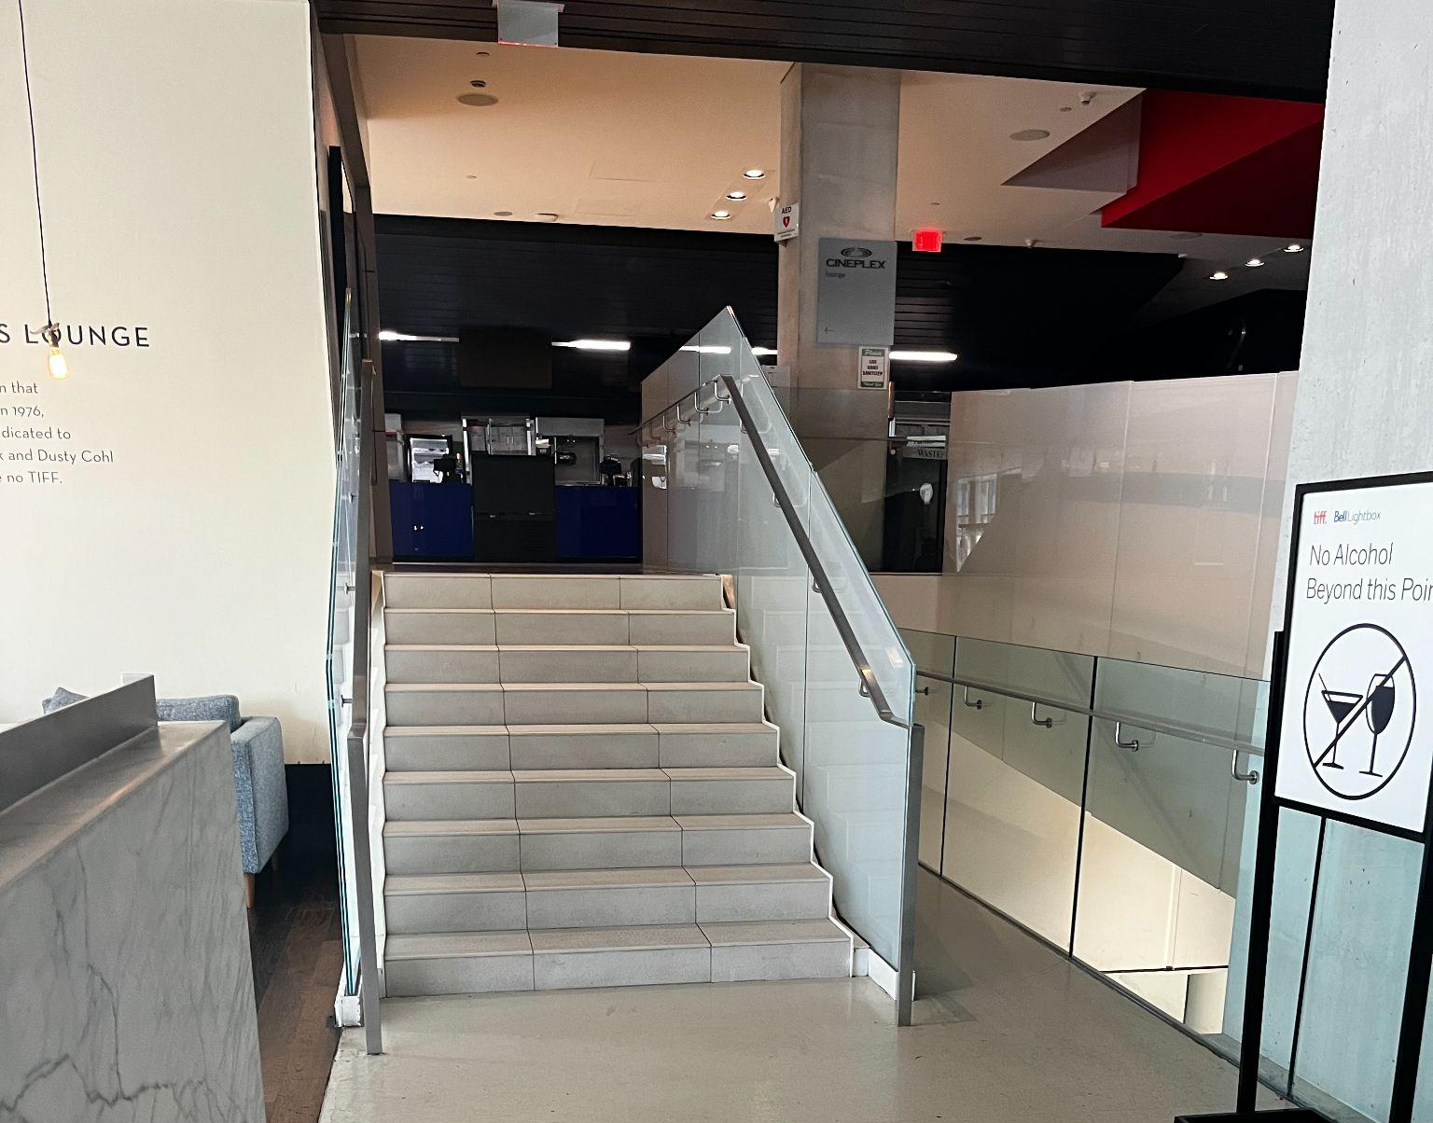
Figures 8 and 9: Photograph of ramp on second floor and stairs to the left of the ramp

Accessible seating options
- Accessible seat location:
an empty space for a mobility device (sold as 1 ticket)
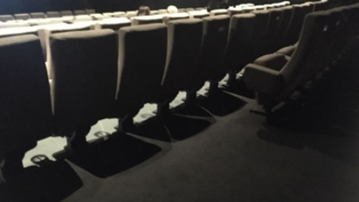
Figure 10: Example of accessible empty spaces
- Accessible jump seat:
this is a fold-up seat that can be flipped up to use as an empty space for a mobility device — these seats do not have arm rests
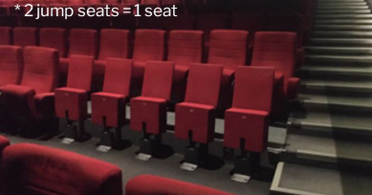
Figure 11: Example of jump seating found in cinemas

- Companion seat:
A typical cinema seat beside an accessible seat that is reserved for use by companions of those requiring accessibility accommodations
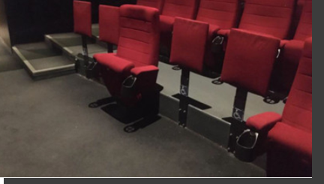
Figure 12: Example of companion seat location

Cinema 1*  522 seats | Accessible Seating  5 “Jump Seats”  and  4 accessible spaces that are empty | Companion Seating  3 seats | Step-Free  Row F
Cinema 2  352 seats | Accessible Seating  4 “Jump Seats” | Companion Seating  2 Seats | Row E
Cinema 3  225 seats | Accessible Seating  3 accessible spaces that are empty | Companion Seating  2 seats | Row A
Cinema 4  149 seats | Accessible Seating  3 accessible spaces that are empty | Companion Seating  1 Seat | N/A
Cinema 5  45 seats | Accessible Seating  2 accessible spaces that are empty | Companion Seating  N/A | Row A
Cinema 6 | Accessible Seating  2 accessible spaces that are empty | Companion Seating  N/A | Row A

*Cinema 1 – The balcony can be accessed by stairs or elevator

Assistive devices and services available
Closed Captions | Yes* | - Captiview  - No Closed Captions in cinemas 6 and 7
Assisted Listening | Yes | - Receiver with disposable earbud, limited neck loops available
Descriptive Sound | Yes* | - Receivers with disposable earbuds
*Closed Caption or Descriptive Sound are subject to content including a Closed Caption and/or Descriptive sound option

Concession stand
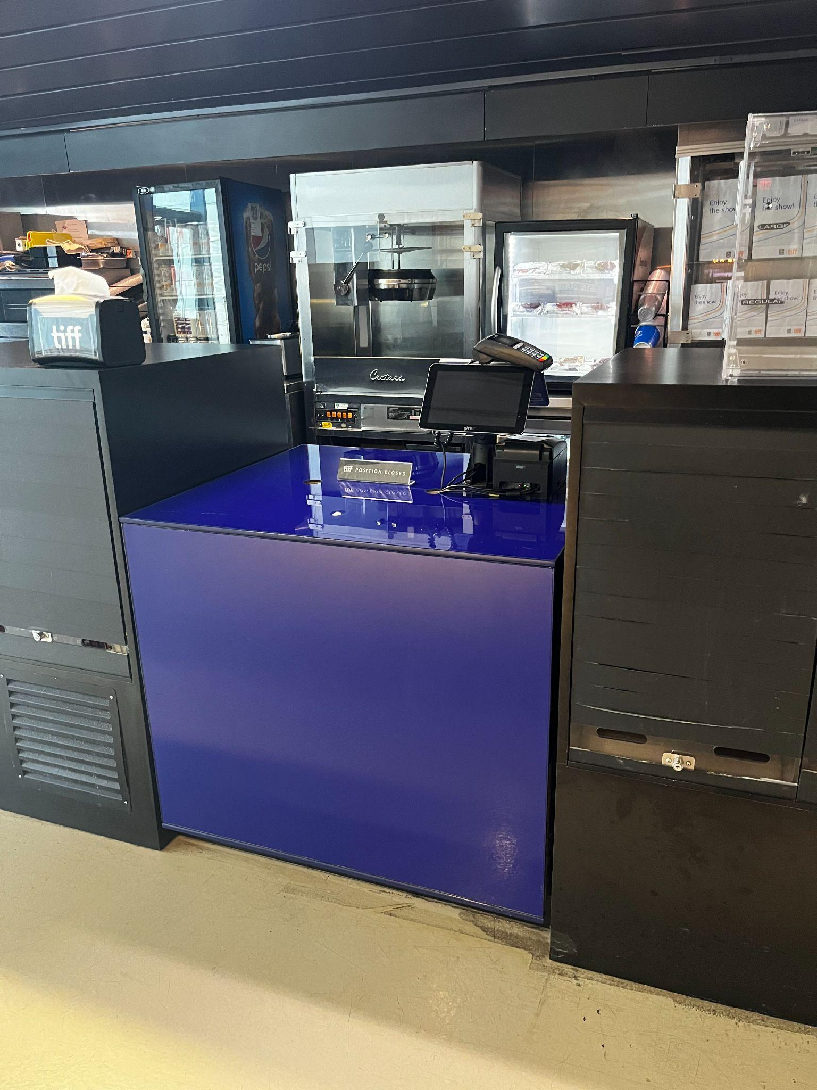
Figure 13: Photograph of concession stand counters
- Refillable water and coffee containers are allowed.
- A Water Bottle Refill station can be found on the second floor, near the concession stand.
- Alcohol is permitted inside the cinema if purchased through concessions.
- Concessions take cash, debit, and credit.

Washrooms
Gender Neutral | Yes | All levels
Sensored Flushing | Yes | All levels
Sensored Faucets | Yes | All levels
Automatic soap dispensers | Yes | All levels
Sensored paper towel or hand dryer | No | Manual paper towel
Change Tables | Partial | 2nd floor only
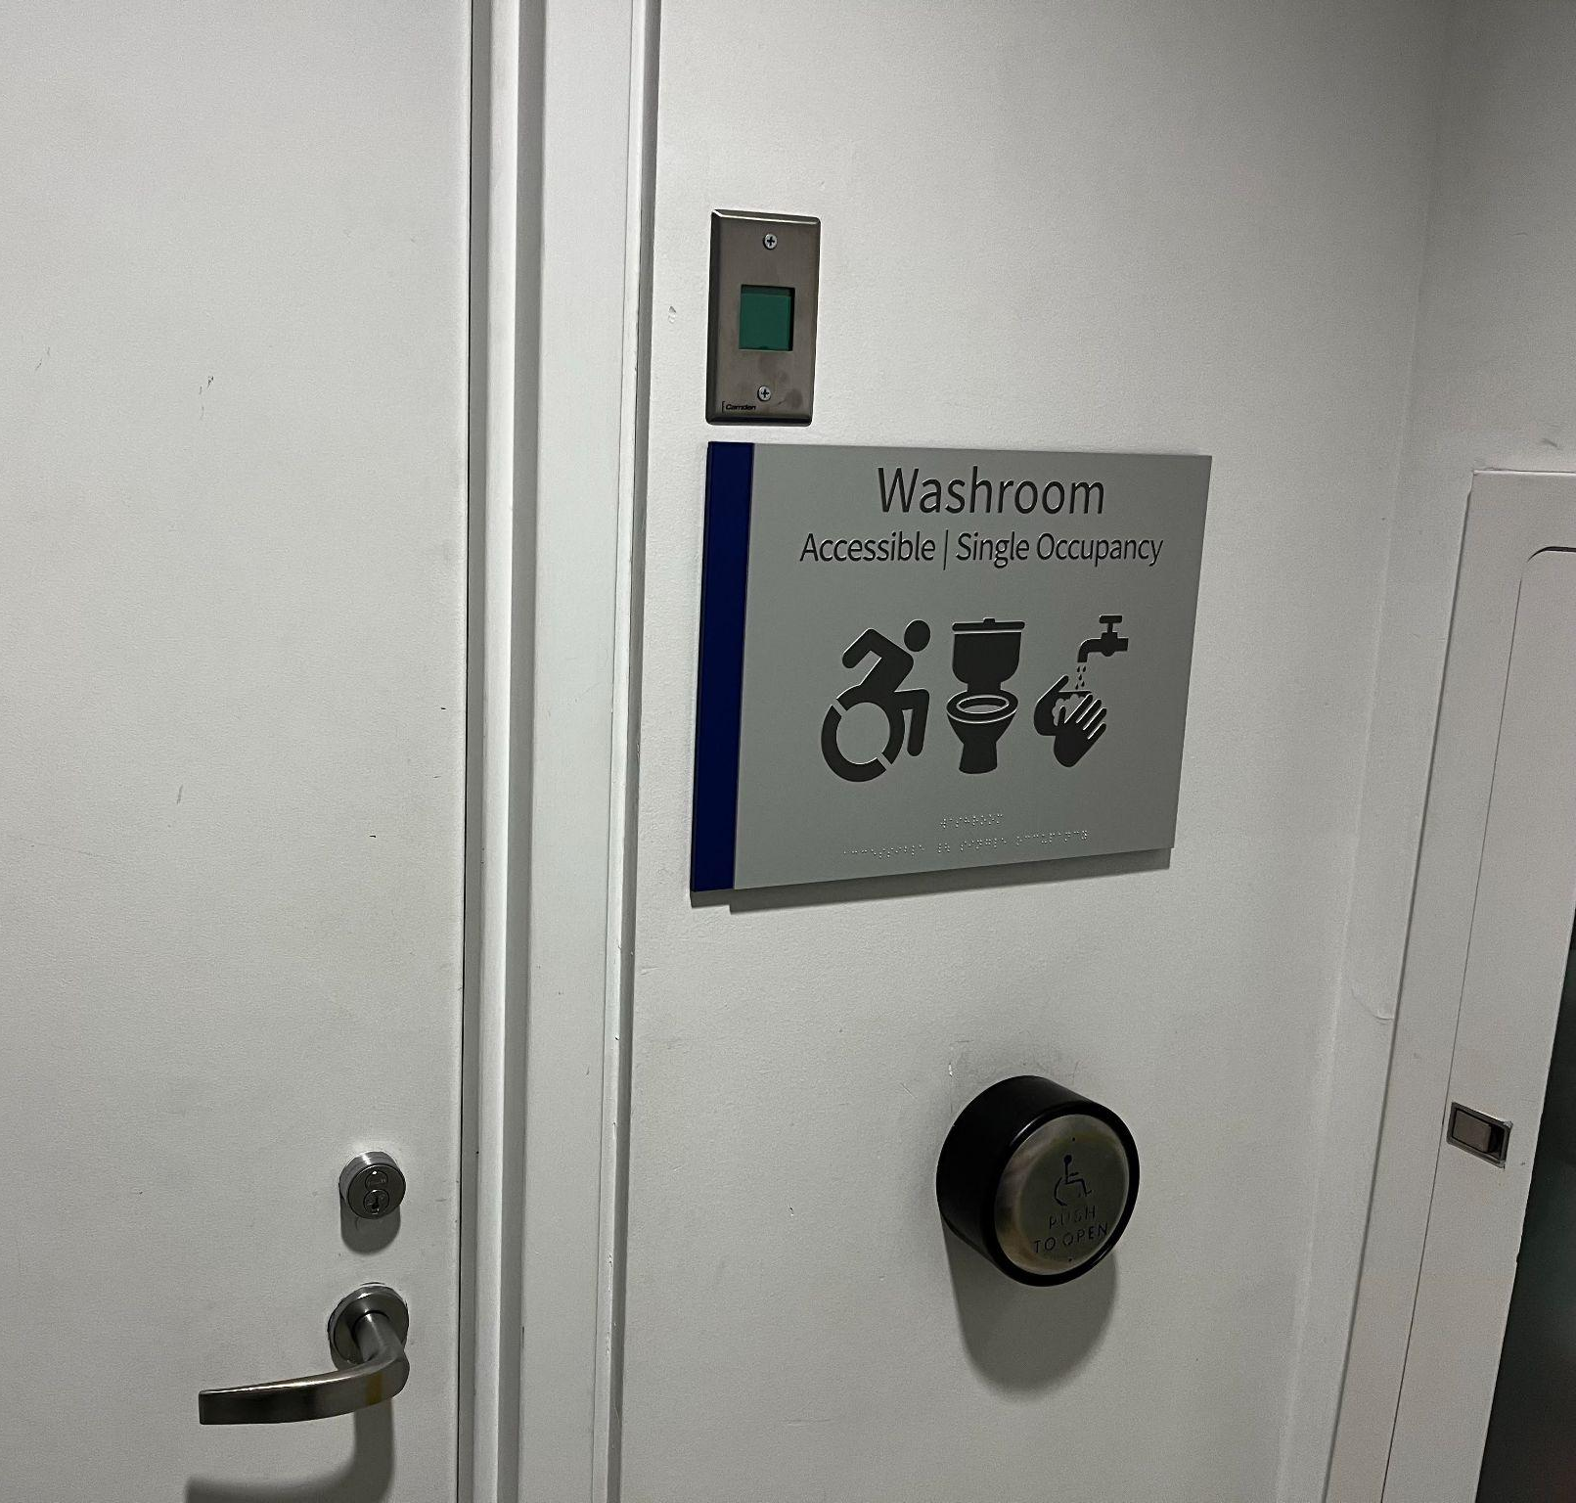
Figure 14: Washroom signs will indicate facilities available inside.
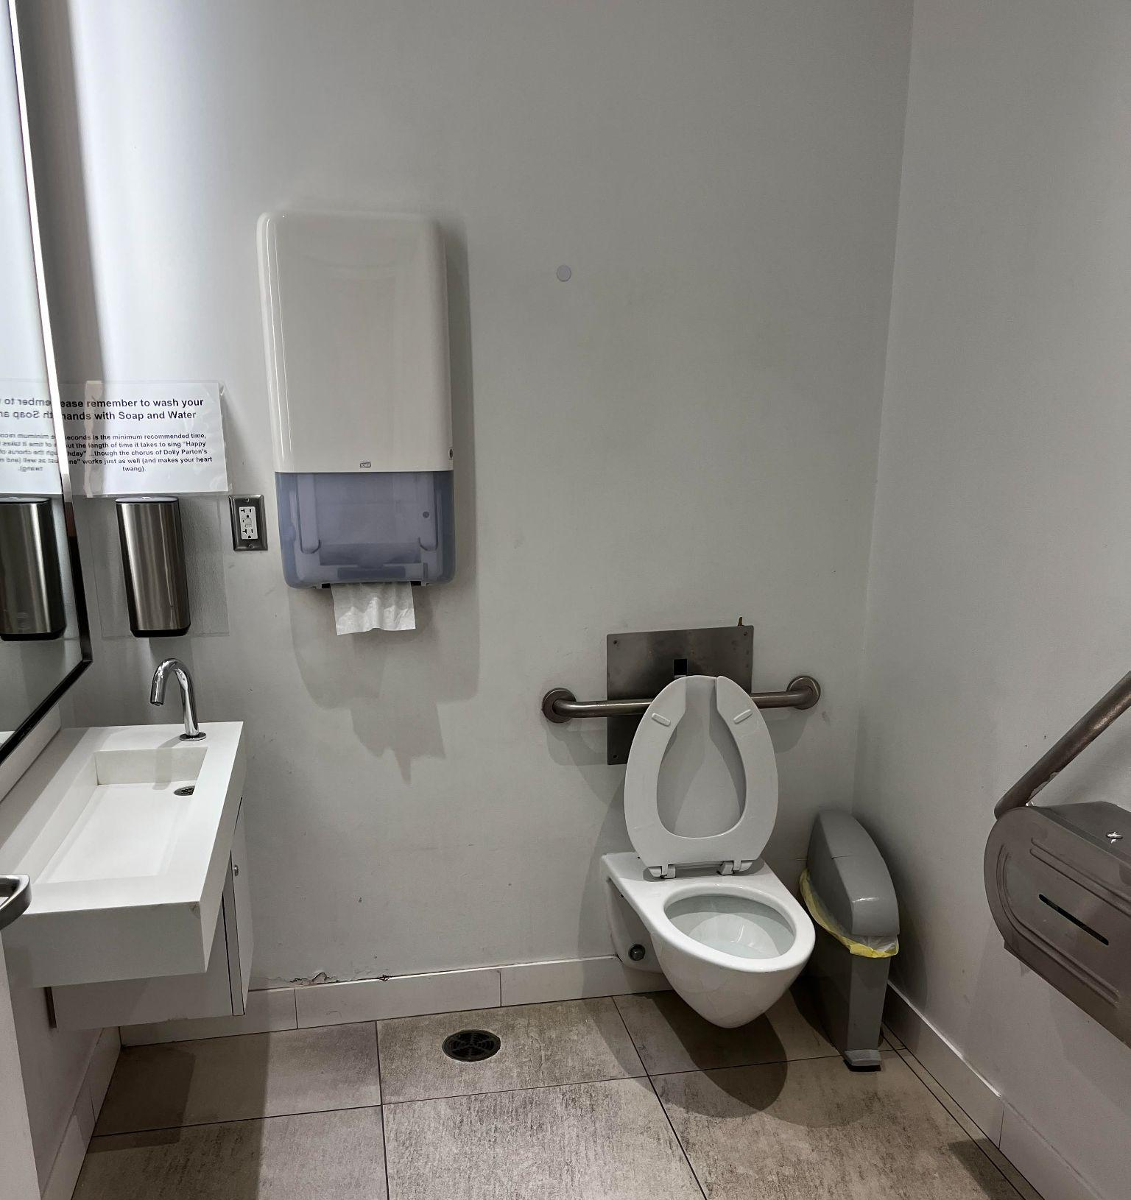
Figure 15: Example image of the washroom in Atrium. The washroom can be found underneath the back of the escalators.

- The lobby washroom can be found underneath the back of the escalators.
- The washrooms on the second, third, and fifth floors are to the right of the elevators if you are facing north; there is signage in the hallway indicating which way to turn to access the washrooms.

