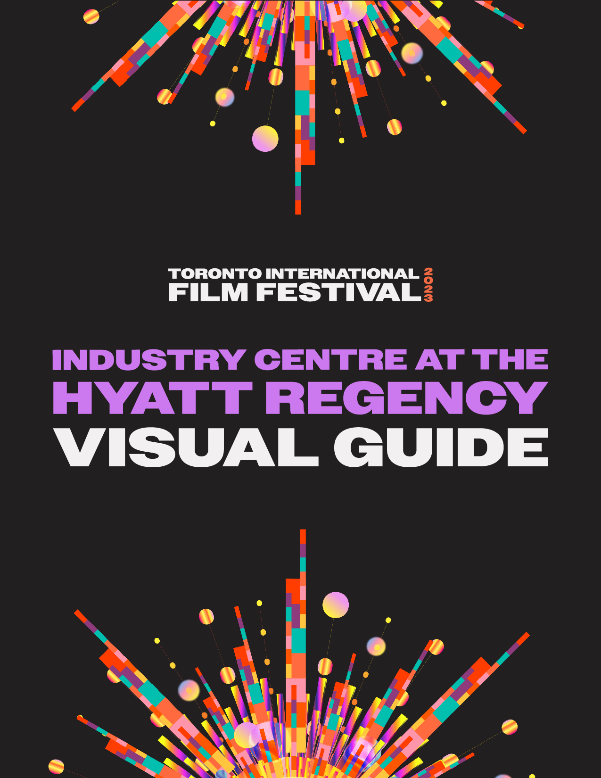

Industry Centre at the Hyatt Regency Visual Guide

Location
370 King Street West, Toronto, ON M5V 1J9
Closest intersection
King St. W and Peter St. 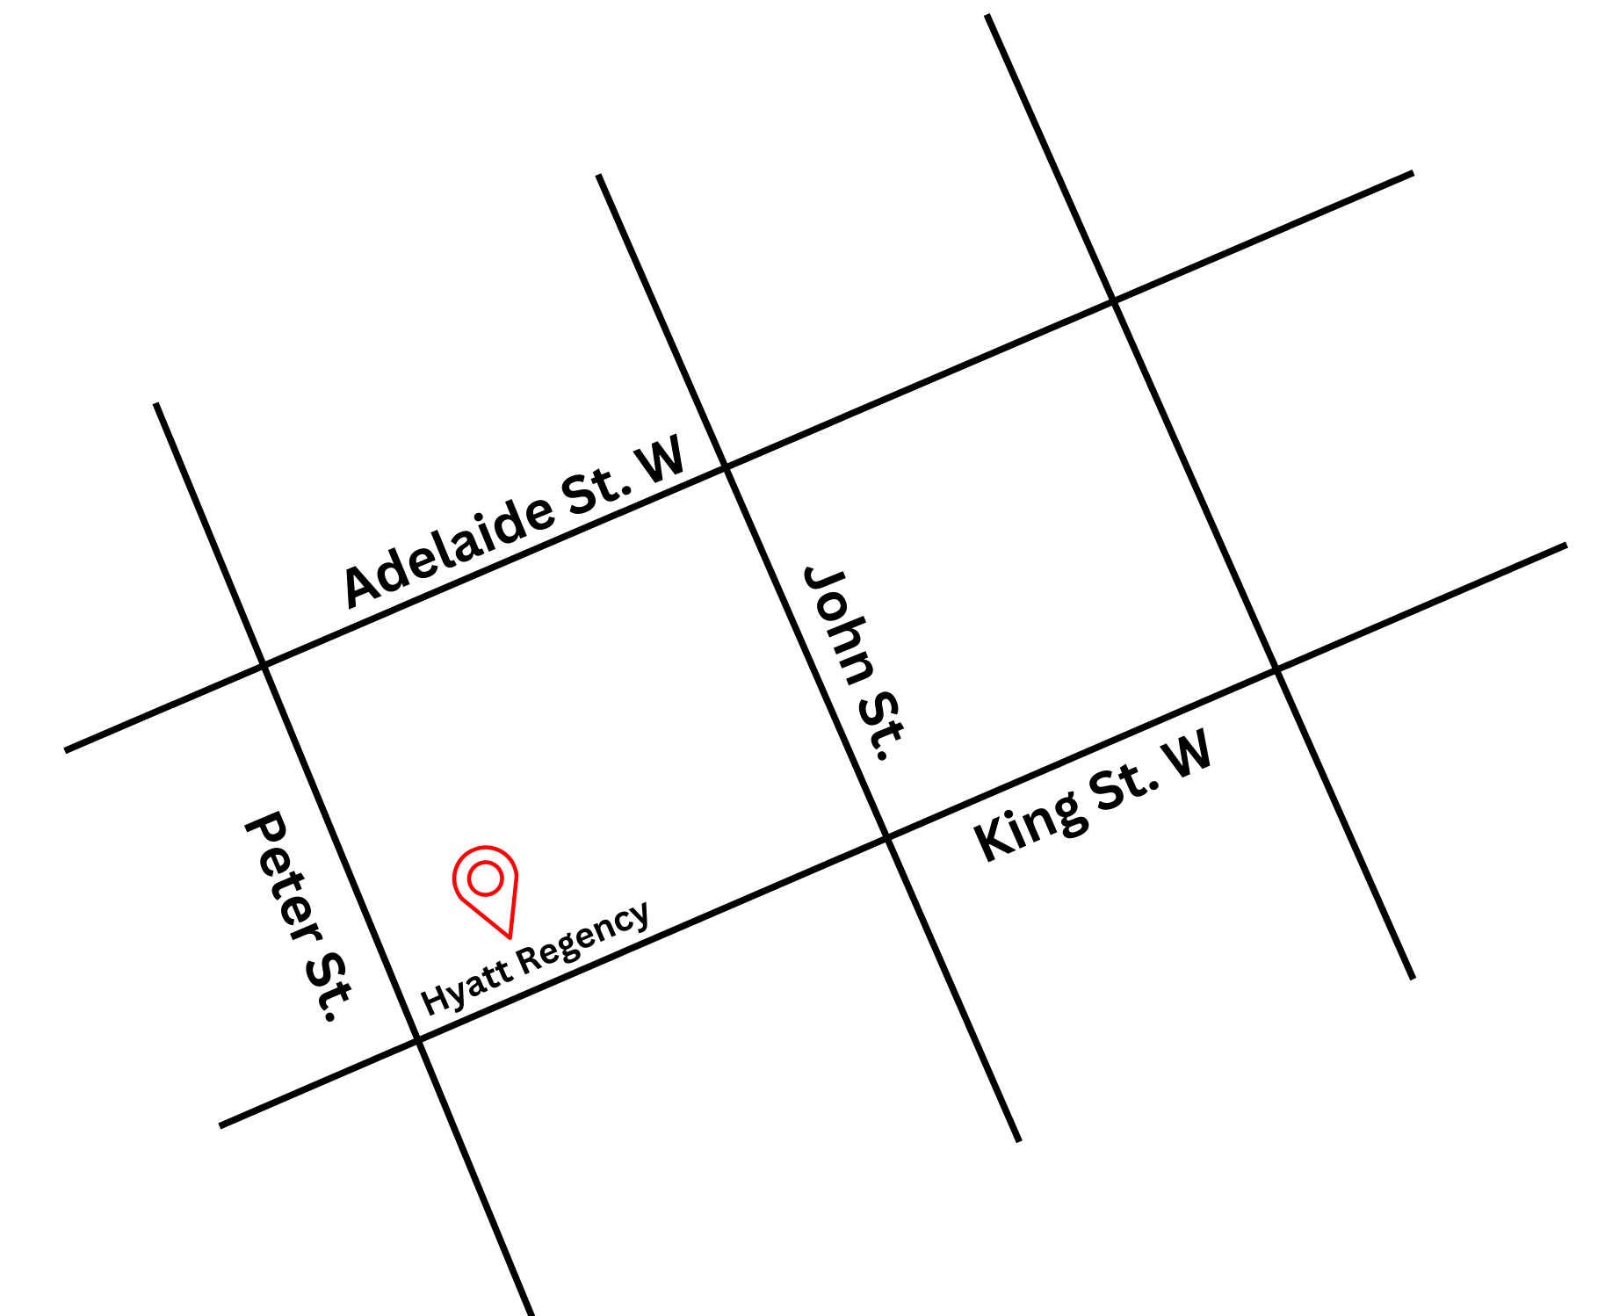
Figure 1: A map of downtown Toronto with the Hyatt Regency at King St. W. and Peter St., with Adelaide St. W. to the north

General information
- Outside food and drink is permitted but discouraged.
- Water stations located on Mezzanine level for attendees.
Routes of arrival
*Please see Festival Street closures
Subway
The Hyatt Regency is located nearest to St. Andrew subway station on Line 1. It is a 7-minute or 550 m walk from the subway.
Streetcar or bus
The King streetcar (Route 504) stops at the corner of King Street & John Street, in front of TIFF Bell Lightbox. It is a 2-minute walk from this stop.
GO Transit or Via Rail
It is a 19-minute or 1.4 km walk via the PATH from Union Station
Driving
Underground paid parking available at:
  - GoPark, 5 Widmer St. There is an elevator in the parking garage to street level near King St. W. and John St.

The entrance and lobby
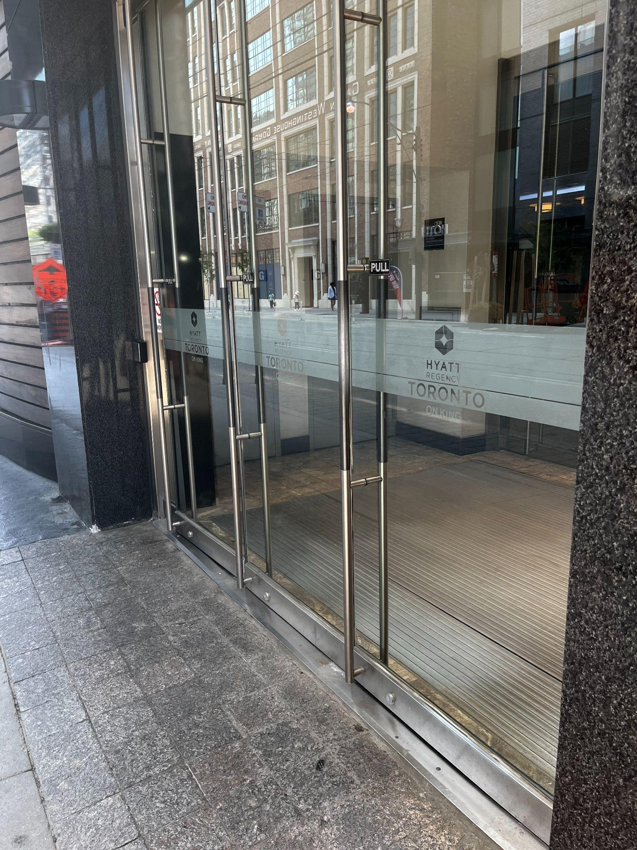
Figure 2: A photograph of the entrance along King St. W.
- To access the main hotel lobby there is a set of steps, but there is also an elevator to the left of the stairs for those with accessibility needs.
  - The Hyatt recommends the roundabout entrance on Widmer St. for those with mobility devices or accessibility needs.
  - Please note* vehicles frequent the Widmer St. entrance. The ground surface is made up of uneven concrete tiling, and the incline to the entrance may be steep for those in a manual wheelchair.

- There are currently no tactile colour-contrast cane detection tiles or truncated domes at the entrance or drop-off areas.

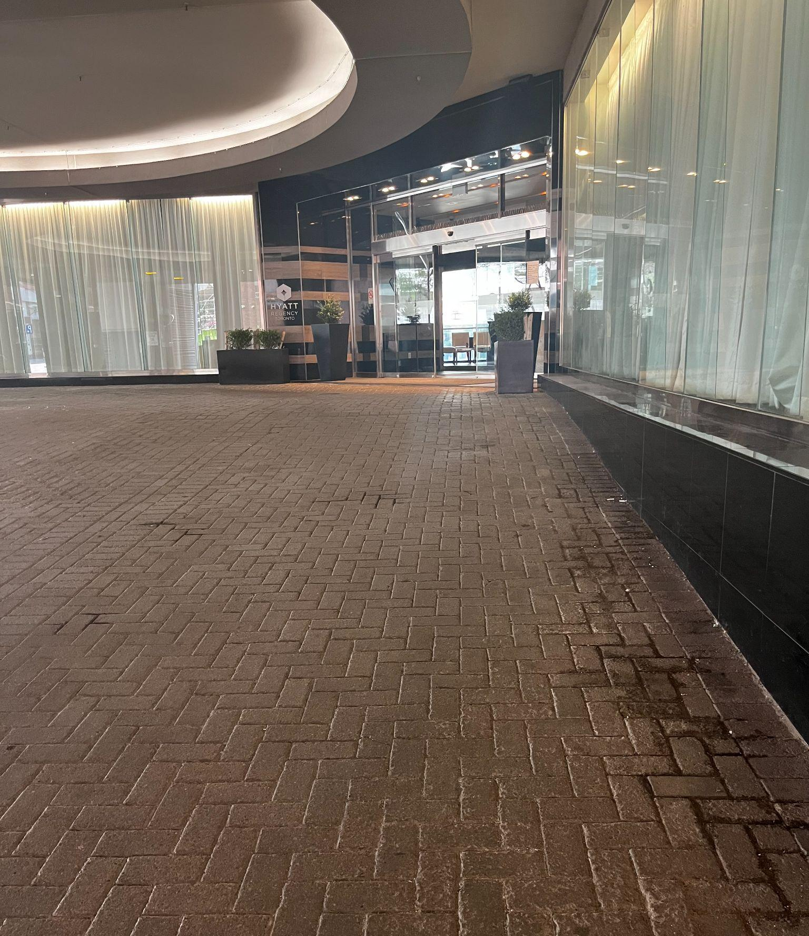
Figure 3: A photograph of the entrance ramp along Widmer St.
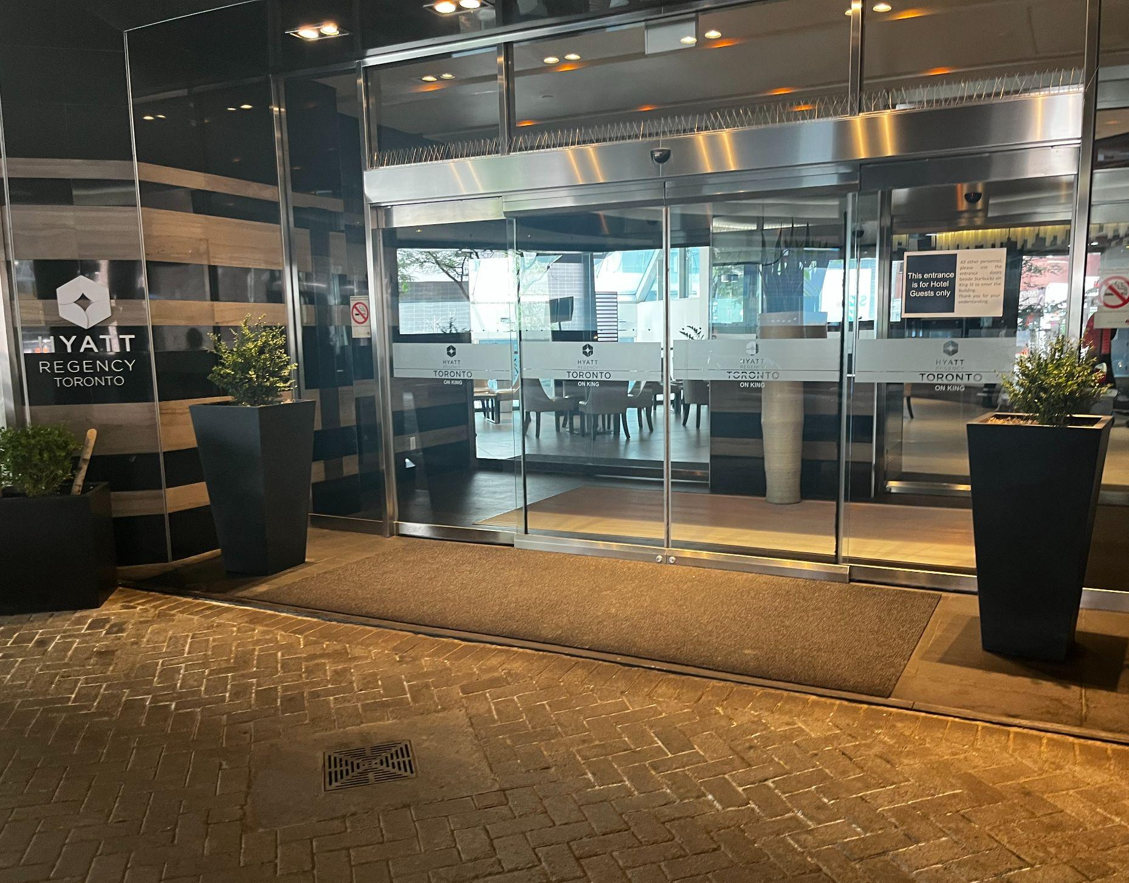
Figure 4: A photograph of the sliding door on Widmer St.

Access to ballrooms
- There are escalators up to Mezzanine Floor and Stairs to Lower Level.
  - The stairs are in between the escalators, to the left when facing the entrance moves downward, and to the right when facing the entrance moves upward.
  - There are elevators available to access both floors.
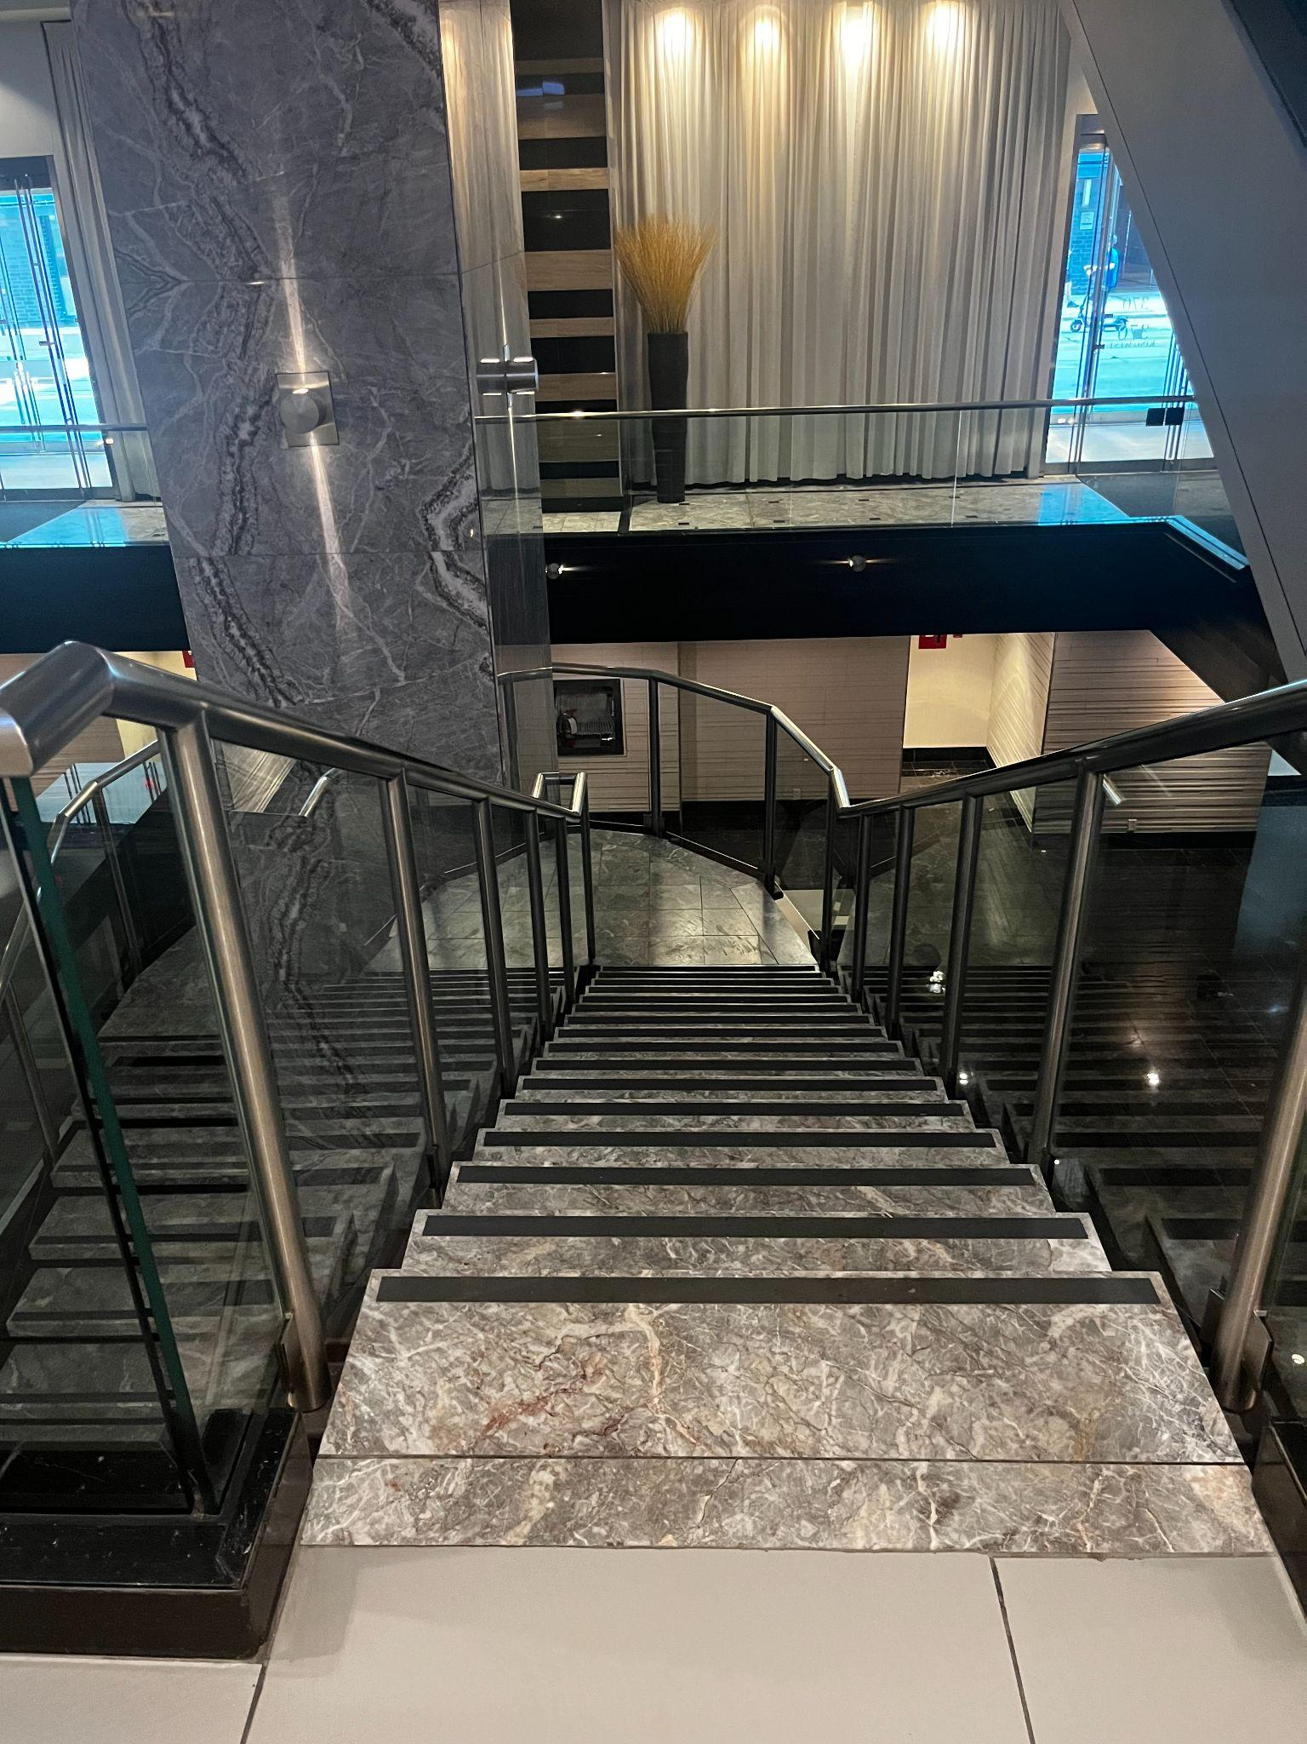
Figure 5: A photograph of stairs leading to the lower level.
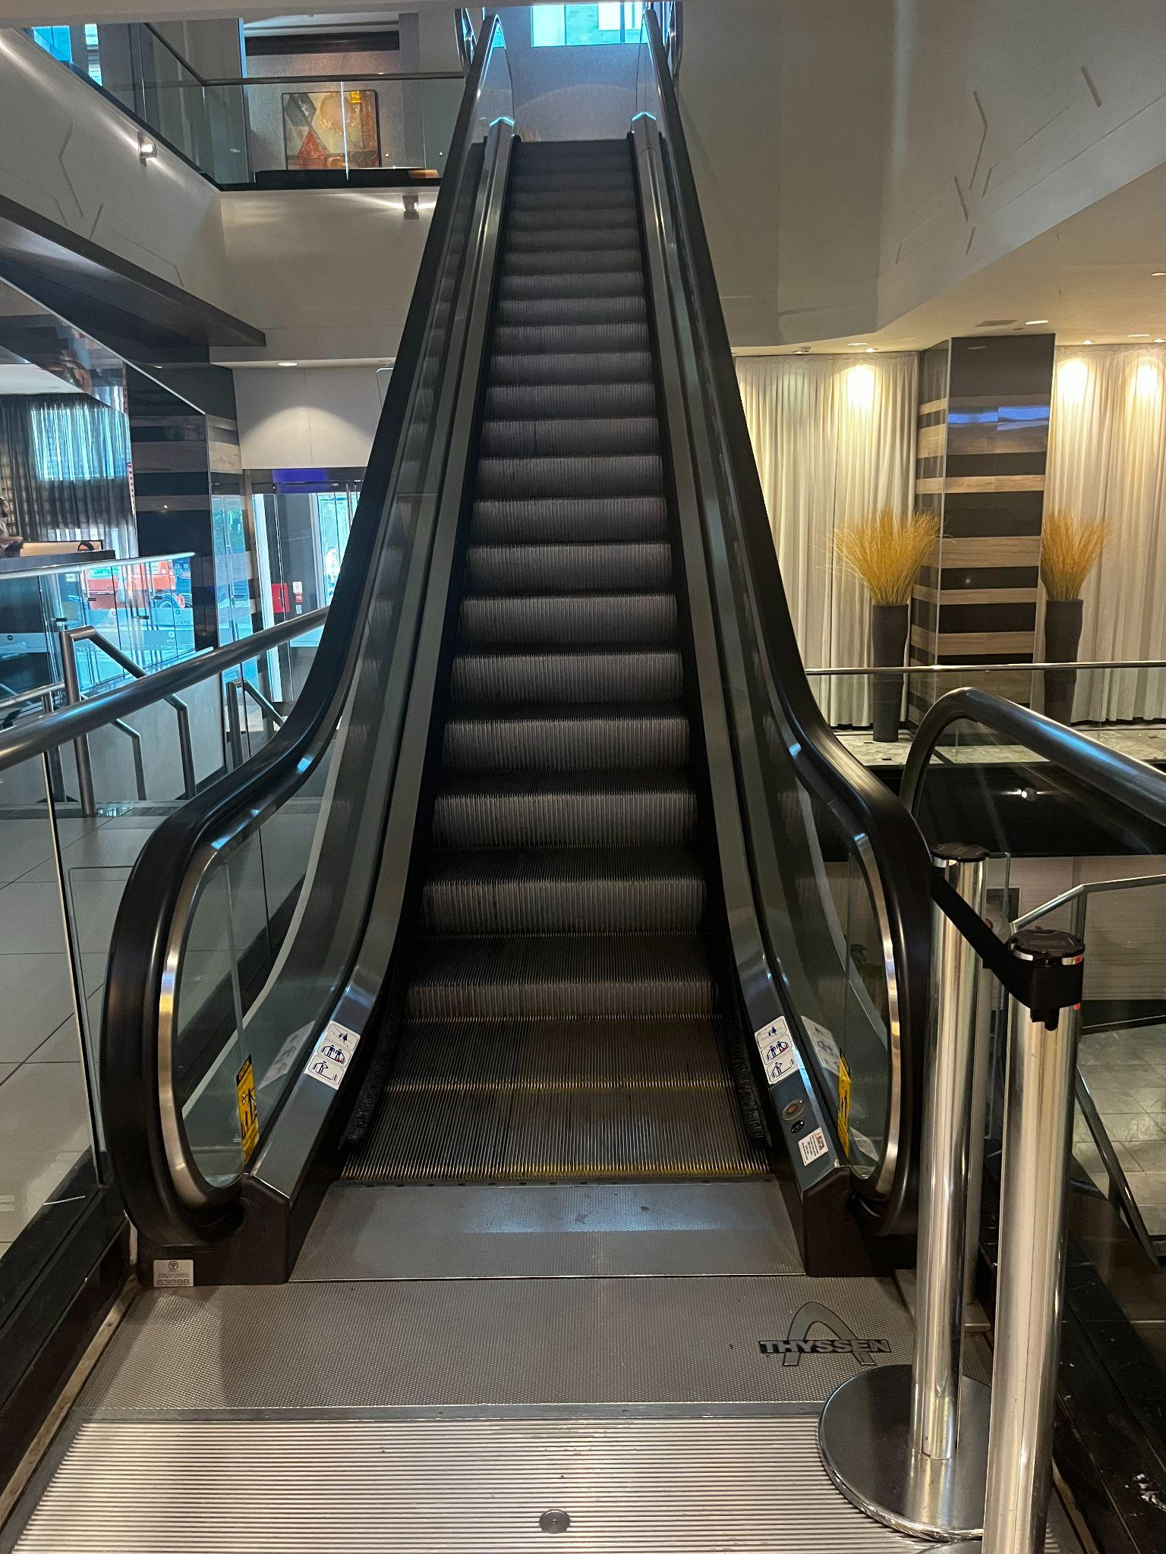
Figure 6: A photograph of escalators.
- Rooms used include Regency & King Ballrooms (Mezzanine Level) and Conference Centre rooms and Family Room (Lower Level).
  - Seating areas available in both ballrooms

Accessibility services and devices available:
On a first come, first served basis and upon request:
- FM Systems
- Pocket Talkers (personal sound amplifier)
- Raised Seating Platforms
- Walkers
- Walking Canes
- Wheelchairs

Washrooms
- Accessible washrooms are located on Lower, Ground, and Mezzanine levels of the hotel.

Mezzanine accessible washroom
Gender Neutral | Yes | Single Washroom
Sensored Flushing | No
Sensored Faucets | No
Automatic soap dispensers | No
Sensored hand dryer or paper towel | Yes
Change Tables | Yes
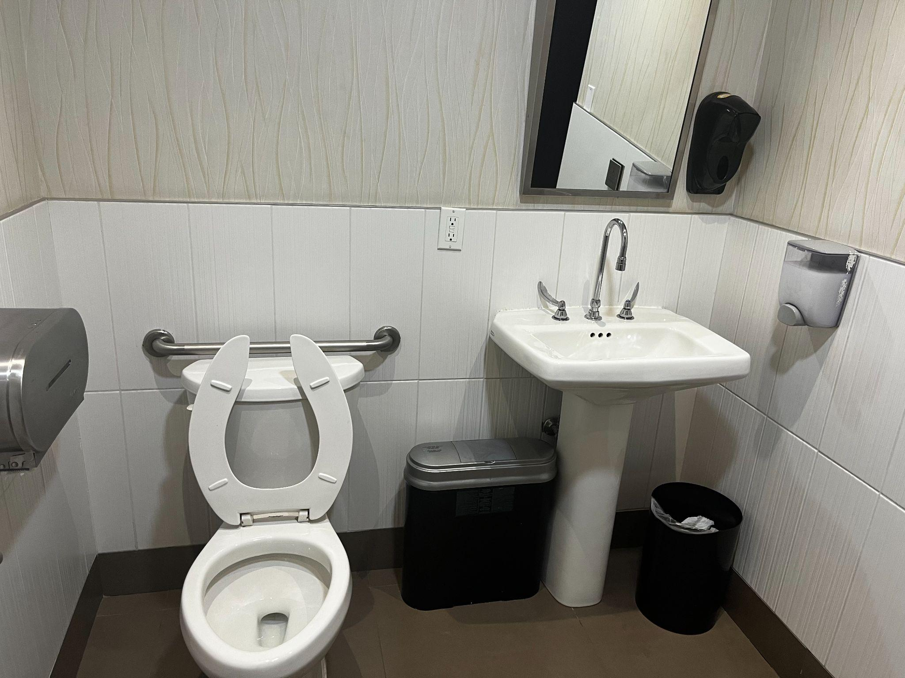
Figure 6: A photograph of the mezzanine accessible washroom at the Hyatt Regency.
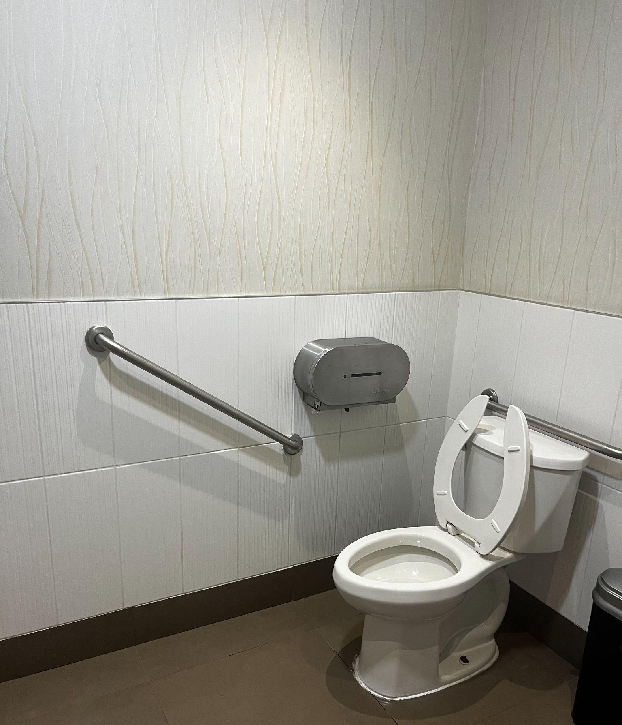
Figure 7: A photograph of the secondary angle of the mezzanine accessible washroom at the Hyatt. There is a toilet to the left and sink to the right

Mezzanine washrooms
Gender Neutral | No
Sensored Flushing | Yes
Sensored Faucets | Yes
Automatic soap dispensers | Yes
Sensored hand dryer or paper towel | Yes
Change Tables | Partial – See Notes | Change table in accessible washroom and in Family Room on Lower Level

