

TIFF General Festival Accessibility Guide
TIFF General Festival Accessibility Guide
Table of Contents
Introduction

General information
- Festival ticketing
- Rush tickets
- Lobby Pass
- Assistive Devices and Accessibility Features for Screenings and Events
- Noise levels
- Active listeners

Navigating the Festival: Venues
- TIFF official screening venues and locations
- Wheel-Trans drop-off
- Festival Street
- Venue and bag policy
- Other accessibility needs or questions

Introduction

TIFF strives to be accessible to all of our audiences and is committed to providing equitable access to participation in services and programs. TIFF is invested in the evaluation and continuous improvement of accessibility offerings and working to remove barriers to equitable access and participation.
TIFF has established an Accessibility Steering Committee with representation from each department, and is working toward advancing accessibility for both year-round and Festival programming from screenings to venue considerations.
As part of our ongoing commitment to removing barriers, this guide has been designed to help visitors navigate the Festival when visiting the various venues, according to individual needs and preferences.

General information

Festival ticketing
All TIFF screenings offer accessible seating. We make every effort to accommodate accessibility and support person seating requests; however, seating is limited and subject to availability.
Guests requiring accessibility accommodations must contact TIFF Customer Relations in advance through TIFF's Call Centre at 416-599-2033 or 1-888-258-8433 or email customerrelations@tiff.net. This allows our team to discuss your access requirements and identify available options that best support your needs.
You may also visit our Box Office in person at 350 King Street West (find our opening hours at tiff.net/visit). Please note, a valid piece of ID may be requested for in-person service.

Before booking tickets, if you wish to see a map of the cinemas at the TIFF Lightbox — including the location of accessible seating — you may view digital copies of our seating maps at https://tiff.net/ticketing/our-cinemas. For accessibility information at other Festival venues, please download the Venue Access Guides in either PDF or Word formats available at https://tiff.net/accessibility-at-tiff.

Our Customer Relations team can be reached at:

Local: 416-599-2033
Toll-free: 1-888-258-8433
Email: customerrelations@tiff.net

Rush tickets
If a screening is off-sale, customers without tickets may wait in the Rush line as a last chance to see the film. We recommend arriving for a Rush line no earlier than 60 minutes prior to your screening. Please note that being in a Rush line does not guarantee a ticket to the screening.

If guests have a Lobby Pass and are rushing a film, they must speak to a member of our Front of House team managing the Rush line for that screening when they arrive. Front of House will take note of their place in line, then direct them to the designated waiting area for audience members with Lobby Passes. When it comes time for their spot in line to move into the theatre, Front of House will let guests know and will assist them in getting into the cinema. Admittance to the screening is still subject to ticket availability. Read more about Lobby Passes below.

Lobby Pass
A Lobby Pass grants a Festival-goer and their support persons (if applicable) access to a designated waiting area, available at every indoor Festival venue.
Lobby Passes can be requested from now until the end of the Festival by anyone who has an accessibility consideration that limits their ability to stand in a lineup at a venue. Access to the designated waiting area is granted to the passholder and their support person upon the presentation of a Lobby Pass and a valid ticket or Official Pass (Market, Media, Guest) to a TIFF Front of House representative. The nature of the waiting areas vary by venue, and space may be limited.
Please note:
- Lobby passes are non-transferrable and belong solely to the designated recipient. You cannot hand your pass to a companion or anyone else to wait in line for you.
- Holding a lobby pass does not guarantee admission to Press & Market screenings or rush ticketing lines.
- If you do not have a Lobby Pass and are unable to wait in a traditional queue due to an accessibility-related need, please speak with a TIFF Front of House representative for assistance.
- Lobby Passes are provided to support accessibility needs. Misuse of a Lobby Pass may result in the pass and event access being revoked in accordance with TIFF's Code of Conduct.

Requesting a Lobby Pass

Lobby Passes are available by request starting in August.
- Lobby passes can be requested directly through the Customer Relations team. Any requests can be submitted by the visitor over the phone at 416-599-2033 or 1-888-258-8433, in person at TIFF Lightbox, or by email at customerrelations@tiff.net.

How to download a digital Lobby Pass

Lobby Pass holders will access their Lobby Pass by signing in to TIFF Festival Account Manager and downloading the pass to their mobile device, similar to downloading a digital ticket.

- Visit TIFF Festival Account Manager from your mobile device: https://am.ticketmaster.com/tiff2/

- Click “Sign In” in the top right corner.

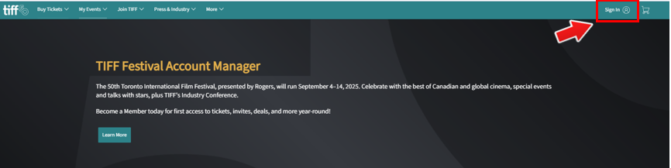
Figure 1: Screenshot of https://am.ticketmaster.com/tiff2/ with an arrow pointing to the sign-in button in the top right corner

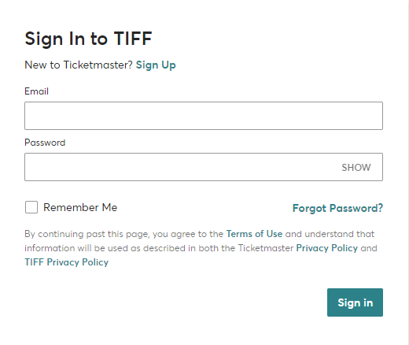
Figure 2: Screenshot of https://am.ticketmaster.com/tiff2/ sign-in page

- Select “My Events.”

- Your Lobby Pass will appear here. Look for “2025 Lobby Pass” and click “Select Event.”

- Under “My Tickets” click the line that reads: “Lobby Pass, General Admission.”

- A pop-up will appear here with the QR code for your Lobby Pass. You may display the Lobby Pass from this screen, or add the Lobby Pass to your mobile wallet (for example, click the “Add to Apple Wallet” icon).

Physical Lobby Pass

If you require a physical Lobby Pass, please let our Customer Relations team know by phone at 416-599-2033 or 1-888-258-8433, or by email at customerrelations@tiff.net in order to arrange a pickup at our TIFF Lightbox Box Office.
If you are attending as a Press and Media delegate and require a Lobby Pass, please reach out to media@tiff.net.

Assistive Devices and Accessibility Features for Screenings and Events
- Accessibility features we offer for screenings and events where available are: assisted listening, audio description (AD), closed captions (CC), and open captions (OC)
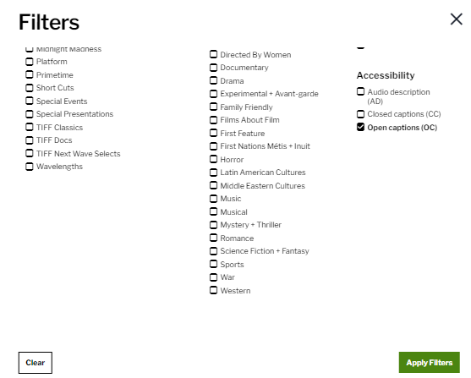

- To access assistive devices, visit the Box Office at the venue of your screening. Please note, a valid piece of ID may be required.
- Select screenings and events include open captions, live captions, or ASL interpretation. These features will be listed on the film or event page in advance.

Noise levels
● At times during the Festival, the lobby areas, lineups, or Fan Zones can exceed comfortable noise levels for those who are sensitive to loud noises.

Quiet spaces and sensory bags
- To help support a positive and welcoming environment, a quiet space will be available at TIFF Lightbox, located in Meeting Room 1 on the 4th floor. This room can be found to the left of the elevators. If you need assistance finding it, a Front of House staff member or Volunteer can assist you. This space is meant for anyone who may need a break from sensory stimulation or noise.
- Quiet spaces may be available upon request at other Festival venues and a Front of House staff member or Volunteer can assist with this inquiry.
- We are working with KultureCity to make TIFF more sensory accessible and inclusive. Trained volunteers and a limited number of sensory bags from KultureCity will be available to families and individuals who have sensory needs/non-visible disabilities. Sensory bags are equipped with noise cancelling headphones, fidget tools, and verbal cue cards, and will be available for guests to use and return at no additional cost. You can access sensory bags at the box office in the lobbies of TIFF Lightbox and Scotiabank Theatre.

Active listeners

- Active listeners provide trauma-informed support for attendees who may be affected by difficult, sensitive, or potentially distressing content during or after a film or event. Active Listener support is available only when specified on the related film or event page.
- If active listeners will be available, this will be noted directly on the film pages at tiff.net/films. Information on contacting the active listeners will be shared prior to the film and available during the film.

Navigating the Festival: Venues
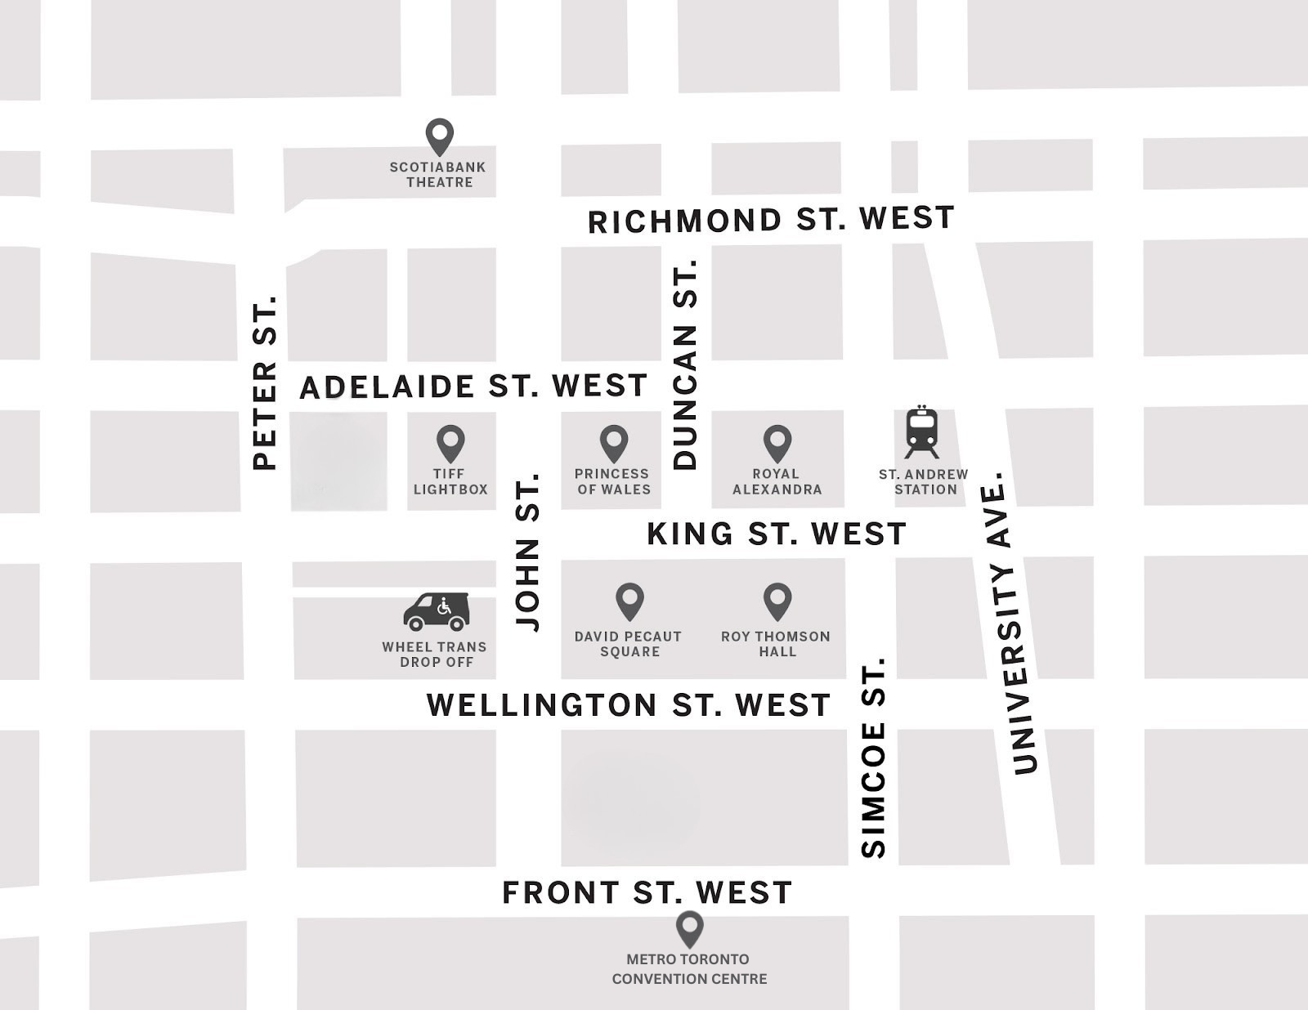

Figure 5: A map of the TIFF Festival venues. These include Scotiabank Theatre Toronto, TIFF Lightbox, the VISA Screening Room at the Princess of Wales Theatre, Royal Alexandra Theatre, David Pecaut Square, Roy Thomson Hall, Metro Toronto Convention Centre, and the Wheel Trans Drop Off.

TIFF official screening venues and locations

- TIFF Lightbox
○ 350 King St. W., Toronto, ON M5V 3X5
○ Located at the corner of King St. W. and John St.

- Scotiabank Theatre Toronto
○ 259 Richmond St. W., Toronto, ON M5V 3M6
○ Located at the corner of Richmond St. W. and John St.

- Visa Screening Room at the Princess of Wales Theatre
○ 300 King St. W., Toronto, ON M5V 1J2
○ Located at the corner of King St. W. and John St. on the opposite side of TIFF Lightbox

● Royal Alexandra Theatre
○ 260 King St. W., Toronto, ON M5V 1H9
○ Located along King St. W. between Simcoe St. and Duncan St.

- Roy Thomson Hall
○ 60 Simcoe St., Toronto, ON M5J 2H5
○ Located at the corner of King St. W. and Simcoe St.

- TIFF The Market at the Metro Toronto Convention Centre
○ 255 Front St. W., Toronto, ON M5V 2W6
○ Located at along Front St. between John St. and Simcoe St.

● Cinema Park at David Pecaut Square
○ 215 King St. W., Toronto, ON M5V 3G2
○ Located between Wellington St. W. and King St. W., and between John St. and Simcoe St.

Most venues are within a 10–15-minute walk of each other at an average pace; travel time may vary.

Wheel-Trans drop-off
- The Wheel-Trans drop-off is at the corner of Wellington St. W. and John St. on the north east side of the intersection.

Festival Street
- Festival Street is made up of a series of street closures along King St. W. that span across University St. to Peter St., and select streets between Wellington St. and Pearl St. may be affected.
- These closures occur in order to secure the street for red carpet events and to allow spaces for partners to set up booths.
- There may be other temporary road closures throughout the run of the Festival.
- Finding parking spots can often be difficult due to street closures. We recommend taking public transit if possible.

Festival Street hours
- Street closures occur from Thursday to Sunday, September 4–7, 2025, from approximately 10am–10pm.
  - Venues affected are: TIFF Lightbox, Roy Thomson Hall, Visa Screening Room at Princess of Wales Theatre, Royal Alexandra Theatre, and David Pecaut Square.
  - By law, no vehicles outside of talent or emergency vehicles are allowed to drive along Festival Street.

Navigating Festival Street
- Due to the safety and security of those working and attending the Festival, the use of barricades, including concrete barriers, are used along Festival Street.
○ Some barriers go up to 4-feet high and are immovable.
- Navigating to and from venue sites may be difficult for those with accessibility or mobility needs. We strive to maintain gaps between barriers and appropriate widths for lineups (with stanchions and barricades) for wheelchairs.
○ If you have accessibility needs, we suggest you find a Volunteer or staff member upon your arrival and let them know.
○ You can email customerrelations@tiff.net to inquire about our closures and find out how we can best accommodate your needs.
- For travel to and from Festival Street and TIFF venues, a wheel-trans stop is located at the intersection of Wellington St. and John St. More information about Toronto’s Wheel-Trans system, including bookings, can be found at ttc.ca/wheel-trans.
- Scotiabank Theatre allows for direct drop-offs from personal vehicles, taxis, or Ubers via Richmond St.
- During Festival Street’s closure (September 4–7), we recommend drop-offs for the following venues occur near the following locations:
○ 106 John St. (For TIFF Lightbox and the Rush line at the Visa
Screening Room at the Princess of Wales Theatre)
○ 14 Duncan St. (For ticket holders for the Visa Screening Room
at the Princess of Wales Theatre, and the Royal Alexandra
Theatre)
- If you have accessibility needs, we suggest you find a Volunteer or staff member upon your arrival and let them know.

For additional information on navigating the streets connecting festival venues, please contact customerrelations@tiff.net or TIFF’s Call Centre at 416-599-2023 or toll-free at 1-888-258-8433.

Venue and bag policy
- Please note that there will be security present at Festival Street and in venues.
- For security purposes, bags will be checked at all Fan Zone entrances, Roy Thomson Hall, the Visa Screening Room at the Princess of Wales Theatre, the Royal Alexandra Theatre, Scotiabank Theatre, and at other venues periodically.
- Any purses or bags that are larger than 12″ × 12″ × 6″ will not be allowed inside the above-mentioned venues. Permitted bags should be soft-sided and able to fit completely under the venue seats. No outside food or drink can be brought in.

Other accessibility needs or questions
Our Call Centre is open Tuesday to Sunday 12pm–5pm, at 416-599-2023 or toll-free at 1-888-258-8433, or by email at customerrelations@tiff.net.

