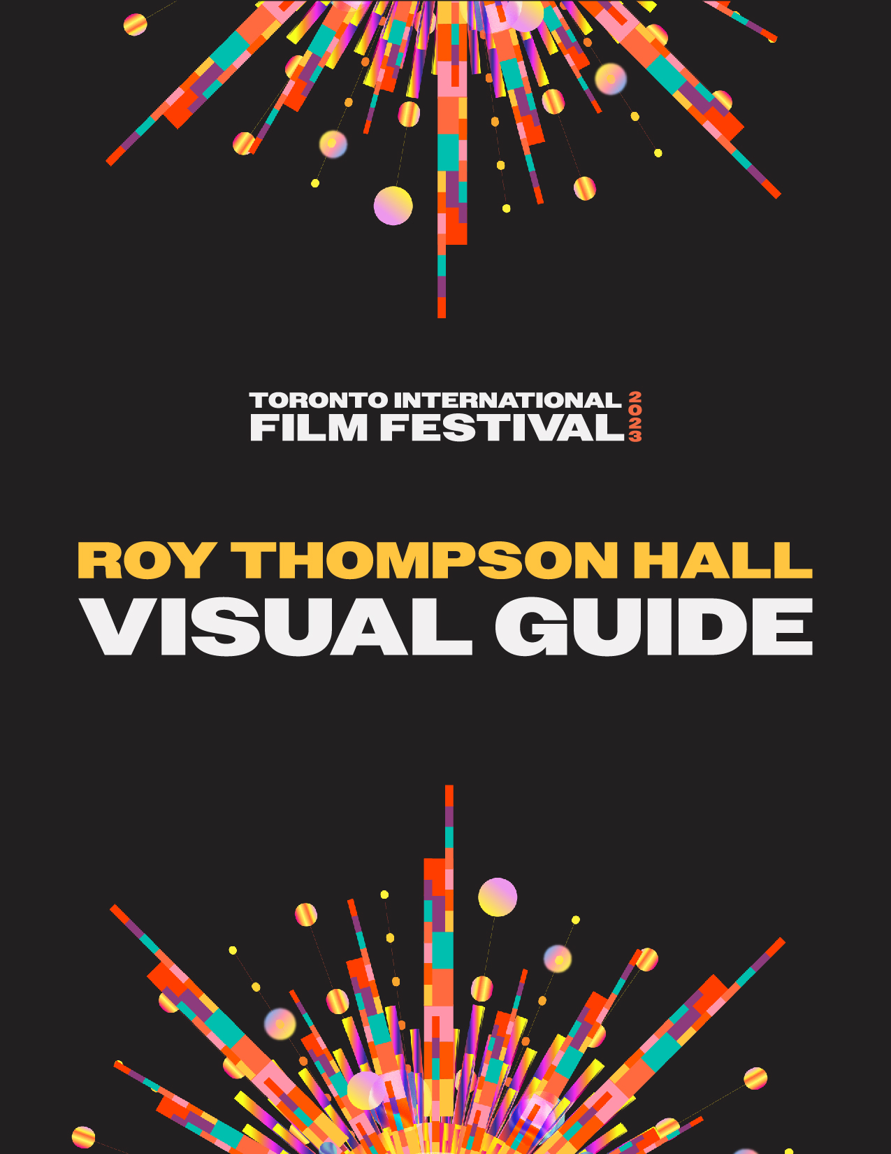

Roy Thomson Hall Visual Guide

Location
60 Simcoe Street, Toronto, ON M5J 2H5

Closest intersection
King St. W. and Simcoe St.
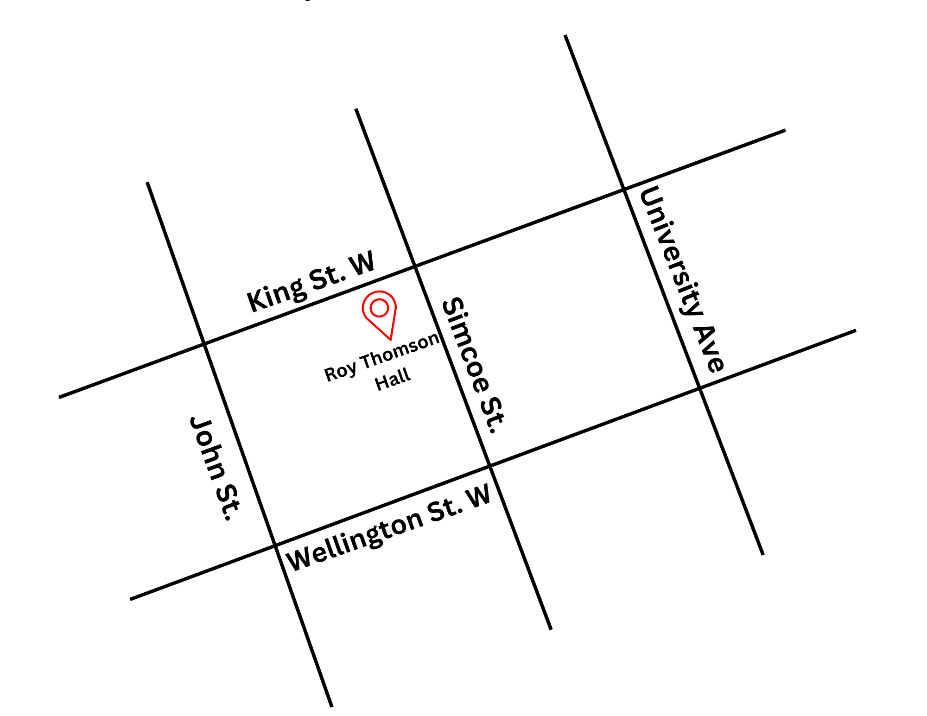
Figure 1: A Map of downtown Toronto with Roy Thomson Hall at King St. W. and Simcoe St., and John St. and Simcoe St. to the West and East, and Wellington St. W. to the South

General information
- Patrons are discouraged from wearing scented products; however, we cannot guarantee a scent-free environment.
- Water bottles are not allowed in the venue.
- This venue has reserved seating
  - The free TTC screening on September 16 is General Admission seating.
Routes of arrival
Subway
Roy Thomson Hall is located next to the St. Andrew subway station on Line 1. It is a 210 m or 3-minute walk from the subway.
Streetcar or bus
Take the King streetcar (Route 504). The closest stop is King Street & University Ave. It is a 300 m or 4-minute walk once exiting the streetcar.
GO Transit or Via Rail
Roy Thomson Hall is a 1.2 km or 15 minute walk from Union Station. It can also be reached by subway (one stop from Union Station to St. Andrew Station).
Driving
There is accessible parking available at the rear of Roy Thomson Hall via Wellington Street. There are 23 spots available in the surface parking lot, and 6 parking spots in the underground parking lot. These spots are available on a first-come, first-served basis.

The entrance and lobby
- Patrons with accessibility needs should arrive via the main entrance on Simcoe Street. Priority will be given to patrons who identify their accessibility needs.

Rush lines
- Rush line is at the corner of King St. W. and Simcoe St. and continues West along King St.
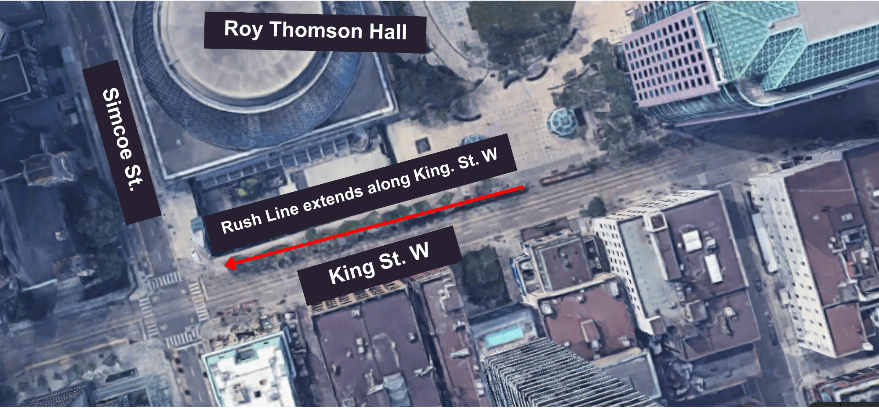
Figure 3: An aerial view map of King St. W. and Simcoe St. to indicate where the rush line will begin.

Access to theatres and seating
All levels of Roy Thomson Hall are wheelchair-accessible.
Main Hall  810 seats | Accessible Seating  6 seats | Companion Seating  4 seats
Mezzanine:  478 seats | Accessible Seating  0 seats | Companion Seating  0 seats
Balcony:  498 seats | Accessible Seating  0 seats | Companion Seating  0 seats

Assistive devices & services available
Closed Captions | No
Assisted Listening | Yes | Stethoset headsets
Descriptive Sound | Yes* | Receivers with headsets or disposable earbuds
*Descriptive Sound are subject to content including a descriptive sound option

Concessions Stand
- No outside food and drink permitted inside.
- Alcohol is allowed in the theatre.
- Cash and Debit only; Roy Thomson Hall is a cashless venue.

