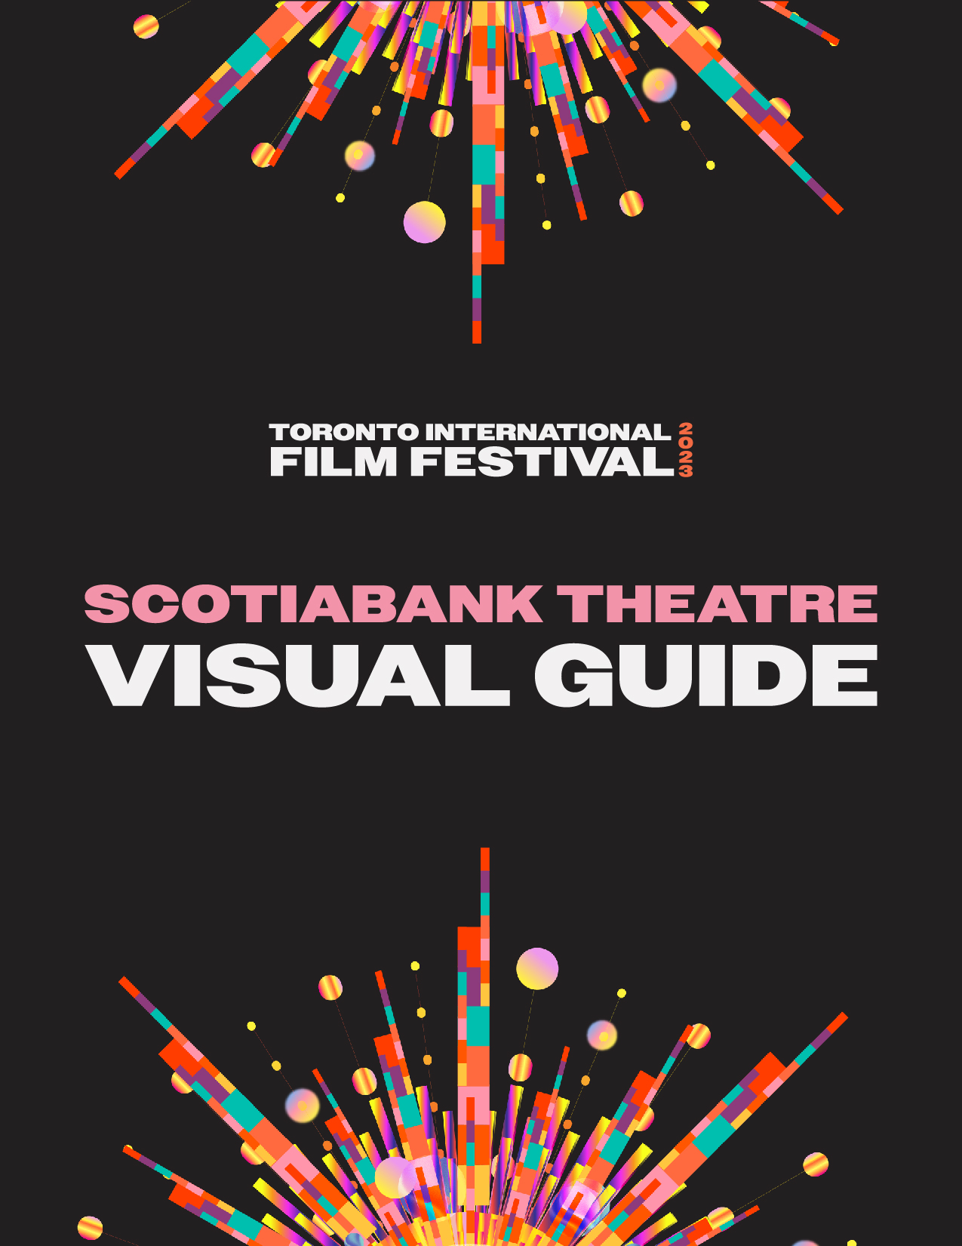

Scotiabank Theatre Visual Guide

Location
259 Richmond Street West, Toronto, ON M5V 3M6

Closest intersection
Richmond St. W. & John St.
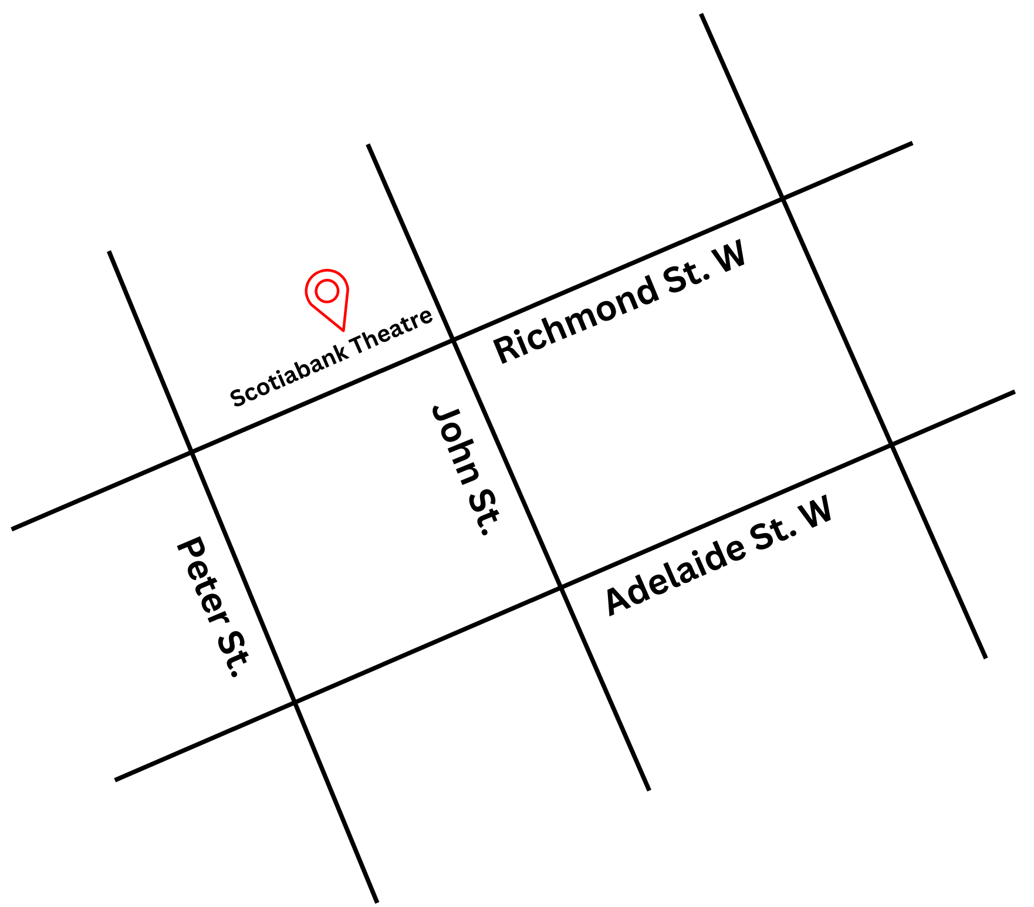
Figure 1: A Map of downtown Toronto with Scotiabank Theatre at Richmond St. W. and John St., and Adelaide St. W. to the south.

General information
- This venue is general admission

Routes of arrival
*Please see Festival Street closures
Subway
Scotiabank Theatre is located near Osgoode Station on Line 1. It is a 500 m or 6-minute walk from Osgoode Station to the theatre.
Streetcar or bus
The Queen Streetcar (Route 501) stops at Queen St. W. & John St. It is a 150 m or 2-minute walk from the streetcar to the theatre.
GO Transit or Via Rail
Scotiabank Theatre is a 1.6 km or 21-minute walk from Union Station. From Union station the subway can be taken Northbound to Osgoode Station.
Driving
Accessible underground RioCan Hall paid parking lot is within 30 m.
The entrance and lobby
- Patrons with accessibility needs should arrive via the main entrance.
- Passenger drop-off is possible in front of the theatre with curb ramps outside the venue with a step-free, wheelchair-accessible entrance
- The front doors utilize a push-to-open button on the doors furthest to the right of the entrance
- There are currently no tactile colour-contrast cane detection tiles or truncated domes at the entrance or drop-off areas.
- There is a small overhang available for protection from the elements.
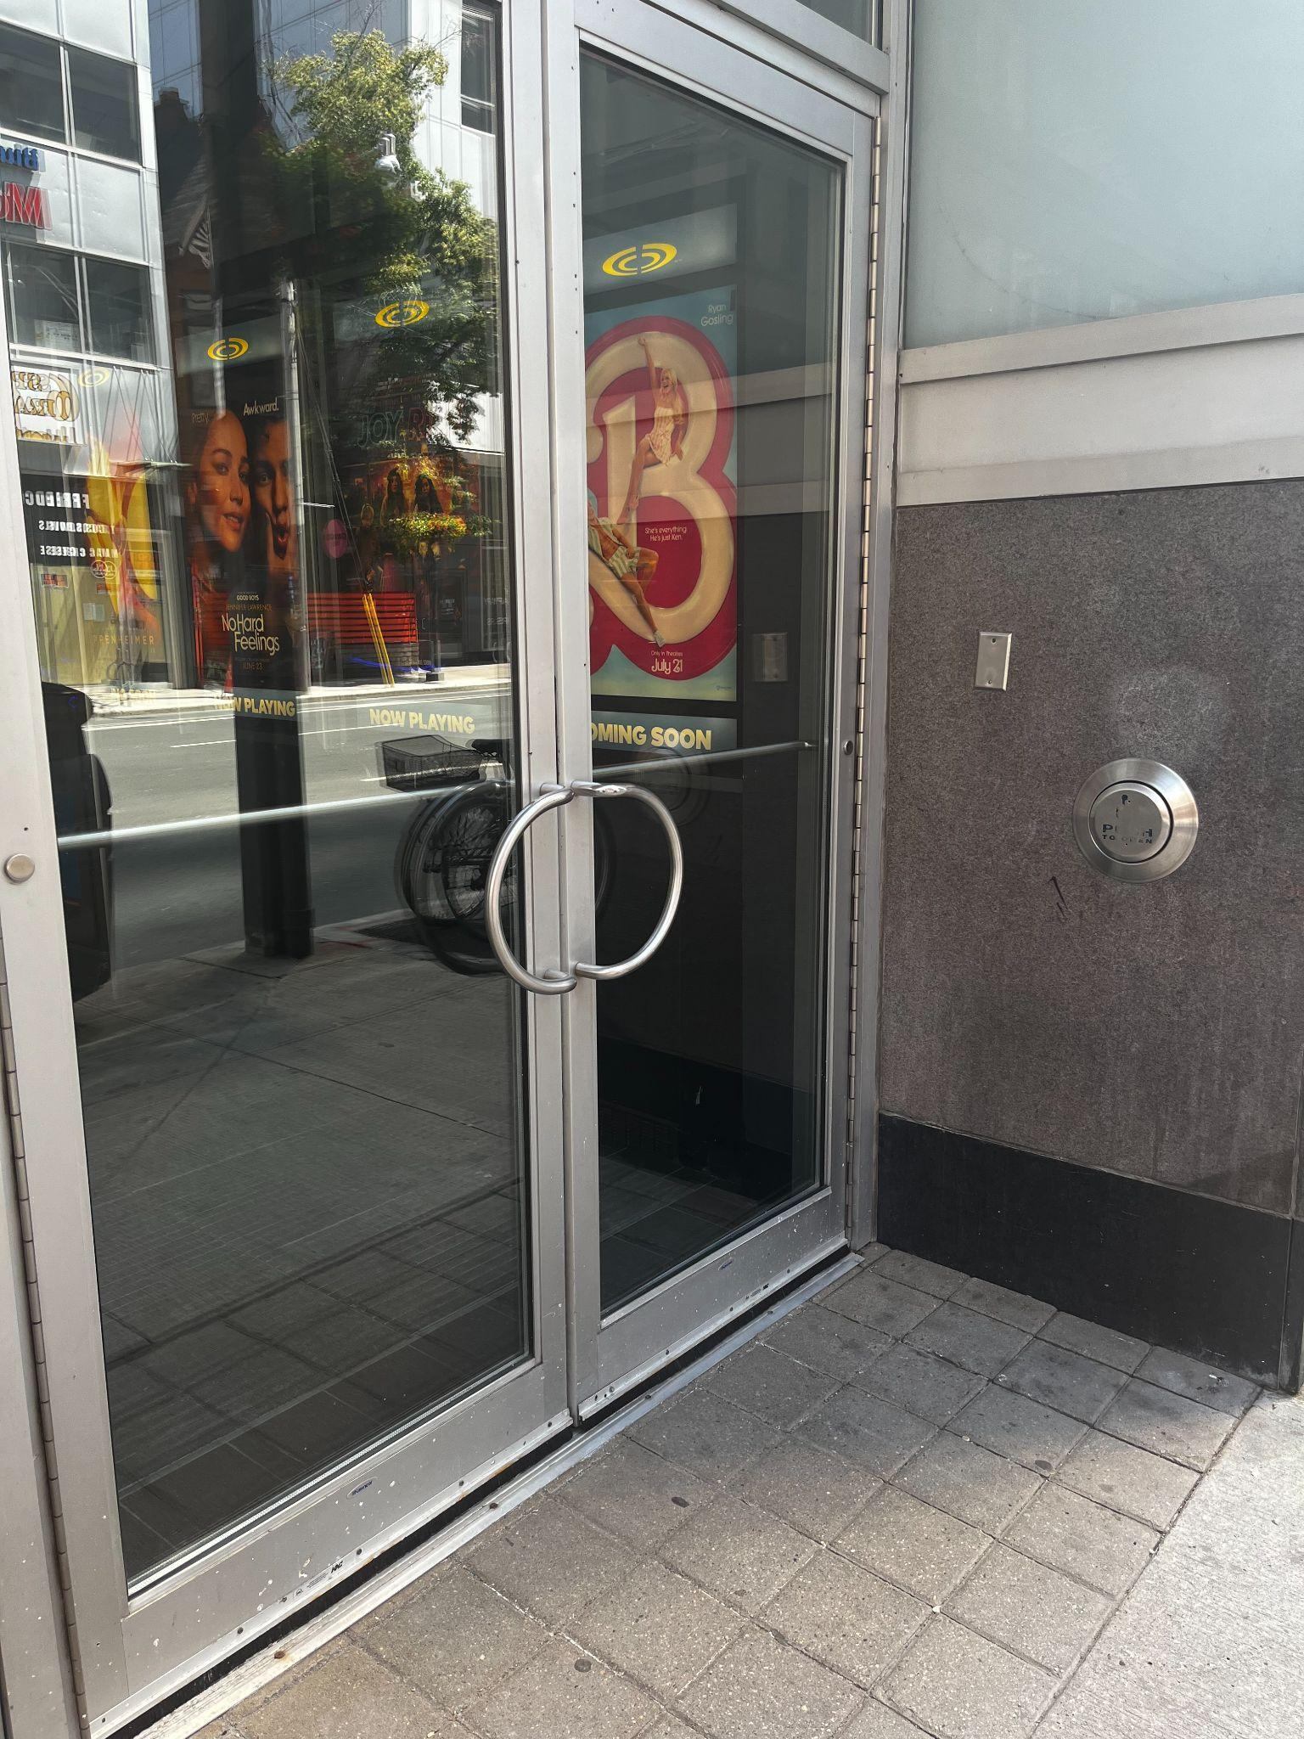
Figure 2: A photograph of the Scotiabank Theatre entrance with the accessible push-to-open button to the right side
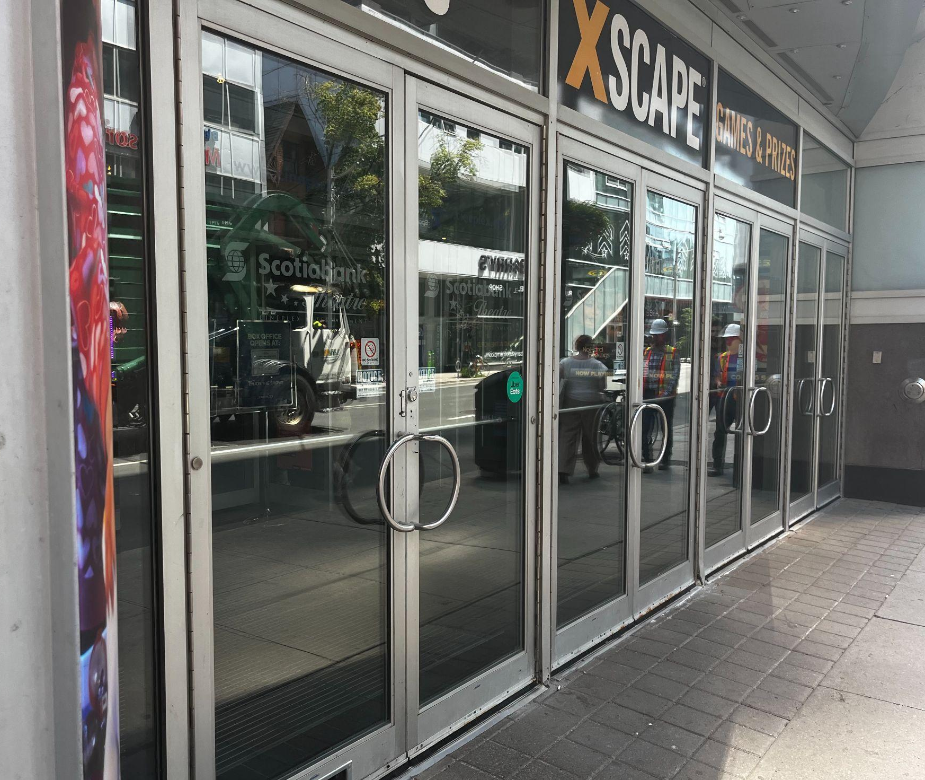
Figure 3: A photograph of the Scotiabank Theatre entrance doors

Rush lines
- Rush Lineups are located on Richmond St. heading west away from the entrance to the building. If the lineup is large it curves and heads South on Widmer.
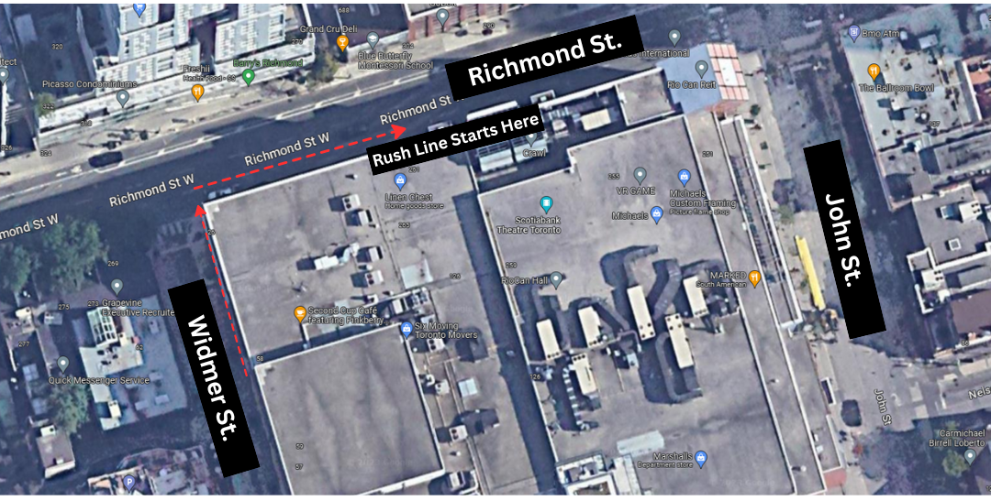
Figure 4: A photograph of the rush line for Scotiabank Theatre. An arrow pointing along Richmond St. W. and heading south down Widmer St.

Access to theatres
- Access to the theatres include stairs, escalators, and an elevator
- Patrons who need elevator access can find the elevators located to the right (south) of the “up” escalators
- There are 75 stairs to get to the second floor
- There is escalator access both up and down from the second floor
- There is a ramp to access theatres 5–11

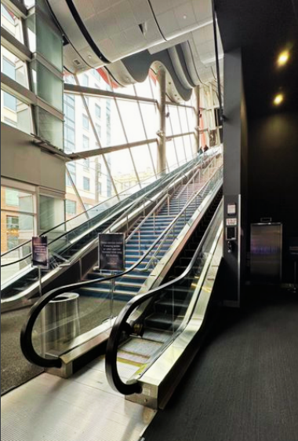
Figure 5: A photograph of the up and down escalators at Scotiabank Theatre. The “up” escalator is to the right and the “down” escalator to the left. The elevator is to the right of the escalators
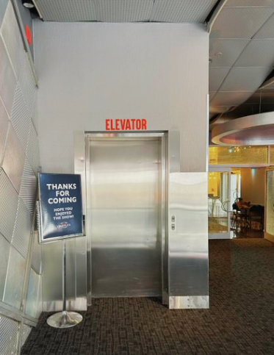
Figure 6: Elevators to exit
.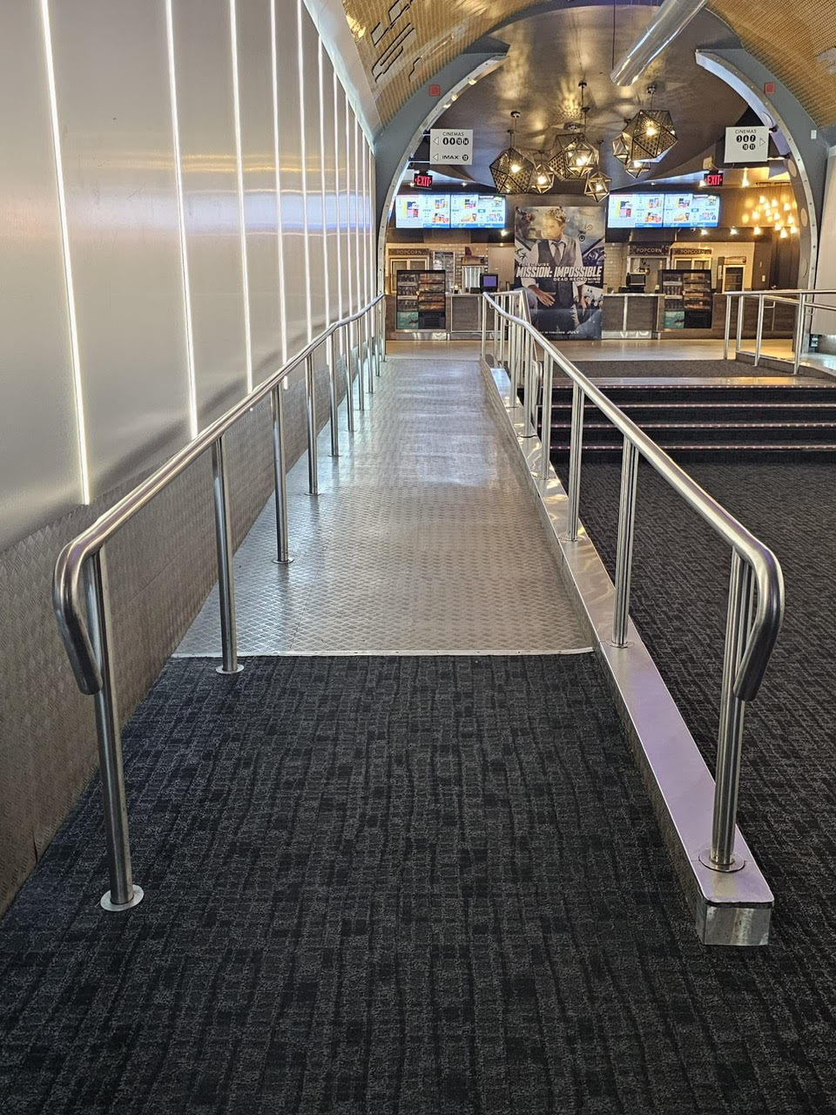
Figure 7: Photograph of the ramp leading towards cinemas 5–11.

Seating
*Most cinemas have 2–3 steps between each row. Cinemas 12 (IMAX) has 1–4 steps between rows
Cinema 1  Total Seats: 552 | Accessible Seating  4 seats | Companion Seats  2 seats | Step-Free seating  Row A
Cinema 2  Total seats: 475 | Accessible Seating  6 seats | Companion Seats  6 seats | Step-Free seating  Rows AA, BB, and A
Cinema 3  Total Seats: 386 | Accessible Seating  3 seats | Companion Seats  2 seats | Step-Free seating  Row A
Cinema 4  Total seats: 388 | Accessible Seating  3 seats | Companion Seats  1 | Step-Free seating  Row A
Cinema 5  Total seats: 134 | Accessible Seating  3 seats | Companion Seats  2 | Step-Free seating  Row A
Cinema 6  Total Seats: 137 | Accessible Seating  3 seats | Companion Seats  2 | Step-Free seating  Row A
Cinema 7  Total Seats: 184 | Accessible Seating  3 seats | Companion Seats  2 | Step-Free seating  Row A
Cinema 8  Total Seats: 178 | Accessible Seating  3 seats | Companion Seats  1 | Step-Free seating  Row A
Cinema 9  Total Seats: 192 | Accessible Seating  3 seats | Companion Seats  0 | Step-Free seating  Row A
Cinema 10  Total Seats: 228 | Accessible Seating  3 seats | Companion Seats  2 | Step-Free seating  Row A
Cinema 11  Total Seats: 227 | Accessible Seating  4 seats | Companion Seats  4 | Step-Free seating  Row A
Cinema 12 (IMAX)  Total Seats: 412 | Accessible Seating  4 seats | Companion Seats  2 | Step-Free seating  Row C
Cinema 13  Total Seats: 310 | Accessible Seating  4 seats | Companion Seats  2 | Step-Free seating  Row A
Cinema 14  Total Seats: 305 | Accessible Seating  4 seats | Companion Seats  2 | Step-Free seating  Row A

Assistive devices & services available
Closed Captions | Yes | - Captiview  - Compatible with all theatres
Assisted Listening | Yes | - Receivers with headset or neckloop option
Descriptive Sound | Yes | - Receivers with headset or neckloop option

Concession stand
- Food, drinks, and alcohol can be purchased the concessions and outtakes stands, or bar/lounge area
- No outside food or drinks
- Cash, Debit, and Credit are accepted
- Water fountains are available near the accessible washroom on the left side of the Outtakes counter
- Water Bottles can be refilled with concession attendants and audience members can request a cup of water

Washrooms
- The closest washrooms to the cinemas are located in the hallway directly across from Cinema 6 and are accessible
Figure 8: Photograph of accessible washroom near concession stand
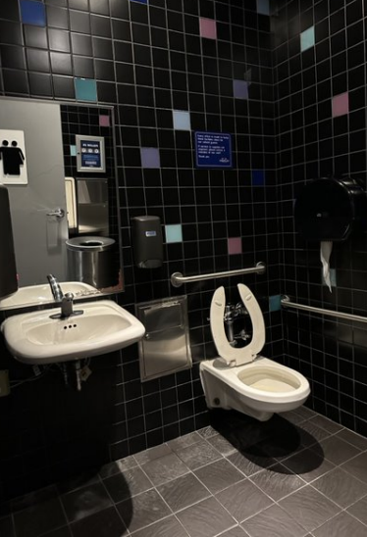
Gender Neutral | No
Sensored Flushing | Yes
Sensored Faucets | Yes
Automatic soap dispensers | Yes
Sensored hand dryers | Yes | No paper towel
Change Tables | Partial | Family Washroom near concession

