Glenn Gould Studios at the Canadian Broadcasting Centre Visual Guide

Location
250 Front Street West, Toronto, ON M5V 3G5

The closest intersection
Front St. W. & John St.
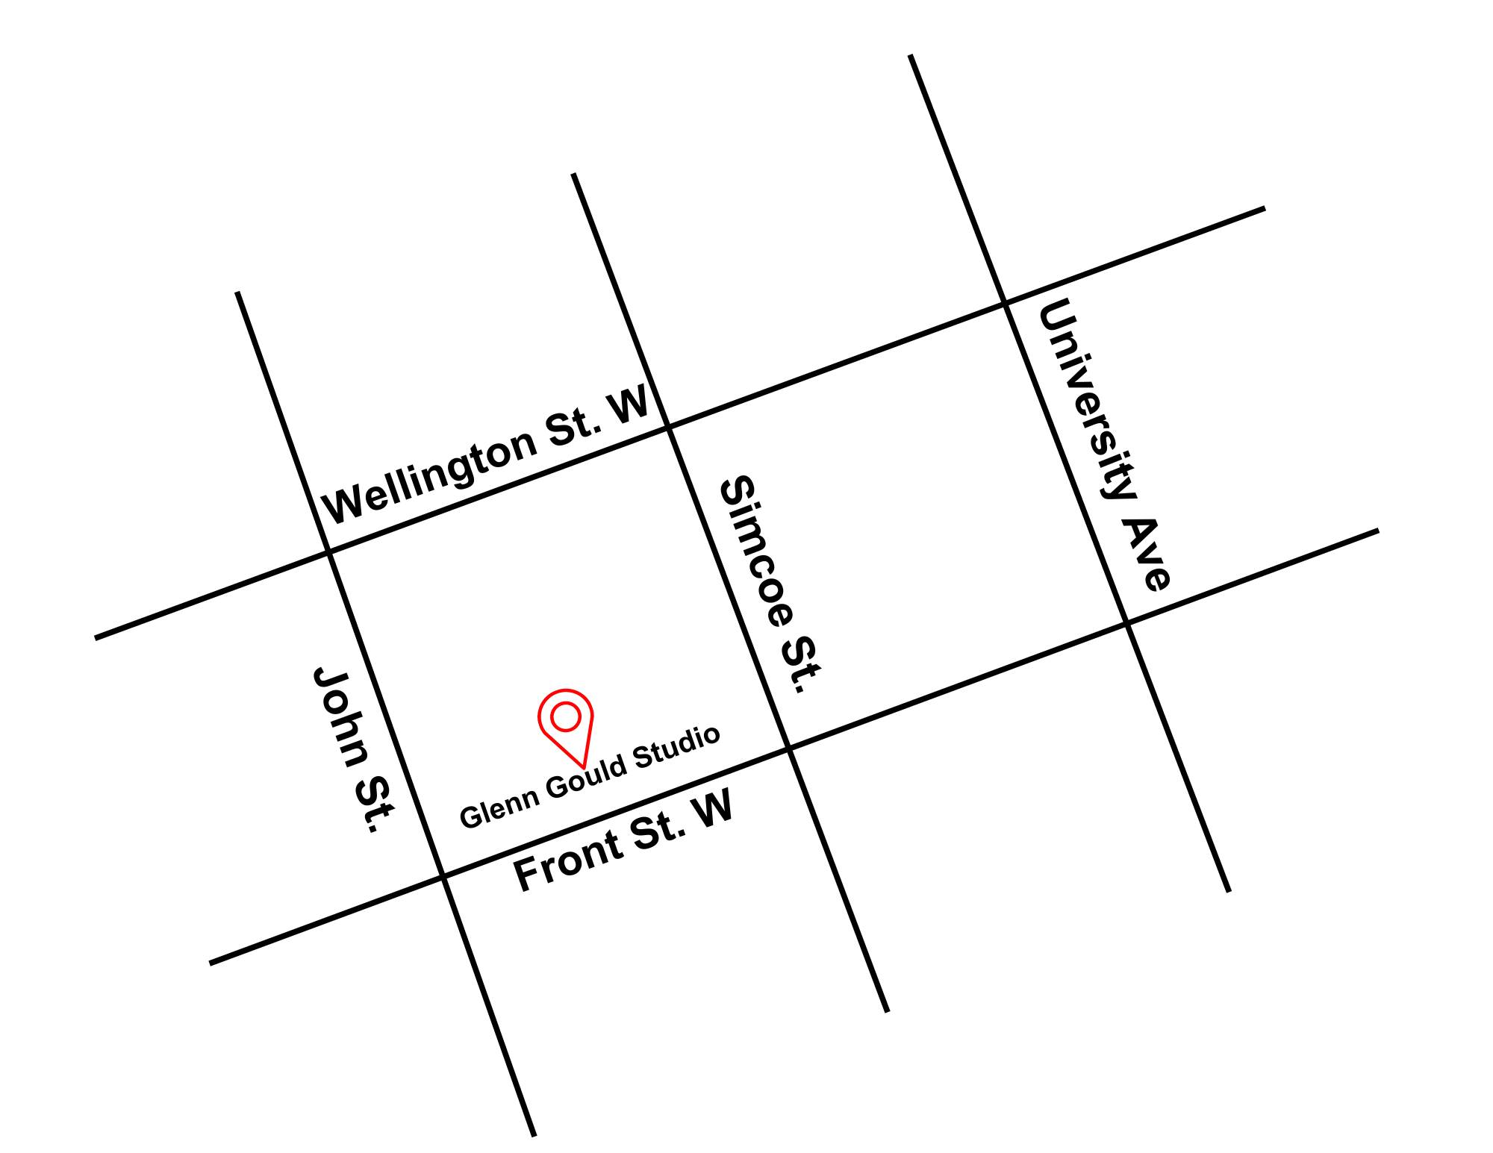
Figure 1: Map of downtown Toronto with Glenn Gould Studio at Front St. W. and John St., with Wellington St. W. to the North

Routes of arrival
Subway/GO Train/Via Rail
Glenn Gould Studio is located near Union Station. It is a 1.0 km walk via the PATH or 1.2 km walk via Front St. W.
Streetcar or bus
The King streetcar (Route 504) stops at the corner of King Street & University Street. It is a 4-minute or 300 m walk from the streetcar.
Driving
There is indoor parking available at 315 Front St. Reservations can be made online in advance at bestparking.com. Parking is also available at 306 Front St. W. It is a 2-minute or 150 m walk from the parking to Glenn Gould Studios.

The entrance and lobby
- Front entrance can be accessed by an accessible button to activate.
- There are no tactile tiles available at the entrance.
- Front Street is the best entrance for accessibility needs.
- Main Front Street entrance are double doors and 32" each in width. When both are open, it gives a 64" opening.
- Theatre doors are 36" wide each. When both are open, it gives a 72" opening.
- There is an overhang for protection from the elements.

Access to theatres
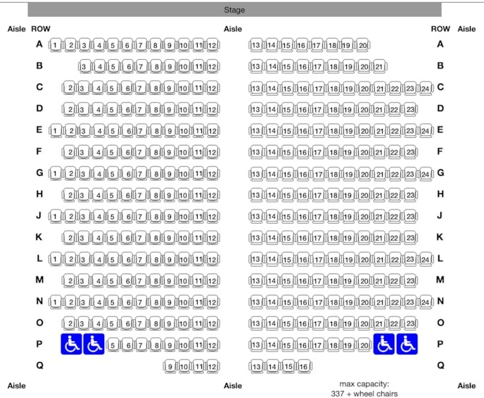
Figure 2: A seating map of Glenn Gould Studios. The wheelchair seating are to the left and right of Row P with blue wheelchair icons
- 337 seats with general admission
- Four permanent wheelchair positions located in the last row

Accessibility services and devices available:
Closed Captions | N/A
Assisted Listening | Yes | Receivers can be used with single use earbuds or neckloop. Assisted listening only in the main theatre.
Descriptive Sound | N/A

