

TIFF Lightbox

Venue Access Guide

TIFF Lightbox Venue Access Guide
Overview
This guide provides accessibility information to support visitors in planning their experience. If you have specific access needs, we recommend contacting the venue in advance.

Location
350 King Street West, Toronto, ON M5V 3X5

Closest intersection
King St. W. and John St.
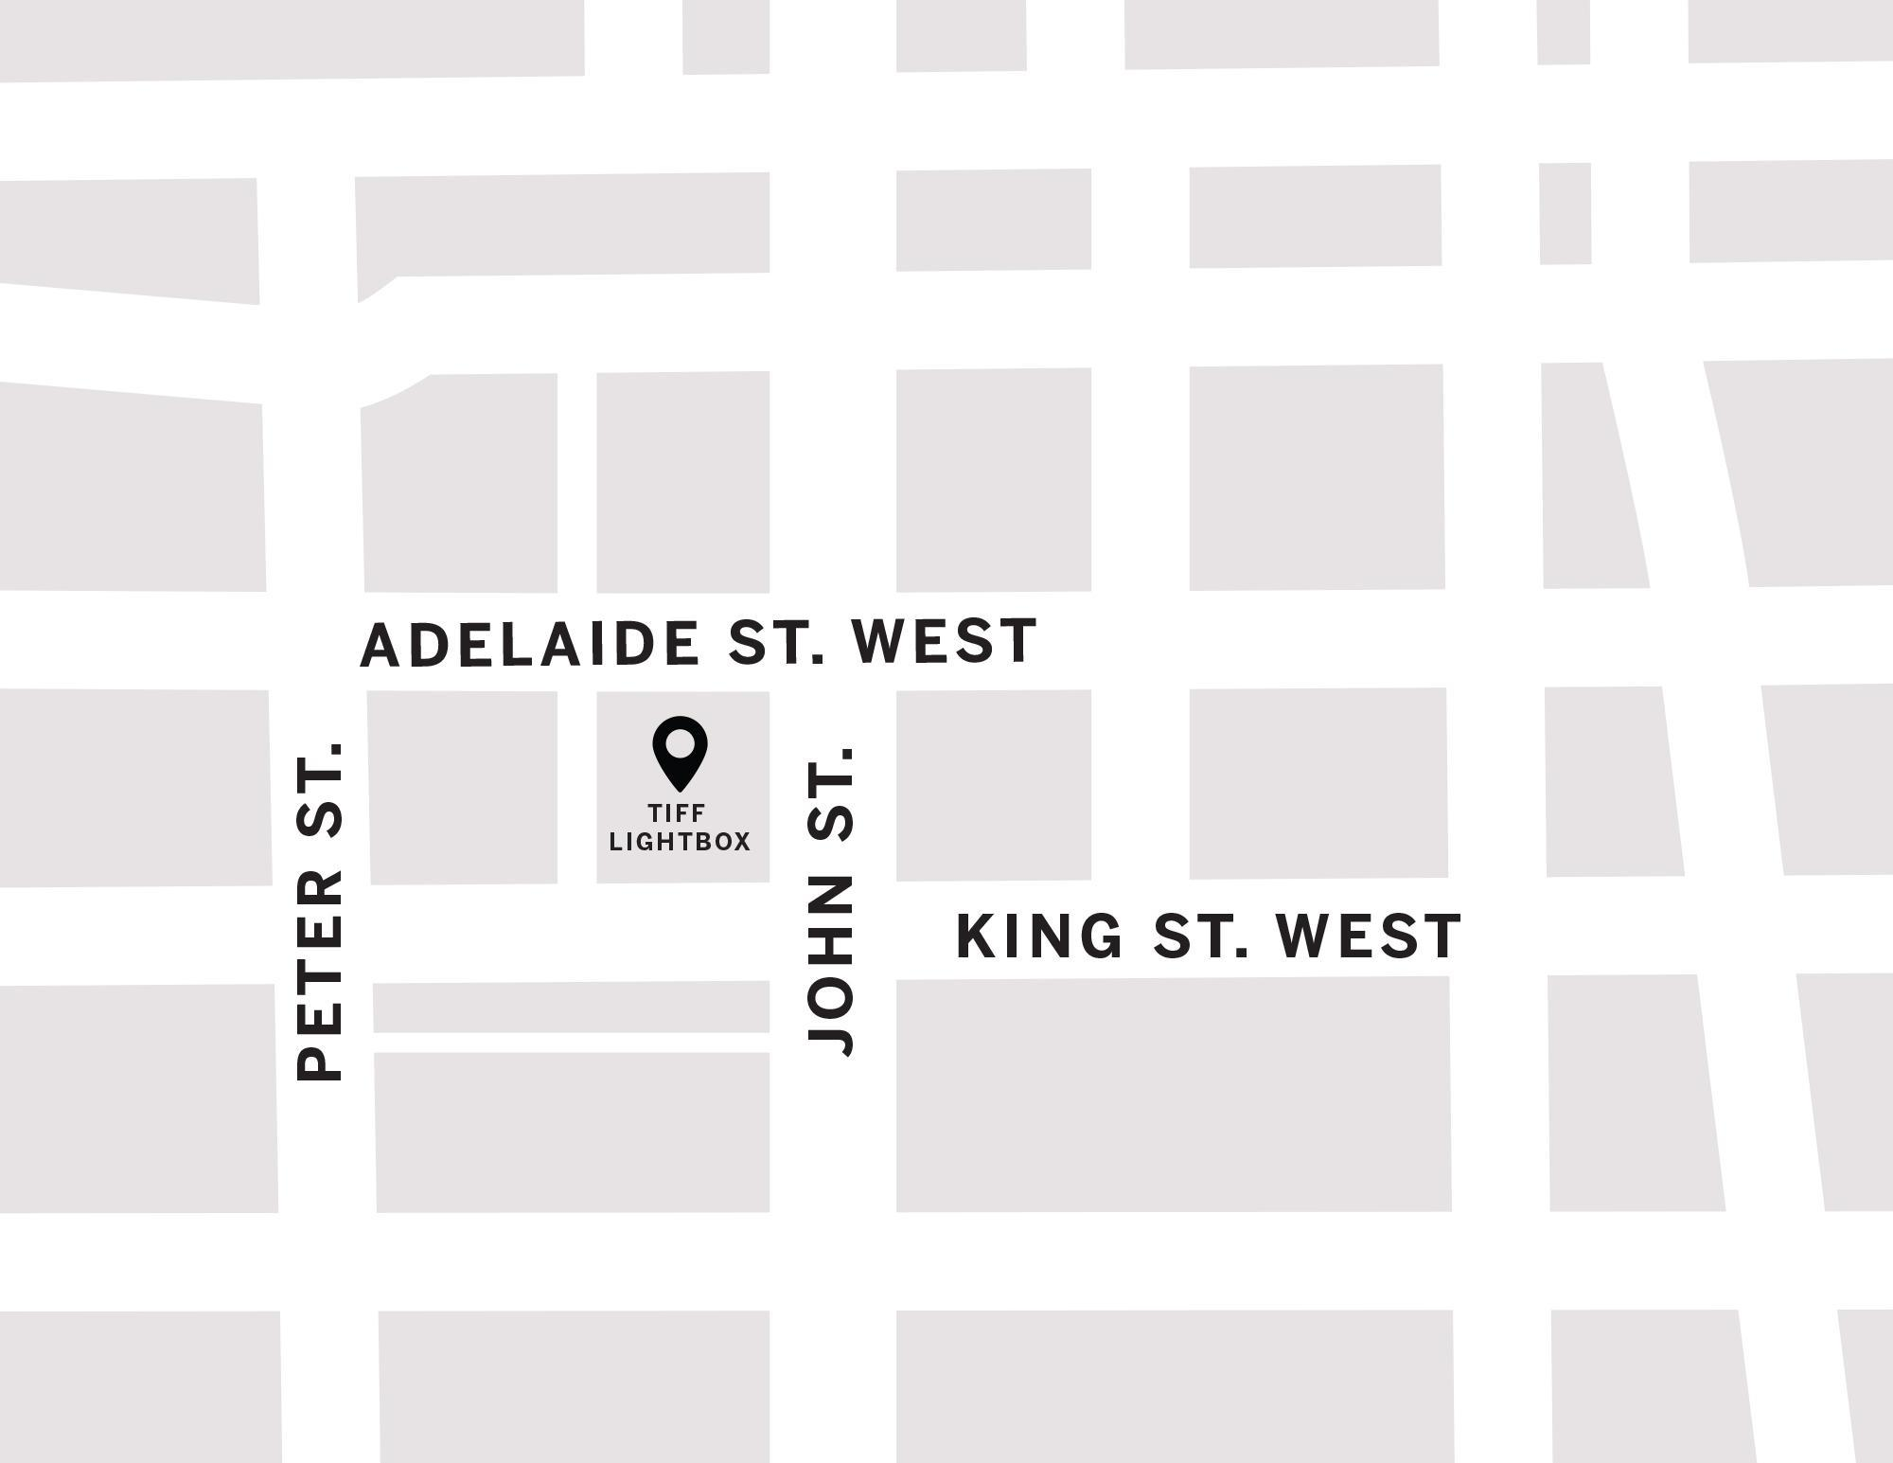
Figure 1: A Map of downtown Toronto with TIFF Lightbox between John St. and Peter St. to the west and east and Adelaide St. W. and King St. W. to the north and south.

General information
- This venue has reserved seating

Getting There
Please see Festival Street closures
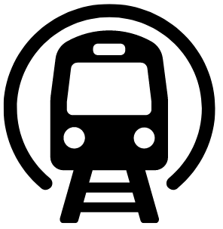
Subway
TIFF Lightbox (TLB) is closest to the St. Andrew subway station on Line 1. TLB is 450m (about a 6-minute walk at an average pace; travel time may vary) from the subway.
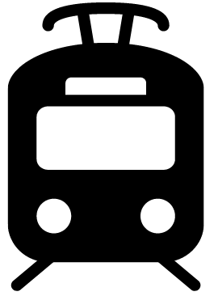
Streetcar or bus
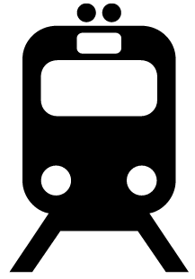
During the first weekend of the Festival, the King streetcar (Route 504) stops at the corner of King Street & University Ave., or the corner of King St. and Spadina Ave. It is diverted to Adelaide between these stops during this time. After the first weekend of the Festival onwards, the King streetcar (Route 504) stops at the corner of King St. and John St., in front of TIFF Lightbox (TLB).
GO Transit or VIA Rail

TIFF Lightbox is 850 m (about a 15-minute walk at an average pace; travel time may vary) from Union Station. It can also be reached by subway (one stop from Union Station to St. Andrew Station).
Driving
Paid underground parking is available at TLB, but it is not operated by TIFF.

Reitman Square parking
- Precise ParkLink runs the underground parking at TLB
    - Note: P2 is not available from the elevator. It must be accessed from P1 or P3, then by taking the ramp up/down
    - Parking App Code: #1176

Arrival and entrance
- The front entrance is step-free and includes automatic sliding doors
- An overhang provides protection from weather
- There are currently no tactile walking surface indicators at the entrance or drop-off areas
- A sloped roadway is located directly in front of the building

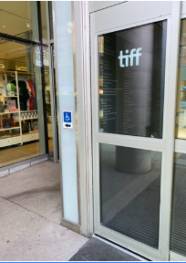
Figure 2: The door on the left side has a pressure sensitive plate for opening.

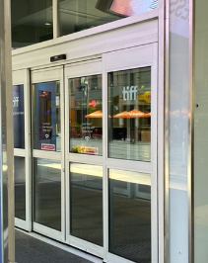
Figure 3: The larger doors on the right side have movement sensors which will automatically open for you.

Rush line
The rush line is located on the west side of the King Street entrance and extends toward Widmer Street.
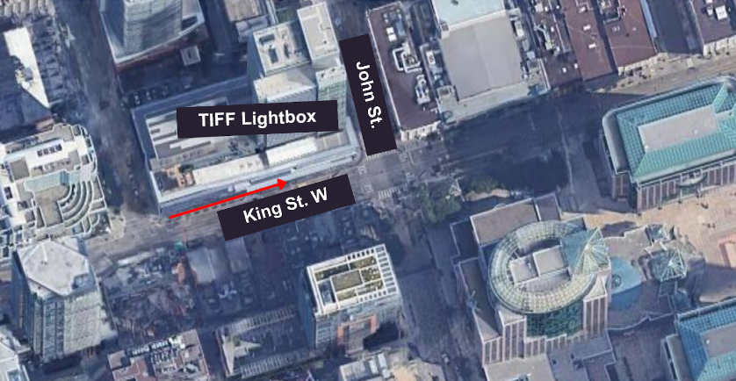
Figure 4: Map of TIFF Lightbox rush line from an aerial view

Access to theatres and seating
Access to theatres
- The building includes escalators, stairs, and elevators connecting all levels
- Elevators are located beside the escalators and provide step-free access to all cinema levels
- Cinemas are located on multiple floors:
  - Cinemas 1-3: second floor
  - Cinemas 4-5: third floor
- On the second floor, a ramp and stairs provide access to the concession area and Cinemas 1-3
- Elevators include both a touchscreen and keypad for floor selection, and provide audible floor announcements
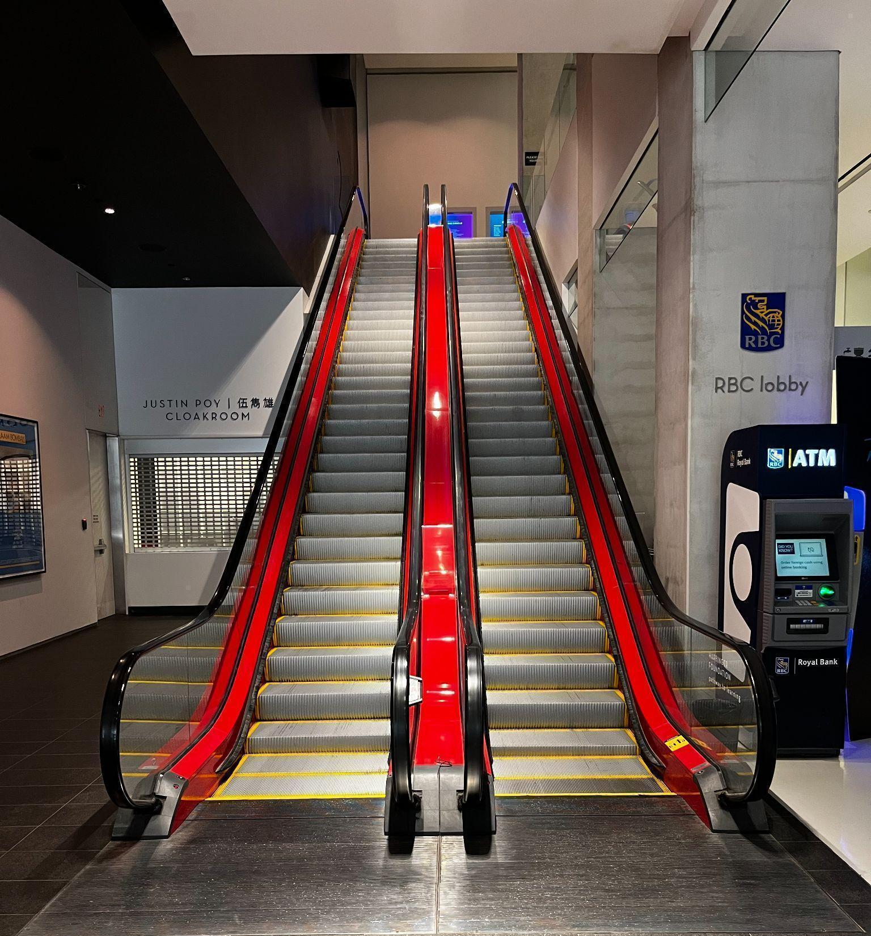
Figure 5: Photograph of the escalators in the front lobby of TIFF Lightbox. The escalator to the right will allow you to move upwards to the second floor.
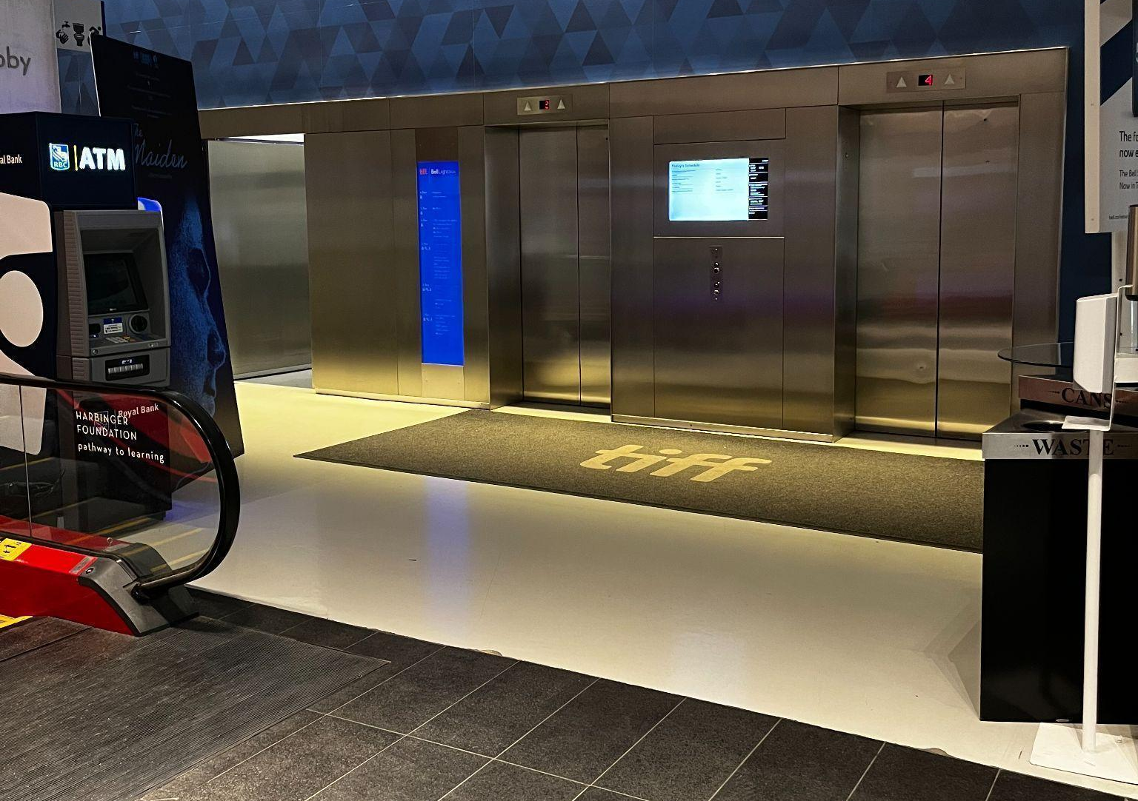
Figure 6: Photograph of the two metal elevators on the right side of the Atrium beside the escalators.
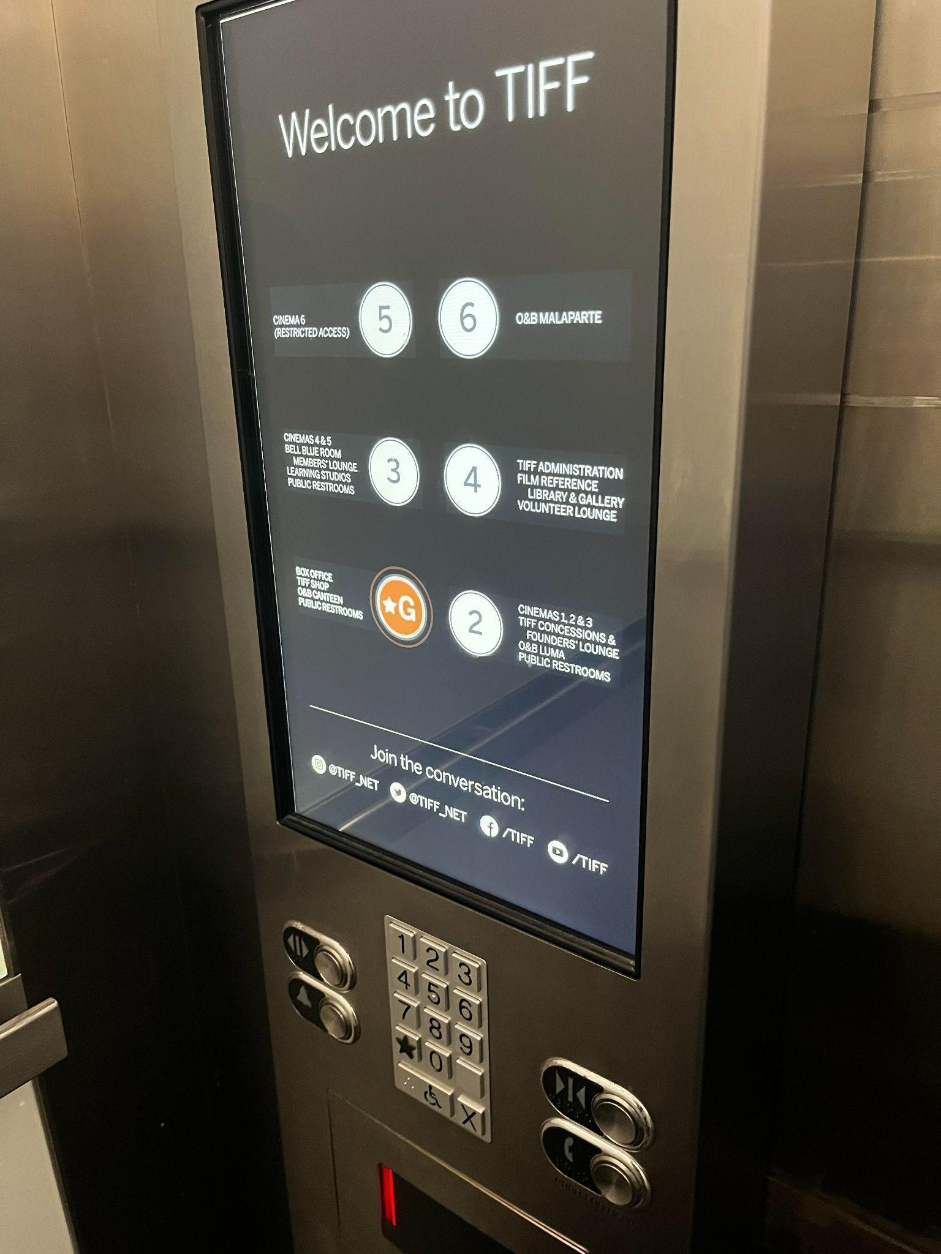
Figure 7: Photograph of elevator touch screen and keypad underneath

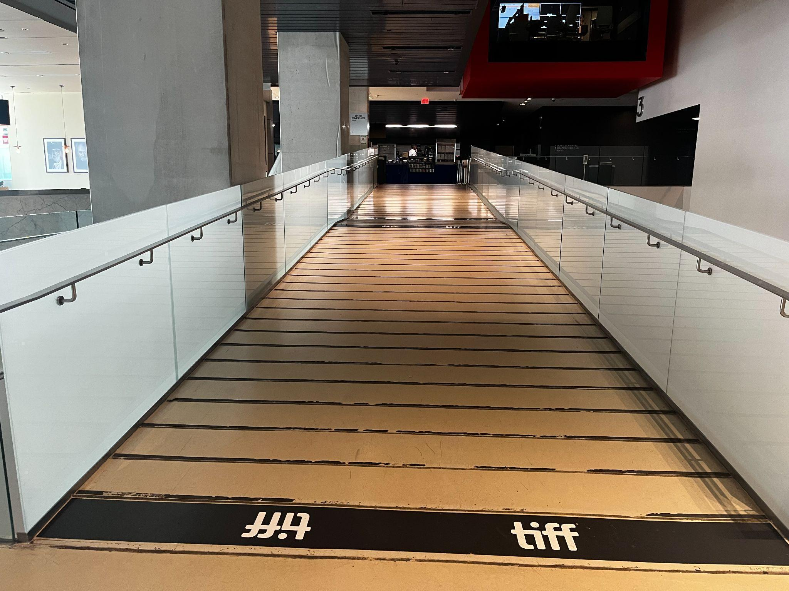
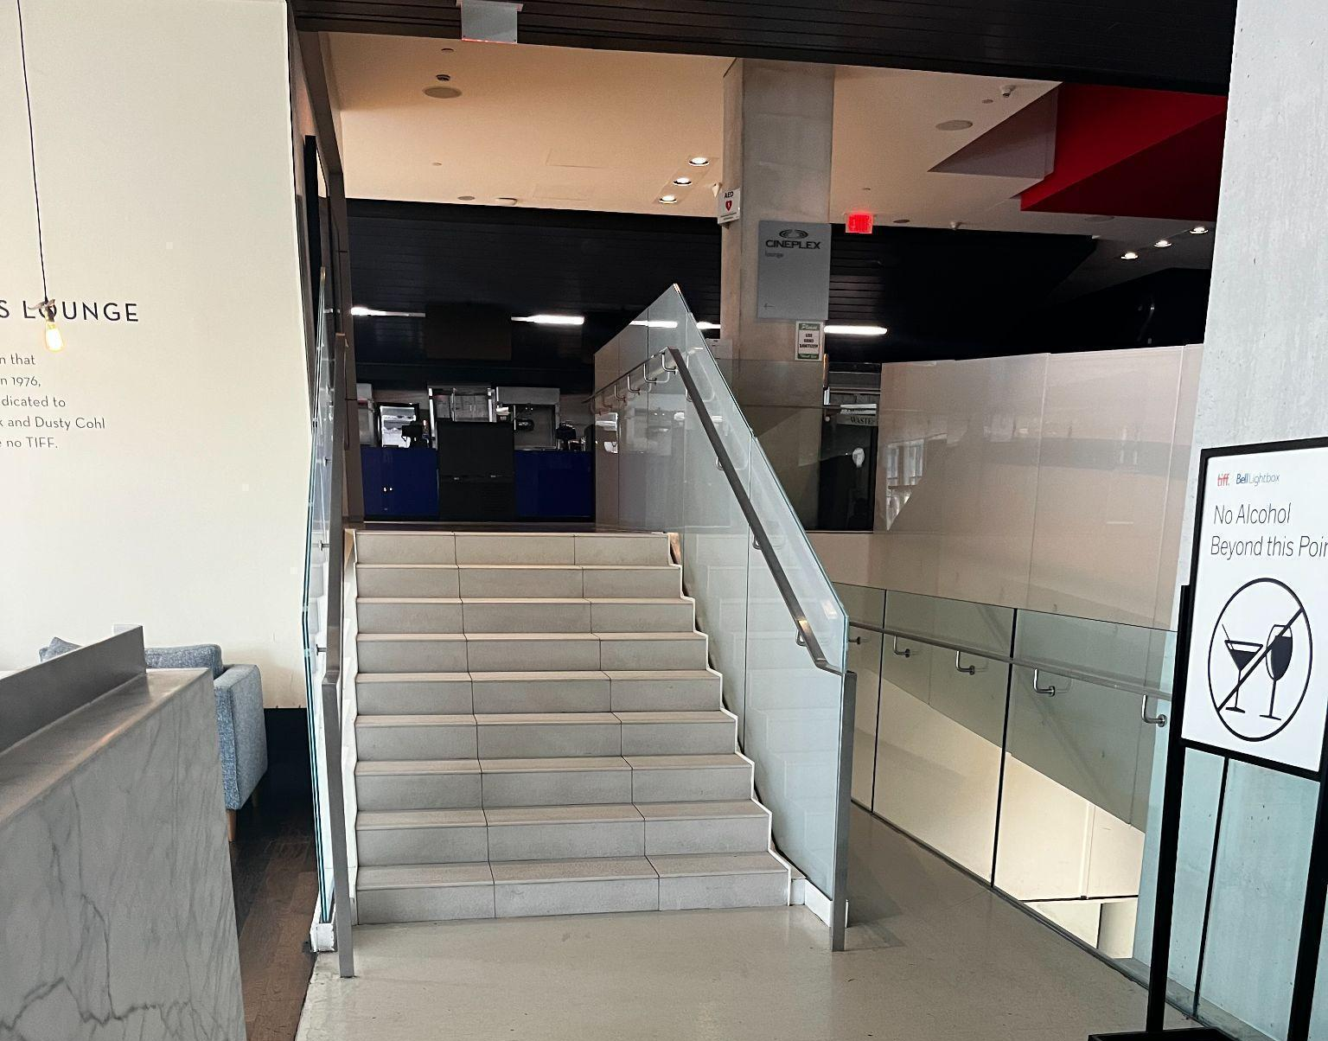
Figures 8 and 9: Photograph of ramp on second floor and stairs to the left of the ramp

Venue measurements
Door/Area | W x H | Notes
Front Doors (Double doors) | 10' x 7' | 10'x 7' per door + couple of inches added on each side for metal frame
Front Door (Handicap accessible) | 41.5" x 94"
Curb Height (front doors) | 6 inches
Escalator (width) | 40 inches
Elevator Door | 41.5" x 83"
Cinema 1 Doors | 83.5" x 83"
Cinema 2 Doors | 70" x 92"
Cinema 3 Doors | 42" x 96"
Cinema 4 Doors | 6' x 8'
Cinema 5 Doors | 6' x 8' 4"
Gallery Doors | 42" x 99" | Door exterior is 42" - once door opened space narrows down due to existing wall (4 inches width)
TIFF Shop (width) | 195.5 inches
Box Office Counter | 224.5" x 34"
Second Floor Accessibility Ramp | 112 inches
Accessible Washroom 1 - Main floor (Exterior door) | 50.5" x 98"
Accessible Washroom 1 - Main floor (Washroom door) | 34.5" x 78.5"
Accessible Washrooms 2 - Second Floor (Exterior entrance) | 61.5" x 83.5" | First Entrance with WASHROOMS sign
Accessible Washrooms 2 - Second floor (Washroom entrance) | 58" x 92" | Main washroom entrance
Accessible Washrooms 2 - Second floor (Washroom with stairs) | 56.5" x 93.5"
Accessible Washrooms 2 - Second floor (2 washrooms with doors) | 35" x 78" | 2 Handicap accessible washrooms
Accessible Washroom 3 - Third floor (exterior door) | 61.5 inches | First Entrance with WASHROOMS sign
Accessible Washroom 3 - Third floor (Washroom entrance) | 46 inches | Main washroom entrance is 11' width, then there two entrances (right & left) ; those two are 46"
Varda (exterior entrance) | 40 inches
Varda (Main door) | 37.5" x 96"

Accessible seating options
- Accessible seat spaces:
Open floor spaces are designed for mobility devices. Each space is sold as one ticket.
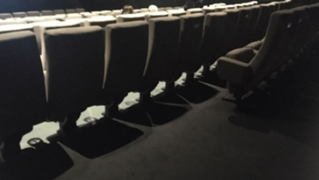
Figure 10: Example of accessible open floor spaces
- Accessible jump seat:
Fold-up seats that can be raised to create space for a mobility device. These seats do not have armrests.
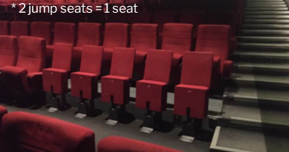
Figure 11: Example of jump seating found in cinemas

- Companion seating:
Standard seats located beside accessible seating spaces for use by support persons or companions.
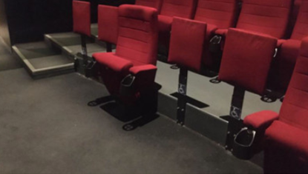
Figure 12: Example of companion seat location

Cinema | Typical Seating | Accessible Seating | Companion Seating | Step-Free
Cinema 1 | 523 seats | 5 spaces available; 3 of these are in front of the jump seats | 3 seats | Row F
Cinema 2 | 353 seats | 4 spaces available, all in front of the jump seats | seat + 1 jump seat | Row E
Cinema 3 | 223 seats | 3 spaces available | 2 seats | Row A
Cinema 4 | 147 seats | 3 spaces available | 1 seat | N/A
Cinema 5 | 45 seats | 2 spaces available | 1 seat | Row A
Cinema 6 | 39 seats | 2 spaces available | N/A | Row A

Seating maps for each cinema are linked in the table above. You can also access all seating maps by clicking here.

Assistive devices and services available
Feature | Availability | Device | Notes
Closed Captions | Yes | CaptiView
Assisted Listening | Yes | Receiver with disposable earbud, limited neck loops available
Audio Description | Yes | Receivers with disposable earbuds | Closed Captions or Audio Description are subject to content including a Closed Caption and/or Audio Description option

Concession stand

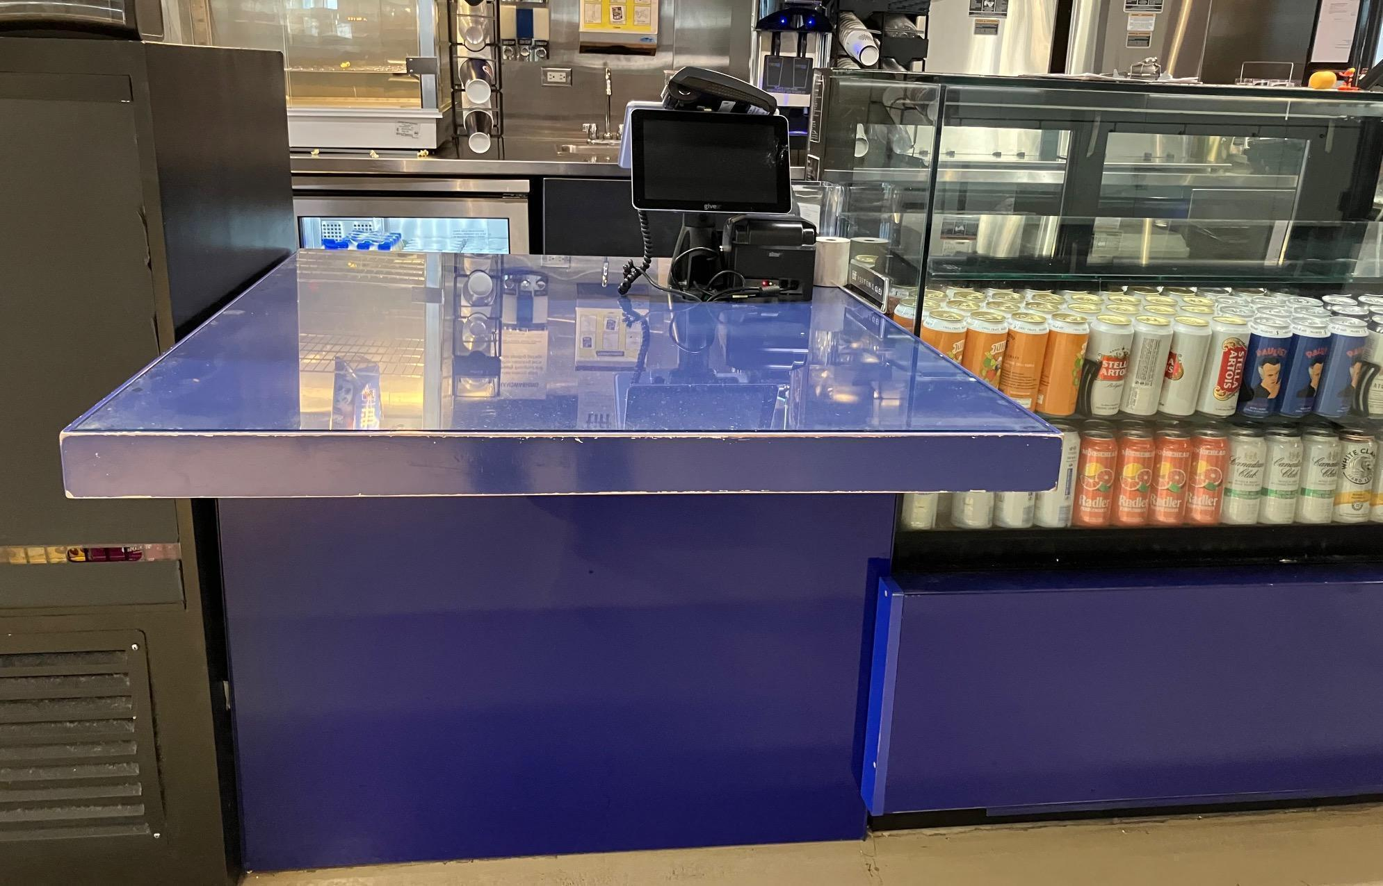
Figure 13: Photograph of accessible counter at the concession stand

- Refillable water bottles and coffee containers are allowed
- A water bottle refill station is located on the second floor, near the concession stand
- Alcohol is permitted inside the cinema if purchased through Concessions.
- Cash, debit, and credit are accepted

Varda (Café-Bar)
Varda is a café-bar located on the third floor, accessible via the escalators and elevators.

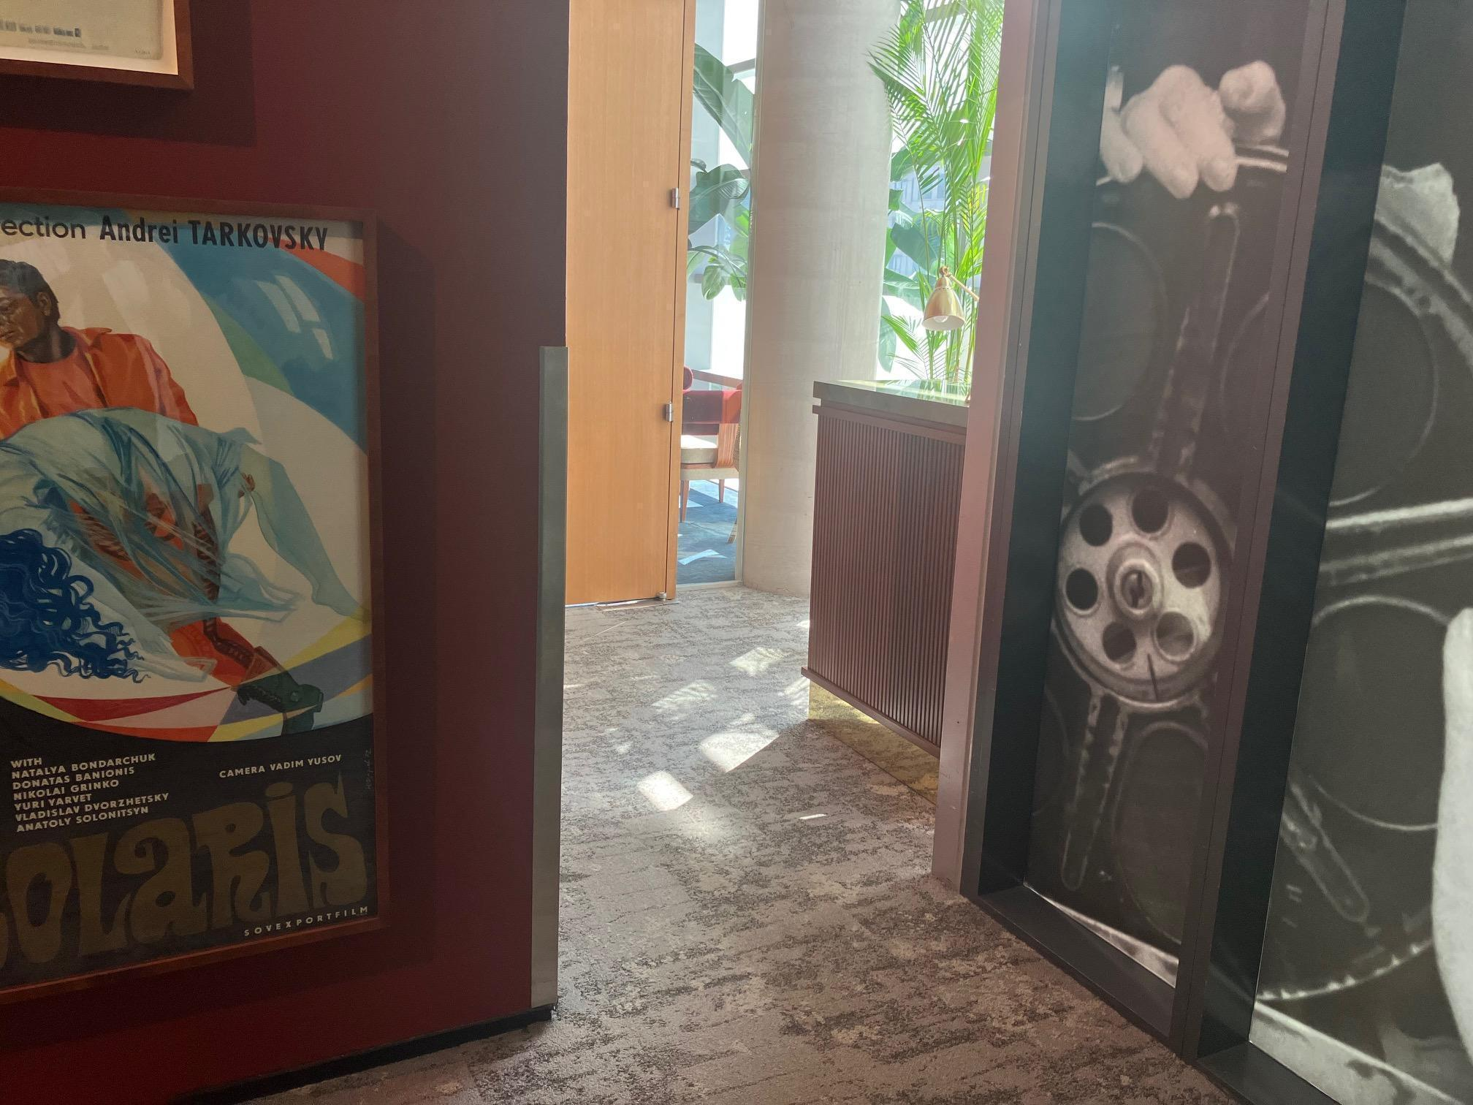
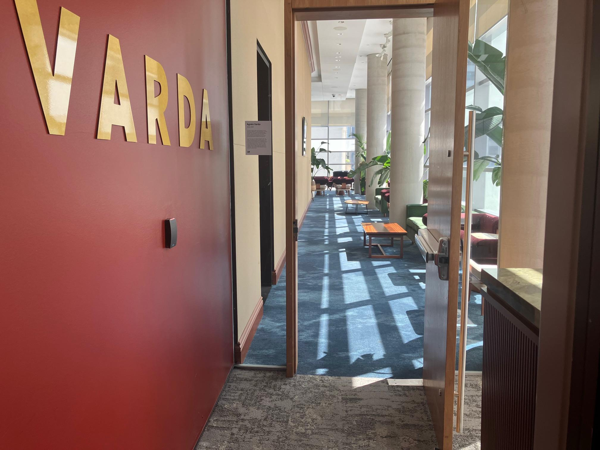
Figure 14 & 15: Photographs of entrance doors leading to Varda

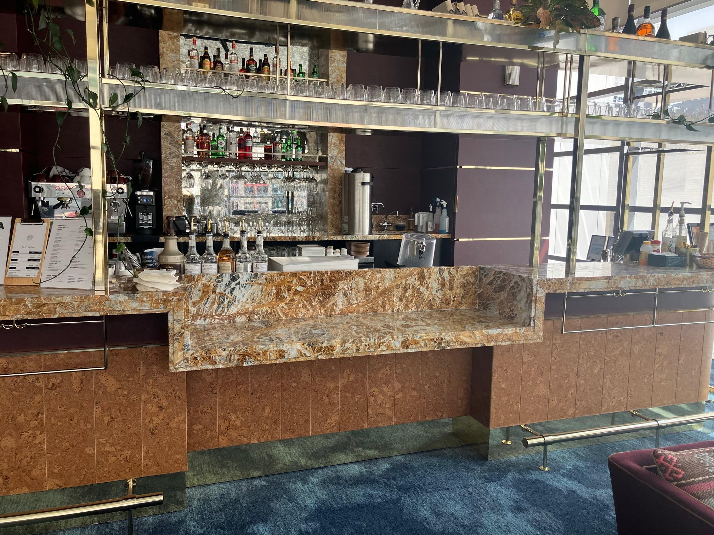
Figure 16: Photograph of accessible counter at the bar inside Varda.

Restaurants (Oliver & Bonacini Spaces)
Luma ( Floor 2 or Second Floor) and Malaparte ( Floor 6 or Sixth Floor)

Entrance and Interior
- Pedestrian routes to and from the main entrance to both restaurants have a level path
- All entrances and interior pathways accommodate mobility devices
- Elevators are available

Washrooms
- Designated accessible washrooms with a level path are available in both restaurantsAutomatic door openers are not provided

Washrooms
Feature | Availability | Notes
Gender neutral | Yes | All levels
Sensored flushing | Yes | All levels
Sensored faucets | Yes | All levels
Automatic soap dispensers | Yes | All levels
Sensored paper towel or hand dryer | No | Manual paper towel
Change tables | Partial | 2nd floor only

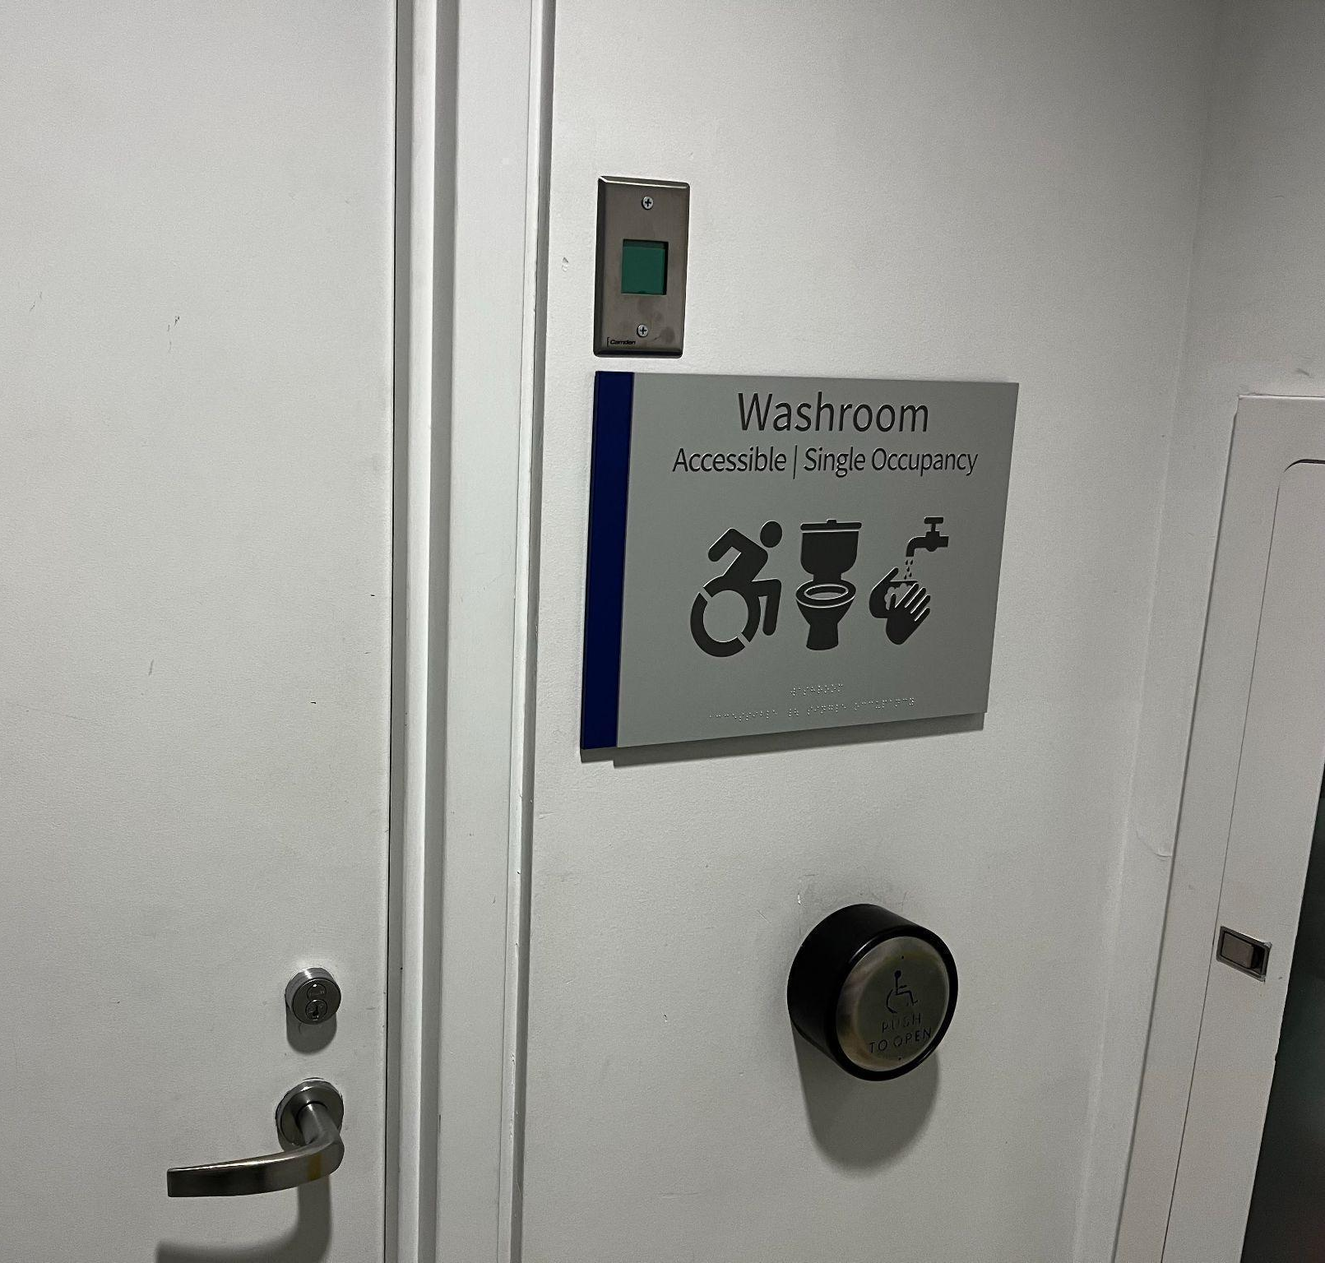
Figure 17: Washroom signs will indicate facilities available inside.
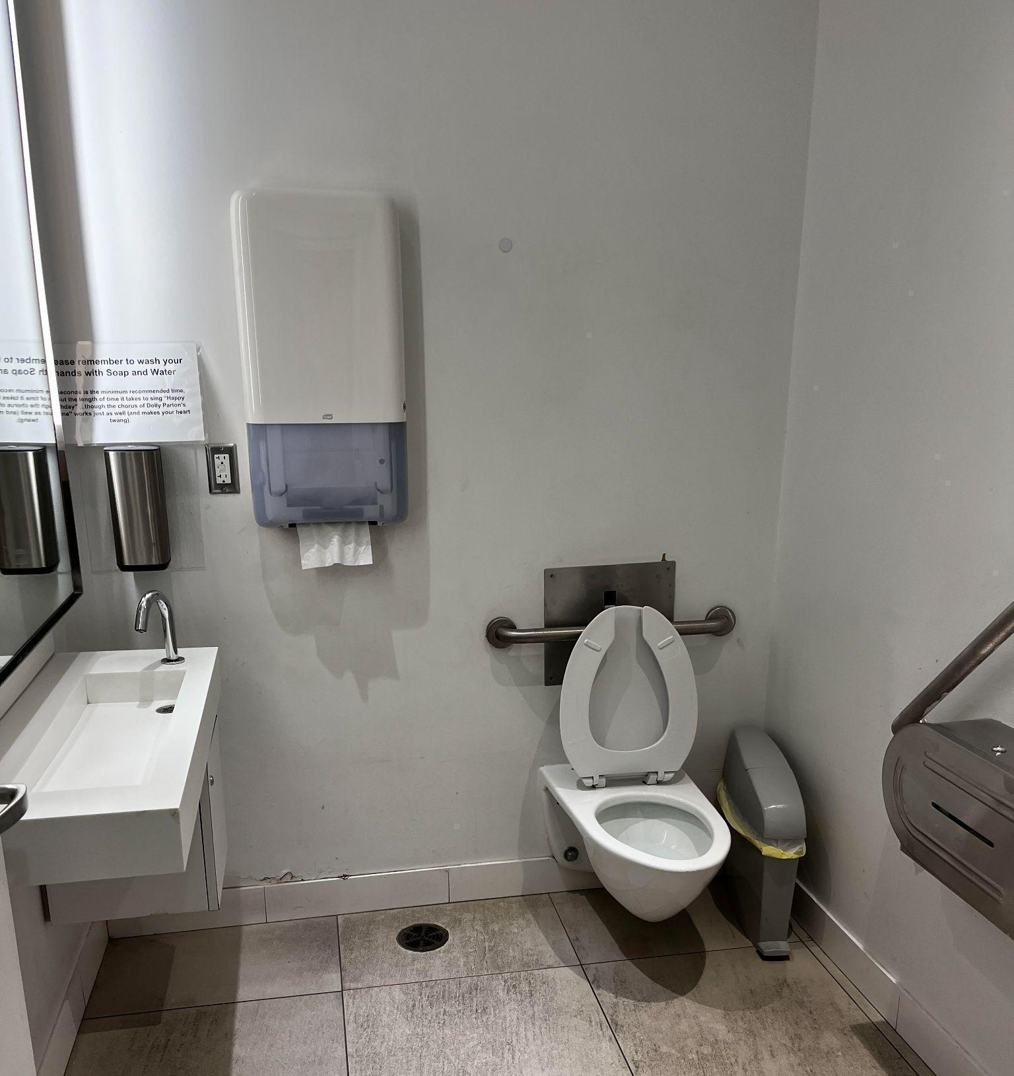
Figure 18: Example image of the washroom in Atrium. The washroom can be found underneath the back of
the escalators.

- The lobby washroom is located underneath the back of the escalators
- From the elevators, washrooms are located to the right

