

TIFF Lightbox Visual Guide

Location
350 King Street West, Toronto, ON M5V 3X5

Closest intersection
King St. W. and John St.
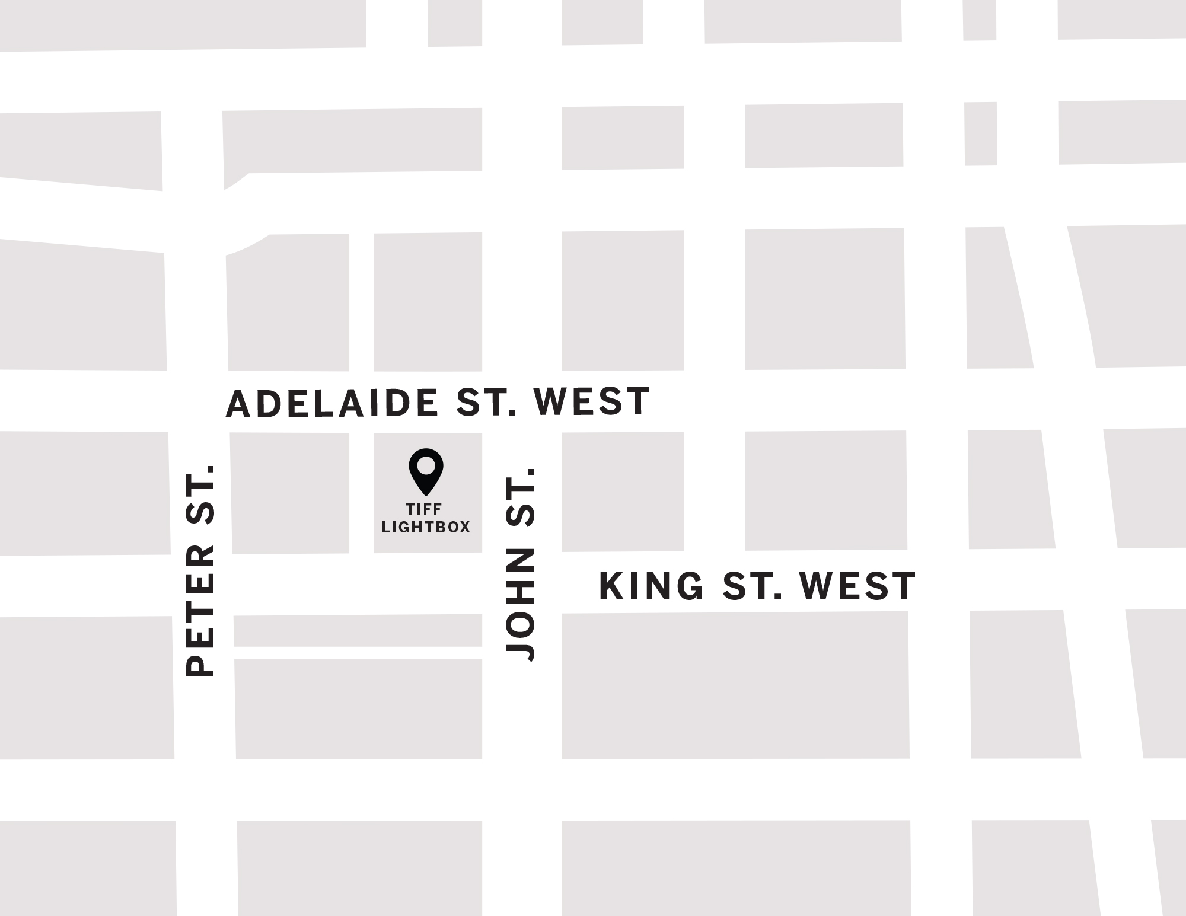
Figure 1: A Map of downtown Toronto with TIFF Lightbox between John St. and Peter St. to the west and east and Adelaide St. W. and King St. W. to the north and south.

General information
- This venue has reserved seating

Routes of arrival
*Please see Festival Street closures
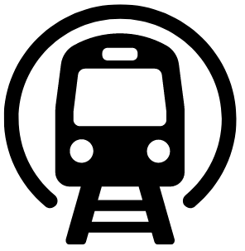
Subway
TIFF Lightbox is closest to the St. Andrew subway station on Line 1. TIFF is a 450 m or 6-minute walk from the subway.
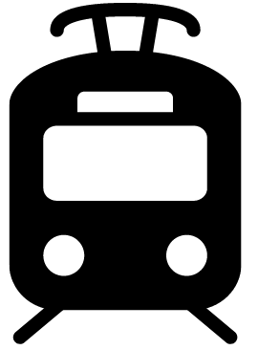
Streetcar or bus
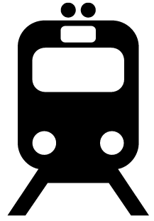
From September 4th to September 7th, the King streetcar (Route 504) stops at the corner of King Street & University Ave., or the corner of King St. and Spadina Ave. It is diverted to Adelaide between these stops during those dates. From September 8th onwards, the King streetcar (Route 504) stops at the corner of King St. and John St., in front of TIFF Lightbox.
GO Transit or VIA Rail

TIFF Lightbox is a 550 m or 15-minute walk from Union Station. It can also be reached by subway (one stop from Union Station to St. Andrew).
Driving
Paid underground parking is available at TLB, but it is not operated by TIFF.

Reitman Square parking
- Precise ParkLink runs the underground parking at TLB
    - Note: P2 is not available from the elevator. It must be accessed from P1 or P3, then by taking the ramp up/down
    - Parking App Code: #1176

The entrance and lobby

- The front entrance to the TLB is step-free
- There is an overhang for protection from wind and rain
- There are currently no tactile colour-contrast cane detection tiles or truncated domes at the entrance or drop-off areas
- There is a small road ramp directly in front of the building
- The entrance utilizes double automatic sliding doors

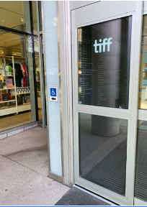
Figure 2: The door on the left side has a pressure sensitive plate for opening.

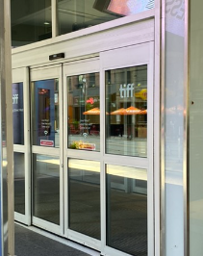
Figure 3: The larger doors on the right side have movement sensors which will automatically open for you.

Rush line
Located outside TIFF Lightbox on the west side of the King Street entrance and extends towards Widmer Street.
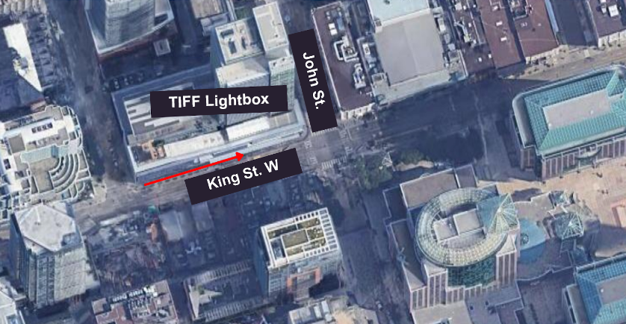
Figure 4: Map of TIFF Lightbox rush line from an aerial view

Access to theatres and seating
- TIFF Lightbox has two escalators leading up to and from the atrium lobby
The escalator on the right side from the ground floor leads upwards to Cinemas 1–3
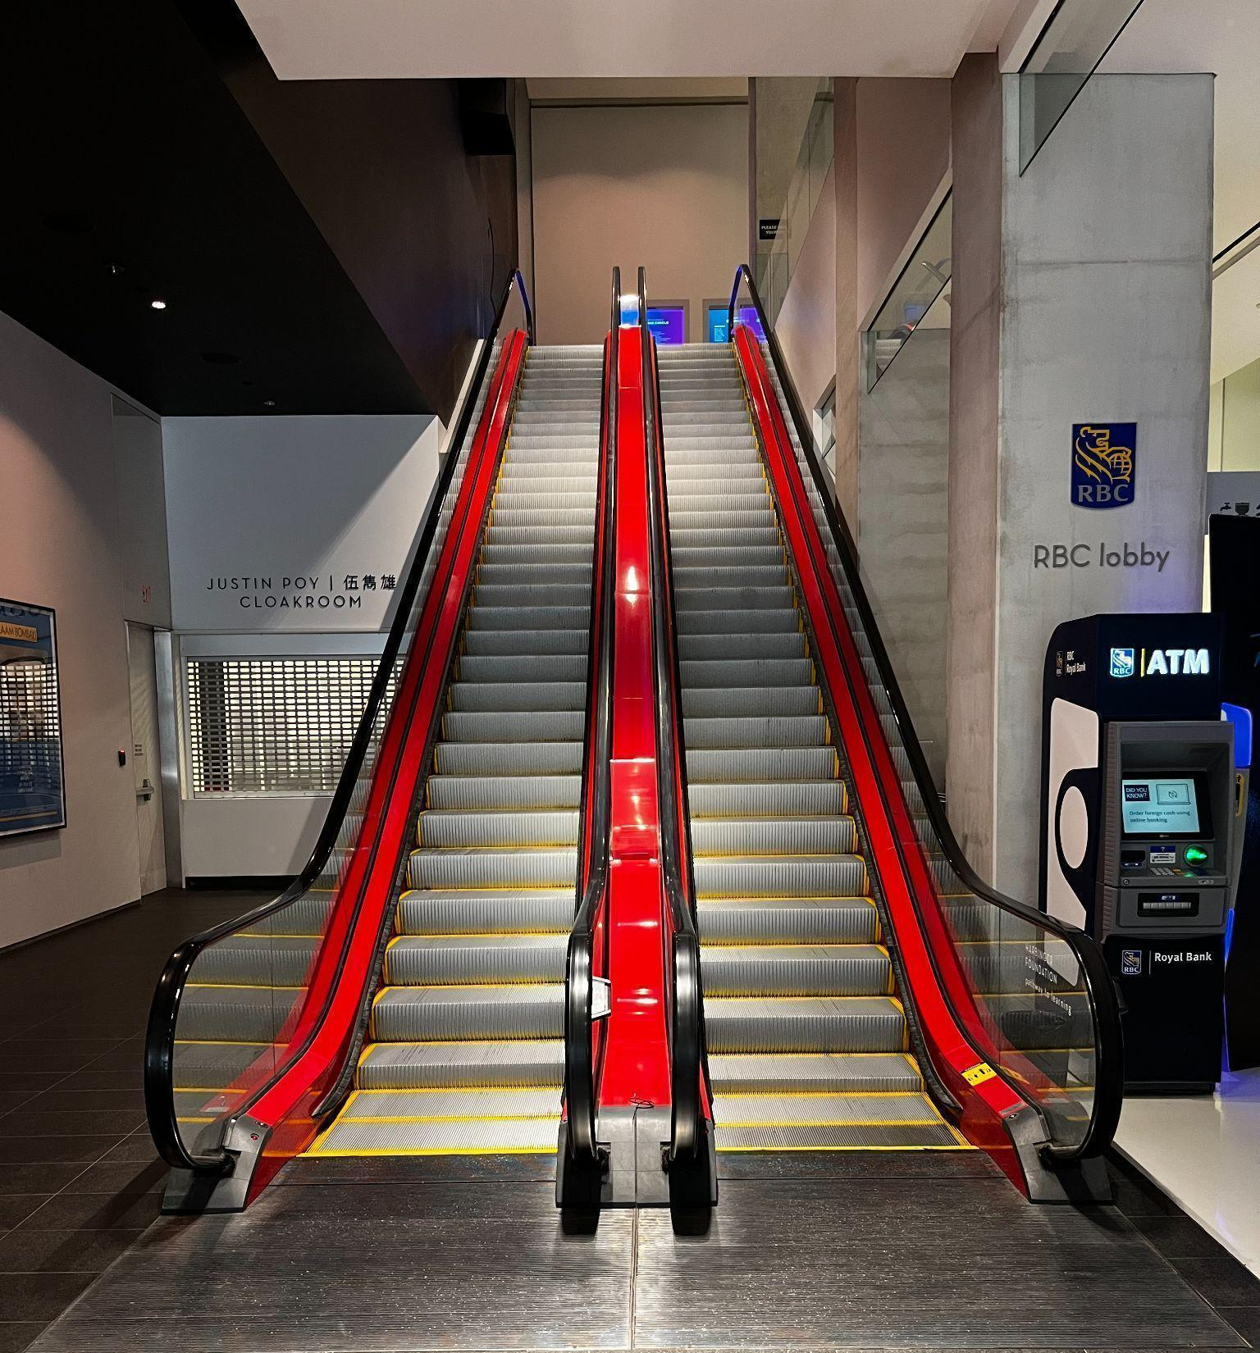
Figure 5: Photograph of the escalators in the front lobby of TIFF Lightbox. The escalator to the right will allow you to move upwards to the second floor.
- There are 2 elevators located on the east side of the atrium beside the escalators. If you’re facing the escalators, it is a right turn to access the escalators.
  - Cinemas 4 and 5 on floor 3 can be accessed via elevator
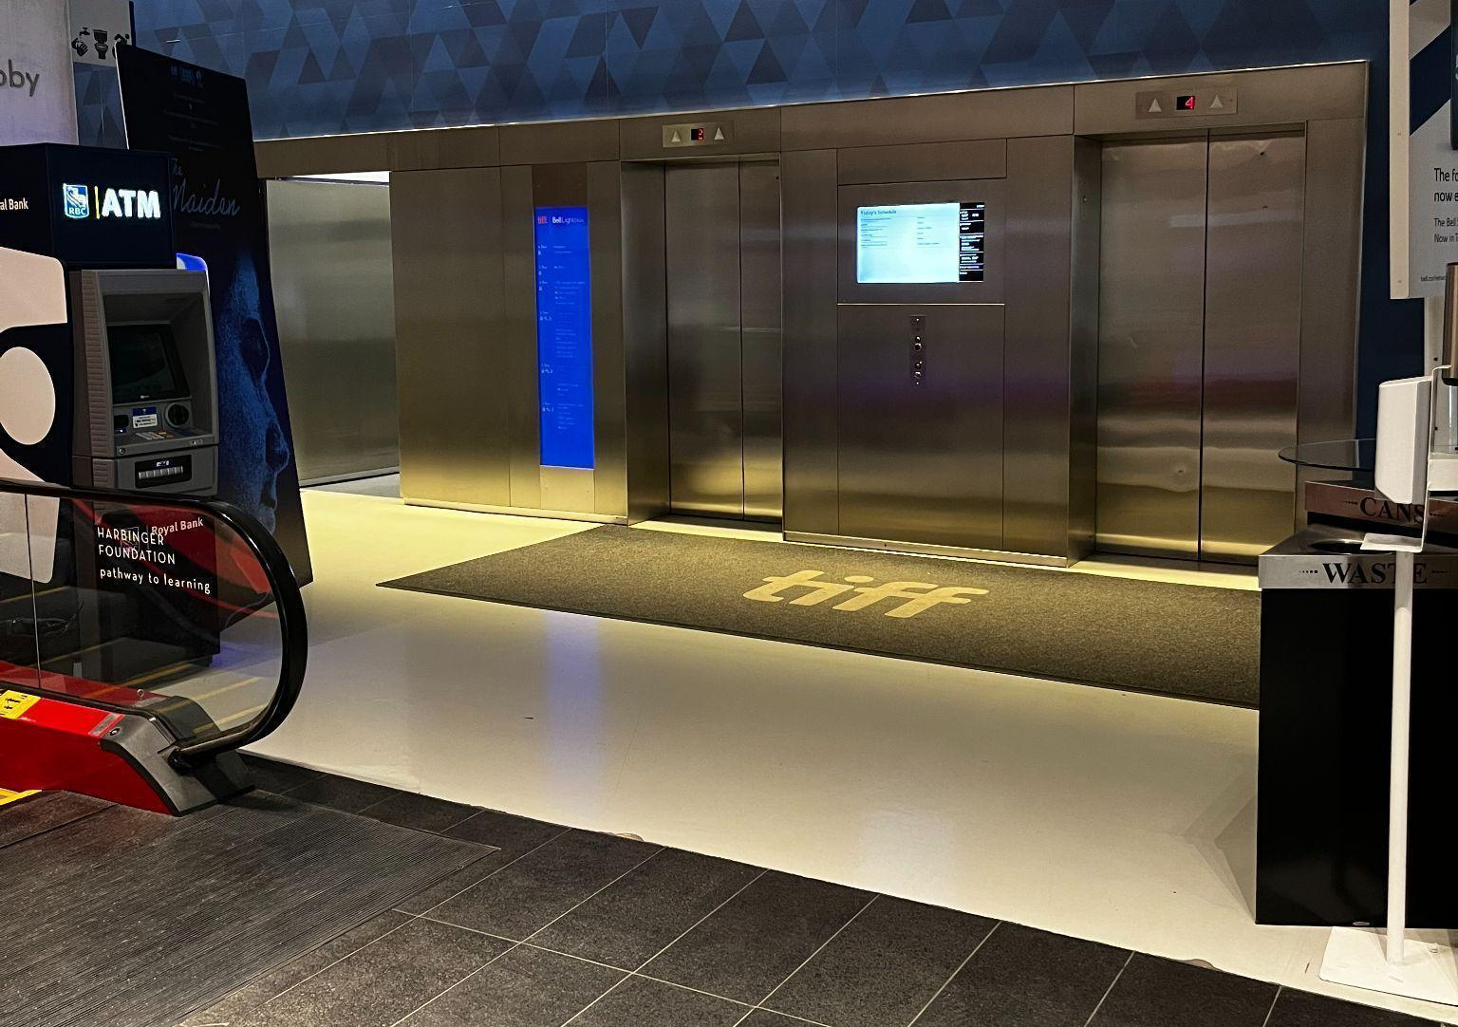
Figure 6: Photograph of the two metal elevators on the right side of the Atrium beside the escalators.
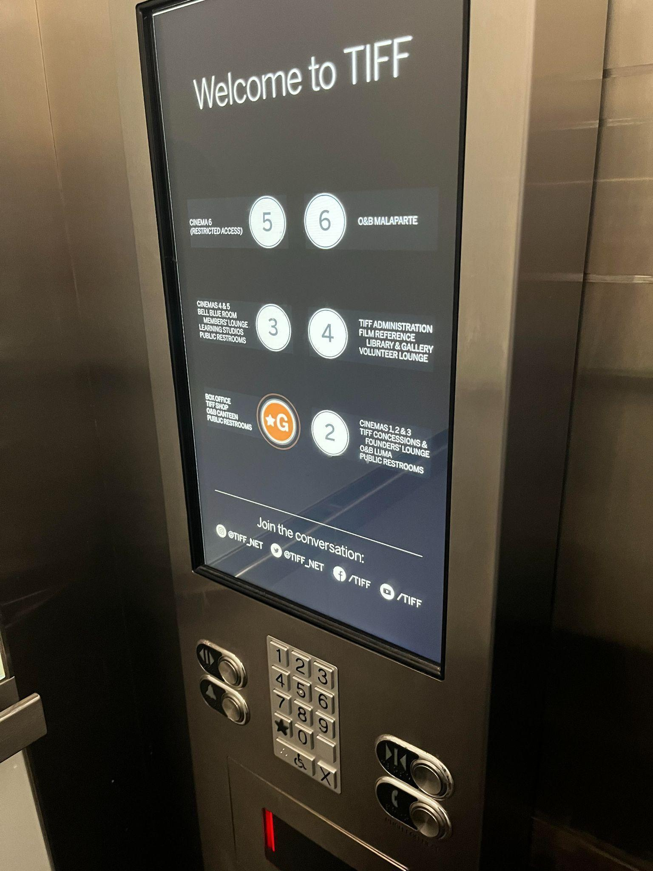
Figure 7: Photograph of elevator touch screen and keypad underneath

- The elevator contains a touch screen to select a floor. The elevator will audibly announce once it has arrived at the floor selected.
  - There is a keypad underneath the touch screen that can also be used to select a floor

- The 2nd floor utilizes both stairs and a ramp to access the concession stand and Cinemas 1–3

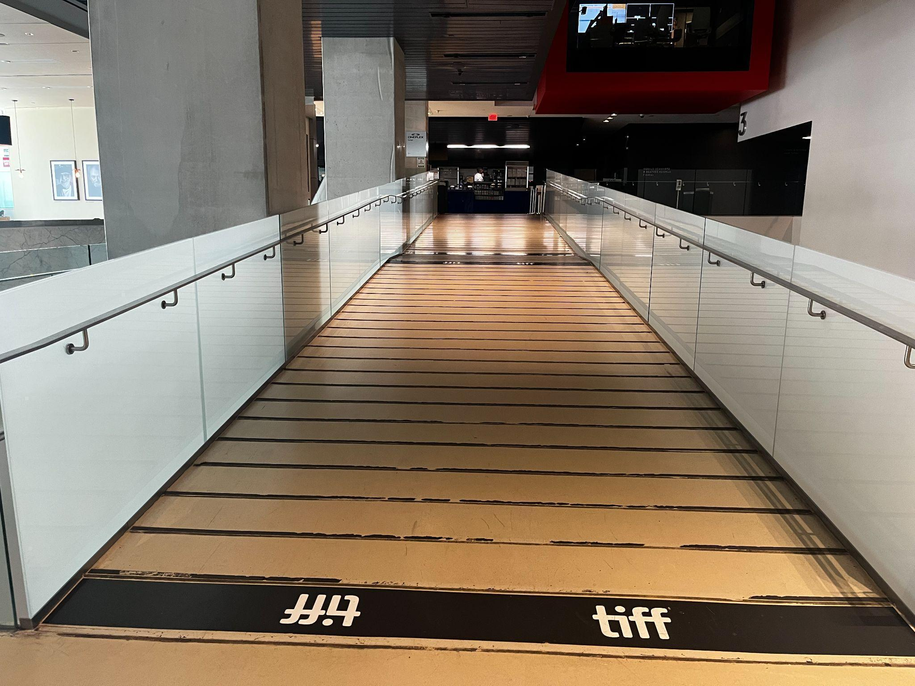
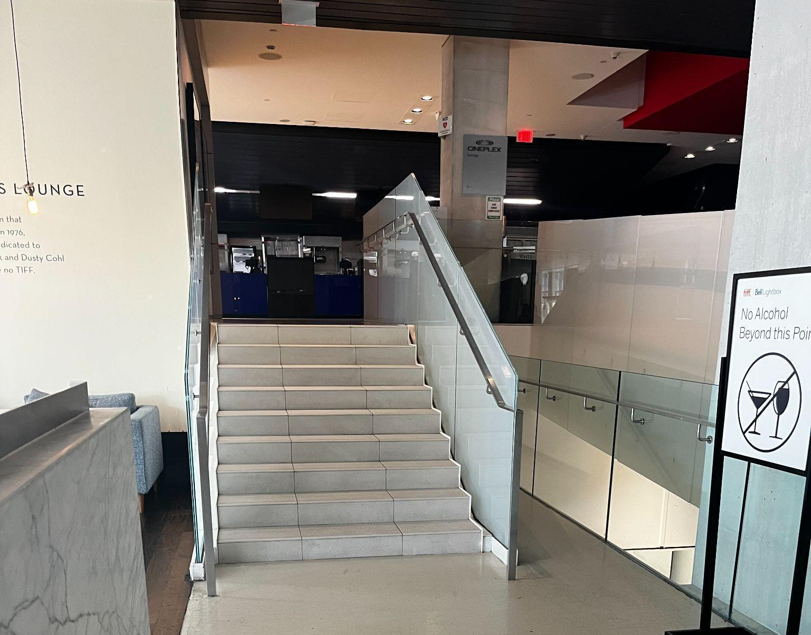
Figures 8 and 9: Photograph of ramp on second floor and stairs to the left of the ramp

Venue measurements
Door/Area | W x H | Notes
Front Doors (Double doors) | 10' x 7' | 10'x 7' per door + couple of inches added on each side for metal frame
Front Door (Handicap accessible) | 41.5" x 94"
Curb Height (front doors) | 6 inches
Escalator (width) | 40 inches
Elevator Door | 41.5" x 83"
Cinema 1 Doors | 83.5" x 83"
Cinema 2 Doors | 70" x 92"
Cinema 3 Doors | 42" x 96"
Cinema 4 Doors | 6' x 8'
Cinema 5 Doors | 6' x 8' 4"
Gallery Doors | 42" x 99" | Door exterior is 42" - once door opened space narrows down due to existing wall (4 inches width)
TIFF Shop (width) | 195.5 inches
Box Office Counter | 224.5" x 34"
Second Floor Accessibility Ramp | 112 inches
Accessible Washroom 1 - Main floor (Exterior door) | 50.5" x 98"
Accessible Washroom 1 - Main floor (Washroom door) | 34.5" x 78.5"
Accessible Washrooms 2 - Second Floor (Exterior entrance) | 61.5" x 83.5" | First Entrance with WASHROOMS sign
Accessible Washrooms 2 - Second floor (Washroom entrance) | 58" x 92" | Main washroom entrance
Accessible Washrooms 2 - Second floor (Washroom with stairs) | 56.5" x 93.5"
Accessible Washrooms 2 - Second floor (2 washrooms with doors) | 35" x 78" | 2 Handicap accessible washrooms
Accessible Washroom 3 - Third floor (exterior door) | 61.5 inches | First Entrance with WASHROOMS sign
Accessible Washroom 3 - Third floor (Washroom entrance) | 46 inches | Main washroom entrance is 11' width, then there two entrances (right & left) ; those two are 46"
Varda (exterior entrance) | 40 inches
Varda (Main door) | 37.5" x 96"

Accessible seating options
- Accessible seat location:
An empty space for a mobility device (sold as 1 ticket)
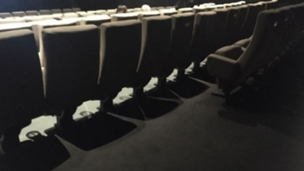
Figure 10: Example of accessible empty spaces
- Accessible jump seat:
This is a fold-up seat that can be flipped up to use as an empty space for a mobility device — these seats do not have arm rests
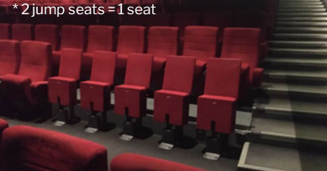
Figure 11: Example of jump seating found in cinemas

- Companion seat:
A typical cinema seat beside an accessible seat that is reserved for use by companions of those requiring accessibility accommodations
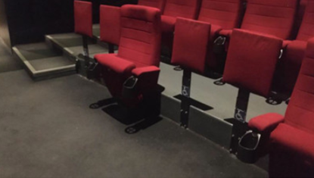
Figure 12: Example of companion seat location

Cinema 1*  523 seats | Accessible Seating  5 spaces available; 3 of these are in front of the jump seats | Companion Seating  3 seats | Step-Free  Row F
Cinema 2  353 seats | Accessible Seating  4 spaces available, all in front of the jump seats | Companion Seating  1 seat + 1 jump seat | Row E
Cinema 3 223 seats | Accessible Seating  3 spaces available | Companion Seating  2 seats | Row A
Cinema 4  147 seats | Accessible Seating  3 spaces available | Companion Seating  1 Seat | N/A
Cinema 5  45 seats | Accessible Seating  2 spaces available | Companion Seating  1 seat | Row A
Cinema 6  39 seats | Accessible Seating  2 spaces available | Companion Seating  N/A | Row A

Seating maps for each cinema are linked in the table above. You can also access all seating maps by clicking here.

Assistive devices and services available
Closed Captions | Yes* | - CaptiView
Assisted Listening | Yes | - Receiver with disposable earbud, limited neck loops available
Audio Description | Yes* | - Receivers with disposable earbuds
*Closed Captions or Audio Description are subject to content including a Closed Caption and/or Audio Description option

Concession stand

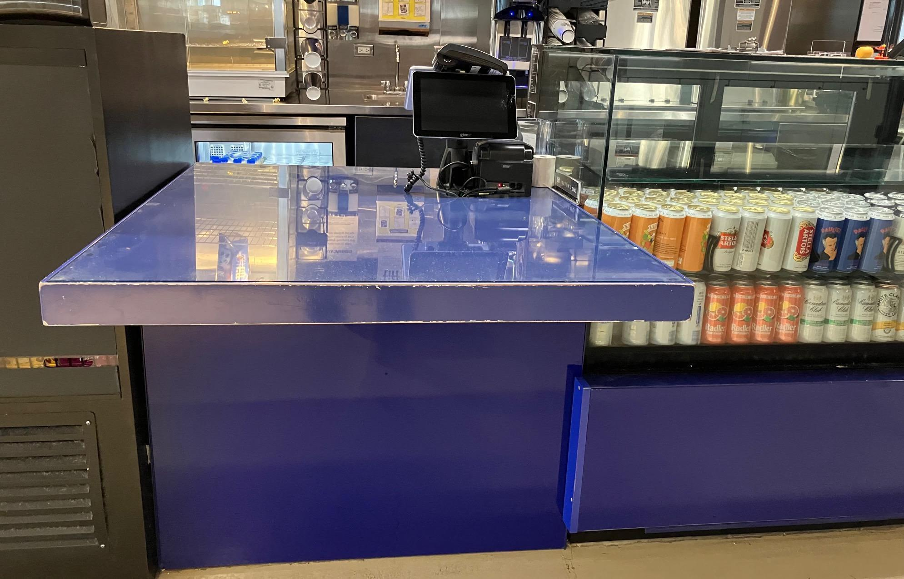
Figure 13: Photograph of accessible counter at the concession stand

- Refillable water and coffee containers are allowed
- A Water Bottle Refill station can be found on the second floor, near the concession stand
- Alcohol is permitted inside the cinema if purchased through Concessions.
- Concessions takes cash, debit, and credit

Varda
Varda is a café-bar located on the third floor of TIFF Lightbox, accessible via the public escalators and elevators.

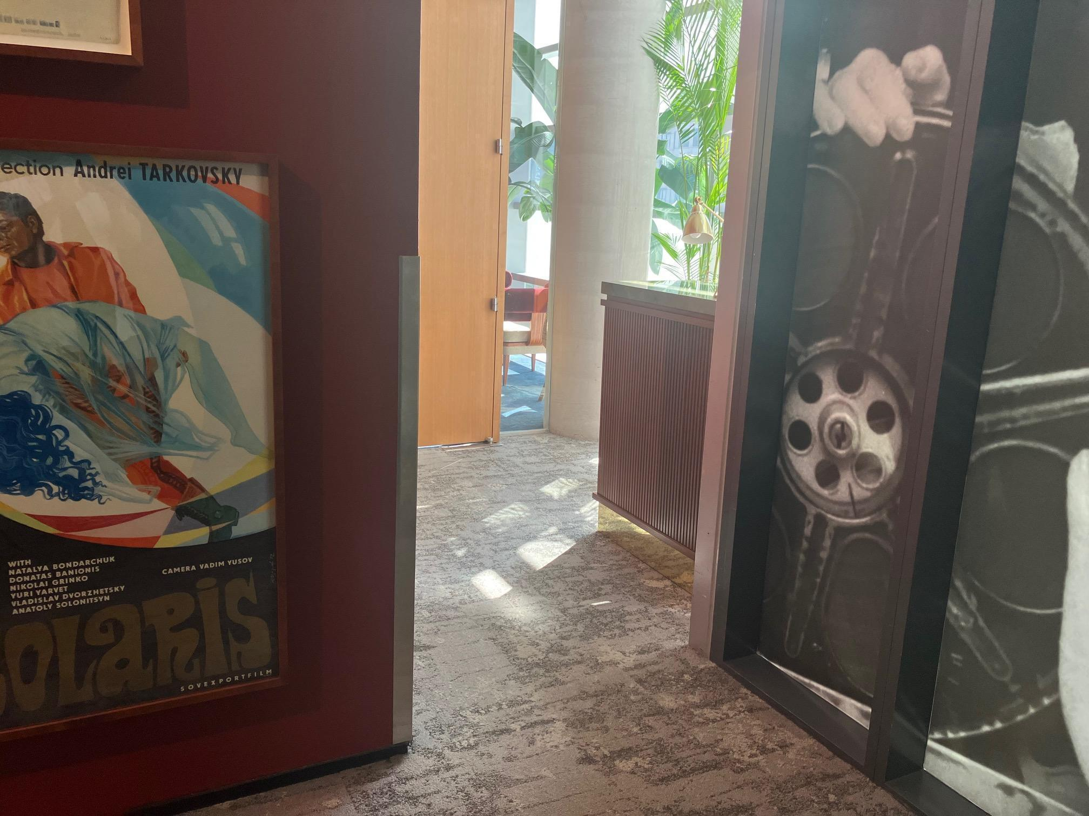
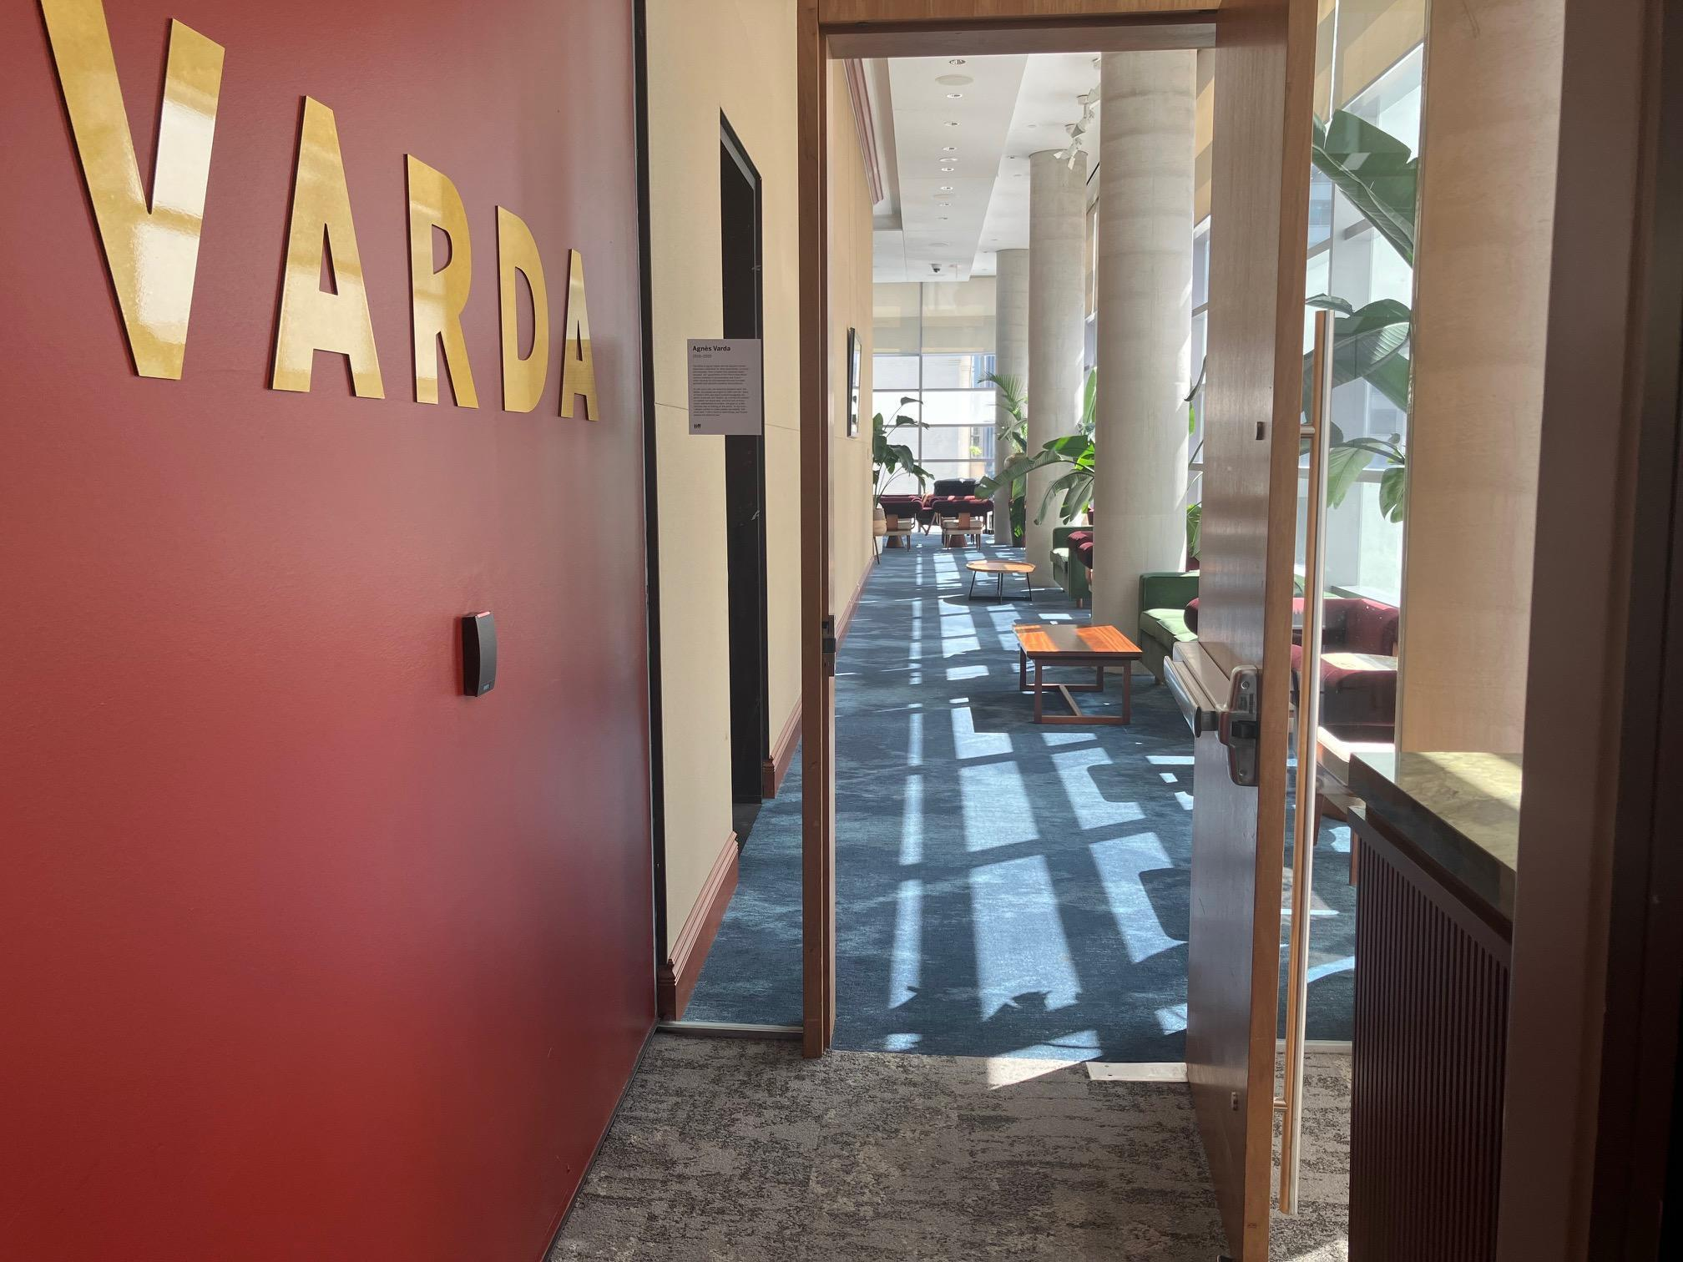
Figure 14 & 15: Photographs of entrance doors leading to Varda

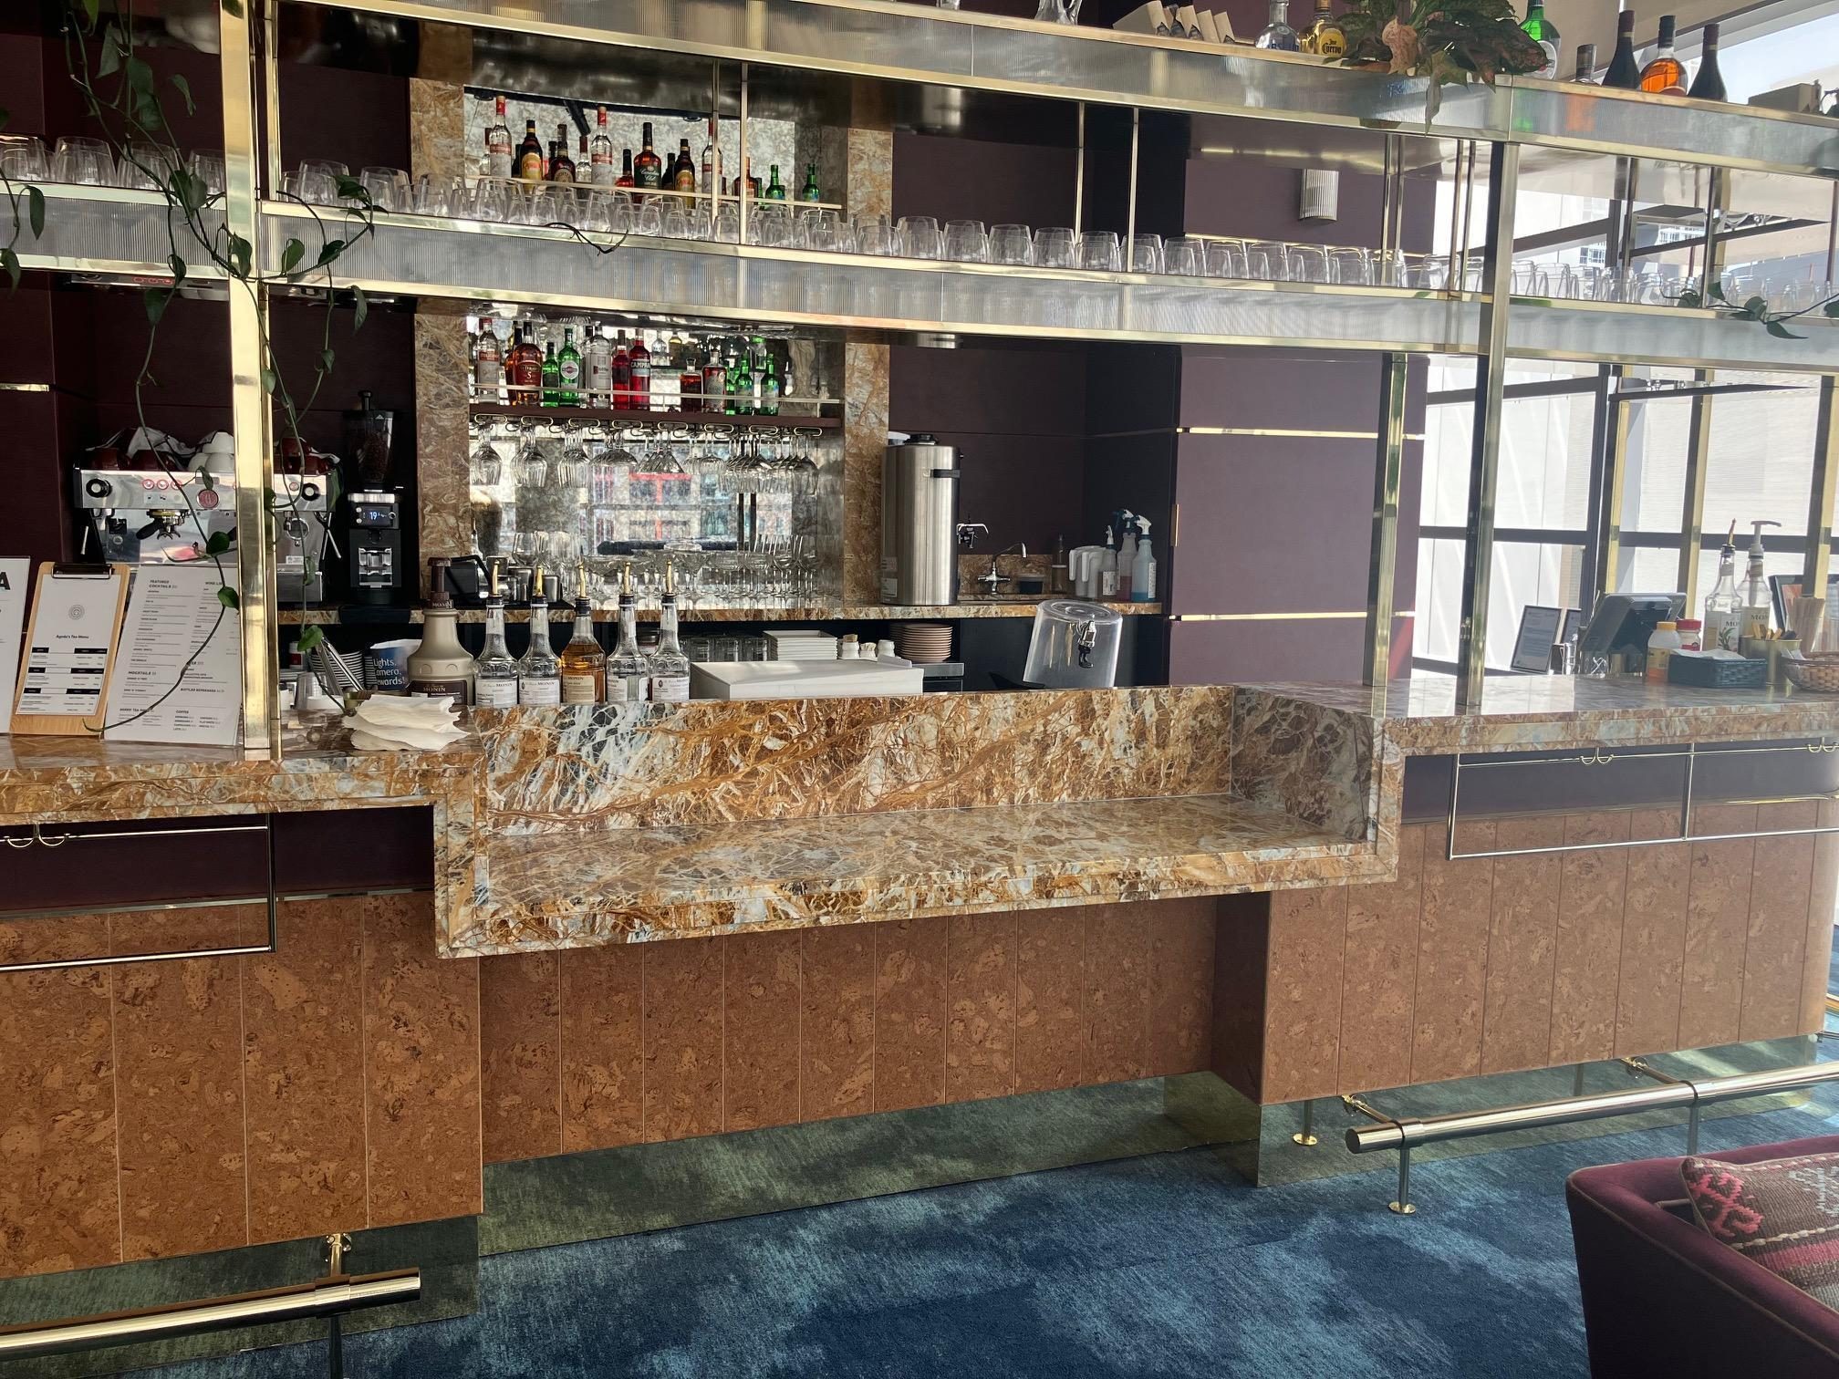
Figure 16: Photograph of accessible counter at the bar inside Varda.

Oliver & Bonacini Spaces
Luma (2nd floor) and Malaparte (6th floor)

Entrance and Interior
- Pedestrian routes to and from the main entrance to both restaurants have a level path
- All entrances are wide enough to allow safe passage of persons who use mobility aids
- Elevators are available

Washrooms
- Designated accessible washrooms with a level path are available in both restaurants
  - There is no automatic door opener on either of the O&B restaurant washrooms

Washrooms
Gender neutral | Yes | All levels
Sensored flushing | Yes | All levels
Sensored faucets | Yes | All levels
Automatic soap dispensers | Yes | All levels
Sensored paper towel or hand dryer | No | Manual paper towel
Change tables | Partial | 2nd floor only

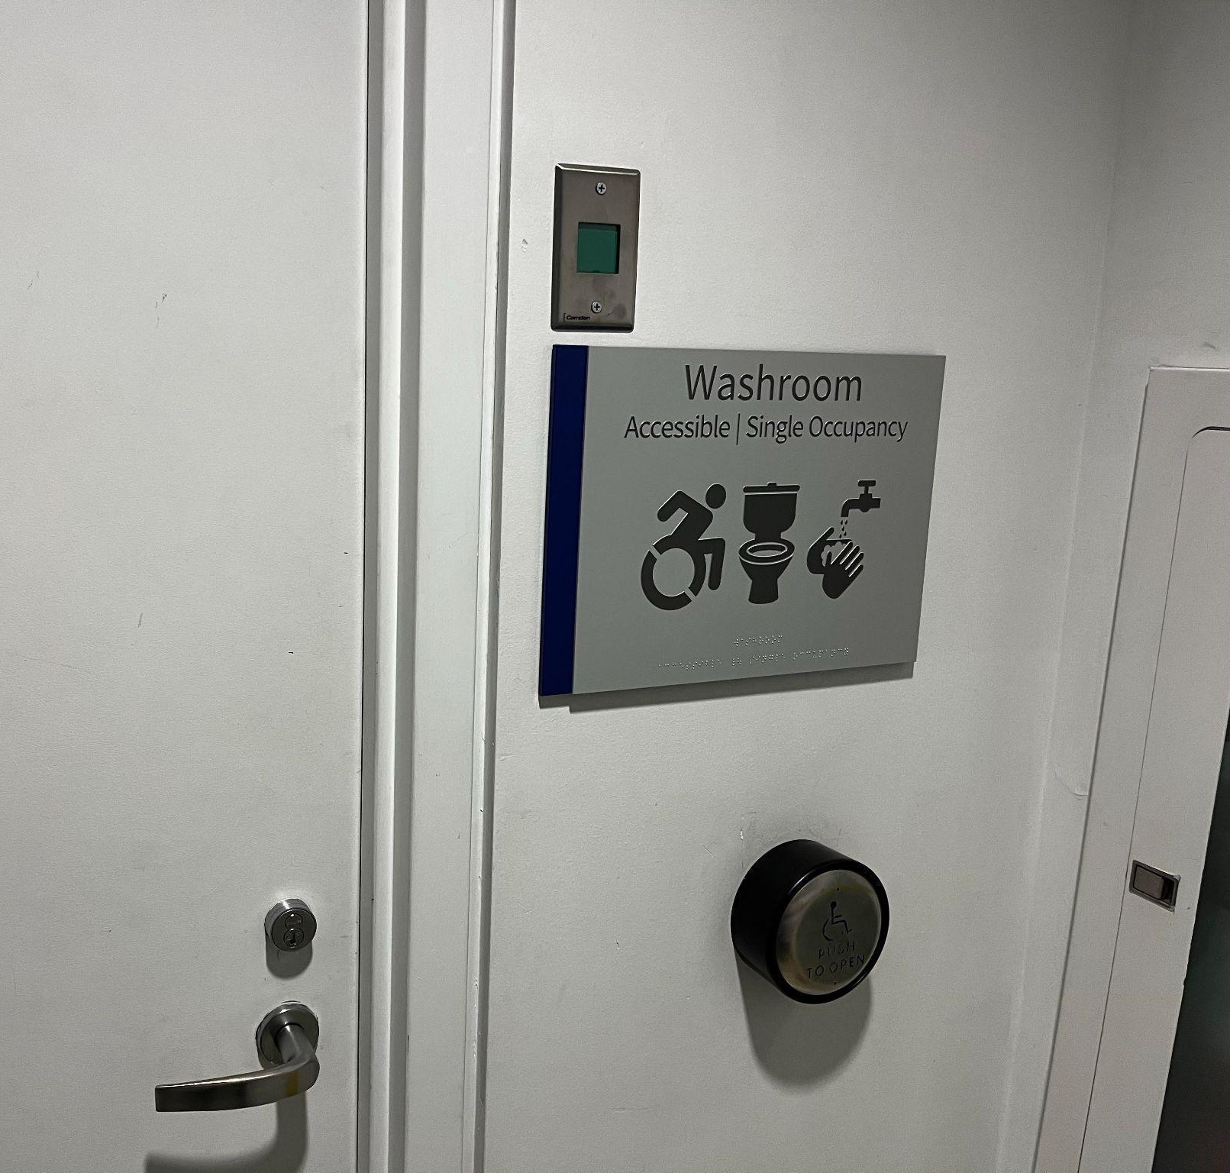
Figure 17: Washroom signs will indicate facilities available inside.
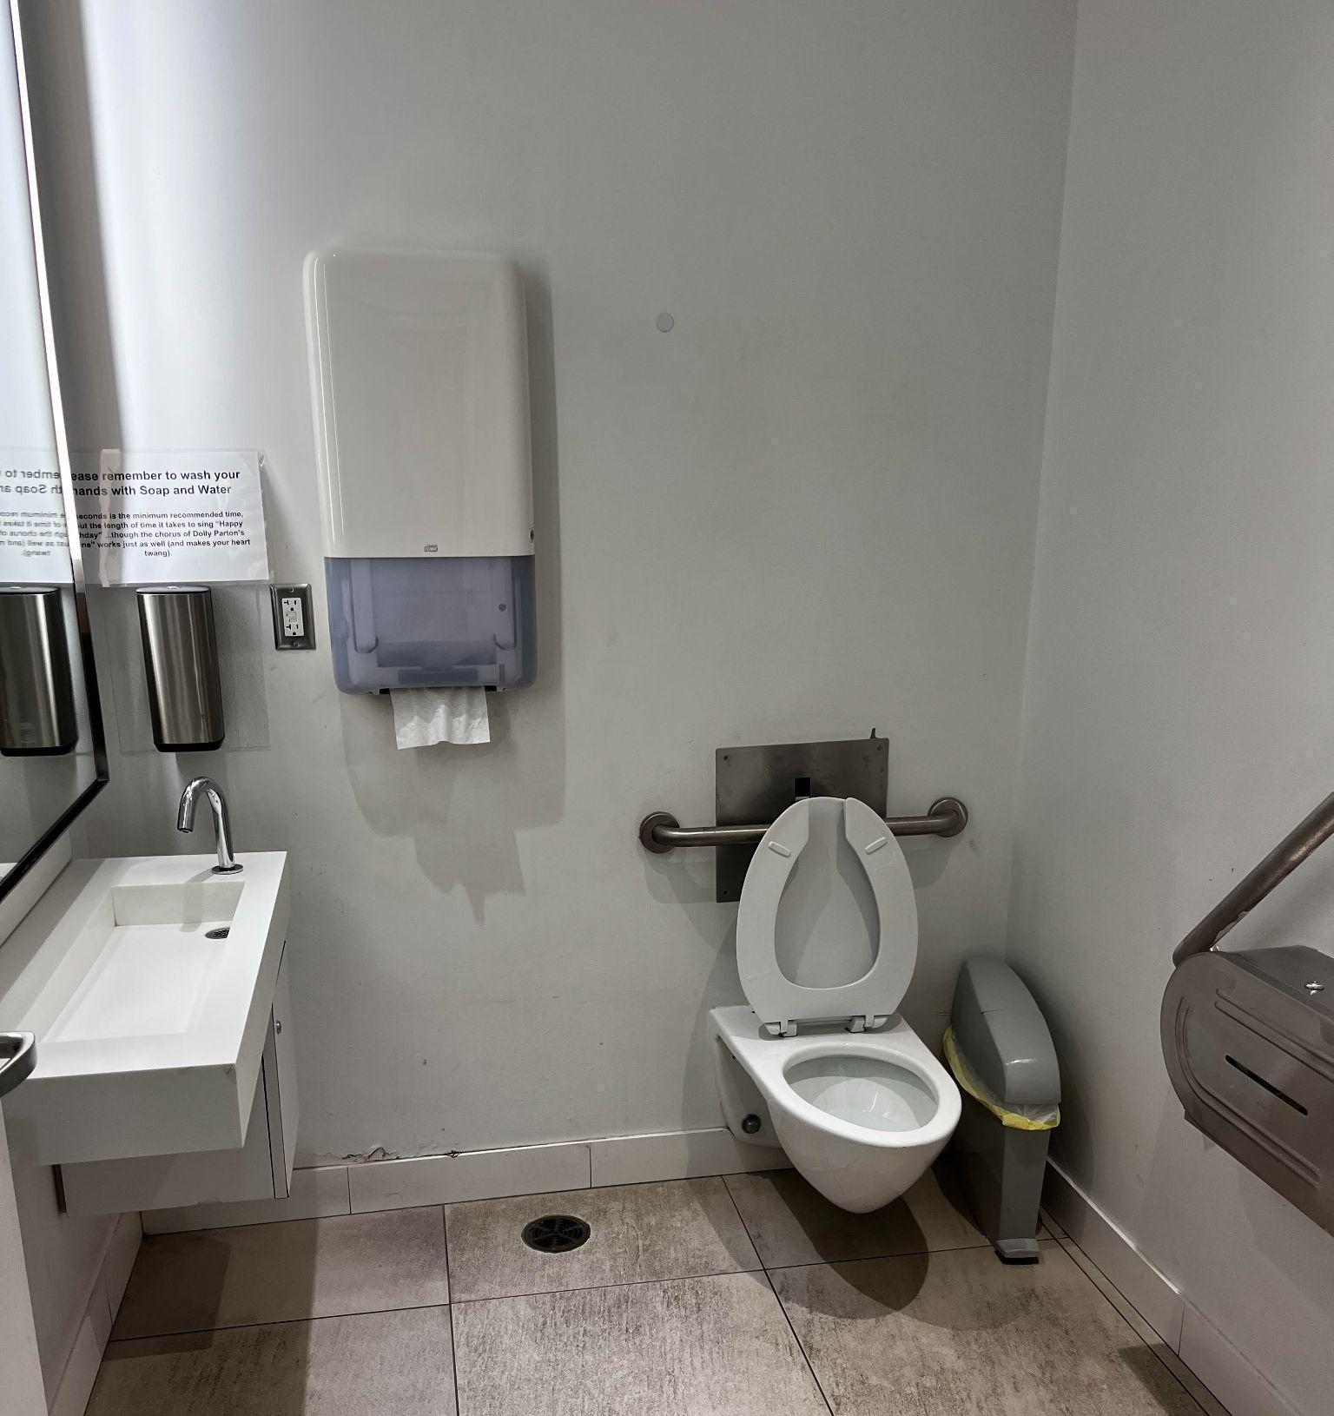
Figure 18: Example image of the washroom in Atrium. The washroom can be found underneath the back of
the escalators.

- The lobby washroom can be found underneath the back of the escalators
- If exiting the elevators, washrooms are to the right

