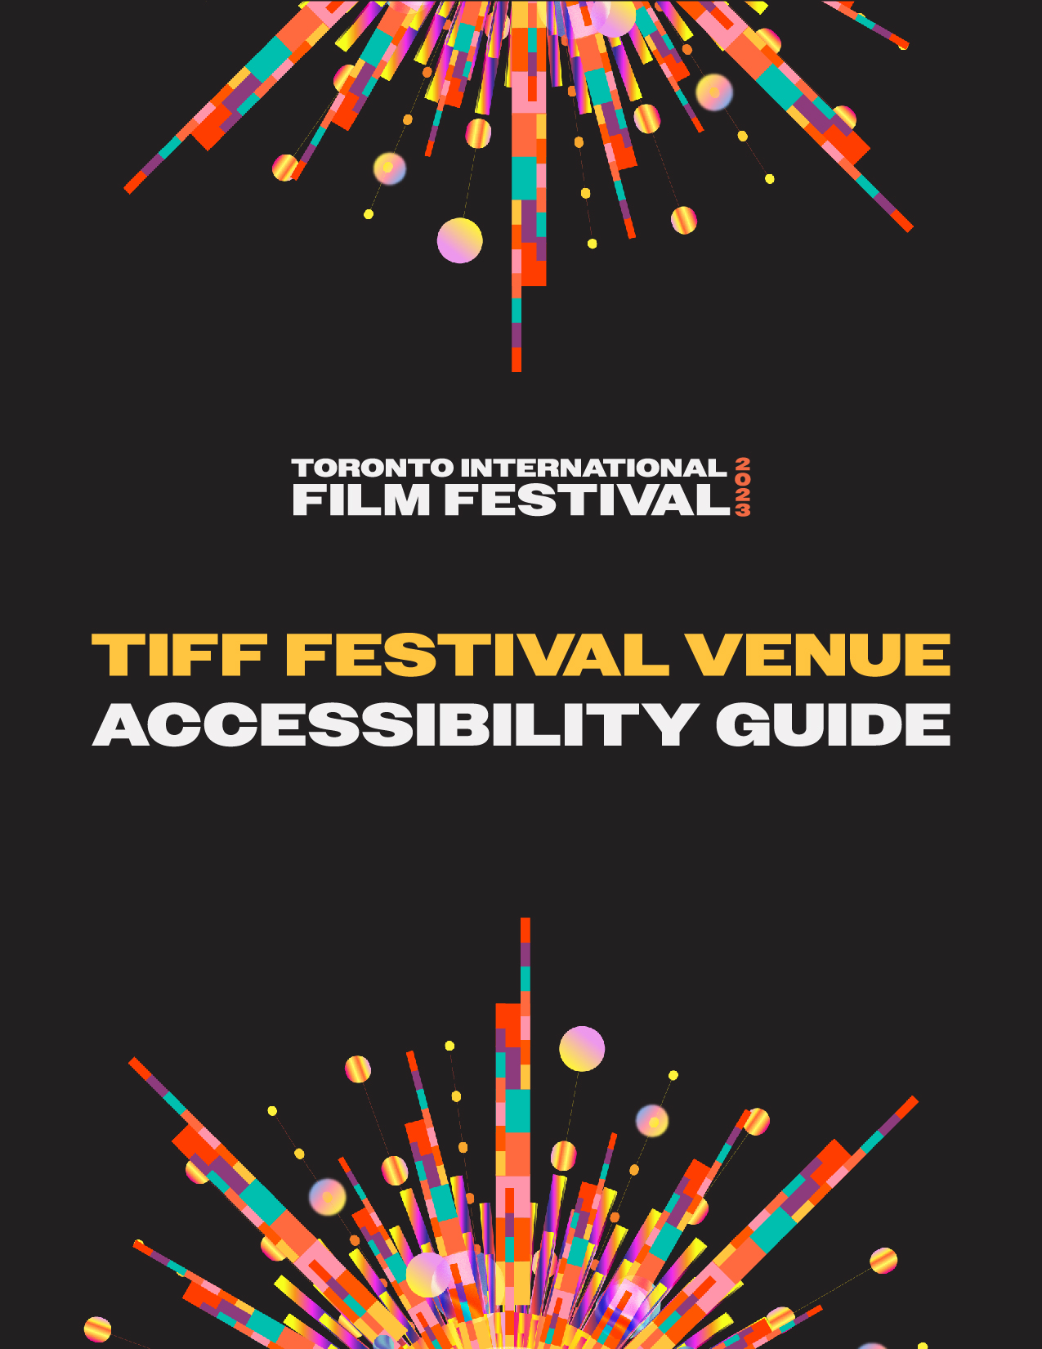
TIFF Festival Venue Accessibility Guide
Table of Contents
Introduction
General Information
  - Festival ticketing
  - Rush tickets
  - Lobby Pass
  - Communication Access Realtime Translation (CART) & American Sign Language (ASL) Interpretation
  - Noise levels
  - Active Listeners
Navigating the Festival: Venues
  - Wheel-Trans drop-off
  - Festival Street

Introduction
TIFF strives to be accessible to all our audiences. We work closely with our accessibility stakeholders to help inform best accessibility practices and to provide an inclusive film-going experience.
TIFF welcomes all members of its community in the Entertainment District of downtown Toronto, as well as guests from all over the world. We are committed to making screenings accessible to as many people with disabilities as we can, and we strive to remove barriers to access whenever possible.
As part of our ongoing commitment to improving and removing barriers, this guide has been designed to help visitors navigate the Festival when visiting the various venues, according to individual needs and preferences.

General information

Festival ticketing
For festival ticketing, we encourage attendees to buy tickets online in advance of the showtime at www.tiff.net. Accessible and companion seating must be booked over the phone for all screenings.
If you require assistance, our Call Centre is open daily from 10am to 7pm, and 8am–10pm from September 7 to 17, 2023, at:
Local: 416-599-2033
Toll-free: 1-888-258-8433
Email: customerrelations@tiff.net

Rush tickets
If a screening is off-sale, customers without tickets may wait in the Rush line as a last chance to see the film. We recommend arriving for a Rush line no earlier than 60 minutes prior to your screening. Please note that being in a Rush line does not guarantee a ticket to the screening.

Lobby Pass
Lobby Passes are available to any visitor and their support person, if applicable, who has an accessibility consideration that limits their ability to stand in a lineup at a venue. The Lobby Pass grants access to a designated waiting area for the passholder and a companion* (if required) upon presentation of the Lobby Pass to a TIFF Front of House staff member, alongside a valid ticket to the screening. For the Festival, lobby access and designated waiting areas vary by venue, and space is limited.

*What is a Companion Pass?
TIFF provides complimentary access to companions of customers with accessibility needs. Companion Passes are meant to accompany patrons and/or delegates with Lobby Passes to and during their screenings. Companion Passes and Lobby Passes are almost always booked together.

Who qualifies for a Lobby Pass?
Lobby Passes are available to any visitor who has an accessibility consideration that limits their ability to stand in a lineup at a venue. No supporting documentation is required for requesting or obtaining a lobby pass.

Requesting a Lobby Pass
Lobby Passes are available for request starting in August. The deadline to request a Lobby Pass in advance is Wednesday, August 31, 2023.

- Lobby passes can be requested directly through the Customer Relations team. Any requests can be submitted by the visitor over the phone at 416-599-2033 or 1-888-258-8433, in person at TIFF Bell Lightbox, or by email at customerrelations@tiff.net.

How to download a digital Lobby Pass
Lobby Pass holders will access their Lobby Pass by signing in to TIFF Festival Account Manager and downloading the pass to their mobile device, similar to downloading a digital ticket.
- Visit TIFF Festival Account Manager from your mobile device: https://am.ticketmaster.com/tiff2/
If you have a Industry, Guest, or Press accreditation, you may sign in on TIFF Industry, Guest, and Press Account Manager: https://am.ticketmaster.com/tiff4/
2. Click “Sign In” in the top right corner.
Figure 1: Screenshot of https://am.ticketmaster.com/tiff2/ with an arrow pointing to the sign-in button in the top right corner
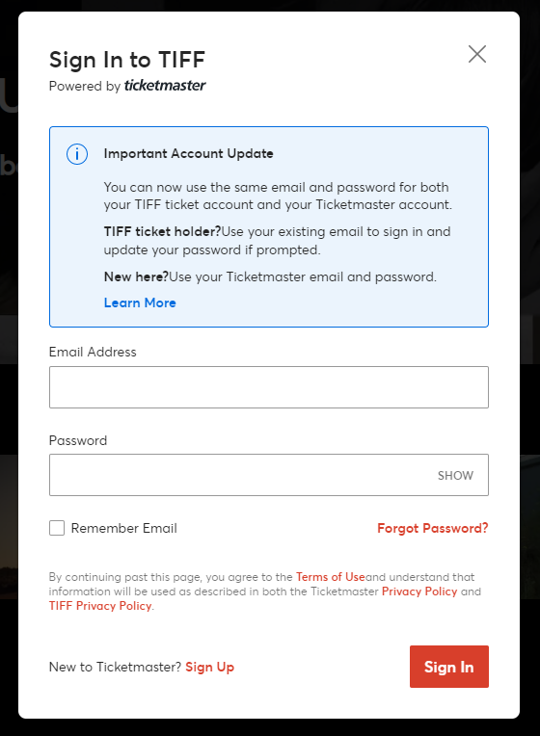
Figure 2: Screenshot of https://am.ticketmaster.com/tiff2/ sign-in page

3. Click the Menu option at the top left corner (three lines) and select “My Events.”
4. Your Lobby Pass will appear here. Look for “2023 Lobby Pass” and click “Select Event.”
5. Under “My Tickets” click the line that reads: “Lobby Pass, General Admission.”
6. A pop-up will appear here with the QR code for your Lobby Pass. You may display the Lobby Pass from this screen, or add the Lobby Pass to your mobile wallet (for example, click the “Add to Apple Wallet” icon).

Physical Lobby Pass
If you require a physical Lobby Pass, please let our Customer Relations team know by phone at 416-599-2033 or 1-888-258-8433, or by email at customerrelations@tiff.net in order to arrange a pick-up at our TIFF Bell Lightbox Box Office.

If you are attending the Festival as an Industry delegate and require a Lobby Pass, please contact the Industry team by email at registration@tiff.net to arrange pick up at the Hyatt Regency.
If you are attending as a Press and Media delegate and require a Lobby Pass, please reach out to media@tiff.net to arrange a pick up at the Hyatt Regency.
Communication Access Realtime Translation (CART) & American Sign Language (ASL) Interpretation
- ASL sign language is available on-demand for our Industry programming. Industry delegates can contact registration@tiff.net for assistance. Please contact us as early as possible once the schedule goes live on August 15, 2023.

Open-captioning will be offered onscreen in real time at TIFF’s In Conversation With… in-person events.

Noise levels
- At times during the Festival, the lobby areas, lineups, or fan zones can exceed comfortable noise levels for those who are sensitive to loud noises.

Quiet space
  - If you require a quiet space during the Festival, Room 1 on the 4th floor of TIFF Bell Lightbox will be available for public use. To access this space, take the elevator from the TIFF Bell Lightbox lobby to the 4th floor, and make a left after exiting the elevator.

Active listeners
- Active listeners can provide support for patrons after a film or event with difficult or triggering content. Support may look like talking through observations and feelings, providing suggestions or resources in the city of Toronto as it relates to counseling, crisis support and/or other community services, or friendly conversation.
- Active listeners can be found on the 4th floor in Room 1 at the TIFF Bell Lightbox for the duration of the festival between 11am–3pm and 6pm–10pm. To access this space, take the elevator from the TIFF Bell Lightbox lobby to the 4th floor, and make a left after exiting the elevator.

Navigating the Festival: Venues
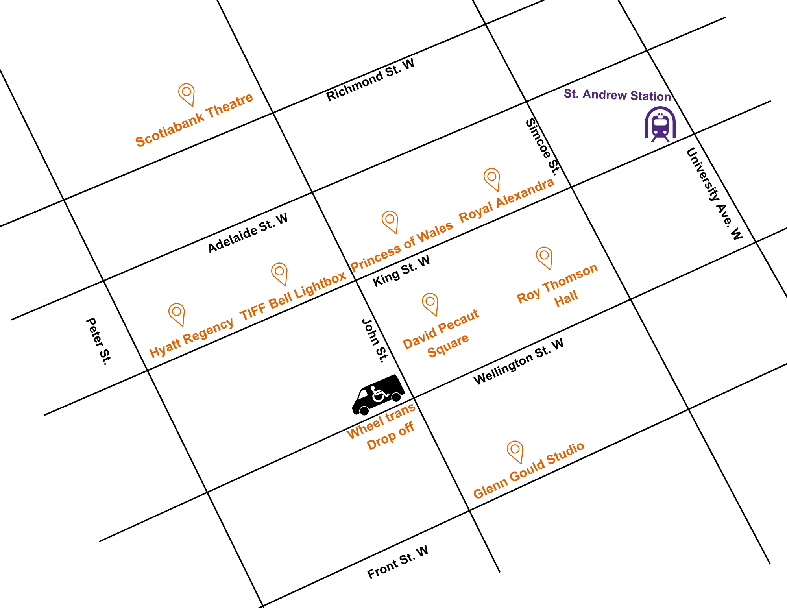
Figure 5: A Map of the venues where TIFF Festival Theatres, Studios, and Hotels are located. These include Scotiabank Theatre, Hyatt Regency, TIFF Bell Lightbox, Princess of Wales, Royal Alexandra, David Pecaut Square, Roy Thomson Hall, and Glenn Gould Studio.

TIFF 2023 official screening venues and location details

- TIFF Bell Lightbox
  - Located at the corner of King St. West and John St.
- Scotiabank Theatre Toronto
  - Located at the corner of Richmond St. West and John St.
- Visa Screening Room at the Princess of Wales Theatre
  - Located at the corner of King St. West and John St. on the opposite side of TIFF Bell Lightbox
- Royal Alexandra Theatre
  - Located along King St. West between Simcoe St. and Duncan St.
- Roy Thomson Hall
  - Located at the corner of King St. West and Simcoe St.
- Glenn Gould Studio at the Canadian Broadcast Centre
  - Located at the corner of Front St. West and John St.
- Industry Centre at the Hyatt Regency
  - Located at the corner of King St. West and Peter St., across from TIFF Bell Lightbox
- OLG Cinema Park at David Pecaut Square
  - Located between Wellington St. W. and King St., and between John St. and Simcoe St.

Most venues are within a 10–15 minute walk of each other

Wheel-Trans drop-off
- WheelTrans drop-off is at the corner of Wellington Street West and John Street.

Festival Street
- Festival Street is made up of a series of street closures along King Street West that span across University St. to Peter St., and select streets between Wellington St. and Pearl St. may be affected.
- These closures occur in order to secure the street for red carpet events and to allow spaces for partners to set up booths.
- There may be other temporary road closures throughout the run of the Festival.
- Finding parking spots can often be difficult due to street closures. We recommend taking public transit if possible.

Festival Street hours
- Street closures occur from Thursday to Sunday, September 7–10, 2023, from approximately 10am–10pm
  - Venues affected are: TIFF Bell Lightbox, Roy Thomson Hall, Visa Screening Room at Princess of Wales Theatre, Royal Alexandra Theatre, David Pecaut Square.
  - By law, no vehicles outside of talent or emergency vehicles are allowed to drive along Festival Street.

Navigating Festival Street
- Due to the safety and security of those working and attending the Festival, the use of barricades, including concrete barriers, are used along Festival Street.
  - Some barriers go up to 4 feet high and are immovable.
- Navigating to and from venue sites may be difficult for those with accessibility or mobility needs. We strive to maintain gaps between barriers and appropriate widths for lineups (with stanchions and barricades) for wheelchairs.
  - If you have accessibility needs, we suggest you find a volunteer or staff member upon your arrival and let them know.
  - You can email customerrelations@tiff.net to inquire about our closures and find out how we can best accommodate your needs.

Other accessibility needs or questions
Our Call Centre is open daily from 10am to 7pm and 8am–10pm from September 7 to 17, 2023, at 416-599-2033 or 1-888-258-8433, or by email customerrelations@tiff.net.

