

Roy Thomson Hall

Venue Access Guide

Roy Thomson Hall Venue Access Guide

Location
60 Simcoe Street, Toronto, ON M5J 2H5

Closest intersection
King St. W. and Simcoe St.

Overview
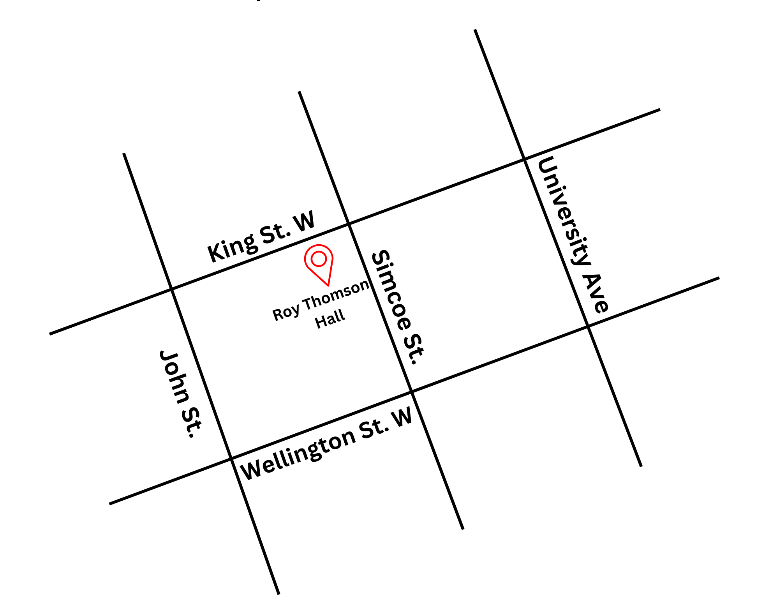
This guide provides accessibility information to support visitors in planning their experience. If you have specific access needs, we recommend contacting TIFF Customer Relations in advance by emailing customerrelations@tiff.net or calling TIFF's Call Centre at 416-599-2033 or 1-888-258-8433.
Figure 1: A Map of downtown Toronto with Roy Thomson Hall at King St. W. and Simcoe St., and John St. and Simcoe St. to the west and east, and Wellington St. W. to the south

General information
- Patrons are discouraged from wearing scented products; however, we cannot guarantee a scent-free environment.
- Water bottles are not allowed inside the venue.
- This venue has reserved seating
  - The free TTC screening is General Admission seating
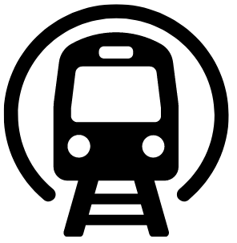
Getting There
Subway
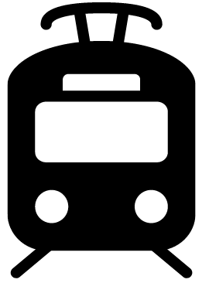
Roy Thomson Hall is located next to the St. Andrew subway station on Line 1. It is 210 m (about a 3-minute walk at an average pace; travel time may vary) from the subway.
Streetcar or bus
Take the King streetcar (Route 504). The closest stop is King Street & University Ave. It is 300 m (about a 4-minute walk at an average pace; travel time may vary) once exiting the streetcar.
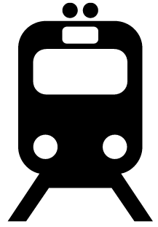
GO Transit or VIA Rail
Roy Thomson Hall is 650 m (about a 10-minute walk from Union Station at an average pace; travel time may vary). It can also be reached by subway (one stop from Union Station to St. Andrew Station).

Driving
There is accessible parking available at the rear of Roy Thomson Hall via Wellington Street. There are 23 spots available in the surface parking lot, and 6 parking spots in the underground parking lot. These spots are available on a first-come, first-served basis.

Arrival and Entrance
- The main entrance on Simcoe Street provides step-free access.
Staff are available on-site; visitors can identify access needs if support is required.

Rush lines
- The rush line begins at the corner of King St. W. and Simcoe St. and extends west along King St. W.
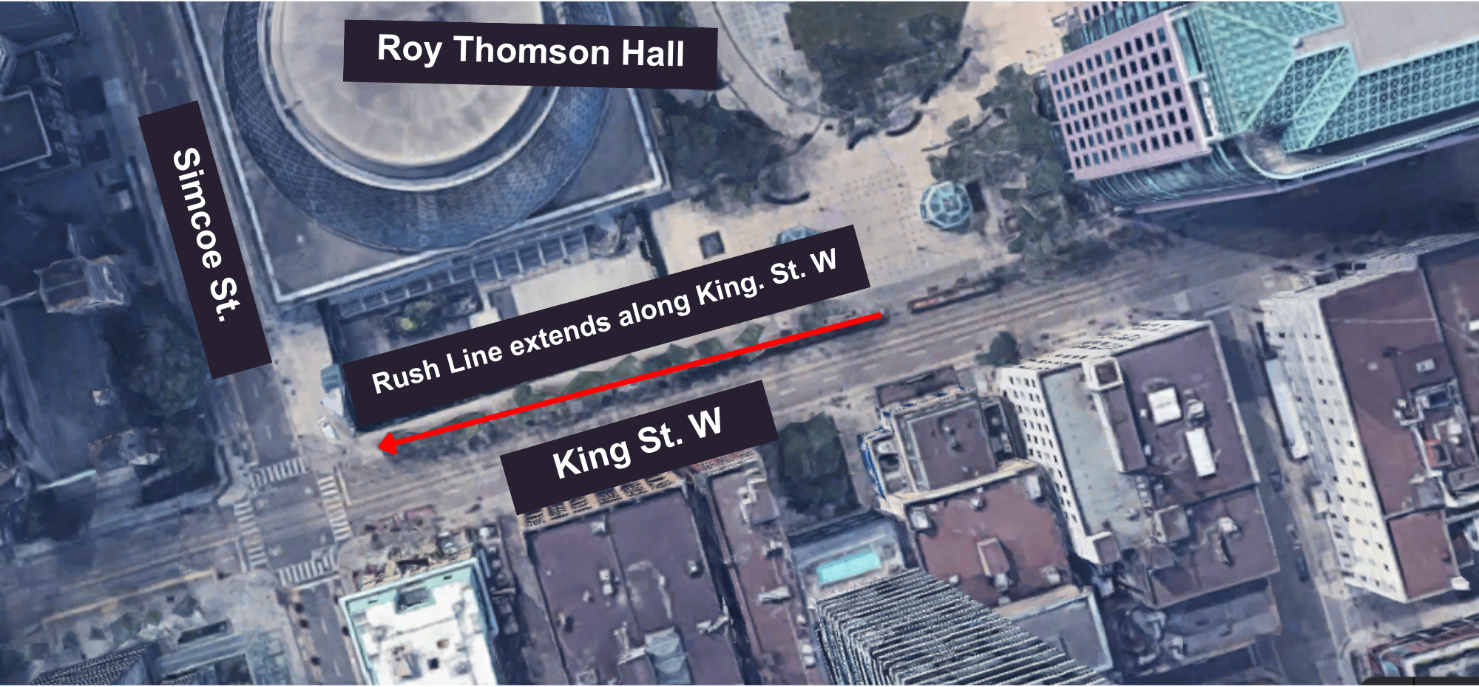
Figure 3: An aerial view map of King St. W. and Simcoe St. to indicate where the Rush line will begin.

Venue measurements
Door/Area | W x H | Notes
Doors to Box Office | 3 feet | 3-4 inches less when door is open
Box Office Counter (Height) | 34 inches
Box office Window (Height) | 50 inches | To speak to Box office Agent
Accessibility Ramp (in building) | 65 inches
Doors from Box Office to Hall | 3 feet | 3-4 inches less when door is open (door-divider-door)
Elevator (Box Office to Parking) | 42 inches
Front Doors | 3 Feet | 8 single doors in total (each 3 feet: 3-4 inches less when open)

Access to theatres and seating
All levels of Roy Thomson Hall are accessible by elevator and provide step-free access.
Accessible seating spaces are located in the Main Hall.

Level | Typical Seating | Accessible Seating | Companion Seating
Main Hall | 796 | 8 | 4
Mezzanine | 466 | 4 | 4
Balcony | 482 | 4 | 4

Assistive devices and services available
Feature | Availability | Device | Notes
Closed Captions | Yes | Dolby Accessibility Solution
Assisted Listening | Yes | Stethoset headsets
Audio Description | Yes | Receivers with headsets or disposable earbuds | Audio Description is subject to content including an Audio Description option
Concessions Stand
- Outside food and drink are not permitted
- Alcohol is allowed inside the theatre
- Debit and credit only; Roy Thomson Hall is a cashless venue

Washroom Access
- Three individual gender-neutral washrooms on the Main Floor.
- These three gender-neutral/accessible washrooms include lower sinks with knee clearance, accessible-height fixtures, grab bars, and paper towel dispensers that are generally within reach. The stalls also provide turning space once inside.
- There are accessible washroom options on multiple levels, providing alternatives if one location is busy.

Accessibility Limitations:
- The accessible washrooms do not have automatic door operators because of ceiling clearance limitations, meaning some guests may require assistance opening the doors. Staff and volunteers will be available to offer assistance with doors.
- There is no accessible men's washroom on the Mezzanine level. Men requiring an accessible washroom would need to use the Main Floor or Balcony accessible washroom instead.

