

Cinema Park at David Pecaut Square Visual Guide

Location
215 King Street West, Toronto, ON M5V 3G2
Closest Intersection
King St. W. & Simcoe St.
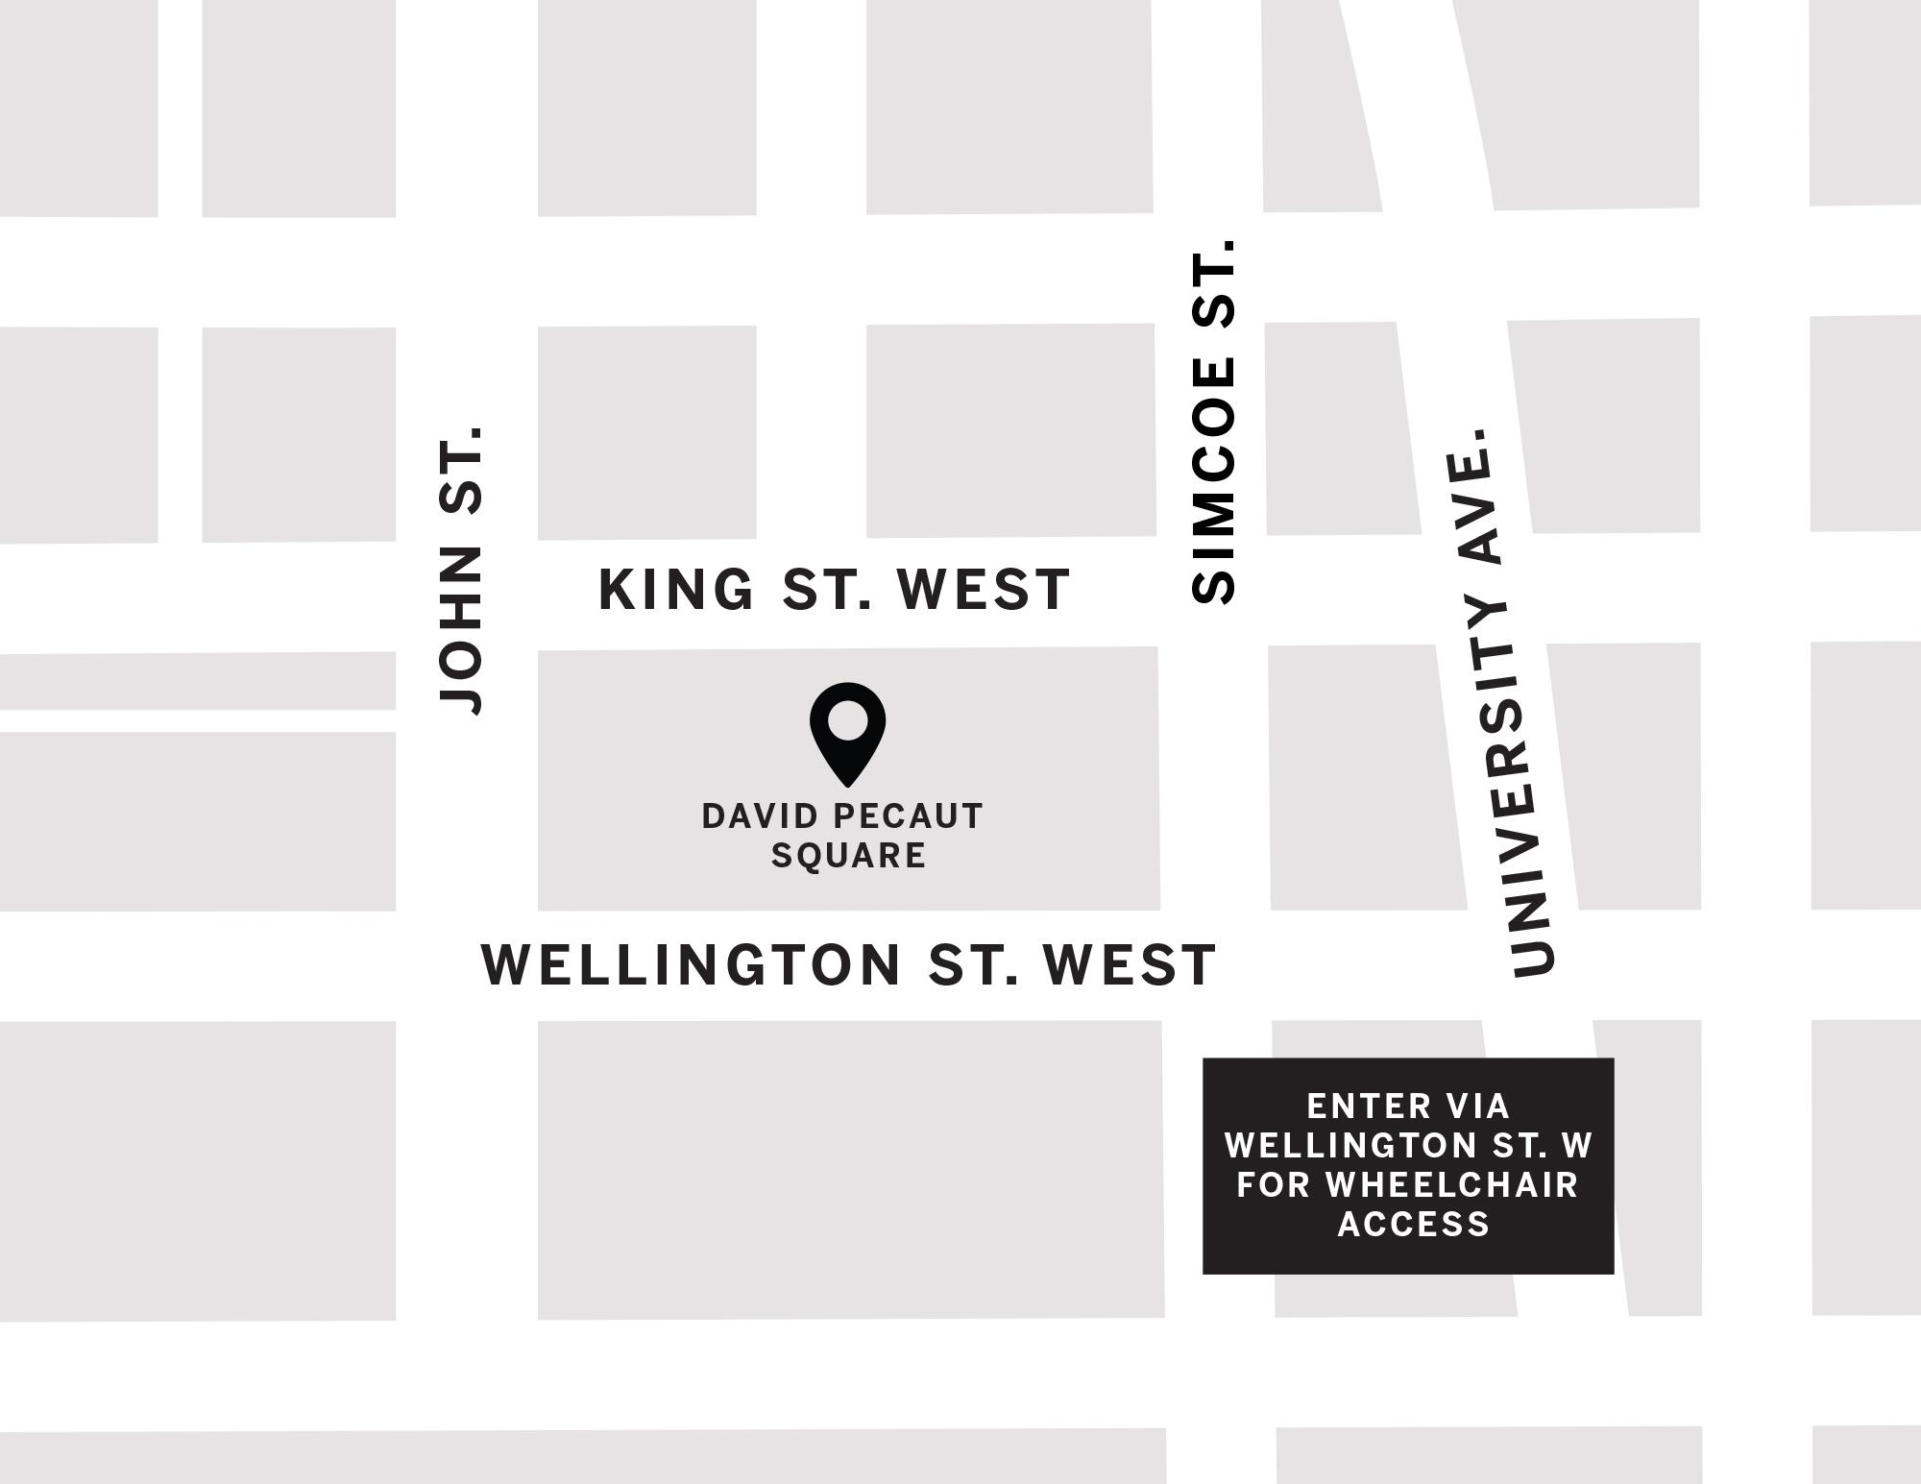
Figure 1: A Map of downtown Toronto with David Pecaut Square in between King St. W. and John St., and King St. W. and Simcoe St.

General information
There is one open-air cinema screen at this venue with a capacity of 250 general admission
- All screenings are free


Routes of arrival
Subway

David Pecaut Square is located next to St. Andrew subway station on Line 1. It is beside Roy Thomson Hall. It is a 210 m or 3-minute walk from the subway.
Streetcar or bus
The King streetcar (Route 504) stops at the corner of King Street & University Street. It is a 300 m or 4-minute walk from the streetcar.

GO Transit or VIA Rail

David Peacaut Square is a 1.2 km or 15-minute walk from Union Station. It can also be reached by subway (one stop from Union Station to St. Andrew).
Driving
There is accessible parking available at the rear of Roy Thomson Hall via Wellington Street. There are 23 spots available in the surface parking lot, and 6 parking spots in the underground parking lot.

The entrance and seating
- This area is an outdoor venue; there is little to no protection from the elements
- This area is on ground level with grass and can be best accessed from Wellington St. W. for those with a wheelchair or other mobility needs
- The Entrance and Seating" section, can you say "Lawn-style chairs are available as seating and guests are encouraged to bring their own blankets and/or chairs as well

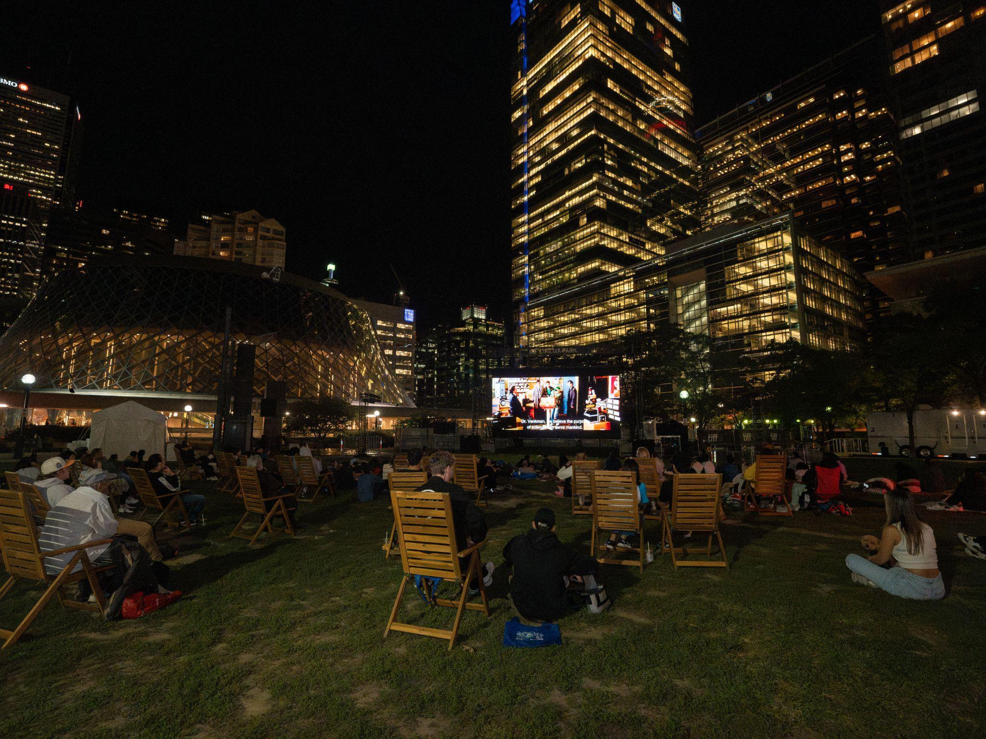
Figure 2: Photograph of Cinema Park.

Accessibility services
- All films screened at the Cinema Park open-air cinema will include open captions on screen

Washrooms

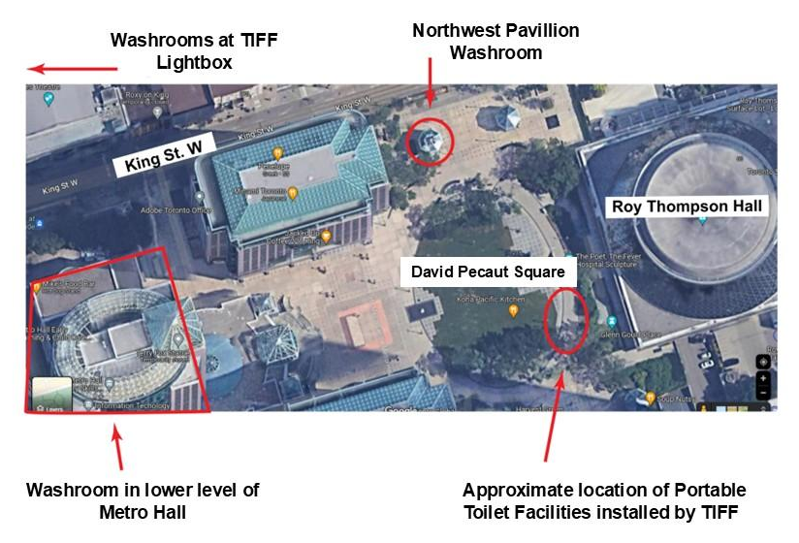
Figure 3: Aerial view of washrooms available near David Pecaut square. Arrows point to the Pavilion washroom near King St. W., and the temporary washrooms installed by TIFF in the square, Metro Hall, and TIFF Lightbox

Washroom facilities are available at the following locations:
- Portable Toilet Facilities on David Pecaut Square can be accessed by wheelchair or those with mobility considerations
- North West Pavilion
- Metro Hall (Lower Level) open daily between 7am–11pm (accessible stalls available)
- TIFF Lightbox
- Please note if you exit any Fan Zones within the area, you may need to line back up to enter if capacity has been reached

