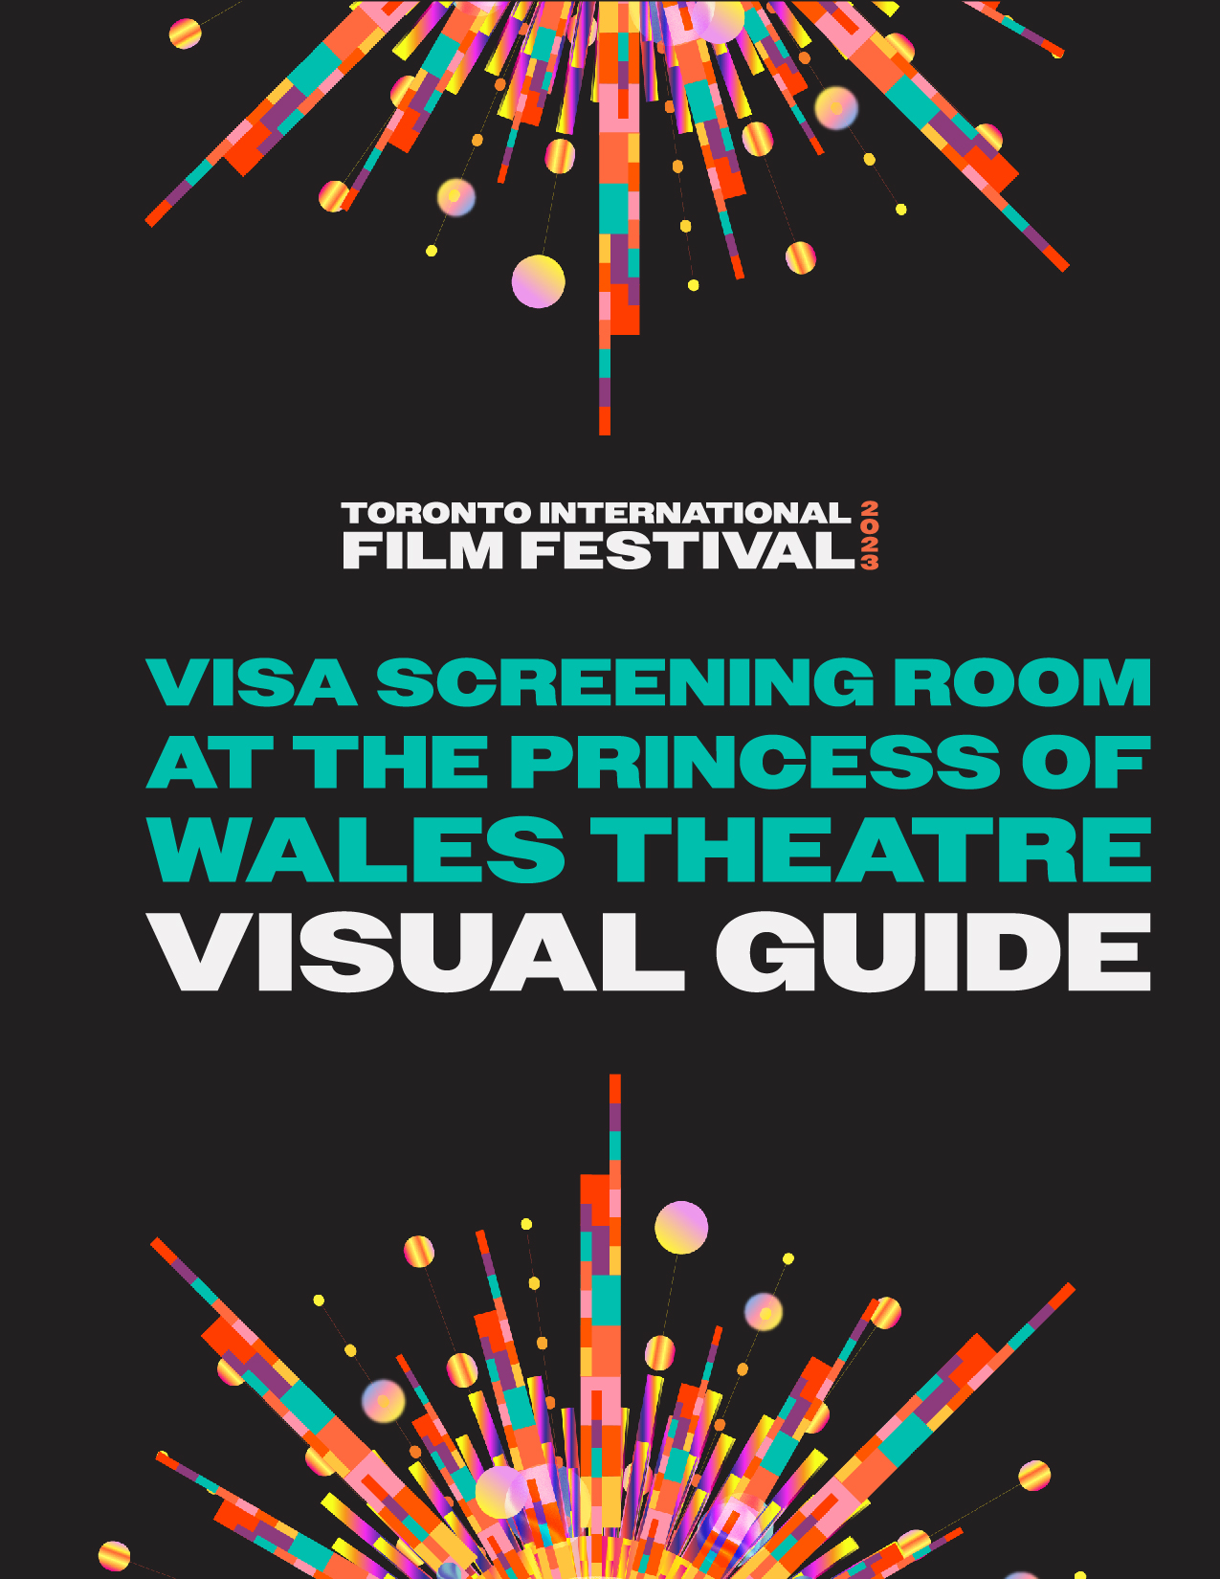

Visa Screening Room at the Princess of Wales Theatre Visual Guide

Location
300 King Street West, Toronto, ON M5V 1J2
Closest intersection

King St. and John St.
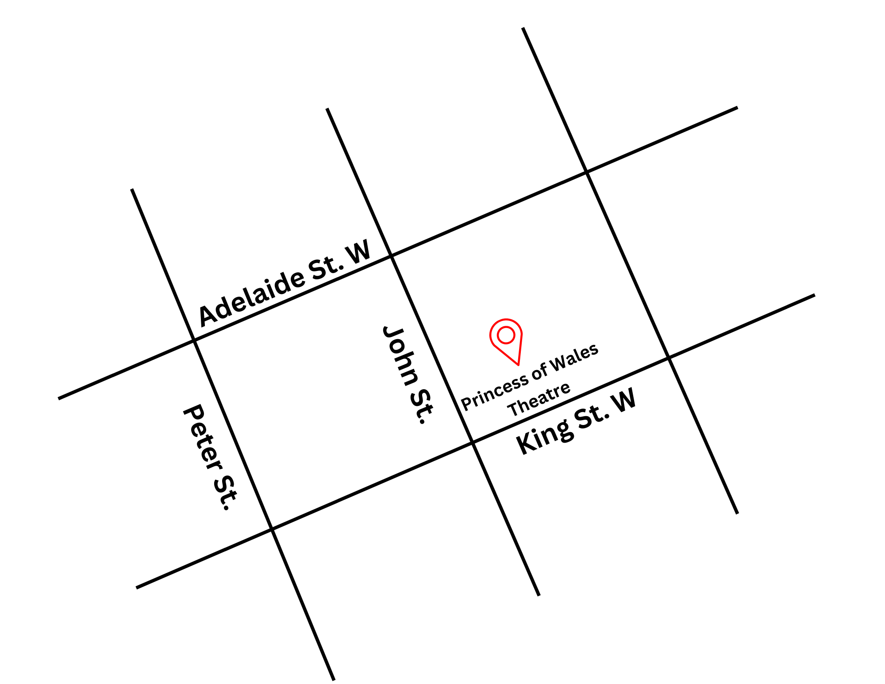
Figure 1: A Map of downtown Toronto with Princess of Wales at King St. W. and John St., and Adelaide St. W. and King St. W. to the North and South.

General information
- This venue has reserved seating

Routes of arrival
*Please see Festival Street closures
Subway
The Princess of Wales theatre is located near St. Andrew subway station on Line 1. It is a 350 m or 4-minute walk from the subway
Streetcar or bus
The King streetcar (Route 504) stops at the corner of King Street & University Ave. It is a 450 m or 6-minute walk from the streetcar stop
GO Transit or Via Rail
It is a 17-minute or 1.3 km walk from Union Station. The subway can be taken from Union Station (on the University line) one stop North to the St. Andrew Subway Station
Driving
There are four levels of parking located beneath the theatre, with an entrance ramp off John Street. If arriving from the parking garage located beneath the Princess of Wales Theatre, elevators are available on levels P1 and P4, which can take patrons to street level.

The entrance and lobby
- The front doors have automatic doors to the Front Lobby and can be opened by a pushed accessibility button on the right side.
- These doors may be heavy for some. There are volunteers or other staff members who will assist in opening these doors.
- The entrance is step-free and leads into the Main Lobby.
- There are no tactile colour-contrast cane detection surfaces at the entrance.
- There are large openings around trees at the Princess of Wales Theatre.
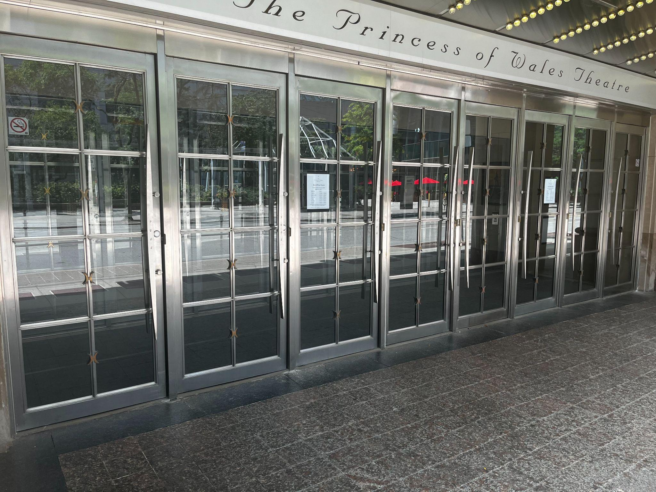
Figure 2: A photograph of the Front Doors to the Princess of Wales Theatre. There are Ushers who can assist in opening these doors.

Main Lobby
- Main Lobby down to Lower Lobby has 9 stairs with handrails.
- Main Lobby down to Lower Lobby down to CAA Lounge has 14 stairs, or 9 stairs and ramp with handrails.
- Main Lobby up to Lower Orchestra has 11 stairs.
- Main Lobby up to Orchestra has 23 stairs.
- Main Lobby up to Orchestra up to Dress Circle has 53 stairs.
- Main Lobby up to Orchestra up to Dress Circle up to Balcony has 84 stairs.

Rush lines
- The rush line starts at the Northeast corner of King St. and John St. and moves north up John St. towards Pearl St.
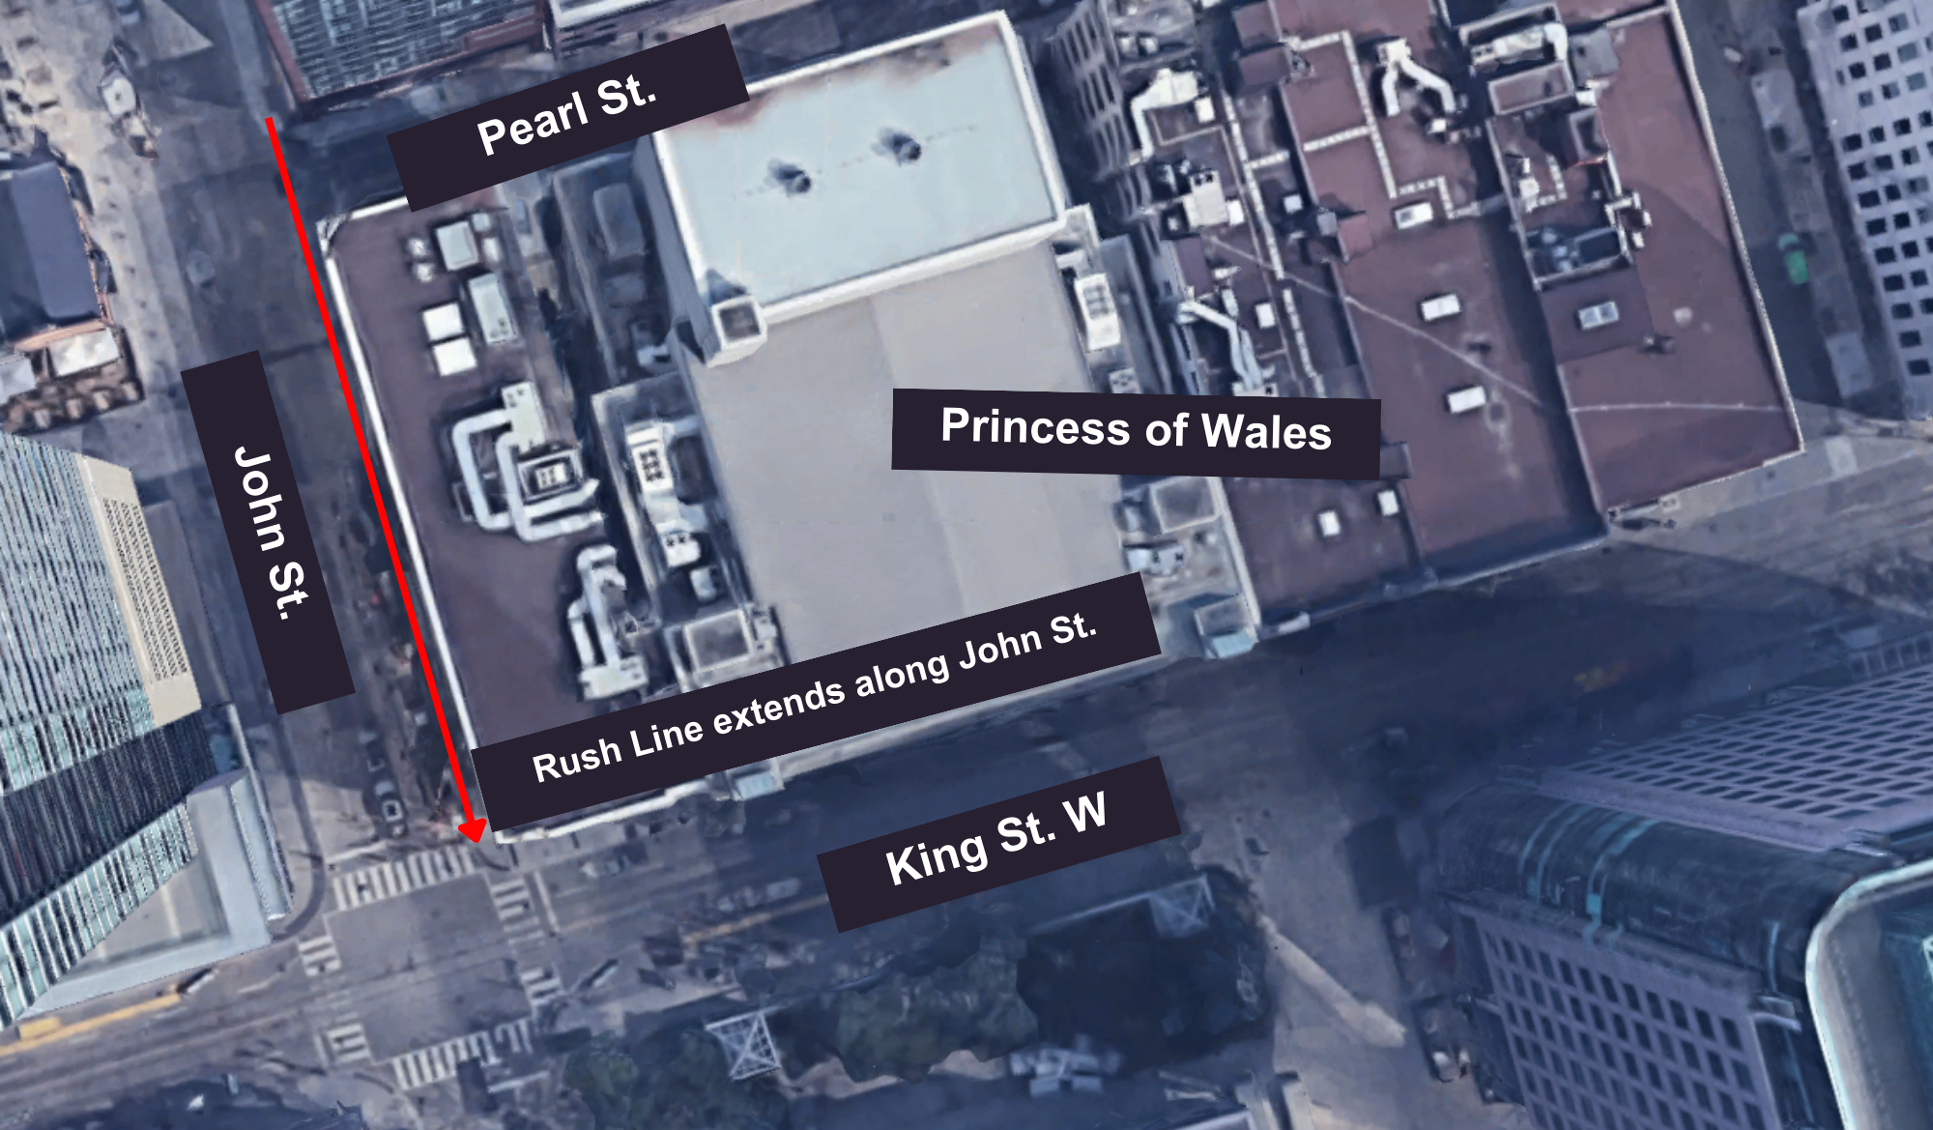
Figure 3: Aerial image of rush line for Princess of Wales

Access to theatres and seating
- All levels of the theatre can be accessed via lobby elevators, which provide access to wheelchair and assisted seating in the Orchestra, Dress Circle, and Balcony.
- The Orchestra is step-free from the street and Main Lobby, and there are lobby elevators to access the seating from street level and from the parking garage below the theatre.
- Once inside the auditorium, there are steps to reach rows H–W, all of which are highlighted with a handrail in place. There is a gradual ramp between rows AA–G.
- The Dress Circle has step-free access from street level and the Main Lobby.
- The Balcony can be accessed step-free from street level.

Orchestra
- Orchestra Rows AA–HH and A–G do not have any stairs.
- Row H–U contains stairs and this zone contains 14 shallow, wide steps (one per row), with handrails on the outer-left and right-side walls.
Accessible seating:
  - Row GG (Left section) Seats 40 to 41
  - Row GG (Right section) Seats 10 to 11
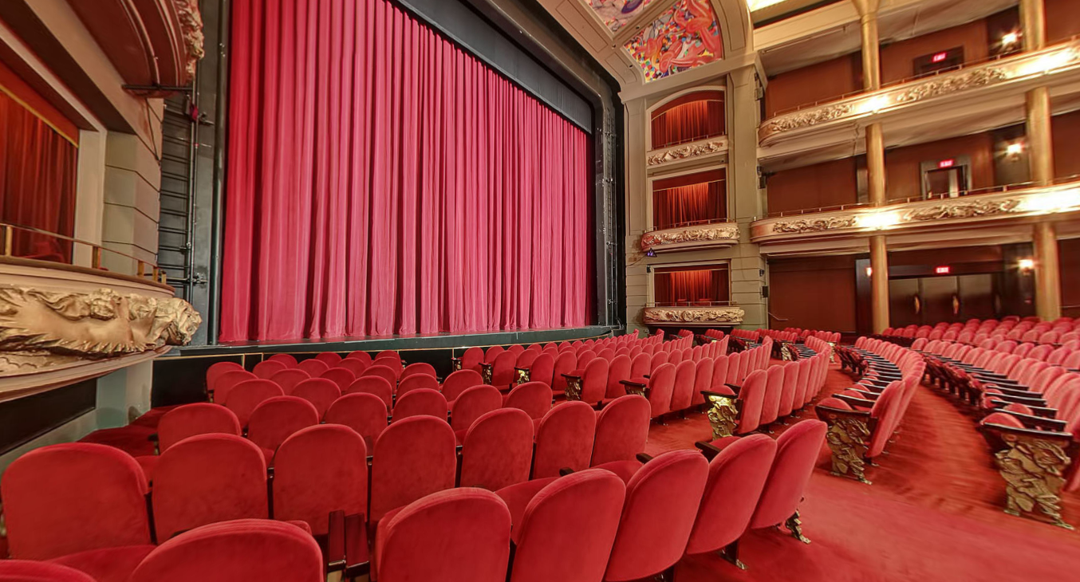
Figure 4: A photograph of the approximate view from Row GG 40–42

Dress circle
- There are no stairs in row K.
- Rows A–J contains 18 stairs (2 per row) with handrails on the outer- left and right-side aisles, and 12 stairs (2 per row) with no handrails on the inner-centre aisle.
Accessible seating:
  - Row K (Centre section) Seats 23 to 37
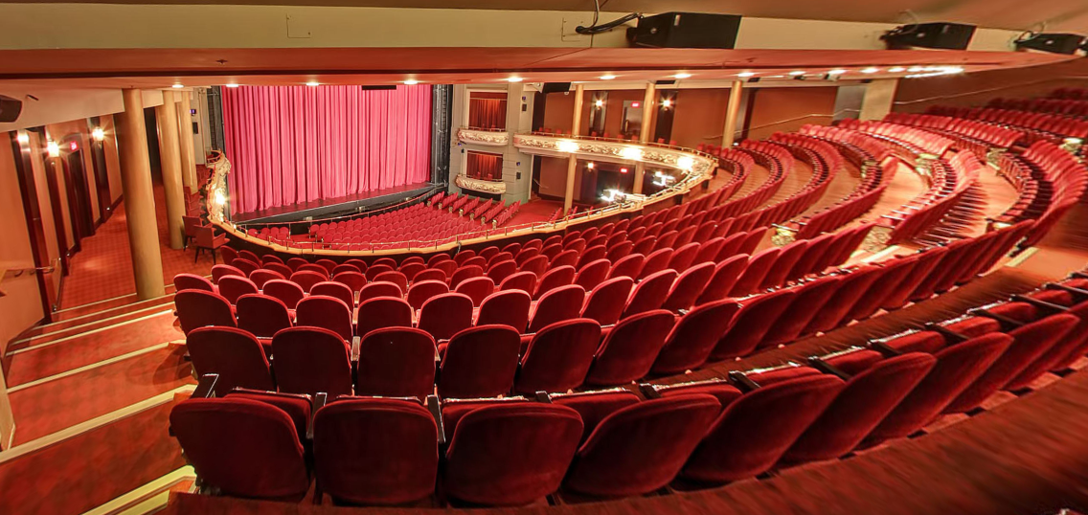
Figure 5: A photograph of the approximate view from dress circle Row K

Balcony
- There are no stairs within the Balcony Lobby
- No stairs within row J
Accessible seating
  - Row J (right section) Seats 6–9
  - Row K (left section) Seats 52–55
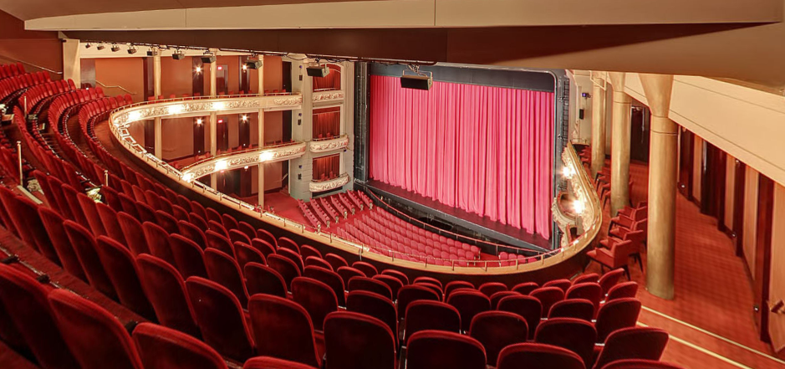
Figure 6: A photograph of the approximate view from Balcony row J

Accessibility services and devices available
Closed Captions | No
Assisted Listening | Yes | Stethoset, limited neck loops
Descriptive Sound | Yes* | Receivers with disposable earbuds

*Descriptive Sound are subject to content including a Descriptive Sound option
Concession stand
- No outside food and drink permitted inside.
- All payments accepted at sales locations (major credit cards and cash).
- No water fountains, but the bar staff can pour glasses of water upon request.

Washrooms
Accessible stall | Yes | There are barrier-free washrooms on the ground floor, dress circle, and balcony, with single stalls
Gender Neutral | No
Sensored Flushing | Partial | Lower lounge Accessible Washrooms only
Sensored Faucets | Yes
Automatic soap dispensers | Yes
Sensored paper towel | No
Change Tables | No

