

Scotiabank Theatre

Venue Access Guide

Scotiabank Theatre Venue Access Guide

Location
259 Richmond Street West, Toronto, ON M5V 3M6

Closest intersection
Richmond St. W. & John St.

Overview
This guide provides accessibility information to support visitors in planning their experience. If you have specific access needs, we recommend contacting the venue in advance.

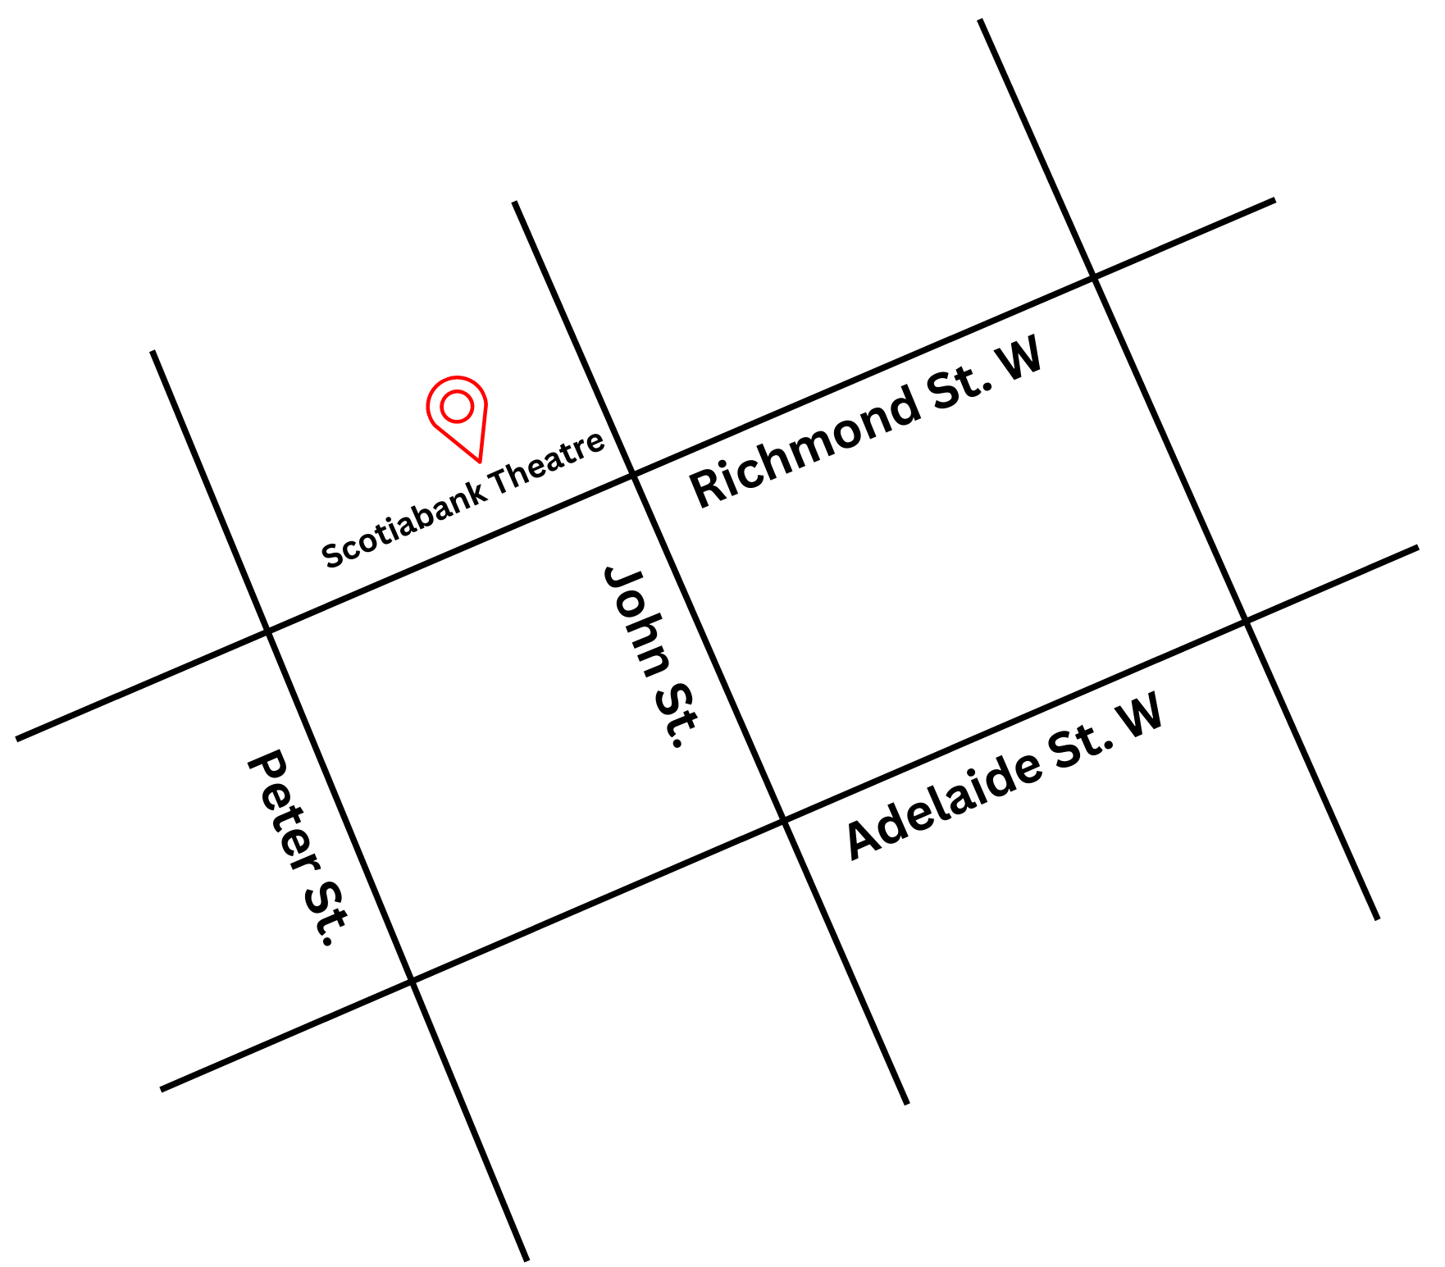
Figure 1: A Map of downtown Toronto with Scotiabank Theatre at Richmond St. W. and John St., and Adelaide St. W. to the south.

General information
- This venue is general admission

Getting There
*Please see Festival Street closures
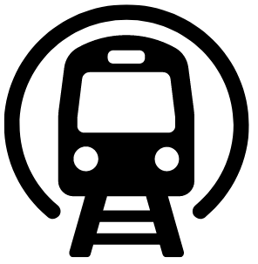
Subway
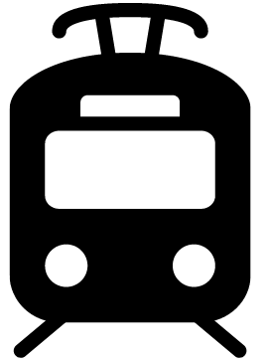
Scotiabank Theatre is located near Osgoode Station on Line 1. It is a 500 m (about a 6-minute walk at an average pace; travel time may vary) from Osgoode Station to the theatre.
Streetcar or bus
The Queen Streetcar (Route 501) stops at Queen St. W. & John St. It is 150 m (about a 2-minute walk at an average pace; travel time may vary) from the streetcar to the theatre.

GO Transit or VIA Rail

Scotiabank Theatre is 1.6 km (about a 21-minute walk at an average pace; travel time may vary) from Union Station. From Union station the subway can be taken Northbound to Osgoode Station.
Driving
Accessible underground RioCan Hall paid parking lot is within 30 m.

Arrival and entrance
The main entrance includes a step-free, wheelchair accessible entry with curb ramps.
Passenger drop-off is available in front of the theatre
- The front doors include a push-button automatic opener on the right side.
- There are currently no tactile walking surface indicators at the entrance or drop-off areas.
- A small overhang provides limited weather protection.
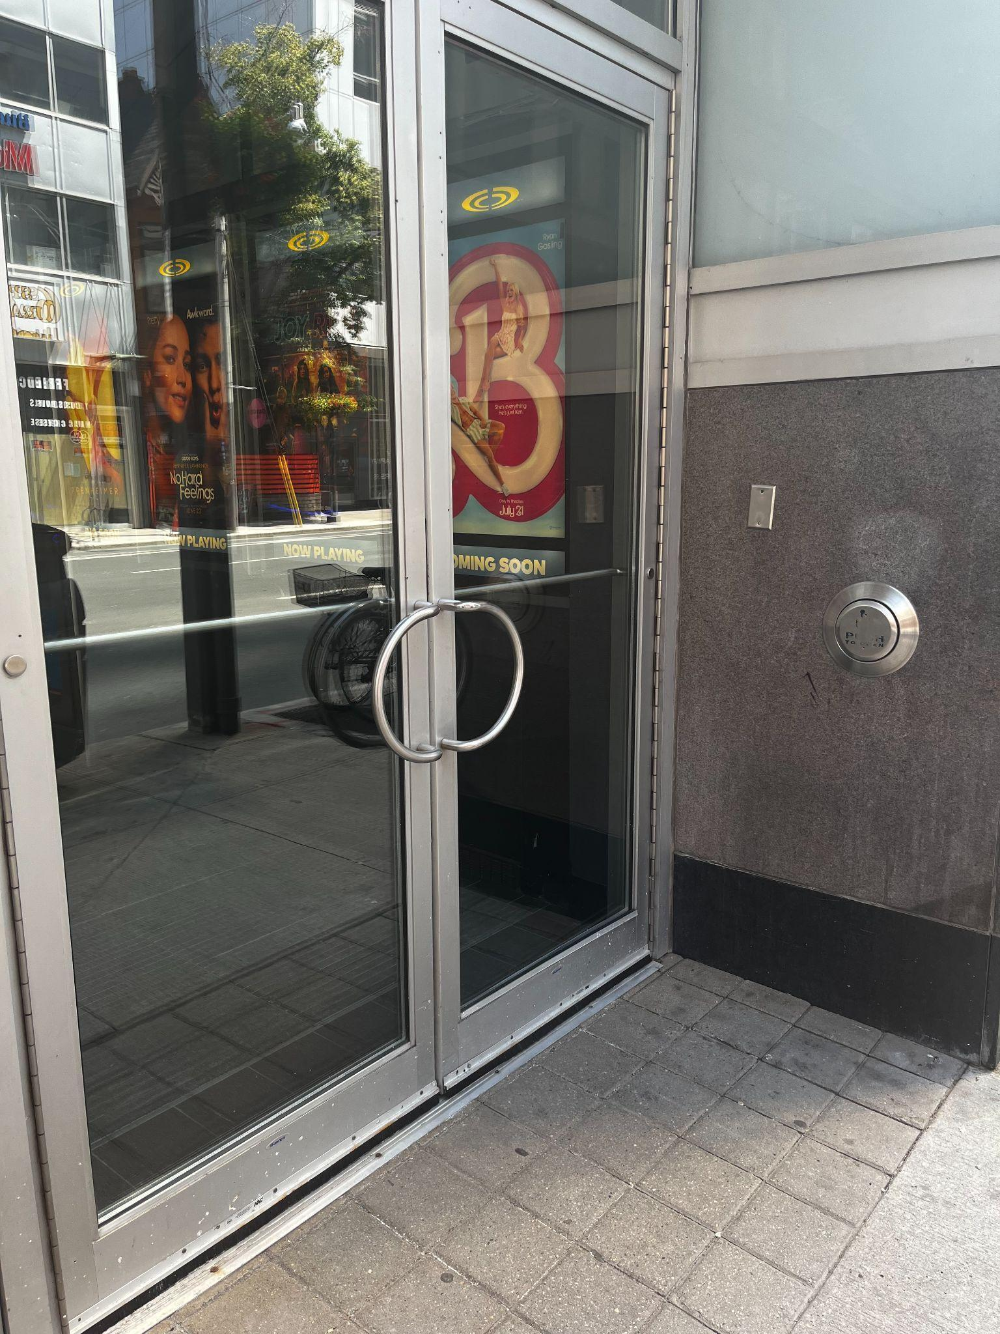
Figure 2: A photograph of the Scotiabank Theatre entrance with the accessible push-to-open button to the right side
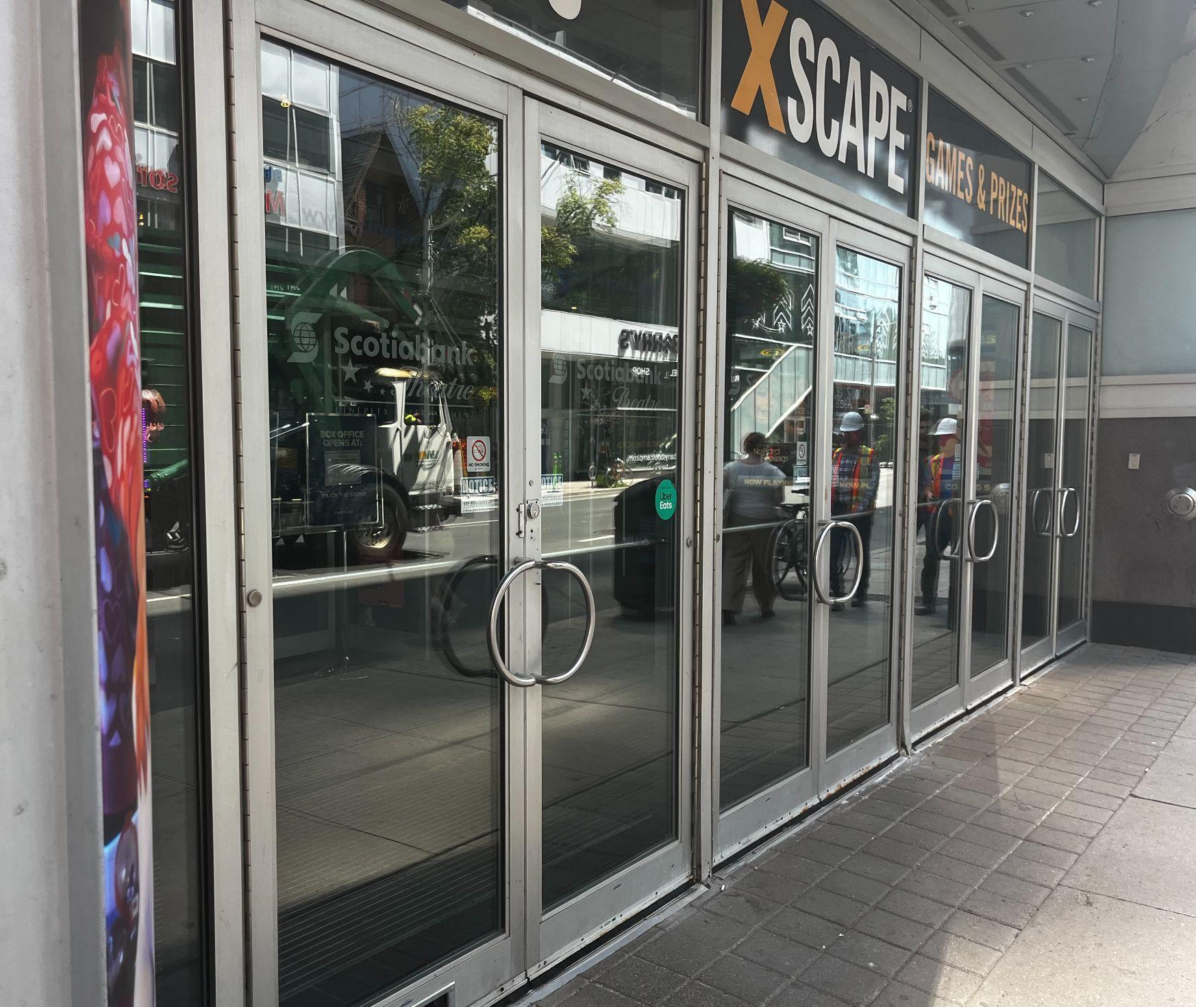
Figure 3: A photograph of the Scotiabank Theatre entrance doors

Rush lines
- Rush lines are located on Richmond St. heading west from the entrance. If the line is long, it may extend south along Widmer Street.
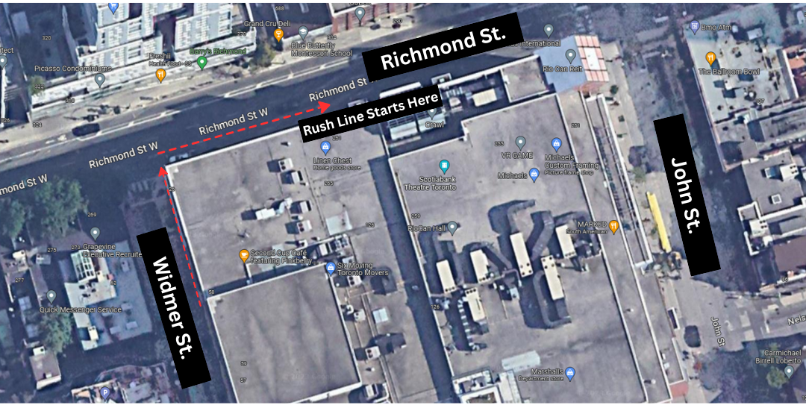
Figure 4: A photograph of the Rush line for Scotiabank Theatre. An arrow pointing along Richmond St. W. and heading south down Widmer St.

Access to theatres
- The theatres can be accessed by stairs, escalators, or an elevator
- Elevators are located to the right of the escalators and provide step-free access to all levels
- Escalators travel both up and down between floors
- There are approximately 75 stairs to the second floor
- A ramp provides access to theatres 5–11

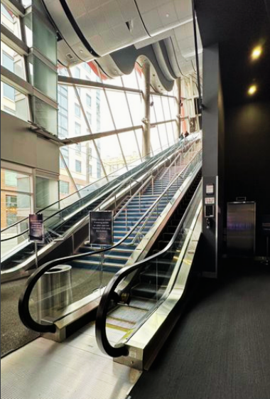
Figure 5: A photograph of the up and down escalators at Scotiabank Theatre. The “up” escalator is to the right and the “down” escalator to the left. The elevator is to the right of the escalators
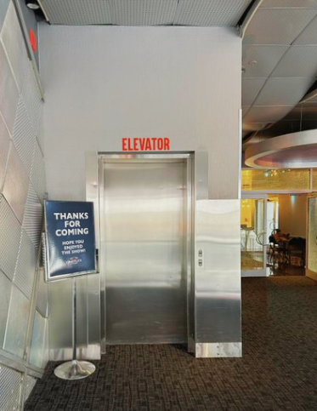
Figure 6: Elevators to exit
.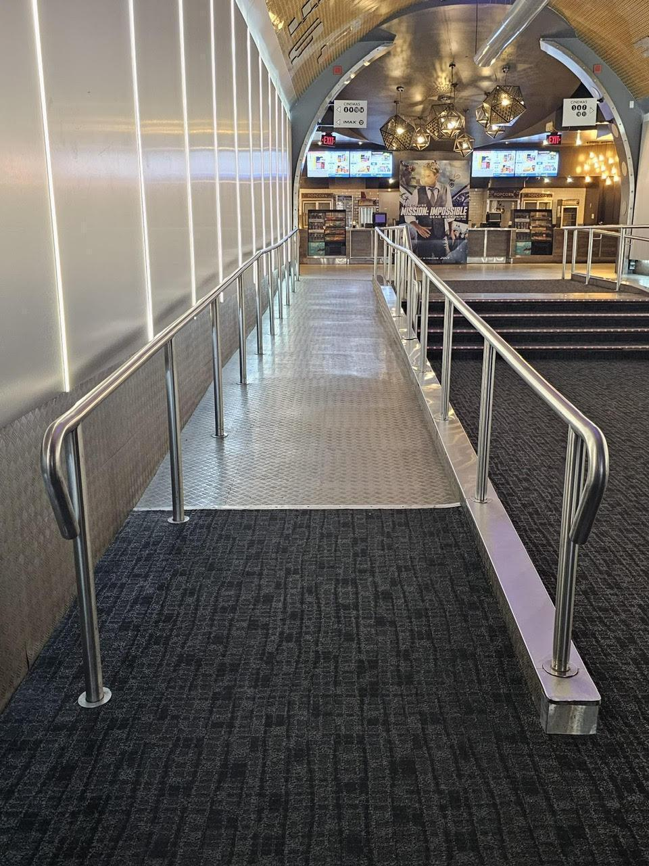
Figure 7: Photograph of the ramp leading towards cinemas 5–14.

Venue measurements
Door/Area | W x H | Notes
Front Doors | 70 inches | When both doors open, width is 65"
Curb Height (front doors) | 4.5 inches
Elevator Doors | 3 feet | Both ground floor + 1st floor
Escalator | 31 inches
Double doors - Reps Lounge | 80 inches
Bar Counter Height | 43 inches
Box Office Counter Height | 36 inches
Concessions Counter Height | 35 inches
Cinema 1 Doors | 67 inches
Cinema 2 Doors | 67 inches
Cinema 3 Doors | 65 inches
Cinema 4 Doors | 66 inches
Cinema 5 Doors | 67 inches
Cinema 6 Doors | 67 inches
Cinema 7 Doors | 67 inches
Cinema 8 Doors | 66 inches
Cinema 9 Doors | 64 inches
Cinema 10 Doors | 67 inches
Cinema 11 Doors | 67 inches
Cinema 12 Doors (IMAX) | 70 inches | main entrance (before the doors) : 117 inches
Cinema 13 Doors | 68 inches
Cinema 14 Doors | 69 inches | main entrance (before the doors) : 82 inches
Accessibility Ramp (in building) | 50 inches
Accessible Washroom 1 | 33 inches
Accessible Washroom 2 | 33 inches

Accessible Seating
*Most cinemas have 2–3 steps between each row. Cinemas 12 (IMAX) has 1–4 steps between rows

Cinema | Typical seating | Accessible seating | Companion seating | Step-free seating
Cinema 1 | 552 seats | 4 seats | 2 seats | Row A
Cinema 2 | 476 seats | 6 seats | 6 seats | Rows AA, BB,  and A
Cinema 3 | 387 seats | 3 seats | 2 seats | Row A
Cinema 4 | 388 seats | 3 seats | 1 seat | Row A
Cinema 5 | 134 seats | 3 seats | 2 seats | Row A
Cinema 6 | 137 seats | 3 seats | 2 seats | Row A
Cinema 7 | 184 seats | 3 seats | 2 seats | Row A
Cinema 8 | 182 seats | 3 seats | 1 seats | Row A
Cinema 9 | 189 seats | 3 seats | 2 seats | Row A
Cinema 10 | 228 seats | 4 seats | 2 seats | Row A
Cinema 11 | 227 seats | 4 seats | 2 | Row A
Cinema 12 | 412 seats | 4 seats | 4 | Row C
Cinema 13 | 314 seats | 4 seats | 2 | Row A
Cinema 14 | 309 seats | 4 seats | 2 | Row A
Assistive devices and services available
Feature | Availability | Device | Notes
Closed Captions | Yes | Captiview (all theatres) | Closed Caption or Audio Description are subject to content including a Closed Caption and/or Audio Description option
Assisted Listening | Yes | Receivers with headset or neckloop option
Descriptive Sound | Yes | Receivers with headset or neckloop option | Closed Caption or Audio Description are subject to content including a Closed Caption and/or Audio Description option

Concession stand
- Food and beverages, including alcohol, are available for purchase at concession stands and the bar/lounge.
- Outside food and drink are not permitted
- Cash, debit, and credit are accepted
Water fountains are located near the accessible washroom. Visitors may also request water from concession staff.

Washrooms
- Accessible washrooms are located in the hallway across from Cinema 6.

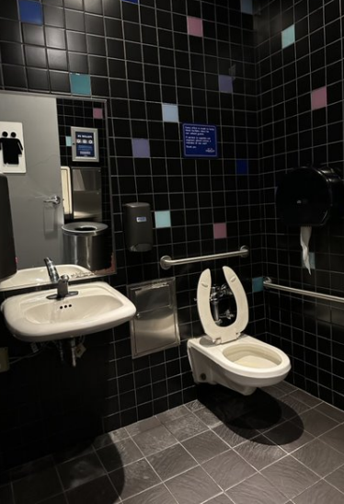
Figure 8: Photograph of accessible washroom near concession stand

Features | Availability | Notes
Gender neutral | No
Sensored flushing | Yes
Sensored faucets | Yes
Automatic soap dispensers | Yes
Sensored hand dryers | Yes | No paper towel
Change tables | Partial | Family Washroom near concession

