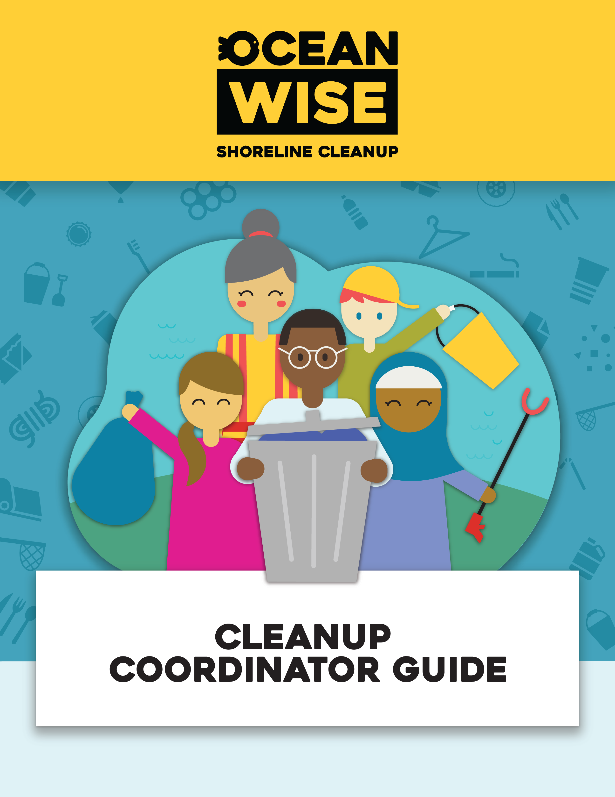

Contents
Welcome! 2
Before Your Cleanup 3
Register your Cleanup 3
Consult your Municipality 7
Recruit Volunteers 8
Get your Cleanup Supplies 12
During Your Cleanup 13
Set up the Cleanup Site 13
Lead, Monitor, And Supervise the Cleanup 13
Ensure Correct Data Collection 15
Conclude the Cleanup 17
After Your Cleanup 18
Dispose of Waste Properly 18
Share your Experience 18

Welcome!
Welcome to the Ocean Wise Shoreline Cleanup - Cleanup Coordinator Guide! As a Cleanup Coordinator, you play a vital role in organizing and leading shoreline cleanup initiatives, making a positive impact on our precious coastal ecosystems.
By participating as citizen scientists, your team plays an essential role in gathering valuable data about the types and quantities of litter discovered along your local shoreline and green spaces. This information can be recorded using the Data Card provided through our website and will strengthen our national litter database.
In this guide, you will find comprehensive information and step-by-step instructions to help you effectively coordinate and execute shoreline cleanup events. From pre-event preparations to post-event activities, we will guide you through the entire process, equipping you with the knowledge and skills needed to make each cleanup a success.
As a Cleanup Coordinator,
you are responsible for:

- Planning & organizing the cleanup event
- Volunteer recruitment & communication
- Providing instructions & guidelines to volunteers
- Providing necessary equipment & supplies
- Monitoring & supervising the cleanup activities
- Addressing any safety concerns or emergencies
- Collecting data on the cleanup efforts
Please be aware that you must be 19 years of age or older to serve as a cleanup coordinator. However, participants who are underage may still join cleanups with the consent of their parents or legal guardians. In such cases, an underage waiver will need to be signed on their behalf.

Before Your Cleanup

Register your Cleanup
STEP ONE is to register your cleanup event on our website. By doing so, you can access all the necessary tools and resources to organize a successful shoreline cleanup.
- Log in or create an account on Ocean Wise - Log In, once you are logged in, select Shoreline Cleanup to jump into our program.
- Once you are logged in, select the Lead/Join button located on the left menu.

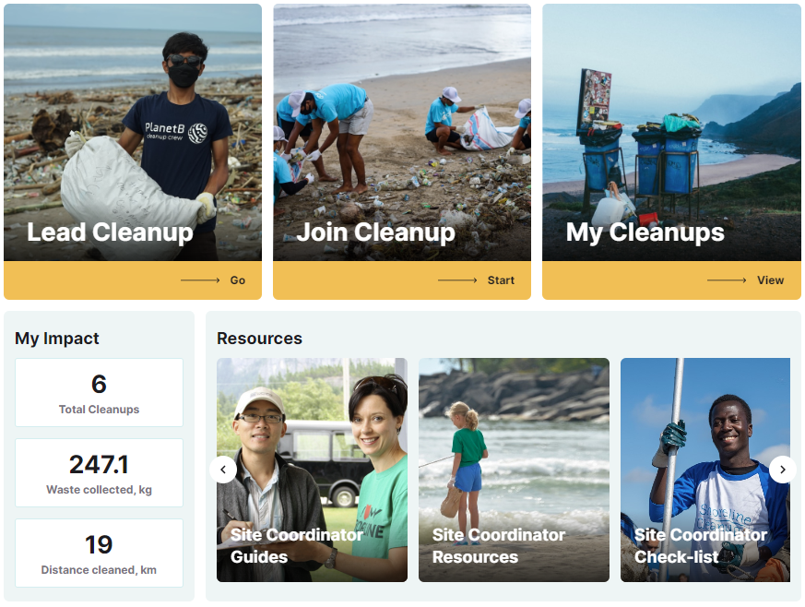
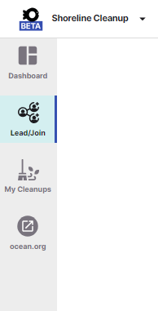

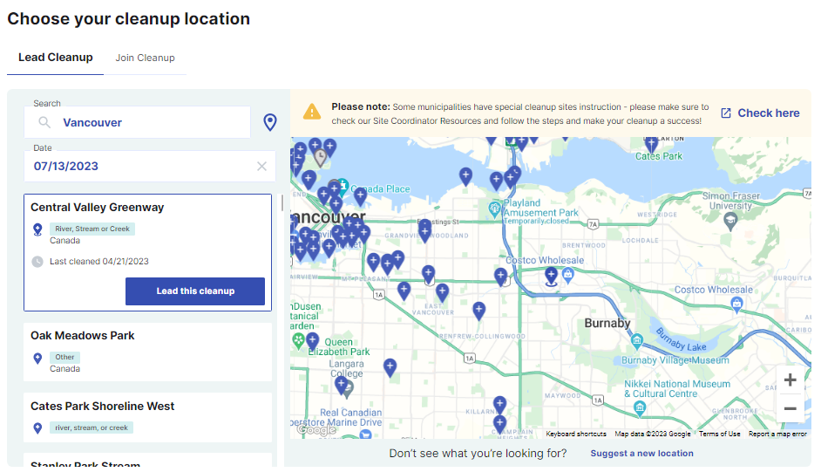
- This will lead you to our cleanup location map. Here, you will be able to enter your preferred cleanup date and city/town, which will then display available cleanup sites for that date with a distinctive blue marker.

Don’t see the location you are looking for?

Select the option on the bottom of the page to Suggest a new location! Once you submit all the necessary information, we will carefully assess your site suggestion based on its accessibility, security, and public or private state.

- Site Acceptance: If the site meets our criteria and aligns with our standards, we will gladly accept your suggestion. You will receive an email notification confirming the availability of your chosen site for the cleanup event.

- Site Rejection: In the event that the site does not meet our requirements, we will send you an email with a detailed explanation of the reasons for the rejection.
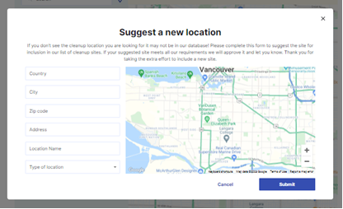

- Choose the blue marker corresponding to your desired cleanup site and click on the blue Lead this cleanup button to select it as your designated location for the cleanup.
PRO TIP: Conduct a Site Visit Before Registering Your Cleanup

Evaluate the accessibility and safety of the site. Determine if it is easily reachable and safe for your group. Identify a designated meeting spot where participants can conveniently gather.
Assess whether the cleanup site provides sufficient space to accommodate your group comfortably.
Take note of any potential hazards present at the site. This could include uneven terrain, sharp objects, or other safety concerns.
Observe and document the quantity of litter at the site, including both large and small items such as cigarette butts and plastic fragments.

- Customize your event page by entering the relevant event details. Ensure to include important information such as the cleanup name, description, meeting location, and the anticipated number of participants.
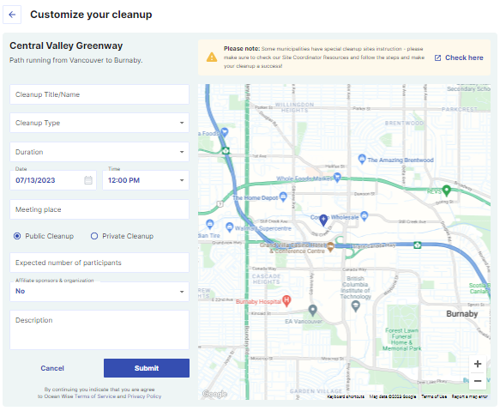
For more detailed information about permits, you can refer to STEP TWO of the planning process.
- Congratulations! You have successfully created your cleanup event page with Ocean Wise Shoreline Cleanup.
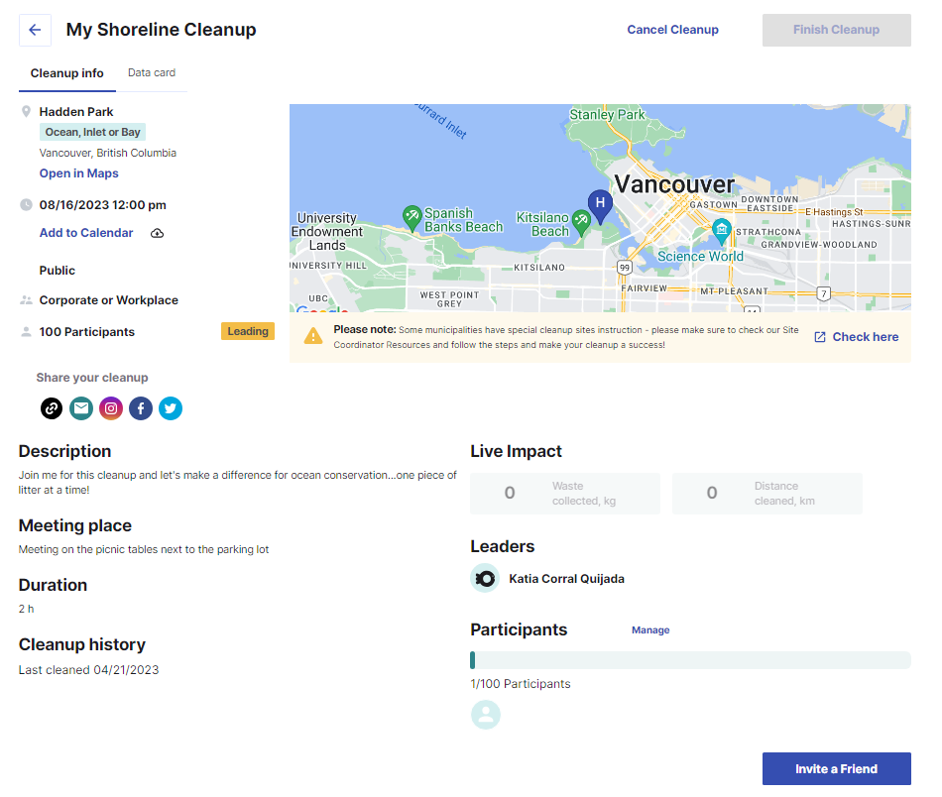

Consult your Municipality
STEP TWO is to consult your municipality. Before your cleanup, it is crucial to acquire the necessary permissions and permits from your local municipality. it is your responsibility to reach out to your municipality and:
- Confirm that you have permission to clean the registered site. Permits are often required in some cities where substantial amount of people gather under an organization; therefore, it is important to verify with the local municipality if a permit is needed. The earlier to apply for the permit, the better!
- Verify the availability of the shoreline on the cleanup day to make sure there are no conflicting large events scheduled.
- Seek guidance from the municipality on proper disposal methods for the collected litter by your group.

Need help? Use our Municipality Request Template for assistance
on contacting your local government for support and advice.

Recruit Volunteers
STEP THREE is to recruit volunteers and maintain effective communication with them. By promoting your cleanup through various channels, you can attract more volunteers and create greater awareness and support for your shoreline conservation efforts.
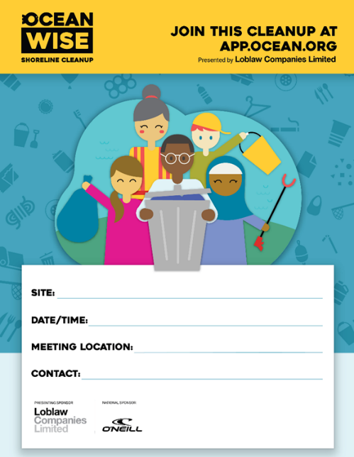
- Promote Your Cleanup! Spreading the word about your cleanup is a great way to get more helping hands-on board. Here are some ways to promote your cleanup…
Use our poster to help spread the word!

- Share on social media: Use the options on your cleanup page to share a link, email, Facebook, and Twitter to promote your cleanup. Encourage friends, family, and colleagues to share the event with their networks as well. The more people, the greater your impact! Let's have fun along the way!

- Tag us on social media @oceanwise

- Don’t forget to use our hashtags!
#TeamShoreline #ShorelineCleanup
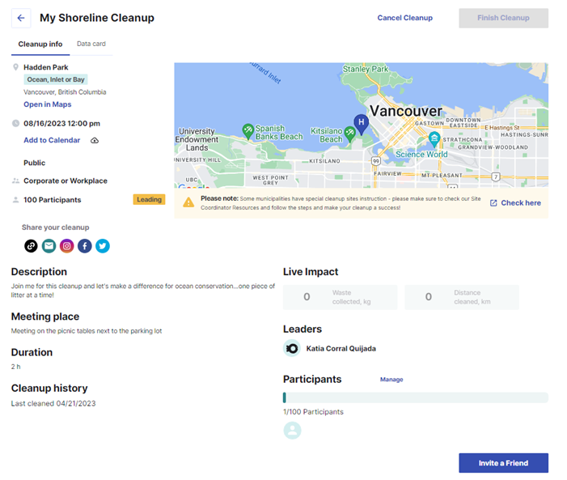

- Additional tips:
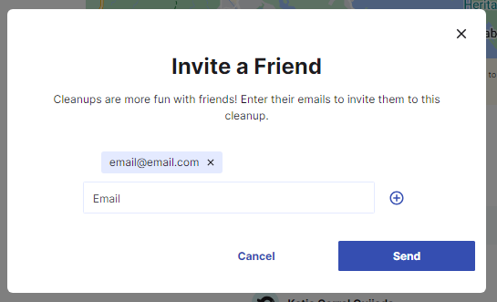
- Invite a Friend: Select  to invite your friends and family to your cleanup by entering their email and clicking the (+) sign, you can input as many emails as you like.

- Community Calendars: Check if your municipality has an online listing of local events. Submit your cleanup event to these calendars to reach a broader audience.
- Local Business Collaboration: Challenge a local business to join your cleanup. They may even donate supplies or offer support. Building partnerships with businesses can help increase participation and visibility.
- Local Media Outreach: Reach out to local TV and radio stations, as well as community newspapers, to request sharing your cleanup message. Many media outlets have event listings where you can promote your cleanup.
- Get creative! Unleash your creativity by using our customizable poster, engaging videos, and exciting recruitment messages to attract volunteers. Promote the cleanup event as a fun and impactful experience that participants won't want to miss.

- Maintain Regular Communication: Keep volunteers informed with updates, reminders, and important details through email, social media, and dedicated channels.

- Provide Clear Instructions: Share comprehensive instructions on what to bring, where to park, and any site-specific considerations or safety guidelines.

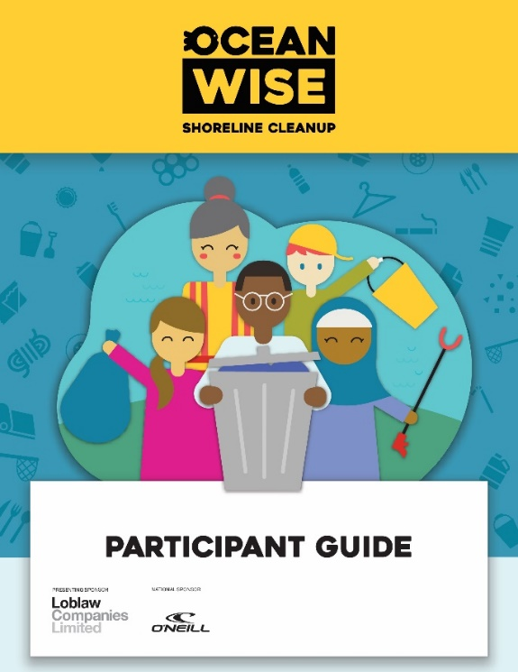
- Share our Participant Guide so all volunteers are prepared for the big day!

And make sure participants bring:

- Reusable water bottle
- Sturdy shoes or boots (no sandals or other open-toed shoes)
- Additional garbage/recycling bags and gloves

Get your Cleanup Supplies
Step Four is to get your cleanup supplies, and necessary forms. To ensure a smooth and organized cleanup event, it's essential to gather the necessary supplies and forms in advance. Follow these steps to prepare for your shoreline cleanup:

- Identify Essential Supplies: Make a checklist of needed supplies like gloves, garbage bags, litter pickers and buckets. Check the list we had created for you!

- Acquire Supplies: Purchase or seek donations from your municipality, local businesses, organizations, or volunteers.
- Prepare Safety Equipment: Advise your participants to bring sunscreen, hats, insect repellent, and hand sanitizer. If possible, bring a first aid kit.

- Print Necessary Forms: Prepare required forms such as liability waivers and physical data cards. Underage participants need their parents or legal guardian to sign the underage waiver on their behalf.

Please be aware that while we offer printable resources for volunteers to bring to cleanups, we encourage the use of our online data card and waiver system to minimize paper waste. If you prefer using printed data cards, please make sure to submit the data through our website after completing the cleanup.

During Your Cleanup

Set up the Cleanup Site
Step Five is setting up the cleanup site. Clearly identify your meeting location with posters, signs etc. Set up a central sign-in station with a first aid kit, Liability Waivers for any drop-in participants, your cleanup supplies, and printed Data Cards if you are not using the online data card feature.

- Organize Supplies: Pack cleanup supplies conveniently and create supply stations at the site for easy access.

Lead, Monitor, And Supervise the Cleanup
Step Six is leading, monitoring, and supervising the cleanup activities. Before sending off everyone to the cleanup make sure they have registered and signed the waiver (underage participants need their parents or legal guardian to sign the waiver on their behalf). Follow these guidelines to effectively lead, monitor, and supervise the cleanup:

- Welcome your participants and make sure that they are all registered to the event

- Set a time for arrival: Coordinate a time to return to the home base and sort through all the litter.

- Assign Roles: Assign roles to different individuals within the cleanup team. Participants will need to divide into groups of 3-4. When dividing into groups, each group should have:

- 1 designated data collector
- 1 garbage collector

- Ensure Safety: By following these safety guidelines, you can ensure a safe and enjoyable experience during the shoreline cleanup:

- Stay Hydrated
- Protective Gear: Always wear gloves when picking up litter and ensure you have proper footwear (no open-toe shoes) to protect your feet.
- Watch Your Step:.
- Supervise Children
- Handling Sharp Objects: If you come across sharp or dangerous items like syringes or broken glass, place them in a designated Sharps Container.
- Large or Heavy Items: If you encounter items that are too large or heavy to handle safely, do not attempt to lift them.
- Ensure proper lifting technique to prevent injuries.
- Respect Animal Habitats
- Avoid approaching any animal, whether it is dead or alive.
GIVE AN INSPIRING PEP TALK
Land acknowledgment: The Shoreline Cleanup team encourages you to include a land acknowledgment into your pep talk. This is more than just recognizing the traditional Indigenous territories on which we live -- it means supporting reconciliation efforts and recognizing the sacred role that Indigenous peoples have played and continue to play in the conservation of our environment.
Share interesting facts about plastic: “Plastic pollution affects us all. It accumulates in landfills, oceans, and habitats, endangering ecosystems, and wildlife. Additionally, chemicals from plastics can contaminate food and water sources, posing health risks.”
Did you know…
- Annually, 13 million tons of plastic end up in our oceans.
- In Canada, only 9% of single-use plastic is recycled.
Connect to a larger purpose: Explain how they contribute to protecting ecosystems, driving policy changes, and addressing the pressing issue of plastic waste. They help emphasize the need for policy reforms towards a more sustainable future.
Express optimism for the future and challenge their plastic consumption: Conclude the pep talk on a positive note. Encourage participants to make sustainable choices in their daily lives.

- Promote Environmental Education: Take the opportunity to educate participants about the importance of shoreline conservation, the impact of marine pollution, and the significance of their cleanup efforts.
- Monitor Progress and Provide Guidance: Check in with the groups or individuals to monitor their progress and help if needed

Ensure Correct Data Collection
Step Seven is ensuring correct data collection on the cleanup efforts. Data collected by your participants is crucial to our citizen science program and is used to inform plastic policy! We strongly recommend tallying up the litter you collect as you walk along the shoreline rather than waiting until the end of the cleanup to sort and count everything. This data helps expand our understanding of the amount of litter and the most commonly found plastics.

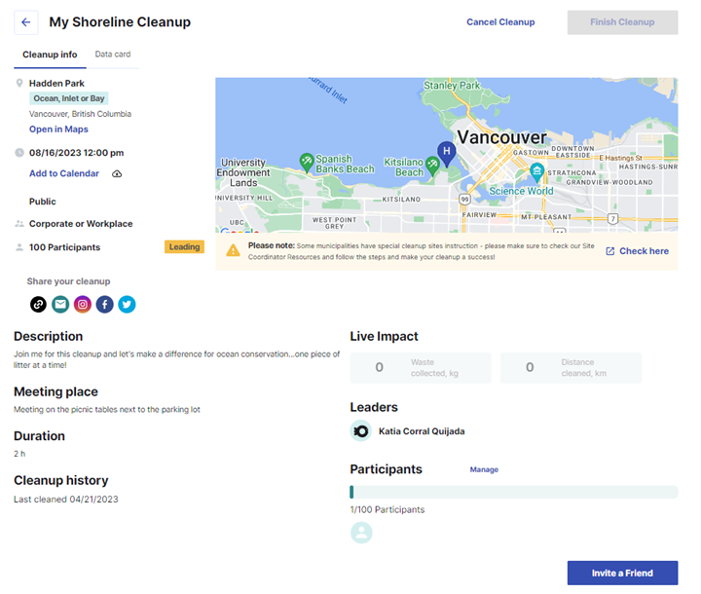
Why is it important to use the Data Card? Recording litter with the Data Card is an integral part of our citizen science program. By contributing this data, you are helping researchers, policymakers, and communities to gain insights into the state of our environment and the impact of plastic pollution.
Where to find the Data Card?
You can conveniently access your
Data Card through the Ocean Wise App
on your mobile device. Simply log
in to your Ocean Wise account on app.ocean.org and navigate to "My Cleanups." Find the specific cleanup you participated in, and click on the "Data Card" tab that appears at the start time of the cleanup.

What's included in the Data Card?
The Data Card provides a structured format to record essential details about the litter you and your team collect during the cleanup. The items are categorized into six groups, including:

- Most likely to find
- Fishing gear
- Product packaging
- Personal hygiene items
- Tiny trash
- Other trash

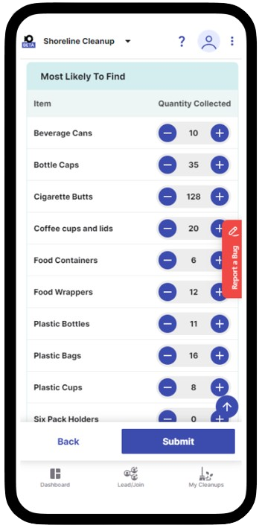
How does it work?
As you walk along the cleanup site, the Data Card will prompt you to provide details about the type and quantity of items collected. You can easily add items by clicking the +/- buttons or typing in the number. Feel free to input data in real-time as you clean up the site. Once you have completed the data entry, click the submit button to save your valuable contributions.

Submit your data!
After filling in the Data Card with the collected litter details, don't forget to submit your data. The submit button is located at the end. Don’t forget to add the approximate total weight of the trash
you or your team collected! Your contribution will be securely stored and utilized to enrich our understanding of plastic pollution and drive evidence-based policies for a cleaner and healthier
ocean environment.

Conclude the Cleanup
The final Step is concluding the cleanup. After completing the cleanup, take the opportunity to engage with participants and gather their feedback on the cleanup experience.. Did they come across any peculiar or surprising finds? Encourage them to share their stories and experiences on social media.

- Ensure that everyone has completed their data collection. This step is crucial, so if any participants haven't finished inputting their data, provide them with the necessary tools, such as another bucket, to sort through the collected litter.

- Monitor Progress and Provide Guidance: Check in with ‘Now it's time to make sure participants record the final weight of their buckets and, without including any units (kg) on their data cards.’ Once this step is done, you can submit the data cards.

- Sort out the litter onto the designated tarp and see the fascinating items that participants found along the shoreline. Take a group photo with the collected litter spread out on the tarp and share it with us!


- Separate trash and recyclables: Separate the recycling items from the garbage. Place all the recycling bottles in a clear recycling bag and use black trash bags for the garbage.


- Follow your municipality’s guidelines for recyclables: Familiarize yourself with local recycling guidelines to ensure you correctly identify recyclable items. When in doubt, it's best to place the item in the non-recyclable trash bag to prevent contamination of recyclables.

By the end of the cleanup, you should have the following data recorded:
- Total number of participants who joined the cleanup.
- Approximate total distance covered during the cleanup (in kilometers).
- Include any unusual items your team found along the cleanup site!

After Your Cleanup

Dispose of Waste Properly
Ensure all the collected waste is placed in the designated location for proper disposal. This helps maintain cleanliness and prevents further pollution.

Share your Experience
Take pictures of the cleanup efforts and share them on social media to inspire others. Tag us on social media @oceanwise
Don't forget to include the following hashtags in your social media posts: #TeamShoreline #ShorelineCleanup
By sharing your photos and using these hashtags, you help raise awareness about the importance of plastic reduction and the impact of shoreline cleanups. Together, we can make a greater difference and encourage more individuals to join the cause!

Recognizing and appreciating volunteers' efforts. Thank your participants after the cleanup with our Participant Certificates.
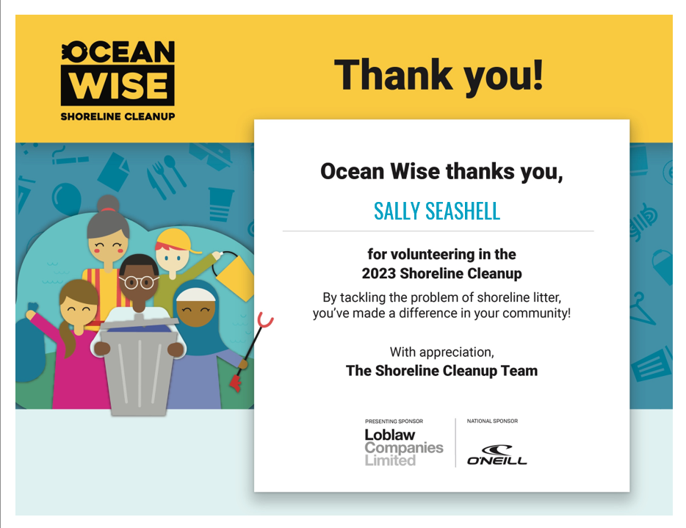
Reflect on your impact. Consider how your actions can influence positive change in your daily life to reduce waste and protect the environment. Here are some of the ways in which you can take action:
- Take the Plastic Pledge! Take the first step in reducing your plastic footprint with the Plastic Pledge. Then you’re all set to take on the Plastic Challenge, where you actually get to see how much plastic you use, and plan plastic swaps that will fit into your own life. Follow this Link to Take the Plastic Pledge
- Take the Plastic Challenge! It’s simple – all you have to do is take a look at your trash from the last week, see where you can make a change to use less plastic, and review your trash again in a month’s time. Follow this Link to Take the Ocean Wise Plastic Challenge
- Lead a Shoreline Cleanup! Take charge and organize your own shoreline cleanup.
- Sign up for more public Cleanups! Join more impactful public cleanup events to contribute to the preservation of our environment.

Thank you for your dedication and efforts in making
a positive impact on our coastal ecosystems!

