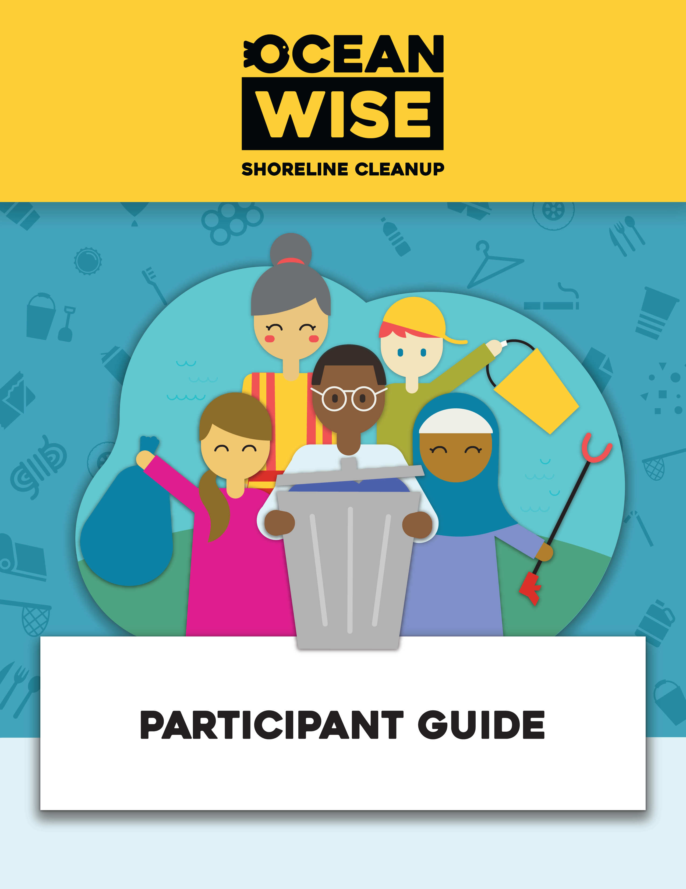

Contents
Welcome! 2
Before Your Cleanup 3
Register for the cleanup 3
Prepare for the Cleanup: 6
During Your Cleanup 7
Collect Supplies 7
Record Litter on the Digital Data Card 7
After the Cleanup 9
Dispose of waste properly 9
Share your experience! 9
Reflect on your impact 9

Welcome!
Welcome to the Ocean Wise Shoreline Cleanup - Participant Guide! Becoming a participant in an Ocean Wise Shoreline Cleanup is an opportunity to embark on a rewarding and impactful journey. By participating a citizen scientist, you play an essential role in gathering valuable data about the types and quantities of litter discovered along your local shoreline and green spaces. This information can be recorded using the Data Card provided through our website and will strengthen our national litter database that can be shared with industry leaders and policy makers to make valuables changes in our communities.
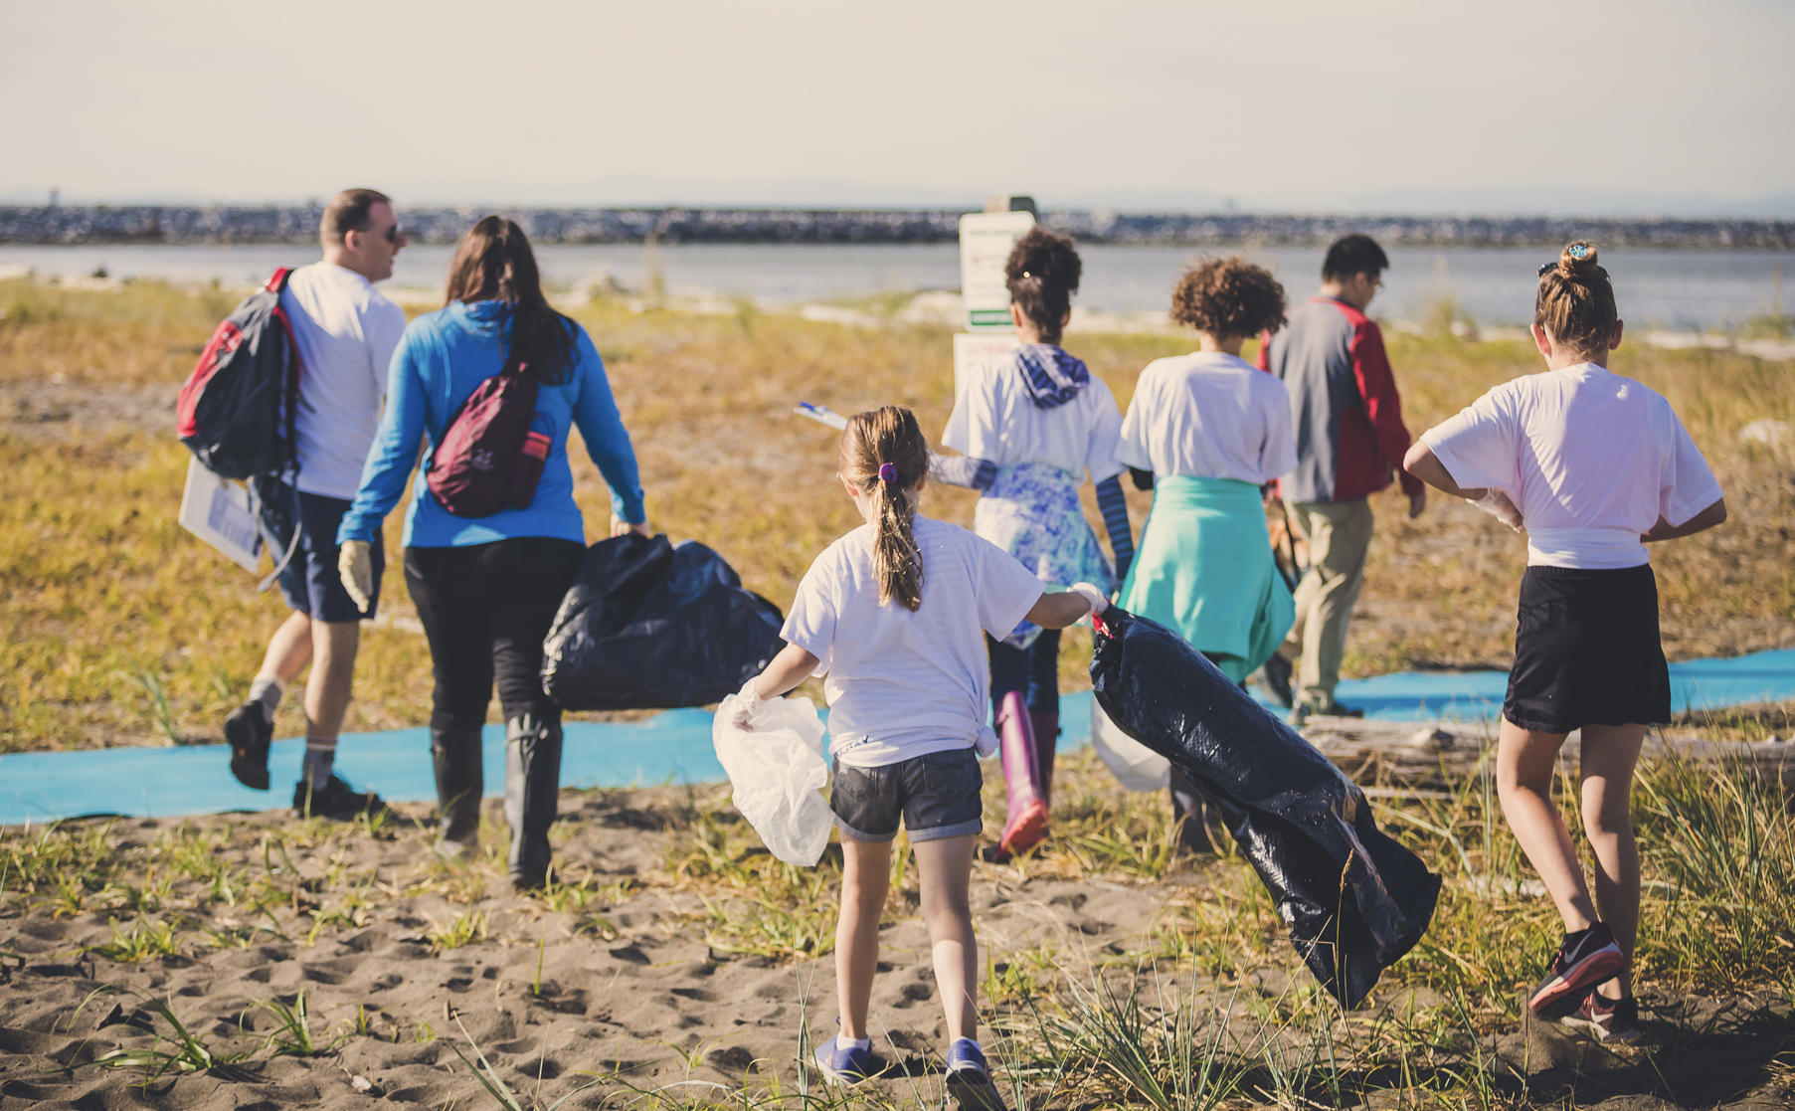
In this guide, you will find information on how to register for a cleanup, preparation tips, safety guidelines, general cleanup procedure, environmental considerations, and steps to follow once the cleanup has concluded.

Before Your Cleanup

Register for the cleanup
- Log in or create an account on Ocean Wise - Log In, once you are logged in, select Shoreline Cleanup to jump into our program.
- Once you are logged in, select the Lead/Join button located on the left menu.

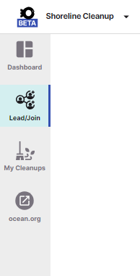
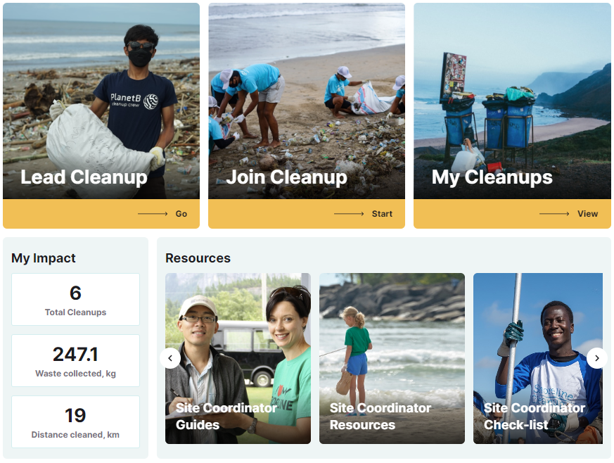

- Based on your location, a list of upcoming public cleanups will appear on the left side of the map. You can search based on location and how to zoom in/out and navigate the map to see more options.
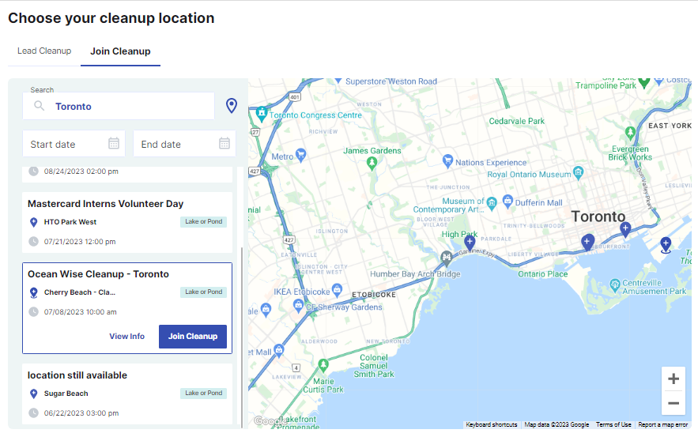
- Select Join Cleanup, indicate whether you have an affiliation to any listed organization, and read and accept the terms of conditions.
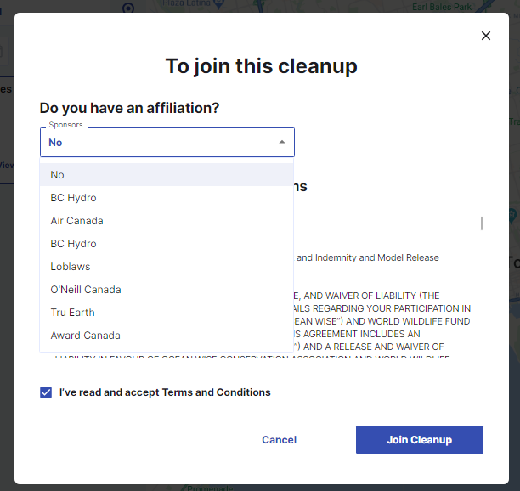
- Success! You have now joined a Cleanup. You will be able to find all cleanup information, including options to share the cleanups for your friends and family to join! Please make sure to visit the cleanup page to review any changes. You will be able to view and access your upcoming cleanups by selecting My Cleanups on the left side menu.

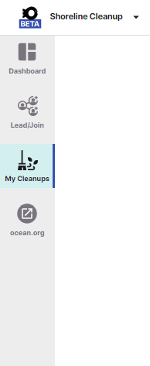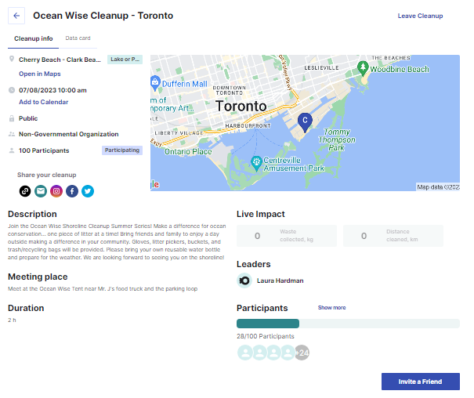

Prepare for the Cleanup:
Dress appropriately: Wear comfortable clothes and closed-toe shoes that you don't mind getting dirty. Consider wearing long pants and sleeves to protect yourself from sharp objects or plants.
Bring essential items: Carry sunscreen, a hat, insect repellent, and reusable gloves to protect yourself from the elements. You are also welcome to bring extra supplies you may already have in your home, such as trash / recycling bags, reusable gloves, buckets, and litter pickers.
Stay hydrated: Bring a reusable water bottle to stay hydrated throughout the activity.
Coordinate transportation: Carpooling or using public transportation is encouraged to minimize the environmental impact.
Bring your phone: Remember to bring your mobile phone with you to ensure easy access to the data card.
Safety Guidelines
- Follow the event organizer’s instructions:
- Time to team up in groups of 2-4: Each team should have a data collector and a garbage collector.
- Use caution & report any hazards to the organizers
- Avoid sensitive environmental areas
- Be aware of wildlife: Respect local wildlife and avoid touching or approaching any animals you encounter.
- Report unusual or hazardous items: If you come across hazardous materials or sharp objects, inform the organizers immediately and do not handle them.

During Your Cleanup

Collect Supplies
Collect the necessary cleanup supplies from the organizers, such as trash bags, gloves, buckets, and litter pickers.

Record Litter on the Digital Data Card
Data collected by volunteers is crucial to our citizen science program and is used to inform plastic policy! We strongly recommend tallying up the litter you collect as you walk along the shoreline rather than waiting until the end of the cleanup to sort and count everything. This data helps expand our understanding of the amount of litter and the most commonly found plastics.
Why is it important to use the Data Card?
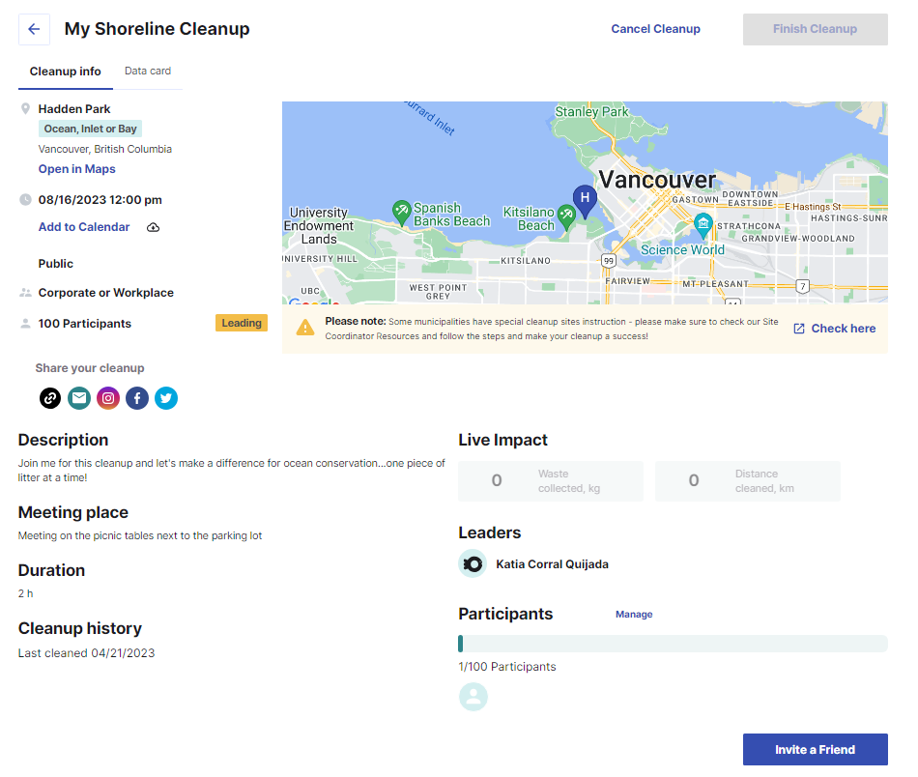
Your participation in recording litter with the Data Card is an integral part of our citizen science program. By contributing this data, you are helping researchers, policymakers, and communities to gain insights into the state of our environment and the impact of plastic pollution.
Where to find the Data Card?
You can conveniently access your Data Card through the Ocean Wise App on your mobile device. Simply log in to your Ocean Wise account on app.ocean.org and navigate to "My Cleanups." Click on the "Data Card" tab that appears at the start time of the cleanup.

What's included in the Data Card?
The Data Card provides a structured format to record essential details about the litter you and your team collect during the cleanup. The items are categorized into six groups, including:

- Most likely to find
- Fishing gear
- Product packaging
- Personal hygiene items
- Tiny trash
- Other trash

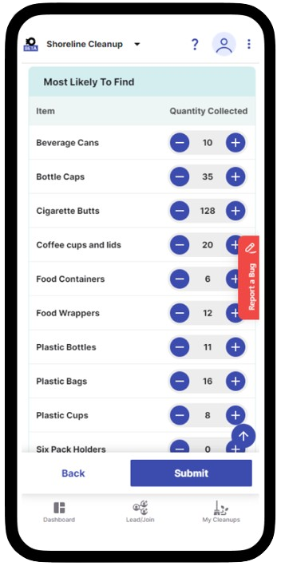
How does it work?
When you access the Data Card, you'll have the option to input data for yourself or for a group of individuals.
As you walk along the cleanup site, the Data Card will prompt you to provide details about the type and quantity of items collected. You can easily add items by clicking the +/- buttons or typing in the number.
Submit your data!
After filling in the Data Card with the collected litter details, don't forget to submit your data. The submit button is located at the end.

After the Cleanup

Dispose of waste properly
Place all collected litter in the designated trash and recycling bags, and dispose of them as instructed by the organizers. Here's how you can help the coordinators and ensure that every item finds its proper place:
- Separate trash and recyclables by your municipality guidelines: Familiarize yourself with local recycling guidelines to ensure you correctly identify recyclable items. When in doubt, it's best to place the item in the non-recyclable trash bag to prevent contamination of recyclables.

Share your experience!
Take photos of the cleanup and share your efforts on social media to raise awareness about the importance of shoreline conservation. Tag us on the following platforms:
- Tag us on social media @oceanwise

- Don’t forget to use our hashtags!
#TeamShoreline #ShorelineCleanup

By sharing your photos and using these hashtags, you help raise awareness about the importance of plastic reduction and the impact of shoreline cleanups. Together, we can make a greater difference and encourage more individuals to join the cause.

Reflect on your impact
Consider how your actions can influence positive change in your daily life to reduce waste and protect the environment. Here are some of the ways in which you can take action:
- Take the Plastic Pledge! Take the first step in reducing your plastic footprint with the Plastic Pledge. Then you’re all set to take on the Plastic Challenge, where you actually get to see how much plastic you use, and plan plastic swaps that will fit into your own life. Follow this Link to Take the Plastic Pledge
- Take the Plastic Challenge! It’s simple – all you have to do is take a look at your trash from the last week, see where you can make a change to use less plastic, and review your trash again in a month’s time. Follow this Link to Take the Ocean Wise Plastic Challenge
- Lead a Shoreline Cleanup! Take charge and organize your own shoreline cleanup.
- Sign up for more public Cleanups! Join more impactful public cleanup events to contribute to the preservation of our environment.
Thank you for your dedication and efforts in making
a positive impact on our coastal ecosystems!

