

**Edinburgh Airport Consultative Committee**

*Chief Executive’s Report*

*[Provided in confidence]*

|  |  |
| --- | --- |
| **Meeting date** | 5 August, 2024 |
| **Period covered** (Year/Quarter/covering months) | 2024, Q2  April, May, June |
| **Prepared by and date** | Greg Maxwell, Head of Corporate Affairs  25/07/2024 |
| **Approved by and date** | Robert Fairnie, Communications and Content Manager 29/07/2024 |

1 Traffic figures

1.1 Passenger figures 3

1.2 Aircraft movements 3

1.3 Aircraft traffic mix 3

1.4 Day v Night aircraft movements 4

1.5 Traffic commentary 4

2 Capital investment

2.1 Key projects in development, design & delivery…5

2.2 Summary of key projects 5

2.3 Projects commentary 6

3 Community investment

3.1 Community Fund 6

3.2 Charity work………………………………………………………6

4 Surface access

4.1 Bus and tram services 7

4.2 Taxis 8

4.3 Yearly Mode Share 8

5 Aircraft noise

5.1 Noise complaints received 9

5.2 Runway use………………………………………………………9

5.3 Complaints by type of enquiry………………………….9

5.4 Complaints by area sorted by number………………11

5.5 NAX ……………………………………………12

5.6 Complaints 14

5.7 Noise commentary 15

6 Route developments

6.1 Route commentary 16

7 Passenger satisfaction analysis

7.1 Complaints, compliments and enquiries 18

7.2 Passenger satisfaction 19

|  |
| --- |
| 1. Traffic figures  * All percentages are reported to one decimal place. * Any negative figures or decrease in percentages are reported in red. |

**1.1 Passenger figures**

|  |  |  |  |  |  |  |  |
| --- | --- | --- | --- | --- | --- | --- | --- |
| **Passenger figures** | **Apr ‘24** | **May ‘24** | **Jun ‘24** | **Q2 ‘24 Total** | **Q2 ‘24 % of Total** | **Q2 ‘23 % of Total** | **% change ‘24 vs ‘23** |
| **Domestic** | 375,562 | 400,378 | 402,118 | 1,178,058 | 27.1% | 28.7% | 5.8% |
| **International** | 909,076 | 1,094,919 | 1,159,304 | 3,163,299 | 72.9% | 71.3% | 14.0% |
| **Total** | **1,284,638** | **1,495,297** | **1,561,422** | **4,341,357** | **100.0%** | **100.0%** | **11.7%** |

**1.2 Aircraft movements**

|  |  |  |  |  |  |  |  |
| --- | --- | --- | --- | --- | --- | --- | --- |
| **Aircraft movements** | **Apr ‘24** | **May ‘24** | **Jun ‘24** | **Q2 ‘24 Total** | **Q2 ‘24 % of Total** | **Q2 ‘23 % of Total** | **% change ‘24 vs ‘23** |
| **Domestic** | 3,958 | 4,222 | 3,888 | 12,068 | 36.4% | 40.3% | -2.2% |
| **International** | 6,149 | 7,352 | 7,579 | 21,080 | 63.6% | 59.7% | 15.3% |
| **Total** | **10,107** | **11,574** | **11,467** | **33,148** | **100.0%** | **100.0%** | **8.3%** |

**1.3 Aircraft traffic mix**

|  |  |  |  |  |  |  |  |
| --- | --- | --- | --- | --- | --- | --- | --- |
| **Passenger traffic mix** | **Apr ‘24** | **May ‘24** | **Jun ‘24** | **Q2 ‘24 Total** | **Q2 ‘24 % of Total** | **Q2 ‘23 % of Total** | **% change ‘24 vs ‘23** |
| **Scheduled** | 1,282,909 | 1,488,192 | 1,550,977 | 4,322,078 | 99.6% | 99.4% | 11.9% |
| **Charter** | 836 | 5,694 | 8,999 | 15,529 | 0.4% | 0.6% | -29.3% |
| **Other** | 893 | 1,411 | 1,446 | 3,750 | 0.1% | 0.1% | 23.2% |
| **Total** | **1,284,638** | **1,495,297** | **1,561,422** | **4,341,357** | **100.0%** | **100.0%** | **11.7%** |

**1.4 Day v night aircraft movements**

|  |  |  |  |  |  |  |  |
| --- | --- | --- | --- | --- | --- | --- | --- |
| **Day vs night aircraft movements** | **Apr ‘24** | **May ‘24** | **Jun ‘24** | **Q2 ‘24 Total** | **Q2 ‘24 % of Total** | **Q2 ‘23 % of Total** | **% change ‘24 vs ‘23** |
| **Night (0000-0559)** | 604 | 700 | 705 | 2,009 | 6.1% | 6.2% | 5.9% |
| **Day (0600-2159)** | 8,837 | 10,147 | 10,029 | 29,013 | 87.5% | 87.0% | 8.9% |
| **Evening (2200-2359)** | 666 | 727 | 733 | 2,126 | 6.4% | 6.8% | 2.4% |
| **Total** | **10,107** | **11,574** | **11,467** | **33,148** | **100.0%** | **100.0%** | **8.3%** |

**1.5 Traffic commentary**

* Between April-June 2024, 4.34 million passengers used Edinburgh Airport – that’s 12% higher than the same period in 2023.
* There has been an 8.9% increase in aircraft movements occurring in daytime hours compared to Q2 2023.

|  |
| --- |
| 1. Capital Investment |

* 1. **Key projects in development, design & delivery**

|  |  |  |
| --- | --- | --- |
| **Project / Initiative Name** | **Stage** | **End Date** |
| East Access Road | Development | On hold |
| Security Futures | Delivery | Mar-25 |
| Major Runway Rehab | Design | Mar-26 |
| Global Air Park | Delivery | On hold |
| District Heating | Development | Mar-26 |
| WDF extension | Delivery | Aug-24 |
| Archimedes Storm Screw | Delivery | Sep-24 |

* 1. **Summary of key projects**

**EAST Access Road**

The EAST Access Road project will provide resilience to the airport, creating a 2nd access from the Gogar Roundabout interchange. The project is currently on hold following the rejected planning application.

**Major Runway Rehab**

The major Runway Rehabilitation project will re-life the runway. A resurfacing exercise will be undertaken in winter 2025-26.

**Security Futures**

The Security Futures project commenced construction in June 2023. The project will complete in early 2025 and provide enhanced security control within the passenger search area.

**Water Quality**

EAL are working closely with SEPA on the Water Quality project which provides an enhanced ability to capture de-icing runoff, it will improve the water quality across all adjacent watercourses.

**Global Airpark Phase 1**

The Global Airpark project will provide additional cargo capacity at the east of the campus near Turnhouse.

* 1. **Projects commentary**
* In 2023 the final year capital expenditure figure was £31m, an increase of £14m in 2022. A total of 131 separate capital projects where underway in the period.
* In 2024 the number of projects will be 118, the forecast capital expenditure increases by £24m to £55m.
* The team continue to future proof the airport and map out projects to improve the airport longer term but are also heavily involved in solutions to immediate issues when and where they require input.

|  |
| --- |
| 1. Community Investment  * *The Community Fund budget is generated from the drop off fee and increases in line with passenger numbers.* * *The Community Fund board meet three times a year and is chaired by Alex Cole-Hamilton, MSP for Edinburgh Western.* * *Application information can be found at edinburghairport.com/community* |

* 1. **Community Fund**
* April saw the first Community Fund meeting of 2024 and new records in number of applications received (136), the total amount distributed at a single meeting (£75,000), and the total number of projects supported at a single meeting (37).
* Successful projects covered a variety of topics across the airport’s Greater Good pillars: Zero Carbon, Enhancing Scotland, Scotland’s Best Business, Trusted Neighbour.
* Projects supported during the April meeting included – the installation of a heat pump and insulation, hearing loops for hard of hearing theatre goers, mountain bikes and gear for a local Scout group, the creation of a woodland path in Dalgety Bay, creation of an outdoor learning centre in West Lothian, a new heating system for a community sports club, and much more.
* 2024 sees the community fund with a new expanded pot of £300,000. The next meeting is due to be held at the end of August.
  1. **Charity Work**
* Edinburgh Children’s Hospital Charity (ECHC) is a local charity with a national reach. They impact almost all aspects of the patient experience at the Royal Hospital for Sick Children and Young People – from wellbeing support to specialist service, arts classes to funding life changing equipment.
* Q2 2024 saw a great deal of engagement and fundraising going on across Edinburgh Airport. Colleagues from almost every department have been involved in fundraisers, raffles, and events. There have been skydives, bungee jumps and marathons run all to raise vital funds for the charity.
* In Q2, more than £9,000 was raised through staff fundraising alone.
* ECHC has continued to provide high quality volunteering opportunities with teams from Security and Finance attending the hospital to help them set up special events within their “Hub” space.

|  |
| --- |
| 1. Surface access |

* 1. Bus and tram services

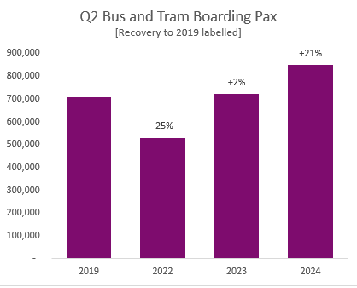

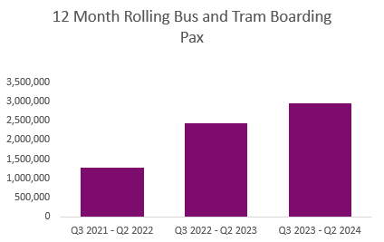

* Transport mode share for Q2 2024 was 40%.
  1. **Taxi services**

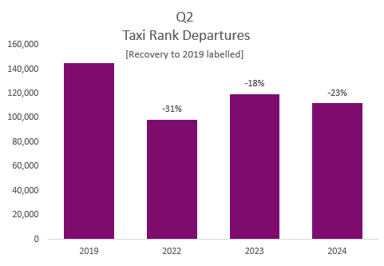

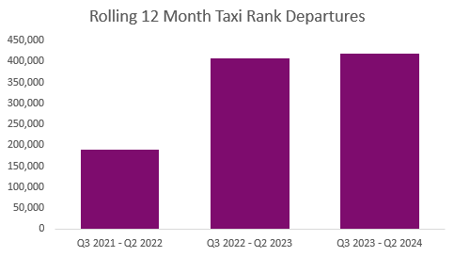

* There are two new projects starting in Q2 2024 to improve overall driver and passenger experience in the rank;
  + Queue wait time measurement – we are installing our own system to monitor any queuing more accurately and provide this information to our passengers.
  + New ANPR system – a new barrier system will make the journey far more seamless and give us better control and data from the rank.
  1. **Yearly Mode Share**

|  |  |  |  |  |  |  |
| --- | --- | --- | --- | --- | --- | --- |
|  | Car Parking | Public Transport | Taxi | Coaches | Car Rental | Other |
| **2019** | 40.6% | 33.7% | 11.0% | 7.1% | 6.7% | **0.9%** |
| **2022** | 40.3% | 34.1% | 13.3% | 4.3% | 5.0% | **3.1%** |
| **2023** | 39.7% | 36.6% | 8.9% | 6.3% | 5.5% | **3.0%** |
| **2024** | 40.7% | 39.5% | 6.8% | 6.2% | 5.7% | **1.2%** |

|  |
| --- |
| **5. Aircraft noise**   * *Our Service Level Agreement (SLA) is to respond to noise complaints within five days.* * *All percentages are reported to one decimal place.* * *Any negative figures or decrease in percentages are reported in red* |

5.1 Noise complaints received

|  |  |  |  |  |  |  |  |
| --- | --- | --- | --- | --- | --- | --- | --- |
|  | **Apr-24** | **May-24** | **Jun-24** | **Q2/2024**  **total** | **Q1/2024**  **total** | **% change**  **Q2/2024 v**  **Q1/2024** | **% change**  **Q2/2024 v**  **Q2/2023** |
| Noise complaints | 117 | 90 | 100 | 307 | 205 | 49.8% | -21.7% |
| Complainers | 16 | 15 | 19 | 36 | 37 | -2.7% | -21.7% |
| Answered in SLA | 97.4% | 86.7% | 79.0% | 88.3% | 91.7% | -3.7% | 8.8% |

5.2 Runway use

|  |  |  |  |  |  |  |  |  |
| --- | --- | --- | --- | --- | --- | --- | --- | --- |
|  | **Period** | **Apr-24** | **May-24** | **Jun-24** | **Q2/2024**  **total** | **Q1/2024**  **total** | **% change**  **Q2/2024 v**  **Q1/2024** | **% change**  **Q2/2024 v**  **Q2/2023** |
| Runway 06 | day | 4254 | 7731 | 1745 | 13730 | 7062 | 94.4% | -11.0% |
| night | 321 | 552 | 181 | 1054 | 338 | 211.8% | -15.7% |
| Runway 24 | day | 5051 | 2956 | 8798 | 16805 | 15647 | 7.4% | 31.7% |
| night | 418 | 301 | 693 | 1412 | 859 | 64.4% | 31.5% |

5.3 Complaints by type of enquiry

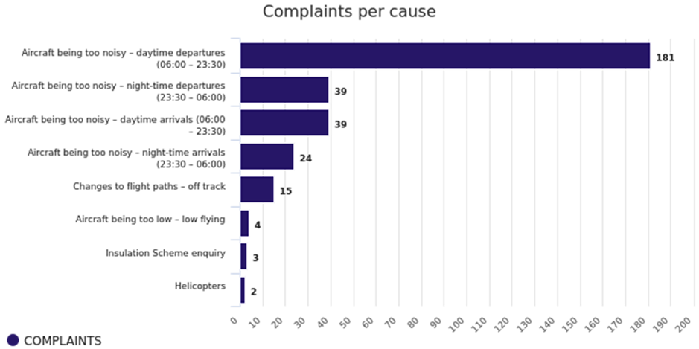

|  |  |
| --- | --- |
| **Defined terms - As perceived by complainant not EDI defined** | |
| Ground running | Complainant considers noise source to be Engine testing operations or noise of aircraft on ground within the airport grounds. |
| Helicopter | Complainant considers noise source to be EDI related Helicopter movement complaints – generally not Edinburgh Airport movements |
| General/non specific | Complainant wishes to report a Non noise related complaint – still logged as it is received to Noise line or noise email address. |
| Off track | Complainant considers the aircraft to be flying out with the SID or NPR |
| Low flying | Complainant considers noise source to be due to the Altitude of Aircraft being to low |
| Arriving aircraft noise Daytime | Daytime (06:00 – 23:30) noise level complaints for arrivals |
| Departing aircraft noise Daytime | Daytime (06:00 – 23:30) noise level complaints for Departures |
| Arriving aircraft noise Night-time | Night-time (23:30 – 06:00) noise level complaints for arrivals |
| Departing aircraft noise Night-time | Night-time (23:30 – 06:00) noise level complaints for Departures |
| Daytime Noise Levels | Daytime (06:00 – 23:30) noise level complaints – Arrivals and Departures |
| Night flight noise | Night time (23:30 to 06:00) noise level complaints |

**5.4 Complaints by area sorted by number of complainants**

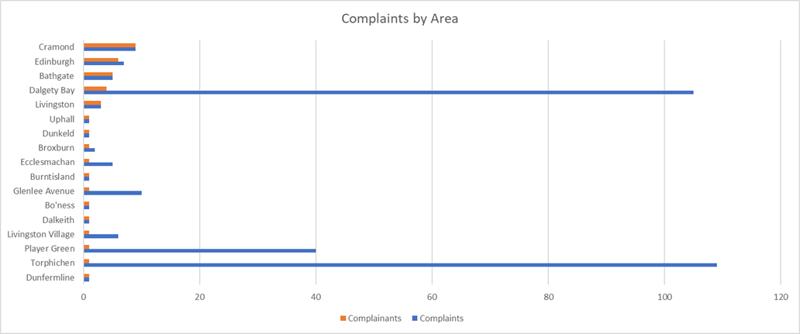

Heat map detailing location of complaints and altitude of aircraft:

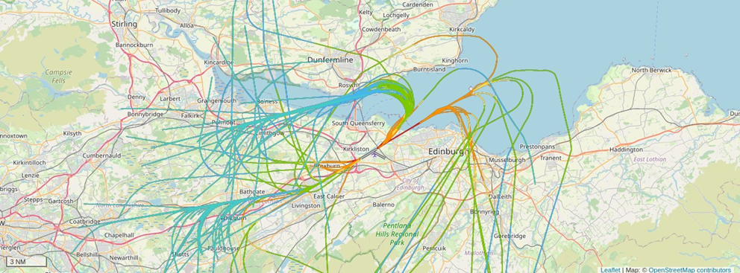

**5.5 NAX**

NAX charts below detail the number of aircraft that exceeded the noise level detailed on the X axis, at that monitor during the quarter.

Monitor 1 – Livingston

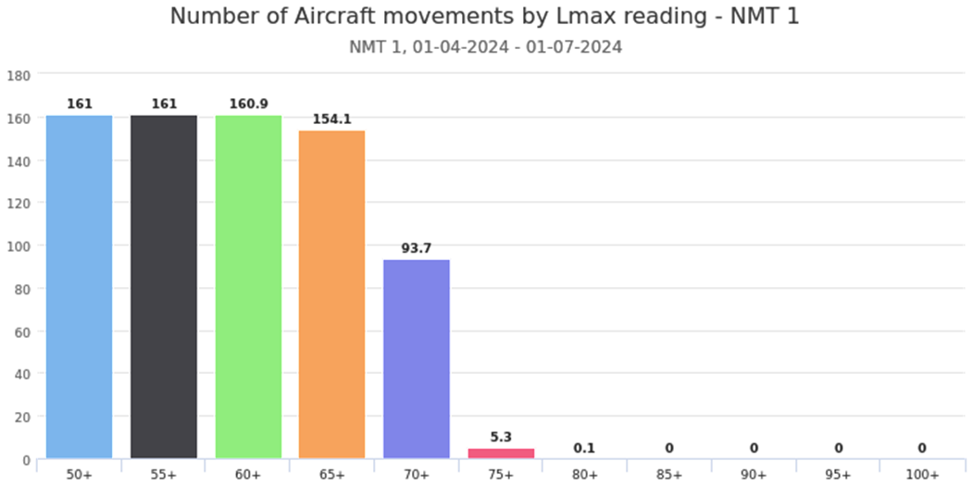

Monitor 2 – Bathgate

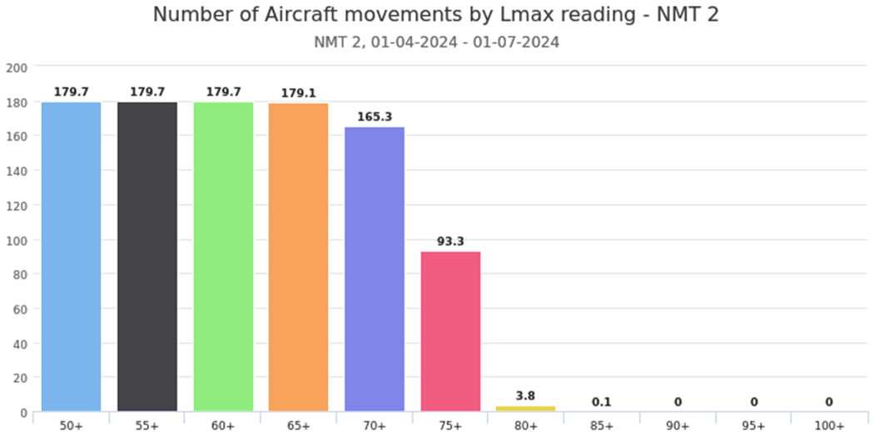

Monitor 3 – Cramond

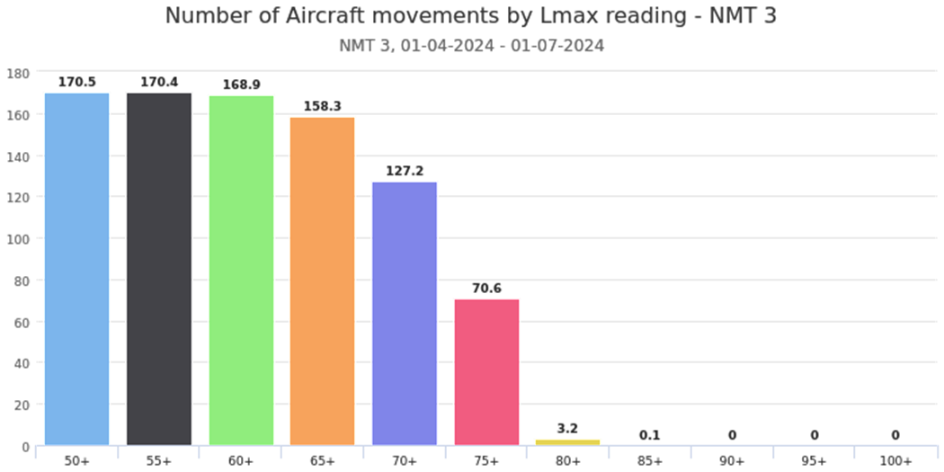

Monitor 7 - Cramond Primary School

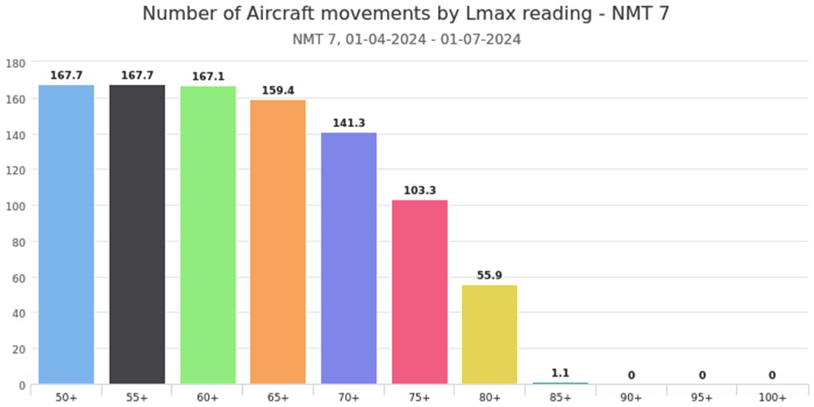

**5.6 Complaints**

The table below details any complaints found to be justified and the reason for the diversion from SID along with any other relevant details. Standard Instrument Departures or SIDs are the technical term for departure flight paths.

|  |  |  |  |  |  |  |  |  |  |
| --- | --- | --- | --- | --- | --- | --- | --- | --- | --- |
| **EDI Day quarterly complaints (06:00 - 23:30)** | | | | | | | | | |
| **Complaint made** | **Date/time** | **Area** | **Cause** | **A/C Type** | **Dep. Airport** | **Dest. Airport** | **SID** | **Valid Y/N** | **Reason** |
| 08/05/24  16:45:35 | 08/05/24 16:06:08 | Edinburgh | Aircraft being too noisy – daytime arrivals (06:00 – 23:30) | UNK | UNK | UNK | None | Y | Military exercise -LOS00071 |
| 10/05/24  09:45:00 | 08/05/24 16:07:00 | Edinburgh | Aircraft being too noisy – daytime departures (06:00 – 23:30) | UNK | UNK | UNK | None | Y | Military exercise -LOS00071 |
| 11/05/24 12:10:00 | 11/05/24 12:10:00 | Edinburgh | Helicopters | B06 | EGPH | EGPH | UNK | Y | Non-EDI traffic out of Kirkliston- Transiting |
| 13/06/24 16:59:00 | 10/06/24 13:55:00 | East Calder | Aircraft being too noisy – daytime departures (06:00 – 23:30) | B738 | EGPH | LIBD | GRI3C | N | Weather |
| 20/06/24 08:39:26 | 14/06/24 12:30:00 | Uphall | Aircraft being too noisy – daytime departures (06:00 – 23:30) | A333 | EGPH | ZBAA | GRI3C | N | Weather diversion |
| 14/06/24 13:38:23 | 14/06/24 12:30:15 | Ecclesmachan | Changes to flight paths – off track | A333 | EGPH | ZBAA | GRI3C | N | Weather  diversion |
| 14/06/24 13:41:55 | 14/06/24 13:33:59 | Ecclesmachan | Changes to flight paths – off track | B738 | EGPH | ENGM | GRI3C | N | Weather diversion |
| 14/06/24 14:11:03 | 14/06/24 14:03:43 | Ecclesmachan | Changes to flight paths – off track | B38M | EGPH | EKCH | GRI3C | N | Weather  diversion |
| 14/06/24  14:17:08 | 14/06/24 14:09:11 | Ecclesmachan | Changes to flight paths – off track | A321 | EGPH | EDDF | GRI3C | N | Weather diversion |
| 02/07/24 09:28:18 | 28/06/24 11:36:00 | Cramond | Aircraft being too noisy – daytime Arrivals (06:00 – 23:30) | B38M | EGPH | LIME | Go-Around | Y | Go-Around |

|  |  |  |  |  |  |  |  |  |  |  |
| --- | --- | --- | --- | --- | --- | --- | --- | --- | --- | --- |
| **EDI Night Quarterly complaints (23:30 - 06:00)** | | | | | | | | | | |
| **Date complaint made** | **Date/time of disturbance** | | **Area** | **Cause** | **Aircraft Type** | **Departure Airport** | **Destination Airport** | **SID** | **Valid Y/N** | **Reason** |
| None | N/A | N/A | | N/A | N/A | N/A | N/A | N/A | N/A | N/A |

**5.7 Noise commentary**

* We are currently investigating one further site for installation of another fixed noise monitor in the area around the Craigiehall Barracks. This will assist us in better monitoring of the R06 Departure noise levels.
* Of the 307 complaints received during Q2 2024, 253 (82.4%) were made by four frequent complainants.
  + 109 (35.5%) by a complainant in Torphichen
  + 94 (30.6%) by a complainant in Dalgety Bay
  + 40 (13.0%) by a complainant in Livingston, Player Green
* In April 2024, a mobile monitor was installed in the Dalgety Bay area below the Runway 06 GOSAM Departure route. This monitor will remain in-situ for one year. The data and flight information collected by this monitor can be viewed online using our Noise Lab and Flight Tracker websites: <https://noiselab.casper.aero/edi/>
* Further information and analysis of noise complaints may be downloaded within the EANAB quarterly reports:

<https://corporate.edinburghairport.com/community/edinburgh-airport-noise-advisory-board>

<https://www.eanab.org.uk/>

|  |
| --- |
| 6. Route development |

**6.1 Route commentary**

**Overall Market Update:**

* Q2 performance remained strong following on from a positive Q1. We have had a particularly strong start to the summer season, with overall Q2 passengers sitting 11.7% ahead vs Q2 2023.
* Q2 saw 226 routes to 154 destinations with 36 airlines, as always, with scope for changes in quick succession.
* International recovery continued to drive overall recovery rate in Q2, with international passenger volumes growing by 20% vs Q2 in 2019 and 14% vs 2023.
* Each month saw an increase in passengers vs the same months in 2023. April’s growth was 7%, May was 16% and June 12% ahead.
* Throughout the month of June we had on average more than 35 additional flights to connect passengers to Germany for the Euros 2024. This increase of operation had a positive impact on the overall June performance, with load factors remaining high.
* Headwinds continue to the present surrounding both delivery of new aircraft and technical issues with some aircraft types in service.
* As we continue into the summer season, demand remains strong with performance benchmarking historical levels.

**Airline Updates:**

**Aurigny:**

* Launched summer operations to Guernsey on 29th May (1x weekly on Wed).
* Pushed operations into winter (2x weekly, Mon and Thu (apart from 5 weeks in Jan/Feb).

**Pegasus:**

* Launched Istanbul Sabiha Gokcen on 27th June (2x weekly on Thu and Sun).
* It has already planned to add frequency and from w/c 22nd July will start operating 4x weekly, adding a Tue and Fri to their schedule.

**British Airways:**

* Commenced operations to Olbia on 25th May (1x weekly on a Sat) and San Sebastian also on 25th May (2x weekly on Tue and Sat).

**Eurowings:**

* Launched new Stuttgart route on 1st May (4x weekly operating Mon, Wed, Fri and Sun)

**Jet2:**

* On 1st May we welcomed its 7th based aircraft, alongside their new Malta route.

**JetBlue:**

* Launched their JFK service on 23rd May (operating daily). We have had great feedback from this new addition to our Transatlantic portfolio, particularly surrounding JetBlue’s premium product, Mint.

**Hainan:**

* After reinstating earlier this year, Hainan introduced two additional frequencies on 28th June, meaning they are now operating 4x weekly over the summer.

|  |
| --- |
| 7. Passenger satisfaction analysis |

**7.1 Complaints, compliments, enquiries and suggestions**

*Received via email, phone call, webform, letter and live chat.*

**7.1.2 Commentary**

|  |  |  |  |  |  |  |  |
| --- | --- | --- | --- | --- | --- | --- | --- |
|  | **Apr-24** | **May-24** | **Jun-24** | **Total Q2 2024** | **Q2 vs Q1 % change** | **Total Q2 2023** | **Q2 2024 vs Q2 2023 % change** |
| Complaints | 190 | 215 | 291 | 696 | 75% | 645 | 8% |
| Compliments | 7 | 2 | 16 | 25 | -17% | 40 | -38% |
| Neutral | 1,001 | 1,085 | 1,347 | 3433 | 48% | 3378 | 2% |
| **Total** | **1,198** | **1,302** | **1,654** | **4,154** | **51%** | **4,063** | **2%** |

**7.1.2 Commentary**

* The two most favoured methods of contact in Q2 were phone call and live chat – 21% of queries being via phone, 20% online.
* Q2 closed with an average of 1.59 complaints per 10k pax.
* 97% of customers received a first response to their case within the SLA of 8 working days (95% target).
* There has been a 51% increase in overall contact in Q2 vs Q1 2024. This is in line with the trends seen last year.

**7.2 Passenger Satisfaction**

Based on the steps of the passenger journey, the following graph* shows how many items of feedback we have received for each area across the 10 steps of the customer journey.

*\*The graph does not include any enquiries that have been received via live chat as chats cannot be categorised in the same way.*

* In Q2 the area with the most items of enquiries and feedback is ‘Journey Preparation’, and this is closely followed by ‘Security’. Journey Preparation and Security feedback was led by enquiries from customers planning their journey.
* The Customer Experience survey has launched, and collection is stable. Customers signing up to Wi-Fi are encouraged to fill out the survey with analysis taking place in house. The date is used to drive improvements and change.