Edinburgh Airport Consultative Committee
Chief Executive’s Report
[Provided in confidence]

Meeting date | 9 May 2022
Period covered (Year/Quarter/covering months) | 2022 Q1  January, February, March
Prepared by and date | Greg Maxwell  Head of Corporate Affairs  02/05/2022
Approved by and date | Robert Fairnie  Digital Content Editor  02/05/2022

Table of contents

1 Traffic figures
1.1 Passenger figures 3
1.2 Aircraft movements 3
1.3 Aircraft traffic mix 3
1.4 Cargo figures in kg 4
1.5 Day v Night aircraft movements 4
1.6 Traffic commentary 4

2 Capital investment
2.1 Projects in development, design & delivery 5
2.2 Summary of key projects 5
2.3 Projects commentary 7

3 Community investment
3.1 Community Fund 7
3.2 Charity work………………………………………………………8

4 Surface access
4.1 Bus and tram services 8
4.2 Taxis 10

5 Aircraft noise
5.1 Noise complaints received 11
5.2 Runway use………………………………………………………11
5.3 Complaints by type of enquiry………………………….12
5.4 Complaints by area sorted by number………………14
5.5 Noise commentary……………………………………………14
6 Route developments
6.1 Route commentary 15
7 Passenger satisfaction analysis
7.1 Complaints, compliments and enquiries 15
7.2 Passenger satisfaction 17
- Traffic figures
- All percentages are reported to one decimal place.
- Any negative figures or decrease in percentages are reported in red.

1.1 Passenger figures

Passenger figures | Jan-22 | Feb-22 | Mar-22 | Q1 2022 total | Q1 2022 % of total | Q1 2021 % of total | % change 2022 vs 2021
Domestic | 141,996 | 193,103 | 239,351 | 574,450 | 38.0% | 56.3% | 1108.2%
International | 175,015 | 322,086 | 440,825 | 937,926 | 62.0% | 43.7% | 2443.8%
Total | 317,011 | 515,189 | 680,176 | 1,512,376 | 100.0% | 100.0% | 1691.6%
Aircraft movements | Jan-22 | Feb-22 | Mar-22 | Q1 2022 total | Q1 2022 % of total | Q1 2021 % of total | % change 2022 vs 2021
Domestic | 2,257 | 2,544 | 3,141 | 7,942 | 48.5% | 72.1% | 201.9%
International | 2,101 | 2,765 | 3,583 | 8,449 | 51.5% | 27.9% | 730.8%
Total | 4,358 | 5,309 | 6,724 | 16,391 | 100.0% | 100.0% | 349.3%
Passenger traffic mix | Jan-22 | Feb-22 | Mar-22 | Q1 2022 total | Q1 2022 % of total | Q1 2021 % of total | % change 2022 vs 2021
Scheduled | 312,640 | 497,184 | 671,286 | 1,481,110 | 97.9% | 96.2% | 1723.9%
Charter | 3,701 | 16,860 | 8,296 | 28,857 | 1.9% | 1.5% | 2149.2%
Other | 670 | 1,145 | 594 | 2,409 | 0.2% | 2.3% | 24.9%
Total | 317,011 | 515,189 | 680,176 | 1,512,376 | 100.0% | 100.0% | 1691.6%
Cargo figures in KGs | Jan-22 | Feb-22 | Mar-22 | Q1 2022 total | Q1 2022 % of total | Q1 2021 % of total | % change 2022 vs 2021
Mail | 1,274,574 | 1,276,906 | 1,499,491 | 4,050,971 | 49.3% | 58.5% | -32.9%
Freight | 1,267,477 | 1,301,988 | 1,591,787 | 4,161,252 | 50.7% | 41.5% | -2.8%
Total | 2,542,051 | 2,578,894 | 3,091,278 | 8,212,223 | 100.0% | 100.0% | -20.4%
Day vs night aircraft movements | Jan-22 | Feb-22 | Mar-22 | Q1 2022 total | Q1 2022 % of total | Q1 2021 % of total | % change 2022 vs 2021
Night (0000-0559) | 225 | 240 | 273 | 738 | 4.5% | 17.3% | 17.3%
Day (0600-2159) | 3,789 | 4,654 | 5,954 | 14,397 | 87.8% | 68.6% | 475.2%
Evening (2200-2359) | 344 | 415 | 497 | 1,256 | 7.7% | 14.1% | 143.4%
Total | 4,358 | 5,309 | 6,724 | 16,391 | 100.0% | 100.0% | 349.3%

  - Traffic commentary

- Between Jan-March 2022, 1.5 million passengers used Edinburgh Airport – that’s up nearly 17 times on the values in the same period the previous year when 84 thousand people travelled through the airport.
- Aircraft movements increased 349% compared to same period last year, with international growth outpacing the domestic growth year on year.
- While overall aircraft movements increased, these were for the most part due to daytime movement (88% of total) increases.
- In terms of Cargo, we are now reporting Net Weight instead of Gross Weight – the difference being the weight of the ULD’s (containers) that the mail is placed in. As you can see this has a significant impact on the reported weight, but this is in line with CAA expectations and feedback from Royal Mail is we remain as busy as ever.

- Capital investment

  - Projects in development, design & delivery

Project | Value | Stage | Due to Complete
Baggage Hall Futures | £450,315 | Delivery | Q2 2022
East Access Road | £126,538 | Development | Waiting planning
Surface water to Foul | £3,204,844 | Delivery | Q4 2022
General Aviation Project | £2,784 | Delivery | Q3 2022
Network Strategy | £280,651 | Delivery | Q2 2022
Security Futures | £1,295,781 | Development | Q4 2024
Fire Appliance Replacement | £814,678 | Delivery | 2024
Energy LCITP | £2,400,312 | Design | Q2 2023
Airport Control Futures | £524,992 | Design | Q1 2023
Intranet Redesign | £33,950 | Delivery | Q3 2022
Mobile Telephony | £- | Delivery | Q2 2022
COP - Global Air Park | £445,923 | Design | 2027
ATC Asset Replacement 2020/21 | £494,730 | Delivery | Q4 2022
Terminal Forecourt - Entry and Exit Barriers | £455,532 | Delivery | Q2 2022
Airspace Change | £182,654 | Delivery | 2025
Long Stay Walkable | £128,200 | Development | Q4 2022
Terminal Roof Slab Failure & Reconstruction | £728,034 | Design | 2025
JCD Multi Story Car Park Advertising site | £11,500 | Delivery | Q2 2022
AGL Workstation UPS Replacement | £13,697 | Delivery | Q3 2022
Level 3 Runway Upgrade 2022 | £823,177 | Delivery | Q4 2022
Check-in Summer ‘22 Readiness | £179,066 | Delivery | Q2 2022
East Terminus Private Hire Kiosks | £19,192 | Delivery | Q2 2022

  - Summary of key projects

Air Traffic Control – Equipment Asset Replacement
The ATC Asset Replacement project is an ongoing programme to upgrade and replace business critical air traffic control equipment. Work has been ongoing on site since 2019 with completion expected 2025.

Value: £8.8m
Due to be complete: 2025

Surface Water to Foul
There are seven locations across the airport campus where rainfall drains directly to the foul water system, as opposed to the surface water drainage network. This project will rectify these historical issues, freeing up capacity in the Scottish Water foul network. In addition, the project facilitates the completion of the glycol capture system installed for the new “300” stands and provides a long-term surface water drainage solution for the 2040 Airfield masterplan. Works are underway on site with completion forecast for Sept 2022.

Value: £4.3m (Current approx. final cost)
Due to be complete: Sept 2022

Baggage Futures
This project started in September 2018 and will deliver additional baggage handling capacity to meet forecast demand beyond 2021 and comply with EU Hold Baggage security screening legislation. It will be housed within the footprint of the existing Baggage Hall and utilises the footprint of the old domestic arrival area. This project aims to improve reliability, resilience and capacity of the hold baggage and sorting system.
This project is now 99% complete with all baggage handling equipment handed over and operational. Builders work to provide new welfare and office accommodation within the Baggage Hall will be complete in Q2 2022.
Value: £32.5m
Due to be complete: Q2 2022

Security Futures
The Security Futures project will replace all x-ray and body scanning equipment in central search in line with regulatory changes mandated by the UK Department for Transport. New technology solutions are under review, the project is due for completion in Dec 2024.

Value: £14.4M
Due to Complete: Dec 2024

General Aviation
The General Aviation project facilitates the relocation of the Signature General Aviation facility from Eastfield Avenue to a new facility at Turnhouse. Enabling works are complete. Works to install the new Signature facility are due to be complete in July 2022.

Value: £1.6M (enabling works only)
Due to Complete: July 2022

Low Carbon Energy
The Low Carbon Energy project comprises a 9.9MW Solar Farm at Crash gate 3, adjacent to the Royal Highland Show ground, covering approximately 19 acres. The project will also include on site battery storage and 40 electric vehicle charges. The project will reduce carbon emissions by 22,533 tonnes over the 30-year life of the asset, providing self-generation of approximately 25% of our current energy needs. Design work and procurement of materials is underway, installation will start in Q3 2022, the facility will be operational in Q2 2023.

Value: £9.0M

  - Projects commentary

The Capital Investment Plan for 2022 and 2023 will see a significant increase in capital expenditure from the low levels imposed due to the COVID pandemic. Capital expenditure in 2021 was £9.9m, this is planned to more than double to £19.0m in 2022, key projects that will commence during the next quarter are;-

- AOS Chroma Strategy £1.1m
- Data warehouse upgrade 22-23 £0.2m
- Taxiway echo bay replace £0.3m
- BMS £0.3m
- Main roof £0.6m
- LED plantrooms change £0.1m
- Carpark futures PH2 £2.1m
- Wasteyard £0.3m
- Airside fuel tanks £0.2m
- WDF 2nd hit £0.3m
- Lift logic TEX £0.1m
- District Heating £0.7m
- Coach Replacement 23 £1.6m
- Landside GF Retail £0.1m

- Community investment
- The Community Fund budget is generated from the drop off fee and increases in line with passenger numbers.
- The Community Fund board meet three times a year and is chaired by Alex Cole-Hamilton, MSP for Edinburgh Western.
- Application information can be found at edinburghairport.com/community

  - Community Fund

- The Community Fund criteria was revised to ensure that applications and projects relate to the four pillars of our Greater Good Sustainability Strategy.
- The Community Fund has £100,000 to distribute to local groups and community organisations throughout 2022.
- 45 applications were received for the first meeting on 29 April 2022. £32,000 was awarded to 13 applications which support one or more of our four pillars including funds towards new solar panels, community wellbeing gardens, accessible rest rooms and sports equipment.
- The next meeting is on 26 August.

Charity work

- We began work with our 2022 Charity of the Year, The Larder in January 2022.
- The Larder is based in West Lothian and works to provide training for young people around issues such as employability, health, wellbeing and life skills, as well as learning how to cook and using food as a way to promote social change. The social enterprise provides direct work experience for young people within its cafes, which also provide nutritious and affordable food for people within local communities.
- As part of our Greater Good sustainability strategy, we want to create a business with integrity. We not only encourage staff to participate in any volunteering opportunities with the Charity of the Year, but we are also committed to investing in and promoting youth employment and creating work placement opportunities for the people who live in our local communities. We are working with The Larder to develop and promote any opportunities to our staff and wider campus partners during the yearlong partnership.
- Fundraising for The Larder has begun in earnest – a charity raffle and bake sale has raised more than £1,500 and staff collected more than 250 Easter Eggs (worth approx. £500 in donations in kind) to be distributed to the young people and families who receive support from The Larder, through their project Catalyst Kitchen. More than 200 bottles of confiscated alcohol have been donated to The Larder which equates to more than £6,000.

- Surface access
- Surface access target is 35% of passengers using public transport by 2022.

  - Bus and tram services

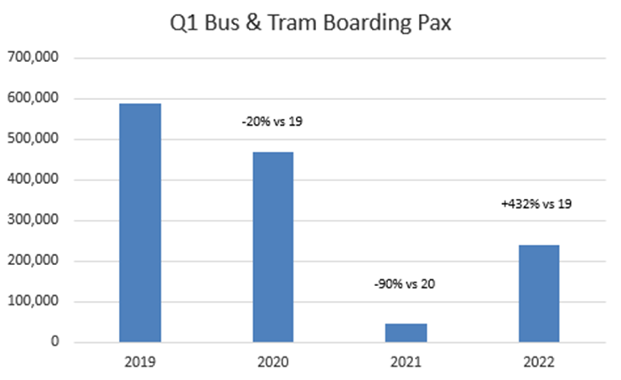
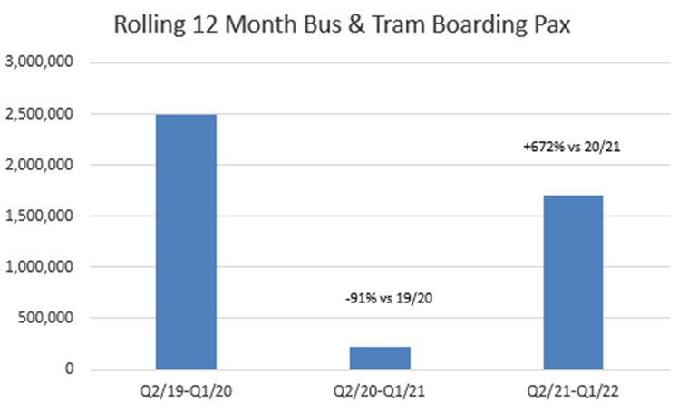

- Public transport market share of arriving pax currently sits at 33.4% YTD compared to 39.6% at the same point in 2021
  - Party due to forecourt closure from 31 Jan- 8 Apr, making public transport less visible and accessible
  - Expansion works in the city centre also meant the tram only operated part route at the start of the year
  - Directionality of passengers has changed with a higher outbound mix

- Tram mode share has increased in previous twelve months it is believed this is partly down to more space for passengers on board and the ease of social distancing.
- Social distancing and face masks have now been removed on buses and frequencies are increasing on the bus services again – Citylink AIR (Glasgow) and Airlink 100 (express service to Edinburgh city centre) are back 24/7 and to pre-Covid levels of service.

  - Taxi services

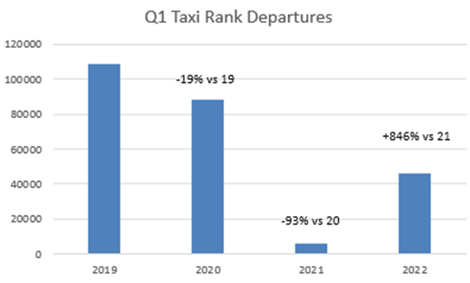

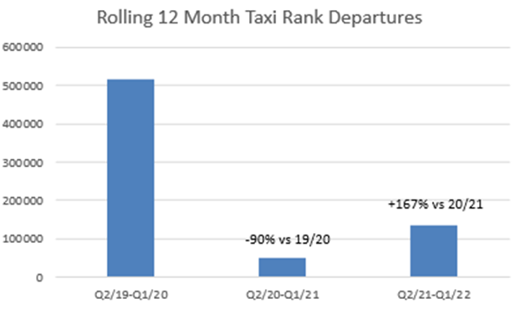
- Private Hires returned to the East Terminus rank in Nov-21
- Initially the market share of Taxis increased after the move to East Terminus but has now returned to a similar level to 2019, partly due to changes in government public transport messaging
- Both Hackney Taxis and Private Hires have had issues with recruiting drivers back into the trade – both are improving driver numbers with PHC driver numbers returning to pre-pandemic levels

5. Aircraft noise
- Our Service Level Agreement (SLA) is to respond to noise complaints within five days.
- All percentages are reported to one decimal place.
- Any negative figures or decrease in percentages are reported in red

5.1 Noise complaints received

 | Jan-22 | Feb-22 | Mar-22 | Q1/2022  total | Q4/2021  total | % change  Q1/2022 v  Q4/2021 | % change  Q1/2022 v  Q1/2021
Noise complaints | 10 | 17 | 96 | 123 | 101 | 27.1% | 52.0%
Complainants | 6 | 7 | 15 | 23 | 33 | -30.3% | 34.8%
Answered in SLA | 72.7% | 88.2% | 98.0% | 94.4% | 98.0% | -3.6% | 24.4%

NB - Highlighted figures include 2 deleted enquiries which were added onto the system as part of staff training – both were re ACP, and are also included in the graph 5.3 below but excluded from graph 5.4

5.2 Runway use

 | Jan-22 | Feb-22 | Mar-22 | Q1/2022  total | Q4/2021  total | % change  Q1/2022 v  Q4/2021 | % change  Q1/2022 v  Q1/2021
Runway 06 | 119 | 228 | 2582 | 2929 | 2777 | 5.5% | 153.8%
Runway 24 | 4229 | 5048 | 4119 | 13396 | 15344 | -12.7% | 442.6%

5.3 Complaints by type of enquiry

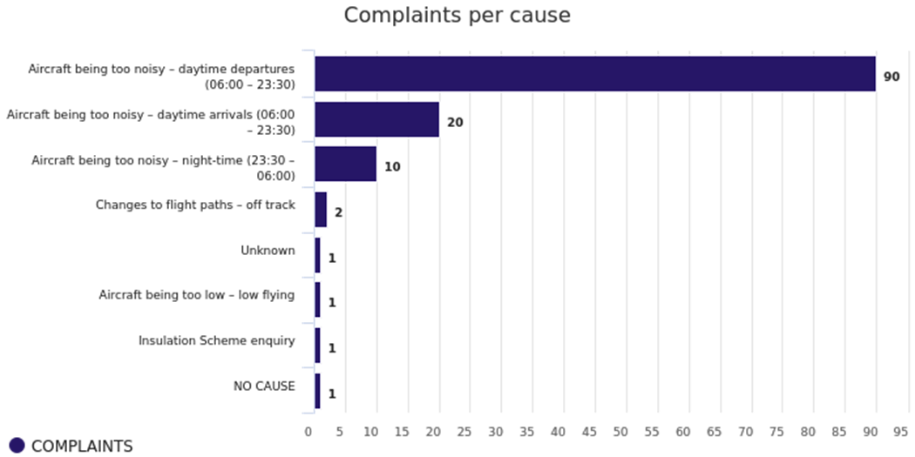

Defined terms - As perceived by complainant not EDI defined
Ground running | Complainant considers noise source to be engine testing operations or noise of aircraft on ground within the airport grounds
Helicopter | Complainant considers noise source to be EDI related helicopter movement complaints – generally not Edinburgh Airport movements
General/non-specific | Complainant wishes to report a non-noise related complaint – still logged as it is received to noise line or noise email address
Off track | Complainant considers the aircraft to be flying out with the SID or NPR
Low flying | Complainant considers noise source to be due to the altitude of aircraft being too low
Arriving aircraft noise | Daytime (06:00 – 23:30) noise level complaints for Arrivals
Departing aircraft noise | Daytime (06:00 – 23:30) noise level complaints for Departures
Daytime Noise Levels | Daytime (06:00 – 23:30) noise level complaints – Arrivals and Departures
Night flight noise | Night time (23:30 to 06:00) noise level complaints
ACP | Enquiries regarding noise levels relating to proposed new flight paths not yet flown
Military flight noise | Noise complaints regarding military aircraft not associated with Edinburgh Airport

5.4 Complaints by area sorted by number of complainants

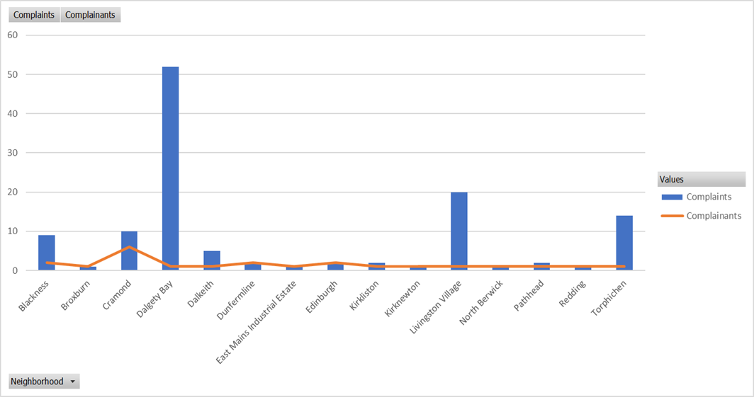

5.5 Noise commentary
- During Q1 2022 we received 123 complaints or enquiries from 23 individuals - this is far lower than pre pandemic levels.
- As aviation continues to recover and air traffic movements increase towards pre pandemic levels, we expect that noise enquiries will start to increase, both from previous complainants and new sources.
- The table (5.1) shows a total of 123 complaints were received in Q1 but the chart (5.3) shows 126 – the additional three complaints were created during a training exercise, therefore not actual complaints.

- Route development

  - Route commentary

- EDI has so far recovered 123 origin and destination (O&Ds) in Q1 2022 and is set to have 153 O&Ds by the end of 2022. This is compared with 156 we had pre-pandemic.
- In terms of airlines, we have recovered 26 in Q1 2022, with 33 expected in total to return by the end of 2022. This is compared with 34 that we had in 2019.
- This recovery has been driven by good mixture of returning airlines to existing routes, new routes launched by existing airlines and new airlines commencing operations at the airport.

EDI welcomed several new airlines since the start of the pandemic:

- Virgin Atlantic, with 2 new routes - one to Barbados commencing in December and one to Orlando which started in late March 2022.
- Westjet is another new airline who will operate to Toronto starting June 2022.
- Air Baltic, the flag carrier of Latvia who operate to their hub in Riga.
- Flybe, which went into administration prior to the pandemic, relaunched in Q1 2022. They will operate 2 routes from EDI starting June to Belfast (BHD) and July to Birmingham.
- SunExpress, which began operating from its base in Antalya at the start of the 2022 summer season.
- Emerald, which commenced EDI operations at the start of the summer season, taking over from Aer Lingus mainline which has operated the Dublin and Belfast (BHD) routes since the collapse of Stobart Air in 2021.
- Flyr, which started operating to Oslo in April 2022.

There were also a number of upgauges and new route announced this quarter:

- Air Canada: confirmed increase from 737-MAX (169 seats) to 787 (251 seats) and will operate 6 times a week, up from 4 in 2019 with a month’s extension to October, despite Westjet competing on the same route.
- Delta, who will operate to both Boston and New York using a 767 (2019: 757)
- United also upgauged to a 767 (240 seats) and will operate this until at least 30th Jun 2022 (2019: 757 with 169 seats).
- Ryanair has increased capacity with an additional based aircraft which resulted in new destinations such as Nimes and additional capacity to several existing destinations.
- Easyjet launched routes to two destinations in Greece: Kefalonia and Corfu which begin operating in late June and continue until early September this year.
- Lufthansa added an extra daily service to Frankfurt, now operating 3 times daily.

There are a number of other points we wish to note:

- EDI is expected to have 5 widebody operators this summer for the first time (United-IAD, Delta-BOS/JFK, Virgin-MCO, Air Canada-YYZ, Qatar-DOH).
- Qatar Airways and Turkish Airlines have continued to provide long haul connectivity to markets in the East as Emirates – Dubai service is currently on pause.
- Our capacity to North America will be ahead of pre-pandemic levels with Delta, United and Virgin to the USA, and Westjet and Air Canada to Canada compensating for American Airlines not operating this season.

- Passenger satisfaction analysis

7.1 Complaints, compliments and enquiries
Received via email, phone call, webform and letter.

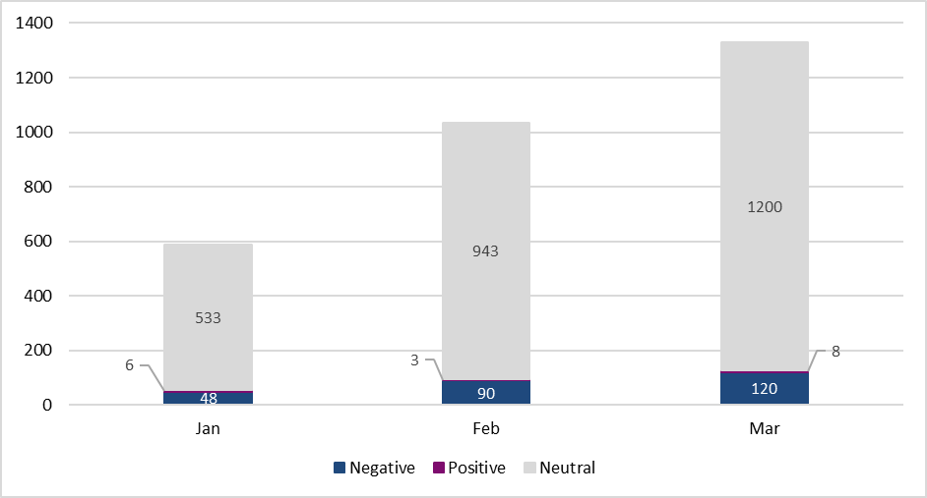

 | January | February | March | Total Q1 2022 | Total Q1 2021 | Q1 2022 vs Q4 2021 % change
Complaints 2022 | 48 | 90 | 120 | 258 | 39 | 30%
Compliments 2022 | 6 | 3 | 8 | 17 | 6 | -45%
Enquiries 2022 | 533 | 943 | 1200 | 2676 | 99 | 43%
Total | 587 | 1036 | 1328 | 2951 | 144 | 41%

    - Commentary

- In line with last year’s trends, our most popular method of contact is via phone call, closely followed by live chat.
- Interestingly, the majority of complaints and compliments are submitted via webform/email, and the majority of enquiries are via phone call and live chat. This is reflective of the often-complex nature of enquiries we receive and the need to discuss the matter.
- As the table indicates, we have seen a 41% increase in cases in Q1 2022, vs Q4 2021.
- Q1 2022 vs 2021 shows a 1,950% increase in contact. This illustrates the demand for support from our customers.
- The areas of most comment in Q1 were:
- Coronavirus – comments regarding testing requirements and necessary documents for travel.
- Baggage hall – comments regarding baggage delivery speed.
- Airlines – comments regarding the check-in process, and travel denial due to incorrect documentation.

  - Passenger Satisfaction

Based on the steps of the passenger journey, the following graph shows how many items of feedback we have received for each area;

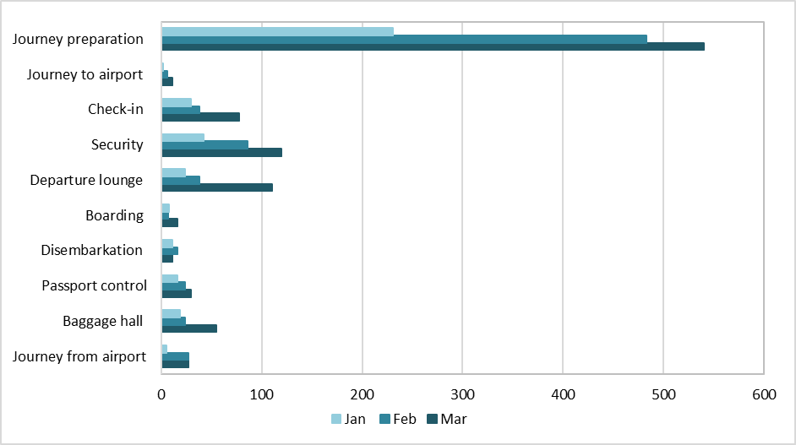

*The graph does not include any enquiries that have been received via live chat. At present, we are not able to tag live chats in line with the passenger journey however, we are working with our live chat provider on a possible solution

- In line with last year’s trends, the area with the most items of enquiries and feedback is ‘Journey Preparation’. There is an increased appetite from customers to prepare pre-travel and arrive with knowledge of what the full airport process will be.
- Though many processes are now automated (check-in, passport control etc.) there is an increased demand for physical support and reassurance when in the terminal.
- Face-to-face surveying was suspended in 2020. This will not be returning, and we are instead exploring the potential of surveying customers electronically through wi-fi sign ups. We are currently trailing this survey method with the PRM team.

