Edinburgh Airport Consultative Committee
Chief Executive’s Report
[Provided in confidence]

Meeting date | 7 February 2022
Period covered (Year/Quarter/covering months) | 2021 Q4  October, November, December
Prepared by and date | Greg Maxwell  Head of Corporate Affairs  31/01/2022
Approved by and date | Alan Connor  Digital Marketing Manager  02/11/2021

Table of contents

1 Traffic figures
1.1 Passenger figures 3
1.2 Aircraft movements 3
1.3 Aircraft traffic mix 3
1.4 Cargo figures in kg 4
1.5 Day v Night aircraft movements 4
1.6 Traffic commentary 4

2 Capital investment
2.1 Projects in development, design & delivery 5
2.2 Summary of key projects 5

3 Community investment
3.1 Community Fund 7
3.2 Charity work………………………………………………………7

4 Surface access
4.1 Bus and tram services 8
4.2 Taxis 9

5 Aircraft noise
5.1 Noise complaints received 10
5.2 Runway use………………………………………………………10
5.3 Complaints by type of enquiry………………………….11
5.4 Complaints by area sorted by number………………13
5.5 Noise commentary……………………………………………13
6 Route developments
6.1 Route commentary 13
7 Passenger satisfaction analysis
7.1 Complaints, compliments and enquiries 14
7.2 Passenger satisfaction 15
- Traffic figures
- All percentages are reported to one decimal place.
- Any negative figures or decrease in percentages are reported in red.

1.1 Passenger figures

Passenger figures | Oct-21 | Nov-21 | Dec-21 | Q4 2021 total | Q4 2021 % of total | Q4 2020 % of total | % change 2021 vs 2020
Domestic | 238,047 | 224,934 | 205,220 | 668,201 | 43.2% | 46.0% | 348.2%
International | 350,912 | 294,969 | 232,386 | 878,267 | 56.8% | 54.0% | 402.0%
Total | 588,959 | 519,903 | 437,606 | 1,546,468 | 100.0% | 100.0% | 377.2%
Aircraft movements | Oct-21 | Nov-21 | Dec-21 | Q4 2021 total | Q4 2021 % of total | Q4 2020 % of total | % change 2021 vs 2020
Domestic | 3,150 | 3,042 | 2,953 | 9,145 | 50.2% | 57.2% | 116.8%
International | 3,133 | 2,839 | 3,093 | 9,065 | 49.8% | 42.8% | 187.4%
Total | 6,283 | 5,881 | 6,046 | 18,210 | 100.0% | 100.0% | 147.0%
Passenger traffic mix | Oct-21 | Nov-21 | Dec-21 | Q4 2021 total | Q4 2021 % of total | Q4 2020 % of total | % change 2021 vs 2020
Scheduled | 584,550 | 514,017 | 431,435 | 1,530,002 | 98.9% | 98.8% | 377.8%
Charter | 2,566 | 4,781 | 5,520 | 12,867 | 0.8% | 0.8% | 428.4%
Other | 1,843 | 1,105 | 651 | 3,599 | 0.2% | 0.4% | 159.5%
Total | 588,959 | 519,903 | 437,606 | 1,546,468 | 100.0% | 100.0% | 377.2%
Cargo figures in KGs | Oct-21 | Nov-21 | Dec-21 | Q4 2021 total | Q4 2021 % of total | Q4 2020 % of total | % change 2021 vs 2020
Mail | 1,389,392 | 1,422,685 | 1,585,540 | 4,397,617 | 47.3% | 55.3% | -28.1%
Freight | 1,640,031 | 1,616,402 | 1,638,209 | 4,894,642 | 52.7% | 44.7% | -1.1%
Total | 3,029,423 | 3,039,087 | 3,223,749 | 9,292,259 | 100.0% | 100.0% | -16.0%
Day vs night aircraft movements | Oct-21 | Nov-21 | Dec-21 | Q4 2021 total | Q4 2021 % of total | Q4 2020 % of total | % change 2021 vs 2020
Night (0000-0559) | 376 | 248 | 257 | 881 | 4.8% | 9.6% | 23.9%
Day (0600-2159) | 5,480 | 5,186 | 5,391 | 16,057 | 88.2% | 80.8% | 169.6%
Evening (2200-2359) | 427 | 447 | 398 | 1,272 | 7.0% | 9.6% | 80.2%
Total | 6,283 | 5,881 | 6,046 | 18,210 | 100.0% | 100.0% | 147.0%

  - Traffic commentary

- Between October-December 2021, 1.5 million passengers used Edinburgh Airport – that’s up 377% on the same period in 2020 when 324 thousand people travelled through the airport.
- Aircraft movements increased 147% compared to same period last year, driven by both domestic (117%) and international (187%) movement increases.
- While overall aircraft movements increased, these were for the most part due to daytime movement (88% of total movements) increases. Night and evening time movements decreasing slightly as a percentage of total.
- In terms of Cargo, we are now reporting Net Weights instead of Gross Weight – the difference being the weight of the ULD’s (containers) that the mail is placed in. As you can see this has a significant impact on the reported weight, but this is in line with CAA expectations and feedback from Royal Mail is we remain as busy as ever.

- Capital investment

  - Projects in development, design & delivery

Project | Value | Stage | Due to Complete
Airport Control Futures | £1.4m | Development | 2023
ATC Asset Replacement 2021 | £0.8m | Delivery | Nov 2022
ATC Asset Replacement 2022 | £1.0m | Development | Q1 2023
Baggage Futures | £32.1m | Delivery | Feb 2022
BBHS | Non-capex project | Design | Jul 2022
Check-in Readiness | £0.3m | Development | Q3 2022
DAS | £0.1m | Design | Mar 2022
EAST Access Road | £19.3m | Development | TBC - Planning appeal in
EAST Terminus Taxi Kiosks | £0.1m | Development | Q2 2022
Flood Prevention | £0.3m | Design | Q4 2022
Global Airpark (GAP) | £7.4m | Development | TBC
General Aviation | £1.6m | Delivery | July 2022
Intranet Redesign | £0.1m | Design | Q3 2022
Runway Rehab Spring | £0.5m | Delivery | Q2 2022
Low Carbon Energy | £9.0m | Design | Sep 2022
Network Strategy | £5.8m | Delivery | Apr 2022
Security Futures | £14.4m | Development | Dec-2024
Stand 11 Slot Drain | £0.2m | Delivery | Feb 2022
Surface Water to Foul | £4.3m | Delivery | Sept 2022
Terminal Forecourt Barriers | £0.4m | Delivery | May 2022
Terminal Walking Routes | £0.2m | Delivery | Mar 2022
Terminal Roof Slab Repairs | £0.8m | Design | Dec 2022

  - Summary of key projects

Air Traffic Control – Equipment Asset Replacement

The ATC Asset Replacement project is an ongoing programme to upgrade and replace business critical air traffic control equipment. Work has been on going on site since 2019 with a scheduled competition date of 2025.

Value: £8.8m
Due to be complete: 2025

Surface Water to Foul

There are seven locations across the Airport campus where rainfall drains directly to the foul water system, as opposed to the surface water drainage network. The Surface Water to Foul project will rectify these historical issues, freeing up capacity in the Scottish Water foul network. In addition, the project facilitates the completion of the glycol capture system installed for the new “300” stands and provides a long-term surface water drainage solution. Works are due to start on site in February 2022 with completion forecast for Sept 2022.

Value: £4.3m (Current approx. final cost)
Due to be complete: Sept 2022

Baggage Futures

This project started in September 2018 and will deliver additional baggage handling capacity to meet forecast demand beyond 2021 and comply with EU Hold Baggage security screening legislation. It will be housed within the footprint of the existing Baggage Hall and utilises the footprint of the old domestic arrival area. This project aims to improve reliability, resilience and capacity of the hold baggage and sorting system.
This project is now 95% complete with all baggage handling equipment handed over and operational. Builders work to provide new welfare and office accommodation within the Baggage hall will be completed in February 2022.
Value: £32.5m
Due to be complete: February 2022

Security Futures

The Security Futures project will replace all the x-ray and body scanning equipment in central search in line with regulatory changes mandated by the UK Department for Transport. New technology solutions are under review, the project is due for completion in Dec 2024.

Value: £14.4M
Due to Complete: Dec 2024

General Aviation

The General Aviation project facilitates the relocation of the Signature General Aviation facility from Eastfield Avenue to a new facility at Turnhouse. Enabling works are complete. Works to install the new Signature facility are due to be complete in July 2022.

Value: £1.6M (enabling works only)
Due to Complete: July 2022

Low Carbon Energy
The Low Carbon Energy project comprises a 9.9MW Solar Farm at Crash gate 3, adjacent to the Royal Highland Show ground, covering approximately 19 acres. The project will also include on site battery storage and 40 electric vehicle charges. The project will reduce carbon emissions by 22,533 tonnes over the 30-year life of the asset, providing self-generation of approximately 25% of our current energy needs. Design work and procurement of materials is underway, survey works started in Dec 2021, installation will start in May 2022, the facility is scheduled to be operational in Q4 2022.

Value: £9.0M
Due to Complete: Q4 2022

- Community investment
- The Community Fund budget is generated from the drop off fee and increases in line with passenger numbers.
- The Community Fund board meet three times a year and is chaired by Alex Cole-Hamilton, MSP for Edinburgh Western.
- Application information can be found at edinburghairport.com/community

  - Community Fund

- The Community Fund board met in October to discuss the approach for 2022. Revised criteria will be shared and applications are due to reopen in early 2022.
- The Community Fund criteria has been revised to ensure that applications and projects relate the wider Greater Good Sustainability Strategy. Applications reopened on Tuesday 1 Feb. The Community Fund will have £100,000 to distribute to local groups and community organisations throughout 2022.

Charity work

- Our partnership with the Scottish Association for Mental Health (SAMH) came to an end at the end of 2021. Although we were impacted greatly by Covid-19 during 2020 / 2021, at the end of the partnership we had raised nearly £100,000 for SAMH through fundraising and donations in kind.

- We announced in December 2021 that our Charity of the Year 2022 partner would be The Larder. The Larder is The Larder is based in West Lothian and works to provide training for young people around issues such as employability, health, wellbeing and life skills, as well as learning how to cook and using food as a way to promote social change. The social enterprise provides direct work experience for young people within its cafes, which also provide nutritious and affordable food for people within local communities. The Larder was one of more than 50 charities and organisations that applied to become the airport’s charity partner for 2022, eventually coming out on top of a staff vote. The criteria for 2022 was changed to align with the airport’s Greater Good sustainability strategy

- Surface access
- Surface access target is 35% of passengers using public transport by 2020.

  - Bus and tram services

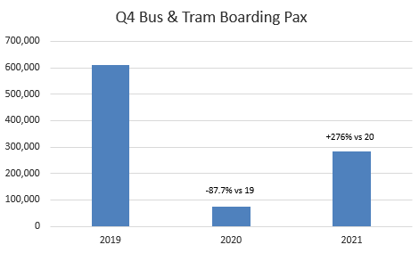
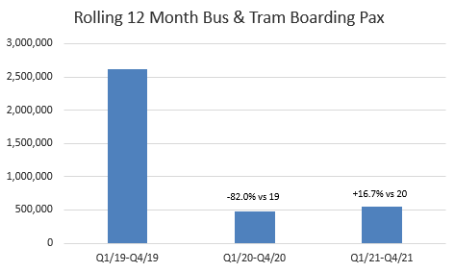

- Public transport market share of arriving pax currently sits at 36.8% YTD compared to 36.5% at the same point in 2020 and 36.7% at the same point in 2020
- Tram mode share has increased in previous 12 months which we believe is partly down to more space for passengers on board as they seek to keep socially distant
- Social distancing has now been removed on buses and frequencies are increasing on the bus services again

  - Taxi services

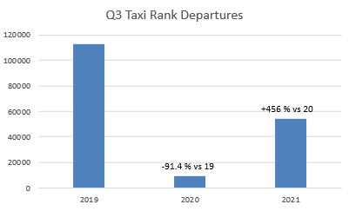

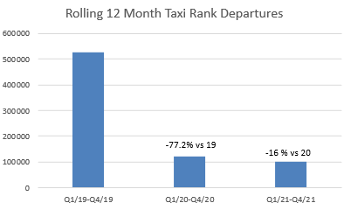

- Private Hires returned to the East Terminus rank in Nov-21
- Initially the market share of Taxis increased after the move to East Terminus as people looked to avoid other forms of public transport during the pandemic. The share has returned to 2019 levels
- Penetration is flat vs 2019 for Q4

5. Aircraft noise
- Our Service Level Agreement (SLA) is to respond to noise complaints within five days.
- All percentages are reported to one decimal place.
- Any negative figures or decrease in percentages are reported in red

5.1 Noise complaints received

 | Oct-21 | Nov-21 | Dec-21 | Q4/2021  total | Q3/2021  total | % change  Q4/2021 v  Q3/2021 | % change  Q4/2021 v  Q4/2020
Noise complaints | 46 | 21 | 36 | 103 | 274 | -63.1% | 74.6%
Complainants | 17 | 14 | 10 | 29 | 37 | -21.6.3% | 20.7%
Answered in SLA | 100.0% | 95.2% | 97.2% | 98.1% | 94.9% | 3.3% | 20.5%

NB - Highlighted figures include 2 deleted enquiries which were added onto the system as part of staff training – both were re ACP, and are also included in the graph 5.3 below but excluded from graph 5.4

5.2 Runway use

 | Oct-21 | Nov-21 | Dec-21 | Q4/2021  total | Q3/2021  total | % change  Q4/2021 v  Q3/2021 | % change  Q4/2021 v  Q4/2020
Runway 06 | 680 | 330 | 1767 | 2777 | 6926 | -59.9% | 103.9%
Runway 24 | 5577 | 5502 | 4265 | 15344 | 8494 | 80.6% | 155.8%

5.3 Complaints by type of enquiry

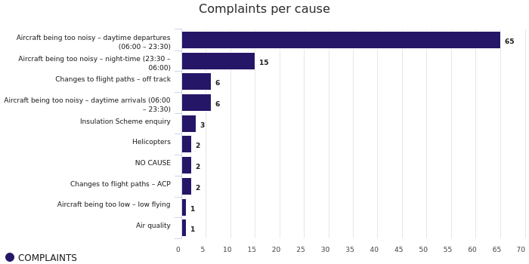

Defined terms - As perceived by complainant not EDI defined
Ground running | Complainant considers noise source to be engine testing operations or noise of aircraft on ground within the airport grounds
Helicopter | Complainant considers noise source to be EDI related helicopter movement complaints – generally not Edinburgh Airport movements
General/non-specific | Complainant wishes to report a non-noise related complaint – still logged as it is received to noise line or noise email address
Off track | Complainant considers the aircraft to be flying out with the SID or NPR
Low flying | Complainant considers noise source to be due to the altitude of aircraft being too low
Arriving aircraft noise | Daytime (06:00 – 23:30) noise level complaints for Arrivals
Departing aircraft noise | Daytime (06:00 – 23:30) noise level complaints for Departures
Daytime Noise Levels | Daytime (06:00 – 23:30) noise level complaints – Arrivals and Departures
Night flight noise | Night time (23:30 to 06:00) noise level complaints
ACP | Enquiries regarding noise levels relating to proposed new flight paths not yet flown
Military flight noise | Noise complaints regarding military aircraft not associated with Edinburgh Airport

5.4 Complaints by area sorted by number of complainants

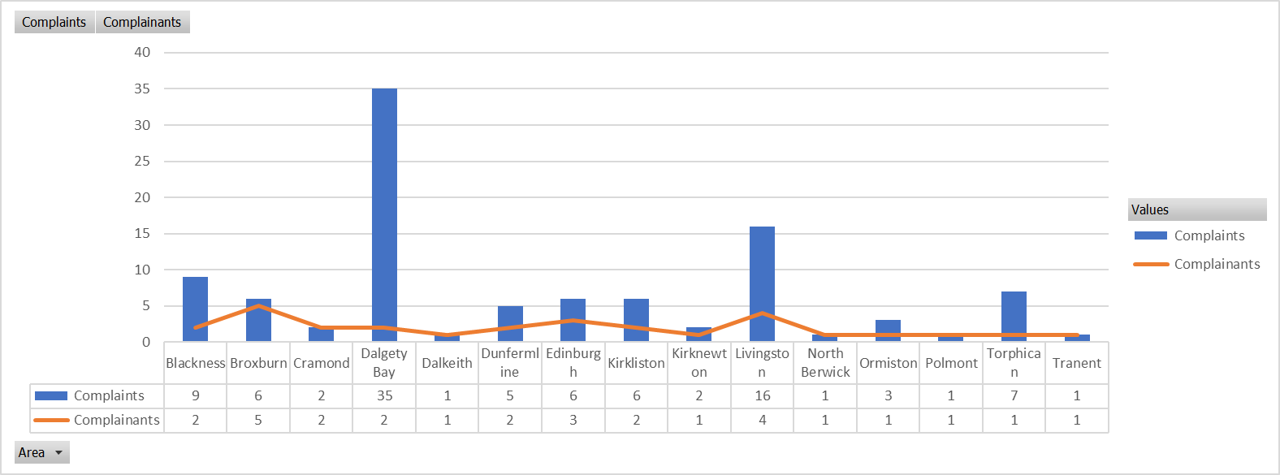

5.5 Noise commentary
- In Q4 the arrival of the Omicron Covid strain impacted the expected increase in operations during the last quarter of the year as less flights were flown. This in turn reduced the number of noise complaints received from the public.
- Of the 35 complaints received from the Dalgety Bay area, 34 of them came from one person.
- Of the 9 complaints received from the Blackness area, 8 of them were from one person.
- Of the 16 complaints received from the Livingston area, 8 of them were from one person.

- Route development

  - Route commentary

- EDI has so far recovered 120 origin and destination (O&Ds) and is set to have 146 O&Ds by 2022. This is compared with 156 we had pre-pandemic.
- In terms of airlines, we have recovered 25 so far, with 32 expected in total to return by 2022. This is compared with 35 that we had in 2019.
- This recovery has been driven by good mixture of returning airlines to existing routes as well as new routes by existing airlines and entirely new airlines as well.

EDI announced 4 new airlines during the pandemic:

- Virgin Atlantic, with 2 new routes - one to Barbados commencing in December and one to Orlando starting in late March 2022*.
- Westjet is another new airline who will operate and compete along with flag carrier Air Canada to Toronto starting June 2022.
- Air Baltic, the flag carrier of Latvia who operate to their capital Riga.
- Sun Express, who will operate to Antalya twice a week starting April 2022.

Our portfolio has also been expanded by our existing airlines to new routes – these include Vueling who added Paris-Orly starting in November 2021 and Turkish Airlines who added Dalaman to their portfolio starting June 2022. Ryanair has also added 10 new destinations and with easyJet adding 3, British Airways with 2 and Loganair with 4.

In 2021, existing airlines on the existing destinations have been quick to respond to changes with Turkish Airlines for example ramping up from 1 to 4x weekly flights in a space of 8 weeks following the easing of restrictions. British Airways/BA Cityflyer too have responded rapidly to the increase in demand by increasing frequency to 8-9 times daily.

Qatar Airways and Turkish Airlines have continued to provide long haul connectivity to markets in the East as Emirates – Dubai service is currently on pause.

In terms of connectivity to the west, this will really recommence in Summer 2022 with Delta, United and Virgin to the USA, and Westjet and Air Canada to Canada.

*Barbados is a winter only route that will pause operations on 22nd February 2022 before recommencing for the next winter on 12th Dec 2022

- Passenger satisfaction analysis

7.1 Complaints, compliments and enquiries
Received via email, phone call, webform and letter.

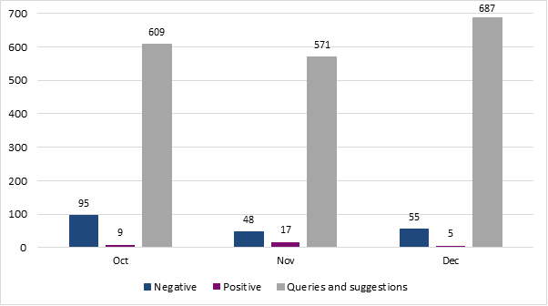

 | October | November | December | Q4 | Q4 vs Q3 % change | Total Q4 2020
Complaints 2021 | 95 | 48 | 55 | 198 | 9% | 86
Compliments 2021 | 9 | 17 | 5 | 31 | 55% | 11
Enquiries and suggestions 2021 | 609 | 571 | 687 | 1867 | 1% | 63
Total 2021 | 713 | 636 | 747 | 2096 | 2% | 160

    - Commentary

- Since the launch of the Support Centre, we have seen a vast increase in the contact we receive. Though not openly advertised, there is a clear desire and need for customers to reach out for support.
- Our most popular method of contact is phone call, followed by live chat. This is indicative of our customers’ desire to receive quick, instant answers.
- As the table indicates, we have received ~1,900 more cases than we did in 2020’s fourth quarter. There has been little change in the reason for contact and the common themes are:
  - Coronavirus – guidance on documentation needed for travel and destination entry requirements
  - Check-in – staff service in relation to covid documentation checks
  - Journey from the airport – wait for taxi and overall service

  - Passenger Satisfaction

Based on the steps of the passenger journey, the following graph shows how many items of feedback we have received for each area;

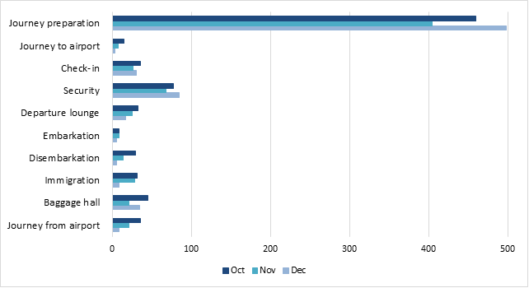

- As expected, the area with the most items of enquiries and feedback is ‘Journey preparation’. Customers are seeking advice pre-travel more than ever, and we plan to tap into this in 2022. The more prepared our passengers are, the better equipped they will be to navigate their journey on-site.
- Our chatbot continues to handle ~12,000 questions per month, which deflects these enquiries away from the support team.
- We’ve seen a number of customers who are intending to travel from another airport contact us in desperation for help.
- We expect to see feedback numbers dip in the coming months due to decreased passenger numbers, with a sharp increase expected to take place again in Q2 and Q3.

