Edinburgh Airport Consultative Committee
Chief Executive’s Report
[Provided in confidence]

Meeting date | 8 August 2022
Period covered (Year/Quarter/covering months) | 2022 Q2  April, May, June
Prepared by and date | Greg Maxwell  Head of Corporate Affairs  29/07/2022
Approved by and date | Robert Fairnie  Digital Content Editor  01/08/2022

Table of contents

1 Traffic figures
1.1 Passenger figures 3
1.2 Aircraft movements 3
1.3 Aircraft traffic mix 3
1.4 Cargo figures in kg 4
1.5 Day v Night aircraft movements 4
1.6 Traffic commentary 4

2 Capital investment
2.1 Projects in development, design & delivery 5
2.2 Summary of key projects 6
2.3 Projects commentary 7

3 Community investment
3.1 Community Fund 7
3.2 Charity work………………………………………………………7

4 Surface access
4.1 Bus and tram services 8
4.2 Taxis 9

5 Aircraft noise
5.1 Noise complaints received 10
5.2 Runway use………………………………………………………11
5.3 Complaints by type of enquiry………………………….11
5.4 Complaints by area sorted by number………………14
5.5 Noise commentary……………………………………………14
6 Route developments
6.1 Route commentary 15
7 Passenger satisfaction analysis
7.1 Complaints, compliments and enquiries 15
7.2 Passenger satisfaction 17
- Traffic figures
- All percentages are reported to one decimal place.
- Any negative figures or decrease in percentages are reported in red.

1.1 Passenger figures

Passenger figures | Apr-2022 | May-2022 | Jun-2022 | Q2 2022 Total | Q2 2022 % of Total | Q2 2021 % of Total | % change 2022 vs 2021
Domestic | 257,035 | 274,028 | 275,294 | 806,357 | 25.3% | 74.7% | 271.4%
International | 674,952 | 795,246 | 911,169 | 2,381,367 | 74.7% | 25.3% | 3146.7%
Total | 931,987 | 1,069,274 | 1,186,463 | 3,187,724 | 100.0% | 100.0% | 997.6%
Aircraft movements | Apr-2022 | May-2022 | Jun-2022 | Q2 2022 Total | Q2 2022 % of Total | Q2 2021 % of Total | % change 2022 vs 2021
Domestic | 3,274 | 3,551 | 3,525 | 10,350 | 38.0% | 71.0% | 129.6%
International | 4,926 | 5,792 | 6,183 | 16,901 | 62.0% | 29.0% | 816.0%
Total | 8,200 | 9,343 | 9,708 | 27,251 | 100.0% | 100.0% | 329.0%
Passenger traffic mix | Apr-2022 | May-2022 | Jun-2022 | Q2 2022 Total | Q2 2022 % of Total | Q2 2021 % of Total | % change 2022 vs 2021
Scheduled | 922,820 | 1,063,109 | 1,176,073 | 3,162,002 | 99.2% | 99.2% | 997.5%
Charter | 8,412 | 5,231 | 8,871 | 22,514 | 0.7% | 0.5% | 1370.5%
Other | 755 | 934 | 1,519 | 3,208 | 0.1% | 0.3% | 307.1%
Total | 931,987 | 1,069,274 | 1,186,463 | 3,187,724 | 100.0% | 100.0% | 997.6%
Cargo figures in KGs | Apr-2022 | May-2022 | Jun-2022 | Q2 2022 Total | Q2 2022 % of Total | Q2 2021 % of Total | % change 2022 vs 2021
Mail | 1,315,342 | 1,289,380 | 1,209,827 | 3,814,549 | 46.7% | 53.8% | -32.3%
Freight | 1,305,320 | 1,400,761 | 1,644,226 | 4,350,307 | 53.3% | 46.2% | -10.0%
Total | 2,620,662 | 2,690,141 | 2,854,053 | 8,164,856 | 100.0% | 100.0% | -22.0%
Day vs night aircraft movements | Apr-2022 | May-2022 | Jun-2022 | Q2 2022 Total | Q2 2022 % of Total | Q2 2021 % of Total | % change 2022 vs 2021
Night (0000-0559) | 491 | 603 | 675 | 1,769 | 6.5% | 9.0% | 210.9%
Day (0600-2159) | 7,190 | 8,099 | 8,387 | 23,676 | 86.9% | 80.9% | 360.8%
Evening (2200-2359) | 519 | 641 | 646 | 1,806 | 6.6% | 10.2% | 180.0%
Total | 8,200 | 9,343 | 9,708 | 27,251 | 100.0% | 100.0% | 329.0%

  - Traffic commentary

- Between Apr - Jun 2022, 3.2 million passengers used Edinburgh Airport – that’s up nearly 11 times on the values in the same period the previous year when 290 thousand people travelled through the airport.
- Aircraft movements increased 329% compared to the same period last year, with international growth outpacing the domestic growth year on year.
- While overall aircraft movements increased, these were for the most part due to daytime movement (87% of total) increases.
- In terms of Cargo, figures are now reported in Net Weights instead of Gross Weight – the difference being the weight of the ULD’s (containers) that the mail is placed in. As noted above, this has a significant impact on the reported weight, but aligns with CAA expectations.

- Capital investment

  - Projects in development, design & delivery

Project | Value | Stage | Due to Complete
Baggage Hall Futures | £32,000k | Delivery | Q3 2022
BBHS | N/A | Delivery | Q4 2022
ATC Asset Replacement 2021 (EFPS) | £847k | Delivery | Q4 2022
ATC Asset Replacement 2022 (MET) | £947k | Design | Q1 2023
Network Strategy | £5,870k | Delivery | Q3 2022
East Access Road | £19,260k | Design | Await Planning
Low Carbon Energy | £2,580k | Delivery | Q2 2023
Airport Control Futures | £687k | Design | Q2 2023
Global Air Park | £7,380k | Development | 2024
Flood Management (Capital) | £601k | Design | Q2 2023
Intranet Redesign | £54k | Delivery | Q3 2022
Security Futures | £14,300k | Development | 2025
Terminal Forecourt Barriers | £602k | Delivery | Q3 2022
Surface Water / Foul Water Separation | £3,920k | Delivery | Q3 2022
Terminal Roof Slab Failure & Reconstruction | £2,120k | Design | Q2 2023
Check-In Readiness S2022 | £179k | Delivery | Q3 2022
SKIDATA Car Park Resilience | £579k | Design | Q2 2023
Major Runway Rehabilitation | £30,300k | Development | 2026
Retail Changes FY22 (Fast Track Kiosks) | £30k | Delivery | Q3 2022
Retail Changes FY22 (Gate 6 & Coffee Estate) | £124k | Development | Q1 2023
Strategic Planning 2022 | £92k | Development | Q1 2023
Water Quality Phase 2 | £19,900k | Development | 2024
Cyber Security Enhancement 2022 | £128k | Design | Q4 2022
Machine Learning Pricing Machine | £163k | Delivery | Q4 2022
Pick Up Drop Off (PUDO) | £1,330k | Design | Q2 2023
Terminal Moving Platforms | £476k | Delivery | Q2 2023
Terminal Stairwell Essential Works | £143k | Design | Q2 2023
AOS Chroma 2022 | £1,320k | Development | 2023
Airside Fuel Tanks | £195k | Development | Q2 2023
Low Carbon Heat Network | £706k | Development | 2025
Vehicle Asset Replacement (Day to Day Vehicles) | £134k | Delivery | Q2 2023
Vehicle Asset Replacement (Non-Pax Vehicles) | £68k | Delivery | Q2 2023
Vehicle Asset Replacement (Specialist Vehicles) | £272k | Delivery | Q3 2023
Data Warehouse Upgrade | £247k | Design | Q3 2023

Echo Taxiway Rehabilitation | £600k | Development | Q2 2023
Human Detection | £80k | Development | Q2 2023
Long Stay Walking Route | £155k | Development | Q2 2023
SMART Street Lighting Upgrade | £318k | Development | Q3 2023
Airside Coach Vehicle Replacement 2022/23 | £1,600k | Development | Q4 2023
Car Parking Phase 2 | £2,120k | Development | 2024
Waste Out | £260k | Development | Q3 2023
WDF 2nd Hit Store | £292k | Development | Q2 2023
WDF Main Extension | £2,300k | Development | Q4 2023

  - Summary of key projects

Baggage Futures & BBHS
Value £32m

The BBHS element of the Baggage Futures project will introduce automation to the baggage handling process for in and out bound baggage. This project is due to complete the setting up of a trial by Q4 2022.

Water Quality Phase 2
Value £20m

The Water Quality project has appointed the survey contractor, works will start in Q3 2022. Preliminary remote de-icing pad configuration options are being evaluated at project level. Further source control options will be evaluated during Q4 2022. The project is due to return at TG2 in Q3 2022.

Security Futures
Value £14m

The Security Futures project continues with trials at Gatwick Airport. In terms of the number of lanes, 9 and 10 lane options can both meet peak hour capacity requirements during construction, 9 lanes provide capacity to 2026 with 10 lanes beyond 2027. Welfare location is still being optioneering. Passenger flow modelling is underway to support the option decision.

Low Carbon Energy
Value £3m

The Low Carbon Energy project design is scheduled to complete design in Q3 ‘22. The application for the grid connection is now in place and the switchboards in the main substation are now on order. The CAP 791 safeguarding submission parts 1 and 2 are now approved by the CAA. The procurement of the remaining specialist equipment continues, notable items are the batteries, chargers, ground frames and inverters. The target date for go live is Q2 2023. Approximately 30% of the solar panels are now on site with the rest in transit from UK docks.

Surface Water to Foul
Value £4m

The Surface Water to Foul project continues in construction. Circa 1100m of the total pipe length of 1550m is now installed. Overall, the project remains on programme to complete in Sept ‘22.

  - Projects commentary

- The increase in the number of projects that the team are now looking at is a clear demonstration of the airport’s commitment to continue to improve and develop areas.

- The budget for Projects has increased significantly to allow for these plans.

- The team continue to future proof the airport and map out projects to improve the airport longer term but are also heavily involved in solutions to immediate issues when and where they require input.

- Community investment
- The Community Fund budget is generated from the drop off fee and increases in line with passenger numbers.
- The Community Fund board meet three times a year and is chaired by Alex Cole-Hamilton, MSP for Edinburgh Western.
- Application information can be found at edinburghairport.com/community

  - Community Fund

- The Community Fund criteria was revised to ensure that applications and projects relate to the four pillars of our Greater Good Sustainability Strategy.
- The Community Fund has £100,000 to distribute to local groups and community organisations throughout 2022.
- £32,000 was awarded to 13 applications in April and the next meeting is on 26 August.

Charity work

- We continue to work with our 2022 Charity of the Year, The Larder.
- The Larder is based in West Lothian and works to provide training for young people around issues such as employability, health, wellbeing and life skills, as well as learning how to cook and using food as a way to promote social change. The social enterprise provides direct work experience for young people within its cafes, which also provide nutritious and affordable food for people within local communities.
- As part of our Greater Good sustainability strategy, we want to create a business with integrity. We are working with The Larder to help them develop their own sustainability strategy.
- Fundraising for The Larder has continued throughout the year – staff are participating in the Edinburgh Kiltwalk in September and are organising a Fun Run round the airport’s perimeter track in August. More than 300 bottles of confiscated alcohol have been donated to The Larder which equates to more than £8000.
- We’ve also begun a new project to donate any items confiscated from Security directly to The Larder for them, or any of their partners, to make use of. This means we are reducing waste and items going to the landfill. So far more than 1400 unopened items such as bottles of water, food stuff (cans and jars) and toys worth around £3000 have been collected by The Larder.

- Surface access
- Surface access target is 35% of passengers using public transport by 2022.

  - Bus and tram services

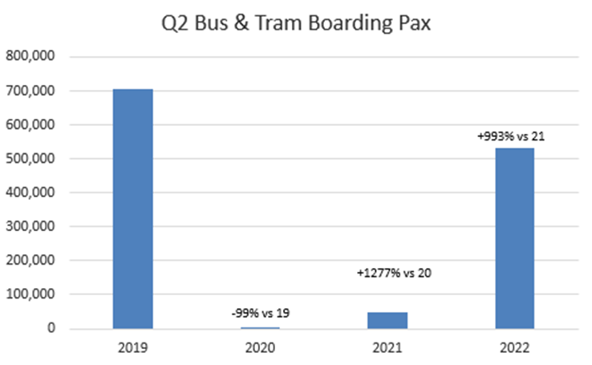
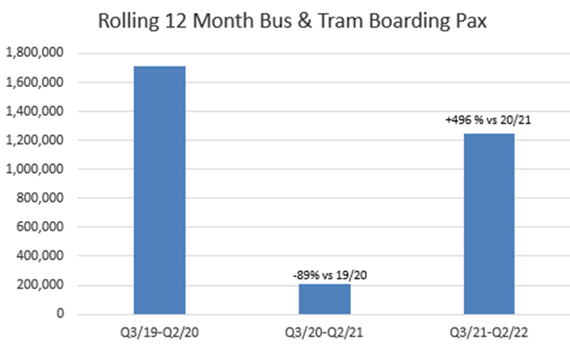

- Public transport market share of arriving pax currently sits at 36.8% for Q2 2022.
- We have relocated the Airlink 100 Bus to a more prominent location at the exit to the Terminal building which has resulted in market share.
- Social distancing and face masks have now been removed on buses and frequencies are increasing on the bus services again – Citylink AIR (Glasgow), Airlink 100 (express service to Edinburgh city centre) and Jet747 (Fife) are back 24/7 and to pre-Covid levels of service.

  - Taxi services

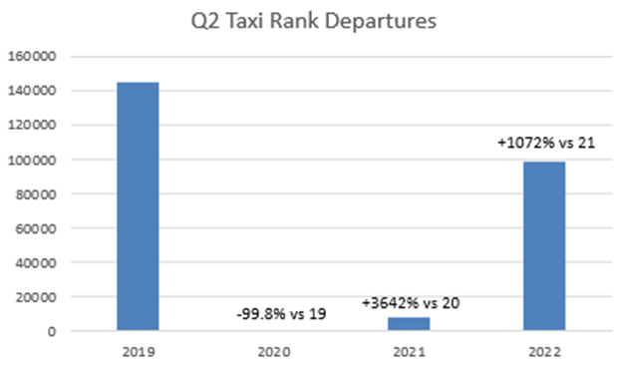

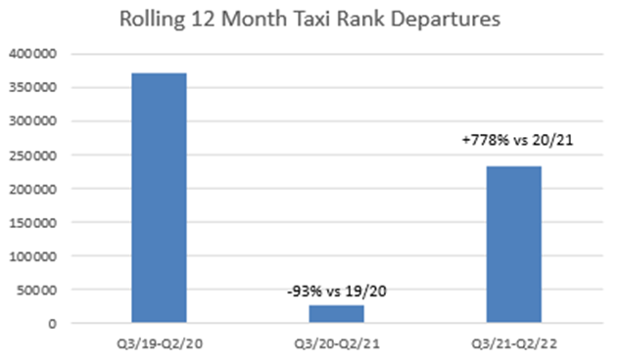
- Private Hires returned to the East Terminus rank in Nov-21.
- There is still a shortfall in provision of vehicles at EDI with both Hackney Taxis and Private Hires having issues with recruiting drivers back into the trade.

5. Aircraft noise
- Our Service Level Agreement (SLA) is to respond to noise complaints within five days.
- All percentages are reported to one decimal place.
- Any negative figures or decrease in percentages are reported in red

5.1 Noise complaints received

 | Apr-22 | May-22 | Jun-22 | Q2/2022  total | Q1/2022  total | % change  Q2/2022 v  Q1/2022 | % change  Q2/2022 v  Q2/2021
Noise complaints | 102 | 77 | 59 | 238 | 126 | 88.9% | 183.3%
Complainaints | 20 | 22 | 17 | 42 | 26 | 82.6% | 68.0%
Answered in SLA | 99.0% | 93.5% | 91.5% | 95.4% | 94.4% | 1.0% | 11.3%

5.2 Runway use

 | Apr-22 | May-22 | Jun-22 | Q2/2022  total | Q1/2022  total | % change  Q2/2022 v  Q1/2022 | % change  Q2/2022 v  Q2/2021
Runway 06 | 4067 | 2572 | 2632 | 9271 | 2929 | 216.5% | 238.1%
Runway 24 | 4113 | 6734 | 7053 | 17900 | 13396 | 33.6% | 401.4%

5.3 Complaints by type of enquiry

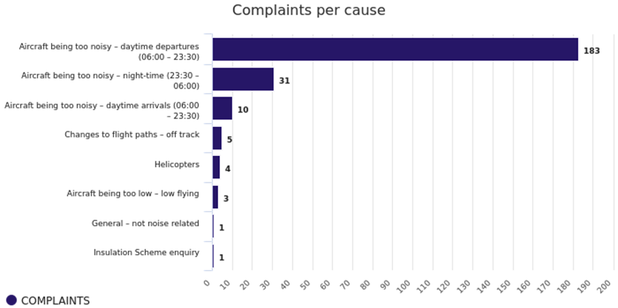

Defined terms - As perceived by complainant not EDI defined
Ground running | Complainant considers noise source to be engine testing operations or noise of aircraft on ground within the airport grounds
Helicopter | Complainant considers noise source to be EDI related helicopter movement complaints – generally not Edinburgh Airport movements
General/non-specific | Complainant wishes to report a non-noise related complaint – still logged as it is received to noise line or noise email address
Off track | Complainant considers the aircraft to be flying out with the SID or NPR
Low flying | Complainant considers noise source to be due to the altitude of aircraft being too low
Arriving aircraft noise | Daytime (06:00 – 23:30) noise level complaints for Arrivals
Departing aircraft noise | Daytime (06:00 – 23:30) noise level complaints for Departures
Daytime Noise Levels | Daytime (06:00 – 23:30) noise level complaints – Arrivals and Departures
Night flight noise | Night time (23:30 to 06:00) noise level complaints
ACP | Enquiries regarding noise levels relating to proposed new flight paths not yet flown
Military flight noise | Noise complaints regarding military aircraft not associated with Edinburgh Airport

5.4 Complaints by area sorted by number of complainants

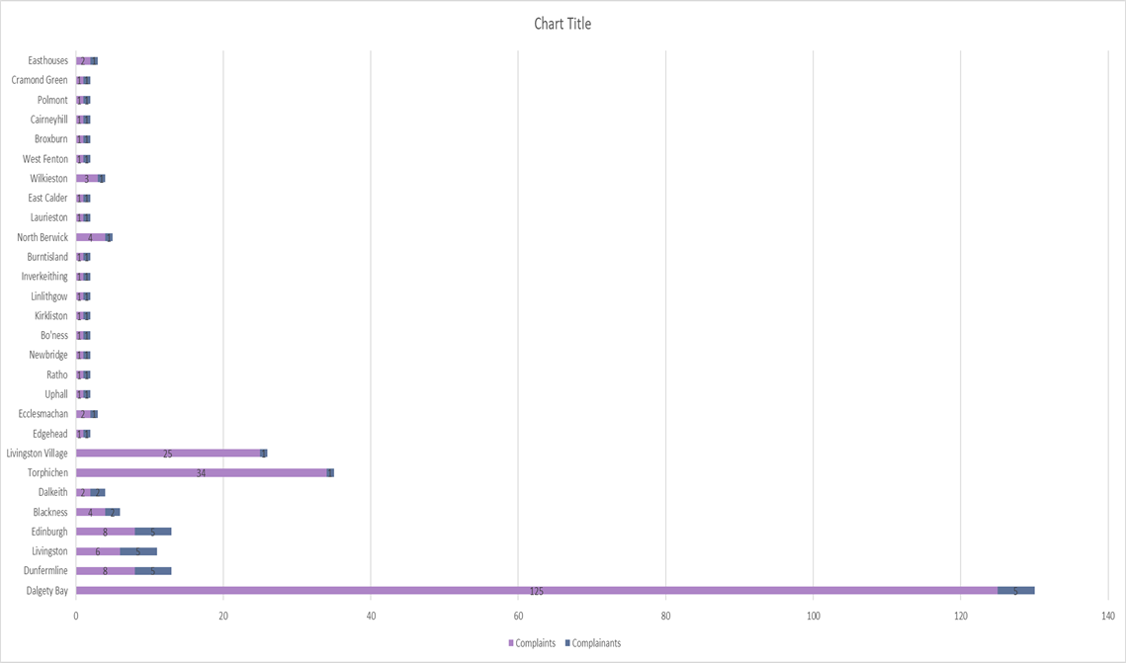

5.5 Noise commentary
- 240+ complaints were received via an email from one individual in Blackness, as with historic complaints received in this manner these have been noted but will not be added to the system due to the resources required to add each complaint individually to the NTK system. One complainant and one complaint have been added to Table 5.5 for Blackness.

- Of the complains received for Dalgety Bay, one individual was responsible for 118 of the 125 complaints made. All complaints re Torphichen were made by one individual, and all complaints regarding Livingston Village were also made by one individual.

- The number of complaints is expected to continue to rise as we continue towards pre-Covid operations levels.

- Route development

  - Route commentary

Airline Operational Challenges:

- Of note this quarter were operational disruptions caused as a result of demand returning quicker than the ability of airlines and ground handlers to recruit staff. Airlines including easyJet and British Airways struggled with operational issues this quarter, resulting in a number of ad-hoc cancellations.
- In response to the wider staffing challenge, several slot-coordinated airports including Amsterdam, Gatwick, Heathrow and Frankfurt, recently imposed capacity limits to address handler and airport resource shortages, which will restrict passengers travelling to or from those airports going forward.
- Despite this, airlines at EDI are recovering strongly. For example, in June, passenger recovery for Ryanair was 120%, easyJet 84% and Jet2 102%. Moreover, transatlantic passengers in June were more than 100% recovered vs Jun-19, due to up-gauges by Delta, United and Air Canada, and new services from Virgin Atlantic (Orlando) and WestJet (Toronto).
EDI Summer Recovery:
- For S22, we have 147 destinations recovered (operating a min. of 4 weeks scheduled service), compared to 149 destinations in Summer 2019.
- For S22, we have 34 airlines operating scheduled services compared to 33 airlines in S19.
Airline Updates:

- British Airways: Made significant reductions to the Heathrow schedule removing flights from mid-July through the end of summer 2022, in response to the Heathrow cap (~3 daily departures).
- Easyjet: Launched routes to two destinations in Greece: Kefalonia and Corfu which begin operating in late June and continue until early September this year.
- Emerald (Aer Lingus Regional): Took over from Aer Lingus mainline which had operated the Dublin and Belfast City routes since the collapse of Stobart Air in 2021, increased to 5 daily flights on Dublin and 3 daily flights on Belfast City.
- Flybe: Re-commenced, post administration, at EDI to Belfast (Jun-22) and Birmingham (Jul-22). They will only scale to 2 daily flights on BHX rather than 4 daily due to delayed aircraft deliveries and operational constraints.
- Flyr: The new Norwegian carrier which launched in April to Oslo, cancelled this service from July. The route remains served by Norwegian and SAS.
- Lufthansa: Started their 3rd daily on FRA and will continue operating until September when the service will return to twice daily.
- Qatar: Upgauged to a larger aircraft (the A350-900) from 1st July.
- Virgin Atlantic: Started 2 routes at EDI, to Barbados (Dec-21) and Orlando (Mar-22), but have since cancelled Barbados for this coming winter. The Orlando route is performing well.
- Westjet: began operations at EDI in June 2022, operating three times weekly to Toronto.

Other Notes:

- EDI has 5 widebody operators this summer for the first time (United, Delta, Virgin, Air Canada, and Qatar)
- Qatar Airways and Turkish Airlines have continued to provide long haul connectivity to markets in the East as Emirates – Emirates Dubai service is still on pause and expected to return in S23.

- Passenger satisfaction analysis

7.1 Complaints, compliments and enquiries
Received via email, phone call, webform and letter.

 | April | May | June | Total Q2 2022 | Total Q2 2021 | Q2 2022 vs Q1 2022 % change
Complaints 2022 | 119 | 219 | 259 | 597 | 31 | 131%
Compliments 2022 | 17 | 9 | 31 | 57 | 2 | 235%
Enquiries 2022 | 932 | 1,176 | 1,400 | 3,508 | 167 | 31%
Total | 1,068 | 1,404 | 1,690 | 4,162 | 200 | 41%

    - Commentary

- In line with Q1 trends, our most popular method of contact is via phone call, with webform submissions marginally higher (2%) than live chat requests in Q2
- Though our complaints have risen MoM, complaints per 10k pax have returned to, but not exceeded pre-pandemic levels
- As the table indicates, we have seen a 41% increase in cases in Q2 2022, vs Q1 2022
- The areas of most comment in Q2 were:
- Baggage hall – comments regarding baggage delivery speed and missing luggage reconciliation
- Security – comments regarding FastTrack, permitted items and damaged property
- Check-in – comments regarding airline policies

  - Passenger Satisfaction

Based on the steps of the passenger journey, the following graph shows how many items of feedback we have received for each area;

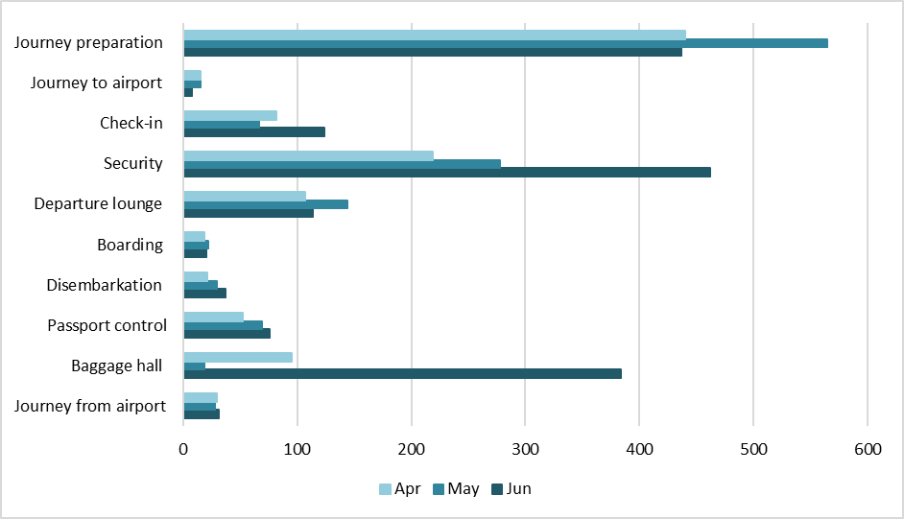

*The graph does not include any enquiries that have been received via live chat. We have now began tagging live chats in line with our categories, however they do not yet feed neatly into our journey steps. Working with our live chat provider, we hope to be able to achieve this by the end of Q4.

- In line with Q1’s trends, the area with the most items of enquiries and feedback is ‘Journey Preparation’, and this is now closely followed by security. This is indicative of customers’ desire to prepare for their journey – be that through enquiring about hand luggage rules, or whether it is advisable to purchase FastTrack.

- The tail end of June, the team saw an unprecedented surge in requests for support (over 2,500 tickets in two weeks, inclusive of car parking) and we expect contact volume to remain high for the remainder of the summer schedule.

- We have now established a review solicitation process, and the team have assumed ownership of all related Edinburgh Airport pages on; Reviews.io, Trustpilot and Google:

  - Car parking customers are now solicited for a review, 3 days post exit. Thanks to a reconfiguration of the solicitation process, customers will be able to view reviews for each parking product (as opposed to previous ‘overall’ reviews) assisting their selection of the most suitable facility.

