Engine

L-Twin, Desmodromic distribution, 2 valves per cylinder, air cooled

Displacement

803 cc

Power

73 hp (54 kW) @ 8,250 rpm

Torque

49 lb-ft (6.8 kgm, 67 Nm) @ 5,750 rpm

Frame

Tubular steel Trellis frame

Front suspension

Upside down Kayaba Ø41 mm fork

Front tyre

Pirelli MT 60 RS 110/80 R18

Rear suspension

Kayaba rear shock, pre-load adjustable

Rear tyre

Pirelli MT 60 RS 180/55 R17

Front brake

Ø330 mm disc, radial 4-piston 2-pad callipers, Cornering ABS as standard equipment

Rear brake

Ø245 mm disc, 1-piston floating calliper with Cornering ABS as standard equipment

Dry weight

173 kg (381 lb)

Weight in running order

189 kg (417 lb)

Seat height

798 mm (31.4 in) - low seat 778 mm (30.6 in) available as accessory

Fuel tank capacity

13.5 l (3.57 US gal)

Standard equipment

Steel tank with interchangeable aluminium side panels, Headlight with DRL by LED light-guide and interchangeable aluminium cover, LED rear light with diffusion-light, LED turn indicator, LCD instruments with gear and fuel level indications and interchangeable aluminium cover, Under-seat storage compartment with USB socket, Cornering ABS, Machine-finished aluminium belt covers, Black engine with brushed fins

Icon equipment

Dedicated logo, Dedicate handlebar, Matching mudguards, Aluminium muffler cover

Emissions & Consumption*

Euro 4 Standard - CO2 Emissions 119 g/km - Consumption 5.1 l/100 km

9.550 € ‘62 Yellow

9.550 € Atomic Tangerine

Price

Retail price (VAT included - Italy)

*Only for countries where Euro 4 standard applies.

**ICON**

Engine

L-Twin, Desmodromic distribution, 2 valves per cylinder, air cooled

Displacement

803 cc

Power

73 hp (54 kW) @ 8,250 rpm

Torque

49 lb-ft (6.8 kgm, 67 Nm) @ 5,750 rpm

Frame

Tubular steel Trellis frame

Front suspension

Upside down Kayaba Ø41 mm fork

Front tyre

Pirelli MT 60 RS 110/80 R18

Rear suspension

Kayaba rear shock, pre-load adjustable

Rear tyre

Pirelli MT 60 RS 180/55 R17

Front brake

Ø330 mm disc, radial 4-piston 2-pad callipers, Cornering ABS as standard equipment

Rear brake

Ø245 mm disc, 1-piston floating calliper with Cornering ABS as standard equipment

Dry weight

173 kg (381 lb)

Weight in running order

189 kg (417 lb)

Seat height

798 mm (31.4 in) - low seat 778 mm (30.6 in) available as accessory

Fuel tank capacity

13.5 l (3.57 US gal)

Standard equipment

Steel tank with interchangeable aluminium side panels, Headlight with DRL by LED light-guide and interchangeable aluminium cover, LED rear light with diffusion-light, LED turn indicator, LCD instruments with gear and fuel level indications and interchangeable aluminium cover, Under-seat storage compartment with USB socket, Cornering ABS, Machine-finished aluminium belt covers, Black engine with brushed fins

Icon equipment

Dedicated logo, Dedicate handlebar, Matching mudguards, Aluminium muffler cover

Emissions & Consumption*

Euro 4 Standard - CO2 Emissions 119 g/km - Consumption 5.1 l/100 km

9.550 € Atomic Tangerine

9.550 € ‘62 Yellow

Price

Retail price (VAT included - Italy)

*Only for countries where Euro 4 standard applies.

**ICON**

Engine

L-Twin, Desmodromic distribution, 2 valves per cylinder, air cooled

Displacement

803 cc

Power

73 hp (54 kW) @ 8,250 rpm

Torque

49 lb-ft (6.8 kgm, 67 Nm) @ 5,750 rpm

Frame

Tubular steel Trellis frame

Front suspension

Upside down Kayaba Ø41 mm fork

Front tyre

Pirelli MT 60 RS 110/80 R18

Rear suspension

Kayaba rear shock, pre-load adjustable

Rear tyre

Pirelli MT 60 RS 180/55 R17

Front brake

Ø330 mm disc, radial 4-piston 2-pad callipers, Cornering ABS as standard equipment

Rear brake

Ø245 mm disc, 1-piston floating calliper with Cornering ABS as standard equipment

Dry weight

173 kg (381 lb)

Weight in running order

189 kg (417 lb)

Seat height

798 mm (31.4 in) - low seat 778 mm (30.6 in) available as accessory

Fuel tank capacity

13.5 l (3.57 US gal)

Standard equipment

Steel tank with interchangeable aluminium side panels, Headlight with DRL by LED light-guide and interchangeable cover, LED rear light with diffusion-light, LCD instruments with gear and fuel level indications and interchangeable cover, Cornering ABS, Machine-finished aluminium belt covers, Black engine with brushed fins

Icon equipment

Dedicated logo, Dedicate handlebar, Matching mudguards, Aluminium muffler cover

Emissions & Consumption*

Euro 4 Standard - CO2 Emissions 119 g/km - Consumption 5.1 l/100 km

8.850 € Black

Price

Retail price (VAT included - Italy)

*Only for countries where Euro 4 standard applies.

**ICON DARK**



Engine

L-Twin, Desmodromic distribution, 2 valves per cylinder, air cooled

Displacement

1.079 cc

Power

86 hp (63 kW) @ 7,500 rpm

Torque

65 lb-ft (9.0 kgm, 88 Nm) @ 4,750 rpm

Frame

Tubular steel trellis frame

Front suspension

Marzocchi fully adjustable Ø45 mm usd fork

Front tyre

Pirelli MT 60 RS 120/70 ZR18

Rear suspension

Progressive linkage with adjustable Kayaba monoshock. Aluminium double-sided swingarm

Rear tyre

Pirelli MT 60 RS 180/55 ZR17

Front brake

2 x Ø320 mm semi-floating discs, radially mounted Brembo Monobloc M4.32 callipers, 4-piston, axial pump with Cornering ABS as standard equipment

Rear brake

Ø245 mm disc, 1-piston floating calliper with Cornering ABS as standard equipment

Dry weight

189 kg (417 lb)

Weight in running order

206 kg (454 lb)

Seat height

810 mm (31.9 in)

Fuel tank capacity

15 l (3.96 US gal)

Standard equipment

Riding Modes, Powerr Modes, Ducati Safety Pack (Cornering ABS + DTC), Ride by Wire (RbW), Brembo braking system, LED light guide, LED rear light with diffusion-light, LCD instruments with gear and fuel level indications, Steel tank with interchangeable aluminium side panels, Machine-finished aluminium belt covers, Under-seat storage compartment with USB socket

Emissions & Consumption*

Euro 4 Standard - CO2 Emissions 120 g/km - Consumption 5.0 l/100 km

13.096 €‘62 Yellow

13.096 € Shining Black

Price

Retail price (VAT included - Italy)

*Only for countries where Euro 4 standard applies.

**SCRAMBLER 1100**



**SCRAMBLER 1100 SPORT**

Engine

L-Twin, Desmodromic distribution, 2 valves per cylinder, air cooled

Displacement

1.079 cc

Power

86 hp (63 kW) @ 7,500 rpm

Torque

65 lb-ft (9.0 kgm, 88 Nm) @ 4,750 rpm

Frame

Tubular steel trellis frame

Front suspension

Öhlins fully adjustable Ø48 mm usd fork

Front tyre

Pirelli MT 60 RS 120/70 ZR18

Rear suspension

Progressive linkage with adjustable Öhlins monoshock. Aluminium double-sided swingarm

Rear tyre

Pirelli MT 60 RS 180/55 ZR17

Front brake

2 x Ø320 mm semi-floating discs, radially mounted Brembo Monobloc M4.32 callipers, 4-piston, axial pump with Cornering ABS as standard equipment

Rear brake

Ø245 mm disc, 1-piston floating calliper with Cornering ABS as standard equipment

Dry weight

189 kg (417 lb)

Weight in running order

206 kg (454 lb)

Seat height

810 mm (31.9 in)

Fuel tank capacity

15 l (3.96 US gal)

Standard equipment

Riding Modes, Powerr Modes, Ducati Safety Pack (Cornering ABS + DTC), Ride by Wire (RbW), Brembo braking system, LED light guide, LED rear light with diffusionlight, LCD instruments with gear and fuel level indications, Steel tank with interchangeable aluminium side panels, Machine-finished aluminium belt covers, Under-seat storage compartment with USB socket

Sport equipment

Low handlebar, Adjustable Öhlins suspensions, Fuel tank with yellow central stripes and under side covers, Mudguard with yellow stripes, Black fuel tank covers, Dedicated seat fabric, Aluminium double swingarm

Emissions & Consumption*

Euro 4 Standard - CO2 Emissions 120 g/km - Consumption 5.0 l/100 km

15.096 € Viper Black

Price

Retail price (VAT included - Italy)

*Only for countries where Euro 4 standard applies.

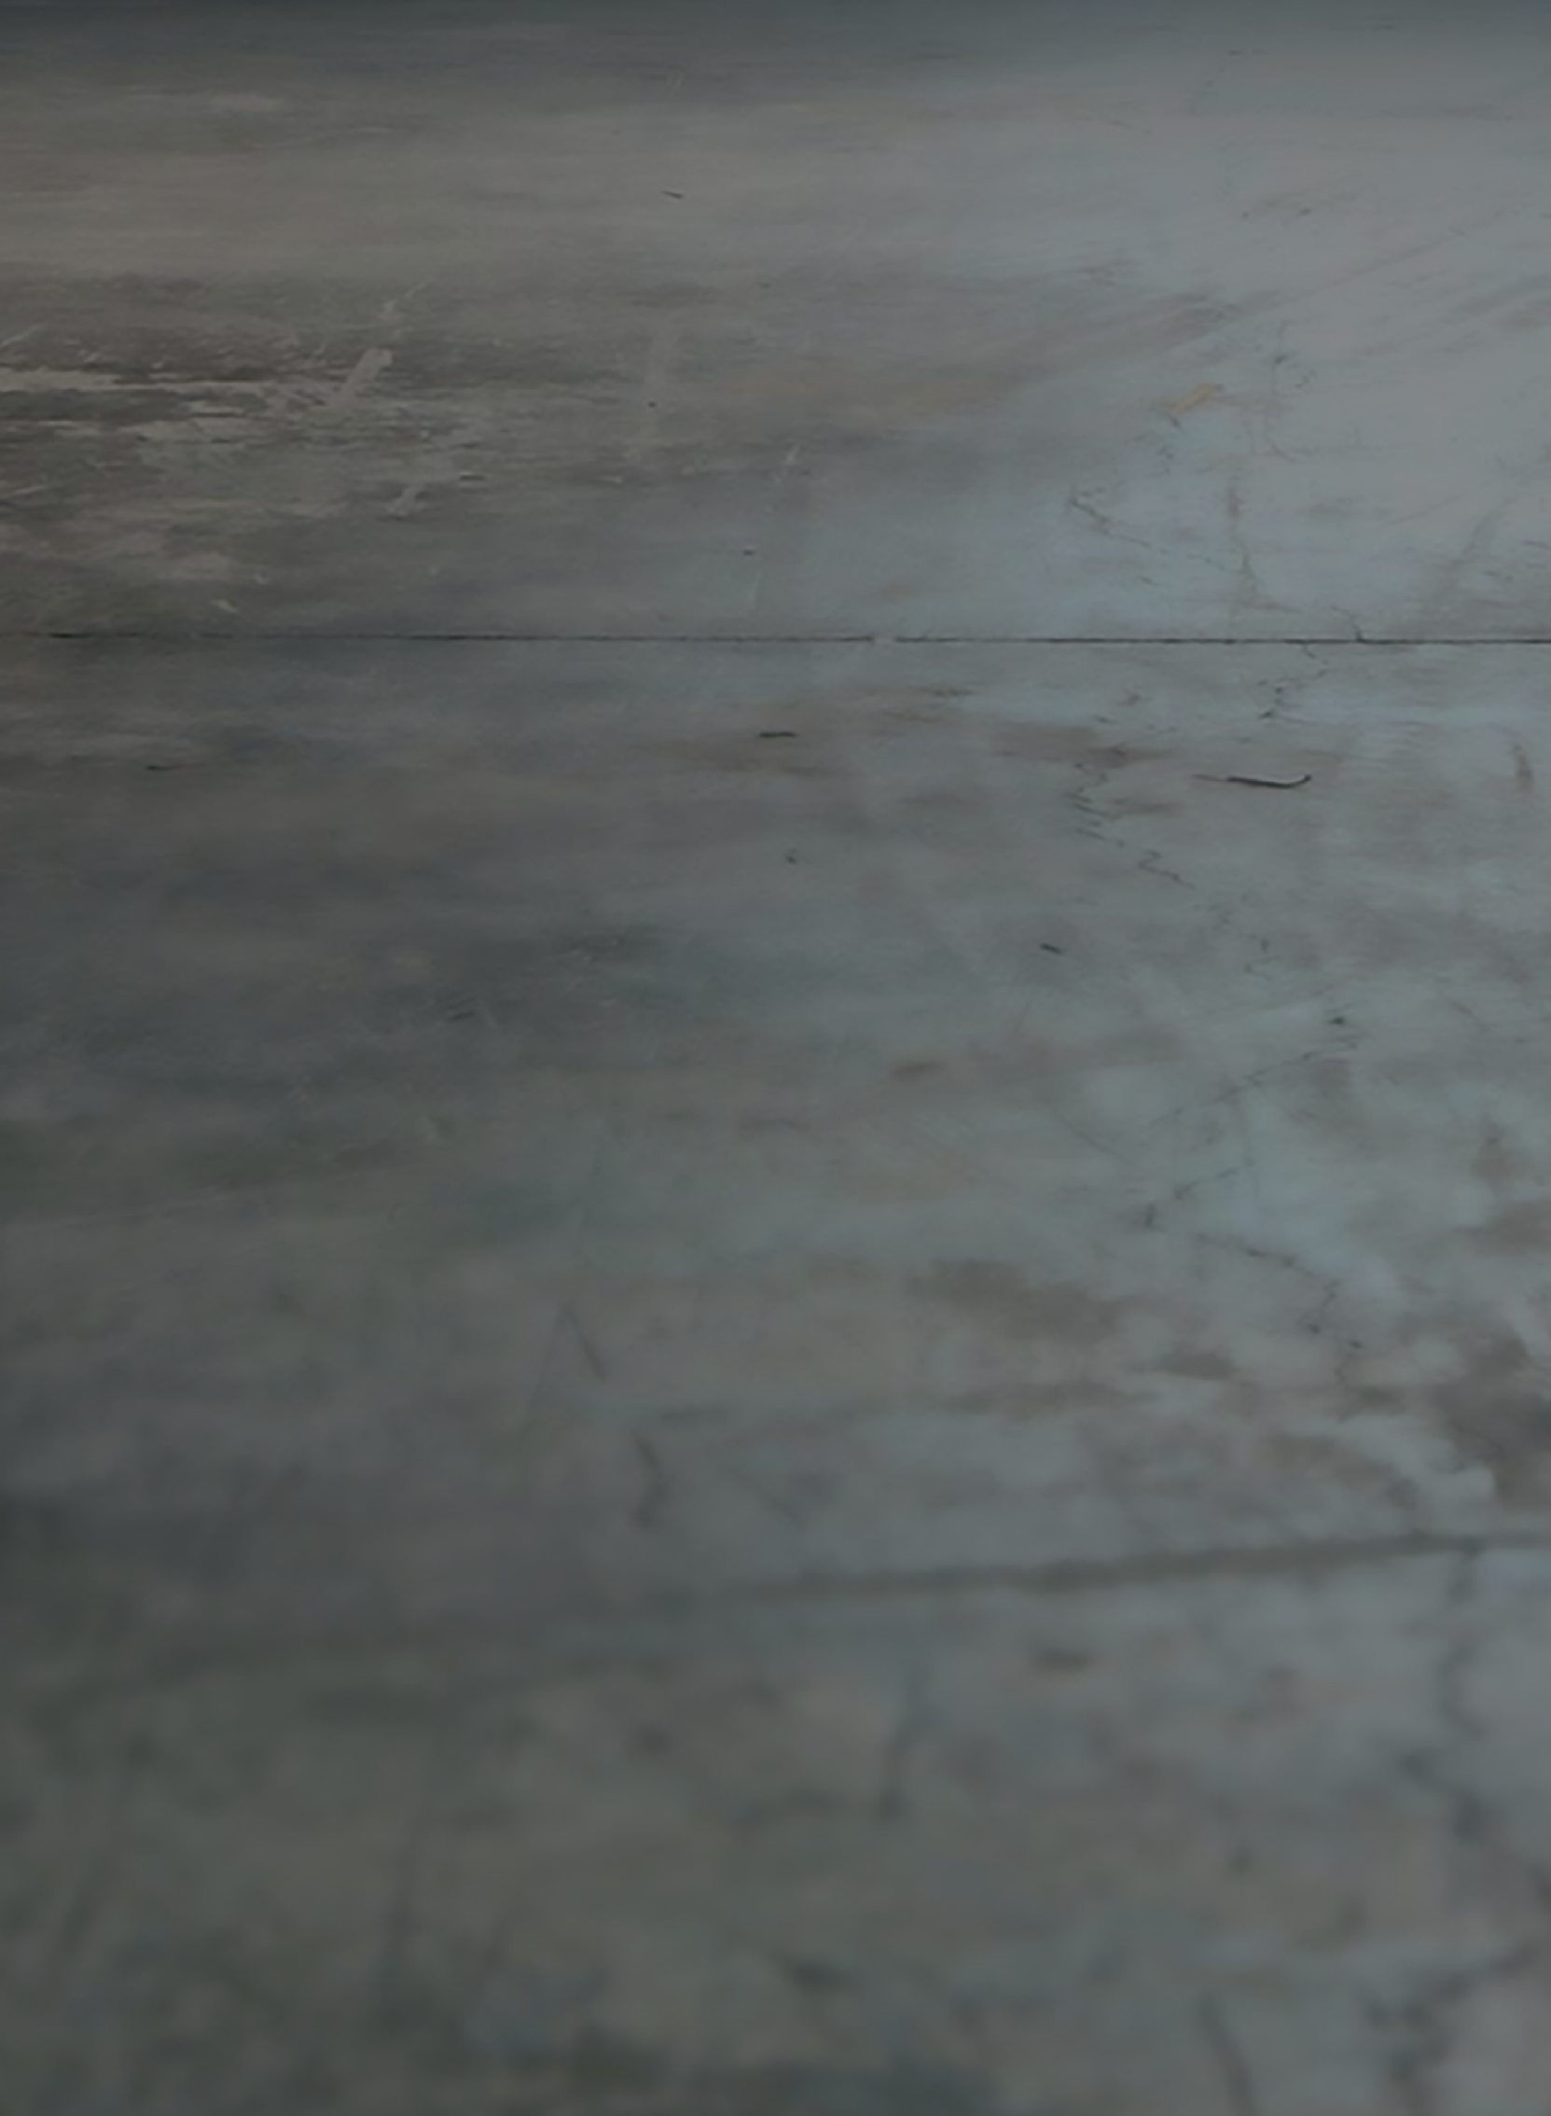

Engine

L-Twin, Desmodromic distribution, 2 valves per cylinder, air cooled

Displacement

1.079 cc

Power

86 hp (63 kW) @ 7,500 rpm

Torque

65 lb-ft (9.0 kgm, 88 Nm) @ 4,750 rpm

Frame

Tubular steel trellis frame

Front suspension

Marzocchi fully adjustable Ø45 mm usd fork

Front tyre

Pirelli MT 60 RS 120/70 ZR18

Rear suspension

Progressive linkage with adjustable Kayaba monoshock. Aluminium double-sided swingarm

Rear tyre

Pirelli MT 60 RS 180/55 ZR17

Front brake

2 x Ø320 mm semi-floating discs, radially mounted Brembo Monobloc M4.32 callipers, 4-piston, axial pump with Cornering ABS as standard equipment

Rear brake

Ø245 mm disc, 1-piston floating calliper with Cornering ABS as standard equipment

Dry weight

194 kg (428 lb)

Weight in running order

211 kg (465 lb)

Seat height

810 mm (31.9 in)

Fuel tank capacity

15 l (3.96 US gal)

Standard equipment

Riding Modes, Powerr Modes, Ducati Safety Pack (Cornering ABS + DTC), Ride by Wire (RbW), Brembo braking system, LED light guide, LED rear light with diffusion-light, LCD instruments with gear and fuel level indications, Steel tank with interchangeable aluminium side panels, Machine-finished aluminium belt covers, Under-seat storage compartment with USB socket

Special equipment

Low handlebar, Front and rear aluminium mudguards, Chromed exhaust pipes, Black spoked wheels, Anodized aluminium fuel tank side covers, Double swingarm with brushed surface finishing, Dedicated seat fabric

Emissions & Consumption*

Euro 4 Standard - CO2 Emissions 120 g/km - Consumption 5.0 l/100 km

14.396 € Custom Grey

Price

Retail price (VAT included - Italy)

*Only for countries where Euro 4 standard applies.

**SCRAMBLER 1100 SPECIAL**

**FULL THROTTLE**

Engine

L-Twin, Desmodromic distribution, 2 valves per cylinder, air cooled

Displacement

803 cc

Power

73 hp (54 kW) @ 8,250 rpm

Torque

49 lb-ft (6.8 kgm, 67 Nm) @ 5,750 rpm

Frame

Tubular steel Trellis frame

Front suspension

Upside down Kayaba Ø41mm fork

Front tyre

Pirelli MT 60 RS 110/80 R18

Rear suspension

Kayaba rear shock, pre-load adjustable

Rear tyre

Pirelli MT 60 RS 180/55 R17

Front brake

Ø330 mm disc, radial 4-piston 2-pad callipers, Cornering ABS as standard equipment

Rear brake

Ø245 mm disc, 1-piston floating calliper with Cornering ABS as standard equipment

Dry weight

173 kg (381 lb)

Weight in running order

189 kg (417 lb)

Seat height

798 mm (31.4 in) - low seat 778 mm (30.6 in) available as accessory

Fuel tank capacity

13.5 l (3.57 US gal)

Standard equipment

Steel tank with interchangeable aluminium side panels, Headlight with DRL by LED light-guide and interchangeable aluminium cover, LED rear light with diffusion-light, LED turn indicator, LCD instruments with gear and fuel level indications and interchangeable aluminium cover, Under-seat storage compartment with USB socket, Cornering ABS, Machine-finished aluminium belt covers, Black engine with brushed fins

Full Throttle equipment

Low aluminium handlebars, Flat-track inspired seat with passenger seat cover, Sport tail piece with dedicate turn indicator support, Sports style front mudguard, Dedicate fuel tank side covers, Dedicated logo

Emissions & Consumption*

Euro 4 Standard - CO2 Emissions 119 g/km - Consumption 5.1 l/100 km

10.990 € Hooligan Livery

Price

Retail price (VAT included - Italy)

*Only for countries where Euro 4 standard applies.



**CAFÉ RACER**

Engine

L-Twin, Desmodromic distribution, 2 valves per cylinder, air cooled

Displacement

803 cc

Power

73 hp (54 kW) @ 8,250 rpm

Torque

49 lb-ft (6.8 kgm, 67 Nm) @ 5,750 rpm

Frame

Tubular steel Trellis frame

Front suspension

Upside down Kayaba Ø41mm fork

Front tyre

Pirelli Diablo Rosso III - 120/70 R17

Rear suspension

Kayaba rear shock, pre-load adjustable

Rear tyre

Pirelli Diablo Rosso III - 180/55 R17

Front brake

Ø330 mm disc, radial 4-piston 2-pad callipers, Cornering ABS as standard equipment

Rear brake

Ø245 mm disc, 1-piston floating calliper with Cornering ABS as standard equipment

Dry weight

180 kg (396.8 lb)

Weight in running order

196 kg (432 lb)

Seat height

805 mm (31.7 in)

Fuel tank capacity

13.5 l (3.57 US gal)

Standard equipment

Steel tank with interchangeable aluminium side panels, Headlight with DRL by LED light-guide and interchangeable aluminium cover, LED rear light with diffusion-light, LED turn indicator, LCD instruments with gear and fuel level indications and interchangeable aluminium cover, Under-seat storage compartment with USB socket, Cornering ABS, Machine-finished aluminium belt covers, Black engine with brushed fins

Café Racer equipment

Clip on handlebars, Alluminium handelbars mirrors, Sports style front mudguard, Dedicated side number plate, “café racer” seat with passenger seat cover, Spoked aluminium wheels

Emissions & Consumption*

Euro 4 Standard - CO2 Emissions 119 g/km - Consumption 5.1 l/100 km

11.990 € Silver Ice Matt

Price

Retail price (VAT included - Italy)

*Only for countries where Euro 4 standard applies.

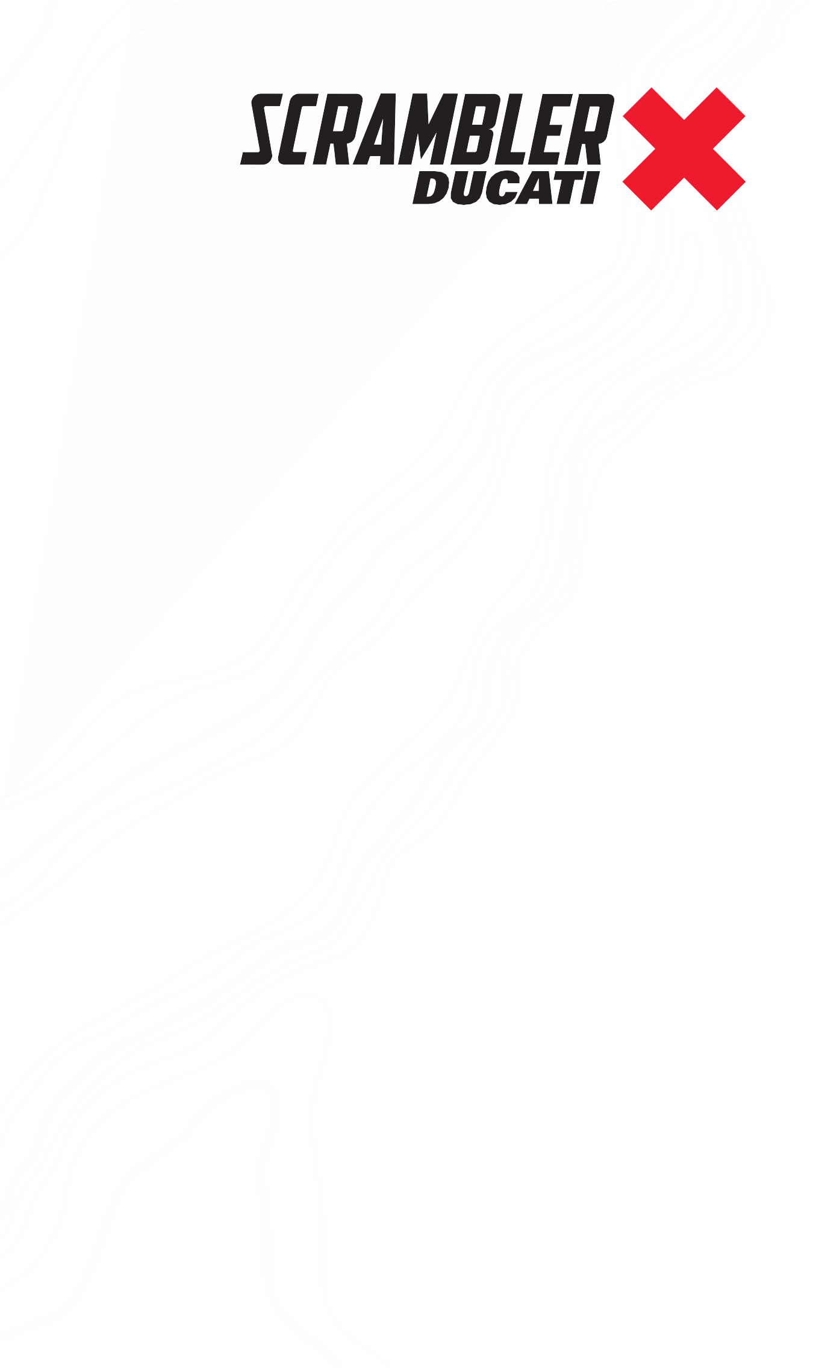

**DESERT SLED**

Engine

L-Twin, Desmodromic distribution, 2 valves per cylinder, air cooled

Displacement

803 cc

Power

73 hp (54 kW) @ 8,250 rpm

Torque

50 lb-ft (6.8 kgm, 67 Nm) @ 5,750 rpm

Frame

Tubular steel Trellis frame

Front suspension

Ø46 mm fully adjustable usd forks

Front tyre

Pirelli SCORPION™ RALLY STR 120/70 R19

Rear suspension

Kayaba rear shock, pre-load and rebound adjustable. Aluminium double-sided swingarm

Rear tyre

Pirelli SCORPION™ RALLY STR 170/60 R17

Front brake

Ø330 mm disc, radial 4-piston 2-pad callipers, Cornering ABS as standard equipment

Rear brake

Ø245 mm disc, 1-piston floating calliper with Cornering ABS as standard equipment

Dry weight

193 kg (425.5 lb)

Weight in running order

209 kg (461 lb)

Seat height

860 mm (33.9 in) - low seat 840 mm (33.0 in) available as accessory

Fuel tank capacity

13.5 l (3.57 US gal)

Standard equipment

Steel tank with interchangeable aluminium side panels, Headlight with DRL by LED light-guide and

interchangeable aluminium cover, LED rear light with diffusion-light, LED turn indicator, LCD instruments with

gear and fuel level indications and interchangeable aluminium cover, Under-seat storage compartment with

USB socket, Cornering ABS, Machine-finished aluminium belt covers, Black engine with brushed fins

Desert Sled equipment

Aluminium handlebar with cross-strut, Front stem protectors, Seat with specific design, High front mudguard,

Long rear mudguard and high plate support

Emissions & Consumption*

Euro 4 Standard - CO2 Emissions 119 g/km - Consumption 5.1 l/100 km

11.990 € White Mirage

Price

Retail price (VAT included - Italy)

*Only for countries where Euro 4 standard applies.

7.990 € Atomic Tangerine

Engine

L-Twin, Desmodromic distribution, 2 valves per cylinder, air cooled

Displacement

399 cc

Power

40 hp (30 kW) @ 8,750 rpm

Torque

25 lb-ft (3.5 kgm, 34 Nm) @ 8,000 rpm

Frame

Tubular steel Trellis frame

Front suspension

Traditional Showa Ø41 mm fork

Front tyre

Pirelli MT 60 RS 110/80 R18

Rear suspension

Kayaba rear shock, pre-load adjustable

Rear tyre

Pirelli MT 60 RS 160/60 R17

Front brake

Ø320 mm disc, 2 -piston floating calliper with ABS as standard equipment

Rear brake

Ø245 mm disc, 1-piston floating calliper with ABS as standard equipment

Dry weight

167 kg (368 lb)

Weight in running order

183 kg (403 lb)

Seat height

790 mm (31.1 in) - low seat 770 mm (30.3 in) and high 810 mm (31.9 in) available as accessory

Fuel tank capacity

14 l (3.7 US gal)

Standard equipment

Steel tank, Front headlight with glass lens, LED positioning light with interchangeable surround, Rear headlight with LED technology, LCD instrumentation with interchangeable surround, 18” front wheel and 17” rear wheel

Emissions & Consumption*

Euro 4 Standard - CO2 Emissions 108 g/km - Consumption 4.6 l/100 km

Price

Retail price (VAT included - Italy)

*Only for countries where Euro 4 standard applies.

**SIXTY2**