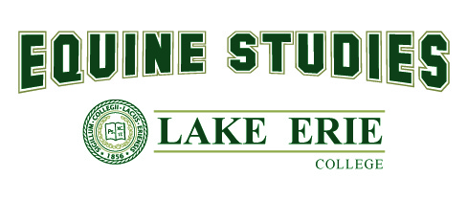
Lake Erie College 4-H Equine Talent Scholarship

Students who are members of 4-H and are pursuing a major in equine studies may apply for the Lake Erie College 4-H Equine Talent Scholarship, valued up to $7500 annually, with either a riding or a non-riding primary component. Our goal is to award excellence in horsemanship. Riders at any level are encouraged to apply. Award amount will be determined by a panel of Admissions and Equine Studies staff and faculty using a holistic evaluation of all application materials sent with criteria including depth of 4-H resume, correct grammar and formatting of written materials, riding skill level (for riding videos), academics, and financial need (based on the FAFSA). This scholarship is renewable for up to 4 years and is dependent on the student’s continued academic success. The student must make satisfactory academic progress, and any additional criteria set by the School of Equine Studies. This scholarship is available for first-time freshman or transfer students who are members of 4-H when entering Lake Erie College

Application Components

Riding
- A riding video of no longer than 2:00 minutes demonstrating ability
- Two letters of recommendation from 4-H equine professionals in the equine industry regarding the applicant’s ability, experience, and reliability
- Resume of 4-H-related equine experience including a brief personal statement regarding how participation in 4-H benefited the applicant

OR
Non-Riding
- An essay (minimum 500 words), PowerPoint presentation (minimum 10 slides), or 2-minute video about one of the following topics:
- Equine Business Plan
Include target demographic, geographic location, number of horses involved (if applicable), number of employees, and basic numbers including income vs. cost
- Equine Product Idea
Include intended use, method of action, expected result, and the problem the product is designed to solve
- Facility Design
Include dimensions, arena location(s) and sizes, pasture layout, water access, waste management, fence material, and intended use
- Two letters of recommendation from 4-H equine professionals in the equine industry regarding the applicant’s ability, experience, and reliability
- Resume of 4-H-related equine experience including a brief personal statement regarding how participation in 4-H benefited the applicant

For applicants admitted before 11/15, components must be submitted by 12/1. All other applications are due no later than 21 days after being admitted to Lake Erie College. All materials should be submitted to wburtt@lec.edu. Large files including videos and PowerPoint presentations may be submitted via email as a shared Google Drive file.

