Bill.com
Basic Accounts Payable (AP) Automation using Hubdoc and QuickBooks Online

Process/System Documentation

June 24, 2019^

^Modified July 29, 2019 by Bill.com

Table of Contents

1 Introduction 2
1.1 Executive Overview 2
1.2 Reference Documents 2
1.3 Glossary 2
2 Process/System Overview 3
2.1 Process Overview 3
2.1.1 Process Roles 3
2.2 Systems Overview & Descriptions 3
3 Process Documentation 4
3.1 Process 1.0 Connecting Hubdoc and Bill.com 4
3.1.1 Process 1.1 Hubdoc Policy Admin configures integration with Bill.com 4
3.2 Process 2.0: Connecting Hubdoc and QBO 6
3.2.1 Process 2.1: Hubdoc Policy Admin configures integration with QBO 6
3.3 Process 3.0: Connecting Bill.com and QBO 9
3.3.1 Data and Document Flow Considerations 9
3.3.2 Process 3.1 Bill.com Policy Admin configures integration with QBO 10
3.4 Process 4.0: Basic AP Automation via Bill.com, Hubdoc, and QBO Integration 12
3.4.1 Process Map – Process 4.0 Basic AP Automation via Bill.com, Hubdoc, & QBO Integration 13
3.4.2 Process Considerations – Basic AP Automation via Bill.com, Hubdoc & QBO Integration 13
3.4.3 Internal Control Considerations – Basic AP Automation via Bill.com, Hubdoc & QBO Integration 14
3.4.4 Data & Document Flows – Basic AP Automation via Basic AP Automation via Bill.com, Hubdoc & QBO Integration 14
3.4.5 Process 4.1 Client Submits Bill 15
3.4.6 Process 4.2 AP Clerk Checks DOCS Queue 15
3.4.7 Process 4.3 AP Clerk Codes Bill(s) 16
3.4.8 Process 4.4 AP Clerk Publishes Bill 18
3.4.9 Process 4.5 Bill.com Routes Bill for Approval 19
3.4.10 Process 4.6 Client Approves Bill 21
3.4.11 Process 4.7 CD Clerk Schedules Bill for Payment 23
3.4.12 Process 4.8 CD Clerk Syncs with QBO 24

Introduction
This document is designed to provide a detailed understanding of the sub-processes and systems involved in performance of a given process.

Executive Overview
This document summarizes the Accounts Payable Automation Process utilizing the integrations among the Bill.com, Hubdoc, and QuickBooks Online applications.

Reference Documents

The following documents were used as a reference in generating this document:
Document | Author/File Name
Bill.com Support – QuickBooks Online Sync Setup Guide | N/A

Glossary
The glossary lists all acronyms, abbreviations, terminology, and industry jargon used in this document.
Acronym | Definition
QBO | QuickBooks Online

Process/System Overview
This section provides an overview of the process including:
- A description of the processes involved;
- A description of the roles instrumental in the process; and
- A description of the systems involved.

Process Overview
The Basic AP Automation Process utilizing the integrations among Bill.com, Hubdoc, and QuickBooks Online (QBO) involves the following processes:
- Connecting Hubdoc with Bill.com to enable Hubdoc to pass data and documents to Bill.com
- Connecting Hubdoc with QBO to enable the applications to synchronize
- Connecting Bill.com with QBO to enable the applications to synchronize
- The submission and processing of bill payments via the integration between Bill.com, Hubdoc, and QBO

A diagram showing the potential flow of the processes is provided below.
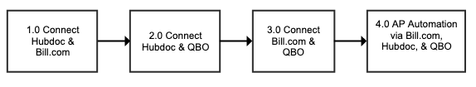

NOTE: The connections established between each application (i.e., Hubdoc & Bill.com, Hubdoc & QBO, and Bill.com and QBO) are not required to be performed in sequential order as illustrated above and can be performed as parallel processes.

Process Roles
The following is an overview of key roles in this process.

Role and Organization | Responsibilities | Bill.com Role
Hubdoc Admin  (either) | Responsible for establishing connections between Hubdoc and the other applications | N/A
Bill.com Admin  (either) | Responsible for establishing connections between Bill.com and QBO. Person must have the Sync with Accounting System permission in Bill.com. | Administrator
Bill Submitter  Client | Responsible for submitting the bill to HubDoc. If the submitter is emailing in bills, they don’t need a user account. If a submitter is uploading bills, then they need a Hubdoc user account. | N/A or Custom Role
Bill Approver  Client | Responsible for approving the bill in Bill.com. Person must have the Approve Bills/Vendor Credits permission in Bill.com. | Approver or Custom Role
Accounts Payable (AP) Clerk Accounting Firm | Responsible for processing the bill in Bill.com and routing it for approval. Person must have the Manage Bills/Vendor Credits permission in Bill.com | Clerk
Cash Disbursements (CD) Clerk Accounting Firm | Responsible for processing the payment of the vendor bill. Person must have the Pay approved bills via Bill.com permission in Bill.com | Payer

Systems Overview & Descriptions
The following applications are used in this process.
System/Application | Description
Bill.com | Bill.com is a cloud-based business payments software platform that helps automate the approval and payment processing for bills (vendor invoices).
Hubdoc | Hubdoc is a cloud-based document automation tool that collects key business documents (either from 3rd party websites or manually uploaded by users), organizes & securely stores the documents, extracts data, and publishes the documents and associated data to third party accounting and cloud storage platforms.
QuickBooks Online (QBO) | QuickBooks Online is a cloud-based small business accounting software platform used by record accounting transactions.

Process Documentation
The section documents the details of the process including lower level process maps.

Process 1.0 Connecting Hubdoc and Bill.com
For bills to be submitted from Hubdoc to Bill.com, a connection must first be established between Hubdoc and Bill.com.

Process 1.1 Hubdoc Admin configures integration with Bill.com
Use Case: | 1.1: Hubdoc Admin configures integration with Bill.com.
Summary: | The Hubdoc Admin configures the integration between Hubdoc and Bill.com.
Reference: | N/A
Role(s): | - Hubdoc Admin
System/Interface: | Hubdoc
Pre-condition: | User has logged into Hubdoc
Description: | - After logging into Hubdoc, a screen will be shown with the Name of the organization the Hubdoc Admin is able to access. Click on the Name of the organization to configure the connection between Hubdoc and Bill.com.  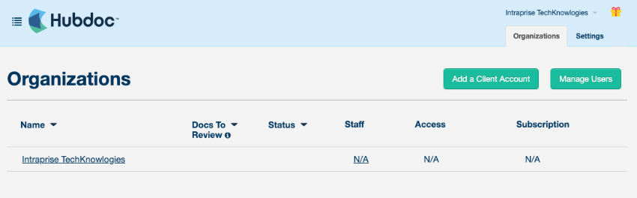  - Once the organization has been selected, the main Hubdoc screen will be shown. On the right side of the screen you will see a Sync + Share section showing the application that can be integrated with Hubdoc.  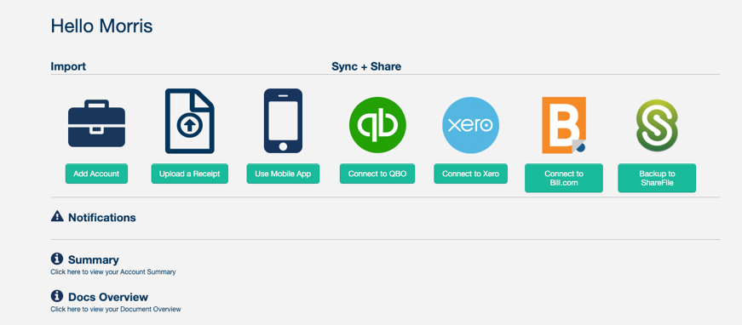  - NOTE: If the Sync + Share section does not appear after logging in, you can also click on the name of the organization in the upper right corner of the screen, click on the Settings option from the dropdown menu, and then click the Destinations tab.  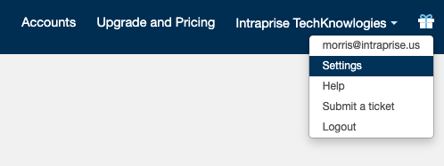  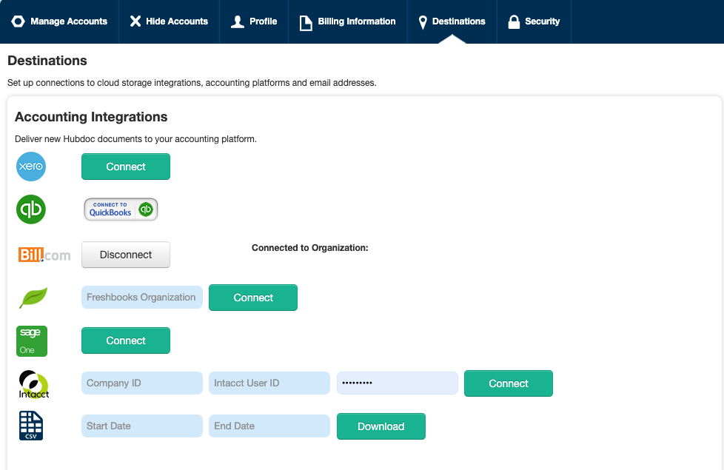  - Press the Connect to Bill.com button option.  - Follow the steps provided in the pop-up window to establish the connection between Hubdoc and Bill.com  Pop-Up Window:  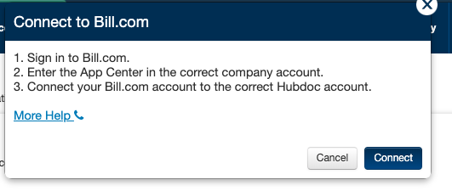  - After the Bill.com Admin signs into Bill.com, navigate to the App Center by following Settings Apps View All.  - Click on the Hubdoc DOCUMENT WORKFLOW option.  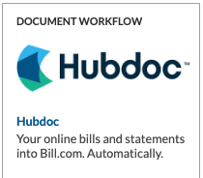  - After selecting the Hubdoc DOCUMENT WORKFLOW option, the Connect with Hubdoc screen will appear. Press the CONNECT button to begin the connection between Hubdoc and Bill.com.  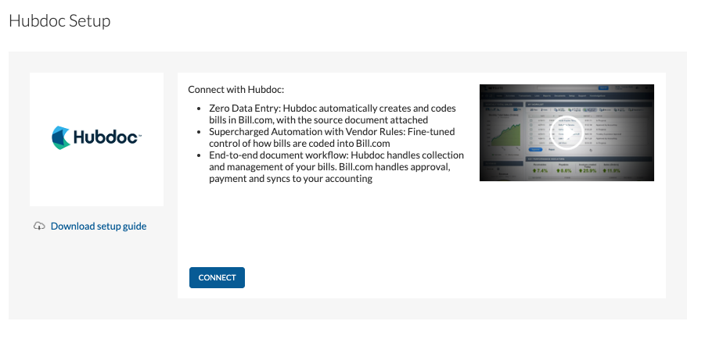
Alternatives: | N/A
Post-condition: | Hubdoc account is connected with the selected organization in Bill.com.

Process 2.0: Connecting Hubdoc and QBO

Process 2.1: Hubdoc Admin configures integration with QBO
Use Case: | 1.1: Hubdoc Admin configures integration with QBO.
Summary: | The Hubdoc Admin configures the integration between Hubdoc and QuickBooks Online.
Reference: | N/A
Role: | Hubdoc Admin
System/Interface: | Hubdoc
Pre-condition: | User has logged into Hubdoc.
Description: | - After logging into Hubdoc, a screen will be shown with the Name of the organizations the Hubdoc Admin is able to access. Click on the name of the organization in the list that you want to configure the connection between Hubdoc and QBO.  - Once the organization has been selected, the main Hubdoc screen will be shown. On the right side of the screen you will see a Sync + Share section showing the application that can be integrated with Hubdoc.  - NOTE: If the Sync + Share section does not appear after logging in, you can also click on the name of the organization in the upper right corner of the screen, click on the Settings option from the dropdown menu, and then click the Destinations tab.  - Press the Connect to QBO button option (or Connect to QuickBooks button from the Destinations screen) and follow the steps provided on screen in order to establish the connection between Hubdoc and QuickBooks Online.  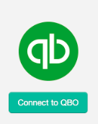  - After pressing the button, enter the QBO User ID and Password for the QBO account that you want to sync with Hubdoc.  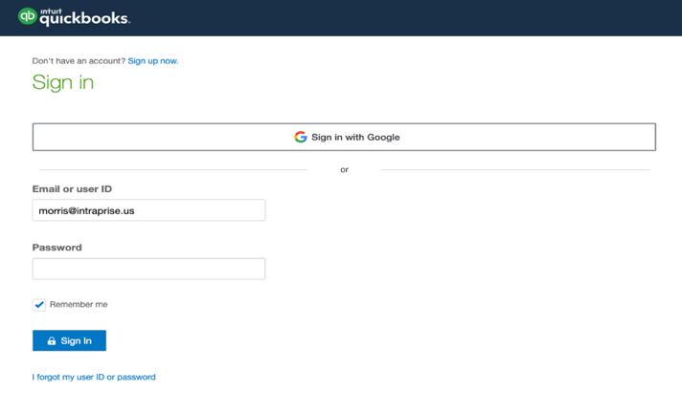  - A screen will be shown with the company/firm(s) that the user is able to access. From the dropdown menu, select the Company/Firm that contains the client that Hubdoc will be connected then select the client from the Client List.  - Once these selections have been made, press the Confirm button. A screen will be shown confirming the action to be taken.  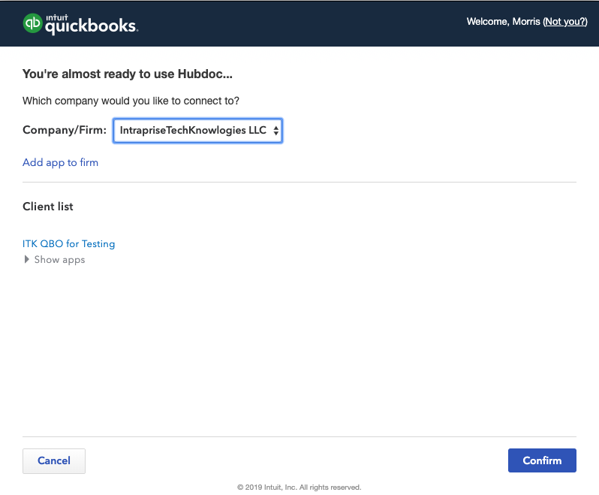  - Press the CONNECT button to complete the integration.  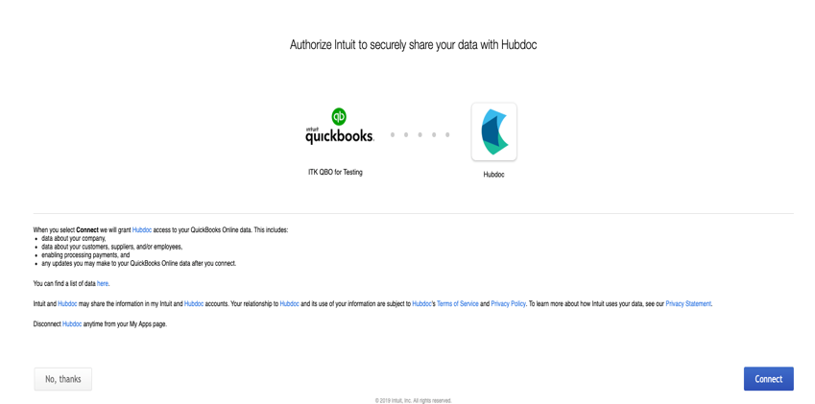
Alternatives: | N/A
Post-condition: | Hubdoc is connected with the selected organization in QBO.

Process 3.0: Connecting Bill.com and QBO
A connection must be established between Bill.com and QBO in order to utilize the Basic AP Automation Process configuration. This connection will enable the Bill.com account being maintained by the Accounting Firm to sync data between the two applications.

Data and Document Flow Considerations
Consider the following when setting up the sync between Bill.com and QBO:
- Master data: Bill.com & QBO. The following master lists are synchronized between Bill.com and QBO. In the Bill.com Sync Preferences for each company you can choose whether QBO or Bill.com “wins” in the event of a conflicting change. Hubdoc syncs separately with Bill.com and QBO, the only master data that can be added from Hubdoc is a Vendor.
  - Chart of Accounts - Since this will have a potential impact on financial reporting and should not be changed without strong consideration, we recommend QBO be the master for this data.
  - Vendor List - Since new vendors will often be first seen first via an incoming Bill. It may make sense to have Bill.com be the master for this data. However, this depends on whether the firm has a policy for obtaining W-9s before processing payment to vendors (to avoid the rush after the end of the year).
    - When a new vendor is added from Hubdoc, Hubdoc only prompts for the vendor name. The rest of the information (e.g. address, contact info, terms, etc.) must be setup in Bill.com or QBO.
  - Locations - Since this will have a potential impact on financial and management reporting and should not be changed without strong consideration, we recommend QBO be the master for this data.
  - Classes - Since this will have a potential impact on management reporting and should not be changed without strong consideration, we recommend QBO be the master for this data.
- Transaction data: Bill.com & QBO. The following transaction data sets are synchronized between Bill.com and QBO. In the Bill.com Sync Preferences for each company you can choose whether QBO or Bill.com “wins” in the event of a conflicting change.
- Bills - Bills in Bill.com are synced to QBO as Bills in the QBO Expenses module. Bills entered into QBO also sync to Bill.com.
    - Note: There is an option for only sync Approved Bills to QBO. Once you turn this on in Bill.com you can’t turn it off. Bill.com says that your setting should ONLY be enabled if ALL bills will go through the Bill.com approval workflow. This setting might be helpful with a cash basis taxpayer if you can keep the time between the approval of the Bill and payment of the Bill small, as it would keep the amount shown in QBO’s Accounts Payable low while providing visibility into full potential liability in Bill.com.
- Vendor Credits - Vendor Credits in Bill.com are synced to QBO as Vendor Credits in the QBO Expenses module. Vendor Credits entered into QBO also sync to Bill.com.

Process 3.1 Bill.com Policy Admin configures integration with QBO
Use Case: | 3.1: Bill.com Policy Admin configures integration with QBO.
Summary: | The Bill.com Policy Admin configures the integration between Bill.com and QuickBooks Online.
Reference: | Bill.com Docs – QuickBooks Online Sync Setup Guide
Role: | Bill.com Policy Admin
System/Interface: | Bill.com
Pre-condition: | User has logged into Bill.com and has Policy Admin rights.
Description: | - Establish the connection between Bill.com and QBO by clicking on the Sync image and then pressing the Setup button.  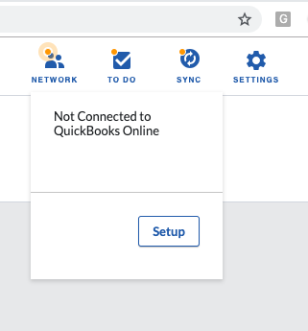  - Upon pressing on the Setup button, you will be directed to the Sync with QBO page. Once on this page, press on the Connect to QuickBooks button.  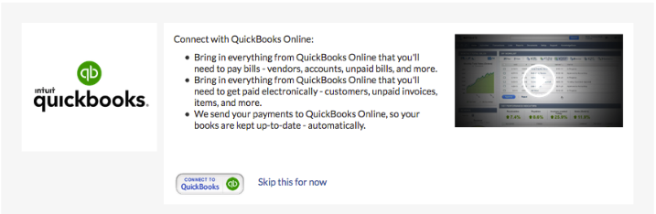  - Enter the QBO User ID and Password for the QBO account that you want to sync with Bill.com.  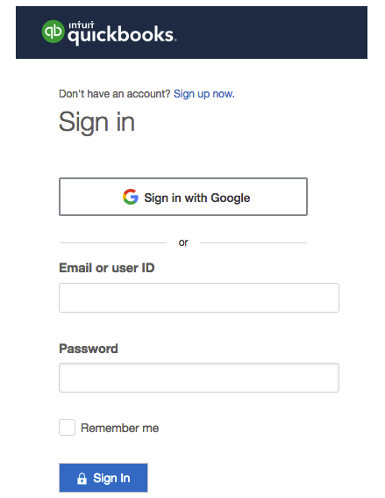  - A screen will be shown with the company/firm(s) that the user is able to access. From the dropdown menu, select the Company/Firm Bill.com will be connected to as well associated client from the Client List.  - Once these selections have been made, press the Confirm button. A screen will be shown confirming the action to be taken.  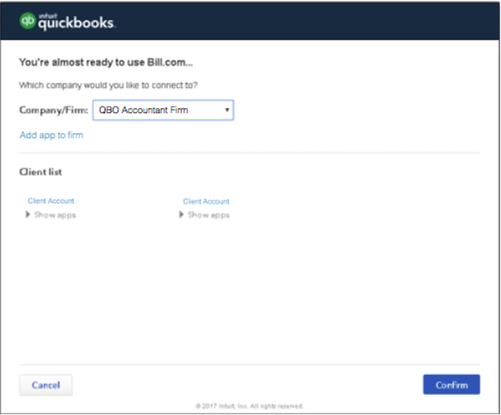  - Press the Connect button to complete the integration.  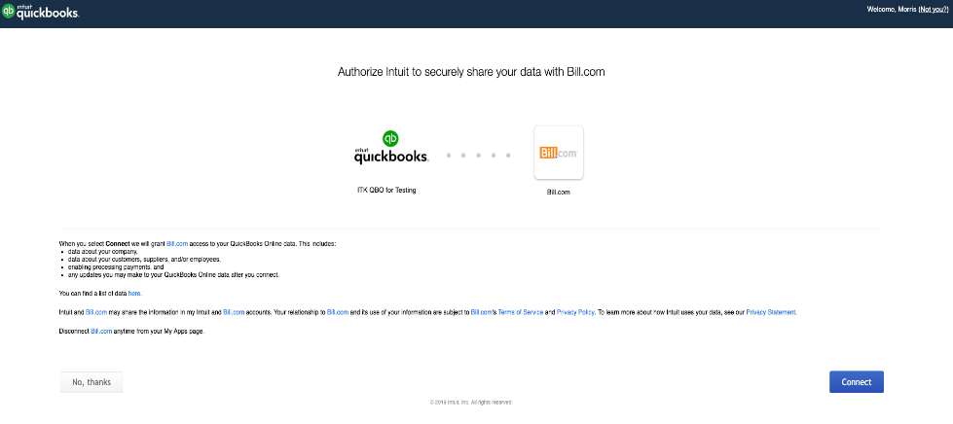  - After pressing the Connect button to link Bill.com with QBO, the synchronization will begin. Once completed, the connection between Bill.com and QBO will be established and the confirmation screen will appear.  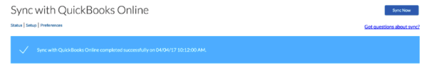  - Upon establishing the sync connection, the option is provided to identify the sync preferences to be established. Learn more about the Sync Preferences by reading the Bill.com QuickBooks Online Sync Setup Guide and the section above on Data and Document Flow Considerations.
Alternatives: | N/A
Post-condition: | - Bill.com account is connected with the selected organization in QBO.  - QBO Master Data (e.g. Chart of Accounts, Vendors, Locations, Classes, etc.) is imported into Bill.com.  - On-going master data and transactional data synchronization is enabled between Bill.com and QBO.

Process 4.0: Basic AP Automation via Bill.com, Hubdoc, and QBO Integration
The basic AP automation process utilizing the integration between Bill.com, Hubdoc, and QBO begins with the Bill Submitter preparing and submitting a bill to Hubdoc. The Bill Submitter can email or upload the bill and any associated supporting documentation (e.g., packing slip) to the Hubdoc DOCS Queue.

Once there are documents in the Hubdoc DOCS Queue, the AP Clerk reviews and codes the bill. The AP Clerk then publishes the bill to the integrated software applications (Bill.com and QBO). After the bill is published, it will show up in QBO and Bill.com. The AP Clerk routes the bill to a person(s) at the client with bill payment approval authority (“Bill Approver”). Bill.com sends a notification via email to the Bill Approver that the bill is awaiting approval (Note: frequency of notification depends on the user’s notification settings).

Once a bill is approved, the CD Clerk is notified, and can schedule the bill for payment (Note: frequency of notification depends on the user’s notification settings). The client receives notification of the scheduled bill payment (Note: frequency of notification depends on the user’s notification settings). The CD Clerk can then perform a sync of Bill.com with QBO to record the payment in QBO. After the sync is performed, the resulting journal entry in QBO will be a debit to Accounts Payable and a credit to designated clearing account. At the specified pay date, Bill.com withdraws the funds from the client’s bank account and places it in a clearing bank account controlled by Bill.com. Bill.com then sends the payment to the vendor from the clearing bank account based on the proscribed payment method (e.g. check, ACH, wire). Once the payment is made, there is a resulting Funds Transfer journal entry in Bill.com that debits the clearing account and credits the bank General Ledger.

Process Map – Process 4.0 Basic AP Automation via Bill.com, Hubdoc, & QBO Integration
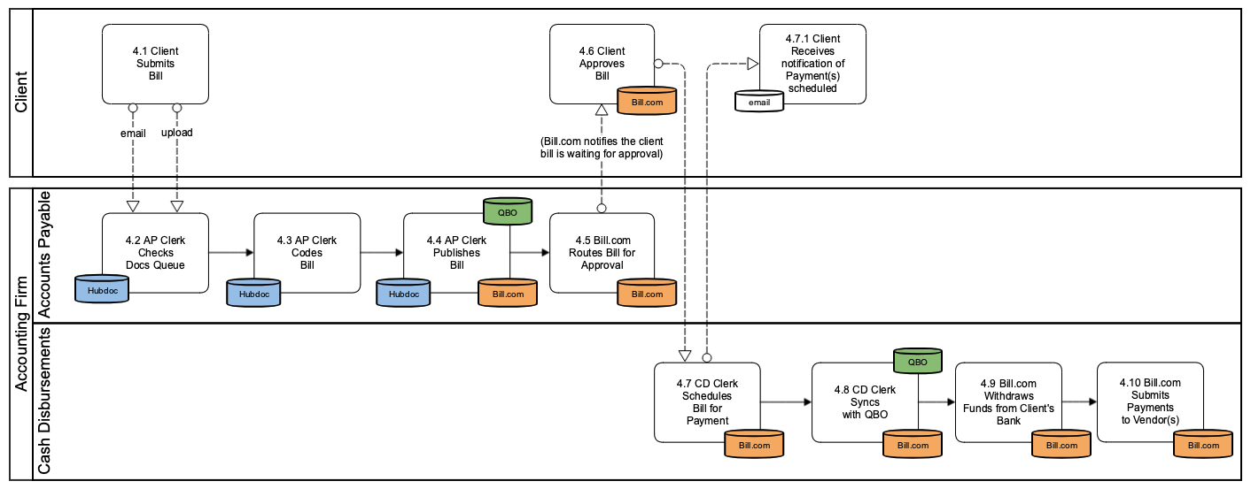
Figure 1 - Basic AP Automation via Bill.com, Hubdoc, and QBO Integration

Process Considerations
Consider the following when developing your policies and procedures:
- Hubdoc is able to retrieve bills and statements from a variety of vendors. Check their list of banks and vendors here.
  - Include as part of your on-boarding of clients a step where you check whether their bills can be retrieved via Hubdoc instead of them having to send/upload the bills.
  - Many of the vendors that Hubdoc retrieves bills for have auto-payment by credit card.
    - These generally should not be published to Bill.com since they do not require a payment. However, if Bill.com is being used as a way to validate coding of expenses, then these bills should be flowed through Bill.com and just marked as paid outside of Bill.com. This causes additional work but maintains the coding validation process.
    - Since they are paid by credit card, some of these transactions may also be entering QBO via an expense report (employee reimbursement or corporate card). If coding is done in the expense report process and there is an integration from that app to QBO, then it is probably not necessary to code in Hubdoc and you would not publish the document from Hubdoc to Bill.com or QBO.
  - Hubdoc has an automatic publishing capability where recognized documents can be set to automatically publish to Bill.com and/or QBO. This is very useful for recurring transactions or those vendors where the coding of the bill is the same every time.
- The Accounting Firm is dependent upon the Client submitting bills that they receive physically or via email (i.e. not retrieved by Hubdoc).
  - Note that since many vendors email copies of their bills directly to their customers, that clients may receive a copy of their bill via email that they then submit to Hubdoc. Care should be taken to determine whether bills received from clients are a duplication of a bill retrieved by Hubdoc--and that both documents are not processed resulting in duplication of the transaction.
    - FYI, Hubdoc’s duplicate detection feature uses the invoice number and vendor name to detect duplicates, so as long as these are captured correctly Hubdoc should detect the duplicates.
- Submission of Bill by Client equates to approval of recording of liability
  - Tip: Train Clients to indicate GL dimension coding (E.g. dept, class, location, etc.) on submitted document or in email
  - Note that when Hubdoc automatically retrieves the Bill that this explicit approval is no longer present. Care should be taken to ensure that client approval is still obtained as part of a transaction validation process either specifically for automatically retrieved bills or as part of the cash disbursements process.
- Hubdoc only remembers coding for single line transactions.
  - If a document has multiple transaction lines, it may be better to just publish the document to Bill.com and use Bill.com’s memory of the transaction since Bill.com does remember multi-line transaction coding.
- Hubdoc does not enforce consistency of coding between what is published to Bill.com and QBO. If there are differences between what is published to each app, these will result in sync errors when Bill.com and QBO performs the transaction level sync. If you’ve set a “winner” for Bill conflicts, Bill.com will follow that instruction (see Data Considerations sections below).
- When a bill is published from Hubdoc to Bill.com the last approval flow used for the vendor is automatically triggered.
- Client approval of Bill in Bill.com is approval to pay
  - Tip: Develop cash disbursements policies / protocols with clients
- The process above shows single level of approval, but multiple levels of approvals can be captured serially via Bill.com on a bill by bill basis.
- NOTE: Bill.com automatically syncs once a day with QBO so manual sync step may not be needed unless you need QBO to be immediately updated after actions are taken (probably more important for cash disbursements since it impacts bank account balance).

Internal Control Considerations
Consider the following related to internal controls when developing your policies and procedures:
- Remember to consider separation of duties related to:
  - Approval of bills versus coding of bills and scheduling of payments. Especially when the same staff person is coding bills and scheduling payments, be sure that the same staff does not have the ability to approve bills. Otherwise that staff person could move a factitious bill through to payment without anyone else having touched the transaction.
  - Creation of new vendors or changes to vendor information (especially payment address and/or bank routing numbers) versus input of bills and scheduling of payments. This is to ensure that a single person on your staff cannot create a factitious vendor, assign real bills to that vendor and have payments directed to themselves.
  - Changes to vendor information (especially payment address and/or bank routing numbers) and access to vendor statements. This is to prevent a staff member from changing payment information for a real vendor and then intercepting statements where a vendor may be showing things as past due when they should have been paid.
  - Scheduling of payments versus performing bank reconciliations. This is a standard internal control protocol.
- When Hubdoc is used to retrieve bank statements, the separation of duties risk is even higher because staff that have access to Hubdoc will have access to both bills and bank statements. Hubdoc does not provide granular control over who has access to which folders and all users are able to perform all actions in Hubdoc.

Data & Document Flows
Consider the following when setting up the sync between Bill.com and QBO:
- Documents (images). When using the Basic AP Automation with Bill.com and Hubdoc workflow, we recommend that all documents be flowed through Hubdoc and that Hubdoc completely replaces the legacy paper “vendor files”. Copies of agreements or contracts with Vendors can be stored in Hubdoc folders, separate from the actual bills. Note that documents published from Hubdoc to Bill.com or QBO are also pushed to the respective app as well, so documents will exist in both places. If you don’t want the document in QBO you can publish just to Bill.com and then sync Bill.com to QBO to move the transaction data to QBO.
  - Client File Repository. Since there are no user-level controls around access to folders in Hubdoc, consider using Hubdoc’s ability to publish documents to file storage apps (e.g. Box.com, DropBox, Google Drive, Sharefile, and SmartVault) for client access. You can select which documents are published to which storage location on a document by document basis as they are processed.

Process 4.1 Client Submits Bill
Use Case: | 4.1: Client Submits Bill
Summary: | Client prepares & submits bill to AP Clerk
Reference: | Hubdoc Quick Start Guide (download)
Role: | Bill Submitter
System/Interface: | Email
Pre-condition: | - Client receives bill from vendor requesting payment for services rendered or product provided.  - Client has the client organization specific Hubdoc email address
Description: | - If the bill or supporting documents are in hardcopy, Bill Submitter scans or takes photo of the bill/documents.  - Client emails the bill/documents to the client organization specific Hubdoc email address.
Alternatives: | - Instead of emailing the bill/document, the Bill Submitter can use the Hubdoc app to capture a photo of the bill/document.  - If the Bill Submitter also has a Hubdoc login, they can login to the web application and upload the scanned files.
Post-condition: | Bill/document is in the Hubdoc DOCS Queue.

Process 4.2 AP Clerk Checks DOCS Queue
Use Case: | 4.2: AP Clerk Checks DOCS Queue
Summary: | AP Clerk checks the Hubdoc Documents Folder to see what bill(s) needs to be processed
Role: | AP Clerk
System/Interface: | Hubdoc
Pre-condition(s): | - Bill Submitters have submitted bill(s)/document(s) for processing.  - AP Clerk has logged into Hubdoc.com.
Description: | - Click on the All Documents folder on the left navigation to see the list of items sitting in the DOCS Queue. By default, the first item will be selected in the list and its associated pages will be displayed to the right.  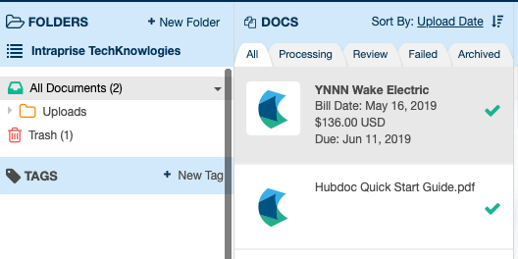  - Select the item you want to process by clicking on the item in the DOCS Queue list.  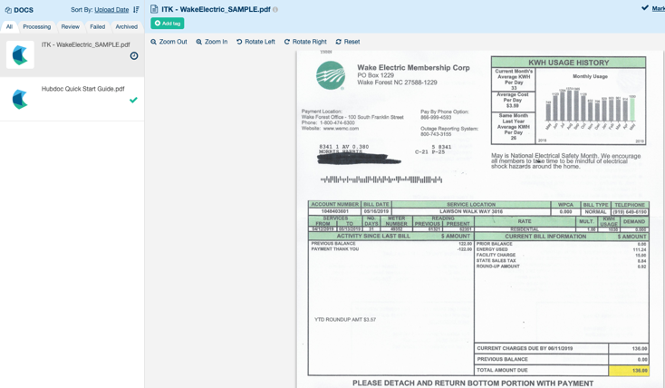
Alternatives: | N/A
Post-condition: | Bill opened in the content frame.

Process 4.3 AP Clerk Codes and Publishes Bill to QBO
Use Case: | 4.3: AP Clerk Codes Bill(s) and Publishes Bill to QBO
Summary: | AP Clerk codes the bill by specifying the payment details and amount of the bill to be published to QBO.
Role: | AP Clerk
System/Interface: | Hubdoc
Pre-condition: | N/A
Description: | - With the bill open on the screen, click on the Pencil Icon to enter the Publish & Proceed portion of the screen to begin coding the bill.  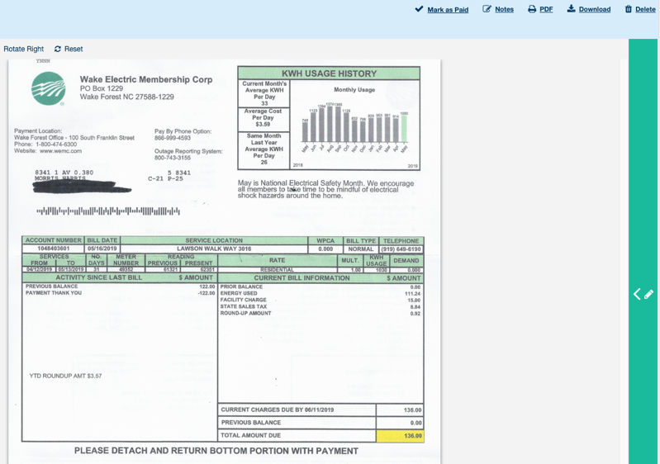  - Enter the bill information into the DETAILS and AMOUNT sections of the Publish & Proceed area. Ensure the required fields (indicated by an asterisk) are completed. NOTE: If the vendor already exists in Hubdoc, it will appear in the Supplier listing. If not, then the supplier will need to be added by clicking on the dropdown menu and then selecting +New Supplier (shown below). Once the new supplier name has been provided, press the Create button.  Publish & Proceed DETAILS and AMOUNT Fields:  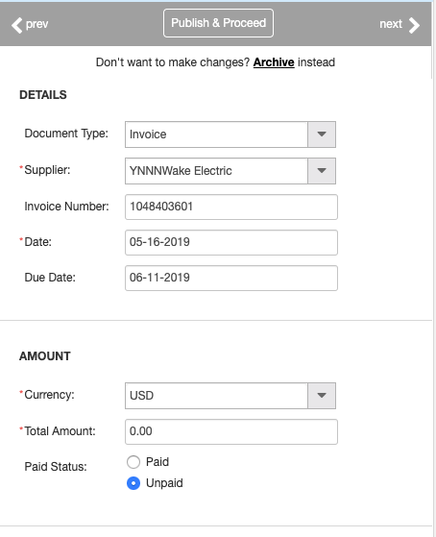  +New Supplier option in the Supplier Field:  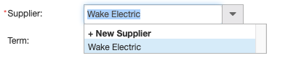  - In the DESINATIONS section below the AMOUNT section, if the QBO Publishing configuration has not been established for the Supplier, the [Configuration] State will indicate Not Configured. Click on the Configure link for QBO.  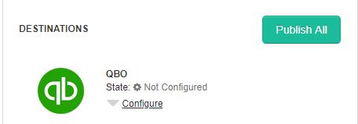  - After clicking on the Configure link, complete the account coding details for each respective field for the QBO section (e.g., Publish As, Supplier, Term, Location, Account, etc.). Ensure the required fields (indicated by an asterisk) are completed. NOTE: If the vendor already exists in QBO, it will appear in the Supplier listing. If not, then the supplier will need to be added by clicking on the dropdown menu and then selecting +New Supplier (shown below). Once the new supplier name has been provided, press the Create button.  QBO Configure screen:  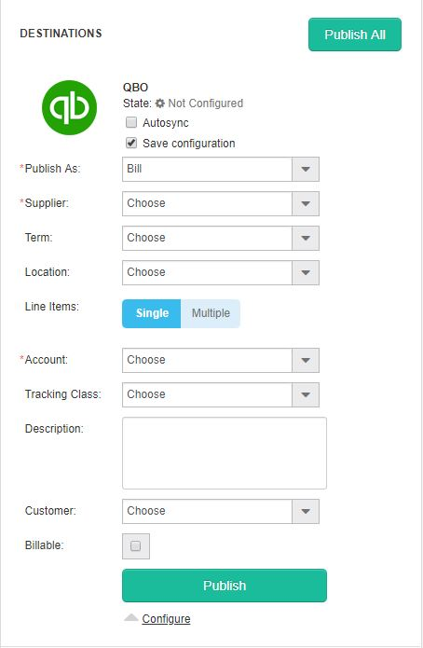  + New QBO Supplier screen:  - After completing the required fields, press the Publish button.  Confirmation that bill has been published will appear.  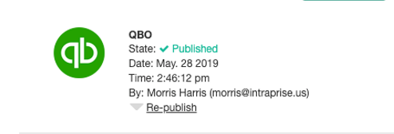
Alternatives: | - Users also have the option to click on the Publish All button (located at the top right of the DESTINATIONS section) instead of performing the Publish operation for each individual application.  - Hubdoc has an automatic publishing capability where recognized documents can be set to automatically publish to QBO.
Post-condition: | - Bill has been coded and has been published to QBO.

Process 4.3 AP Clerk Codes and Publishes Bill to Bill.com
Use Case: | 4.3: AP Clerk Codes and Publishes Bill to Bill.com
Summary: | AP Clerk codes the bill by specifying the payment details and amount of the bill to be published to Bill.com.
Role: | AP Clerk
System/Interface: | Hubdoc
Pre-condition: | - Supplier coding has NOT been configured for Bill.com.  - AP Clerk is on the Publish and Proceed Portion of the screen for the respective bill.
Description: | - Click on the Configure link for Bill.com.  - After clicking on the Configure link for Bill.com, complete the account coding details for each respective field for the Bill.com section (e.g., Document Type, Supplier, Line Items, Account, etc.). Ensure the required fields (indicated by an asterisk) are completed. NOTE: If the vendor already exists in Bill.com, it will appear in the Supplier listing. If not, then the supplier will need to be added by clicking on the dropdown menu and then selecting +New Supplier (shown below). Once the new supplier name has been provided, press the Create button.  Bill.com Configure screen:  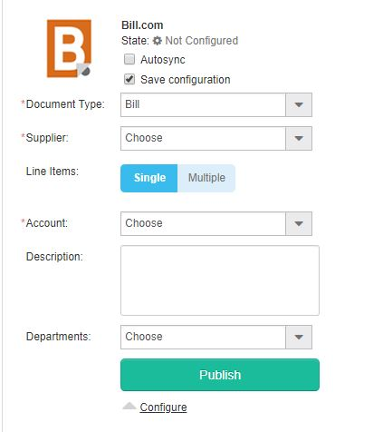  + New Bill.com Supplier screen:  - After completing the required fields, press the Publish button.  Confirmation that bill has been published will appear.  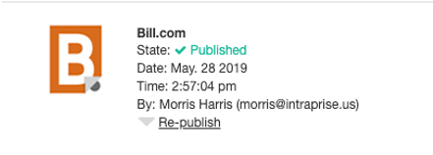
Alternatives: | - Users also have the option to click on the Publish All button (located at the top right of the DESTINATIONS section) instead of performing the Publish operation for each individual application.  - Hubdoc has an automatic publishing capability where recognized documents can be set to automatically publish to Bill.com.
Post-condition: | - Bill has been coded and published to Bill.com.

Process 4.5 AP Clerk Routes Bill for Approval
Use Case: | 2.4: AP Clerk Routes Bill for Approval
Summary: | Bill is routed to client’s Bill Approver by AP Clerk via Bill.com for final approval
Role: | AP Clerk
System/Interface: | Bill.com
Pre-condition: | - Published Bill appears in Vendors area of the PAYABLES section.  - The Bill.com Policy Admin has chosen the payment option, “Bills are routed for approval and are ready to be paid when approved.” in the Settings Payables Bill Approvals section.  - Bill approver has a Bill.com user account that has the Approve Bills/Vendor Credits permission.
Description: | - In the APPROVERS section, click on the add approvers or approval groups dropdown to see the list of available Bill Approvers.  - Select the people that you want to be included in the approval routing by checking the box to the right of their name. When you do this, they will be added to the APPROVERS list above.  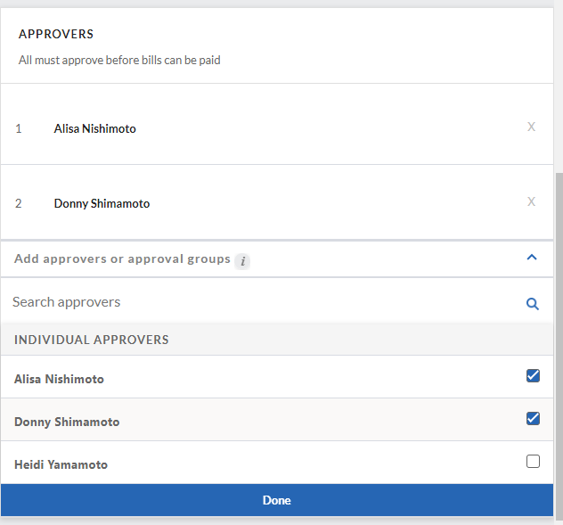  - Press the Done button to save the approvers.  - You can re-order approvers by hovering over the number to the left of their name. The number will change to a handle icon which you can then use to drag and drop the approver into the appropriate order.  - You can also remove an approver by clicking on the X to the right of their name.  - When done, press the Save button at the top of the page.  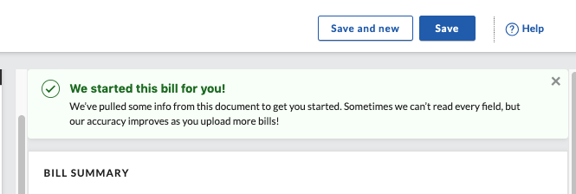  - The Bill Approver will receive a notification via email the bill is ready for approval. NOTE: Receipt of notifications by the Bill Approver are dependent upon how he/she has configured the Email Preferences in Bill.com. (Email preferences can be accessed by navigating to Settings You Email Preferences.)  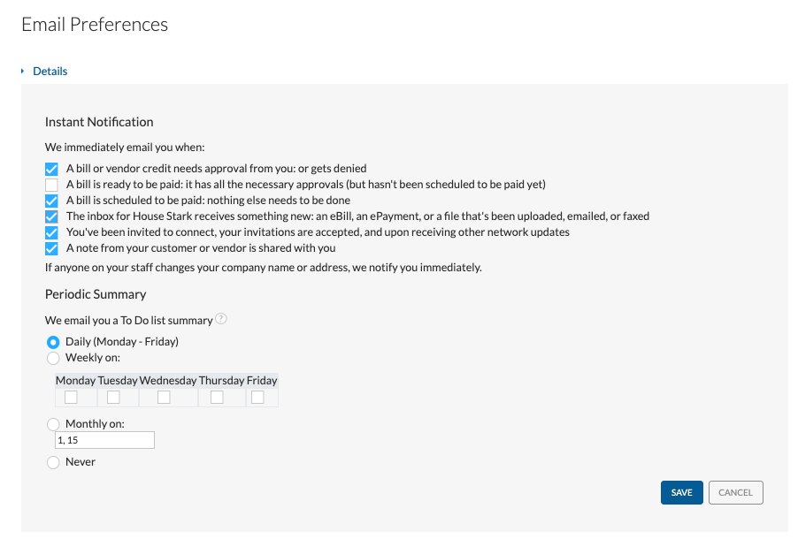
Alternatives: | N/A
Post-condition: | The information, coding, and approval routing for the bill is saved. The bill is shown in the Bills area of the PAYABLES section.

Process 4.6 Client Approves Bill
Use Case: | 4.6: Client Approves Bill.
Summary: | Bill Approver Client approves the bill for payment in Bill.com.
Role: | Client’s Bill Approver
System/Interface: | Bill.com
Pre-condition: | - AP Clerk has routed a bill to the Bill Approver for approval.  - Bill Approver has logged into the Bill.com as a user with the Approve Bills/Vendor Credits permission.
Description: | - Navigate to the Approvals section. A list of bills waiting for approval will be shown.  - Place a checkmark beside the bill(s) that are to be approved.  - Press the Approve button in the upper right corner (see image below). A notification will appear indicating the bill has been approved and it will be removed from the Approvals section.  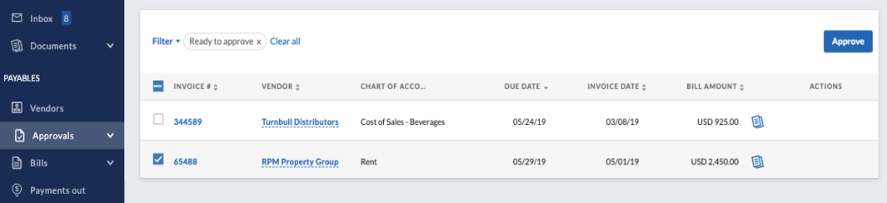
Alternatives: | - Bills can also be approved by clicking on the Invoice Number. This will open the Bill screen where the pages of the bill, bill summary, bill coding, and approvers can be seen. From this screen, press the Approve button in the upper right of the screen to approve this bill for payment.
Post-condition: | Bill is marked as approved. If there are additional approvers, it will be routed to them for approval. If this was the only or last approval then the bill is ready to be processed for payment.

Process 4.7 CD Clerk Schedules Bill for Payment
Use Cases: | 4.7: CD Clerk Schedules Bill for Payment.
Summary: | Bill is scheduled for payment by the CD Clerk.
Role: | CD Clerk
System/Interface: | Bill.com
Pre-condition: | - Bill has been approved by all approvers.  - CD Clerk logged into Bill.com and has the Pay approved bills via Bill.com permission.
Description: | - Navigate to the Overview screen. From the Bills to Pay section, open the Pay dropdown and select the Pay bills option (see below). A list of bills that have been approved for payment will be displayed.  - Locate the bill(s) to be paid and place a check in the box to the left of each bill to be paid.  - Press the Review & Pay button.  - The Pay Bills screen will be shown showing the selected Bills. Confirm or change the payment details (e.g. payment amount, process date, and pay from (bank account) and press the Next button in the right-hand corner.  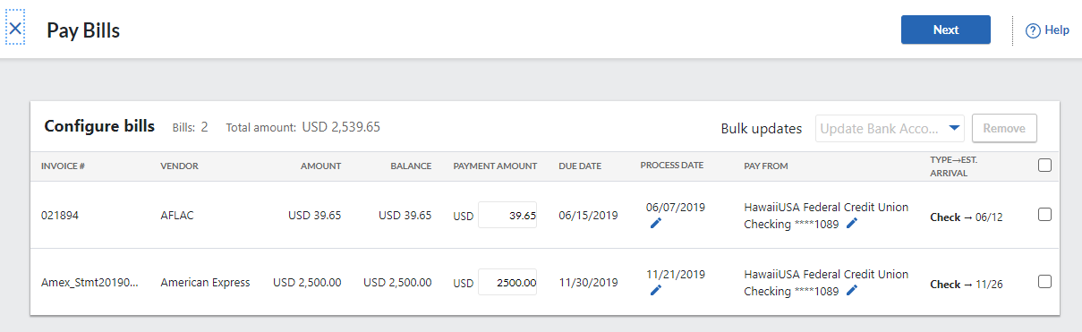  - The Review and send payments screen will be shown providing a final time to review the payments and to also add/change the email address that will receive notification of the scheduling of the payment, or add/change the memo to be shown.  - If all payments look correct, press the Submit payments button in the upper right to confirm scheduling the payments.  - NOTE: There are various ways to connect the electronic payment method: 1.) Via the Bill.com Network/Large Biller Network; 2.) Send an invitation to the vendor to open up a free Bill.com to enter their bank account and receive payment; or 3.) Enter the vendor’s bank account in the vendor profile.  - In Bill.com, once the bill has been submitted for payment, it will appear in the Payments Out section and assigned a payment confirmation number.  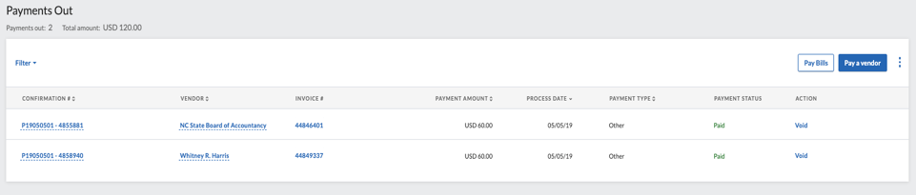  - If the client has requested notification of payments, then they will be notified via email of the payment(s) that have been scheduled.
Alternatives: | N/A
Post-condition: | - The payment for the bill is scheduled and client receives notification of scheduled payment.  - Once the payment is made, there is a resulting Funds Transfer journal entry in Bill.com that debits the clearing account and credits the bank General Ledger.

Process 4.8 CD Clerk Syncs with QBO
Use Cases: | 4.8: CD Clerk syncs with QBO.
Summary: | CD Clerk performs sync between Bill.com and QBO.
Role: | CD Clerk
System/Interface: | Bill.com and QBO
Pre-condition: | Client has approved bill for payment.
Description: | - In Bill.com, the CD Clerk will press the Sync button again to synchronize with QBO (optional). In QBO, the expense will be reflected as paid.  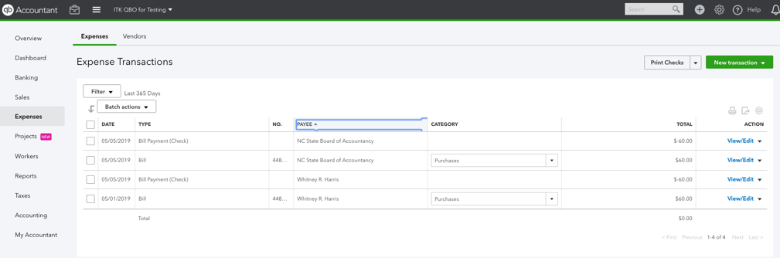
Alternatives: | Note: Bill.com automatically syncs once a day with QBO so manual sync step may not be needed unless you need QBO to be immediately updated after actions are taken (probably more important for cash disbursements since it impacts bank account balance).
Post-condition: | - Bills from Bill.com appear in Expense Transactions section of QBO.  - Payments scheduled in Bill.com will also appear in QBO in the Expense Transactions section.  - In QBO, resulting journal entry will be a debit to Expense and credit to Accounts Payable.

NOTE: For processes 4.9 and 4.10, the automatic withdrawal of funds from the bank account to submit payment to the vendor is dependent upon how the Bill.com Policy Admin has set up the payments to be distributed from the bank (whether via check, ACH payments, or ePay). Refer to Process 4.7, on how to make electronic payments.

