Hi [Customer Name],

Whether it’s IT expertise or organizing employee benefits, the trend of outsourcing processes is how business gets done. It helps us stay efficient, flexible, and able to spend time on the parts of our businesses where it matters most.

Bill.com’s 2018 Client Accounting Services (CAS) Survey shows that successful companies are leveraging CAS to grow their business. Survey respondents say that outsourcing accounting tasks help them make better business decisions and opens the door for better ROI. Here’s what else they have to say about using CAS and Bill.com:

it affords them more time to focus on their business

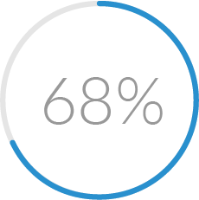

it makes accounting easier and more efficient

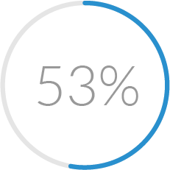

they worry less about mistakes

With our team on board, you’ll have more resources to take your business to where you want it to go. Why spend time on wrestling with your bill management? You’ve got better things to do.

or request a walk-through of the product.

I’m always available to talk if you have questions, just let me know.

[Accountant Name]

