Bill.com
Expense Reimbursement via Accounts Payable using Expensify and QuickBooks Online

Process/System Documentation

June 7, 2019^

^Modified July 29, 2019 by Bill.com

Table of Contents

1 Introduction 2
1.1 Executive Overview 2
1.2 Reference Documents 2
1.3 Glossary 2
2 Process/System Overview 3
2.1 Process Overview 3
2.1.1 Process Roles 3
2.2 Systems Overview & Descriptions 4
3 Process Documentation 4
3.1 Process 1.0: Connecting Expensify and Bill.com 4
3.1.1 Data & Document Flow Considerations 4
3.1.2 Process 1.1: Expensify Policy Admin configures integration with Bill.com 4
3.2 Process 2.0: Connect Expensify and QBO 6
3.2.1 Data & Document Flow Considerations 6
3.2.2 Process 2.1: Expensify Policy Admin configures integration with QBO 7
3.3 Process 3.0: Connecting Bill.com and QBO 9
3.3.1 Data and Document Flow Considerations 9
3.3.2 Process 3.1 Bill.com Policy Admin configures integration with QBO 10
3.4 Process 4.0: Expense report submissions via Expensify 13
3.4.1 Process Map – Process 4.0 Expense report submissions via Expensify 13
3.4.2 Process Considerations – Expense report submissions via Expensify 13
3.4.3 Internal Control Considerations - Expense report submissions via Expensify 15
3.4.4 Data & Document Flows – Expense report submissions via Expensify 15
3.4.5 Process 4.1 Employee Prepares Expense Report 15
3.4.6 Process 4.2 Manager Approves Expense Report 17
3.4.7 Process 4.3 Expensify syncs Expense Report to QBO 18
3.5 Processes 5.0: AP Automation Process via Bill.com and QBO 18
3.5.1 Process Map – Process 5.0 AP Automation with Bill.com and QBO 19
3.5.2 Process 5.1 AP Clerk Syncs between Bill.com and QBO 19
3.5.3 Process 4.4 Expensify Policy Admin syncs Expensify Document to Bill.com 20
3.5.4 Process 5.2 AP Clerk Routes Expense Reports for Approval 21
3.5.5 Process 5.3 Client Approves Expense Report 23
3.5.6 Process 5.4 CD Clerk Schedules Expense Report for Payment 23
3.5.7 Process 5.5 AP Clerk Syncs between Bill.com and QBO 25

Introduction
This document is designed to provide a detailed understanding of the sub-processes and systems involved in performance of a given process.

Executive Overview
This document summarizes the Expense Reimbursement Process utilizing an integration among the Bill.com, Expensify, and QuickBooks Online applications.

Reference Documents

The following documents were used as a reference in generating this document:
Document | Author/File Name
Expensify Docs - Submit expense reports to Bill.com or your connected accounting system | Katie Oswalt
Expensify Docs - QuickBooks Online: Connect Your Policy | Cortney Ofstad
Bill.com Support – QuickBooks Online Sync Setup Guide | N/A

Glossary
The glossary lists all acronyms, abbreviations, terminology, and industry jargon used in this document.
Acronym | Definition
QBO | Abbreviation for QuickBooks Online

Process/System Overview
This section provides an overview of the process including:
- A description of the processes involved and a high-level process map;
- A description of the roles instrumental in the process; and
- A description of the systems involved.

Process Overview
The Expense Reimbursement Process via Accounts Payable using Bill.com, Expensify, and QuickBooks Online (QBO) involves the following processes:
- Connecting Expensify with Bill.com to enable the applications to synchronize
- Connecting Expensify with QBO to enable the applications to synchronize
- Connecting Bill.com with QBO to enable the applications to synchronize
- The submission of expense reports via Expensify
- The comprehensive expense reimbursement AP automation process involving Expensify, Bill.com, and QBO

A diagram showing the flow of the processes is shown below.
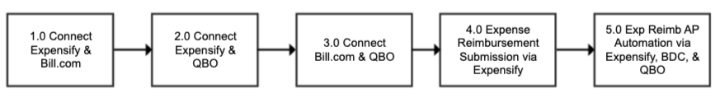
NOTE: The connections established between each application (i.e., Expensify & Bill.com, Expensify & QBO, Bill.com and QBO) are not required to be performed in sequential order as illustrated above and can be performed as parallel processes.

Process Roles
The following is an overview of key roles in this process.
Bill.com Role | Role and Organization | Responsibilities
Administrator | Expensify Policy Admin  (either) | Responsible for configuring the integration between Expensify and Bill.com and Expensify and QBO.
N/A | Employee  Client | Responsible for preparing and submitting the expense report for approval in Expensify.
Approver or Custom Role | Employee Manager/Approver  Client | Responsible for approving the expense report in Expensify and Bill.com
Clerk | Accounts Payable (AP) Clerk  Accounting Firm | Responsible for processing the expense report in Bill.com and submitting it for payment.
Payer | Cash Disbursements (CD) Clerk  Accounting Firm | Responsible for processing the payment of the expense report.

Systems Overview & Descriptions
The following applications are used in this process.
System/Application | Description
Bill.com | Bill.com is a cloud-based business payments software platform that helps automate the approval and payment processing for bills (vendor invoices).
Expensify | Expensify is a cloud-based expense management software platform that helps automate the preparation and approval of expense reports. It enables a user to prepare an expense report, attach digital copies of receipts, route the expense report for approval, and submit the approved expense report to the Bill.com Inbox to be processed for payment.
QuickBooks Online (QBO) | QuickBooks Online is a cloud-based small business accounting software platform used by record accounting transactions.

Process Documentation
The section documents the details of the process including lower level process maps.

Process 1.0: Connecting Expensify and Bill.com
For expense report documents to be submitted from Expensify to Bill.com, a connection must first be established between Expensify and Bill.com. This connection enables expense report documents to be linked to bills in Bill.com.

Note: Bills will be created in Bill.com from the QBO to Bill.com sync. Expensify will link the document to the bill in Bill.com. Documents will not be linked if the bill doesn’t exist in Bill.com.

Data & Document Flow Considerations
Consider the following when establishing the connection between Expensify and Bill.com.
- Master data: Bill.com & Expensify. Master data is not synced between Expensify and Bill.com.
- Transaction data: Bill.com & Expensify
Submit upon Final Approval. If you configure the Bill.com Connection in Expensify, Expensify will link PDFs of expense reports that complete the approval workflow to the corresponding bill in Bill.com. The report will then be put in the closed state in Expensify and the report will be marked as exported to Bill.com, shown by the icon to the right of the report.

Process 1.1: Expensify Policy Admin configures integration with Bill.com
Use Case: | 1.1: Expensify Policy Admin configures integration with Bill.com.
Summary: | The Expensify Policy Admin configures the integration between Expensify and Bill.com.
Reference: | Expensify Docs - Submit expense reports to Bill.com or your connected accounting system
Role: | Expensify Policy Admin
System/Interface: | Expensify
Pre-condition: | - User has logged into Expensify and has Policy Admin rights.  - Expensify Organizational Group Policy and settings have been established.
Description: | - Begin establishing the connection between Expensify and Bill.com by navigating to Settings Policies Group.  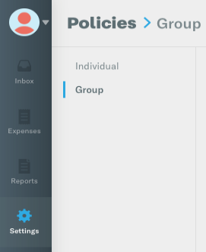  - Click on the Expensify Group policy option to be connected with Bill.com.  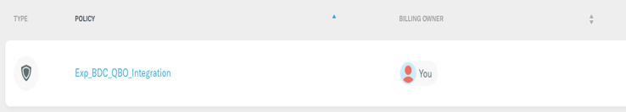  - After selecting the Expensify Group policy, click on Connections.  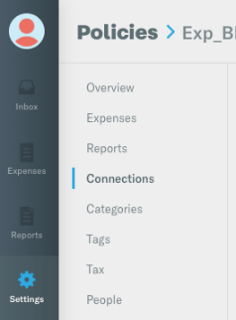  - After clicking on Connections, a space will be provided to identify the Technical Contact that should be notified in the event of any connection issues that arise. In the space provided, if the correct email address is not reflected, enter the email address for the person that should be identified as the Technical Contact.  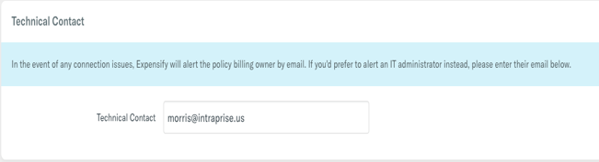  - Below the Technical Contact in the section headed Accounting Integrations, locate the Bill.com integration option and click inside the circle beside the Connect to Bill.com.  - Enter the Username and Token for the Bill.com account you want integrated with this Expensify Policy.  - Once the correct Username and Token for the Bill.com account have been entered, press the Send button.  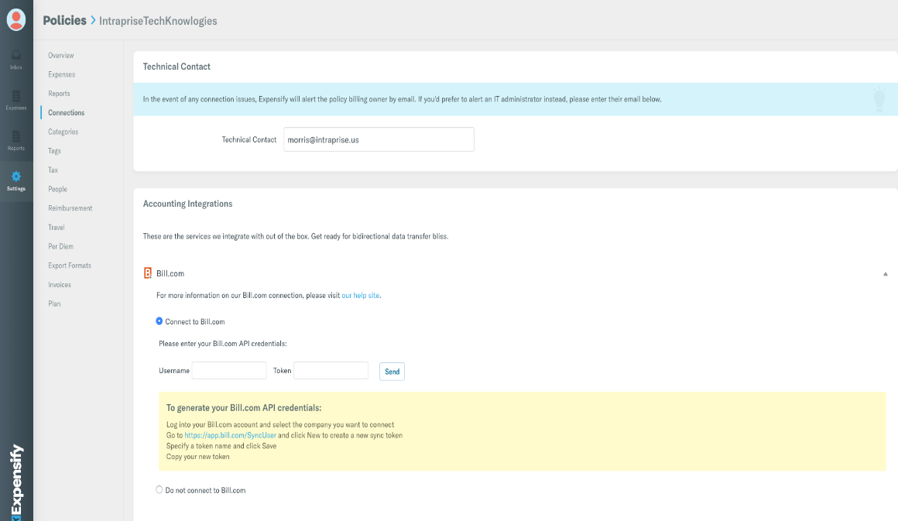  - Once signed in, you will be presented with a dropdown list of organizations in that Bill.com account. Choose the organization in Bill.com to connect with Expensify.  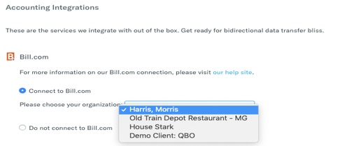  - After selecting the organization within Bill.com to establish a connection with Expensify, an onscreen confirmation will appear stating, “Connected to Bill.com as …”  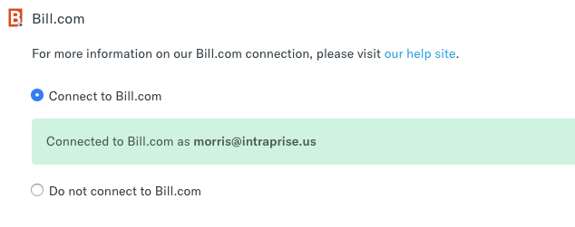
Alternatives: | Instead of configuring the Integration, final approvers in Expensify could forward the approved Expense Report to the appropriate Bill.com Inbox email address.
Post-condition: | The Expensify Policy is connected with the selected organization in Bill.com.

Process 2.0: Connect Expensify and QBO
Connecting Expensify and QBO will enable the data from expense reports approved in Expensify to be automatically recorded in QBO’s Accounts Payable module. The connection also allows the Chart of Accounts (and other applicable dimensions, e.g. Class, Location) to be synchronized from QBO to Expensify. These can then be used to support the coding of expenses in Expensify.

Data & Document Flow Considerations
Consider the following when establishing the sync between Expensify and QBO.
- Master data: Expensify & QBO. The following master lists can be synchronized between Expensify and QBO: Vendors, Chart of Accounts, Customer/Projects List, Locations, Classes, and Items. Expensify does not allow the editing of these lists in Expensify except for the Chart of Account names.
  - Chart of Accounts - Expensify allows you to override the name for a Chart of Accounts entry. This is so that you can put a “user friendly” name on the account to make it easier for users to code their expense reports.
    - If you change these names, you should keep a list of those you change because if you disconnect QBO and reconnect it, the names will revert back to the original names.
    - The Chart of Accounts is shown under the Categories section in the Expensify Policy Settings. All other master data is shown under the Tags area in the Expensify Policy Settings.
  - Note that you can turn “off” any Categories or Tags that would not be appropriate for Expense reports to reduce the list of options that users have (and reduce the risk of miscoding).
  - When configuring the Sync between Expensify and QBO, you can also select whether each master data list (Tag) is shown at the header level or line item level on the policy. Note that Bill.com does not support having Customers/Project at the line item level so if you plan to flow expense reports through Bill.com for coding review, you should not use the Customer/Project at the line item level in Expensify.

Process 2.1: Expensify Policy Admin configures integration with QBO
Use Case: | 2.1: Expensify Policy Admin configures integration with QBO.
Summary: | The Expensify Policy Admin configures the integration between Expensify and QBO.
Role: | Expensify Policy Admin
Reference: | Expensify Docs - QuickBooks Online: Connect Your Policy
System/Interface: | Expensify
Pre-condition: | - Employees have been setup in QBO as Vendors and, at minimum, include the employee email address that is used by that employee in Expensify.  - User has logged into Expensify and has Policy Admin rights.  - Expensify Organizational Group Policy and settings have been established.  - Expensify Policy Admin has already navigated to the Connections section in the Settings menu. (Refer to steps 1- 3 in Process 1.1).
Description: | - In the Accounting Integrations area of Connections section, locate the QuickBooks Online option and click inside the circle beside the Connect to QuickBooks Online option.  - After clicking inside the circle, press the Connect to QuickBooks button.  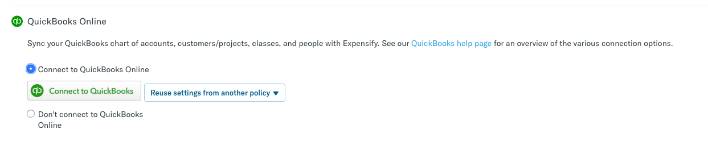  - Once the QuickBooks Sign in window appears, Enter the Email or User Id and Password for a QBO Administrator and press the Sign In button.  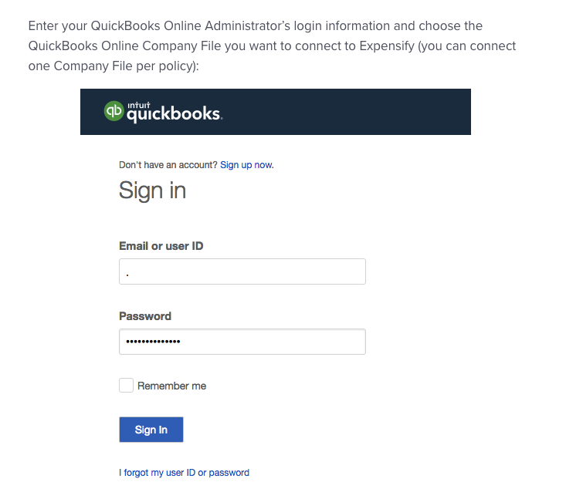  - A screen will appear with the company/firm(s) that the user is able to access. From the dropdown menu, select the Company/Firm Expensify will be connected to as well as the associated client from the Client List.  - Press the Confirm button.  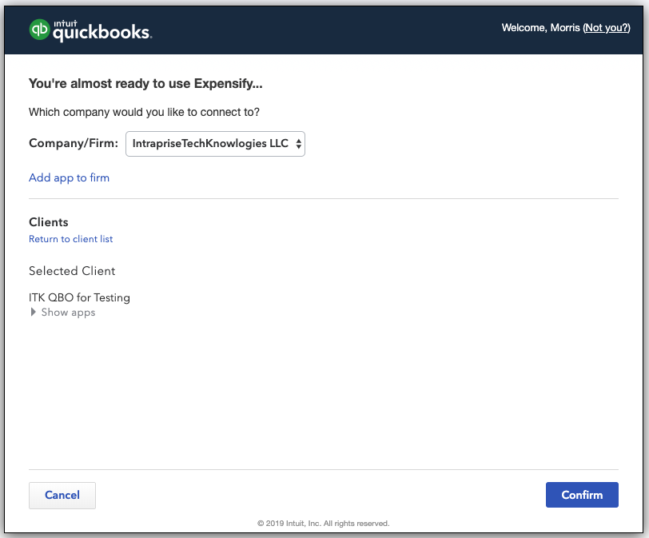  - After pressing the Confirm button, a sync between Expensify and QBO will begin.  - Upon establishing the sync connection, the QBO Sync Options screen will appear and display three tabs: Export, Coding, and Advanced. On the Export tab, select the Vendor Bill option in both the Export Reimbursable Expenses As and Export non-reimbursable expenses as sections, and identify the accounts payable account where expense report transactions should be recorded.  - Press the Save button to confirm the established Expensify and QBO sync settings.  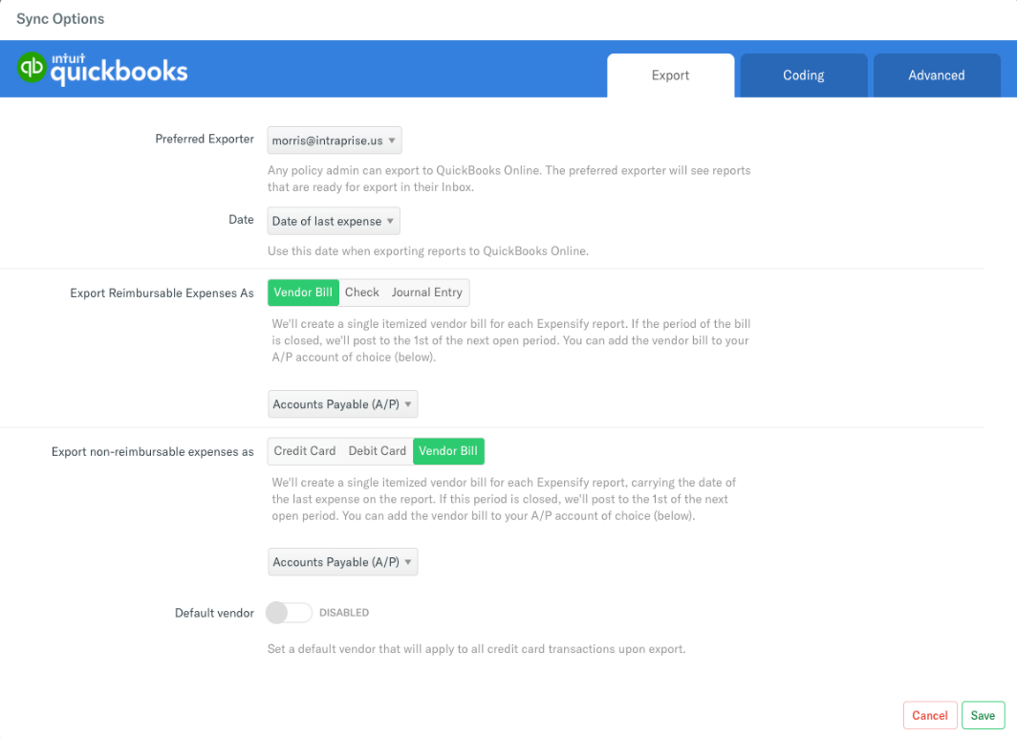
Alternatives: | - Master data could be manually entered into Expensify, but without the sync configured when changes are made to master data in QBO, then changes must also be manually made in Expensify  - Expense report transaction data could be manually input into QBO instead of being passed via the integration.
Post-condition: | - Expensify is connected with QBO.  - QBO Master Data (e.g. Chart of Accounts, Vendors, Locations, Classes, etc.) is imported into Expensify.  - On-going master data synchronization is enabled between Expensify and QBO.

Process 3.0: Connecting Bill.com and QBO
The final connection to be established is between Bill.com and QBO. This connection will enable the Bill.com account being maintained by the Accounting Firm to sync data between the two applications.

Data and Document Flow Considerations
Consider the following when setting up the sync between Bill.com and QBO.
- Master data: Bill.com & QBO. The following master lists are synchronized between Bill.com and QBO. In the Bill.com Sync Preferences for each company you can choose whether QBO or Bill.com “wins” in the event of a conflicting change.
  - Chart of Accounts - Since this will have a potential impact on financial reporting and should not be changed without strong consideration, we recommend QBO be the master for this data.
  - Vendor List - Since new vendors will often be first seen first via an incoming Bill. It may make sense to have Bill.com be the master for this data. However, this depends on whether the firm has a policy for obtaining W-9s before processing payment to vendors (to avoid the rush after the end of the year).
  - Locations - Since this will have a potential impact on financial and management reporting and should not be changed without strong consideration, we recommend QBO be the master for this data.
  - Classes - Since this will have a potential impact on management reporting and should not be changed without strong consideration, we recommend QBO be the master for this data.
- Transaction data: Bill.com & QBO. The following transaction data sets are synchronized between Bill.com and QBO. In the Bill.com Sync Preferences for each company you can choose whether QBO or Bill.com “wins” in the event of a conflicting change.
- Bills - Bills in Bill.com are synced to QBO as Bills in the QBO Expenses module. Bills entered into QBO also sync to Bill.com.
    - Note: There is an option for only sync Approved Bills to QBO. Once you turn this on in Bill.com you can’t turn it off. Bill.com says that your setting should ONLY be enabled if ALL bills will go through the Bill.com approval workflow. This setting might be helpful with a cash basis taxpayer if you can keep the time between the approval of the Bill and payment of the Bill small, as it would keep the amount shown in QBO’s Accounts Payable low while providing visibility into full potential liability in Bill.com.
- Vendor Credits - Vendor Credits in Bill.com are synced to QBO as Vendor Credits in the QBO Expenses module. Vendor Credits entered into QBO also sync to Bill.com.

Process 3.1 Bill.com Policy Admin configures integration with QBO
Use Case: | 3.1: Bill.com Policy Admin configures integration with QBO.
Summary: | The Bill.com Policy Admin configures the integration between Bill.com and QBO.
Reference: | Bill.com Docs – QuickBooks Online Sync Setup Guide
Role: | Bill.com Policy Admin
System/Interface: | Bill.com
Pre-condition: | User has logged into Bill.com and has Policy Admin rights.
Description: | - Establish the connection between Bill.com and QBO by clicking on the Sync image and then pressing the Setup button.  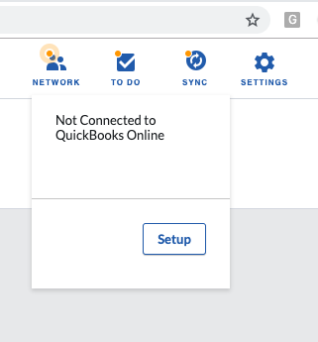  - Upon pressing the Setup button, you will be directed to the Sync with QBO page.  - Press the Connect to QuickBooks button.  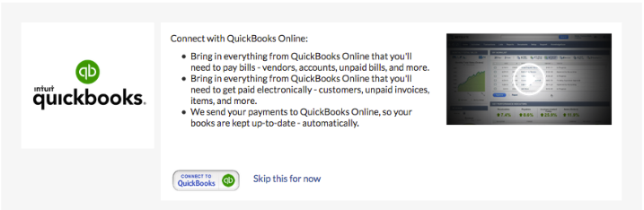  - Enter the QBO Email or user ID and Password for the QBO account that you want to sync with Bill.com.  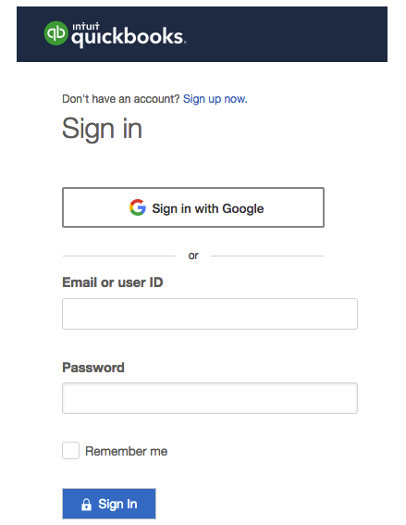  - A screen will be shown with the company/firm(s) that the user is able to access. From the dropdown menu, select the Company/Firm Bill.com will be connected to as well associated client from the Client List.  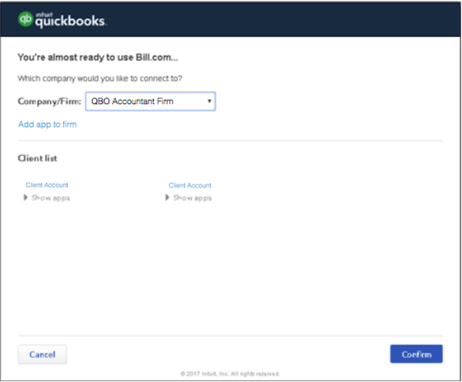  - Once these selections have been made, press the Confirm button. A screen will be shown confirming the action to be taken.  - Press the Connect button to complete the integration.  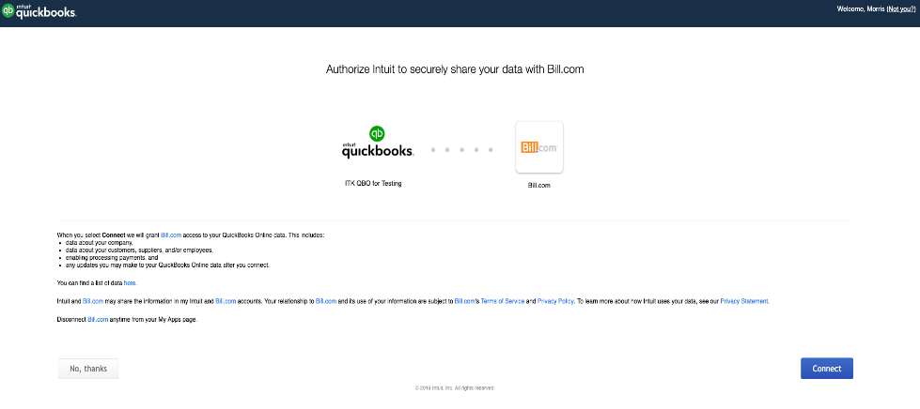  - Upon establishing the sync connection, the option is provided to identify the sync preferences to be established. Learn more about the Sync Preferences by reading the Bill.com QuickBooks Online Sync Setup Guide and the section above on Data and Document Flow Considerations.
Alternatives: | N/A
Post-condition: | - Bill.com account is connected with the selected organization in QBO.  - QBO Master Data (e.g. Chart of Accounts, Vendors, Locations, Classes, etc.) is imported into Bill.com.  - On-going master data and transactional data synchronization is enabled between Bill.com and QBO.

Process 4.0: Expense report submissions via Expensify
The expense reimbursement process begins with the employee preparing the expense report in Expensify. The employee can manually create expense reports containing an individual expense or multiple expenses, scan in or upload receipts and/or supporting documentation, as well as complete mileage expense reports. Once the expense report has been prepared, it is then reviewed by the appropriate party for approval. The authorized party provides approval of the expense report.

Process Map – Process 4.0 Expense report submissions via Expensify

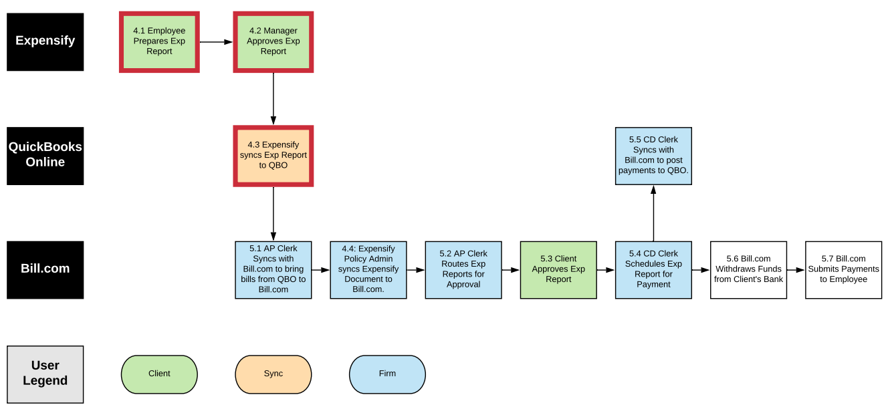
Figure 1 - Expense report submissions via Expensify (4.1 - 4.4)

Process Considerations – Expense report submissions via Expensify
Consider the following when developing your policies and procedures:
- Accounting Firm is dependent upon Expensify users submitting expense reports to have data sync to Bill.com and QBO.
  - Considering adding a procedure to End of Month Close to check Clients' Expensify accounts to determine if there are any outstanding expenses that haven’t been submitted yet.
- The workflow above assumes that the firm’s staff is not involved in the Expensify process. If the client uses the Approval Mode called “Advanced Approval” then all approved expense reports can be flowed to a staff member (e.g., AP Clerk) to code before the report is synced to Bill.com and QBO.
  - Note that this will require the use of the Expensify Control subscription ($9/active user/month) rather than the Collect subscription ($5/active user/month).
- Submission of Expense Report by Client equates to approval of recording of liability
  - This assumes that the client is using the Approval Mode called “Submit and Approve” in Expensify. If the client is using “Submit and Close” then no approval was performed in Expensify.
  - Tip: Use Expensify’s ability to rename Chart of Accounts account names to a more user-friendly name to improve users' ability to code themselves.
  - If the expense report approvals are performed in Bill.com (i.e. no approval flow in Expensify), the drawback is that if an expense report is rejected, someone must inform the Employee since they are not part of the Bill.com workflow. Employees would then have to reopen their expense reports in Expensify, make the correction, then resubmit the expense report. The QBO transaction will re-sync (no duplicate created). The AP Clerk must know to check that the sync has occurred (so that any new coding, if applicable, is showing in Bill.com), detach and delete the rejected expense report, and then attach the revised expense report and then route it for approval again.
- When Expensify is linked to Bill.com and QBO, upon final approval of an expense report, the report is synced as an accounts payable transaction to QBO. The AP Clerk must then sync between Bill.com and QBO to bring the coded transaction to Bill.com. The Expensify Policy Admin will sync the Expensify/Bill.com connection and the PDF document will be linked to the corresponding bill in Bill.com.
  - Note that as with other bills, the expense report’s coding can be changed in either QBO or Bill.com. These changes however cannot be synced back to Expensify. Because of this, we do not recommend that Expensify be considered a system of record.
  - When an expense report is published as an accounts payable entry to QBO, the email of the user that originated the expense report is used as the Vendor for the transaction. This means that all employees who submit expense reports will end up as Vendors in Bill.com too.
- Client approval of expense report in Bill.com is approval to pay.
  - Tip: Develop cash disbursements policies / protocols with clients
- The process displayed in Figure 1 shows single level of approval, but multiple levels of approvals can be captured serially via Bill.com on a bill by bill basis.
- The process displayed in Figure 1 assumes that you are not using the ACH reimbursement feature in Expensify, and instead reimbursing using Bill.com. (Note that you can still get the Employee’s bank information and pay them via ACH in Bill.com by adding their ACH info to their Bill.com vendor record.)
  - This provides more centralized control over cash disbursements and is particularly useful if money has to be transferred into the account from which disbursements will be funded.
  - Expensify processes each expense report reimbursement as individual ACH transactions. Versus when multiple expense reports are reimbursed via Bill.com, Bill.com will process all reimbursements processed for the same pay date as one ACH transaction.
    - Depending on the volume of expense reimbursements, the multiple ACH transactions generated by Expensify can make the bank reconciliation a challenge.
    - If your bank charges per transaction fees for ACH, then reimbursing via Expensify may increase the service charges you pay to your bank if there are a lot of expense reimbursements.
    - Expensify also processes ACH reimbursements with different timings (one to five days) depending on the dollar amounts of the transaction, which can make it difficult to inform employees exactly when they will receive their reimbursements. Versus Bill.com provides you with a predicable date that they will receive their reimbursements (whether by check or ACH).
      - Learn more about Expensify’s reimbursement timing by reading Expensify’s Answers [to] common questions regarding the timing of ACH reimbursements found on Expensify’s website.

Internal Control Considerations - Expense report submissions via Expensify
Consider the following related to internal controls when developing your policies and procedures:
- Remember to consider separation of duties related to:
  - Approval of expense report versus coding of expense reports and scheduling of reimbursements. Especially when the same staff person is coding expense reports and scheduling reimbursements, be sure that the same staff does not have the ability to approve expense reports. Otherwise that staff person could move a factitious expense report through to reimbursement without anyone else having touched the transaction.
  - Creation of new employees or changes to employee information (especially payment address and/or bank routing numbers) versus input of expense reports and scheduling of reimbursements. This is to ensure that a single person on your staff cannot create a factitious employee, assign real expense reports to that employee and have payments directed to themselves.
  - Changes to employee information (especially email, payment address and/or bank routing numbers). This is to prevent a staff member from changing the email and payment information for a real employee, to intercept the email notification that a payment was processed and the actual payment itself. Be sure that the person processing the expense reimbursements is also not the same person that employee would complain to if they didn’t receive their reimbursements.
  - Scheduling of reimbursements versus performing bank reconciliations. This is a standard internal control protocol.

Data & Document Flows – Expense report submissions via Expensify
Consider the following when setting up the sync among Expensify, Bill.com, and QBO:
- Documents (images). Copies of the documents uploaded to the expense report will be available in QBO and Bill.com when viewing the bill.

Process 4.1 Employee Prepares Expense Report
Use Case: | 4.1: Employee Prepares Expense Report
Summary: | Expense report is prepared and submitted by client employee via Expensify
Role: | Client’s Employee
System/Interface: | Expensify
Pre-condition: | - The Expensify Policy is connected with the selected organization in Bill.com.  - Expensify is connected with QBO.  - QBO Master Data (e.g. Chart of Accounts, Vendors, Locations, Classes, etc.) is imported into Expensify.  - On-going master data synchronization is enabled between Expensify and QBO.
Description: | - In the Expenses section of Expensify, press the New Expense button in the upper right corner of the screen.  - After pressing the New Expense button, a listing of Expense options will appear in a drop-down menu. Select one of the options listed in the drop-down menu to begin developing the expense report.  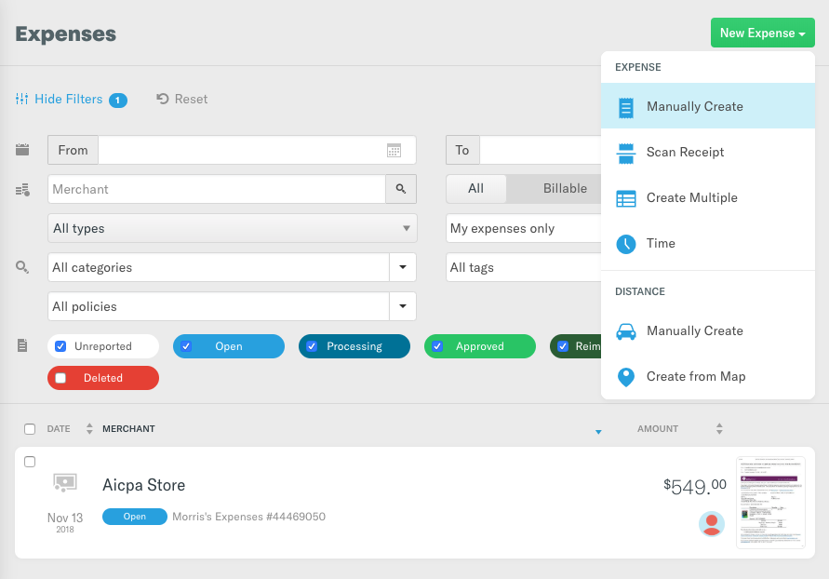  - Prepare the expense report by completing all of the required fields indicated by an asterisk (*).  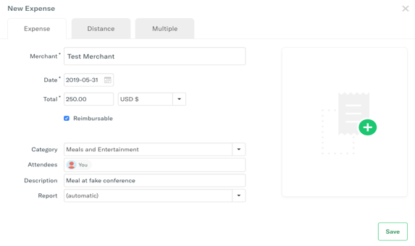  - Scan or upload any supporting receipts for each expense.  - Once the expense report form has been completed, press the Save button.  - After the expense report has been completed and saved, open the expense report by clicking on the name of the expense report displayed in the list of Expenses.  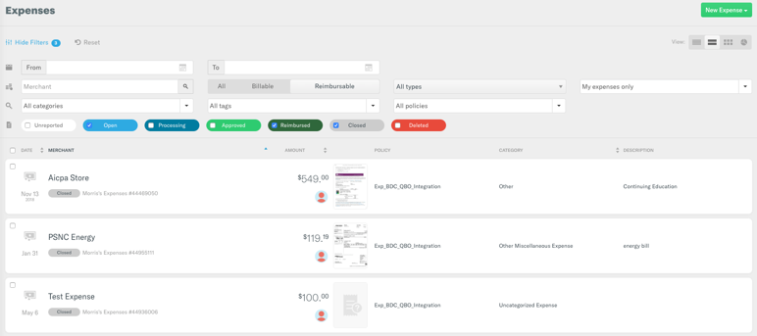  - After opening the applicable expense report, if the report is ready to be submitted for approval, press the Submit button in the top left corner.  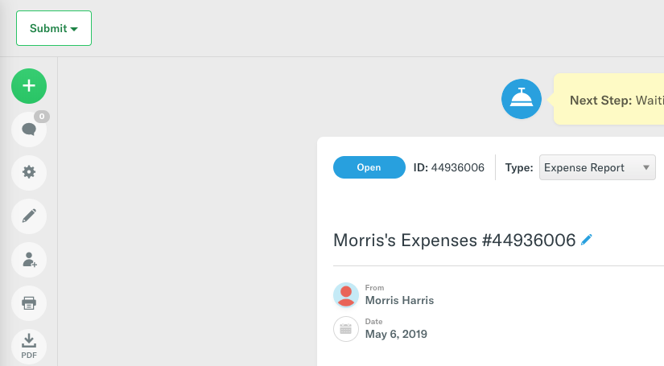
Alternatives: | N/A
Post-condition: | - Expense report(s) has been submitted by client’s employee to authorized approver for approval in Expensify.  - Authorized approver will receive an email notification expense report is awaiting his/her approval.

Process 4.2 Manager Approves Expense Report
Use Case: | 4.2: Manager Approves Expense Report
Summary: | Client’s Authorized Expense Report Approver reviews and approves the expense report.
Role: | Client’s Authorized Expense Report Approver
System/Interface: | Expensify and Email Server
Pre-condition: | Employee has prepared the expense report and submitted it for approval.
Description: | - Expense Report Approver obtains notification via email that an expense report is awaiting his/her approval.  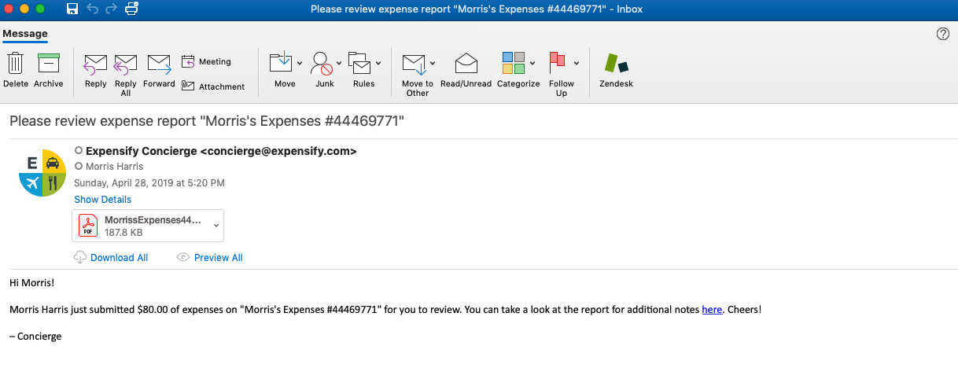  - The approver has the option of either clicking on the link included in the email or logging into Expensify to view the expense report in the Reports section.  - In Expensify, click on the expense report(s) requiring approval.  - Once the expense report has been opened, there are three options provided at the top of the page: Review, Approve, or Reject. To approve the expense report, the press the Approve button.  - Click on Final Approve.  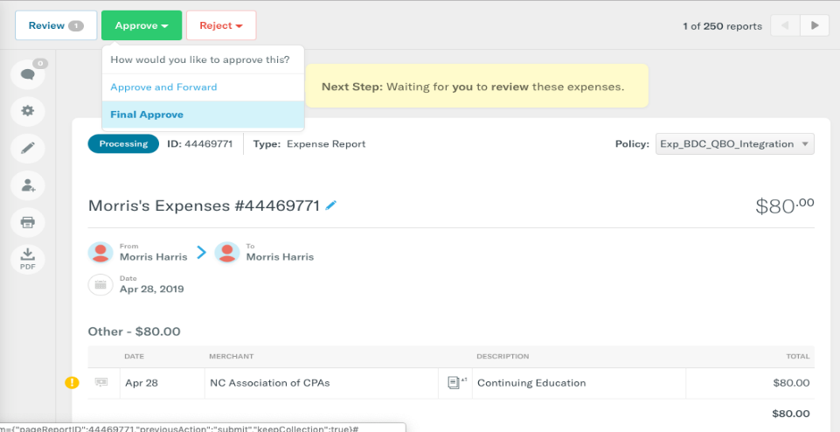  Confirmation of approval will appear on screen to state, “Finished! No further action required!”
Alternatives: | - Approve and Forward is an option used to provide preliminary approval of the expense report and forward onto a secondary approver.
Post-condition(s): | - Expense report is marked as final approved

Process 4.3 Expensify syncs Expense Report to QBO
Use Case: | 4.3: Expensify Syncs Expense Report to QBO
Summary: | Expensify performs synchronization of expense report data to QBO.
Role: | N/A
System/Interface: | Expensify
Pre-condition: | - Expensify is connected with QBO.  - Employees have been setup in QBO as Vendors and, at minimum, include the employee email address that is used by that employee in Expensify.  - On-going master data synchronization is enabled between Expensify and QBO.  - Expense Report has been final approved.
Description: | - Expensify completes the sync with QBO.
Alternatives: | N/A
Post-condition: | - Employee expense report appears as an unpaid bill in the Expenses Vendors section of QBO.

Processes 5.0: AP Automation Process via Bill.com and QBO
The AP Clerk has the option of performing a QBO synchronization to get the data immediately into Bill.com or waiting for the daily sync to be performed. The sync operation will cause the expense report to appear as an unpaid expense in Bill.com. The AP Clerk then routes the expense report to a person(s) at the client with expense report payment approval authority (“Expense Report Approver”). Bill.com sends a notification via email to the Expense Report Approver that the expense report is awaiting approval (Note: frequency of notification depends on the user’s notification settings).

Once an expense report is approved, the CD Clerk is notified, and can schedule the expense report for payment (Note: frequency of notification depends on the user’s notification settings). The CD Clerk can then perform a sync of Bill.com with QBO to record the payment in QBO. At the specified pay date, Bill.com withdraws the funds from the client’s bank account and places it in a clearing bank account controlled by Bill.com. Bill.com then sends the payment to the employee from the clearing bank account based on the proscribed payment method (e.g. check or ACH). Once the payment is made, there is a resulting Funds Transfer journal entry in Bill.com that debits the clearing account and credits the bank General Ledger.

Process Map – Process 5.0 AP Automation with Bill.com and QBO

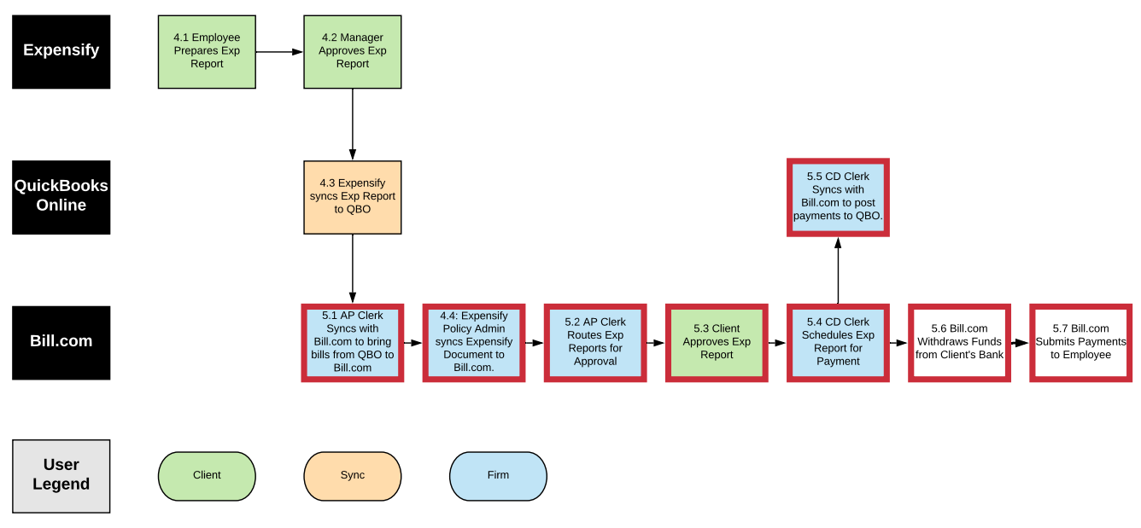
Figure 2 - Process 5.0: AP Automation with Bill.com and QBO (5.1 – 5.7)

Process 5.1 AP Clerk Syncs between Bill.com and QBO
Use Case: | 5.1: AP Clerk Syncs between Bill.com and QBO
Summary: | The User (could be AP Clerk or CD Clerk) forces a synchronization between Bill.com and QBO to bring the bills to Bill.com.
Role: | AP Clerk or CD Clerk
System/Interface: | Bill.com
Pre-condition: | Bill.com and QBO integration has been completed (see Process 3.3 above).
Description: | - Click on the Sync icon in the top right corner, which will display the sync popup windows.  - Press the Sync Now button.  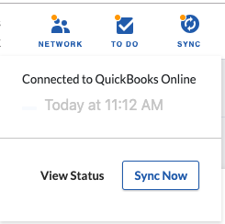
Alternatives: | Note: Bill.com automatically syncs once a day with QBO so the manual sync step may be unnecessary unless you need QBO to be immediately updated after actions are taken (likely more important for cash disbursements since it impacts bank account balance).
Post-condition: | - Bills from Bill.com appear in Expense Transactions section of QBO.  - In QBO, resulting journal entry will be a debit to Expense and credit to Accounts Payable.

Process 4.4 Expensify Policy Admin syncs Expensify Document to Bill.com
Use Case: | 4.4: Expensify Policy Admin syncs Expensify Document to Bill.com.
Summary: | Expensify Policy Admin forces a synchronization between Expensify and Bill.com. Expensify links the Document to the corresponding bill in Bill.com.
Role: | AP Clerk
System/Interface: | Expensify
Pre-condition: | - Expense Report has been final approved.  - The sync between QBO and Bill.com needs to be complete.  - Bill.com connection in Expensify has been configured whereby Final Approve of expense reports automatically links the PDF document to the corresponding bill in Bill.com.
Description: | - Expensify syncs and links a PDF copy of the document to the corresponding bill in Bill.com.  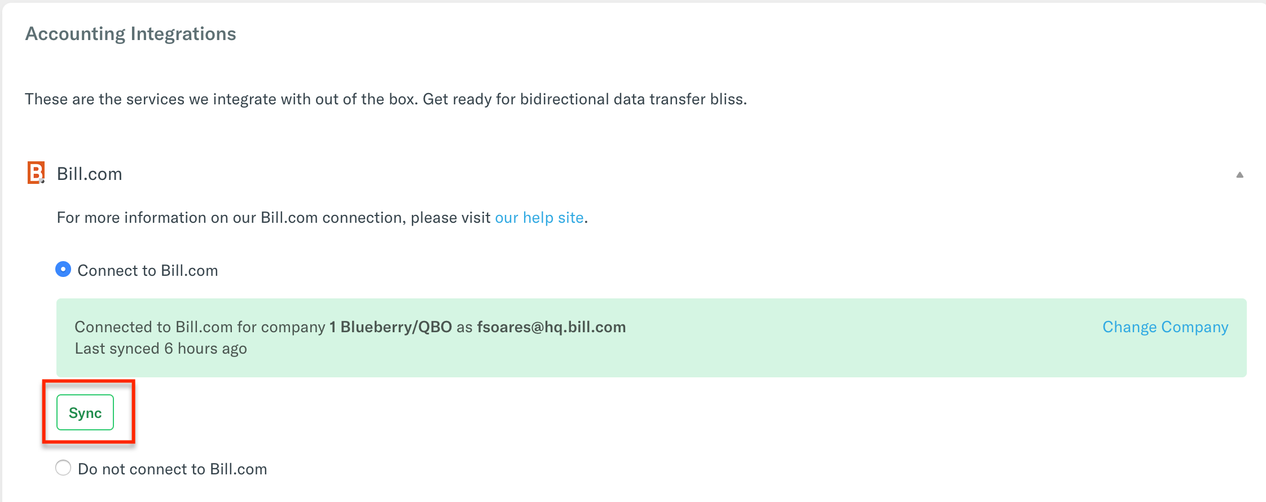
Alternatives:
Post-condition: | The expense report PDF is linked to the corresponding bill in Bill.com.

Process 5.2 AP Clerk Routes Expense Reports for Approval
Use Case: | 5.2: AP Clerk Routes Expense Reports for Approval
Summary: | AP Clerk specifies who the bill should be routed to for approval for pay.
Role: | AP Clerk
System/Interface: | Bill.com
Pre-condition: | - AP Clerk has identified the Expense Report approver.
Description: | - Verify the accuracy of the expense report account coding (i.e., coding in the BILL SUMMARY and EXPENSE DETAILS are accurate).  - In the APPROVERS section, click on the add approvers or approval groups dropdown to see the list of available Bill Approvers.  - Select the people that you want to be included in the approval routing by checking the box to the right of their name. When you do this, they will be added to the APPROVERS list above.  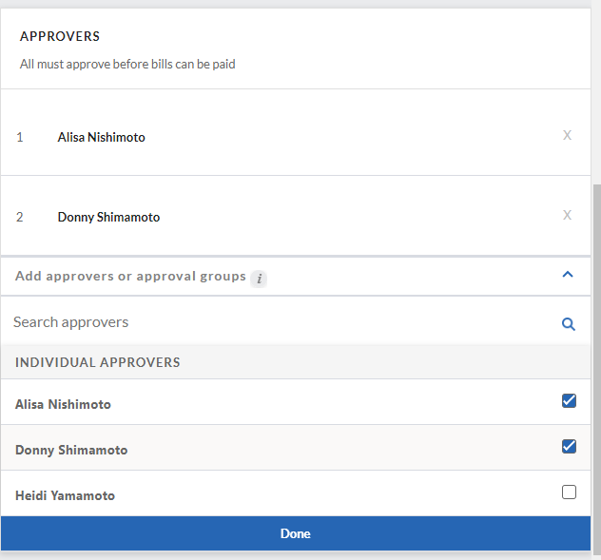  - Press the Done button to save the approvers.  - You can re-order approvers by hovering over the number to the left of their name. The number will change to a handle icon which you can then use to drag and drop the approver into the appropriate order.  - You can also remove an approver by clicking on the X to the right of their name.  - When done, press the Save button at the top of the page.  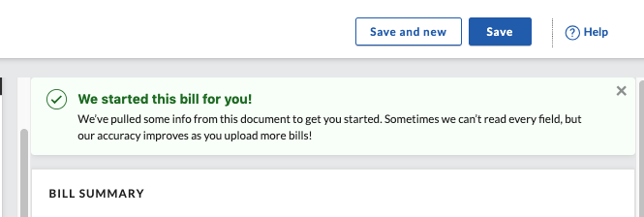  - The Bill Approver will receive a notification via email the bill is ready for approval. NOTE: Receipt of notifications by the Bill Approver are dependent upon how he/she has configured the Email Preferences in Bill.com. (Email preferences can be accessed by navigating to Settings You Email Preferences.)  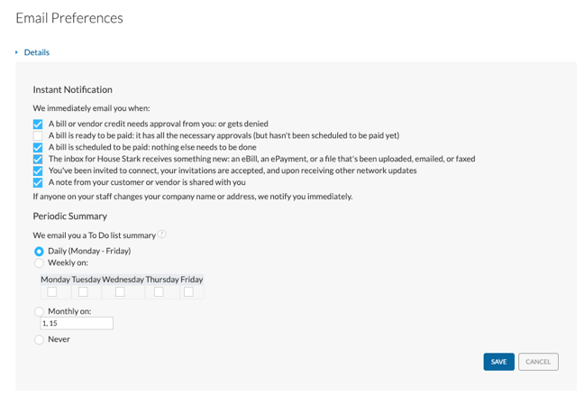
Alternatives: | N/A
Post-condition: | The information, coding, and approval routing for the bill is saved. The bills shown in the Bills area of the PAYABLES section.

Process 5.3 Client Approves Expense Report
Use Case: | 5.3: Client Approves Expense Report
Summary: | Client’s Expense Report Approver approves expense report in Bill.com
Role: | Client
System/Interface: | Bill.com
Pre-condition: | - AP Clerk has routed a bill to the Bill Approval for approval.  - Expense Report Approver has logged into the Bill.com as a user with the Approve Bills/Vendor Credits permission.
Description: | - Navigate to the Approvals section. A list of bills waiting for approval will be shown.  - Place a checkmark beside the expense report(s) that are to be approved.  - Press the Approve button in the upper right corner (see image below). A notification will appear indicating the expense report has been approved and it will be removed from the Approvals section.  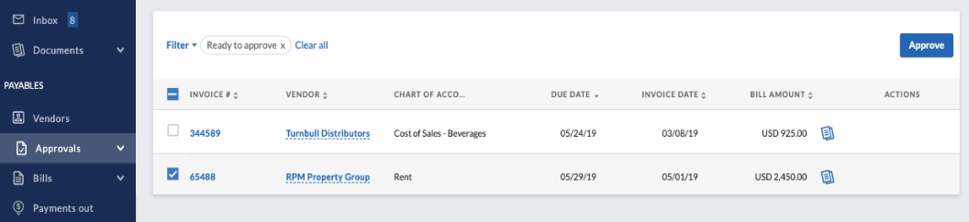
Alternatives: | NOTE: Client approval of expense report in Bill.com is approval to pay.  (Tip: Develop cash disbursements policies / protocols with clients.)
Post-condition: | Expense report is ready to be processed by the CD Clerk for payment.

Process 5.4 CD Clerk Schedules Expense Report for Payment
Use Cases: | 5.4: CD Clerk Schedules Expense Report for Payment.
Summary: | Expense report is scheduled for payment by the CD Clerk.
Role: | CD Clerk
System/Interface: | Bill.com
Pre-condition: | - Expense report has been approved by all approvers.  - CD Clerk logged into Bill.com and has the Pay approved bills via Bill.com permission.  - CD Clerk has the ability to make payments (via the Administrator or Payer role) AND needs to be bank authorized to pay bills via Bill.com.
Description: | - Navigate to the Overview screen. From the Bills to Pay section, open the Pay dropdown and select the Pay bills option (see below). A list of expense reports that have been approved for payment will be displayed.  - Locate the expense report(s) to be paid and place a check in the box to the left of each bill to be paid.  - Press the Review & Pay button.  - The Pay Bills screen will be shown showing the selected Bills. Confirm or change the payment details (e.g. payment amount, process date, and pay from (bank account) and press the Next button in the right-hand corner.  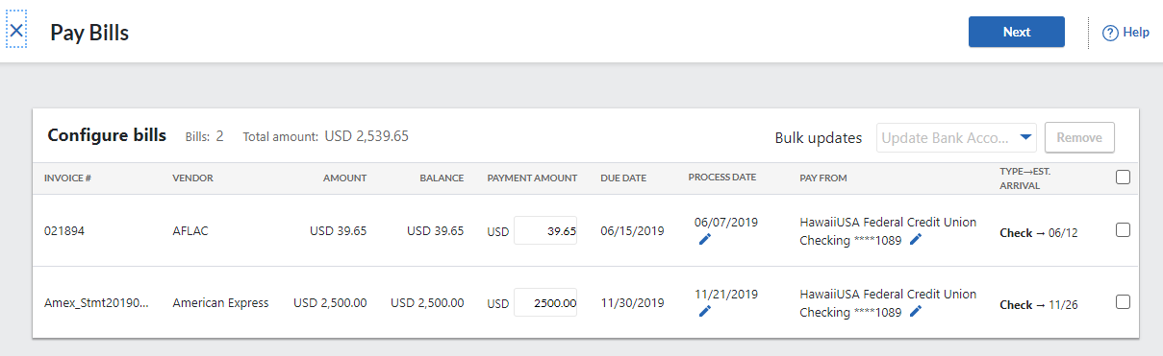  - The Review and send payments screen will be shown providing a final time to review the payments and to also add/change the email address that will receive notification of the scheduling of the payment or add/change the memo to be shown.  - If all payments look correct, press the Submit payments button in the upper right to confirm scheduling the payments.  - NOTE: There are various ways to connect the electronic payment method: 1.) Via the Bill.com Network/Large Biller Network; 2.) Send an invitation to the vendor to open up a free Bill.com to enter their bank account and receive payment; or 3.) Enter the vendor’s bank account in the vendor profile.  - In Bill.com, once the bill has been submitted for payment, it will appear in the Payments Out section and assigned a payment confirmation number.  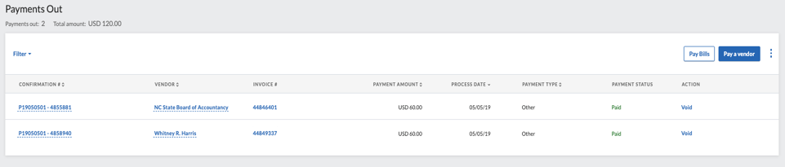  - If the client has requested notification of payments, then they will be notified via email of the payment(s) that have been scheduled.
Alternatives: | N/A
Post-condition: | The payment for the expense report is scheduled.

Process 5.5 AP Clerk Syncs between Bill.com and QBO
Use Case: | 5.5: AP Clerk Syncs between Bill.com and QBO.
Summary: | The User (could be AP Clerk or CD Clerk) forces a synchronization between Bill.com and QBO to push payments to QBO.
Role: | AP Clerk or CD Clerk
System/Interface: | Bill.com
Pre-condition: | Bill.com and QBO integration has been completed (see Process 3.3 above).
Description: | - Click on the Sync icon in the top right corner, which will display the sync popup windows.  - Press the Sync Now button.
Alternatives: | Note: Bill.com automatically syncs once a day with QBO so the manual sync step may be unnecessary unless you need QBO to be immediately updated after actions are taken (likely more important for cash disbursements since it impacts bank account balance).
Post-condition: | - Payments scheduled in Bill.com will appear in QBO in the Expense Transactions section.  - In QBO, resulting journal entry will be a debit to Accounts Payable and credit to Bill.com Money Out Clearing.

NOTE: For processes 5.6 and 5.7, the automatic withdrawal of funds from the bank account to submit payment to the employee is dependent upon how the Bill.com Policy Admin has set up the payments to be distributed from the bank (whether via check or ACH payments). Refer to Process 5.4 on how to make electronic payments.

