Bill.com Setup Reference Guide Part 4: Using Accounts Receivable
Bill.com Accounts Receivable 2
Customizing the Receivables Experience 3
Logo, Branded Website Address, and Network Profile 3
Create an Invoice Template 4
Creating and Sending Invoices 5
Invoice Reminders 6
Recurring Invoices 7
Getting Paid with Bill.com 8
Payment Options 8
The Customer Portal 9
Charging a Customer 10
Recording Payments Received Outside of Bill.com 11
Auto Charge 12
Reporting 13
The Bill.com Mobile App – Managing Receivables 14
Contacting Support for Receivables Help 15

Bill.com Accounts Receivable
With Bill.com AR you can:
- Create, send, and manage invoices
- Collaborate with your team and customers
- Receive payments electronically, and set up auto-charge
- Sync both invoice and payment activity with the most popular accounting software systems
Invoices are organized by customer so you can view outstanding invoices and a complete payment history.

Customizing the Receivables Experience

Logo, Branded Website Address, and Network Profile

Your logo will be included on your company's Network profile, emails to your vendors and customers, invoices you send to customers, and the website where customers pay you.
- Adding a Logo

On the bottom of invoices sent through Bill.com, there will be a URL that points customers
to where they can pay you.
- Branded Website Address

Your Network Profile is how you are represented in the Bill.com Network. Here is where you can display your business contact information, logo, and more. You can also control your profile visibility, allowing or limiting others to search for your business.
- Network Profile Visibility Settings

Create an Invoice Template
You can create a custom invoice template that renames fields, removes unnecessary information, and updates the appearance of invoices you send to your customers.
- Creating a new invoice template

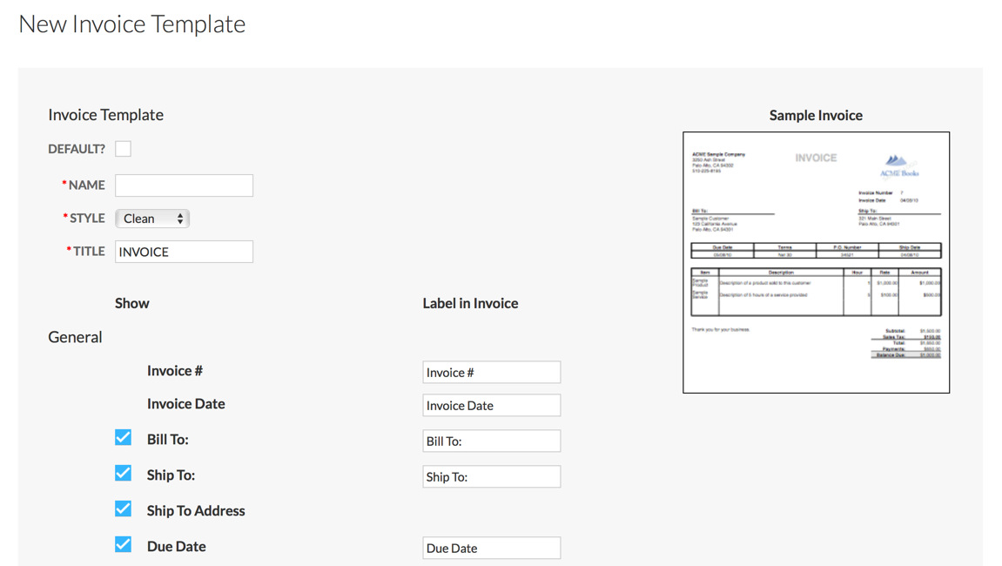

Creating and Sending Invoices
During the first sync with your accounting software, Bill.com will pull in your existing customers, items, and other classifications you may use when creating invoices. You can then email or send your invoices via US mail at the time of creation, or at a later date.

Invoices emailed through Bill.com will include your branded website address so the customer knows where to submit payment to you. The email they receive will also include a “Pay Online Electronically” button that points them to the branded website.

- Enter invoice and email to customer
- Enter invoice without sending
- Email, mail or print an invoice

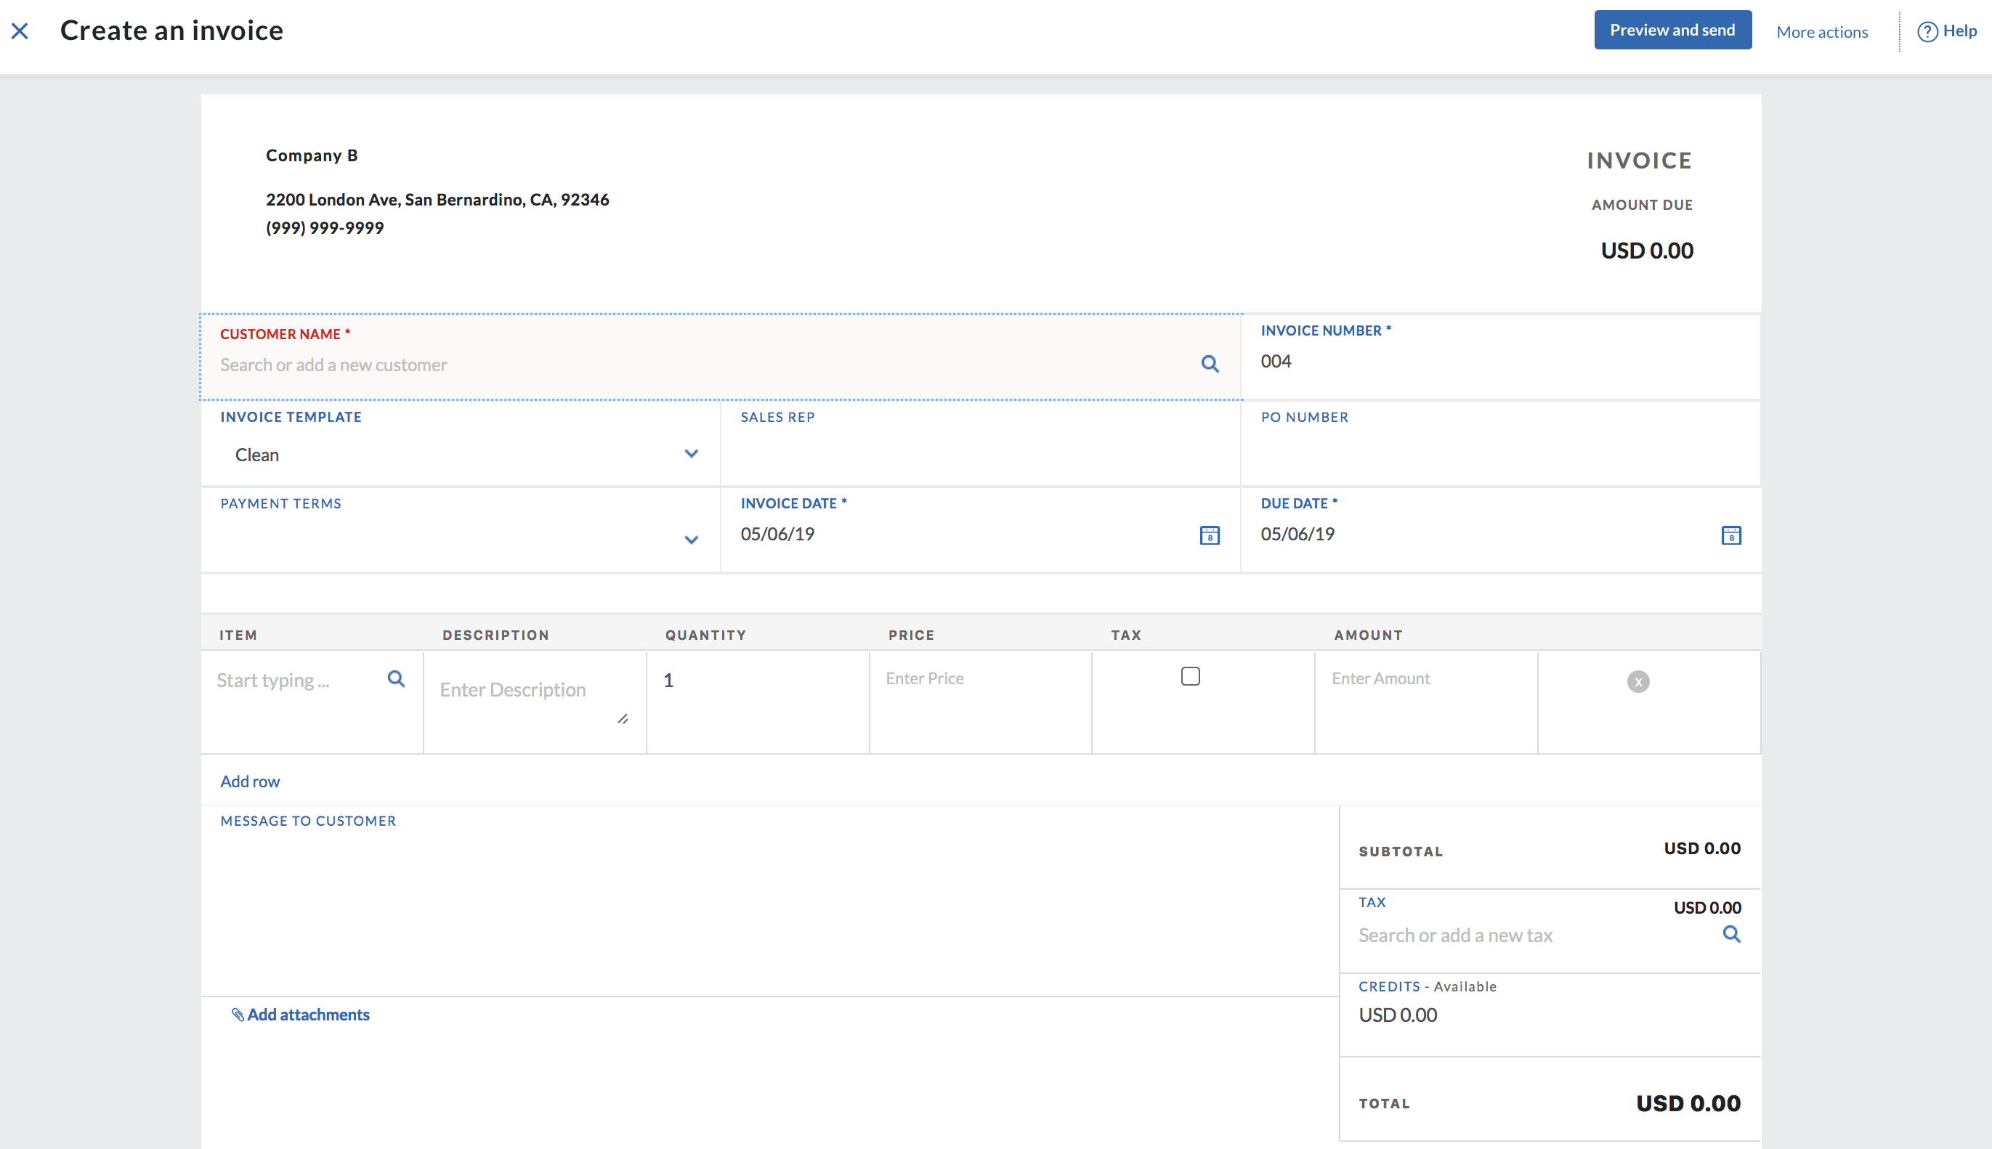

Invoice Reminders
Establish auto reminders, or send a manual reminder, to let customers or clients know when an invoice is either past due or is coming up as due.
- Reminders for Invoices

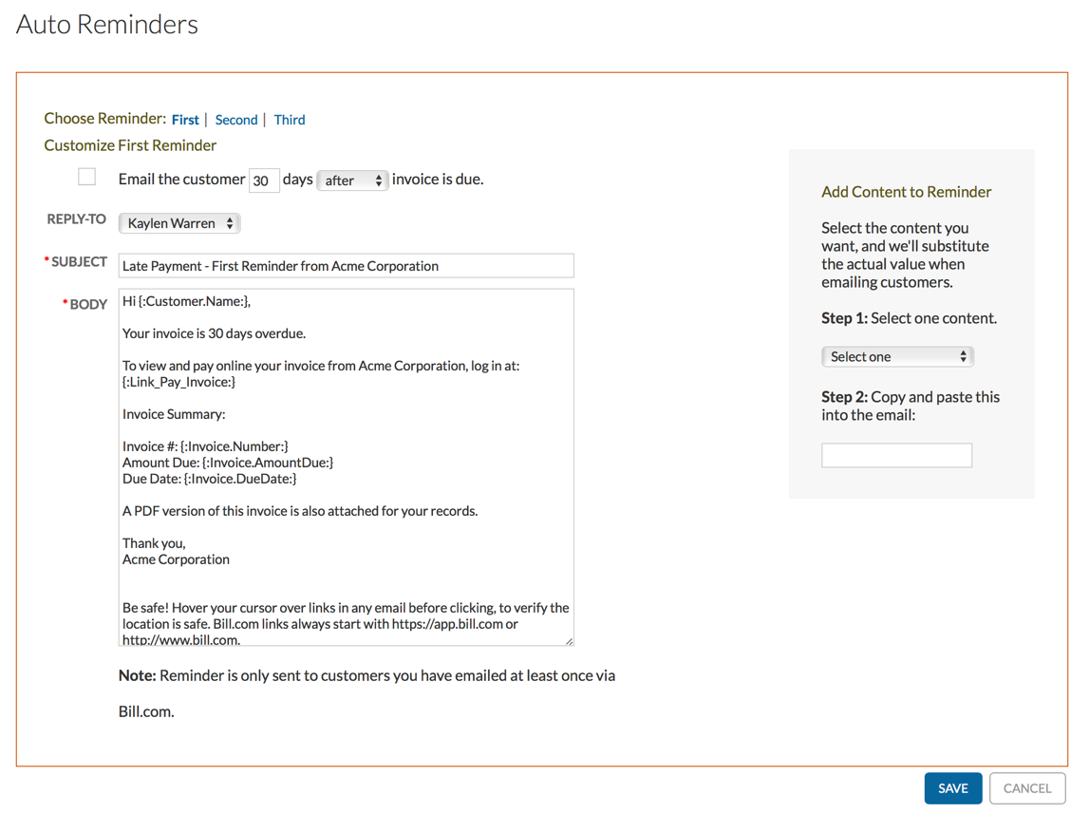

Recurring Invoices
Recurring invoices allow you to automate the creation of invoices that occur regularly and are always the same amount.
- Recurring Invoices

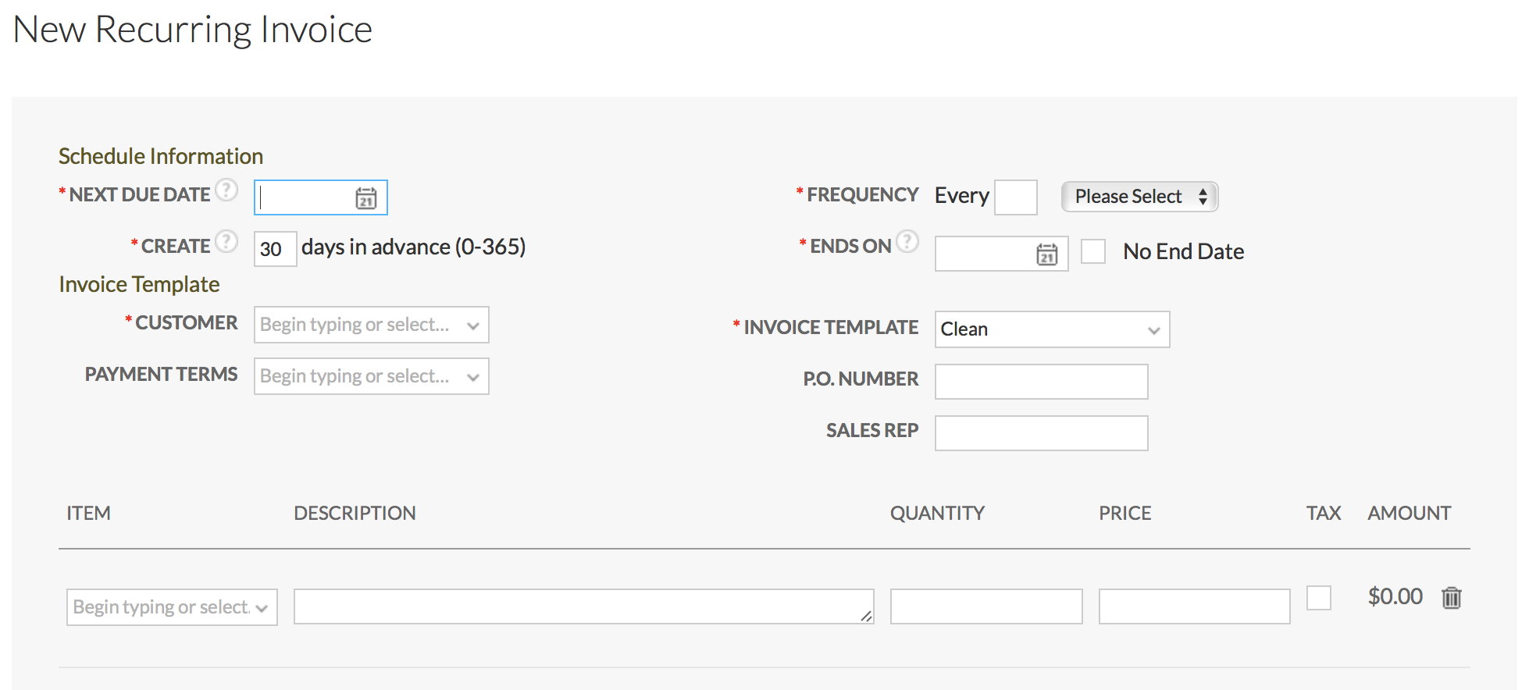

Getting Paid with Bill.com

Payment Options
There are three methods available for receiving payments in Bill.com:
- ePayment: $0.49 per ePayment received
- PayPal: standard PayPal rates apply
- Credit Card: Vantage credit card processing fees apply
For payments received via PayPal and credit card, you can choose to add a convenience fee
To enable a payment method, take the following steps:
- Click Settings
- Under Receivables, click Online Payments
- Click Setup to the right of the desired payment method
- Follow the setup prompts and provide any required information

- Accepting ePayments
- Accepting credit card payments through Vantage
- Bill.com Receivables payments via PayPal

The Customer Portal
When an invoice is sent through Bill.com, it will include a link to your branded Bill.com website, also known as the Customer Portal. The Customer Portal allows customers to view and pay their invoices.
Customers will be able to choose from the payment methods you’ve enabled, and payments made through the Customer Portal will automatically be applied to the invoices on your end.
If desired, customers can also enable Auto Charge from within the Portal (see page 12).

- Receivables via the Customer Portal
- Portal accounts: what the customer sees

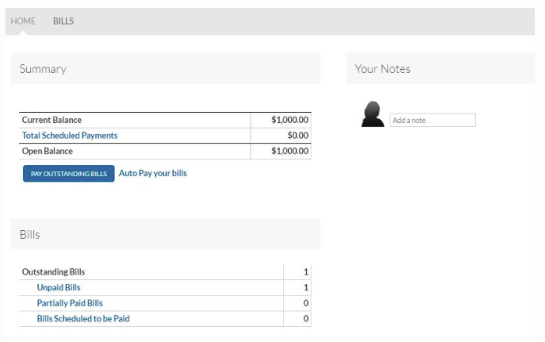

Charging a Customer
You can also charge a customer directly from your end if there is a payment method setup for them.

- Getting signed authorization from customers
- Updating a customer's credit card information through Vantage
- Adding a customer's bank account
- Charging a customer

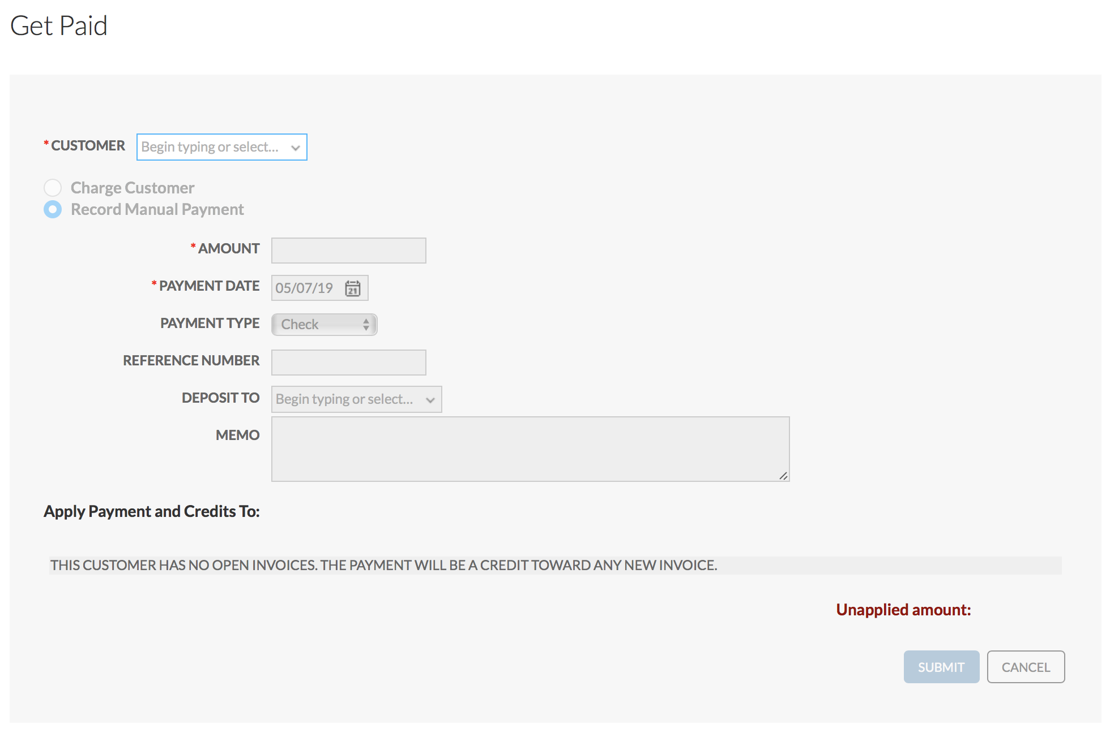

Recording Payments Received Outside of Bill.com
If you receive a customer payment outside of Bill.com, you can still record the payment information in Bill.com

- Record a manual payment on an invoice

Auto Charge
Auto Charge allows you to automatically charge customers for their open invoices. Tip: Set up recurring invoices to be automatically created by the system then Auto Charge can take care of the rest!

- Auto Charge for Customers

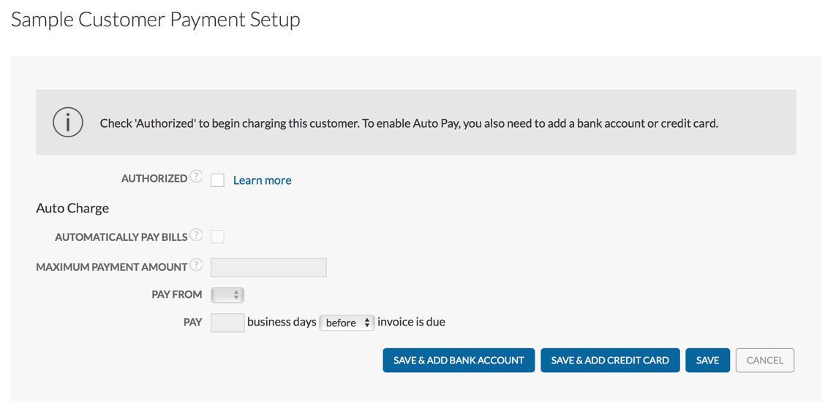

Reporting
Bill.com offers several reports to assist with managing your Receivables
For more complex reporting needs, you’ll use your accounting software
as it allows for greater customization

- Reports Overview

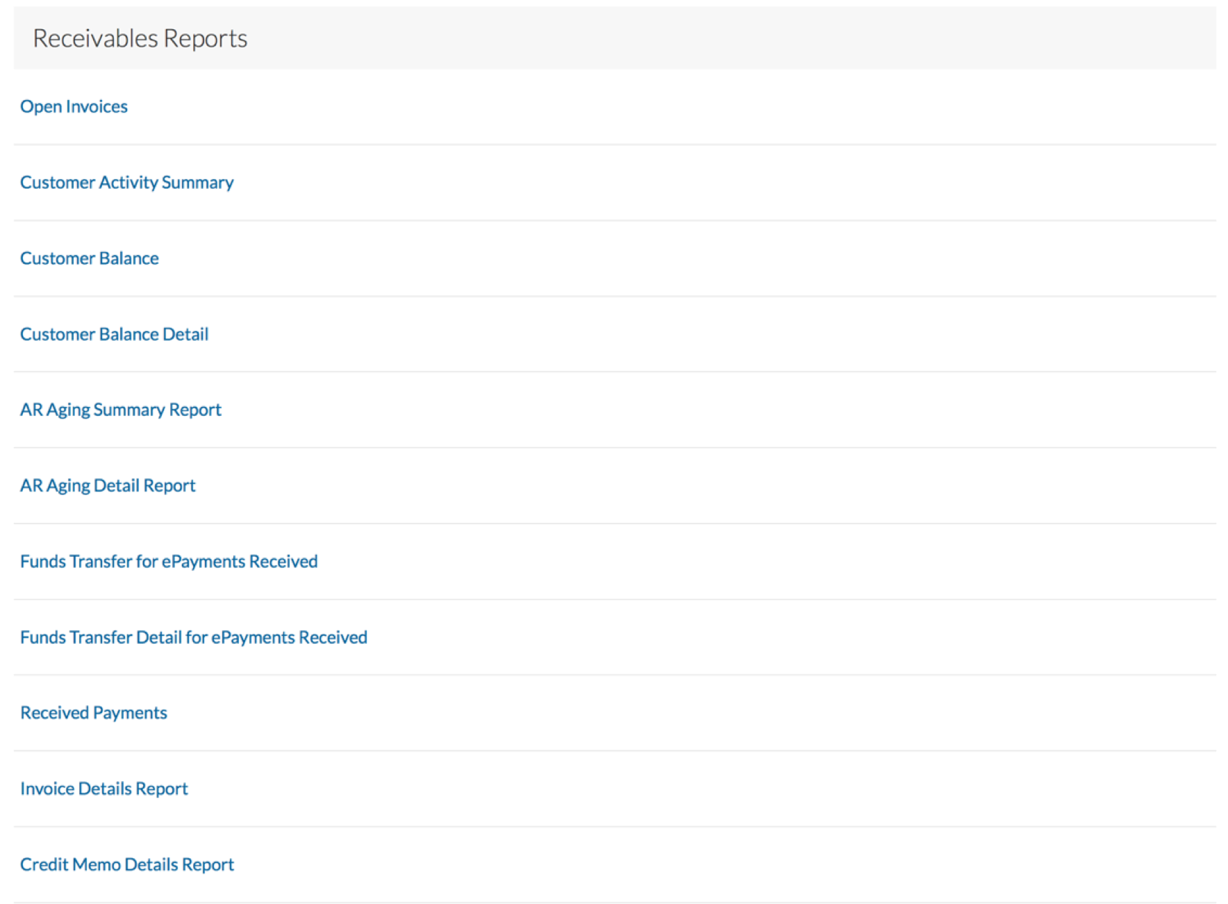

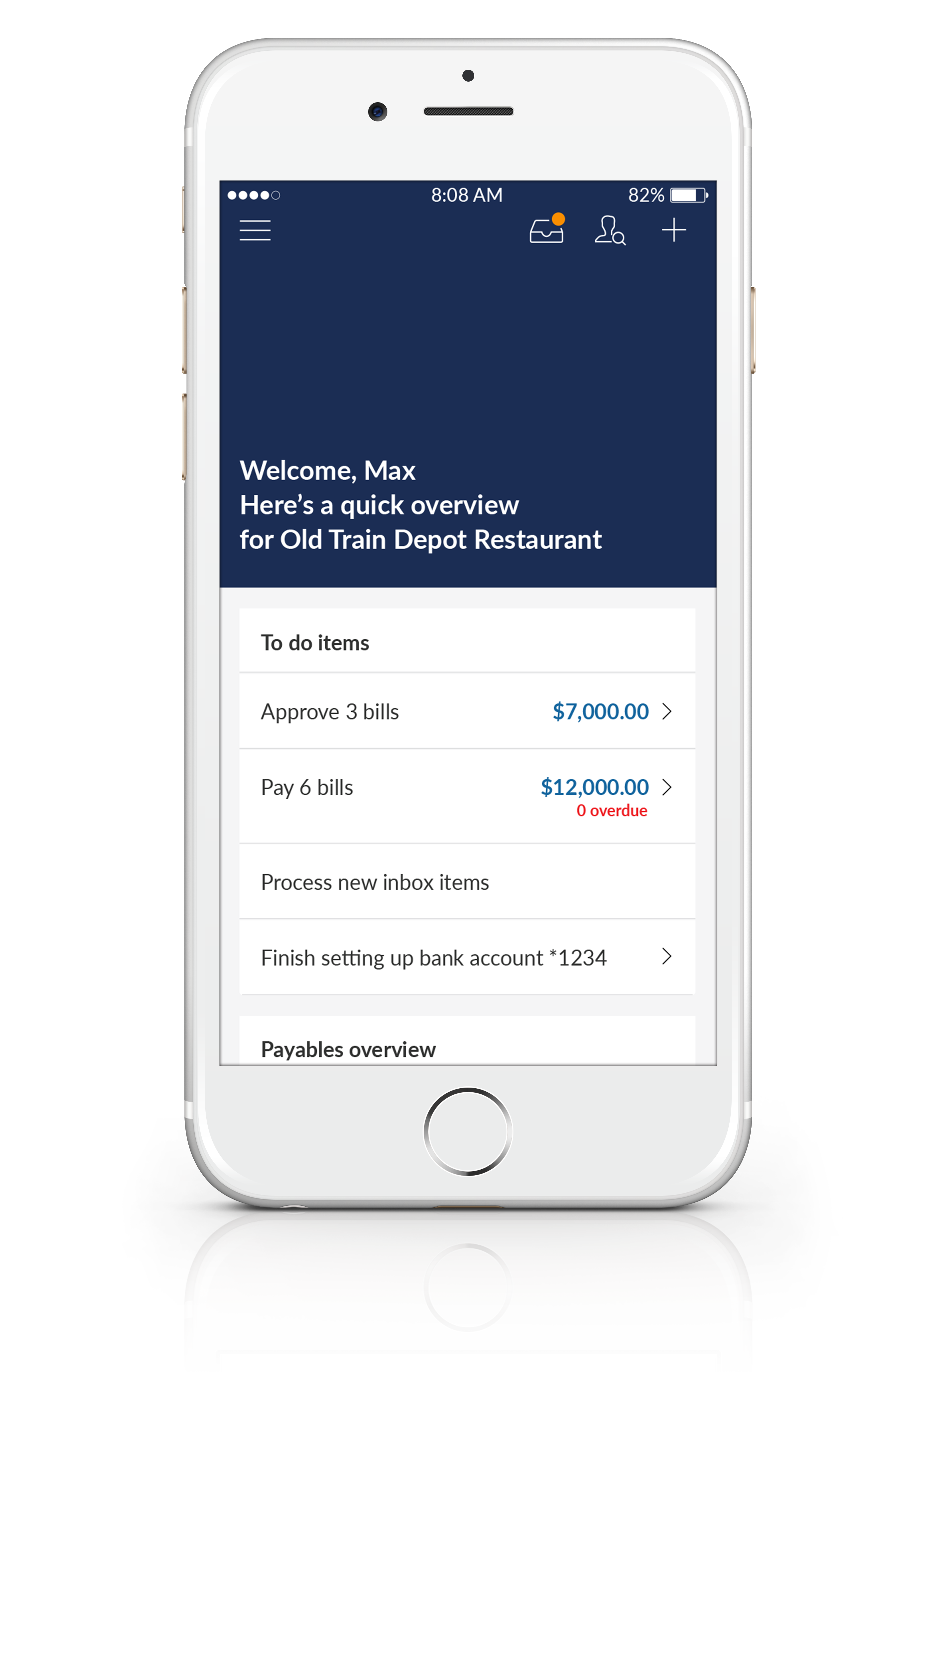
The Bill.com Mobile App –
Managing Receivables
The Bill.com mobile app is available for both
iOS (Apple) and Android devices
- Allows you to work on the go and keep
your back office in your back pocket
- Manage customers and items
- Create invoices with ease
- Keep track of payments received
- And more…

- Bill.com Mobile App for Android

- Bill.com Mobile App for iOS

Contacting Support for Receivables Help
Support can be accessed from the bottom of the left panel in Bill.com
- Self-service articles (available 24/7)
- Chat (weekdays from 5 am to 6 pm PT)
- Email (response within 1-2 business days)
