Bill.com
Basic Accounts Payable Automation using Xero

Process/System Documentation

September 9, 2019^

^Modified September 9, 2019 by Bill.com

Table of Contents

1 Introduction 2
1.1 Executive Overview 2
1.2 Reference Documents 2
2 Process/System Overview 3
2.1 Process Overview 3
2.1.1 Process Roles 3
2.2 Systems Overview & Descriptions 3
3 Process Documentation 3
3.1 Process 1.0: Connecting Bill.com and Xero 3
3.1.1 Data and Document Flow Considerations 3
3.1.2 Process 1.1 Bill.com Policy Admin configures integration with Xero 4
3.2 Process 2.0: Basic AP Automation via Bill.com and Xero Integration 7
3.2.1 Process Map – Process 2.0 Basic AP Automation via Bill.com & Xero Integration 8
3.2.2 Process Considerations – Basic AP Automation via Bill.com & Xero Integration 8
3.2.3 Internal Control Considerations – Basic AP Automation via Bill.com & Xero Integration 8
3.2.4 Data & Document Flows – Basic AP Automation via Bill.com & Xero Integration 9
3.2.5 Process 2.1 Client Submits Vendor Bill for Payment 9
3.2.6 Process 2.2 AP Clerk Checks Bill.com Inbox 9
3.2.7 Process 2.3 AP Clerk Codes Bill(s) 10
3.2.8 Process 2.4 AP Clerk Routes Bill(s) for Approval 11
3.2.9 Process 2.5 AP Clerk Syncs with Xero 14
3.2.10 Process 2.6 Client Approves Bill for Payment 15
3.2.11 Process 2.7 CD Clerk Schedules Approved Bill for Payment 15

Introduction
This document is designed to provide a detailed understanding of the sub-processes and systems involved in performance of a given process.

Executive Overview
This document summarizes the Accounts Payable Automation Process utilizing an integration between the Bill.com and Xero applications.

Reference Documents

The following documents were used as a reference in generating this document:
Bill.com Support Documents
Xero Sync Setup Guide: Initial set up of the Xero + Bill.com sync
Xero Sync - Best Practices: Best practices and process considerations for initial set up
Xero Sync - At a Glance: Sync overview and payables workflow
Xero Sync FAQs: Frequently asked questions and answers

Process/System Overview
This section provides an overview of the process including:
- A description of the processes involved;
- A description of the roles instrumental in the process; and
- A description of the systems involved.

Process Overview
The Basic AP Automation Process utilizing an integration between Bill.com and Xero involves the following:
- Connecting Bill.com with Xero to enable the applications to synchronize
- The submission and processing of bill payments submitted via Bill.com

Process Roles
The following is an overview of key roles in this process.

Role and Organization | Responsibilities
Bill Submitter | Responsible for preparing and submitting the bill to Bill.com.
Bill Approver | Responsible for approving the bill in Bill.com.
Accounts Payable (AP) Clerk Accounting Firm | Responsible for processing the bill in Bill.com and submitting it for approval.
Cash Disbursements (CD) Clerk Accounting Firm | Responsible for processing the payment of the vendor bill.
Bill.com Policy Admin | Responsible for configuring the integration between Bill.com and Xero.

Systems Overview & Descriptions
The following applications are used in this process.
System/Application | Description
Bill.com | Bill.com is a cloud-based business payments software application that helps automate the approval and payment processing for bills (vendor invoices).
Xero | Xero is a cloud-based small business accounting software application used to record accounting transactions.

Process Documentation
This section documents the details of the process including lower level process maps.

Process 1.0: Connecting Bill.com and Xero
A connection must be established between Bill.com and Xero in order to utilize the Basic AP Automation Process configuration. This connection will enable the Bill.com account being maintained by the Accounting Firm to sync data between the two applications.

Data and Document Flow Considerations
Consider the following when setting up the sync between Bill.com and Xero:
Master data: Bill.com & Xero. The following master lists are synchronized between Bill.com and Xero. In the Bill.com Sync Preferences for each company you can choose whether Xero or Bill.com “wins” in the event of a conflicting change.
  - Chart of Accounts - Since this will have a potential impact on financial reporting and should not be changed without strong consideration, we recommend Xero be the master for this data.
  - Vendor and Customer Lists - Since new vendors will often be first seen via an incoming bill, it may make sense to have Bill.com be the master for this data. However, this depends on whether the firm has a policy for obtaining W-9s before processing payments to vendors (to avoid the rush after the end of the year). For such a purpose, the contact can be created in Xero first and then imported into Bill.com.
    - You can import vendors into Bill.com before their first bill payment, by adding the contact in Xero to the group, ‘Sync to Bill.com Vendors’.
    - You can also import customers into Bill.com for accounts receivable purposes, by adding the contact in Xero to the group, ‘Sync to Bill.com Customers’.
See Xero Sync - Best Practices for more detail on vendors vs. customers in Xero.
  - Tracking Categories - Since this will have a potential impact on financial and management reporting and should not be changed without strong consideration, we recommend Xero be the master for this data. If using Locations and Departments, they must be named ‘Location’ and ‘Department’ within Xero to ensure a proper sync.

- Transaction data: Bill.com & Xero. The following transaction data sets are synchronized between Bill.com and Xero. In the Bill.com Sync Preferences for each company you can choose whether Xero or Bill.com “wins” in the event of a conflicting change.
- Bills - Bills in Bill.com are synced to Xero as Bills in the Xero Expenses module. Bills entered into Xero also sync to Bill.com.
    - Note: There is an option to only sync Approved Bills to Xero. Once you turn this on in Bill.com you can’t turn it off. Bill.com says that your setting should ONLY be enabled if ALL bills will go through the Bill.com approval workflow. This setting might be helpful with a cash basis taxpayer if you can keep the time between the approval of the Bill and payment of the Bill short, as it would keep the amount shown in Xero’s Accounts Payable low while providing visibility into full potential liability in Bill.com.
- Vendor Credits - Vendor Credits in Bill.com are synced to Xero as Credit Notes and applied to the corresponding bill. Be advised that this is a one way sync. Credit Notes entered into Xero do not sync back to Bill.com. Ideally, you would only need to update credit notes from within Bill.com to avoid unnecessary data entry.

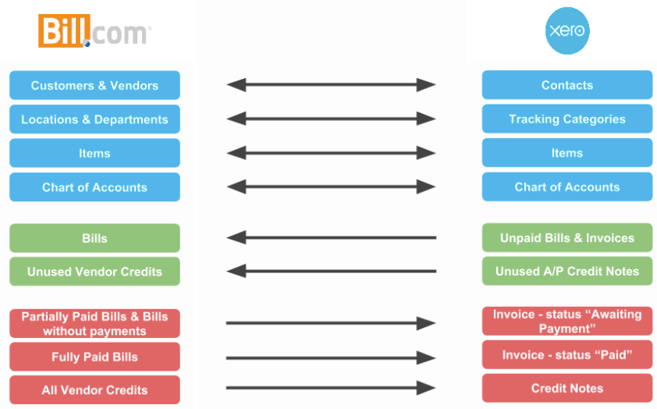

Process 1.1 Bill.com Policy Admin configures integration with Xero
Use Case: | 1.1: Bill.com Policy Admin configures integration with Xero.
Summary: | The Bill.com Policy Admin configures the integration between Bill.com and Xero.
Reference: | Bill.com Docs – Xero Sync Setup Guide
Role: | Bill.com Policy Admin
System/Interface: | Bill.com
Pre-condition: | User has logged into Bill.com and has Policy Admin rights.
Description: | - Establish the connection between Bill.com and Xero by clicking on the Sync image and then pressing the Setup Xero button.  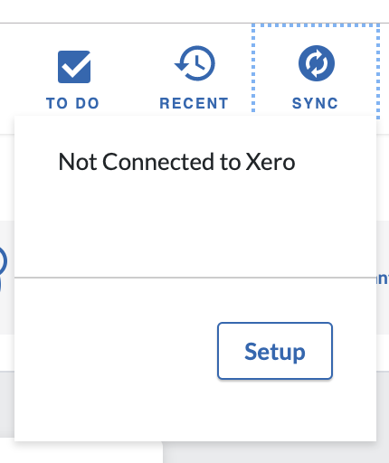  - Upon pressing on the Setup button, you will be directed to the Sync with Xero page.  - Press on the Connect to Xero button.  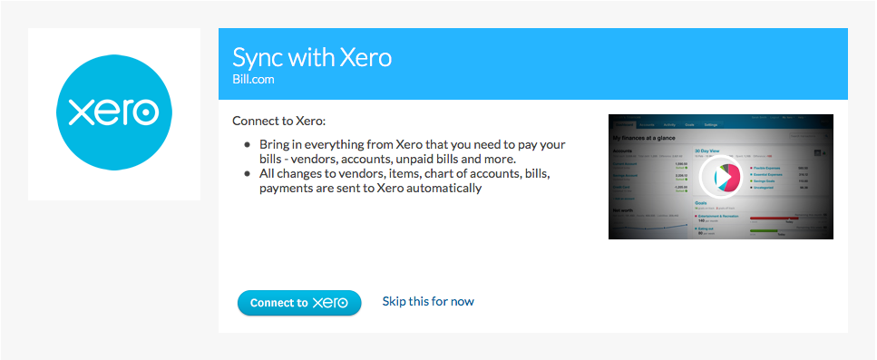  - Enter the Xero User ID and Password for the Xero account that you want to sync with Bill.com.  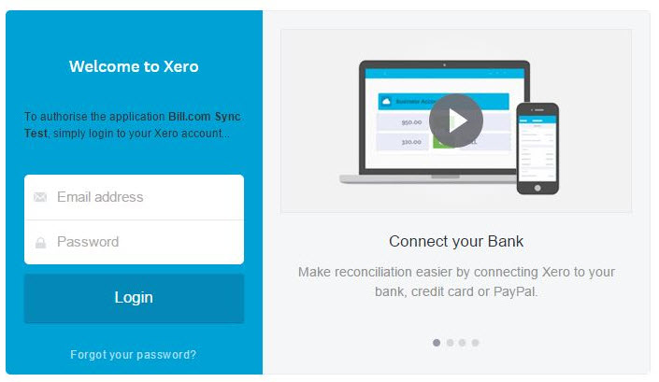  - A screen will be shown with the company/firm(s) that the user is able to access. From the dropdown menu, select the Company/Firm Bill.com will be connected to as well as the associated client from the Client List.  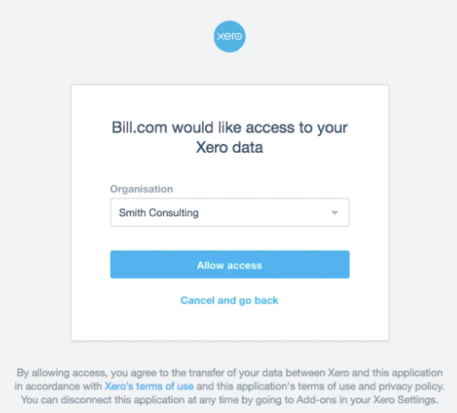  - Once these selections have been made, click on the Confirm button. A screen will be shown confirming the action to be taken.  - Click on the Connect button to complete the integration.  - After clicking on the Connect button to link Bill.com with Xero, the synchronization will begin. Once completed, the connection between Bill.com and Xero will be established and the confirmation screen will appear.  - Upon establishing the sync connection, the option is provided to identify the sync preferences to be established. Learn more about sync preferences, tracking categories, and payables workflow by reading the Bill.com & Xero Sync Setup Guide and the section above on Data and Document Flow Considerations.
Alternatives: | N/A
Post-condition: | - Bill.com account is connected with the selected organization in Xero.  - Xero Master Data (e.g. Chart of Accounts, Vendors, Tracking Categories, etc.) is imported into Bill.com.  - On-going master data and transactional data synchronization is enabled between Bill.com and Xero.

Process 2.0: Basic AP Automation via Bill.com and Xero Integration
The basic AP automation process utilizing the integration between Bill.com and Xero begins with a person(s) at the client responsible for preparation and submittal of bills to Bill.com (“Bill Submitter”). The Bill Submitter can email or scan and upload the bill along with any associated supporting documentation (e.g. packing slip) to the Bill.com Inbox. Vendors may also submit bills directly to the Inbox, by providing them with the associated Bill.com email address.

Once there are documents in the Bill.com Inbox, the bill details are then extracted by the Bill.com Intelligent Virtual Assistant (IVA). The AP Clerk reviews the bill to ensure all data is captured and the bill is coded correctly. The AP Clerk then routes the bill back to a person(s) at the client with bill payment approval authority (“Bill Approver”). Bill.com sends a notification via email to the Bill Approver that the bill is awaiting approval (Note: frequency of notification depends on the user’s notification settings). The AP Clerk then has the option of performing a Xero synchronization to get the data immediately into Xero or waiting for the daily sync to be performed. The sync operation will cause the bill to appear as an unpaid expense in Xero.

Once a bill is approved, the CD Clerk is notified, and can schedule the bill for payment (Note: frequency of notification depends on the user’s notification settings). The client receives notification of the scheduled bill payment (Note: frequency of notification depends on the user’s notification settings). The CD Clerk can then perform a sync of Bill.com with Xero to record the payment in Xero. At the specified pay date, Bill.com withdraws the funds from the client’s bank account and places it in a clearing bank account controlled by Bill.com. Bill.com then sends the payment to the vendor from the clearing bank account based on the prescribed payment method (e.g. check, ACH, international wire, Vendor Direct virtual card).

Process Map – Process 2.0 Basic AP Automation via Bill.com & Xero Integration
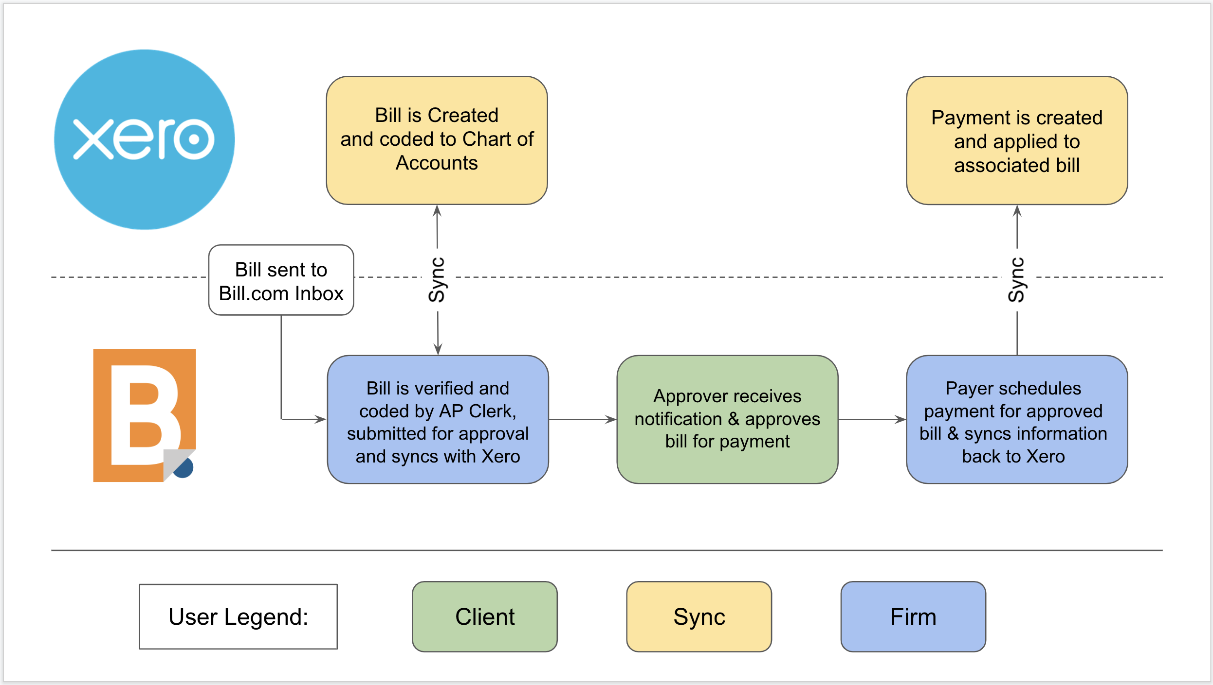
Figure 1 - Process 2.0 Basic AP Automation via Bill.com & Xero Integration

Process Considerations – Basic AP Automation via Bill.com & Xero Integration
Consider the following when developing your policies and procedures:
- The Accounting Firm is dependent upon the Client submitting bills
- The Submission of Bill by Client equates to approval of recording of liability
  - Tip: Train Clients to indicate GL dimension coding (E.g. dept, class, location, etc.) on submitted document or in email
- The Client’s approval of a Bill in Bill.com is the approval to pay
  - Tip: Develop cash disbursements policies / protocols with clients
- The process above shows single level of approval, but multiple levels of approvals can be captured serially via Bill.com on a bill by bill basis.
- The source document of the bill will live in Bill.com and a link to the document is created and attached to the transaction within Xero. A copy of the bill can be attached to the transaction within Xero, but this is a manual upload process.
- Note: Bill.com automatically syncs once a day with Xero so manual sync step may be unnecessary unless you need Xero to be immediately updated after actions are taken (probably more important for cash disbursements since it impacts bank account balance).

Internal Control Considerations – Basic AP Automation via Bill.com & Xero Integration
Consider the following related to internal controls when developing your policies and procedures:
- Remember to consider separation of duties related to:
  - Approval of bills versus coding of bills and scheduling of payments. Especially when the same staff person is coding bills and scheduling payments, be sure that the same staff does not have the ability to approve bills. Otherwise that staff person could move a factitious bill through to payment without anyone else having touched the transaction.
  - Creation of new vendors or changes to vendor information (especially payment address and/or bank routing numbers) versus input of bills and scheduling of payments. This is to ensure that a single person on your staff cannot create a fictitious vendor, assign real bills to that vendor and have payments directed to themselves.
  - Changes to vendor information (especially payment address and/or bank routing numbers) and access to vendor statements. This is to prevent a staff member from changing payment information for a real vendor and then intercepting statements where a vendor may be showing things as past due when they should have been paid.
  - Scheduling of payments versus performing bank reconciliations. This is a standard internal control protocol.

Data & Document Flows – Basic AP Automation via Bill.com & Xero integration
Consider the following when setting up the sync between Bill.com and Xero:
- Documents (images). When using the Basic AP Automation with Bill.com workflow, we recommend that all documents be flowed through Bill.com so that Bill.com completely replaces the legacy paper “vendor files”. Copies of agreements or contracts with Vendors can be stored in the Bill.com Documents module. Note that none of the Documents module data flows to Xero.
  - Vendor Folders - Create a separate Folder for each Vendor and store non-bill documents in those folders. You may also create sub-folders as needed to organize documents associated with a vendor. Note that Bill.com does not currently have a method of associating a non-bill document with a Vendor record, so you must train your staff and clients on what types of documents will be stored in folders.

Process 2.1 Client Submits Vendor Bill for Payment
Use Case: | 2.1: Client prepares & submits bill to AP Clerk
Summary: | Client representative prepares and submits a vendor bill and supporting documents for payment processing
Role: | Bill Submitter
System/Interface: | Email or Upload
Pre-condition: | - Client receives bill from vendor requesting payment for services rendered or product provided.
Description: | - If the bill or supporting documents are in hardcopy, Bill Submitter scans or takes a photo of the bill/documents.  - Bill Submitter submits the bill/documents to Bill.com Inbox via email.
Alternatives:
Post-condition: | Bill/document(s) is in the Bill.com Inbox.

Process 2.2 AP Clerk Checks Bill.com Inbox
Use Case: | 2.2: AP Clerk checks Bill.com Inbox to process bills
Summary: | AP Clerk checks the Bill.com Inbox to see what needs to be processed.
Role: | AP Clerk
System/Interface: | Bill.com
Pre-condition(s): | - Bill Submitter has submitted bill(s)/document(s) for processing.  - AP Clerk has logged into Bill.com and has the Use Inbox permission.
Description: | - Click on the Inbox option on the left navigation to see the list of items sitting in the Inbox. By default, the first item will be selected in the item list and its associated pages will be shown to the right.  - Click on the item that you want to process and press the Review & Save button in the upper right corner to open the bill coding screen.
Alternatives: | If the item is not a new bill, the AP Clerk can open the More actions dropdown to see alternative actions to take with the item:  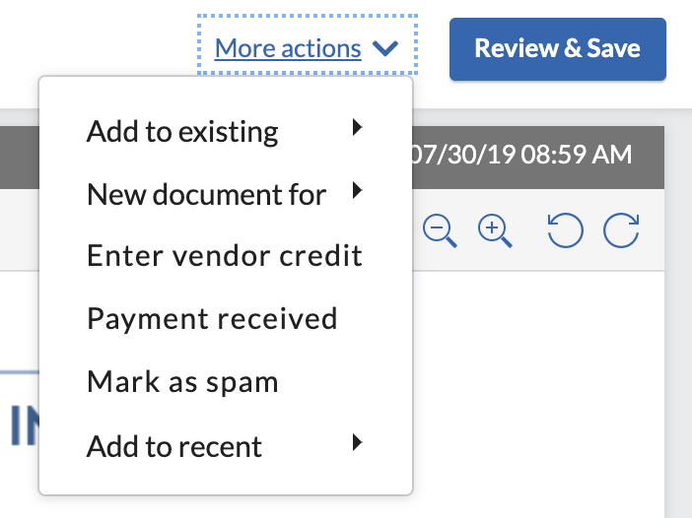
Post-condition: | Bill created and opened for coding on the Bill.com Enter bill screen.

Process 2.3 AP Clerk Codes Bill(s)
Use Case: | 2.3: AP Clerk Codes Bill(s)
Summary: | AP Clerk specifies the vendor, enters the bill information, and enters the GL account coding for the bill.
Role: | AP Clerk
System/Interface: | Bill.com
Pre-condition: | AP Clerk is on the Enter a bill screen.
Description: | - Review the bill information extracted by the Bill.com Intelligent Virtual Assistant (IVA) in the BILL SUMMARY area. Ensure all of the required fields (indicated by an asterisk) are completed and accurate. (NOTE: If the vendor already exists in Bill.com, it will appear in the vendor listing. If not, then the vendor will need to be added by clicking on the Search icon and then selecting Add new vendor. Once the new vendor profile has been completed, click on the Add Vendor button.)  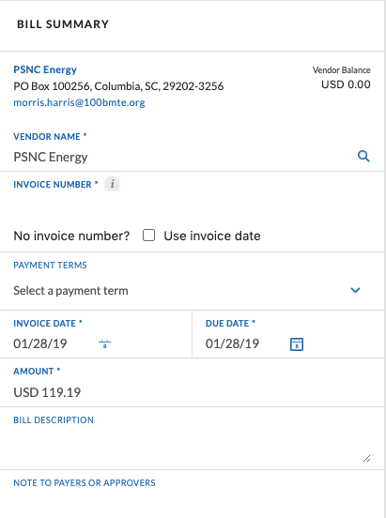  - Enter the GL account coding details in the EXPENSE DETAILS section.  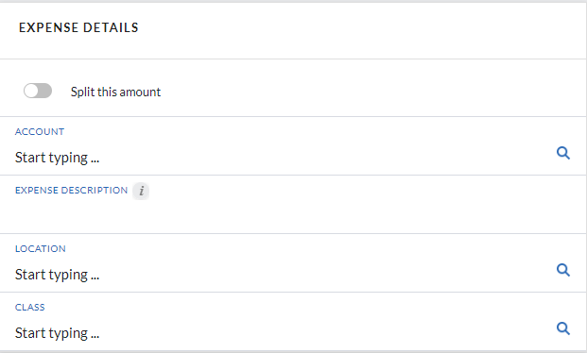  If needed, click the Split this amount switch to distribute the amount to multiple lines.
Alternatives: | N/A
Post-condition: | Bill has been properly coded and is ready to be routed for approval.

Process 2.4 AP Clerk Routes Bill(s) for Approval
Use Case: | 2.4: AP Clerk Routes Bill(s) from Approval
Summary: | AP Clerk specifies who the bill should be routed to for approval for pay.
Role: | AP Clerk
System/Interface: | Bill.com
Pre-condition: | - Bill is already open on the Enter a bill screen.  - The Bill.com Policy Admin has chosen the payment option, “Bills are routed for approval and are ready to be paid when approved.” in the Settings 🡪 Payables 🡪 Bill Approvals section.  - Bill Approver has a Bill.com user account that has the Approve Bills/Vendor Credits permission
Description: | - In the APPROVERS section, click on the Add approvers or approval groups dropdown to see the list of available Bill Approvers.  - Select the people that you want to be included in the approval routing by checking the box to the right of their name. When you do this, they will be added to the APPROVERS list above.  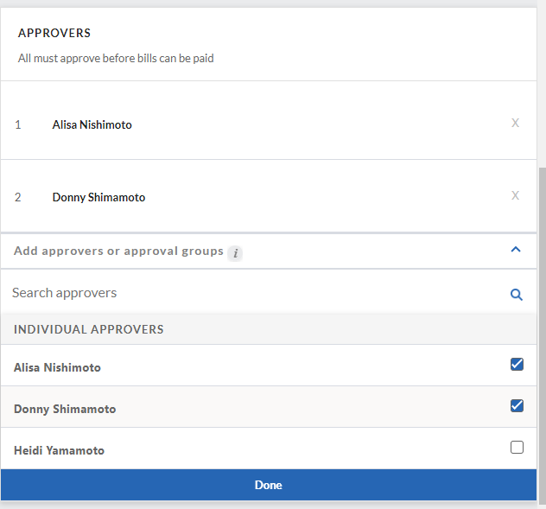  - Press the Done button to save the approvers.  - You can re-order approvers by hovering over the number to the left of their name. The number will change to a handle icon which you can then use to drag and drop the approver into the appropriate order.  - You can also remove an approver by clicking on the X to the right of their name.  - When done, press the Save button at the top of the page.  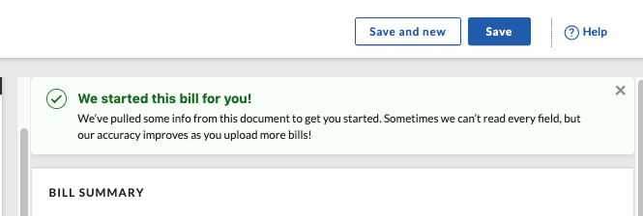  - The Bill Approver will receive a notification via email that the bill is ready for approval. NOTE: Receipt of notifications by the Bill Approver are dependent upon how he/she has configured the Email Preferences in Bill.com. (Email preferences can be accessed by navigating to Settings -> You -> Email Preferences.)  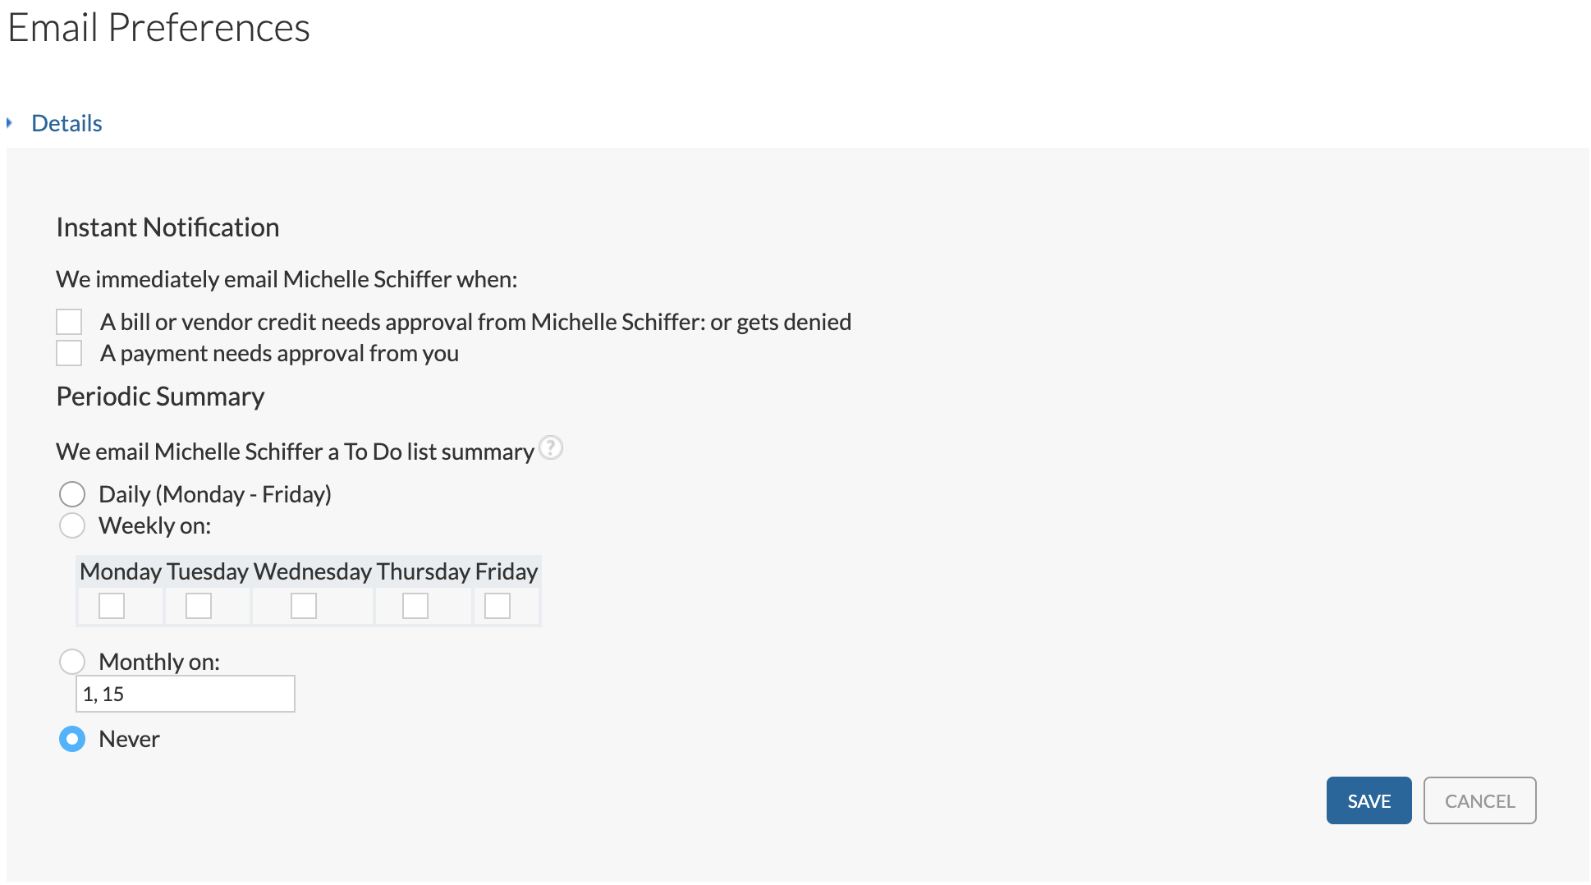
Alternatives: | N/A
Post-condition: | The information, coding, and approval routing for the bill is saved. The bill is shown in the Bills area of the PAYABLES section.

Process 2.5 AP Clerk Syncs with Xero
Use Case: | 2.5: User Syncs with Xero
Summary: | The User (could be AP Clerk or CD Clerk) forces a synchronization between Bill.com and Xero.
Role: | AP Clerk or CD Clerk
System/Interface: | Bill.com
Pre-condition: | - Bill.com and Xero integration has been completed (See Process 1.1 above)
Description: | - Click on the Sync icon in the top right corner, which will display the sync popup windows.  - Press the Sync Now button.  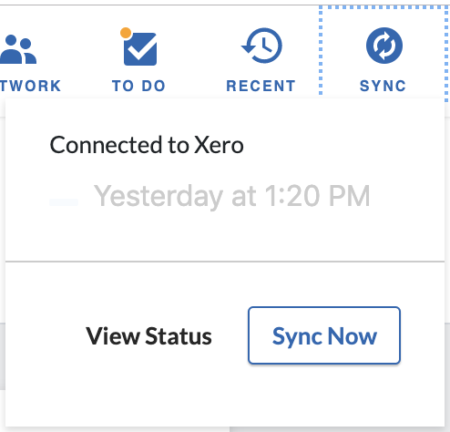
Alternatives: | Note: Bill.com automatically syncs once a day with Xero so the manual sync step may be unnecessary unless you need Xero to be immediately updated after actions are taken (likely more important for cash disbursements since it impacts bank account balance).
Post-condition: | - Bills from Bill.com appear in Expenses section of Xero.  - Payments scheduled in Bill.com will also appear in Xero.

Process 2.6 Client Approves Bill for Payment
Use Case: | 2.6: Client Approves Bill for Payment
Summary: | Client’s Bill Approver goes into Bill.com and approves bill(s) for payment.
Role: | Bill Approver
System/Interface: | Bill.com
Pre-condition: | - AP Clerk has routed a bill to the Bill Approval for approval.  - Bill Approver has logged into the Bill.com as a user with the Approve Bills/Vendor Credits permission.
Description: | - Navigate to the Approvals section. A list of bills waiting for approval will be shown.  - Place a checkmark beside the bill(s) that are to be approved.  - Press the Approve button in the upper right corner (see image below). A notification will appear indicating the bill has been approved and it will be removed from the Approvals section.  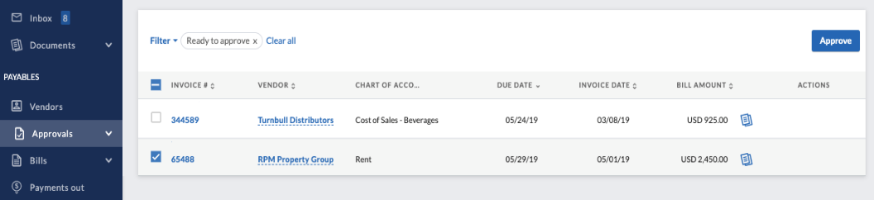
Alternatives: | - Bills can also be approved by clicking on the Invoice Number. This will open the Bill screen where the pages of the bill, bill summary, bill coding, and approvers can be seen. From this screen, press the Approve button in the upper right of the screen to approve this bill for payment.
Post-condition: | Bill is marked as approved. If there are additional approvers, it will be routed to them for approval. If this was the only or last approval, then the bill is ready to be processed for payment.

Process 2.7 CD Clerk Schedules Approved Bill for Payment
Use Cases: | 2.7: CD Clerk Schedules Approved Bill for Payment.
Summary: | Bill is scheduled for payment by the CD Clerk. (Note: The current pay process is under review and revisions may be made in October 2019. No further action is needed at this time.)
Role: | CD Clerk
System/Interface: | Bill.com
Pre-condition: | - Bill has been approved by all approvers.  - CD Clerk logged into Bill.com and has the Pay approved bills via Bill.com permission.
Description: | - Navigate to the Overview screen. From the Bills to Pay section, open the Pay dropdown and select the Pay bills option (see below). A list of bills that have been approved for payment will be displayed.  - Locate the bill(s) to be paid and place a check in the box to the left of each bill to be paid.  - Press the Review & Pay button.  - The Pay Bills screen will show the selected Bills. Confirm or change the payment details (e.g. payment amount, process date, and pay from (bank account) and press the Next button in the right-hand corner.  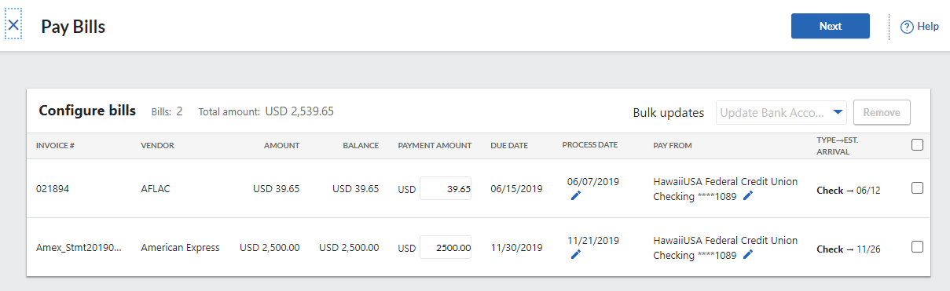  - The Review and send payments screen will be shown providing a final time to review the payments and to also add/change the email address that will receive notification of the scheduling of the payment or add/change the memo to be shown.  - If all payments look correct, press the Submit payments button in the upper right to confirm scheduling the payments.  - In Bill.com, once the bill has been submitted for payment, it will appear in the Payments Out section and assigned a payment confirmation number.  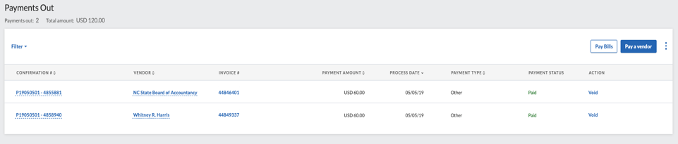  - If the client has requested notification of payments, then they will be notified via email of the payment(s) that have been scheduled.  - A user can sync to push the payment to Bill.com or allow the auto sync.
Alternatives: | N/A
Post-condition: | The payment for the bill is scheduled.

NOTE: For processes 2.8 and 2.9, the automatic withdrawal of funds from the bank account to submit payment to the vendor is dependent upon how the Bill.com Policy Admin has set up the payments to be distributed from the bank (whether via check, ACH payments, or ePay). As noted in Process 2.7, in order to make electronic payments, the vendor must agree to receive this form of payment.

