How to Create a Demo Account on your Bill.com Console

Section 1: Set up a Demo Client on the Accountant Console

- Do not enter any bank account information yet - you will be instructed below.

- Create fictional demo business account information - gather and write this information down before logging in to Bill.com.
  - Fictional company name and address
  - Accounting software you will use in the demo and information on how to access that system (login info, etc)
  - Names and emails of different demo roles - accountant, approver, etc.
  - Fictional bank account info - see step 4 below

- Create invoice documents for the demo to show in various stages of processing. Mock up fake invoices in a Word document template using real invoices as an example.

- Add demo client to the Accountant Console
  - In the Console, select the Clients tab
  - Click the Add Client Company button
  - Enter the demo client information
  - Check the “Bill to” checkbox so Bill.com will not try to charge your demo client for the free demo account, which may result in confusion
  - Under Company Uses, check the box for each feature you want to demo - Payables and/or Receivables
  - Select yourself as the Administrator
  - Click Save.

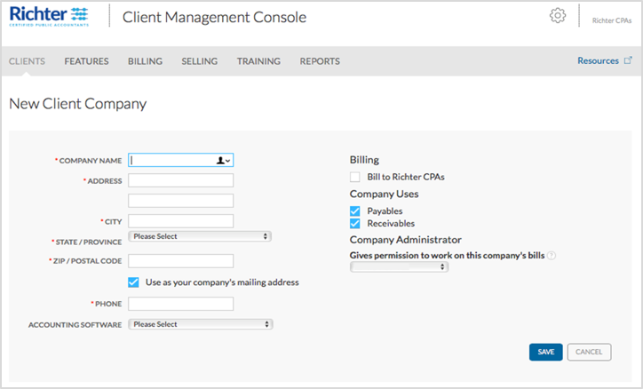

- Go to your name at the top right, select “View all” and select the demo account you created.

- Agree to the Terms of Service

- If you are prompted to setup the sync, select “Skip this for now”. We will setup the sync in Section 2: Step 7.

- At the top, click “Finish company profile” and verify the company information

- Go through the startup checklist on that client account.
  - Click the Gear icon in the upper right to access Settings
  - Across the top, click “Mouse over each circle to see what you're ready to do” and follow those steps in order.
  - Click applicable items to complete the setup tasks for each feature, such as entering the names and roles of each fictional person involved in the demo.
  - Remember to add firm staff who need access to the demo account.
  - Make sure to click on the Inbox to modify the Inbox email address.

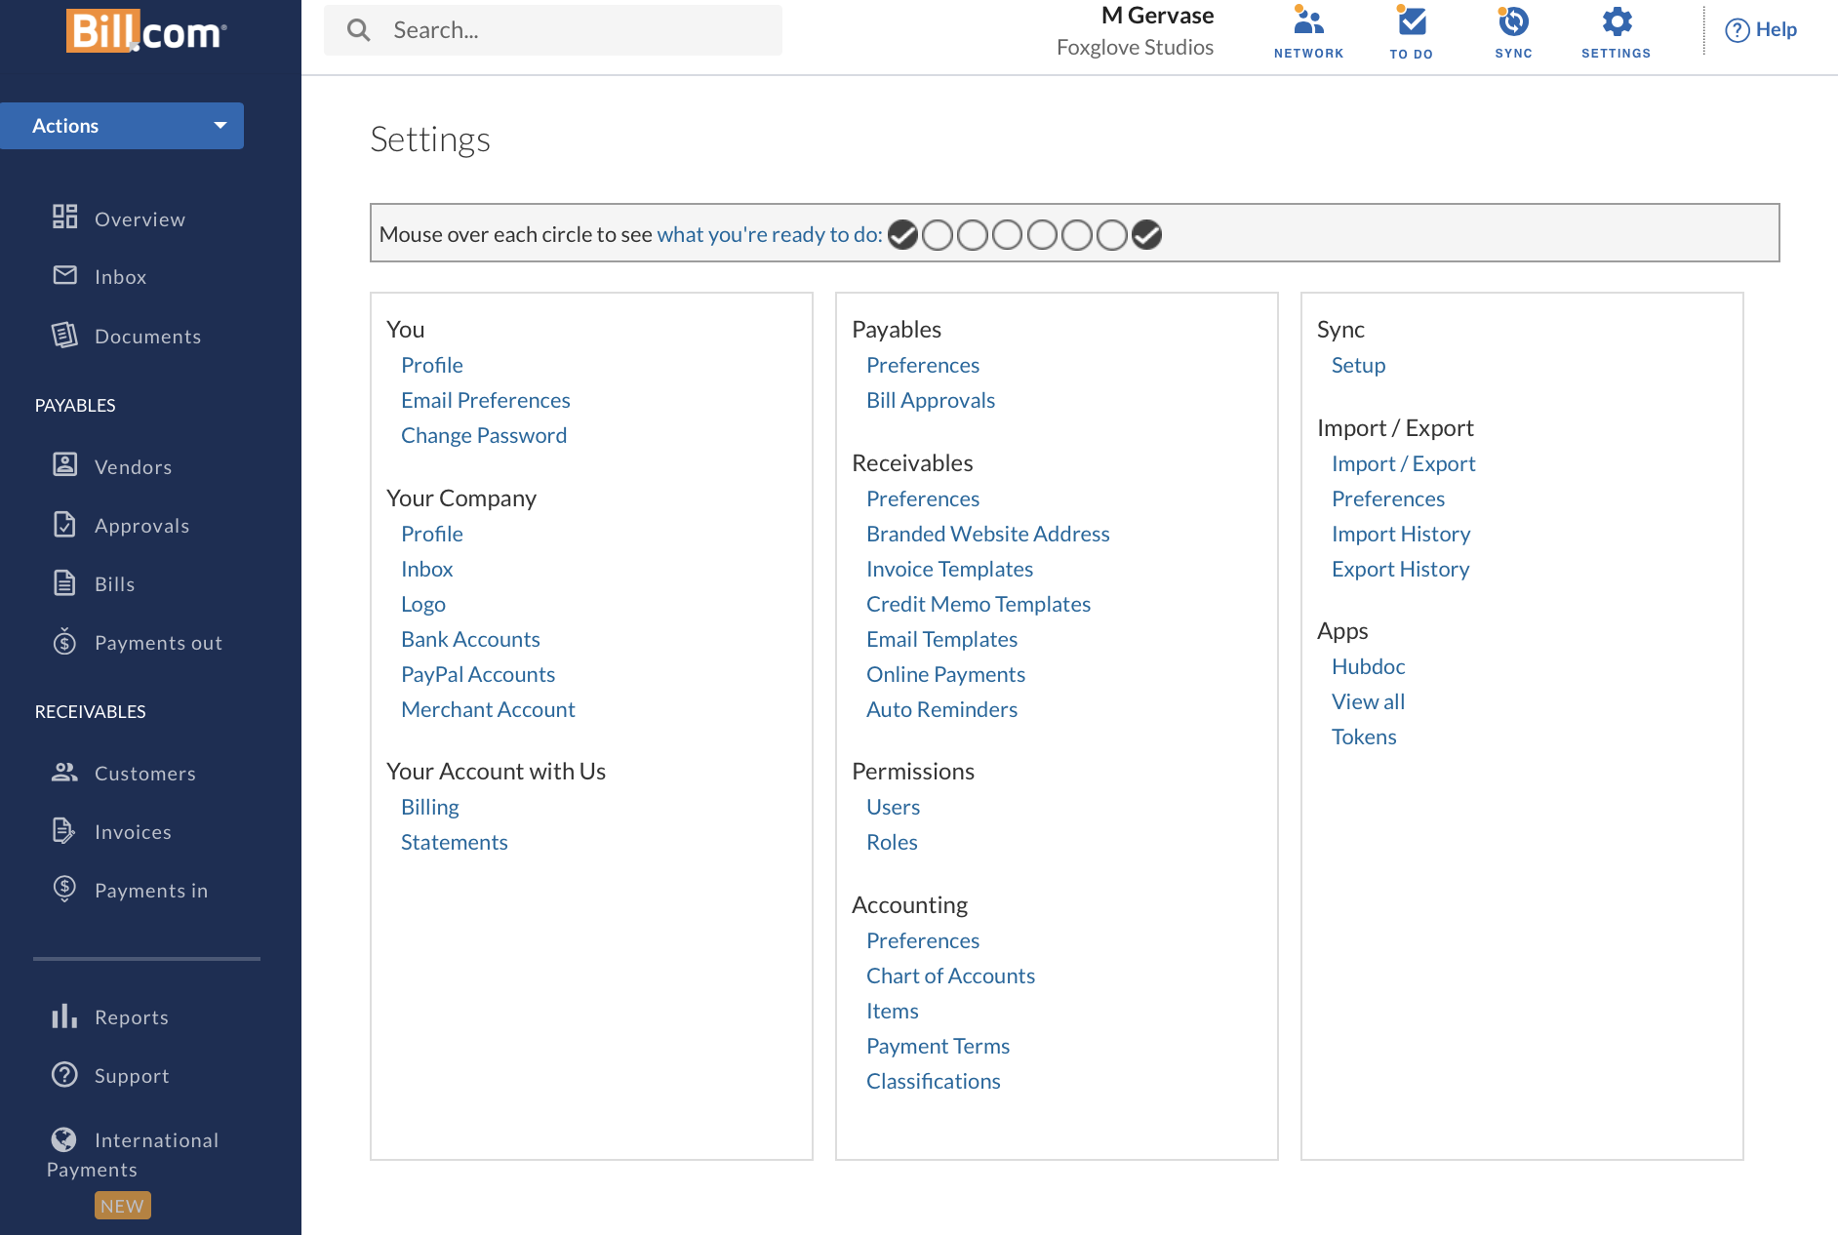

- Bill Approvals
  - Click the Gear Icon > click Bill Approvals > select the option: “Bills are routed for approval and are ready to be paid when approved” > Click Save.
  - If you want a default approver for all bills, add an approver for the Approver #1 field.

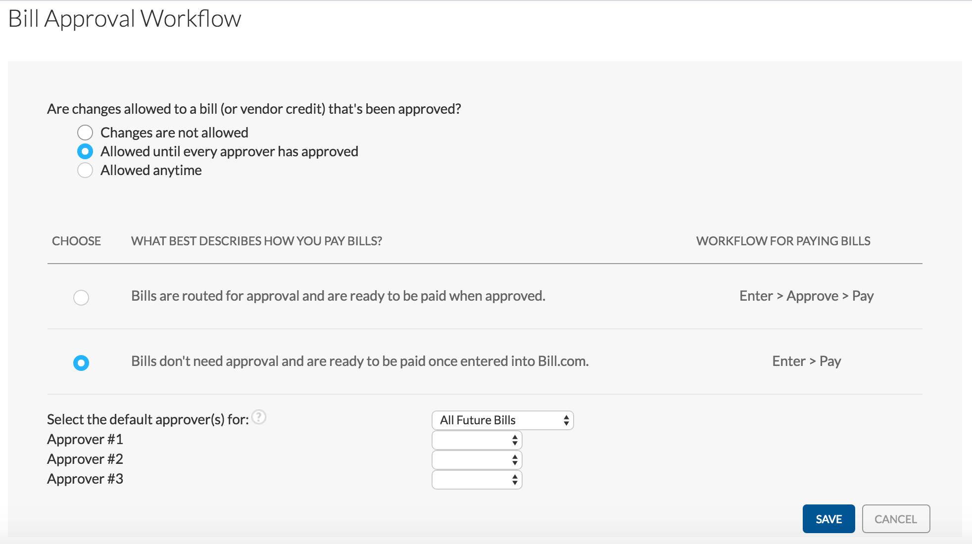

- Customize accounting preferences
  - Click the Gear icon in the upper right to access Settings
  - Under “Accounting” select “Preferences” and select the setting that match the accounting software you will use in the demo.

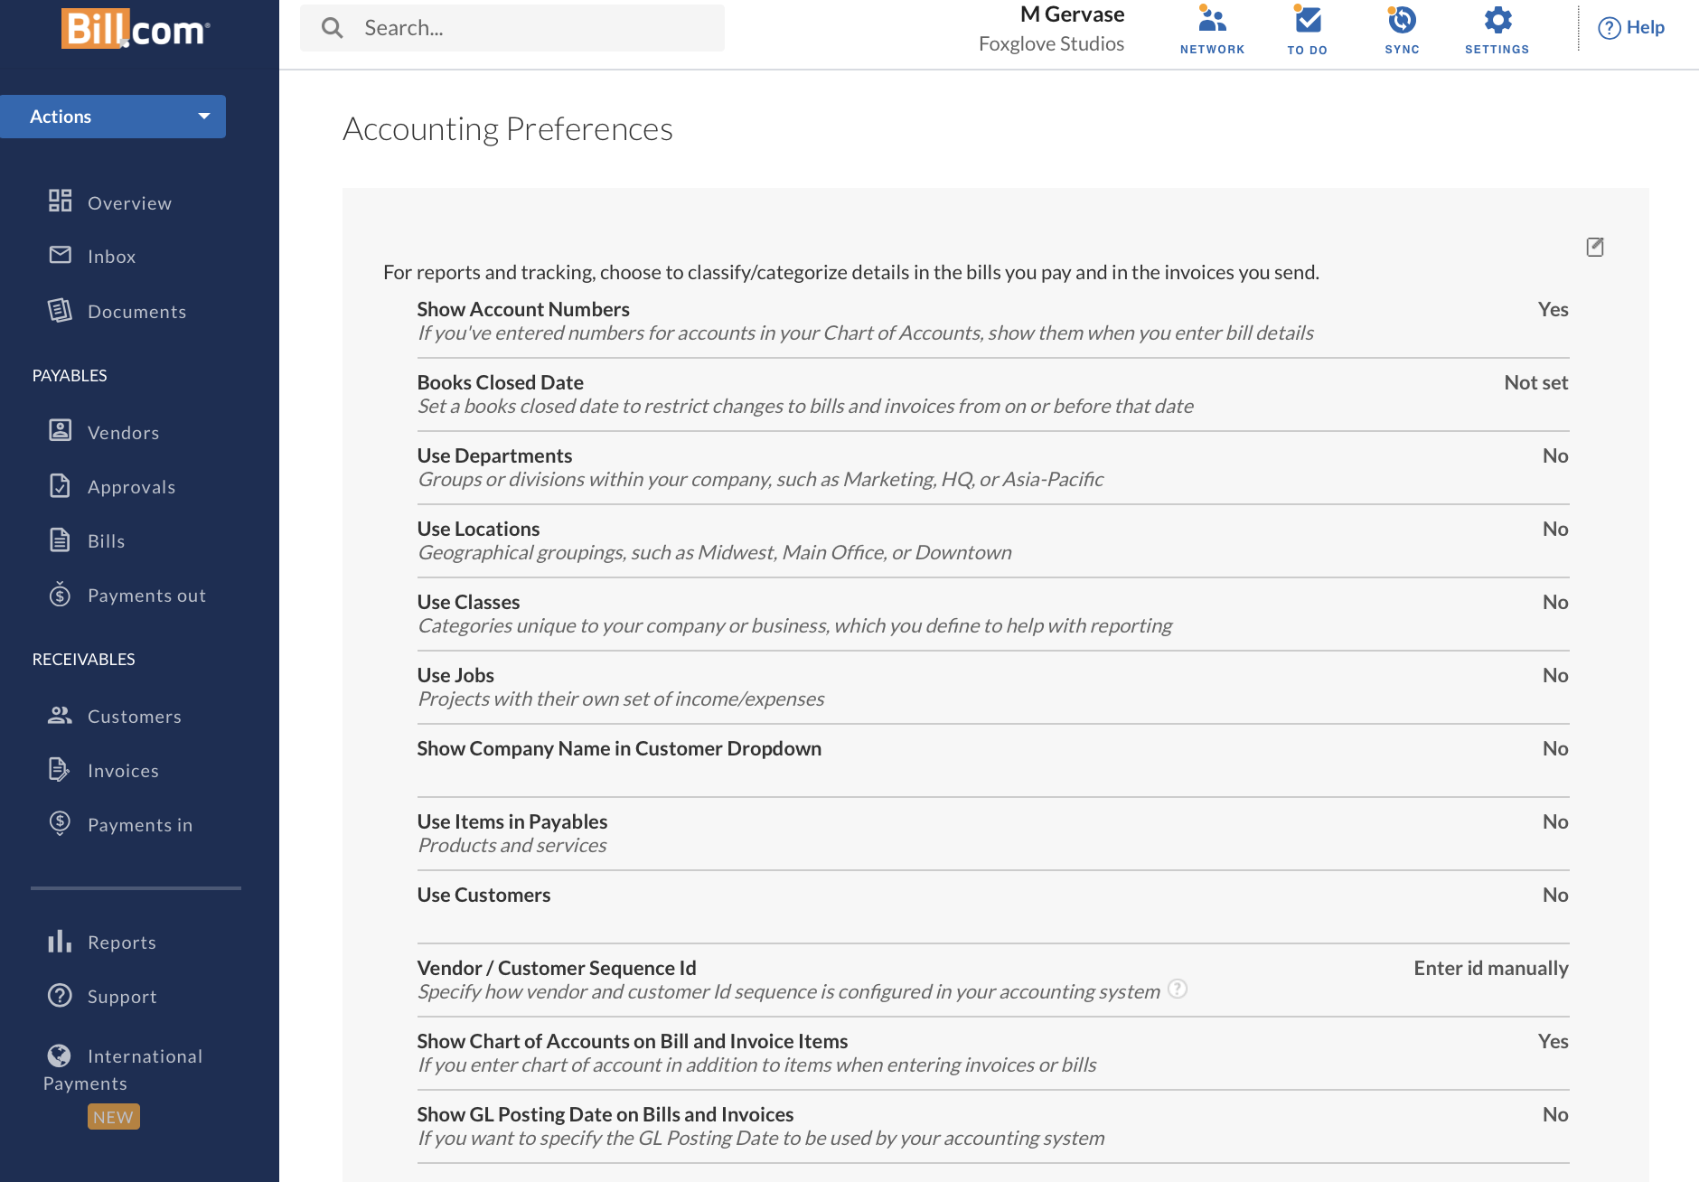

Section 2: Activate Your Demo Account

- Once the account is setup, please email the name of the account and the email address of the admin to your Bill.com Account Manager and let them know you have set up a demo account.

- The Bill.com Account Manager will work with our Operations team to mark the account as free and turn off the money movement feature. The Bill.com Account Manager will confirm with you once this step is complete.

- Once you have confirmation that the money movement has been turned off, please enter the following fake bank account information into the demo account:
  - On the Overview page, click on “Set up ACH/Check payment” button towards the top.
  - Click on “Select” in the “Enter Bank Account Info” section.
  - Bank account holder’s name: Your name or a fake one
  - Account Type: Business Check
  - Bank Name: Chase or any other bank
  - Routing Number: 322271627 (This is a real routing number we use for our demo accounts that we want your firm to use as well)
  - Bank Account Number: 1234567891 (This is a fake number we created for your firm to use). You’ll need to re-enter the Account Name a second time.
  - In the Additional Info section: file in the:
    - Company Owner: Your name or a fake name
    - Business type: Corporation or any other option on the drop down menu
    - Industry: Accounting or Booking or any other option on the drop down menu
    - Tax Type & ID: Select: “EIN” and enter in nine digits (ex:123456789)
  - Click Continue. You will not need to go through verification since this will be disabled.

- Notify your Account Manager that you have entered the fake bank account information.

- Your Account Manager will obtain the debited amount from the test transaction from our Risk and Security team and let you know the amount so you enter this information and complete the bank verification process.

- Enter the test transaction to verify the bank account. Go to the Overview page, click on “Finish bank account setup” > enter in the test transaction (deposit amount) and click “Verify”.

- Now you can sync your Bill.com demo account to the demo account in your accounting software and “make payments.” Because we turned the money movement off, you can demonstrate payments to clients in Bill.com and also show them what that transaction will look like in the accounting software. The payment will never show as “paid” since no money is moving, instead the payment status will show as “scheduled.” Additionally the funds transfer journal entry will not sync to the accounting software.
Section 3: Populating a Demo Account – AP

- You should have a number of roles created for entering, approving, and paying bills - see “Creating a Demo Account” above.

- The sync will bring over the chart of accounts, vendors, and unpaid bills to Bill.com from the accounting software.

- If you want to demonstrate international business payments, make sure you have an international vendor set up in the accounting software or in Bill.com.

- Upload or email vendor documents to the Bill.com inbox.

- Process and pay a few bills to establish a history of activity, assign vendors/bills to expense accounts, and assign approvers.

- Leave a few bills in the approval queue to show work in process.

- Leave a few bills in the inbox to use during the demo.

- Now you are ready to demo AP.

- Add new invoices over time to “reset” your demo with current payables and WIP.

Section 4: Populating a Demo Account – AR

- The sync will bring over items, invoices, and customers to Bill.com from the accounting software.

- Create a number of invoices in Bill.com with a variety of future due dates.

- Process a few invoices to establish a history of activity.

- Leave a few invoices unpaid.

- Create new invoices or show the status of unpaid invoices for the demo.

- Now you are ready to demo AR.

- Create new invoices over time to “reset” your demo with AR aged under 30 days.

