Hi [Client Name],

We bet that on a list of things you like to do, paying bills would rank somewhere near the bottom. It takes time, is prone to errors—especially if paper is still a big presence—and fixing mistakes can be a serious pain. And then there are the security and fraud concerns with sending checks in the mail.

We can help you take care of all of these concerns with Bill.com.

We use Bill.com to do the work for you, so you get the benefits:

Control: All yours, all the time, at every step of your bill pay process

Time Savings: Leave the bill management to us—we alert you when there’s a payment to approve

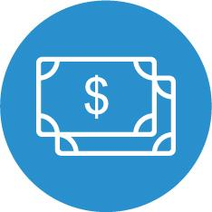
Flexibility: Pay international and domestic vendors how they want to be paid

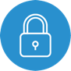
Security: Encryption of data in motion and at rest consistent with leading industry practices

to outsource your bill pay.

If you have any questions or would like a walk-through of the product, please let me know.

[Accountant Name]

