Bill.com Setup Reference Guide Part 1: Accountant Console Setup

Accessing the Console 2
Upload Your Firm Logo 3
Customize the Login URL 3
Add Staff Members 4
Create Custom Roles for Client Accounts 5
Add Clients to the Console 6
Manage Staff Members’ Client Account Access 7
Enable and Disable Features per Client 8
Enter Console Billing Information (firm credit card) 9
Explore the Training Modules 10
Access Sales and Marketing Resources 11
Marketing and Selling: Create a Demo Company 12
Console Reports 13
Contacting Support for Help 14

Accessing the Console
If not already logged in:
- Navigate to Bill.com
- Click Login
- Enter your login credentials
- Click Manage Console
If already logged into a client's account:
- Hover over the client name near the upper right and click View All
- Click Manage Console
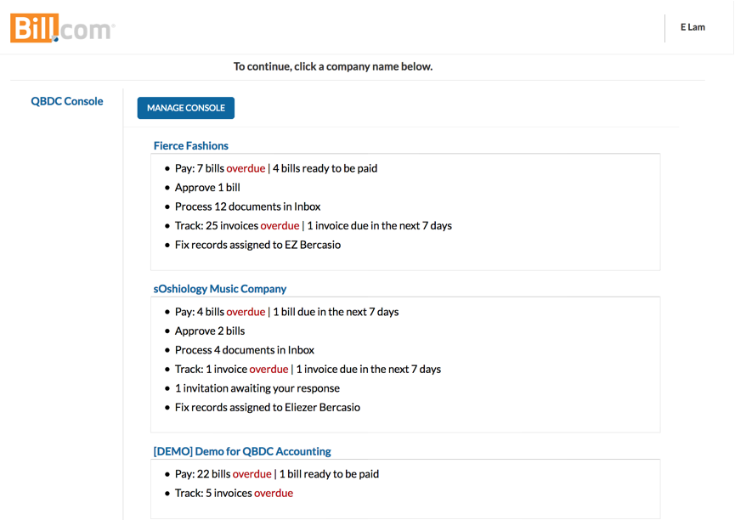

Upload Your Firm Logo
- From the Console, hover over the gear icon and click Logo
- Click Choose File
- Select the image and click Upload Logo

Console clients will see your logo at the top of each page, and the Bill.com logo moves to the bottom right corner.
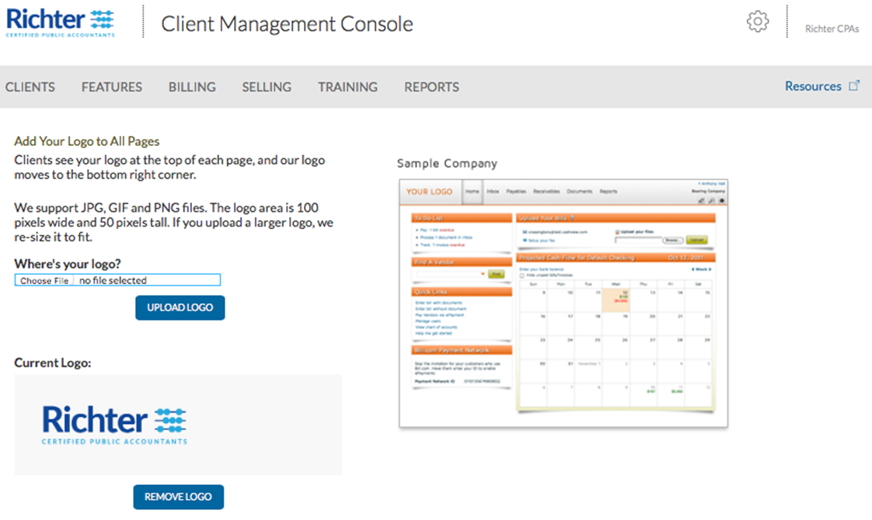

Customize the Login URL
- From the Console, hover over the gear icon and click Logo
- In the "Create a login URL with your logo" section, enter your company's name
- Save

Add Staff Members
Make a Plan
- Who is your Bill.com champion?
- Who is their backup?
- What staff need to access Bill.com?
  - No cost for unlimited number of staff to use Bill.com
- What access level do they need?
  - Admin or Team Member

- Adding a staff member to the Console
- Client account access for staff members

Create Custom Roles for Client Accounts
Custom roles can be added at the console level and synced to all client accounts.
Things to Know
- Console custom role will sync to all clients listed under console
- Console custom role will update existing custom role in client account's
with the same role name, it will not duplicate
- Editing the console custom role will update the role in all accounts
- Editing a console custom role in the client account will not update the role
in any other accounts
- If making an edit to the console custom role in a client, future edits to the console
custom role in the console will override any changes made to the role in the client
- After the role has synced to clients, unchecking the Auto sync role to client accounts
box will not remove the role from clients
- Console custom role name can not be edited after saving
- Audit trail of custom role in client accounts will show the role was created/edited/inactivated by system

- Managing Custom Roles from a Console

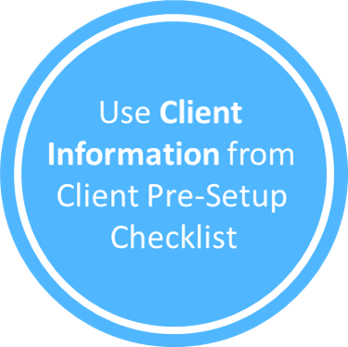
Add Clients to the Console

- Adding a new client account to the Console

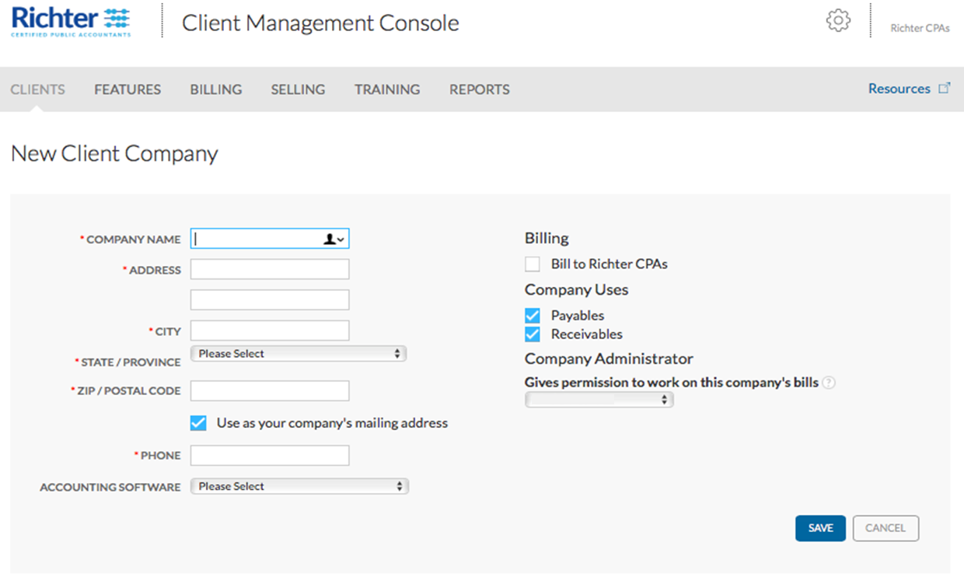

Manage Staff Members’ Client Account Access
Once the client account is added to the console, grant client account access to the staff members that will be working in the account
Add Options:
- Single staff member access to multiple accounts
- Multiple staff member access to a single client account
Remove Options
- Remove access to client accounts for a single staff member
- Remove access to single client account for multiple staff members
Things to know:
- Staff member needs to be added prior to client assignments
- Audit trail of staff in client accounts will show the role was created/inactivated by system
- Console Staff can now be added to existing client accounts, or their existing access to client accounts can be adjusted by editing the staff profile.

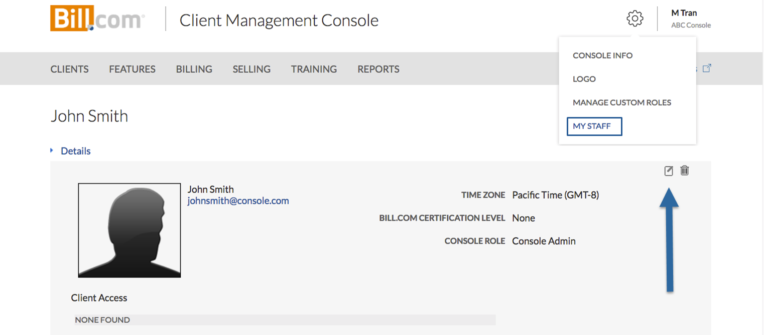

Enable and Disable Features per Client
- From the Console, hover over Features and click the feature that will be enabled or disabled
- If enabling the feature, click Use It to the right of the client's name
- If disabling the feature, click Don't Use It to the right of the client's name
  - Select a Reason to Cancel and enter a comment if applicable
  - Click Confirm

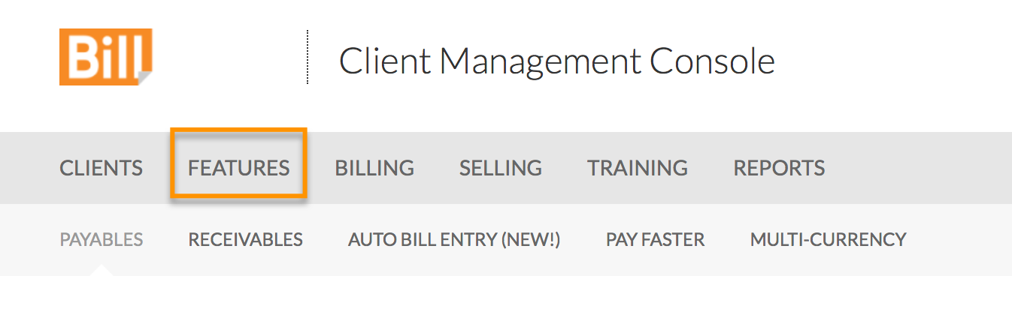

Enter Console Billing Information (firm credit card)
- From the Console, click Billing
- Click Add Card
- Enter the billing information
- Click Save Customer Profile

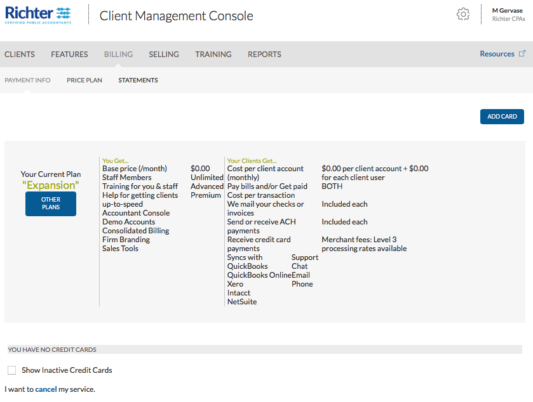

Explore the Training Modules

Self-paced “how to” videos for Bill.com functions for firm staff
From the Console, click Training, then select a training module to complete:
- Basic: Videos that explain how to get started, handle clients' payables and receivables, and keep track of how much cash they have on hand.
- Advanced: An online course that explains how to customize and automate for greater efficiency, and how to handle special payables and receivables situations. Complete this
- Certifications: Recognition that you've completed some (or all) of our Advanced training. Get visibility for both yourself and your company. Existing clients (and prospects) will feel confident knowing that you're on top of current trends, and that you're using the latest technology.

Once you have completed some (or all) of our Advanced training, you will receive badges as recognition of your accomplishment.

You can display the certification badges on your blog, website, or other areas of your business.
The badges are located at Training > Certifications.

Access Sales and Marketing Resources

Marketing and Selling Resources
Click Accountant Resource Center
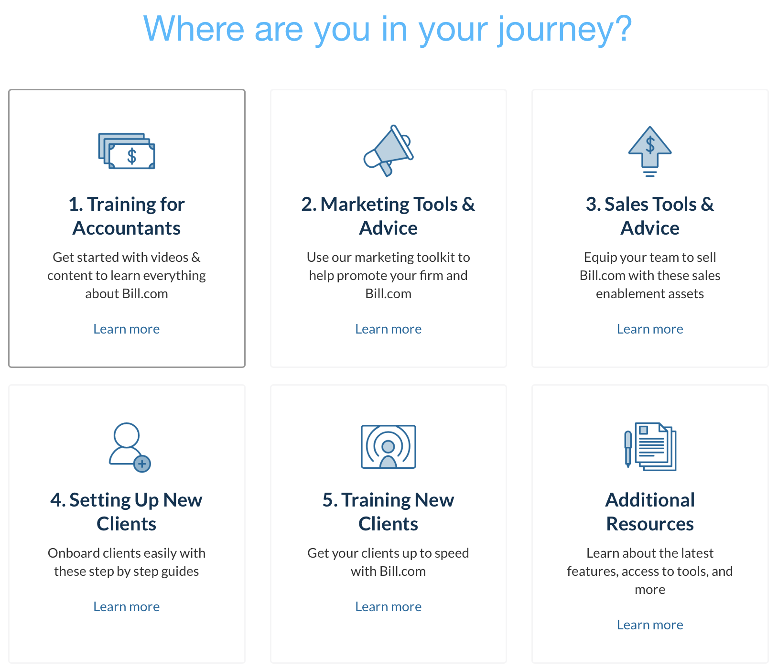

Marketing and Selling: Create a Demo Company
Create a free demo account to help you demonstrate the Bill.com service you'll be providing to your clients.

- Demo Accounts

You can use the Client Demo Kit to help you set up and give a demo that explains and illustrates the roles that your firm and the client play in the bill management process. We created these documents in Microsoft Word format so you can customize each for your unique training and presentation needs.

- Download Instructions
- Download Demo Script
- Download Demo Invoices

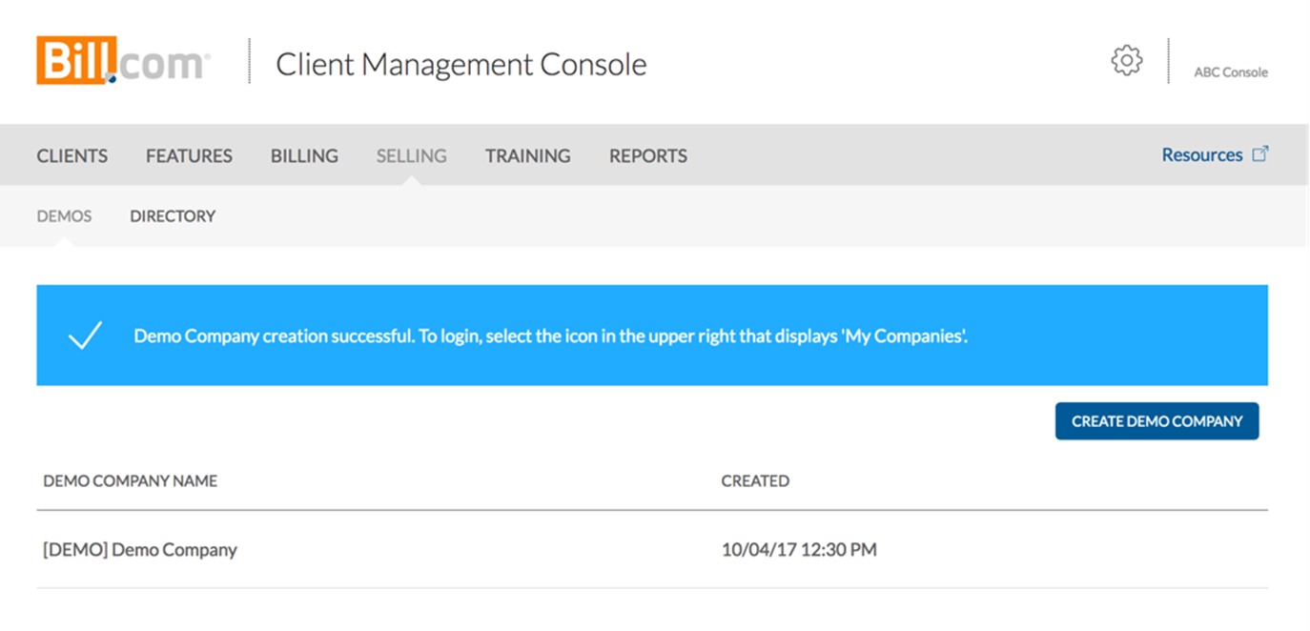

Console Reports
- From the Console, click Reports
- Click the desired Report name:
  - Console Billing: provides a breakdown of client usage fees by categories per client
  - All Console and Client Users: provides a list of all users on the console and each client account; useful for auditing access and bank authorization of every user
  - Payables Efficiency Insights: This report will highlight percentages and counts of bills exceeding your specified SLA in business days, based on clients or staff/users. It also surfaces productivity metrics such as bills created per month per user/staff.
  - Denied Bills List: This report enables your firm to benchmark and improve your process efficiency by identifying the top reasons your clients' bills are getting denied.

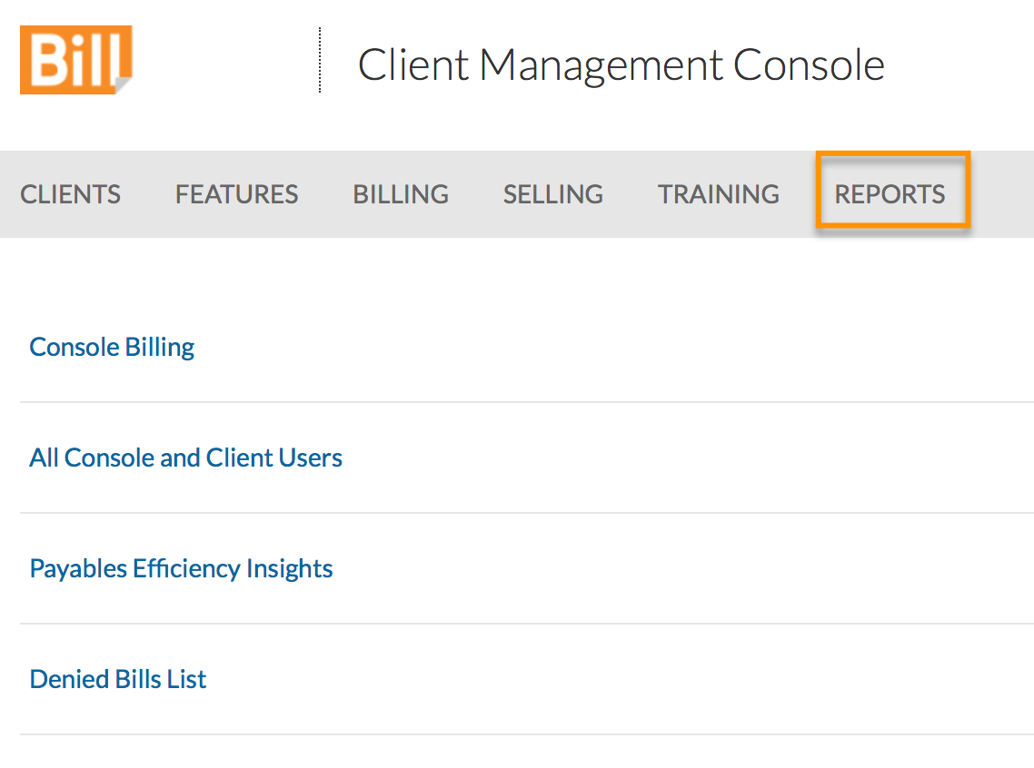

Contacting Support for Help
Support can be accessed from the bottom of the left panel in Bill.com
- Self-service articles (available 24/7)
- Chat (weekdays from 5 am to 6 pm PT)
- Email (response within 1-2 business days)
